Login Page

Bank Facility Management

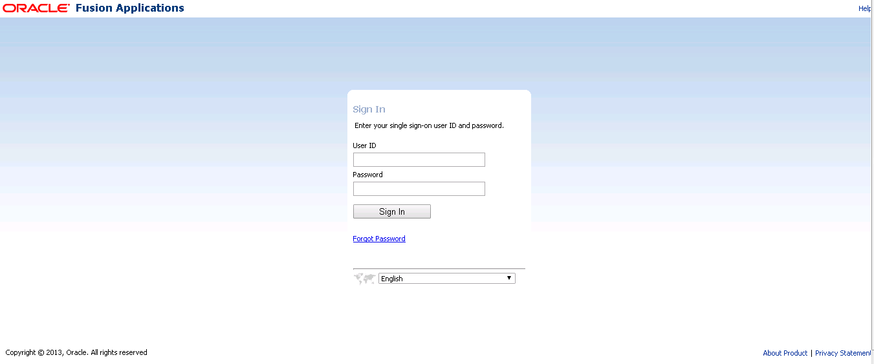

Home Page

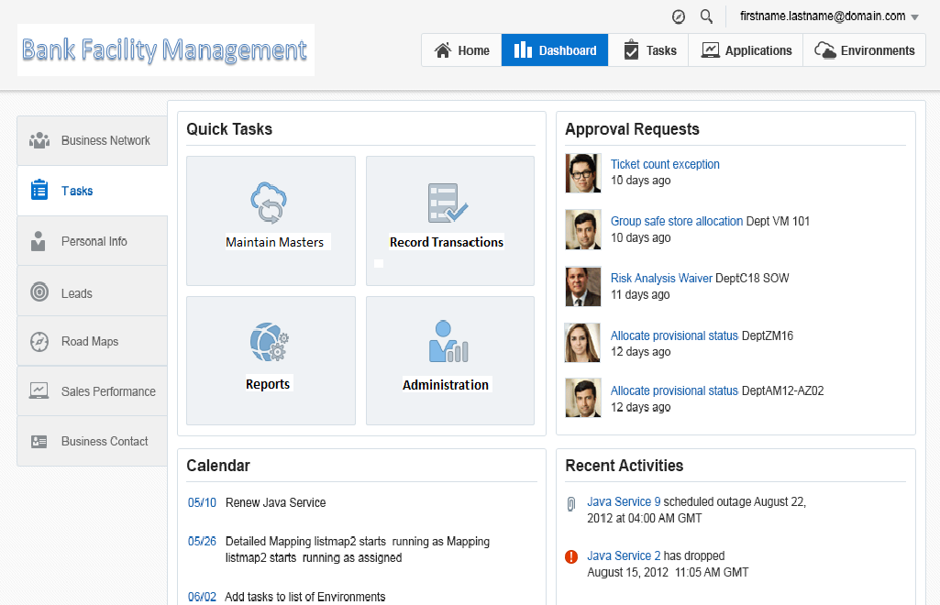

Master

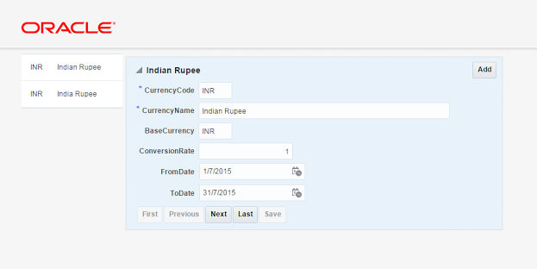

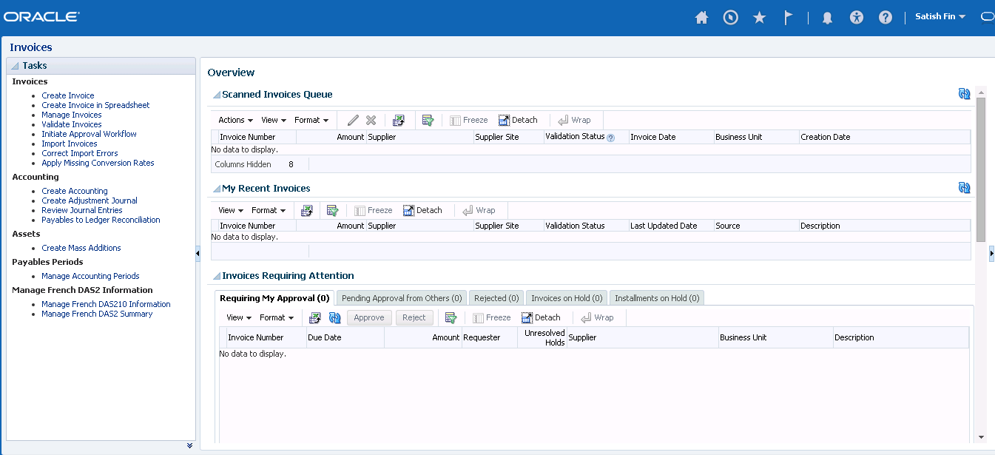

Master Detail

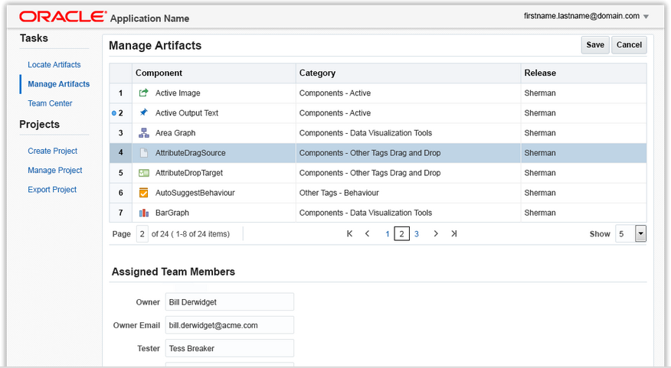

ADF Train concept

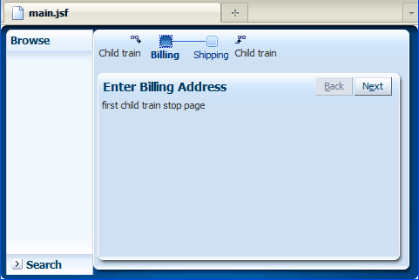

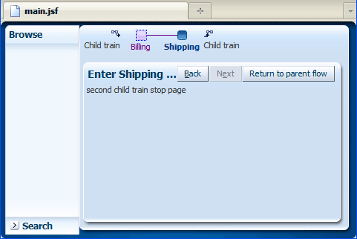

Master Tables

|  |  |  |  |
| --- | --- | --- | --- |
| **Business Entity Master** |  |  |  |
|  | ID | NUMBER | NOT NULL |
|  | Business Entity | VARCHAR2(64) | NOT NULL |
|  | Business Group | VARCHAR2(64) | NOT NULL |
|  | Project code | VARCHAR2(64) |  |
|  | Combination | VARCHAR2(64) |  |
|  | Status | VARCHAR2(64) |  |
|  |  |  |  |
| **Facility Structure** |  |  |  |
|  | ID |  | NOT NULL |
|  | Facility Name |  | NOT NULL |
|  | Component |  |  |
|  | Sub Comp |  |  |
|  | FACILITY COMBINATION |  |  |
|  | Start Date |  |  |
|  | End Date |  |  |

Bank Facility Management