**Task**

Implement single page flower ordering web app with tile view as default view with filtering mechanism.

﻿﻿﻿You should have 2 levels of filtering - display results which satisfy all the filters.

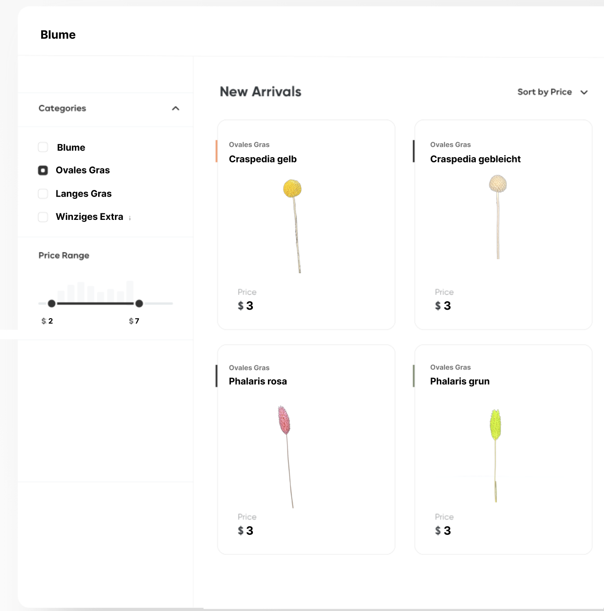

**Type filter**

* Blume
* basis
* Ovales Gras
* Winziges Extra
* Langes Gras
* glatt

**Price filter** in range 1-10

﻿﻿﻿You can use dummy data from this [API](https://blumlinge2.herokuapp.com/api/smallbouquet/)

You are expected to implement it dynamically

**You will be judged on the following criteria**

* ﻿﻿﻿Page layout and functionality
* ﻿﻿﻿Code Readability and Structure
* ﻿﻿﻿Parent-Child component communication
* Information hierarchy of all the content and components

**Submission Details**

﻿﻿﻿Host the code in a version control system e.g., GitHub, Gitlab etc., and submit the link to the repository below.

﻿﻿﻿Also, host the web app online using services like Netlify, Surge etc. and submit its link

DO NOT EXPECT the person checking the task to install your web app locally. There can be a lot of issues and back & forth, in case of any issue during local installation. It's better you host the app and send us the link