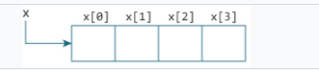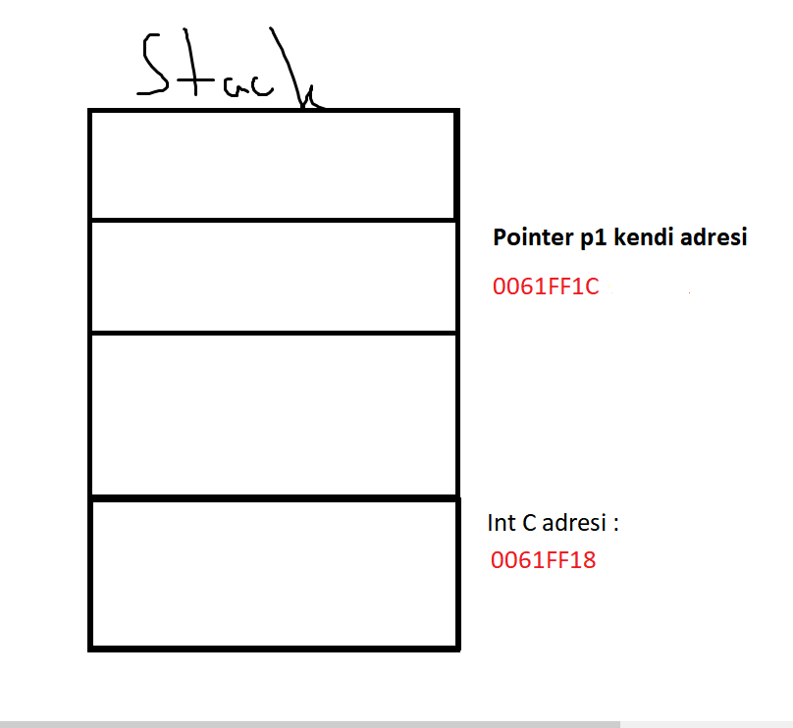

Link edilen adres:

0061FF18

4

Link edilen adres:

00400080

4

Ilk P1 adresinin icergi: 17744

[Grab your reader’s attention with a great quote from the document or use this space to emphasize a key point. To place this text box anywhere on the page, just drag it.]