Smart Xtream AI IPTV Player
App Description File — Samsung TV Seller Office Certification
Item | Value
Application Title | Smart Xtream AI IPTV Player
Version | 1.0.1
Type | Tizen Web Application (.wgt)
Tizen Application ID | SmrtXtrm01.SmartXtream
Minimum Platform | Tizen 4.0 (2018+ Samsung Smart TVs)
Billing | Free — no payment function
Seller | ByBora (Bora Savkar)
Support E-mail | borasavkar@gmail.com

1. Application Overview
Smart Xtream AI IPTV Player is an IPTV player client for Samsung Smart TVs. Users sign in with the credentials of their own IPTV subscription (Xtream Codes API) and watch their provider’s live TV channels, movies and series.
IMPORTANT: The application does NOT provide, host, sell or promote any content. It is a player only — all content comes from the user’s own IPTV provider. Without a subscription, the built-in Demo Mode (sample/open content) demonstrates every feature.

2. How to Test — No Account Required (Demo Mode)
- Launch the application.
- The profile screen appears on first launch. Press the “Load Demo Data (For Reviewers)” button.
- A demo profile is created automatically. The home dashboard loads with sample categories, movies and series that use publicly available sample streams.
- Every feature can now be tested: browsing, search, Quick Preview popup, full-screen player with accelerated seeking, favorites, watch history, settings and language selection.

To test with a real IPTV account instead: choose “Add Profile” and enter any valid Xtream Codes server URL, username and password.

3. Screen Guide

3.1 Home Dashboard
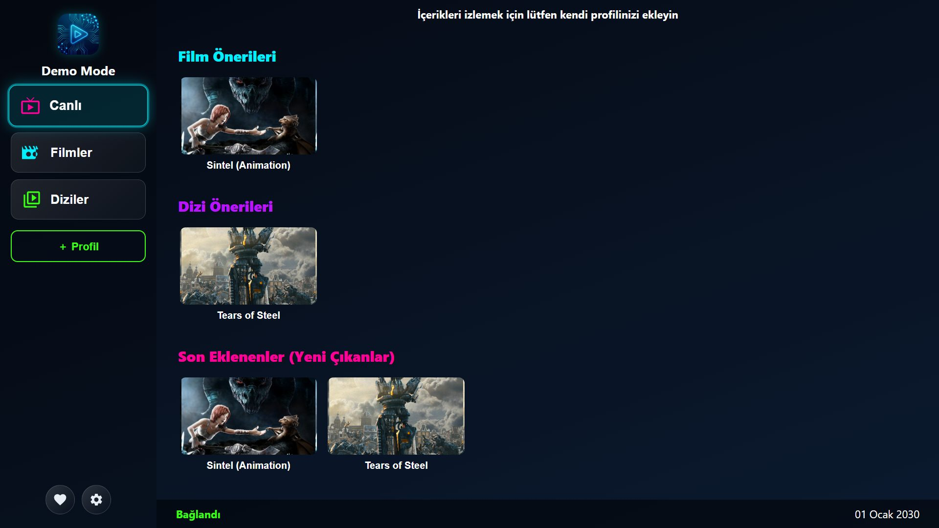
Left sidebar: profile, Live TV / Movies / Series navigation, favorites and settings. Content area: Continue Watching, recommendations and latest additions rails.

3.2 Quick Preview Popup
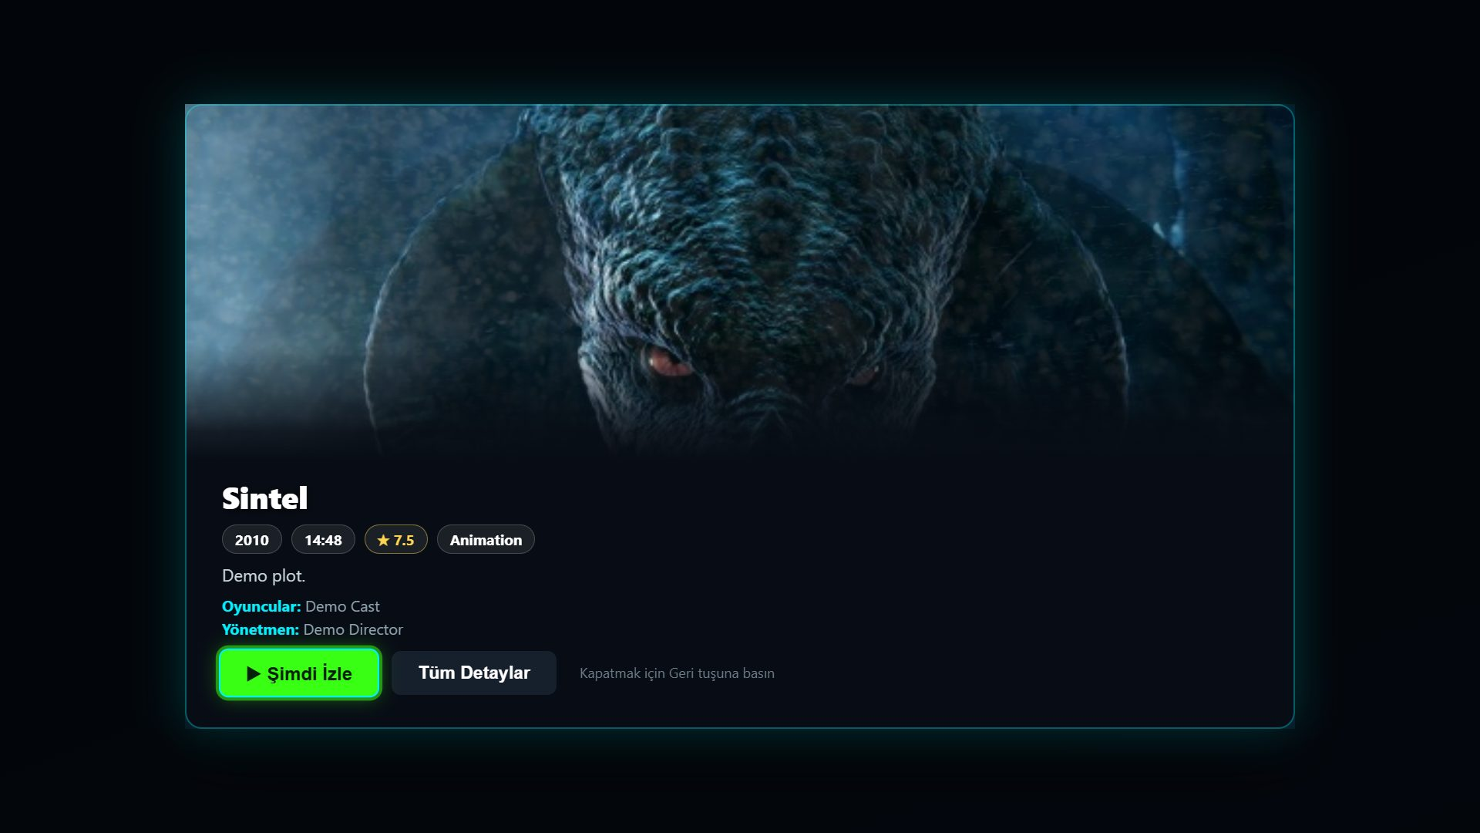
Resting on a poster for ~2 seconds opens a centered popup with an inline muted video preview, metadata chips (year, duration, rating, genre), plot, cast and “Play Now” / “Full Details” actions. Return closes it.

3.3 Player
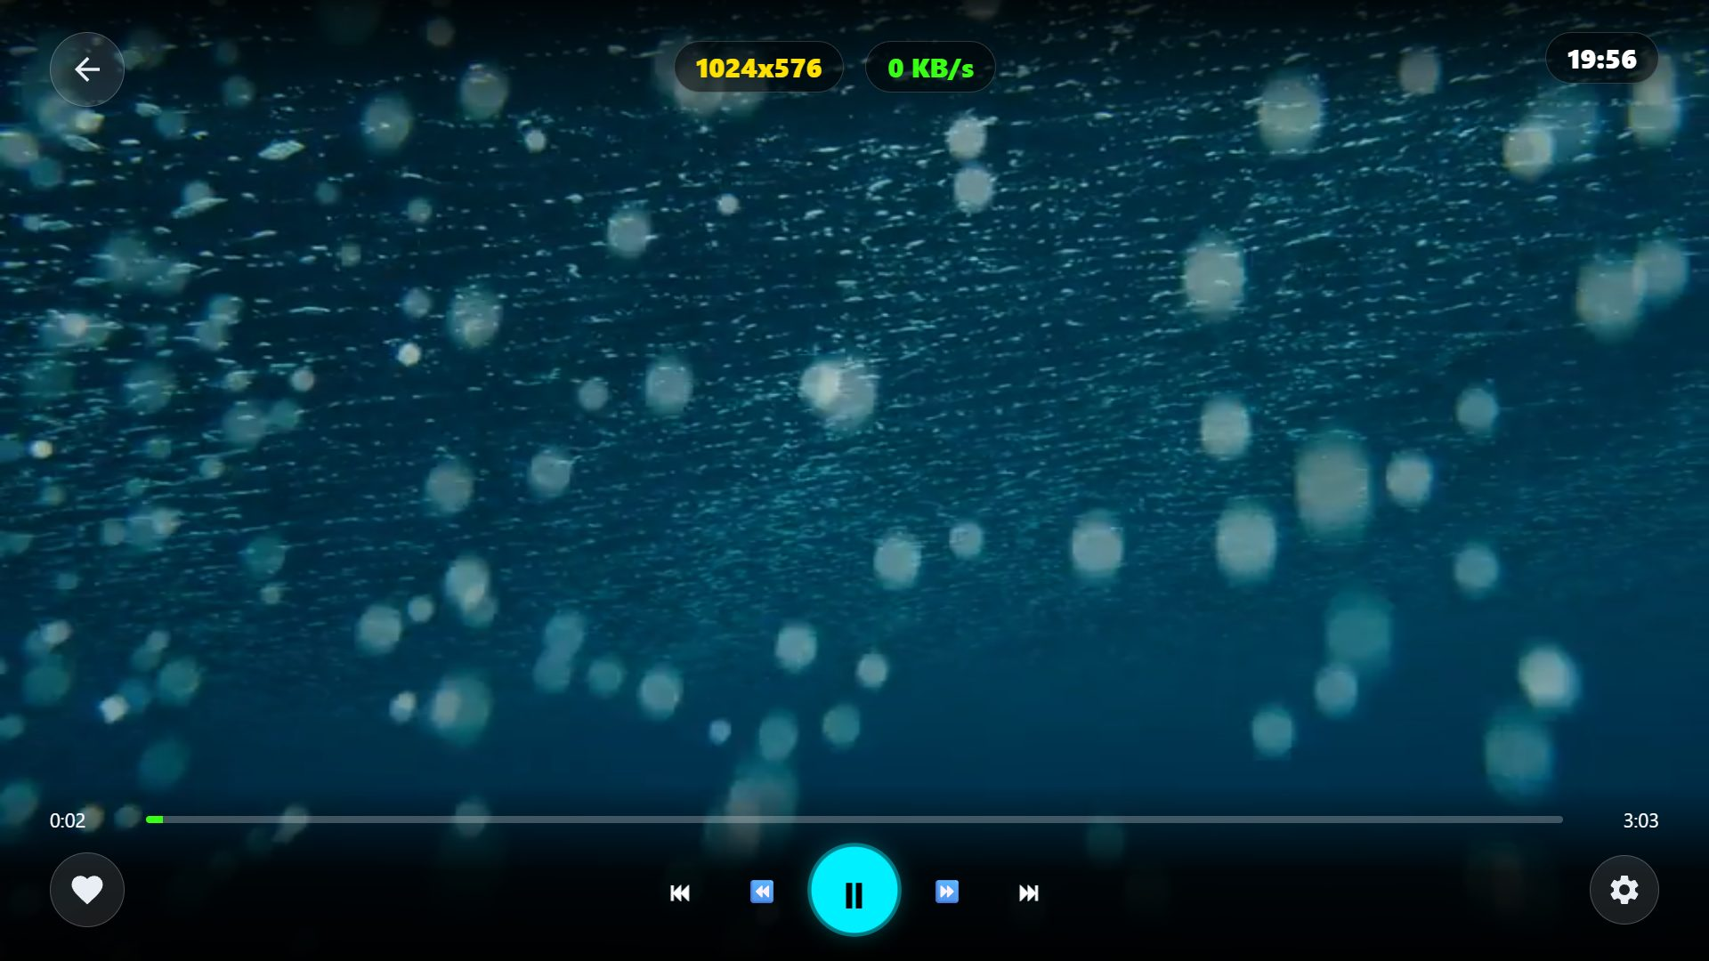
Bottom control bar with focusable progress bar and transport buttons; top HUD shows resolution, bandwidth and clock. Settings menu offers audio track, subtitle, subtitle style and video quality selection.

3.4 Movies Screen
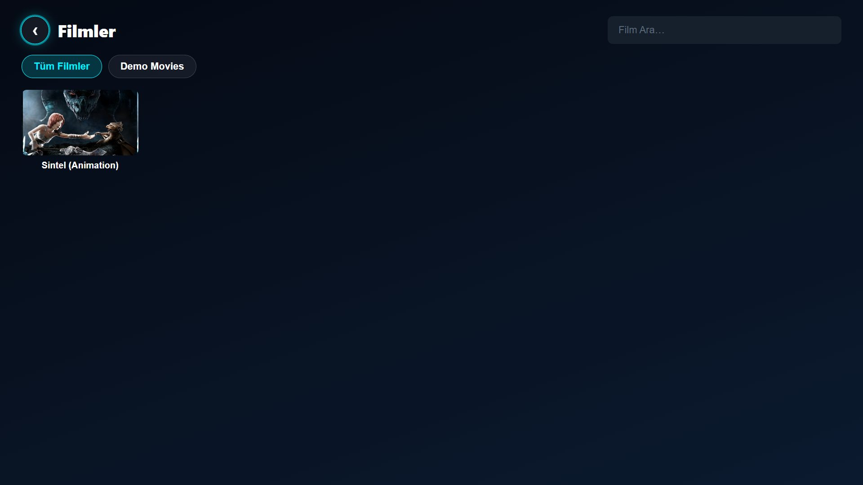
Category list with search; poster grid of the selected category. Series screen follows the same layout with season/episode lists in detail pages.

4. Remote Control Mapping
Remote Key | Function
Arrow keys | Navigate between items / move focus
OK (Enter) | Select / activate focused item
Return (Back) | Go back / close popup / exit text field
Left / Right (during VOD playback) | Accelerated seeking — hold to seek faster (10s → 30s → 60s → 120s steps); the seek is applied once on release
Up / Down (during live TV) | Channel zapping
Play / Pause / Rewind / FF media keys | Standard transport controls

5. Feature Summary
- Multi-profile Xtream Codes login with TV-keyboard-friendly forms (SmartThings mobile keyboard supported)
- Live TV with instant channel zapping, EPG line and favorites
- Movies & series: categories, search, detail pages, episode lists, resume from watch history
- Quick Preview popup with inline video preview and metadata
- Player: AVPlay engine, accelerated hold-seeking, audio/subtitle/quality menus, styled subtitles
- 11 interface languages (TR, EN, DE, FR, ES, IT, PT, NL, PL, RU, AR)

6. Notes for Certification
- Billing: Free. There is no payment function, no in-app purchase and no advertisement in this version.
- No personal information is collected or transmitted to the seller. IPTV credentials are stored only on the device and are sent only to the user’s own IPTV server.
- No DRM is used. Streams play over HTTP/HTTPS (progressive and HLS) through the AVPlay engine.
- Demo Mode uses publicly available sample streams (e.g. open demo MP4s) for testing purposes only.
- Privileges used: internet, application.launch, tv.inputdevice (media key registration).

