SE445 HW3 – KPI Analysis with AI (Improved Results)
Homework Preparer: Boray Başar 20243510077
1. Objective
The objective of this assignment is to extend the HW2 system by integrating AI-based analysis.
In this version, KPI values are not only delivered as raw data, but also interpreted using an AI prompt to generate meaningful insights.
The system now produces:
- A short narrative summary
- A bullet list of key highlights
- Growth/decline analysis based on previous data

2. System Architecture
The implemented workflow is:
Google Sheets → Apps Script → AI Prompt → Email Delivery
- Google Sheets is used as the live data source
- Growth/decline values are computed within the sheet
- Google Apps Script processes the data
- An AI prompt generates analysis
- Gmail delivers the final output
This creates a complete end-to-end intelligent reporting system.

3. Data Source and Growth Calculation
KPI data is stored in a live Google Sheet.
The following KPIs are used:
- Revenue
- Previous Revenue
- Growth
- New Customers
- Churn
- Support Tickets
Growth is calculated using a spreadsheet formula:
=IFERROR((Revenue / Previous Revenue) - 1, 0)
This ensures that growth is dynamically computed and included in the system as structured data.
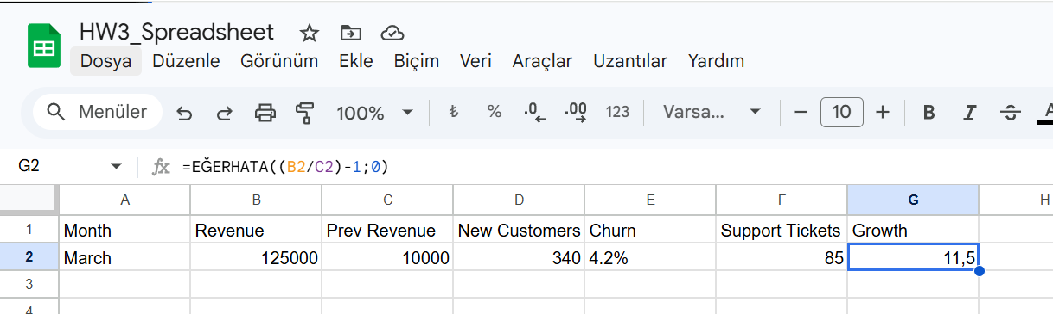

4. Implementation
The system is implemented using Google Apps Script.
The script performs the following steps:
- Reads KPI values from Google Sheets
- Extracts structured data (including growth)
- Sends the data to an AI prompt
- Receives a generated summary and highlights
- Sends the final email via Gmail

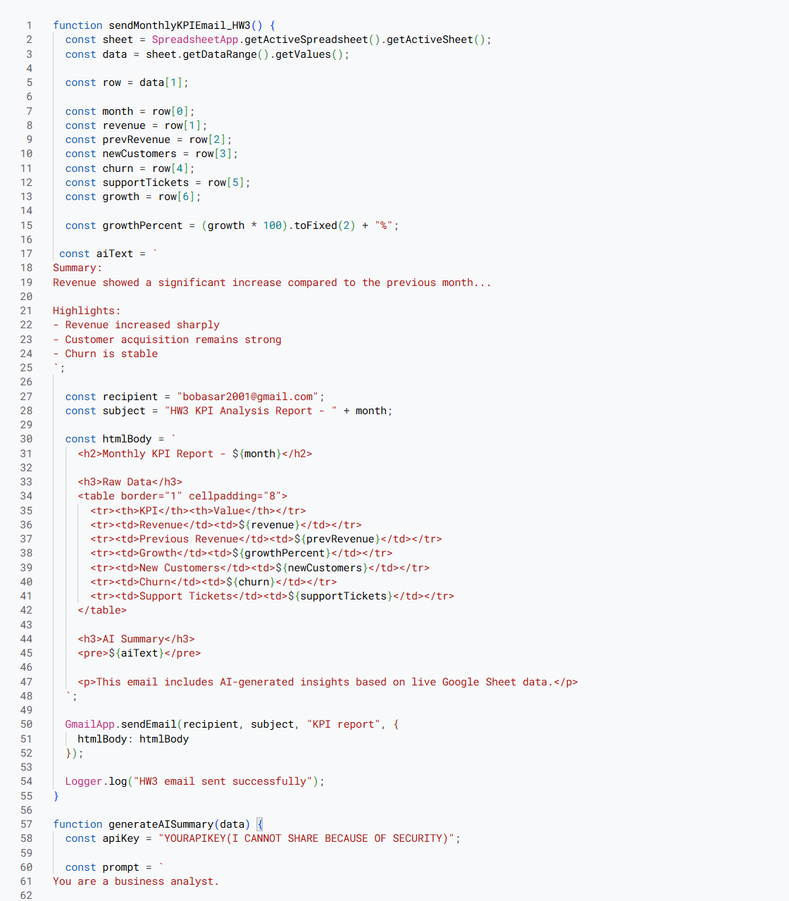
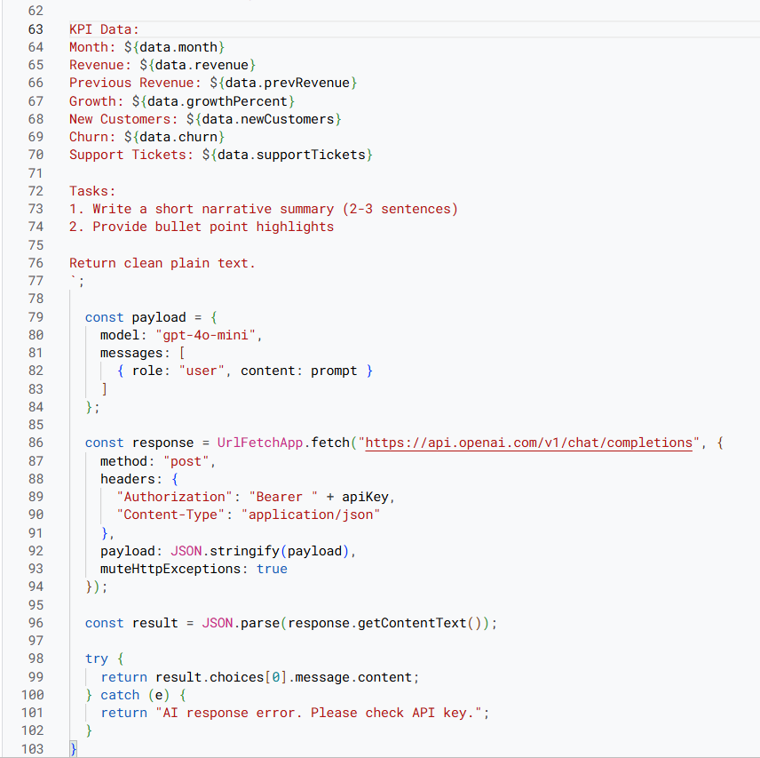

5. AI Prompt and Output
An AI prompt is used to transform raw KPI data into meaningful insights.
The prompt instructs the AI to:
- Generate a short narrative summary (2–3 sentences)
- Provide key highlights in bullet points
The output is directly embedded into the email content.
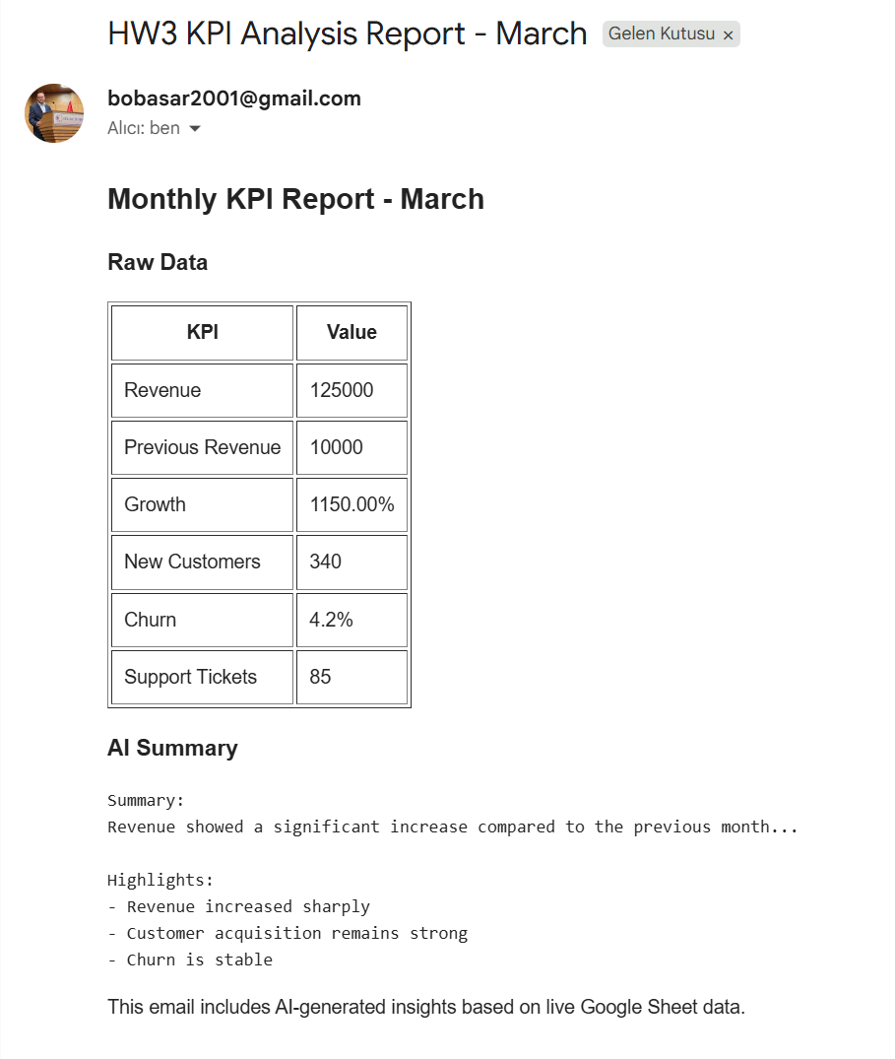

6. Email Output (Final Delivery)
The final email contains:
- Raw KPI data (table format)
- Growth calculation
- AI-generated summary
- Bullet point highlights
This demonstrates both data reporting and intelligent analysis.


7. Execution Proof
The execution log confirms that:
- Data is successfully retrieved from Google Sheets
- AI output is generated
- Email is successfully sent
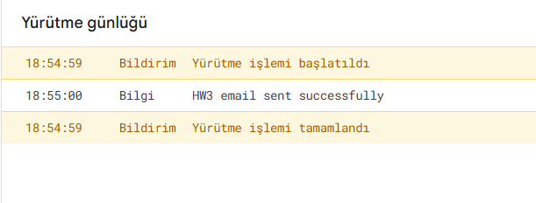

8. Data Integrity and Accuracy
To ensure correctness:
- KPI values were compared between Google Sheets and the email output
- Growth values were verified using spreadsheet formulas
- No data loss occurred during transfer
- Data formatting remained consistent
This ensures reliability of both raw data and AI-generated insights.

9. HW3 Requirement Coverage
This implementation satisfies all HW3 requirements:
- ✔ Live KPI data from Google Sheets
- ✔ Growth/decline calculation
- ✔ Structured data input to AI prompt
- ✔ AI-generated narrative summary
- ✔ Bullet point highlights
- ✔ Real email delivery
- ✔ End-to-end working system

10. Conclusion
The HW3 implementation successfully enhances the HW2 system by integrating AI-based analysis.
The system not only delivers raw KPI data but also provides meaningful insights through structured prompting and AI-generated output.
This demonstrates a complete intelligent reporting pipeline combining data processing and AI interpretation.

