SE445 HW2 – Monthly KPI Raw Data Report
Preparer: Boray Başar 20243510077
1. Objective
The objective of this assignment is to implement a working system that reads KPI values from a live data source and delivers them as raw values through a real email service.
Unlike the initial submission, this corrected version demonstrates a fully functional live data pipeline, where KPI values are retrieved from Google Sheets and sent via Gmail.

2. System Architecture
The implemented workflow is:
Google Sheets → Apps Script → Gmail
- Google Sheets is used as the live KPI data source
- Google Apps Script processes the data
- Gmail is used to deliver the email output
This ensures that the system operates on real data and produces real outputs.

3. Data Source (Live KPI Data)
KPI values are stored in a Google Sheet named:
Monthly_KPIs_HW2
The following KPIs are used:
- Revenue
- New Customers
- Churn
- Support Tickets
The system reads these values dynamically from the sheet.
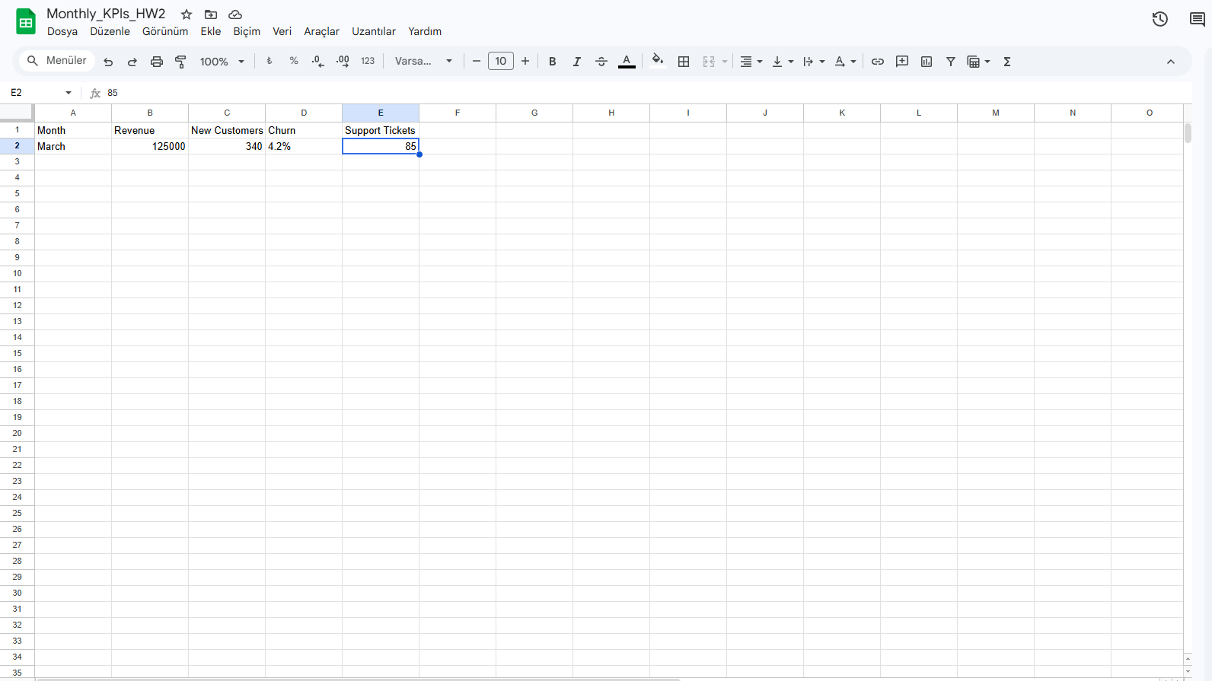

4. Implementation
The system is implemented using Google Apps Script.
The script performs the following steps:
- Accesses the active Google Sheet
- Reads KPI values from the second row
- Formats the data into an email body
- Sends the email using Gmail
The implementation directly integrates with Google services, ensuring real-time data processing.
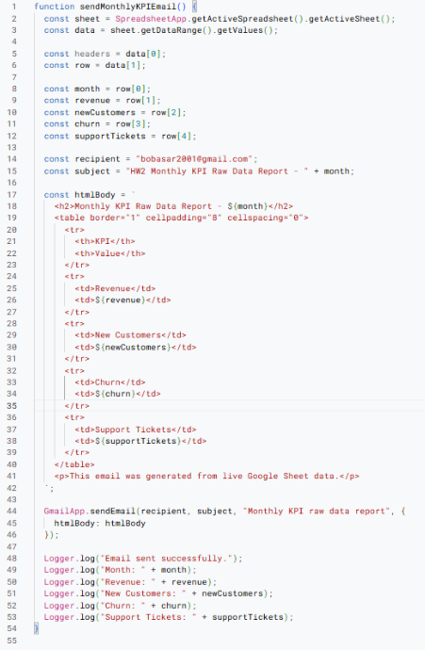

5. Email Output (Real Delivery)
The system sends an actual email containing raw KPI values.
The email includes:
- Subject line with the month
- KPI values in structured format (table or bullet list)
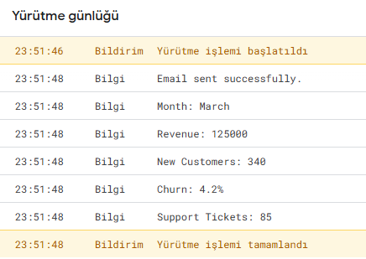

6. Execution Proof
The script execution log confirms that:
- Data is successfully read from Google Sheets
- Email is successfully sent
- KPI values are correctly processed
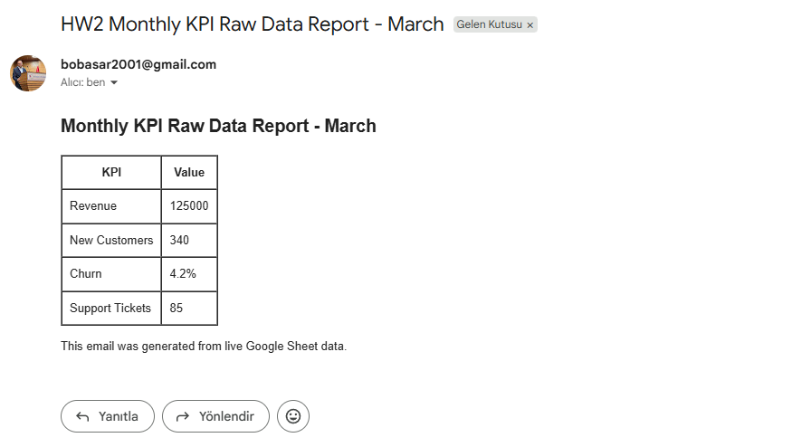

7. Data Integrity and Formatting
To ensure correctness:
- KPI values in Google Sheets were compared with the received email
- All values were transferred without any modification
- No data loss occurred during transfer
- Formatting was preserved correctly
Example verification:
KPI | Google Sheet | Email Output
Revenue | 125000 | 125000
New Customers | 340 | 340
Churn | 4.2% | 4.2%
Support Tickets | 85 | 85
This confirms that the system meets the no data loss and no formatting error requirements.

8. HW2 Requirement Coverage
This implementation satisfies all HW2 requirements:
- ✔ Live data pipeline (Google Sheets)
- ✔ Real email delivery (Gmail)
- ✔ Destination proof (received email)
- ✔ No data loss
- ✔ No formatting errors

9. Conclusion
The corrected implementation successfully transforms the initial simulated workflow into a real, working system.
The system demonstrates:
- Live data retrieval
- Real-time processing
- Successful delivery through an email system
All required criteria are met, and the solution provides verifiable proof of correct functionality.

