**3.1 Introduction**

The Island of knowledge is an adventure game that is suitable for ages 4-7 years old. The main goal of the game is, the player will collect all the things. After collecting a thing, a trivia or fact will pop-up on the screen. The player has 100 seconds to collect things for each level. When the player collects all the things within a level the player will get 3 stars and the player have only 5 lives. The player should avoid the spikes or other traps that will cause the player to reduce the life that the users have. After the player finish a certain level the game will unlock the next level. If the player failed to collect the things within 100 seconds or player dies, the game will start from the beginning of the current level.

**3.2 Overview**

The game has 4 island selection, the alphabet, shapes, colors, and numbers. Each island has different levels, for alphabet island it has 26 levels for shape island it has 10 levels for color island it has 10 levels and for the number island it has 10 levels.

**3.3 System Design Specification**

**3.3.1 Spiral Model**

The spiral model is a risk-driven process model generator for software projects. Based on the unique risk patterns of a given project, the spiral model guides a team to adopt elements of one or more process models, such as incremental, waterfall, or evolutionary prototyping. **[SRCH 2009]**

**Figure 3.1**

**Spiral Model**

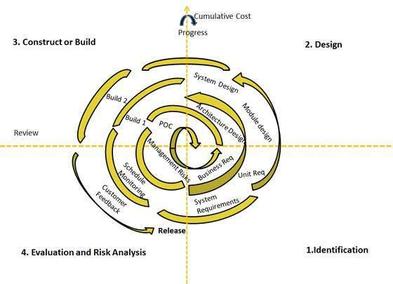

**Figure 3.1**

**Spiral Model**

* **Identification**

This phase starts with gathering the business requirements in the baseline spiral. In the subsequent spirals as the product matures, identification of system requirements, subsystem requirements and unit requirements are all done in this phase. This also includes understanding the system requirements by continuous communication between the customer and the system analyst. At the end of the spiral the product is deployed in the identified market. The developers find all requirements on how to develop the game all the tools that are needed.

3-2

* **Design**

Design phase starts with the conceptual design in the baseline spiral and involves architectural design, logical design of modules, physical product design and final design in the subsequent spirals. **[SRCH 2009]**  The developers find a design that will fit the age of the users.

* **Construct or Build**

Construct phase refers to production of the actual software product at every spiral. In the baseline spiral when the product is just thought of and the design is being developed a POC (Proof of Concept) is developed in this phase to get customer feedback. Then in the subsequent spirals with higher clarity on requirements and design details a working model of the software called build is produced with a version number. These builds are sent to customer for feedback. **[SRCH 2009]** During the production the developers maintain the requirements and tools, if the requirement are still satisfy by the users.

* **Evaluation and Risk Analysis**

Risk Analysis includes identifying, estimating, and monitoring technical feasibility and management risks, such as schedule slippage and cost overrun. After testing the build, at the end of first iteration, the customer evaluates the software and provides feedback. **[SRCH 2009]** The developers make different experiment to test the capability of the software including the survey , the developers conduct a survey to try the software to the users.

**3.3.2 Data Flow Diagram**

A data flow diagram (DFD) illustrates how data is processed by a system in terms of inputs and outputs. As its name indicates its focus is on the flow of information, where data comes from, where it goes and how it gets stored.  Data flow diagram (DFD) is a graphical representation of the "flow" of data through an [information system](https://en.wikipedia.org/wiki/Information_system), modeling its *process* aspects. A DFD is often used as a preliminary step to create an overview of the system, which can later be elaborated. [SMRT]

3-3

Process Entity

Data Store Data Flow

**Figure 3.2**

**Data Flow Diagram Symbols**

3-4

* + **Entity**

Objects outside the system, with which the system communicates. External entities are sources and destinations of the system's inputs and outputs. It is external to the system we study, in terms of the business process. For this reason, people used to draw external entities on the edge of a diagram. [AZZO2001]

* + **Data Flow**

Dataflow is often defined using a model or diagram in which the entire process of data movement is mapped as it passes from one component to the next within a program or a system, taking into consideration how it changes form during the process. [TECH]

* + **Data Store**

Data stores are repositories of data in the system. They are sometimes also referred to as files. A data store represents the storage of persistent data required and/or produced by the process. Here are some examples of data stores: membership forms, database table.. [TECH]

* + **Process**

Sequence of interdependent and linked procedures which, at every stage, consume one or more resources (employee time, energy, machines, money) to convert inputs (data, material, parts) into outputs. These outputs then serve as inputs for the next stage until a known goal or end result is reached. [BUSI]

3-5

**3.3.3.1 Context Flow Diagram**

Context Diagram is a [diagram](https://en.wikipedia.org/wiki/Diagram) that defines the boundary between the [system](https://en.wikipedia.org/wiki/System), or part of a system, and its environment, showing the entities that interact with it. This diagram is a high level view of a [system](https://en.wikipedia.org/wiki/System). It is similar to a [block diagram](https://en.wikipedia.org/wiki/Block_diagram). [PROJ]

**Context Flow Diagram of Island of Knowledge: Adventure Android Game**

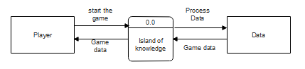

**Figure 3.3**

**Context Flow Diagram**

**Data Flow Diagram**

A data flow diagram (DFD) illustrates how data is processed by a system in terms of inputs and outputs. As its name indicates its focus is on the flow of information, where data comes from, where it goes and how it gets stored.  Data flow diagram (DFD) is a graphical representation of the "flow" of data through an [information system](https://en.wikipedia.org/wiki/Information_system), modelling its *process* aspects. A DFD is often used as a preliminary step to create an overview of the system, which can later be elaborated. [SMRT]

3-6

**Data Flow Diagram of Island of Knowledge: Adventure Android Game**

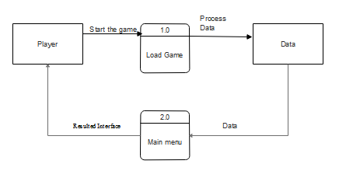

**Figure 3.4**

**Data Flow Diagram**

3-7

**Main Menu Explosion of Island of Knowledge: Adventure Android Game**

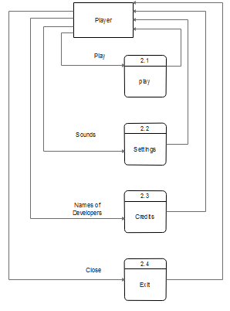

**Figure 3.4.1**

**Main Menu Explosion of Island of Knowledge**

3-8

**Play Explosion of Island of knowledge: Adventure Android Game**

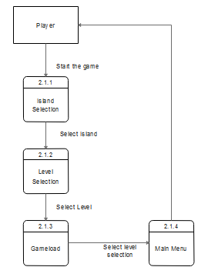

**Figure 3.4.2**

**Play Explosion of Island of knowledge**

3-9

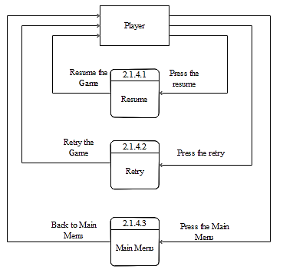**Pause Explosion of Island of knowledge: Adventure Android Game**

**Figure 3.4.3**

**Pause Explosion of Island of knowledge**

3-10

**Settings Explosion of Island of knowledge: Adventure Android Game**

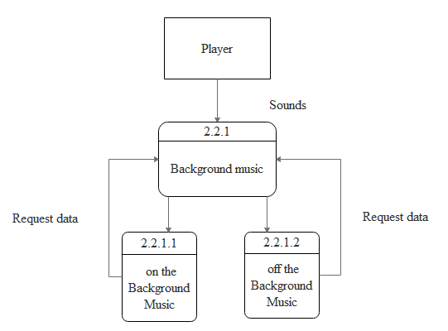

**Figure 3.4.4**

**Settings Explosion of Island of knowledge**

3-11

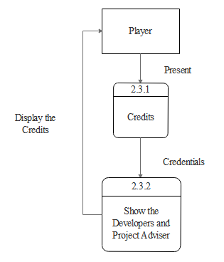 **Credits Explosion of Island of knowledge: Adventure Android Game**

**Figure 3.4.5**

**Credits Explosion of Island of knowledge**

3-12

**Exit Explosion of Island of knowledge: Adventure Android Game**

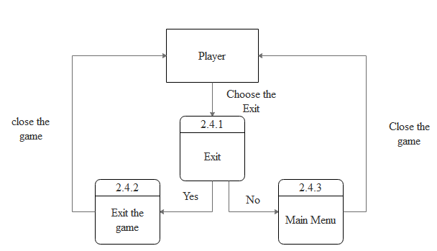

**Figure 3.4.6**

**Exit Explosion of Island of knowledge**

3-13

**3.4.2 System Block Diagram**

A system block diagram is a high level modularization of the system that separates the overall system into maximally decoupled sub-systems. System block diagrams enable one to visualize the system as large interacting components that can be conceptualized and developed independently. This type of architecture also lends itself to greater flexibility and extensibility of the system, enabling it to grow and evolve more easily to adjust for changing requirements and demands. Creating a system block diagram early in the development process is critical for assembling teams of develops that can work in parallel on the project. [RICE]

**System Block Diagram of Island of knowledge: Adventure Android Game**

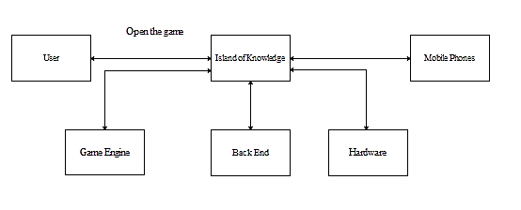

**Figure 3.4.8**

**System Block Diagram of Island of knowledge**

3-14

**3.2.2.4 Hierarchy Input Process Output**

A systems analysis design aid and documentation technique used for representing the modules of a system as a hierarchy and for documenting each module.

**HIPO Diagram of Island of knowledge: Adventure Android Game**

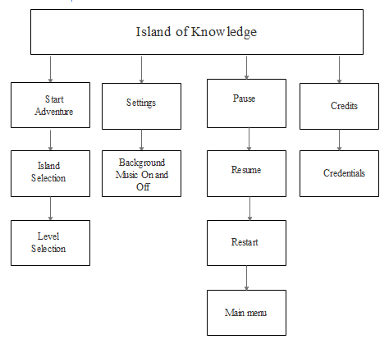

**Figure 3.4.9**

**HIPO Diagram of Island of knowledge**

3-15

**3.5 Story Board**

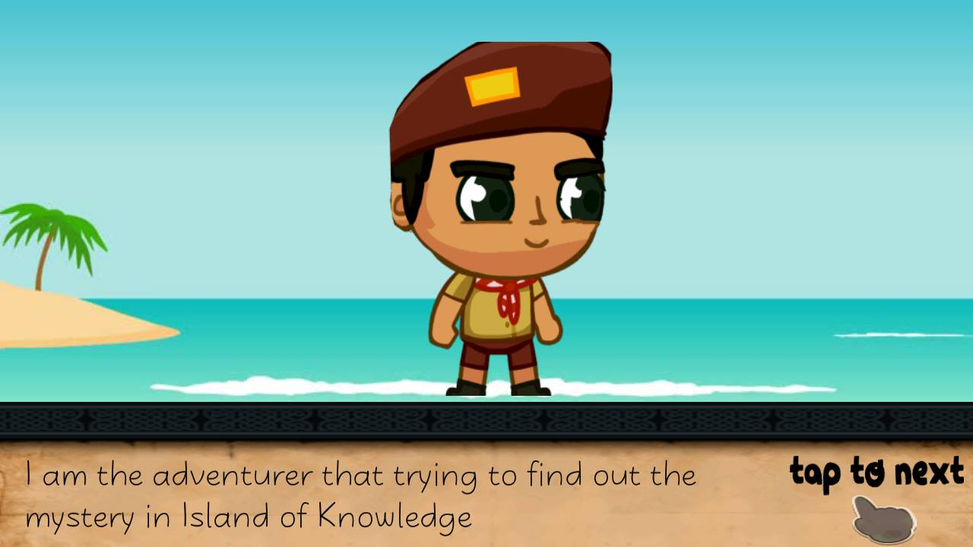  Storyboard is a graphic organizer in the form of illustrations or images displayed in sequence for the purpose of pre-visualizing a motion picture, animation, motion graphic or interactive media sequence.

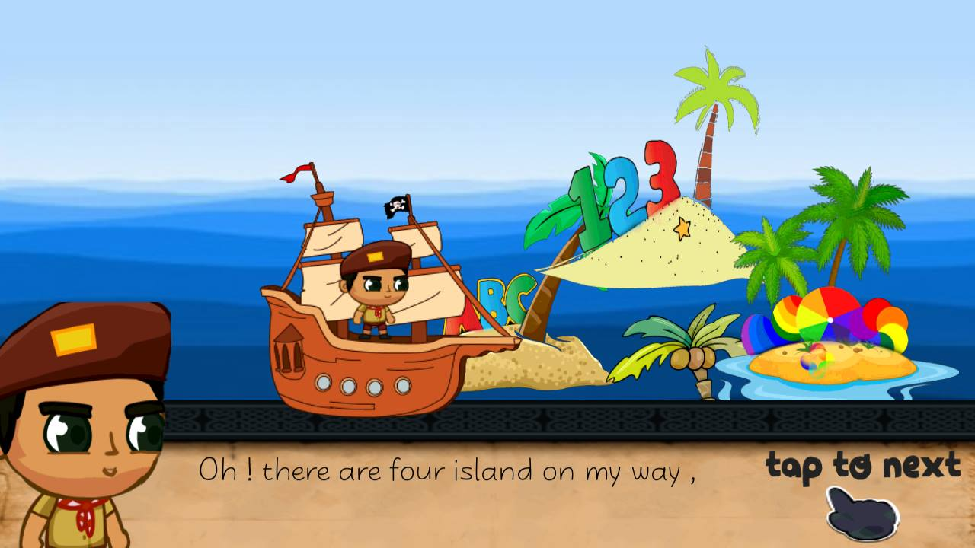

The instruction of the game which the After the introduction the adventurer

Adventurer trying to find out the mystery on the island.

In the Island of knowledge.

3-16

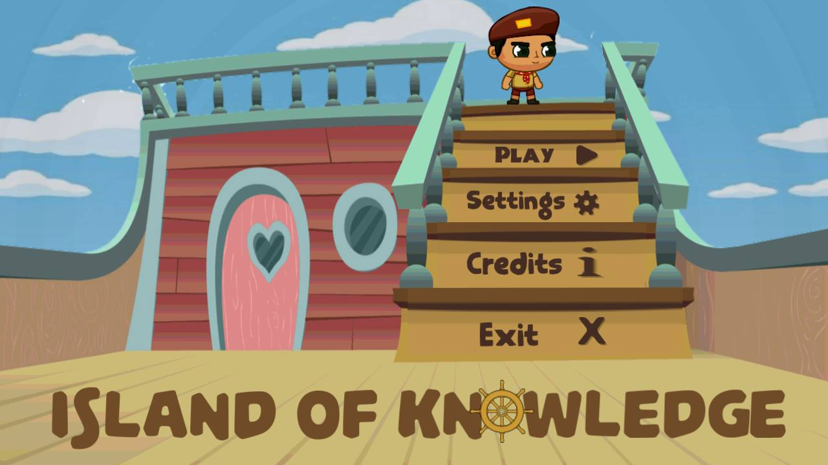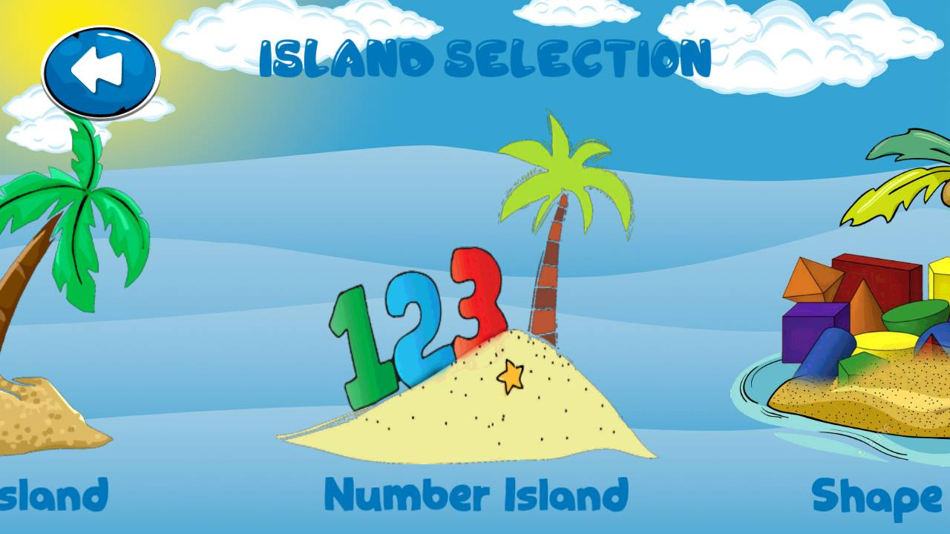

The main Menu, if the user wants to start The player will choose which island that

the adventure, select the settings the player wants to play

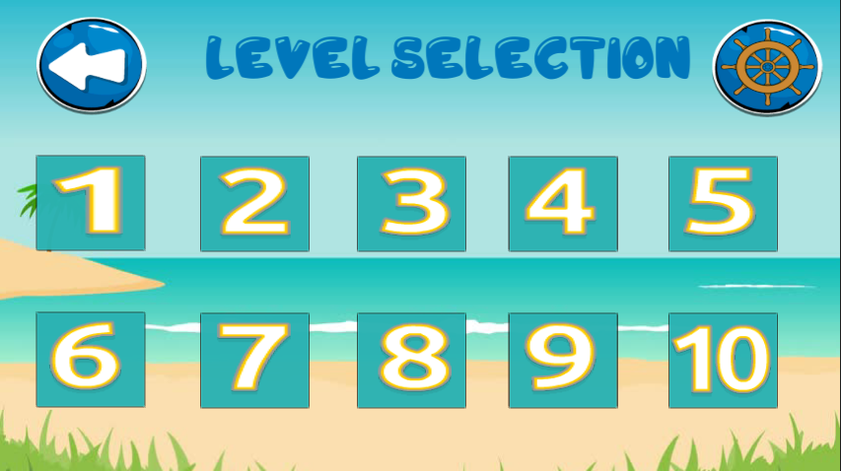

If the user go to number island the game will give examples to teach the

The game will teach the player user how to count numbers.

How to count

3-17

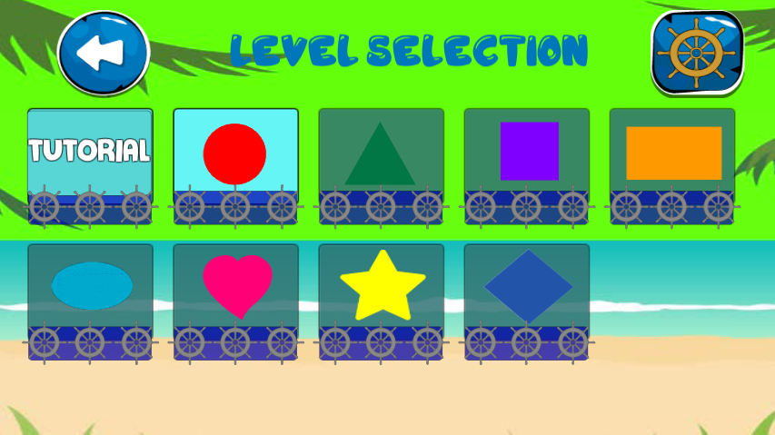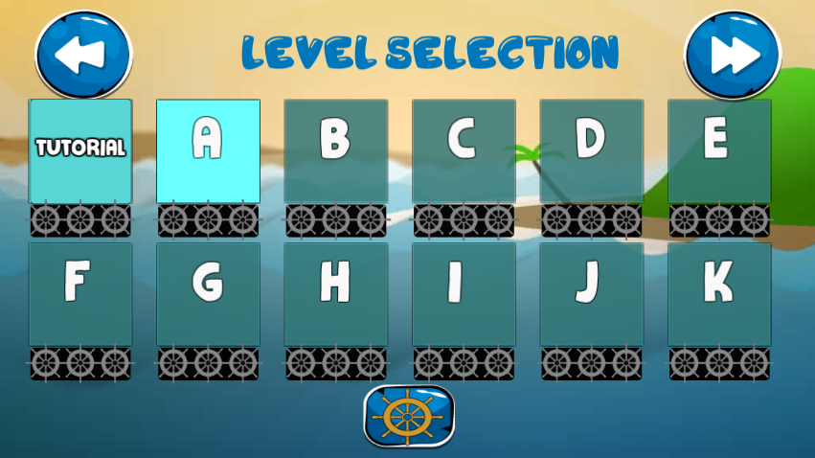

Level selection for the Alphabet Island Level selection for the Shape Island

the Player will collect all the items that the player will collect all the items

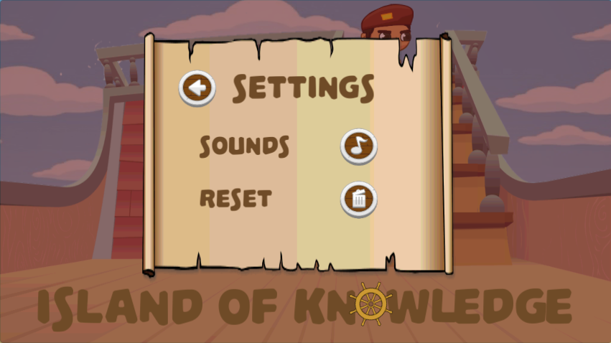 Letter A-Z. that have same shapes.

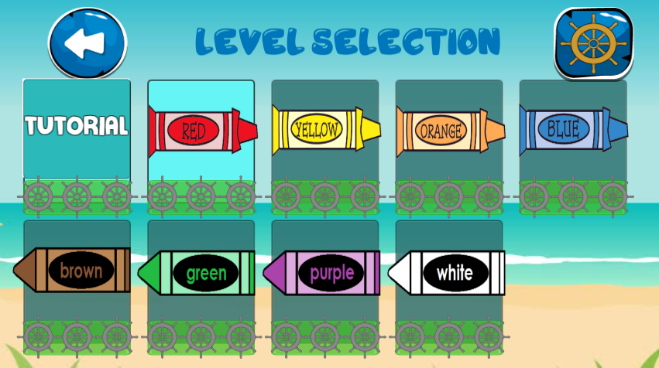

Level selection for the Color Island the the settings is for the sound of the

Player will collect all the items that have game so that the player will enjoy

same Color. The game.

3-18

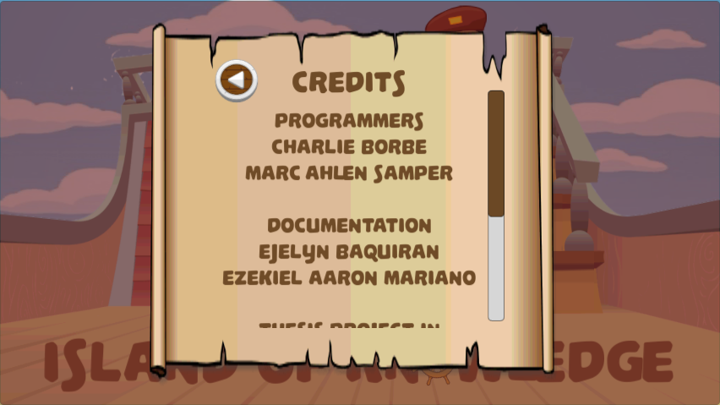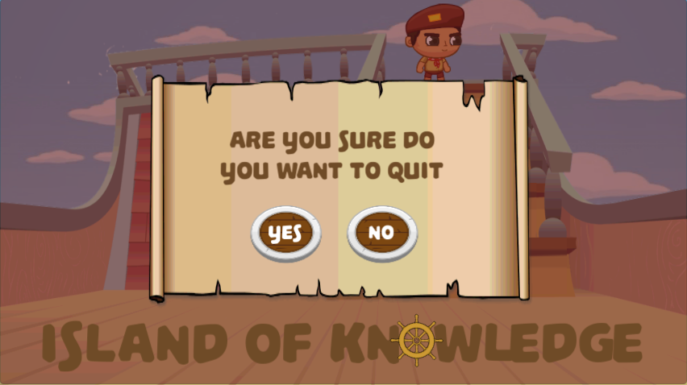

The credits provide the information about Last the exit button if the user want to

the developer and documentation of the game. quit the game.

**3.6 Summary**

In this chapter the developers discuss the flow of the game. The developers also show all the diagrams that explain how the game plays. The story board shows all the

3-21

pictures of every part of the game and has an explanation for each function. The developers explain all the functions and different module of the game. The developers show all the level and each obejctives. It also have tutorials on how to play the game.

3-19