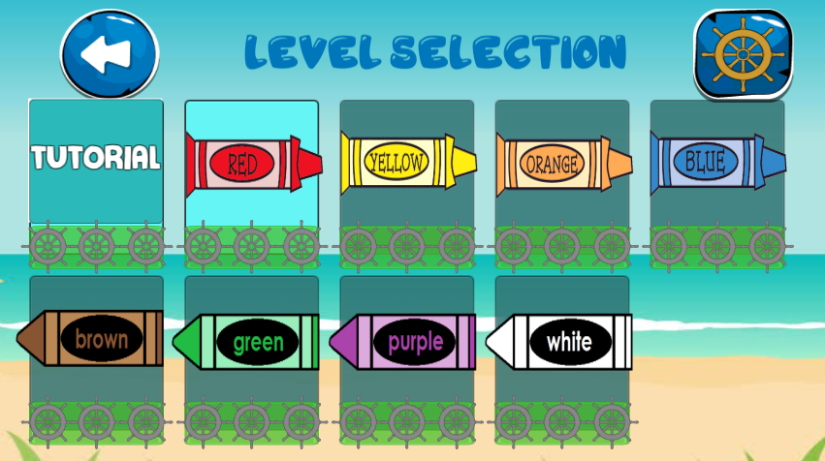 **Color Island (Level Selection)**

Back

Help

**Help**

**Back**

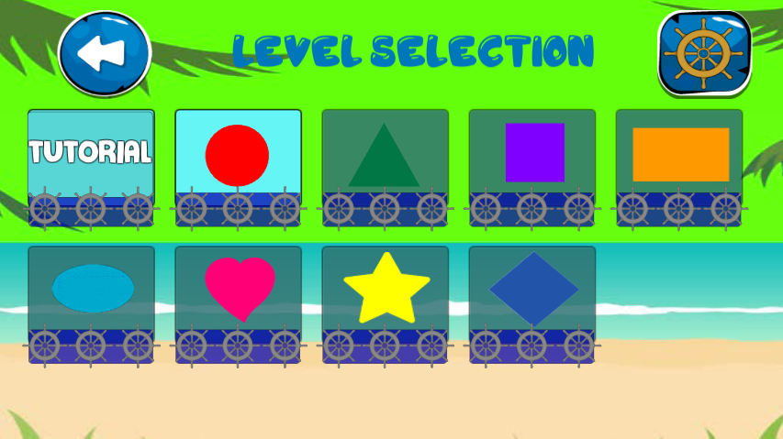**Shape Island (level Selection)**

**Letter Island(level selcetion)**

**Next**

**Back**

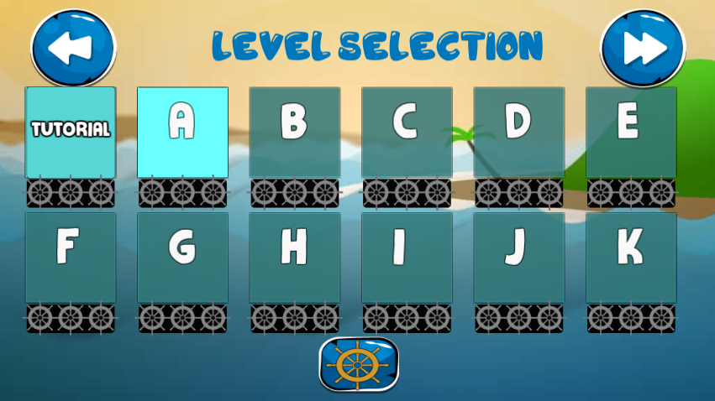

**Help**

**Back**

Help

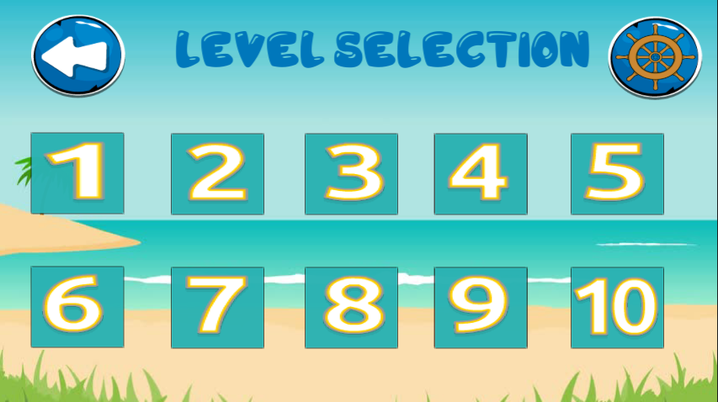**Number Island(level Selection)**

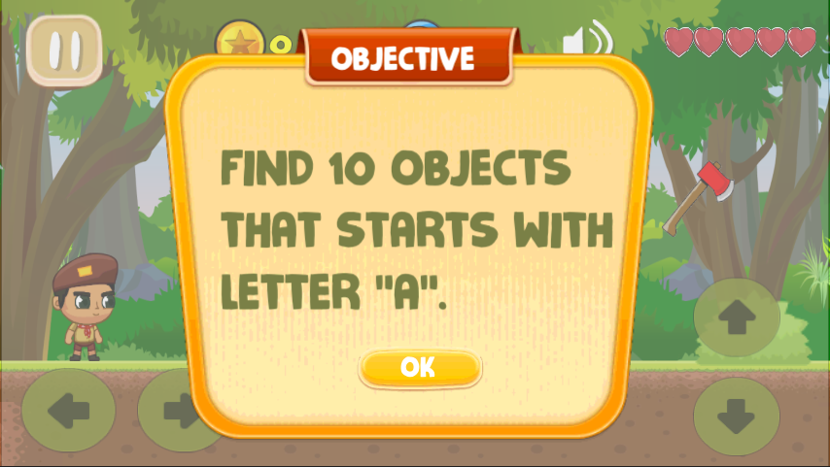

Starting the game

**Continue to play**

**Life**

**Pause**

**coins**

**Time**

**sounds**

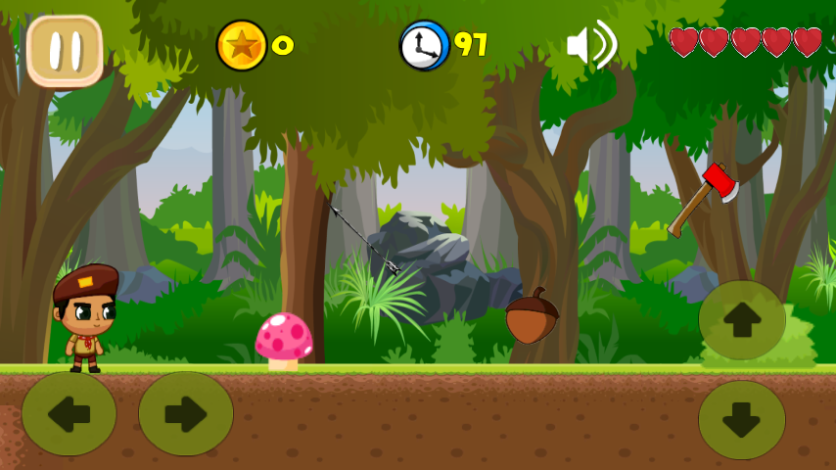

**Jump**

**Down**

**On the game**

**Turn left**

**Turn right**

Turn right

Turn Left

Down

Jump

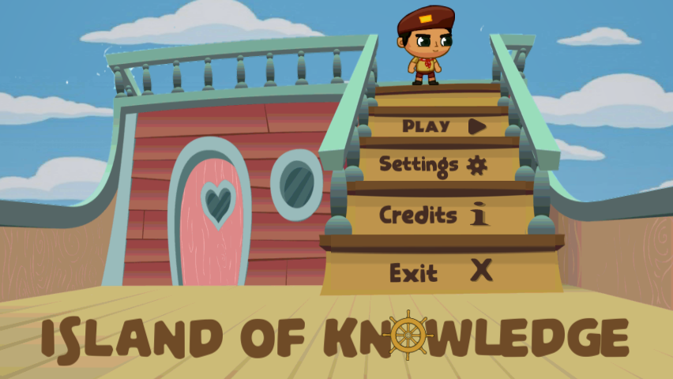

**Start play**

**Sound**

**Developer’s names**

**Close the game**

Main menu of the game

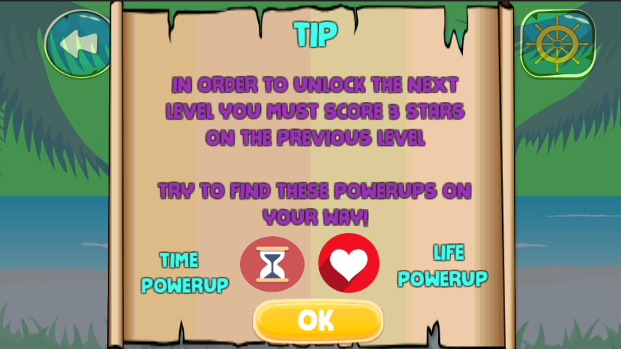

**Help**

**Back**

**Extend the time**

**Extra Life**

**Continue Game**

**Help Button**

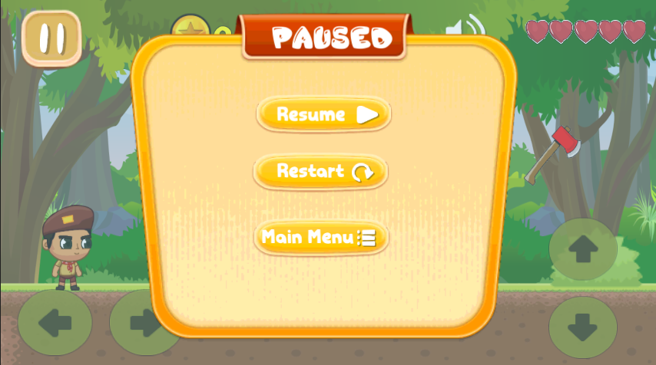

**Pause button**

**Resume the game**

**Restart the game**

**Back to main menu**

**Game over**

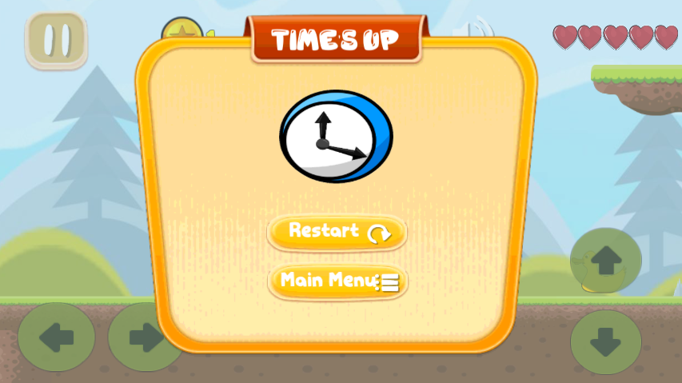

**Restart the game**

**Back to main menu**

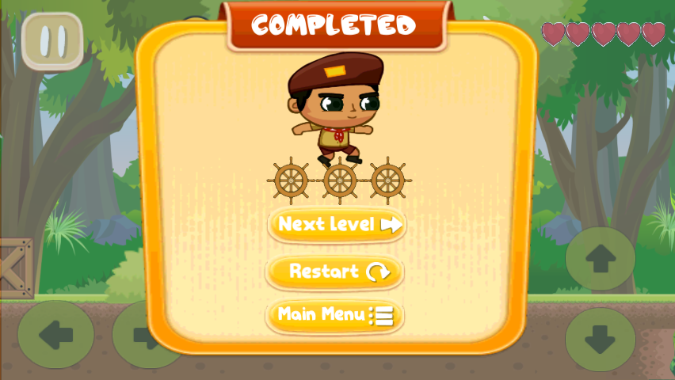

**Next level of the game**

Restart the game

**Back to main menu**

**The level is completed**

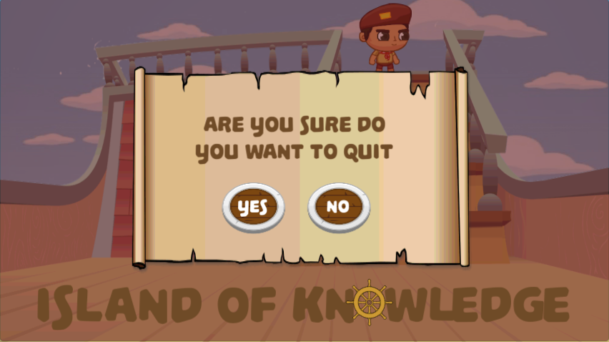

**Continue the game**

**Exit the game**

**Close the game**

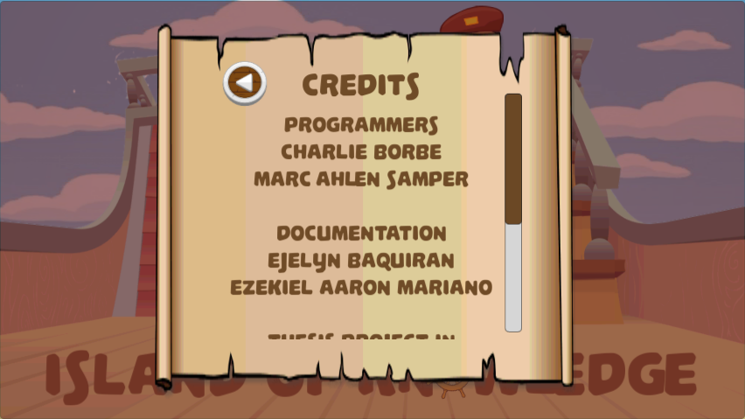

Back

**Scroll**

**Credits Button**

**Game is over**

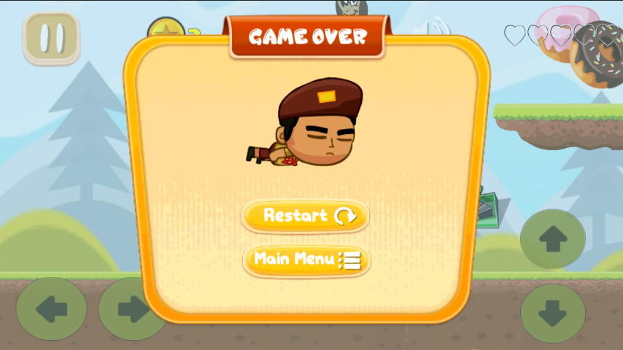

**Resume the**

**game**

**Back to main menu**



Time’s up panel

**Restart the game**

**Back to main menu**

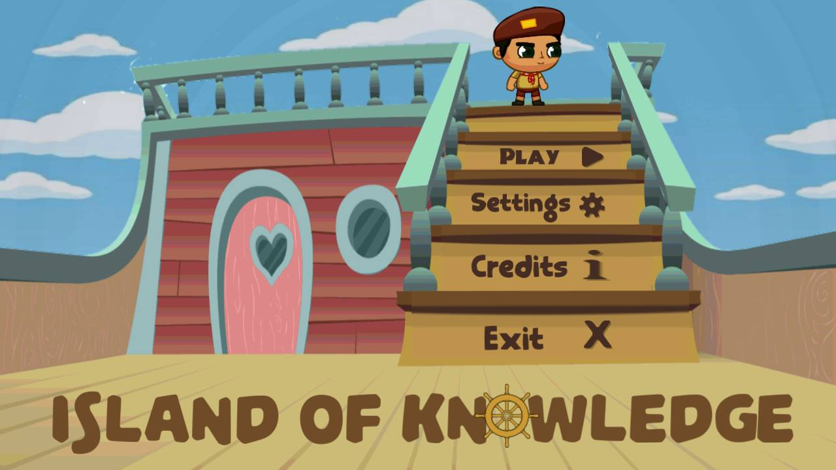

**User Manual**