

**CHARLIE G. BORBE**

**20-A Sterling St. Sterlinglife Subdivision**

**Pamplona 2, Las Pinas City, Metro Manila**

**Phone: 0906-6732315**

**E-mail: charlieborbe@laspinas.sti.edu**

**OBJECTIVES:**

* To further develop my knowledge and skills in the field of Programming.
* To gain experience that I can use in the future**.**

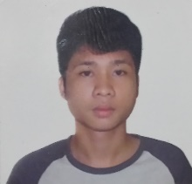

**MARC AHLEN SAMPER**

Pump#9 Abelardo street. executive village ,BF Homes

Paranaque city

09264717913

[marcahlensamper@laspinas.sti.edu](mailto:marcahlensamper@laspinas.sti.edu)

**OBJECTIVES**

My desire job is should be fitted to my knowledge and skills, but I much preferred within IT Department and I can contribute when it comes to programming or web building.

**EJELYN A. BAQUIRAN**

Zapote Plaza Las Pinas City

09362889613

ejelynbaquiran@laspinas.sti.edu

**Objective**

My objective is to improve my skills in other field and have experience in work

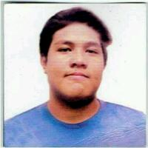**EZEKIEL AARON A. MARIANO**

58, Miranda St. Phil Am Life Village Las PINAS CITY

09289396909

ezekielaaronmariano@laspinas.sti.edu

**Objective**

My objective is to apply my knowledge my skills in work and to improve.