Simple models of non-random mating and environmental transmission bias standard human genetics statistical methods
Richard Border^{1,2,3*}, Jeremy Wang^{2,4}, Christa Caggiano⁵, Sriram Sankararaman^{3,4,6,7}, Chun Chieh Fan^{8,9}, Wei-Yi Kao¹⁰, Mei-Chen Lin¹⁰, Shi-Heng Wang^{10,11}, Andrew J. Schork^{12,13,14}, Patrick Turley^{15,16}, Alexander S. Young^{6,17}, Daniel J. Benjamin^{6,17,18}, Andy W. Dahl¹⁹, and Noah Zaitlen^{2,6,7}
¹Department of Computational Biology, Carnegie Mellon University, Pittsburgh, 15213, United States; ²Department of Neurology, David Geffen School of Medicine, University of California, Los Angeles; Los Angeles, 90095, United States; ³Department of Computer Science, University of California, Los Angeles; Los Angeles, 90095, United States; ⁴Bioinformatics Interdepartmental Program, University of California, Los Angeles; Los Angeles, 90095, United States; ⁵Institute for Genomic Health, Icahn School of Medicine at Mount Sinai, New York, 10029, United States; ⁶Department of Human Genetics, University of California, Los Angeles; Los Angeles, 90095, United States; ⁷Department of Computational Medicine, David Geffen School of Medicine, University of California, Los Angeles; Los Angeles, 90095, United States; ⁸Center for Population Neuroscience and Genetics, Laureate Institute for Brain Research, Tulsa, Oklahoma, United States; ⁹Department of Radiology, University of California, La Jolla, California, United States; ¹⁰National Center for Geriatrics and Welfare Research, National Health Research Institutes, Zhunan, Taiwan; ¹¹Department of Medical Research, China Medical University Hospital, China Medical University, Taichung, Taiwan; ¹²Institute of Biological Psychiatry, Mental Health Center Sct Hans, Copenhagen University Hospital–Mental Health Services CPH, 2100 Copenhagen, Denmark; ¹³Globe Institute, University of Copenhagen, 1350 Copenhagen, Denmark; ¹⁴Neurogenomics Division, The Translational Genomics Research Institute, Phoenix, 85004, United States; ¹⁵Department of Economics, University of Southern California; Los Angeles, 90089, United States; ¹⁶Center for Economic and Social Research, University of Southern California; Los Angeles, 90089, United States; ¹⁷Anderson School of Management, University of California Los Angeles; Los Angeles, 90095, United States; ¹⁸National Bureau of Economic Research; Cambridge, 02138, United States; ¹⁹Section of Genetic Medicine, Department of Medicine, University of Chicago; Chicago, 60637, United States
*Corresponding author. Email: rborder@cs.cmu.edu

Abstract: There is recognition among human complex-trait geneticists that not only are many common assumptions made for the sake of statistical tractability (e.g., random mating, independence of parent/offspring environments) unlikely to apply in many contexts, but that methods reliant on such assumptions can yield misleading results, even in large samples. Investigations of the consequences of violating these assumptions so far have focused on individual perturbations operating in isolation. Here, we analyze widely used estimators of genetic architectural parameters, including LD-score regression and both population-based and within-family GWAS, across a broad array of perturbations to classical assumptions, such as multivariate assortative mating and vertical transmission (parental effects on offspring phenotypes not mediated by genetic inheritance). We find that widely-used statistical approaches are unreliable across a broad range of perturbations, and that structural sources of confounding often operate synergistically to distort conclusions. For example, mild multivariate assortative mating and vertical transmission together can dramatically inflate heritability estimates and GWAS false positive rates. Further, GWAS will become progressively more polluted by off-target associations as sample sizes increase. We show this is particularly salient in the era of multi-million participant GWAS, where increasing sample sizes beyond ~1M can lead to more spurious than on-target associations using existing methods. Given these challenges, we introduce xftsim, a forward time simulation library capable of modeling a wide range of genetic architectures, mating regimes, and transmission dynamics, to facilitate the systematic comparison of existing approaches and the development of robust methods. Together, our findings illustrate the importance of comprehensive sensitivity analysis and present a valuable tool for future research.

Contents:
Introduction 2
Results 3
Discussion 9
Code and data availability 11
Acknowledgments 11
Glossary 11
Online Methods 12
References 22
Tables 30
Figures 31
Supplementary Figures 35
Supplementary Tables 56

Introduction
Analysis of genome-wide data in large samples of unrelated individuals has become increasingly prevalent across the biomedical and social sciences, offering potentially valuable insights into the genetic bases of complex traits. The widespread adoption of these analyses has been propelled by the development of scalable statistical methods typically reliant on assumptions that make the challenging problem of relating individual differences in genetic markers with complex diseases and behaviors mathematically tractable. Examples of such assumptions have included purely additive genetic architectures (without dominance or epistasis), random mate selection, absence of parental genetic influences on offspring beyond direct inheritance, representative population sampling, and Mendelian randomization’s exclusion restriction criterion—the assumption that genetic variants affect outcomes only through the exposure of interest. Understanding that the progress made possible by such simplifications must be balanced by sensitivity analysis and evaluation of alternative models, recent work has interrogated the consequences of perturbing such assumptions, including non-random mating (1–5), fine-scale population structure (6, 7), participation bias (8, 9), indirect genetic effects (10–12), and non-additivity (13–18).
Some of these assumptions appear to be relatively minor and not to distort our understanding of biology. For example, though dominance effects may be commonplace, methods assuming that common loci act additively on polygenic traits have been used to successfully find genetic pathways that are relevant to particular phenotypes (14, 18). In other cases, realistic perturbations distort the conclusions we draw. For example, bivariate cross-trait assortative mating (xAM), which occurs when the process of mate selection results in cross-mate correlations among two phenotypes, can dramatically inflate genetic correlation estimates, though its consequences are highly variable across trait pairs—for example, though empirical genetic correlation estimates between bipolar disorder (BIP) and attention-deficit hyperactivity disorder are consistent with bivariate xAM in the absence of pleiotropy, BIP and schizophrenia evidence much stronger genetic correlation estimates than can be plausibly attributed to xAM alone (1). On the other hand, bivariate xAM causes all loci causal for either phenotype to fail the exclusion-restriction criterion (3), a critical assumption for Mendelian-randomization-based causal inference.
Still, our understanding of the consequences of perturbing such assumptions is limited. First, only simple forms of such violations have been examined. For instance, despite evidence that assortative mating is widespread across the phenome, previous work has assumed that no more than two traits are involved in mate choice (1, 19) or that phenotypes relevant to mate choice can be reduced to a linear dimension (3). Second, to the extent that such perturbations are examined, they tend to be examined in isolation, whereas multiple assumptions will be invalid for many traits of interest. For example, the highly-studied years of education phenotype is correlated across mates with a large number of traits, is thought to be subject to indirect genetic effects, and demonstrates complex causal relations with a number of other phenotypes—for example family wealth, which both impacts educational opportunities in childhood and is inherited through non-genetic mechanisms (i.e., bequests). As a result, despite the availability of increasingly large samples of unrelated genotyped individuals (11, 20), the answers to longstanding questions such as whether or not years of education is affected by genes that influence BMI, remain unclear (21, 22).
In the current manuscript, we analyze results from genome-wide association studies (GWAS), including estimates of trait heritability and genetic correlations, while relaxing standard additive-genetic assumptions and incorporating additional population processes including multivariate xAM—when mate choice is non-random with respect to multiple phenotypes—and vertical transmission (VT)—when parent characteristics influence offspring through non-genetic pathways. Toward this end, we develop xftsim (eXtensible Forward-Time Simulation framework), an open-source tool for scalable genotype / phenotype simulation in the context of complex architectures and mating / transmission dynamics (Table 1).
We show that, under very simple models of non-random mating and vertical transmission, widely used statistical genetic estimators (i.e., association tests, heritability estimators, and genetic correlation estimators) can generate misleading results and biased estimates, even when applied to homogenous groups of unrelated individuals, and that increasing GWAS discovery sample size will only exacerbate such effects. In the process, we demonstrate that, for many phenotypes, xAM is not only multivariate (i.e., involving more than two phenotypes) but high-dimensional (i.e., cross-mate similarity cannot be reduced to assortment on a single linear index of phenotypes). These concepts are distinct: multivariate xAM can be either unidimensional (if all cross-mate correlations arise from sorting on a single linear combination) or high-dimensional (if multiple independent linear combinations are required; #Sfig 20/21)). We also demonstrate higher-order xAM biases widely-utilized statistical procedures to a greater extent than bivariate xAM and accounts for a larger fraction of previously published estimates of genetic overlap among psychiatric disorders. Further, we demonstrate that perturbations of the aforementioned assumptions combine synergistically to further corrupt understanding of underlying biological relationships. For example, multivariate xAM with exchangeable cross-mate correlations of 0.2—which, despite the low per-trait correlations model, implies complete assortment on the standardized trait sum—combined with VT accounting for 5% of phenotypic variance can result in genetic correlation estimates greater than 0.5 despite the complete absence of pleiotropy. Next, employing a heuristic example involving height, years of education, and wealth, we demonstrate that xAM and VT together can induce spurious genetic signals even for phenotypes with no causal genetic basis whatsoever. Finally, we explore the consequences of gene-environment interactions (G×E) and sample ascertainment in the context of nontrivial mating and transmission dynamics, as well as the extent to which family-based association studies are robust under such circumstances.
Together, our results highlight a blind spot in our current conceptualization of complex traits genetics: many existing methods are liable to give misleading results when applied to traits subject to complex social and behavioral dynamics. To address this, we provide a powerful simulation-based tool that enables researchers to assess the vulnerability of different methods to a comprehensive set of perturbations of classical assumptions affecting many human traits.

Results

xAM is multivariate
We began by quantifying the complexity of empirical cross-mate correlation structures across a limited collection of quantitative phenotypes chosen on the basis of previous evidence for xAM (1) and/or hypothesized relevance to selection (23). We applied canonical correlation analysis (CCA) to the cross-mate-cross-trait correlation structure for 34 psychosocial, socioeconomic, and biomedical phenotypes between 8,022 likely mate pairs with complete data in the UK Biobank (24) (Supplementary Table S1). The cross-mate correlation structure was high-dimensional: 22 canonical vectors evidenced significantly non-zero canonical correlations (α=0.05; see Supplementary Tables S2-S3 for complete results) and 8 canonical vectors were required to account for 90% of the sex-averaged relative canonical redundancy (the first canonical vector accounted for 36.7%; Figure 1a; see Supplementary Figures S1-S2 for supplemental analyses using a larger sample with imputed phenotype data). Notably, assortment along individual dimensions was strong: the first canonical correlation was 0.86, with subsequent correlations of 0.68, 0.59, and 0.52 for the second through fourth canonical variates.
We separately quantified the complexity of the empirical cross-mate correlation structure across 11 phenotypes spanning psychiatric and autoimmune disorders in an independent sample of 4,954,870 mates identified in the Taiwan National Health Insurance Research Database (25). The cross-mate correlation structure was again high-dimensional: 7 canonical variates were required to account for 90% of the sex-averaged relative canonical redundancy (the first canonical vector accounted for 26.1%; Figure 1b; see Supplemental Table S4 for cross-mate correlation estimates).
Together, these results imply that the full complexity of mate similarity, even across a limited number of phenotypes, cannot be fully characterized by one or two linear dimensions corresponding to physical appearance and/or a unidimensional social class construct as has been recently suggested (26). Instead, assortment is multifaceted, with many traits loading onto multiple canonical vectors. We further develop and differentiate the concepts of multivariate and multidimensional mating regimes in the Online Methods.

Multivariate xAM induces severe biases relative to bivariate xAM
Having observed that multivariate xAM appears to be widespread across multiple phenotypic domains, we sought to quantify its potential impacts across a range of commonly applied methods for inferring genetic architecture by comparing bivariate xAM to 5-variate xAM. To enable this and all other simulations we present, we developed the xftsim software tool for human complex trait genetics research (27). xftsim allows users to model a wide variety of genetic architectures, mating regimes, and transmission dynamics as well as their effects on population statistics (e.g. allele-substitution effects, heritability, and genetic correlation) and estimators thereof. We provide an overview of the capabilities of xftsim in Table 1 and describe the implementation of multivariate mating and transmission regimes in the Online Methods.
Using xftsim, we simulated sets of two or five phenotypes subject to exchangeable cross-mate cross-trait correlations of 0.2 (i.e., such that all trait pairs are equicorrelated across mates), each with panmictic heritabilities $h_{0}^{2}$=0.5 and non-overlapping causal variant sets, partitioning the genome such that each variant was causal for one and only one phenotype. This exchangeable correlation structure is unidimensional: all cross-mate correlations arise from sorting on the standardized sum of traits, with latent correlation equal to r⋅K (where K is the number of traits). For 5 traits at r=0.2, this implies a latent correlation of 1.0. We note that this represents a boundary case for unidimensional models. However, existing methods proposed for measuring or accounting for xAM assume precisely this structure—that multivariate cross-mate similarity can be reduced to a single sorting dimension ####. Our empirical CCA results demonstrate that this assumption is violated, and we additionally present simulations using empirical (high-dimensional) correlation structures in Figures 2 and 4. We present supplementary analyses with exchangeable correlations of 0.1 in Supplementary Figure SXb and examine the relationship between the number of traits, pairwise correlations, and bias under fixed latent correlation (Supplementary Figure SXa).
. which show qualitatively similar but attenuated biases under xAM alone, though biases remain substantial when combined with vertical transmission (Supplementary Figure SXb##). We also examined the relationship between the number of traits, pairwise correlations, and bias under fixed latent correlation (Supplementary Figure SXa##).
At each generation, we computed the true heritability $h^{2}$ (the ratio of the additive genetic and phenotypic variance components) and true polygenic index (PGI) correlation $r_{score}$ (i.e. the correlation between phenotypes’ additive genetic components), both of which increase over successive generations of assortment (28, 29), as well as the corresponding Haseman-Elston estimators, ${\hat{h}}_{HE}^{2}$and ${\hat{r}}_{HE}$, which are biased upwards and yield results approximately equivalent to the widely used LD-score regression estimators (2, 30).
Consistent with previous results (1), the true heritability increased across successive generations of bivariate xAM from $h_{0}^{2}$=0.499 at generation zero to $h_{5}^{2}$=0.527 at generation five. This increase was modestly larger under 5-variate xAM ($h_{0}^{2}$=0.499 to $h_{5}^{2}$=0.535; Figure 1c). On the other hand, though the estimated heritability was biased upwards under bivariate xAM (${\hat{h}}_{0}^{2}$=0.499 to ${\hat{h}}_{5}^{2}$=0.597), the bias was substantially greater under 5-variate xAM (${\hat{h}}_{0}^{2}$=0.499 to ${\hat{h}}_{5}^{2}$=0.658). We observed a similar pattern of results for genetic correlations, even when the true correlation between effects $r_{β}$ was zero. First, five generations of bivariate xAM induced increases in the true polygenic index correlation ($r_{score}$=0.107) and substantial upward bias in the estimated genetic correlation (${\hat{r}}_{β}$=0.212; Figure 1d). Again, the relative consequences under five generations of 5-variate xAM were moderate for the true polygenic index correlation ($r_{score}$=0.107) but substantial for genetic correlation estimates (${\hat{r}}_{β}$=0.296). These results illustrate not only that the typical interpretation of genetic correlation estimates as measures of $r_{β}$ (i.e., the extent to which loci similarly affect a pair of traits) is invalid for traits subject to assortment (1), but that this interpretation becomes increasingly tenuous when more traits are salient with respect to mate choice. Supplementary analyses using exchangeable correlations of 0.1 (latent r = 0.5) show qualitatively similar but attenuated biases under xAM alone, though biases remain substantial when combined with vertical transmission (Supplementary Figure SXb##).
We also performed a series of simulations examining the impact of bivariate and 5-variate xAM on false-positive associations in the context of GWAS under variable statistical power (Figure 1e). Under the previously described simulation parameters, we performed association studies and computed false positive rates at a threshold of $α$=0.05, varying statistical power from 39% to 66% by fixing sample size $n$ and panmictic heritability while varying the average variance explained by each causal variant. By design, because each simulated variant was chosen to be causal for one and only one phenotype, most false positive associations for one trait will be “off-target” associations with causal variants for another. We quantify excess false positives by examining the ratio of empirical to theoretical type I error rates ($\hat{α}/α$). Consistent with previous results, xAM induced false positive associations, and, as with the variance component analyses, 5-variate xAM generated stronger artifactual signals than bivariate xAM ($\hat{α}/α$=1.52 versus 1.32, respectively, averaging across power conditions). Critically, the false positive rate increases with statistical power: at 66% power, the type-1 error rate was 1.61 times larger than theoretical expectations under bivariate xAM and 1.98 times larger under 5-variate xAM. This implies that we should expect to detect larger numbers of spurious associations as sample sizes increase.

Off-target associations in large sample GWAS
Given that GWAS sample sizes have grown into the millions, we next explored the consequences of multivariate xAM for association study results in extremely large samples. To achieve this without repeatedly simulating multiple million individual samples, we derived closed-form expectations for the non-centrality parameter of GWAS statistics as a function of the true PGI covariance matrices under random mating and xAM—which are sample-size invariant and estimated from the previously described simulations—as well as discovery sample size, the number of causal variants per phenotype, and significance threshold (see Online Methods for further details). To validate our derivations, we compared expected and observed power and type I error rates across varying sample sizes and significance thresholds for the simulations presented in Figure 1f, observing near perfect agreement (all Pearson’s r > 0.99; Supplemental Figure S3). We consider two or five genetically distinct traits (i.e., with no overlapping causal variants), each with random mating heritability set to 0.5, after five generations of bivariate or 5-variate xAM with all cross-mate correlations fixed to 0.2. We consider a GWAS performed on a single focal phenotype and define “on target” associations as genome-wide significant associations (i.e., p < 5e-8) at causal variants for the focal GWAS trait. Likewise, we define “off target” associations as genome-wide significant associations at causal variants for one of the other traits biologically unrelated to the focal trait. Supplemental Figure S4 illustrates the additional (i.e., not cumulative) expected associations for specific increments to the GWAS sample size across varying levels of polygenicity. For traits with 4,000 casual variants under 5-variate xAM, increasing sample size above 1.6 million individuals is expected to yield more off target associations than on target associations. Increasing the sample size to 6.4 million results in empirical type I error rates between over one million times larger than expected (Supplemental Figure S5). This effect is strongest when the secondary traits are less polygenic (Supplemental Figures S4-S6) and occurs first at the largest effect off target variants (Supplemental Figure S7).

Case study: genetic overlap among psychiatric disorders in the context of high-dimensional xAM
Next, having established that psychiatric disorders evidence a high-dimensional cross-mate cross-trait correlation structure, we analyzed the potential consequences of high-dimensional xAM on six previously-studied psychiatric disorder groups with high cross-mate tetrachoric correlations (attention-deficit hyperactivity disorder [ADHD], alcohol use disorder [ALC], anxiety disorders [ANX], bipolar disorders [BIP], major depressive disorder [MDD], and schizophrenia [SCZ]; Supplementary Table S3) (1). Importantly, the empirical 6-variate cross-mate cross-correlation structure between disorders suggests that cross-mate similarity is widespread across pairs of disorders. On the other hand, empirical genetic correlation estimates among nearly all psychiatric disorders are positive and nontrivial, and this high degree of apparent genetic overlap has been interpreted as evidence that the existing psychiatric nosology is inadequate (31). We therefore compared expected genetic correlation estimates under xAM alone ($r_{xAM}$; i.e., without pleiotropy) assuming bivariate versus 6-variate xAM (consistent with empirical cross-mate correlation estimates across the six disorders) and using empirical heritability estimates derived from twin and family studies (1). We also compared $r_{xAM}$ to the empirical LD-score regression estimates of Grotzinger et al. (${\hat{r}}_{empirical}$) to determine the extent to which these estimates are consistent with xAM-induced artifacts alone (32) (Figure 2a). Finally, we characterized the impact of bivariate versus 6-variate xAM on correlations among GWAS effect estimates in the absence of pleiotropy.
As before, 6-variate xAM modestly increased correlations among true PGI when compared to bivariate xAM (e.g., for major depression [MDD] and anxiety disorders [ANX], $r_{score}$=0.087 [se=1.58e-2] after five generations of 6-variate xAM versus $r_{score}$=0.093 [se=1.54e-2] under bivariate xAM; Figure 2a). On the other hand, expected xAM-induced genetic correlation estimates were substantially higher under high-dimensional xAM (e.g., for MDD and ANX, $r_{xAM}$=0.219 [se=3.51e-2] after five generations of 6-variate xAM versus $r_{xAM}$=0.176 [se=4.29e-2] under bivariate xAM). Likewise, five generations of 6-variate xAM alone yielded larger genetic correlation estimates relative to those from the literature ($r_{xAM}/r_{empirical}$=0.427 [se=2.32e-2] under 6-variate xAM versus $r_{xAM}/r_{empirical}$=0.345 [se=2.36e-2] under bivariate xAM; Figure 2b). Notably, 6-variate xAM alone could fully account for empirical genetic correlation estimates for three trait pairs; for example, for the pair attention-deficit hyperactivity disorder and schizophrenia, five generations of 6-variate xAM yields estimates 1.09 [se=0.228] times larger than previously published estimates (33).
In addition to inducing false positives, xAM will induce directional bias in GWAS effect estimates across traits under assortment such that effect estimates become positively correlated. We illustrate this phenomenon for the six psychiatric traits in Figure 2c: although each of the six disorders was modeled as having unlinked, non-overlapping causal variants, five generations of bivariate xAM induced an average correlation among GWAS slope estimates of ${\overline{r}}_{\hat{β}}$=0.113 [se=1.06e-2] across trait pairs. Again, this effect was more pronounced when modeling empirical xAM across all six traits: ${\overline{r}}_{\hat{β}}$=0.149 [se=9.06e-3].

Vertical transmission exacerbates xAM-induced biases
We next turn our attention to another mechanism underlying phenotypic variation that may also bias contemporary statistical genetic models: parents transmit more to their offspring than genetic material. For example, wealth may be transmitted from parent to offspring directly through bequests and indirectly through the opportunities available to individuals with affluent parents. To the extent that wealth is cross-correlated with heritable phenotypes across mates, genetically-transmitted causal variants for these phenotypes will become confounded with environmentally-transmitted correlates of wealth. We find that, in the presence of xAM, even weak parent-offspring (i.e., “vertical”) phenotype transmission (VT) dramatically compromises the interpretability of genetic estimators. We ran additional simulations examining the consequences of random mating (RM) versus 5-variate xAM (5xAM) in combination with multivariate VT explaining only 5% of the total phenotypic variance at generation 0 (Figure 3a; see Online Methods for detailed description of model parametrization). We note that the joint presence of xAM and VT implies assortment not only on parental phenotypes but on grandparental phenotypes and environments. As with the 5-variate results presented in Figure 1c-1e, the five phenotypes were subject to exchangeable cross-mate cross-trait correlations of 0.2, each with panmictic heritabilities $h_{0}^{2}$=0.5 and without pleiotropy across traits.
Compared to five generations of 5xAM alone, 5xAM + VT induced substantial countervailing differences in true and estimated quantities. After five generations of 5xAM + VT, whereas the true heritability fell from $h_{0}^{2}$=0.500 to $h_{5}^{2}$=0.396, the estimated heritability increased to ${\hat{h}}_{5}^{2}$=0.749, with median upward bias of ${\hat{h}}_{5}^{2}-h_{5}^{2}$=0.353 across simulation replicates, far larger than the already considerable bias induced by 5xAM of ${\hat{h}}_{5}^{2}-h_{5}^{2}$=0.124. True heritability decreased because the variance explained by vertical transmission can increase more rapidly than the additive genetic variance under xAM. However, xAM combined with vertical transmission (which also induces indirect genetic effects when the parental phenotype is heritable, as it is here) can lead to strong gene-environment correlation that biases GWAS estimates and heritability estimators utilizing GWAS summary statistics (5, 34). Likewise, 5xAM + VT decreased the true score correlations but increased the estimated effect correlations relative to 5xAM alone ($r_{score}$=0.078 and ${\hat{r}}_{β}$=0.513 versus $r_{score}$=0.132 and $r_{score}$=0.296 after five generations of 5xAM + VT versus 5xAM, respectively). When interpreted as an estimate of the correlation between direct genetic effects, this amounts to upward bias of ${\hat{r}}_{β}-r_{β}$=0.513, but even when interpreted as an estimate of the true polygenic index correlation, this amounts to a bias of ${\hat{r}}_{β}-r_{score}$=0.435.
We again performed a series of simulations examining GWAS false-positive rates under variable statistical power (Figure 3d). Here, as with the variance components analyses, the addition of VT on top of 5xAM induced substantially higher false positive rates relative to 5xAM alone ($\hat{α}/α$=2.779 versus $\hat{α}/α$=1.522, respectively, across power conditions). As before, the inflation of GWAS statistics was exacerbated in larger samples; for example, increasing power from 39% to 66% increased the relative false positive rate from $\hat{α}/α$=1.747 to $\hat{α}/α$=4.251 under 5xAM + VT.
Finally, we performed a number of supplemental simulations incorporating stronger VT (i.e., accounting for up to 20% of total phenotypic variance at generation zero) and/or linear gene-environment interactions (G×E; Supplemental Figures S8-S12; Supplemental Table S5; see Online Methods for details of generative model), a selection of which we highlight here. Although stronger VT (accounting for 20% of phenotypic variance), in combination with 5xAM, resulted in stronger inflation of genetic correlation estimates relative to weaker VT (accounting for 5% of phenotypic variance), the difference between estimates without VT and weaker VT was more substantial (${\hat{r}}_{β}-r_{score}$=0.600 under 5xAM + strong VT; ${\hat{r}}_{β}-r_{score}$=0.435 under 5xAM + weak VT; ${\hat{r}}_{β}-r_{score}$=0.164 under 5xAM alone). In other words, in the context of xAM, relatively weak and strong VT can have comparable effects, especially compared to zero VT. Additionally, incorporating G×E effects had a larger impact on heritability estimates than genetic correlation estimates, especially in the presence of xAM and VT (${\hat{h}}_{5}^{2}-h_{5}^{2}$=0.295 and ${\hat{r}}_{β}-r_{score}$=0.624 versus ${\hat{h}}_{5}^{2}-h_{5}^{2}$=0.403 and ${\hat{r}}_{β}-r_{score}$=0.600 under 5xAM + G×E + strong VT versus 5xAM + strong VT, respectively).

Case study: xAM and VT in a simplified model of years of education
Next, we illustrate how plausible multivariate mating patterns together with cross-generation phenotypic transmission complicates inferences in the context of a simplified, heuristic model of education years (EY), height, and wealth (Figure 4a). Using hypothetical simulation parameters, we center EY in light of the history of misattribution of social determinants of success to biological differences (35, 36), as well as recent evidence that conventional population-based methods have overstated the extent to which EY is affected by genetic variants affecting other traits (e.g., BMI) (11, 21, 22). For simplicity, we assume that, in generation zero: one third of the variation in individual wealth is transmitted parental wealth and the remaining two thirds reflect individual-specific random variation; 1% of the variation in EY is additive genetic, two thirds is due to transmitted parental wealth and EY, and the remaining variation is individual-specific noise; and 60% of the variation in height is additive genetic with the remaining 40% individual-specific. Thus, the generation zero heritability of EY is exceedingly low (1%) and there are no genetic or other systematic influences on individual wealth apart from passed-down parental wealth. Height is 60% heritable at generation zero and exclusively interacts with EY and wealth through trivariate xAM (see Online Methods for further details).
Across subsequent generations of xAM, the true heritability of height increased from $h_{0}^{2}$=0.599 to $h_{5}^{2}$=0.621. This increase was mirrored, but with upward bias, in heritability estimates, which increased from ${\hat{h}}_{0}^{2}$=0.599 to ${\hat{h}}_{5}^{2}$=0.686 (Figure 4b). On the other hand, the true heritability of EY decreased from $h_{0}^{2}$=0.010 to $h_{5}^{2}$=0.005, whereas the estimated heritability increased from ${\hat{h}}_{0}^{2}$=0.010 to ${\hat{h}}_{5}^{2}$=0.068. Likewise, estimated heritabilities for wealth, which had no genetic component whatsoever, increased from ${\hat{h}}_{0}^{2}$=0.000 to ${\hat{h}}_{5}^{2}$=0.036. For both traits, these estimates were larger even than the variance explained by regressing phenotype on the true polygenic indices for either EY or height, which incorporates additive genetic variance and gene-environment covariance—e.g., after five generations, adjusted ${\hat{R}}^{2}$=0.044 (resp. ${\hat{R}}^{2}$=0.031) when regressing EY (resp. wealth) on the true height PGI. Genetic correlation estimates were also substantially biased upwards: though the true PGI correlation between height and EY increased from $r_{score}$=0.0024 to $r_{score}$=0.015 after five generations, the estimated genetic correlation increased from ${\hat{r}}_{β}$=0.0053 to ${\hat{r}}_{β}$=0.863 (Figure 4c). GWAS effect estimates also became correlated; for example, the correlation between effect estimates for height and wealth climbed from $r_{\hat{β}}$=0.001 to $r_{\hat{β}}$=0.273 (Figure 4d). In summary, our simplistic model demonstrates that phenotypic assortment and cross-generational transmission can lead to substantial biases in genetic estimates, even for traits with zero heritability (here, wealth).

Within-sibship GWAS mitigates xAM and VT-induced biases with caveats
Given recent interest in within-family designs for addressing population-level confounds (10–12, 15, 16), as well as in the consequences of GWAS sample ascertainment (8, 9), we performed simulations comparing population-based and within-sibship GWAS across the previously explored simple models, in both representative and ascertained samples. Our results suggest that, in contrast to population GWAS, within-sibship GWAS, under the simple models examined in the primary manuscript, are largely robust to some of the biases induced by xAM, VT, and/or G×E in representative samples: five generations of all combinations of these phenomena failed to increase association false positive rates, induce spurious correlations among slope estimates, or lead to substantial biases in slope effect estimates (Figures S12-S15). On the other hand, non-representative sampling substantially impacted both of these metrics in both population and within-sibship GWAS in a manner dependent on ascertainment regime, xAM, VT, and G×E (Figures S13-S15), though we emphasize that non-representative sampling, which we have only explored briefly here, appeared to have a substantially larger effect than the other perturbations.
Veller and colleagues recently demonstrated that sibling-difference GWAS estimate the local average treatment effect (LATE) of a given allele among individuals with at least one heterozygous parent at said locus, rather than the average treatment effect (ATE) in the population at large (16) (see also (37)). In the presence of G×E, then, sibling-difference GWAS estimates can differ from population average causal effects. Strictly speaking, these estimates are statistically unbiased, but with respect to the corresponding LATE; nevertheless, such estimates may be misleading when interpreted as population average causal effects or used for polygenic prediction. In supplementary analyses (see Online Methods), we show that, in the context of a model including VT and linear G×E, the relative difference between sibling-difference GWAS estimates and ATEs can be substantial at rare variants with large effects (Figures S16-S18). However, when causal variants have neutral effects on average and are symmetrically distributed with respect to allele frequency—as is the case for the simulations presented in the primary manuscript—the discrepancies between ATEs and sibling-difference GWAS estimates are modest and average out to zero across the genome (Figure S19). Under architectures where rare variants tend to have deleterious effects, sibling-difference GWAS derived PGI can differ substantially from PGI derived from true ATEs among carriers of rare variants of large effect (Figure S18). Of course, in the presence of true PGI-by-environment interactions, all polygenic predictors that fail to account for individuals’ environmental context can yield misleading predictions for individuals at environmental extremes (Figure S19), whether derived from within-family or population-based GWAS estimates (38).

Discussion
The present manuscript demonstrates that perturbing common statistical genetic assumptions can cause widely-used estimators to yield misleading results, and that such effects can be compounded when multiple perturbations occur simultaneously. Further, empirical evidence suggests that multivariate xAM is widespread across numerous disease-relevant phenotypes, suggesting that many analyses will be affected by one or more such perturbations. Counterintuitively, we show that increasing sample size fails to mitigate these affects, and, in the case of GWAS discovery, can exacerbate interpretational challenges. Despite the broad array of scenarios examined here, we emphasize that the models we have considered, while less unrealistic than the standard models dominating the statistical genetics literature for many phenotypes, are at best crude approximations of the many social and biological factors that interact to shape genetic architecture and phenotypic diversity. With this in mind, we introduce the xftsim software package to enable comprehensive sensitivity analysis of existing methods and to facilitate the development of more robust approaches.

Limitations of widely-used estimators under realistic complex trait architectures
Our findings underscore inherent limitations of current polygenic estimators, which largely treat genotypes, causal variant effects, and causal environmental factors as conditionally independent given genetic principal components and other covariates. On the other hand, for many disease-relevant phenotypes, such independence is unlikely to hold: assortative mating, which we and others have shown to be ubiquitous across a broad array of phenotypes (1, 39–41) (see also Figure 1a, Supplementary Tables S2-S3), will induce sign-consistent long-range correlations between causal variants as a function of their effects (1, 2, 19, 28, 42, 43), and the presence of indirect genetic effects (e.g., environmentally-mediated influences of parental genotype on offspring phenotype) will induce sign-consistent gene-environment correlations (5, 10). While either of these dynamics in isolation can lead to misleading results, we have demonstrated that, together, even weak xAM combined with weak multivariate vertical transmission — which induces indirect genetic effects — can lead to dramatic overestimates of genetic correlation (Figure 3c) as well as dramatically inflate GWAS false positive rates (Figure 3d). These biases can impact all estimators that treat genotypes as fixed or independent of other parameters (i.e., causal variant and environmentally mediated effects). This does not imply that all inferences based on these approaches are erroneous; for example, five generations 6-variate xAM without pleiotropy yield genetic correlation estimates for major depression and anxiety disorders roughly 25% as large as empirical estimates, implying there is substantial shared genetic signal beyond that attributable to xAM (Figure 2a/b). However, our results do imply that many estimates will be substantially biased and often misleading. For example, for attention-deficit hyperactivity disorder and bipolar disorders, three generations of xAM congruent with empirical mating patterns (and zero pleiotropy) yielded estimates on par with empirical estimates (Figure 2a/b). For many behavioral phenotypes, conventional estimates may be more misleading than informative.

Ultra-large sample sizes present new challenges
Since their inception, GWAS-focused ascertainment efforts have prioritized increasing sample sizes (44) because individual common variant effects are too small to be reliably detected until samples grow into the tens or hundreds of thousands. Moreover, large GWAS samples have enabled the field to progress beyond early candidate-gene research, which yielded numerous associations that later failed to replicate (45–48). Our results, which demonstrate that (i) multivariate xAM is widespread (Figure 1a/b) and (ii) xAM-induced false positives increase not only with dimension but with sample size (Figure 1f), complicate this narrative: with the advent of multi-million participant GWAS datasets (22, 49), we are entering a discovery regime in which increasing sample size and performing conventional GWAS analyses will lead to more, not fewer, false positive associations. This is because we will identify causal variants, or variants in LD with causal variants, for secondary phenotypes under xAM with the focal trait, further complicating the already difficult task of interpreting GWAS findings.

No method is robust across all scenarios examined
Assuming representative sampling and no G×E, within-family GWAS methods (e.g. regressing sibling phenotype differences on sibling genotype differences), appear relatively robust to the consequences of xAM in the context of the models examined here (i.e., do not identify off-target associations with other phenotypes under xAM jointly with the focal traits; Supplemental Figures S12-S13). At the same time, our results show that the within-family estimates can be affected by xAM and VT under some non-representative sampling regimes (Figures S13-S15), suggesting that further analysis is required to understand how such estimators behave in real samples. Further, our results build upon recent work on the interpretation of within-family GWAS estimates (16, 37), illustrating that, in the presence of G×E, sibling-difference GWAS effect estimates for rare variants of large effect may differ substantially from population average effects (Supplemental Figures S16-S18), though we note that G×E can present challenges for all additive polygenic predictors (Supplemental Figure S19). We have developed xftsim to enable researchers to characterize and compare the performance of existing methods in the presence of complex mating and transmission dynamics and of facilitating the development of novel population-based and within-family methods able to accurately characterize complex trait architectures.

Limitations and future directions
Limitations of our analysis provide avenues for future research. First, though it is conceivable that sample ascertainment into the UKB might have resulted in greater cross-mate phenotypic similarity—mating pairs who both participate in the same study may be more similar than couples randomly sampled from the general population—it is not clear how this would affect our analysis of the dimensionality of cross-mate correlation structures. This concern is tempered by our observation of high-dimensional mating in the unascertained Taiwan NHIRD sample, but the relationship between ascertainment and such estimates remains a topic for future investigation. Similarly, we did not explore the consequences of other sample-specific sources of bias, such as measurement error or misdiagnosis, which are likely to be particularly important for both measuring cross-mate similarity across and estimating genetic correlations among psychiatric disorders, as we previously demonstrated is the case under bivariate xAM (1). More generally, within-person correlations among traits—which are substantial for psychiatric phenotypes (Supplementary Table S4)—can arise from multiple sources including true pleiotropy, shared environmental exposures, population stratification, and diagnostic practices. Our simulations are intended as sensitivity analyses demonstrating the consequences of relaxing specific assumptions (random mating, absence of vertical transmission), not as comprehensive models of all factors contributing to observed patterns. The finding that xAM and VT can produce biases of the magnitude seen in empirical data does not imply these are the sole sources of such biases, but rather that they cannot be safely ignored.
More fundamentally, we have restricted our simulations to analyses of ancestrally-homogenous samples, obviating major sources of confounding likely to be present across many disease and disease-relevant phenotypes. Moreover, though we examined several key sources of confounding, the parameter space of plausible perturbations to the classical additive genetic model is vast, and many other complexities could be explored. In future work, we intend to extend our analyses to include a broader array of phenotypic and genetic architectures, including epistasis, admixture, and spatially-varying effects on mating and environment. Further, we have limited our investigation to a subset of commonly used quantitative frameworks for deciphering the genetic basis of disease, leaving a number of questions open for future inquiry. For example, it remains unclear how global estimates of polygenicity are affected by perturbations to classical assumptions, as does the extent to which recently-developed fine-mapping methods that include an infinitesimal component are able to mitigate the confounding influences of multivariate xAM (50). Finally, there remains a need for robust scalable methods applicable to traits subject to the dynamics investigated in the present manuscript (and the many scenarios and phenotypic domains yet to be investigated); we have developed xftsim to facilitate these efforts. Despite these limitations, our work illustrates that understanding the genetic basis of complex traits will require the development of richer models accounting for the complexities of the genome and the phenome, and that existing estimates should be interpreted carefully and critically.

Code and data availability
The xftsim library is open-source under the GNU General Public License v3.0. xftsim is available at https://github.com/border-lab/xftsim (27) and documented online at https://xftsim.readthedocs.io. Code necessary to reproduce our analyses and simulations is available at https://github.com/border-lab/xftmanu_code_supplement (51). UK Biobank data were accessed under application 33127 and are available through the UK Biobank Access Management System at http://amsportal.ukbiobank.ac.uk.

Acknowledgments
We would like to acknowledge Stephen Becker, Graham Coop, Sasha Gusev, Peter Hull, and Carl Veller for providing feedback and/or contributing to helpful discussions. Coauthors DJB and ASY would like to acknowledge support from Open Philanthropy.

Glossary
Bivariate cross-trait assortative mating (xAM) is characterized by correlations between values of two traits across individuals in mating pairs. For a concrete example, in the UK Biobank that, when one mate is tall, their partner is more likely to be tall as well (Pearson’s r=0.24 [s.e.: 0.01]), but is also more likely to have obtained more years of education (r=0.12 [0.01] averaged across traits; Supplemental Table S3). Recent work has shown that this phenomenon is widespread in real human populations (1, 19, 41). Widely used genetic estimators already begin to exhibit bias under this regime: for example, variants which affect only height will become correlated with variants that affect only educational attainment, inflating estimates of heritability for both traits, as well as estimates of genetic correlation between the two traits (1).
Complex traits are those affected by multiple genetic factors as well as by the environment, broadly construed.
Dominance is a type of non-additive genetic effect in diploid organisms where the effect of a given variant is non-additive in the number of copies present. That is, when the average phenotype among heterozygotes does not fall exactly in between the values of homozygotes.
Exclusion-restriction criterion: one of the assumptions required by Mendelian randomization, a causal inference method. It states that the genetic variant studied in the experiment is associated with the outcome only via the exposure. Pleiotropy trivially violates this assumption, but biases in our association estimates due to population structure, vertical transmission, or assortative mating can also violate this assumption.
Gene-environment interactions are present when the effect of one genetic variant depends on a non-genetic factor.
Gene-gene interactions are present when the effect of one genetic variant depends on another genetic variant.
Genetic correlation is a statistical measure of the genetic similarity of two traits and can be defined in terms of effects—i.e., the extent to which direct genetic effects are correlated across traits—or in terms of polygenic indices—the extent to which genetic liabilities are correlated across traits. Though most widely used statistical models fail to distinguish between these definitions, xAM only affects the latter, leading to model misspecification.
Heritability refers to the ratio of additive genetic variance to total phenotypic variance. This quantity depends on the covariance structure of genetic and non-genetic factors. Heritability is not a measure of genetic determinism.
In contrast to direct genetic effects—the biologically mediated effect of a genetic variant possessed by individual A on individual A’s phenotype—indirect genetic effects occur when genetic variants “tags” other causal factors external to a given individual. For example, if a particular variant affects parenting behaviors, parents vertically transmit some portion of that trait to their offspring via the environment. This variant will have an indirect effect on the offspring mediated through the rearing environment.
Mendelian randomization uses genetic variation induced by segregation and random assortment to study the causal effect of an exposure phenotype on another outcome phenotype. More precisely, the effects of a genetic variant on the two phenotypes are compared; if there is any difference, we can infer a causal relationship under a number of strong assumptions.
Multivariate xAM generalizes the bivariate case; here several traits are correlated with one another across mates. Multivariate xAM might be low-dimensional in the sense that correlations across mates can be explained by a single index comprised of multiple phenotypes, or high-dimensional in the sense that there is no one index that can explain cross-mate correlations. Our results suggest that xAM is high-dimensional (Figures 1a-1b). See Supplementary Figures S20-S21 for graphical examples.
Off-target associations are statistical associations between genotypes and a phenotypes that do not reflect causal direct genetic effects on the phenotype of interest. Under xAM, causal variants affecting one phenotype become correlated with all causal variants affecting any trait under assortment with the trait of interest, leading to off-target associations.
Panmictic quantities have been obtained from a population in panmixis, i.e. one that has been mating randomly.
Pleiotropy refers to the phenomenon whereby a single genetic variant may have direct genetic effects on multiple traits.
Polygenic indices (PGI), also called polygenic risk scores, refers to the estimated additive genetic component of a trait: the sum of allele counts weighted by their estimated effect sizes.
Population structure typically refers to systematic differences in allele frequencies across strata of a population which are often confounded with non-genetic factors.
Random mating is the regime under which any individual is equally likely to mate with any other individual. Any departure from this regime constitutes non-random mating.
Tetrachoric correlations quantify associations between binary traits—specifically, they estimate the Pearson correlation between latent liabilities under a liability-threshold model.
Vertical transmission describes environmentally-mediated effects of parent phenotypes, broadly construed, on offspring phenotypes. For example, wealth is transmitted vertically both through the opportunities afforded by having wealthy parents and directly through bequests.

Online Methods

Analysis of empirical mating patterns

Software environment
Analyses were performed using Python v3.9.15 (52), Mathematica v13.3 (53), Hexaly Optimizer v12.5 (54), and R versions v4.1.2 or v4.2.0, depending on compute environments (55). Data cleaning and manipulation was performed using the data.table v1.14.8, reshape2 v1.4.4, and stringr v1.5.1 R libraries and the numpy v1.22.4 and pandas v1.5.3 Python modules (56–60). Graphics were generated using the ggplot2 v3.4.4 and cowplot v1.1.1 R libraries (61, 62).

UK Biobank phenotypes
We selected 46 quantitative traits to examine across mates with previous evidence for assortment (1) and/or hypothesized to be under selection (23) available in the UK Biobank (24) (UKB; Supplementary Table S1), omitting phenotypes likely to be, or by definition, equivalent across mates (e.g., number of children and household income). Most phenotypes are straightforward to extract from corresponding UKB fields (see Supplementary Table S1) with the following exceptions. Blood and lipid phenotypes (HbA1C, glucose, triglycerides, and LDL cholesterol) were first adjusted for fasting time using a simple linear model. Triglycerides and LDL cholesterol were then further adjusted for statin use using literature-derived estimates (i.e., multiplied by 1.4286 and 1.1765, respectively; (63–65)). The definition of EY was complex and is provided in the Supplemental Code (51).

Mate identification in the UK Biobank
We adapted previously published approaches (1, 66) to identify 39,710 pairs of individuals likely to be mates in the UKB. Briefly, we first selected sex-discordant pairs of unrelated individuals who reported living with their spouse and had the same values for distance to coast (field 24508), inverse distance to nearest road (field 24010), nearest distance to nearest major road (field 24012), and household size (field 709), and concordant on whether their property was rented versus owned (field 780).

Defining and quantifying high-dimensional xAM
It is not immediately clear when mate similarity might be termed “high-dimensional.” It is insufficient to require that many phenotypes are correlated across mates as this is expected even when a single construct is involved in assortment. For example, if mates sort on standing height, both standing and sitting height, which are highly correlated within individuals, will be correlated across mates as a result. We therefore operationalized mating regime dimensionality in terms of the number of independent linear dimensions required to account for the variance shared across mates. This allowed us to distinguish between multivariate mating regimes (i.e. those resulting in similarity across multiple traits): unidimensional regimes are well summarized by a single canonical variate, whereas multidimensional regimes require multiple canonical variates (Supplementary Figure S20). We assume linearity in each dimension, which numerical experiments suggest is likely to be conservative with respect to dimensionality—though there may be unidimensional nonlinear sorting regimes that cannot be summarized by a single canonical variate, such regimes are difficult to construct (Supplementary Figure S21).
UK Biobank cross-mate CCA procedure
To quantify xAM dimensionality in the UK Biobank, we applied canonical correlation analysis (CCA) across male and female mates and counted the sex-averaged number of canonical vectors required to explain 95% of the total variation in one mate’s phenotypes explainable by linear combinations of their partner’s phenotypes (by comparing the cumulative sum of the canonical redundancies to the total sum). We note that this approach is more conservative than simply counting the number of canonical correlations statistically different from zero; in a large sample, many canonical variates will be statistically significant; in this case 22 were significant at 𝛼=.05, though canonical variates 15 through 22 accounted for 3.69% of additional covariation beyond the 95.66% attributable to the first 14 canonical variates (Supplementary Table S2).
To mitigate the impact of extreme outliers, all variables were Winsorized at the 0.005 and 0.995 quantiles. We then regressed out linear and quadratic effects of age for all phenotypes separately by sex to account for the fact that couples’ ages are correlated.
Beginning with 39,710 likely mate pairs in the UK Biobank, we then restricted our analyses to individuals with complete data across 34 phenotypes with missingness < 30%, resulting in 8,022 mate pairs without missing data. We performed CCA across mates using the yacca R library v1.4-2 (67), where the two matrices $X$, $Y$ consisted of female and male mates’ respective measurements on the same phenotypes, with the exception of age at menarche, which was specific to females. We computed cumulative relative canonical redundancies as follows by dividing the vector of canonical redundancies (i.e., the vector where each element reflects the total variance in columns of $X$ by columns of $Y$ through each canonical variate, or vice-versa), by the total canonical redundancy (i.e., the total variance in columns of $X$ by columns of $Y$ through all canonical variates, or vice-versa), and averaging these vectors elementwise across males and females. The cumulative sums of the relative canonical redundancy vector thus indicate the fraction of total variance in one mate’s phenotypes explained by optimal linear combinations of their partner’s phenotypes. We assessed the shared dimensionality of the cross-mate phenotyping correlation structure by counting how many canonical variates were required to achieve a sex-averaged relative canonical redundancy of 95%. Canonical cross-loadings were analogously averaged across sexes.
CCA quantifies the dimensionality of cross-mate similarity after accounting for within-person trait correlations. The within-person correlation matrices enter as normalizing factors in the generalized eigenvalue problem (see Taiwan NHIRD CCA procedure below for explicit formulation), ensuring that the canonical correlations reflect independent dimensions of cross-mate similarity rather than artifacts of within-person trait structure. This is the appropriate characterization for our purposes: we seek to determine how many independent linear combinations are required to capture cross-mate similarity, which is precisely what the canonical variates represent.
We performed supplementary analyses in the full sample of 39,710 likely mate pairs after imputing missing values missing values separately by sex using predictive mean matching multiple imputation by chained equations (MICE) via the mice R package v3.16.0 (68). We performed ten imputation replicates separately for male and female mates, resulting in 100 cross-mate analyses; we present median estimates in Supplementary Figure S1. We also performed supplementary analyses based of five replicate imputations using nonlinear MICE via the miceRanger R package v1.5.0 (69), which yielded nearly identical results (Supplementary Figure S2).

Taiwan NHIRD spouse identification and phenotyping
The Taiwan National Health Insurance Research Database is a research resource built from Taiwan national health insurance claims, covering 99% of the approximately 23 million individuals comprising the Taiwan population. In it, each individual has a unique identifier that can be linked to medical utilization and diagnostic registrations. Following the approaches of Wang et al. (70) and Fan et al. (41), we used Taiwan National Insurance dependents information to identify spouses among individuals eighteen years or older with a single identified spouse. We limited focus to sex-discordant couples, resulting in 4,954,870 pairs of individuals. We obtained spousal cross-correlation summary statistics for rheumatoid arthritis (RA), type 1 and 2 diabetes mellitus (T1D, T2D, respectively), and 10 psychiatric disorders for downstream analysis. Diagnoses were derived from ICD codes as detailed in Fan et al. (41) with the following additions: RA: ICD-9: 714.0 or ICD-10: M05-M06; T1D: ICD-9: 250.x1, 250.x3 or ICD-10: E10; T2D: ICD-9: 250 (excluding 250.x1, 250.x3) or ICD-10: E08, E09, E11, E13. Tetrachoric correlations were estimated pairwise within and across spouses. We report mating correlations in Supplementary Table S4.
Taiwan NHIRD cross-mate CCA procedure
Because only summary statistics were available, we used the following procedure to perform CCA and compute the cumulative relative canonical redundancies displayed in Figure 1b. Let $C_{FF}$ and $C_{MM}$ respectively denote the correlation matrices for female and male mates and let $C_{FM}$ and $C_{MF}$ denote the corresponding cross-correlation matrices, where each matrix is $n×n$. CCA solves the generalized eigenvalue problem $C_{MF}C_{FF}^{-1}C_{FM}u=λC_{MM}$and requires the matrix ${C_{MM}^{-1}C}_{MF}C_{FF}^{-1}C_{FM}$ to be positive definite. To achieve this, we dropped three phenotypes (autism spectrum disorders, anorexia nervosa, and type 1 diabetes mellitus), leaving 11 total phenotypes: schizophrenia, bipolar disorder, major depressive disorder, attention-deficit hyperactivity disorder, substance use disorder, obsessive-compulsive disorder, anxiety disorders, tic disorders, epilepsy, rheumatoid arthritis, and type 1 diabetes mellitus. Writing the spectral decomposition $Q_{M}DQ_{M}^{T}={C_{MM}^{-1}C}_{MF}C_{FF}^{-1}C_{FM}$, we can obtain the squared canonical correlations $r^{2}=diag D$. Defining $Q_{F}={C_{FF}^{-1}C}_{FM}Q_{M}D^{-1}$, $P_{M}=Q_{M}^{T}C_{MM}Q_{M}$, and $P_{F}=Q_{F}^{T}C_{FF}Q_{F}$, we obtain the canonical coefficients $W_{M}=Q_{M}U_{M}$, $W_{F}=Q_{F}U_{F}$, where each $U_{A}$ is a diagonal matrix with entries ${\{U_{A}\}}_{ii}=1/\sqrt{{\{P_{A}\}}_{ii}}$ for $A∈\{M,F\}$. We then can compute the structure matrices $S_{A}=C_{AA}W_{A}$. The redundancy indices are then computed ${rd}_{M|F}=r^{2}/n *{(1_{n}^{T}(S_{M}*S_{M}))}^{T}$, ${rd}_{F|M}=r^{2}/n * {(1_{n}^{T}(S_{F}*S_{F}))}^{T}$, where $*$ denotes the element-wise multiplication. Finally, the average cumulative relative redundancies for each jth canonical variate are computed ${\overline{rd}}_{j}=\frac{1}{2}\left(\sum_{i=0}^{j}{{rd}_{M|F}}\right)/\left(\sum_{i=0}^{n}{{rd}_{M|F}}\right)+\frac{1}{2}\left(\sum_{i=0}^{j}{{rd}_{F|M}}\right)/\left(\sum_{i=0}^{n}{{rd}_{F|M}}\right)$.

Simulating complex intergenerational dynamics and phenotypic / genetics architectures

The xftsim library
We developed the xftsim library for flexible and performant forward time simulation of arbitrarily complex mating patterns and trait architectures, including but not limited to: high dimensional xAM, direct and indirect genetic effects, transmissible environments, non-additive genetic effects, and annotation-dependent genetic architectures. We provide efficient implementations of several widely used polygenic estimators, including method of moments heritability and genetic correlation estimators, association studies, and cross-validated polygenic index prediction. The xftsim library is freely available and thoroughly documented online (27). We provide an overview of xftsim’s primary features in Table 1.

Simulating multivariate and multidimensional xAM
Some multivariate xAM regimes (i.e., unidimensional regimes; see Figure S19) can be modeled as sorting on a single linear combination of multiple phenotypes. In such cases, the problem of simulating xAM is computationally simple: males and females may be independently ordered on a linear combination of the component phenotypes and random Gaussian noise and paired. We used this linear unidimensional approach for the simulations presented in Figure 1, Figure 3, and Supplemental Figures S8-S14.
While mathematically convenient, such regimes cannot reproduce realistically complex cross-mate correlation structures such as those observed empirically in the UKB (Figure 1a), across psychiatric disorders (Figure 2), or across the phenotypes presented in Figure 4. We formulate the problem of simulating high-dimensional xAM across an arbitrary number ($k$) of phenotypes as follows: Given $n$ individuals’ phenotypes $Y∈R^{n×k}$, $n$ potential mates’ phenotypes $\tilde{Y}∈R^{n×k}$, and a target empirical $k×k$ cross-mate cross-covariance matrix $\hat{Ω}$, we seek a permutation $P^{⋆}$ satisfying
 | $$P^{⋆}=\underset{P∈P_{n}}{\text{argmin}}{\left\|{\tilde{Y}}^{⊺}PY-\hat{Ω}\right\|}_{F}^{2}$$ | (1)
where $P_{n}$ denotes the space of $n$-dimensional permutation matrices. In other words, we seek a pairing of individuals such that the resulting cross-mate cross-covariance matrix is close (in the least squares sense) to a (scaled) target cross-covariance matrix. Formulated this way, the problem of simulating arbitrary high-dimensional xAM is equivalent to the Quadratic Assignment Problem, a quadratic integer program well known in the fields of combinatorial optimization and operations research (71). Though finding the exact solution is NP-hard (72), we used the logistics optimization software Hexaly Optimizer v12.5 to find approximate solutions (54). In practice, we achieve cross-mate correlations matching target correlations to the third decimal place. Though the Hexaly Optimizer software is closed-source, academic licenses are available at no cost.
Both the linear unidimensional and quadratic integer program-based approaches to multivariate xAM are implemented in xftsim. Despite their implementation differences, both approaches yield nearly identical results when the target correlation structure is unidimensional: across 500 replicates-per-regime under the parameters described in the first row of Supplementary Table S6, resulting cross-mate correlations, heritability, and genetic correlation estimates were indistinguishable across regimes (adjusted $R^{2}$ when regressing outcomes on a mating regime indicator were all < 0.001 in magnitude).

Phenotype-agnostic simulation parametrizations
For a given offspring phenotype vectors $Y_{k}$ denote the corresponding maternal and paternal phenotype vectors by $Y_{k}^{*}$, $Y_{k}^{**}$, respectively. For the results presented in Figures 1 and 3 and Supplemental Figures S8-S14, the phenotypic generative model for $K$ traits within each generation was of the form
 | $$X≔\left(X_{\left[1\right]},…,X_{\left[K\right]}\right)←meiosis(X^{*},X^{**})$$  ${ G}_{k}←X_{\left[k\right]}β_{k}$ for $k=1,…,K$  $ε_{k}\sim N(0,σ_{ε}^{2}≔σ_{e}^{2}-θ-ϕ)$ for $k=1,…,K$  $T_{k}←\sqrt{θ/(2K)}\sum_{k=1}^{K}{(Y_{k}^{*}+Y_{k}^{**}})$ for $k=1,…,K$  $E_{k}←T_{k}+ε_{k}$ for $k=1,…,K$  $Y_{k}←G_{k}+E_{k}+\sqrt{ϕ/\left(σ_{g}^{2}\left(σ_{e}^{2}-θ\right)\right)}\left(G_{k}∘E_{k}\right)$ for $k=1,…,K$ | (2)
where each vector of causal effects${ β}_{k}$ for the $k$th independent set of $m$ standardized SNPs $X_{\left[k\right]}$ is distributed${ β}_{k}\sim MVN(0_{m},σ_{g}^{2}/m)$. At generation zero the variance components represent: $σ_{e}^{2}$, the total non-additive genetic variance; $σ_{ε}^{2}$, the individual-specific noise variance; $σ_{g}^{2}$, the additive genetic variance; $θ$, the variance attributable to the combined effects of transmitted parental effects; and $ϕ$, the variance attributable to gene-environment interaction. Given females’ phenotypes ${\overline{Y}}_{1},…,{\overline{Y}}_{K}$ and males’ phenotypes ${\overset{̿}{Y}}_{1},…,{\overset{̿}{Y}}_{K}$, individuals were paired such that the cross-mate phenotypic cross correlation $cor\left({\overline{Y}}_{k},{\overset{̿}{Y}}_{l}\right)$ was identically equal to $r$ across all pairs of phenotypes $k,l=1,…,K$. Across all simulations the total additive genetic and non-additive-genetic variance components were fixed to $σ_{g}^{2}=σ_{e}^{2}=1$; full parameter specifications are detailed in Supplementary Table S6. Statistical estimates reported were averaged across individual phenotypes for univariate quantities (e.g., true and estimated heritabilities and GWAS false positive inflation indices) and across all distinct pairs of phenotypes for bivariate quantities (e.g., true polygenic index correlations, estimated genetic correlations, and GWAS slope estimate correlations) to minimize sampling error. In the primary simulations, noise components were assumed to be uncorrelated across traits at generation 0. This represents a simplifying assumption; in reality, non-genetic factors such as shared environments may induce within-person correlations among traits. Supplementary analyses examining the impact of within-person noise correlations of 0.1 and 0.2 are presented in Supplementary Figure SX##c.

Psychiatric phenotype simulation parameters
The psychiatric disorder simulations presented in Figure 2 assume a simple genetic architecture where each disorder was comprised of independent additive genetic and non-genetic variance components and each additive component reflected product of $m$ unique (i.e., phenotype-specific, ensuring zero pleiotropy) standardized SNPs with Gaussian effects. Simulations were parametrized using previously published empirical family-based heritability estimates and cross-mate cross-correlation tetrachoric correlation estimates (1), and mating was simulated using the quadratic integer programming approach described above. Statistical estimators were applied directly to continuous liabilities (as opposed to dichotomized phenotypes) to minimize variance.

Height, education, and wealth simulation parameters
Using subscripts to denote height, education, and wealth by $Y_{h}$, $Y_{e}$, $Y_{w}$, respectively, and again distinguishing mates by superscript asterisks, the simulations presented Figure 4. assumed the generative model
 | $$X≔\left(X_{\left[h\right]},X_{\left[e\right]}\right)←meiosis\left(X^{*},X^{**}\right)$$  ${ G}_{h}←X_{\left[h\right]}β_{h}$, ${ G}_{e}←X_{\left[e\right]}β_{e}$  $ε_{h}\sim N\left(0, 1-h_{h}^{2}\right)$, $ε_{e}\sim N(0, 1/3-h_{e}^{2})$ , $ε_{w}\sim N(0, 1/3)$  $T_{e}←\sqrt{1/6}\left({\tilde{Y}}_{e}^{*}+{\tilde{Y}}_{e}^{**}+{\tilde{Y}}_{w}^{*}+{\tilde{Y}}_{w}^{**}\right)$, $T_{w}←\sqrt{1/3}\left({\tilde{Y}}_{w}^{*}+{\tilde{Y}}_{w}^{**}\right)$  $Y_{h}←G_{h}+ε_{h}$, $Y_{e}←G_{e}+T_{e}+ε_{e}$, $Y_{w}←G_{e}+T_{w}+ε_{w}$, | (3)
where the heritabilities of height and education were set to $h_{h}^{2}$=0.6, $h_{e}^{2}$=0.01, and the remaining parameters were chosen such that, at generation zero, 0.67 (resp., 0.32) of the variance in education was attributable to vertically-transmitted education and wealth (resp. independent noise), and 0.67 (resp. 0.33) of the variance in wealth was attributable to transmitted wealth (resp. independent noise). Tildes denote standardized quantities. Mating was simulated using the quadratic integer programming approach described above to achieve the cross-mate cross-correlation structure
$$\begin{matrix} & {\overset{̿}{Y}}_{h} & {\overset{̿}{Y}}_{e} & {\overset{̿}{Y}}_{w} \\ {\overline{Y}}_{h} & 0.23 & & \\ {\overline{Y}}_{e} & 0.12 & 0.46 & \\ {\overline{Y}}_{w} & 0.1 & 0.2 & 0.3\end{matrix}$$
where the correlations across height and education were based on our empirical estimates in the UKB. In the absence of empirical estimates for wealth (only household-level metrics are available in the UKB, which are identical across mates by construction), plausible values were substituted. We emphasize that this analysis is intended to characterize the behavior of statistical estimators under nontrivial models incorporating xAM and VT, not to provide an empirical analysis of the height, wealth, and EY. We further remark that even a simplistic approach such as the above will be less unrealistic than the additive genetic random mating models which dominate the statistical genetics literature.

Expected GWAS power and type-I error rates under multivariate xAM

Model definition
For $N$ individual’s $K$ phenotypes $Y∈R^{N×K}$, define $B∈R^{M×K}$ be the matrix of per-standardized-allele effects of $M$ variants. Let $E∼MN\left(0,I_{N},Σ_{E}\right)$ be environmental noise for the $K$ phenotypes such that
$$Y=XB+E.$$
Define the random-mating genetic covariance $Σ_{g,0}=B^{T}B$. We use a diagonal plus low rank approximation of standardized marker covariance matrix under xAM such that
$$X∼D\left(0,I+BAB^{T}\right)$$
where $A∈R^{K×K}$ is a symmetric parameter matrix identified with excess genetic covariance induced by xAM:
$$\begin{matrix}Σ_{AM}:=Σ_{g,t}-Σ_{g,0} \\ ⟹A=Σ_{g,0}^{-1}Σ_{AM}Σ_{g,0}^{-1}.\end{matrix}$$
The current generation genetic and total variance components are then
$$Σ_{g,t}=Σ_{g,0}+Σ_{g,0}AΣ_{g,0}, Σ_{Y}=Σ_{g,t}+Σ_{E}.$$
We obtain these quantities from simulation as, for polygenic traits, the variance components $Σ_{AM}$ and $Σ_{g,0}$ are invariant with respect to $M$ and $N$. A complete theoretical characterization of the dynamics of these covariance matrices under multivariate xAM and vertical transmission is beyond the scope of the current manuscript and is the subject of ongoing work. Here, we obtain stabilized covariance matrices from simulation and derive analytical expressions for downstream quantities (power, type-I error) conditional on these matrices.

GWAS regression
We now consider the marginal regression of phenotype $k$ on marker $m$. Denote an individual marker $x=X_{.m}∈R^{N}$ and all other markers $Z=X_{-m}∈R^{N×\left(M-1\right)}$. For phenotype $k$, we write
$$Y_{.k}=xβ+ZB_{-m,k}+e,$$
where $β=B_{mk}$ and $e=E_{.k}$. If we estimate the standard GWAS regression $Y_{.k}=x\hat{β}+\hat{ε}$, the OLS estimator is
$$\hat{β}=\frac{x^{T}Y_{.k}}{x^{T}x}=β+\underset{{\text{bias}}_{m}}{\underbrace{\frac{x^{T}Z}{x^{T}x}B_{-m,k}}}+\frac{x^{T}e}{x^{T}x}.$$
Write $b_{m}^{T}=B_{m.}$. Then ${\text{bias}}_{m}=b_{m}^{T}AB_{-m}^{T}B_{-m,k}^{T}/σ_{x}^{2}$ where $σ_{x}^{2}:=var\left(x_{i}\right)=1+b_{m}^{T}A b_{m},$
and $cov\left(x,z\right)=b_{m}^{T}A B_{-m}^{T}.$ The expectation of $\hat{β}$ is then $E\left[\hat{β}\right]=β+{\text{bias}}_{m}.$ Conditional on $X$, the regression estimator sampling variance is $var\left(\hat{β}∣X\right)=σ_{e}^{2}/ x^{T}x$ with $σ_{e}^{2}=\{Σ_{E}\}_{k,k}$. For large $N$, we have $var\left(\hat{β}\right)≈σ_{e}^{2}/Nσ_{x}^{2}$

Test statistic
The $t$-statistic is
$$T_{mk}=\hat{β}/se\left(\hat{β}\right)=\sqrt{Nσ_{x}^{2}/σ_{e}^{2}}\left(β+{\text{bias}}_{m}\right).$$
Squaring $T_{mk}$ yields a non-central $χ_{1}^{2}$ statistic with non-centrality parameter
$$λ_{mk}=\frac{N{\left(β+{\text{bias}}_{m}\right)}^{2}}{\{Σ_{Y}\}_{k,k}\left(1+b_{m}^{T}A b_{m}\right)}:=δ_{mk}^{2}.$$
For off target SNPs (i.e., $β=0$ but $B_{m,-k}≠0_{K-1}$, the statistic is still non–central because, although $β=0$, ${\text{bias}}_{m}$ is not:
$$T∼t_{N-2}\left(δ_{\text{off}}\right), δ_{\text{off}}=\frac{\sqrt{N}b_{m}^{T}AB_{-m.}^{T}B_{-mk}}{\sqrt{\{Σ_{Y}\}_{k,k}\left(1+b_{m}^{T}A b_{m}\right)}}.$$
When $M$ is large, we approximate this as
$$δ_{\text{off}}≈\frac{\sqrt{N}b_{m}^{T}A\{Σ_{g,0}\}_{.k}}{\sqrt{\{Σ_{Y}\}_{k,k}\left(1+b_{m}^{T}A b_{m}\right)}}$$
Squaring gives $Q=T^{2}∼χ_{1}^{2}\left(λ_{\text{off}}\right)$ with $λ_{\text{off}}=δ_{\text{off}}^{2}$. A two–sided $t$ test at level $α$ rejects when $\left|T\right|>z_{1-α/2}$. Because both tails map to the upper tail of $Q$, the equivalent $χ^{2}$ rule is
$$Q>c, c=χ_{1, 1-α}^{2}.$$
Thus, we compute the type 1 error rate at off-target loci $\text{Type I error rate}\left(α\right)=1-F_{χ_{1}^{2}\left(λ_{\text{off}}\right)}\left(χ_{1, 1-α}^{2}\right)$ where
$$λ_{\text{off}}=\frac{N(b_{m}^{T}A \{Σ_{g,0}\}_{.k})^{2}}{\{Σ_{Y}\}_{k,k} \left(1+b_{m}^{T}A b_{m}\right)}.$$
Note that when $A=0_{K×K}$, i.e. there is no excess genetic variance induced by AM,the null distribution is central and $\text{Type I error rate}\left(α\right)=α$. The power at on target loci (i.e., $β≠0$) is similarly $\text{Power}\left(α\right)=1-F_{χ_{1}^{2}\left(λ_{mk}\right)}\left(χ_{1, 1-α}^{2}\right)$ where
$$\begin{matrix} \\ λ_{mk}=\frac{N{\left(β+{\text{bias}}_{m}\right)}^{2}}{\{Σ_{Y}\}_{k,k}\left(1+b_{m}^{T}A b_{m}\right)}.\end{matrix}$$

Expected genome-wide null hypothesis rejection rates under Gaussian effects model
To estimate type-I error rates across all off-target loci and power across all on-target loci, we suppose that of $M=K⋅M_{K}$ standardized variants, $M_{K}$ distinct causal variants are causal for each $k$th phenotype. That is, we can write the genetic effect matrix
$$B={\left(\begin{matrix}B_{11} & ⋯ & B_{1M_{K}} & & & & & & & \\ & & & B_{21} & ⋯ & B_{2M_{K}} & & & & \\ & & & & & & ⋱ & & & \\ & & & & & & & B_{K1} & ⋯ & B_{KM_{K}}\end{matrix}\right)}^{T}$$
where all omitted elements are zero. We assume that for each $k$th phenotype, the non-zero effects are independently and identically distributed
$$B_{k1},…,B_{kM_{K}}\overset{i.i.d.}{∼}N\left(0,σ_{g,0}^{2}/M_{k}\right).$$
In other words, every phenotype has its own independent set of causal variants with Gaussian standardized effects. Thus $Σ_{g,0}=σ_{g,0}^{2}I_{K}$. Likewise, we assume isotropic residual noise such that that $Σ_{E}=σ_{e}^{2}I_{K}$. We seek to compute the probability of rejecting the null in a GWAS of phenotype $k$ averaging over every off-target marker $m$ (i.e., where $B_{mk}=0$). This is achieved by randomly drawing $B$ and averaging the expected type 1 error rate at all $m$ such that $B_{m1}=0$. That is, we average over locus-specific non-centrality parameters (for a GWAS of the first phenotype) at all null variants for the first phenotype. We proceed analogously for on-target loci.

Discrepancies between population average effects and within-sibship GWAS estimates induced by vertical transmission and G×E interactions
Veller and colleagues (16) recently demonstrated that sibling-difference GWAS estimates the local average treatment effect (LATE) of a given variant among individuals with at least one parent heterozygous at said locus. Intuitively, this is because siblings with homozygous parents will always (in the absence of mutation) have the same genotypes. The LATE need not agree with the average treatment effect (ATE), the causal effect of the variant in the general population (corresponding to the hypothetical experiment where an embryo’s genome is altered at the specific locus via gene editing). Particularly, in the presence of G$×$E effects, the LATE and ATE can differ when the average environment among individuals with heterozygous parents differs from the average in the general population. Such discrepancies between LATEs and ATEs can create challenges for clinical applications of within-family GWAS-derived PGI, where we want predictions that generalize across patients regardless of parental genotype.
One important scenario in which this is likely to occur is when allele frequencies vary across population strata with differing environments, as is the case when socioeconomic opportunities and resources are unevenly distributed with respect to genetic ancestry. This is a crucial topic for further research. Another scenario, which has particular relevance to the present manuscript, is vertical transmission of a heritable phenotype, which can induce correlations between parent genotype and offspring rearing environments. However, in the simulations incorporating vertical transmission presented in Supplemental Figure S11, we did not detect substantial differences between true ATEs and sibling-difference GWAS estimates. Here, we show that substantial discrepancies are expected under alternative genetic architectures, focusing on two illustrative examples.

Individual variants accounting for substantial phenotypic variation
Consider the following model for one generation of vertical transmission in the presence of additive and G$×$E effects:
$$\begin{matrix}y=g+e+θ\left(y^{*}+y^{**}\right)+ϕg\left(e+θ\left(y^{*}+y^{**}\right)\right)\end{matrix}$$
Here $y^{*},y^{**}$ denote parents’ phenotypes and $g$ and $e$ are independent zero-mean Gaussians. We assume G$×$E (controlled by $ϕ$) but not vertical transmission ($θ$) was present in the previous generation such that
$$y^{*}=g^{*}+e^{*}+ϕg^{*}e^{*},$$
and likewise for $y^{**}$. We note that this model is the univariate version of the model described in Figure 3. We define the following variance components sequentially:
$$\begin{matrix}V_{g}=var\left(g\right), \\ V_{e}=var\left(e\right), \\ V_{t}=var\left(g+e+θ\left(y^{*}+y^{**}\right)\right)-V_{g}-V_{e}, \\ V_{g×e}=var\left(y\right)-V_{g}-V_{e}-V_{t}.\end{matrix}$$
Decompose $g$ into $g=g_{j}+g_{-j}$ such that $g_{j}:=X_{j}β_{j}$ (a variant of large effect) is Binomial and $g_{-j}:=\sum_{i≠j}{X_{i}}β_{i}$ (the additive genetic component due to all other variants) is Gaussian, and assume these variables are independent. Parametrize the signed fraction of additive genetic variance due to $g_{j}$ by $λ_{j}:=sgn \left(β_{j}\right)var\left(g_{j}\right)/V_{g}$ and denote the allele frequency of $X_{j}$ by $f_{j}$. Using the laws of Mendelian inheritance and doing some nasty algebra reveals that there are four values of $ϕ$, $θ$ that satisfy given values of $V_{g}$, $V_{e}$, $V_{t}$, $V_{g×e}$, $λ_{j}$, and $f_{j}$, counting multiplicities (see Supplemental Code for a Mathematica notebook deriving these results (51)).
Under this model, we obtain unique ATE and LATE values:
$$\begin{matrix}{\text{ATE}}_{j}:=E\left[β_{j}(1+ϕθ\left(y^{*}+y^{**}\right)\right], \\ {\text{LATE}}_{j}:=E\left[β_{j}(1+ϕθ\left(y^{*}+y^{**}\right)|g_{j}^{*}\text{ or }g_{j}^{**}\text{ is heterozygous}\right],\end{matrix}$$
noting that sibling-difference GWAS estimates the latter. Figures S16-S17 display the relative difference of these quantities $\left({\text{LATE}}_{j}-{\text{ATE}}_{j}\right)/\left|{\text{ATE}}_{j}\right|$ as a function of $λ_{j}$, the signed fraction of genetic variance due to a given variant, for fixed $V_{g}=0.5$, $V_{e}=0.3$, $V_{t}=0.1$, $V_{g×e}=0.1$ and varying MAF (only minor allele frequency matters here, the results are symmetric in $f_{j}$ about 0.5). All together, we note that:
- The relative bias (i.e., the expected relative error in a sibling-difference GWAS if interpreted as a measure of the ATE) is not uniquely determined by the variance components / effect / MAF alone. This makes sense as we have a dynamic model where variance components change over time.
- The effects can be substantial for rare variants and/or variants that account for a large fraction of additive variance and are small for common variants with small effects (and approach zero as allele frequency approaches 0.5).
- Fixing all other variables, for any given solution, the relative bias appears to be monotone in $λ_{j}$ in a neighborhood of the origin and crosses the origin for any given solution. Further, the sign of the relative bias is a function of the sign of the causal effect.
- This kind of model does not appear to induce systematic bias in common variant effect estimates derived from sibling-difference GWAS as the half the effects will be upward- versus downward-biased.
- On the other hand, the bias for a single variant of large effect will be greater than the sum of that of many variants of smaller effects (in the same direction) accounting for the same amount of phenotypic variance in aggregate.
We use the term “bias” loosely here, assuming that sibling-difference GWAS slopes are interpreted as ATE estimates. Strictly speaking, these estimators yield unbiased estimates of the LATE in individuals with at least one heterozygous parent.
Note that because PGI sum across variants with upward and downward bias, sibling-difference GWAS will yield unbiased estimates of the “true PGI” for highly polygenic traits without large effect variants (and in the absence of population structure or other confounders), if we define the true PGI to be the sum of genotypes multiplied by the corresponding ATEs. However, in the presence of substantial G$×$E effects, this population average PGI can be extremely misleading for individuals at environmental extremes, which we demonstrate in Figure S19 for $ϕ=0$, $θ=2^{-1/2}$. This effect is not specific to sibling-difference GWAS and can compromise any polygenic predictor that models genetic liability independent of environmental context.

Rare variants with large unstandardized effects
We have so far demonstrated that, when additive genetic effects have zero mean and are symmetrically distributed with respect to allele frequency, discrepancies between ATEs and the LATEs estimated by sibling-difference GWAS average out and sibling-difference GWAS-derived PGI will yield unbiased estimates of the ATE-based PGI (Figure S19). However, when rare alleles tend to have deleterious effects, these discrepancies need not cancel out. To demonstrate one such scenario, we simulated 100 causal variants with allele frequencies following a truncated beta distribution with shape parameters 0.4 and 1.0 on the interval [0.001, 0.98], with Gaussian standardized effects with mean $-0.20$ and variance $V_{g}=0.5$ under the previously described model of vertical transmission and G$×$E with $V_{e}=0.3$, $ϕ=0.32$, and $θ=-0.70$, yielding $V_{t}=V_{g×e}=0.1$. We note that there are many potential causal effect distributions and that we selected this one simply for the sake of generating a clear example. Under these circumstances, despite accounting for little phenotypic variation in the population, the discrepancies between ATEs and sibling-difference GWAS effects for rare variants with large (unstandardized) effects will be negative on average, leading to downward-biased estimates of ATE PGI among carriers (Figure S18).

References
1. R. Border, G. Athanasiadis, A. Buil, A. J. Schork, N. Cai, A. I. Young, T. Werge, J. Flint, K. S. Kendler, S. Sankararaman, A. W. Dahl, N. A. Zaitlen, Cross-trait assortative mating is widespread and inflates genetic correlation estimates. Science 378, 754–761 (2022).
2. R. Border, S. O’Rourke, T. de Candia, M. E. Goddard, P. M. Visscher, L. Yengo, M. Jones, M. C. Keller, Assortative mating biases marker-based heritability estimators. Nat. Commun. 13, 660 (2022).
3. M. Bilghese, R. Manansala, D. Jaishankar, J. Jala, D. J. Benjamin, M. Kimball, P. L. Auer, M. A. Livermore, P. Turley, A general approach to adjusting genetic studies for assortative mating. bioRxiv [Preprint] (2023). https://doi.org/10.1101/2023.09.01.555983.
4. B. Brumpton, E. Sanderson, K. Heilbron, F. P. Hartwig, S. Harrison, G. Å. Vie, Y. Cho, L. D. Howe, A. Hughes, D. I. Boomsma, Avoiding dynastic, assortative mating, and population stratification biases in mendelian randomization through within-family analyses. Nat. Commun. 11, 1–13 (2020).
5. A. S. Young, Estimation of indirect genetic effects and heritability under assortative mating. bioRxiv [Preprint] (2023). https://doi.org/10.1101/2023.07.10.548458.
6. J. J. Berg, A. Harpak, N. Sinnott-Armstrong, A. M. Joergensen, H. Mostafavi, Y. Field, E. A. Boyle, X. Zhang, F. Racimo, J. K. Pritchard, G. Coop, Reduced signal for polygenic adaptation of height in UK biobank. eLife 8, e39725 (2019).
7. M. Sohail, R. M. Maier, A. Ganna, A. Bloemendal, A. R. Martin, M. C. Turchin, C. W. Chiang, J. Hirschhorn, M. J. Daly, N. Patterson, B. Neale, I. Mathieson, D. Reich, S. R. Sunyaev, Polygenic adaptation on height is overestimated due to uncorrected stratification in genome-wide association studies. eLife 8, 1–17 (2019).
8. T. Schoeler, D. Speed, E. Porcu, N. Pirastu, J.-B. Pingault, Z. Kutalik, Participation bias in the UK biobank distorts genetic associations and downstream analyses. Nat. Hum. Behav. 7, 1216–1227 (2023).
9. Reweighting the UK biobank to reflect its underlying sampling population substantially reduces pervasive selection bias due to volunteering | medRxiv. https://www.medrxiv.org/content/10.1101/2022.05.16.22275048v1.
10. A. Kong, G. Thorleifsson, M. L. Frigge, B. J. Vilhjalmsson, A. I. Young, T. E. Thorgeirsson, S. Benonisdottir, A. Oddsson, B. V. Halldorsson, G. Masson, D. F. Gudbjartsson, A. Helgason, G. Bjornsdottir, U. Thorsteinsdottir, K. Stefansson, The nature of nurture: effects of parental genotypes. Science 359, 424–428 (2018).
11. A. Okbay, Y. Wu, N. Wang, H. Jayashankar, M. Bennett, S. M. Nehzati, J. Sidorenko, H. Kweon, G. Goldman, T. Gjorgjieva, Y. Jiang, B. Hicks, C. Tian, D. A. Hinds, R. Ahlskog, P. K. E. Magnusson, S. Oskarsson, C. Hayward, A. Campbell, D. J. Porteous, J. Freese, P. Herd, C. Watson, J. Jala, D. Conley, P. D. Koellinger, M. Johannesson, D. Laibson, M. N. Meyer, J. J. Lee, A. Kong, L. Yengo, D. Cesarini, P. Turley, P. M. Visscher, J. P. Beauchamp, D. J. Benjamin, A. I. Young, Polygenic prediction of educational attainment within and between families from genome-wide association analyses in 3 million individuals. Nat. Genet. 54, 437–449 (2022).
12. A. I. Young, M. L. Frigge, D. F. Gudbjartsson, G. Thorleifsson, G. Bjornsdottir, P. Sulem, G. Masson, U. Thorsteinsdottir, K. Stefansson, A. Kong, Relatedness disequilibrium regression estimates heritability without environmental bias. Nat. Genet. 50, 1304–1310 (2018).
13. V. Hivert, J. Sidorenko, F. Rohart, M. E. Goddard, J. Yang, N. R. Wray, L. Yengo, P. M. Visscher, Estimation of non-additive genetic variance in human complex traits from a large sample of unrelated individuals. Am. J. Hum. Genet. 108, 786–798 (2021).
14. Z. Zhu, A. Bakshi, A. A. E. Vinkhuyzen, G. Hemani, S. H. Lee, I. M. Nolte, J. V. van Vliet-Ostaptchouk, H. Snieder, LifeLines Cohort Study, T. Esko, L. Milani, R. Mägi, A. Metspalu, W. G. Hill, B. S. Weir, M. E. Goddard, P. M. Visscher, J. Yang, Dominance genetic variation contributes little to the missing heritability for human complex traits. Am. J. Hum. Genet. 96, 377–385 (2015).
15. C. Veller, G. M. Coop, Interpreting population- and family-based genome-wide association studies in the presence of confounding. PLoS Biol. 22, e3002511 (2024).
16. C. Veller, M. Przeworski, G. Coop, Causal interpretations of family GWAS in the presence of heterogeneous effects. Proc. Natl. Acad. Sci. 121, e2401379121 (2024).
17. K. E. Westerman, T. D. Majarian, F. Giulianini, D.-K. Jang, J. Miao, J. C. Florez, H. Chen, D. I. Chasman, M. S. Udler, A. K. Manning, J. B. Cole, Variance-quantitative trait loci enable systematic discovery of gene-environment interactions for cardiometabolic serum biomarkers. Nat. Commun. 13, 3993 (2022).
18. A. Pazokitoroudi, A. M. Chiu, K. S. Burch, B. Pasaniuc, S. Sankararaman, Quantifying the contribution of dominance deviation effects to complex trait variation in biobank-scale data. Am. J. Hum. Genet. 108, 799–808 (2021).
19. L. Yengo, M. R. Robinson, M. C. Keller, K. E. Kemper, Y. Yang, M. Trzaskowski, J. Gratten, P. Turley, D. Cesarini, D. J. Benjamin, N. R. Wray, M. E. Goddard, J. Yang, P. M. Visscher, Imprint of assortative mating on the human genome. Nat. Hum. Behav. 2, 948 (2018).
20. J. Huang, J. E. Huffman, Y. Huang, Í. Do Valle, T. L. Assimes, S. Raghavan, B. F. Voight, C. Liu, A.-L. Barabási, R. D. L. Huang, Q. Hui, X.-M. T. Nguyen, Y.-L. Ho, L. Djousse, J. A. Lynch, M. Vujkovic, C. Tcheandjieu, H. Tang, S. M. Damrauer, P. D. Reaven, D. Miller, L. S. Phillips, M. C. Y. Ng, M. Graff, C. A. Haiman, R. J. F. Loos, K. E. North, L. Yengo, G. D. Smith, D. Saleheen, J. M. Gaziano, D. J. Rader, P. S. Tsao, K. Cho, K.-M. Chang, P. W. F. Wilson, Y. V. Sun, C. J. O’Donnell, Genomics and phenomics of body mass index reveals a complex disease network. Nat. Commun. 13, 7973 (2022).
21. L. J. Howe, M. G. Nivard, T. T. Morris, A. F. Hansen, H. Rasheed, Y. Cho, G. Chittoor, R. Ahlskog, P. A. Lind, T. Palviainen, M. D. van der Zee, R. Cheesman, M. Mangino, Y. Wang, S. Li, L. Klaric, S. M. Ratliff, L. F. Bielak, M. Nygaard, A. Giannelis, E. A. Willoughby, C. A. Reynolds, J. V. Balbona, O. A. Andreassen, H. Ask, A. Baras, C. R. Bauer, D. I. Boomsma, A. Campbell, H. Campbell, Z. Chen, P. Christofidou, E. Corfield, C. C. Dahm, D. R. Dokuru, L. M. Evans, E. J. C. de Geus, S. Giddaluru, S. D. Gordon, K. P. Harden, W. D. Hill, A. Hughes, S. M. Kerr, Y. Kim, H. Kweon, A. Latvala, D. A. Lawlor, L. Li, K. Lin, P. Magnus, P. K. E. Magnusson, T. T. Mallard, P. Martikainen, M. C. Mills, P. R. Njølstad, J. D. Overton, N. L. Pedersen, D. J. Porteous, J. Reid, K. Silventoinen, M. C. Southey, C. Stoltenberg, E. M. Tucker-Drob, M. J. Wright, J. K. Hewitt, M. C. Keller, M. C. Stallings, J. J. Lee, K. Christensen, S. L. R. Kardia, P. A. Peyser, J. A. Smith, J. F. Wilson, J. L. Hopper, S. Hägg, T. D. Spector, J.-B. Pingault, R. Plomin, A. Havdahl, M. Bartels, N. G. Martin, S. Oskarsson, A. E. Justice, I. Y. Millwood, K. Hveem, Ø. Naess, C. J. Willer, B. O. Åsvold, P. D. Koellinger, J. Kaprio, S. E. Medland, R. G. Walters, D. J. Benjamin, P. Turley, D. M. Evans, G. Davey Smith, C. Hayward, B. Brumpton, G. Hemani, N. M. Davies, Within-sibship genome-wide association analyses decrease bias in estimates of direct genetic effects. Nat. Genet. 54, 581–592 (2022).
22. T. Tan, H. Jayashankar, J. Guan, S. M. Nehzati, M. Mir, M. Bennett, E. Agerbo, R. Ahlskog, V. P. de A. Anapaz, B. O. Åsvold, S. Benonisdottir, L. Bhatta, D. I. Boomsma, B. Brumpton, A. Campbell, C. F. Chabris, R. Cheesman, Z. Chen, C. K. B. C. Group, E. de Geus, E. A. Ehli, A. G. Elnahas, E. B. R. Team, Finngen, A. Ganna, A. Giannelis, L. Hakaste, A. F. Hansen, A. Havdahl, C. Hayward, J.-J. Hottenga, M. A. Houmark, K. Hveem, J. Kaprio, A. Langhammer, A. Latvala, J. J. Lee, M. Lehtovirta, L. Li, L. C. Study, K. Lin, R. K. Linnér, S. Lombardi, N. G. Martin, M. McGue, S. E. Medland, A. Metspalu, B. L. Mitchell, G. Ni, I. M. Nolte, M. T. Oetjens, S. Oskarsson, T. Palviainen, R. B. Prasad, A. Reigo, K. Reis, J. Sidorenko, K. Silventoinen, H. Snieder, T. Tuomi, B. J. Vilhjálmsson, R. G. Walters, E. A. Willoughby, B. S. Winsvold, E. Ystrom, J. Flint, L. Yengo, P. M. Visscher, A. Kong, E. M. Tucker-Drob, R. Border, D. Cesarini, P. Turley, A. Okbay, D. J. Benjamin, A. S. Young, Family-GWAS reveals effects of environment and mating on genetic associations. medRxiv [Preprint] (2024). https://doi.org/10.1101/2024.10.01.24314703.
23. J. S. Sanjak, J. Sidorenko, M. R. Robinson, K. R. Thornton, P. M. Visscher, Evidence of directional and stabilizing selection in contemporary humans. Proc. Natl. Acad. Sci. 115, 151–156 (2018).
24. C. Bycroft, C. Freeman, D. Petkova, G. Band, L. T. Elliott, K. Sharp, A. Motyer, D. Vukcevic, O. Delaneau, J. O’Connell, A. Cortes, S. Welsh, A. Young, M. Effingham, G. McVean, S. Leslie, N. Allen, P. Donnelly, J. Marchini, The UK biobank resource with deep phenotyping and genomic data. Nature 562, 203–209 (2018).
25. C.-Y. Wei, J.-H. Yang, E.-C. Yeh, M.-F. Tsai, H.-J. Kao, C.-Z. Lo, L.-P. Chang, W.-J. Lin, F.-J. Hsieh, S. Belsare, A. Bhaskar, M.-W. Su, T.-C. Lee, Y.-L. Lin, F.-T. Liu, C.-Y. Shen, L.-H. Li, C.-H. Chen, J. D. Wall, J.-Y. Wu, P.-Y. Kwok, Genetic profiles of 103,106 individuals in the Taiwan Biobank provide insights into the health and history of Han Chinese. Npj Genomic Med. 6, 10 (2021).
26. G. Clark, The inheritance of social status: england, 1600 to 2022. Proc. Natl. Acad. Sci. 120, e2300926120 (2023).
27. R. Border, xftsim: eXtensible Forward Time SIMulator v0.2.0, Zenodo (2025); https://doi.org/10.5281/zenodo.15537315.
28. T. Nagylaki, The correlation between relatives with assortative mating. Ann. Hum. Genet. 42, 131–137 (1978).
29. A. Gimelfarb, Quantitative characters under assortative mating: gametic model. Theor. Popul. Biol. 25, 312–330 (1984).
30. B. Bulik-Sullivan, “Relationship between LD score and haseman-elston regression” (preprint, Genetics, 2015); https://doi.org/10.1101/018283.
31. V. Anttila, B. Bulik-Sullivan, H. K. Finucane, R. K. Walters, J. Bras, L. Duncan, V. Escott-Price, G. J. Falcone, P. Gormley, R. Malik, Others, Analysis of shared heritability in common disorders of the brain. Science 360 (2018).
32. A. D. Grotzinger, M. Rhemtulla, R. de Vlaming, S. J. Ritchie, T. T. Mallard, W. D. Hill, H. F. Ip, R. E. Marioni, A. M. McIntosh, I. J. Deary, P. D. Koellinger, K. P. Harden, M. G. Nivard, E. M. Tucker-Drob, Genomic structural equation modelling provides insights into the multivariate genetic architecture of complex traits. Nat. Hum. Behav. 3, 513–525 (2019).
33. A. D. Grotzinger, T. T. Mallard, W. A. Akingbuwa, H. F. Ip, M. J. Adams, C. M. Lewis, A. M. McIntosh, J. Grove, S. Dalsgaard, K.-P. Lesch, N. Strom, S. M. Meier, M. Mattheisen, A. D. Børglum, O. Mors, G. Breen, P. H. Lee, K. S. Kendler, J. W. Smoller, E. M. Tucker-Drob, M. G. Nivard, Genetic architecture of 11 major psychiatric disorders at biobehavioral, functional genomic and molecular genetic levels of analysis. Nat. Genet. 54, 548–559 (2022).
34. A. I. Young, S. M. Nehzati, S. Benonisdottir, A. Okbay, H. Jayashankar, C. Lee, D. Cesarini, D. J. Benjamin, P. Turley, A. Kong, Mendelian imputation of parental genotypes improves estimates of direct genetic effects. Nat. Genet. 54, 897–905 (2022).
35. D. Martschenko, S. Trejo, B. W. Domingue, Genetics and Education: Recent Developments in the Context of an Ugly History and an Uncertain Future. AERA Open 5, 2332858418810516 (2019).
36. D. Roberts, The ethics of biosocial science. Tann. Lect. Hum. Values Harv. Univ. (2016).
37. D. J. Benjamin, D. Cesarini, P. Turley, A. S. Young, Social-Science Genomics: Progress, Challenges, and Future Directions. National Bureau of Economic Research 32404 [Preprint] (2024). https://doi.org/10.3386/w32404.
38. M. Sadowski, M. Thompson, J. Mefford, T. Haldar, A. Oni-Orisan, R. Border, A. Pazokitoroudi, J. Ayroles, S. Sankararaman, A. Dahl, Characterizing the genetic architecture of drug response using gene-context interaction methods. medRxiv, 2024–03 (2024).
39. H. F. Sunde, N. H. Eftedal, R. Cheesman, E. C. Corfield, T. H. Kleppesto, A. C. Seierstad, E. Ystrom, E. M. Eilertsen, F. A. Torvik, Genetic similarity between relatives provides evidence on the presence and history of assortative mating. Nat. Commun. 15, 2641 (2024).
40. A. E. Nordsletten, H. Larsson, J. J. Crowley, C. Almqvist, P. Lichtenstein, D. Mataix-Cols, Patterns of nonrandom mating within and across 11 major psychiatric disorders. JAMA Psychiatry 73, 354–361 (2016).
41. C. C. Fan, S. R. Dehkordi, R. Border, L. Shao, B. Xu, R. Loughnan, W. K. Thompson, L.-Y. Hsu, M.-C. Lin, C.-F. Cheng, R.-Y. Lai, M.-H. Su, W.-Y. Kao, T. Werge, C.-S. Wu, A. J. Schork, N. Zaitlen, A. B. Demur, S.-H. Wang, Assortative mating across nine psychiatric disorders is consistent and persistent over cultures and generations. medRxiv [Preprint] (2024). https://doi.org/10.1101/2024.09.19.24314024.
42. R. A. Fisher, The correlation between relatives on the supposition of mendelian inheritance. Earth Environ. Sci. Trans. R. Soc. Edinb. 52, 399–433 (1919).
43. J. F. Crow, J. Felsenstein, The effect of assortative mating on the genetic composition of a population. Eugen. Q. 15, 85–97 (1968).
44. N. Risch, K. Merikangas, The future of genetic studies of complex human diseases. Science 273, 1516–1517 (1996).
45. M. R. Munafò, Reliability and replicability of genetic association studies. Addiction 104, 1439–1440 (2009).
46. R. Border, E. C. Johnson, L. M. Evans, A. Smolen, N. Berley, P. F. Sullivan, M. C. Keller, No support for historical candidate gene or candidate gene-by-interaction hypotheses for major depression across multiple large samples. Am. J. Psychiatry 176, appi.ajp.2018.18070881 (2019).
47. E. C. Johnson, R. Border, W. E. Melroy-Greif, C. A. de Leeuw, M. A. Ehringer, M. C. Keller, No evidence that schizophrenia candidate genes are more associated with schizophrenia than non-candidate genes. Biol. Psychiatry 82, 702–708 (2017).
48. R. C. Culverhouse, N. L. Saccone, A. C. Horton, Y. Ma, K. J. Anstey, T. Banaschewski, M. Burmeister, S. Cohen-Woods, B. Etain, H. L. Fisher, N. Goldman, S. Guillaume, J. Horwood, G. Juhasz, K. J. Lester, L. Mandelli, C. M. Middeldorp, E. Olié, S. Villafuerte, T. M. Air, R. Araya, L. Bowes, R. Burns, E. M. Byrne, C. Coffey, W. L. Coventry, K. a. B. Gawronski, D. Glei, A. Hatzimanolis, J.-J. Hottenga, I. Jaussent, C. Jawahar, C. Jennen-Steinmetz, J. R. Kramer, M. Lajnef, K. Little, H. M. zu Schwabedissen, M. Nauck, E. Nederhof, P. Petschner, W. J. Peyrot, C. Schwahn, G. Sinnamon, D. Stacey, Y. Tian, C. Toben, S. V. der Auwera, N. Wainwright, J.-C. Wang, G. Willemsen, I. M. Anderson, V. Arolt, C. Åslund, G. Bagdy, B. T. Baune, F. Bellivier, D. I. Boomsma, P. Courtet, U. Dannlowski, E. J. C. de Geus, J. F. W. Deakin, S. Easteal, T. Eley, D. M. Fergusson, A. M. Goate, X. Gonda, H. J. Grabe, C. Holzman, E. O. Johnson, M. Kennedy, M. Laucht, N. G. Martin, M. R. Munafò, K. W. Nilsson, A. J. Oldehinkel, C. A. Olsson, J. Ormel, C. Otte, G. C. Patton, B. W. J. H. Penninx, K. Ritchie, M. Sarchiapone, J. M. Scheid, A. Serretti, J. H. Smit, N. C. Stefanis, P. G. Surtees, H. Völzke, M. Weinstein, M. Whooley, J. I. N. Jr, N. Breslau, L. J. Bierut, Collaborative meta-analysis finds no evidence of a strong interaction between stress and 5-HTTLPR genotype contributing to the development of depression. Mol. Psychiatry 23, 133–142 (2018).
49. L. Yengo, S. Vedantam, E. Marouli, J. Sidorenko, E. Bartell, S. Sakaue, M. Graff, A. U. Eliasen, Y. Jiang, S. Raghavan, J. Miao, J. D. Arias, S. E. Graham, R. E. Mukamel, C. N. Spracklen, X. Yin, S.-H. Chen, T. Ferreira, H. H. Highland, Y. Ji, T. Karaderi, K. Lin, K. Lüll, D. E. Malden, C. Medina-Gomez, M. Machado, A. Moore, S. Rüeger, X. Sim, S. Vrieze, T. S. Ahluwalia, M. Akiyama, M. A. Allison, M. Alvarez, M. K. Andersen, A. Ani, V. Appadurai, L. Arbeeva, S. Bhaskar, L. F. Bielak, S. Bollepalli, L. L. Bonnycastle, J. Bork-Jensen, J. P. Bradfield, Y. Bradford, P. S. Braund, J. A. Brody, K. S. Burgdorf, B. E. Cade, H. Cai, Q. Cai, A. Campbell, M. Cañadas-Garre, E. Catamo, J.-F. Chai, X. Chai, L.-C. Chang, Y.-C. Chang, C.-H. Chen, A. Chesi, S. H. Choi, R.-H. Chung, M. Cocca, M. P. Concas, C. Couture, G. Cuellar-Partida, R. Danning, E. W. Daw, F. Degenhard, G. E. Delgado, A. Delitala, A. Demirkan, X. Deng, P. Devineni, A. Dietl, M. Dimitriou, L. Dimitrov, R. Dorajoo, A. B. Ekici, J. E. Engmann, Z. Fairhurst-Hunter, A.-E. Farmaki, J. D. Faul, J.-C. Fernandez-Lopez, L. Forer, M. Francescatto, S. Freitag-Wolf, C. Fuchsberger, T. E. Galesloot, Y. Gao, Z. Gao, F. Geller, O. Giannakopoulou, F. Giulianini, A. P. Gjesing, A. Goel, S. D. Gordon, M. Gorski, J. Grove, X. Guo, S. Gustafsson, J. Haessler, T. F. Hansen, A. S. Havulinna, S. J. Haworth, J. He, N. Heard-Costa, P. Hebbar, G. Hindy, Y.-L. A. Ho, E. Hofer, E. Holliday, K. Horn, W. E. Hornsby, J.-J. Hottenga, H. Huang, J. Huang, A. Huerta-Chagoya, J. E. Huffman, Y.-J. Hung, S. Huo, M. Y. Hwang, H. Iha, D. D. Ikeda, M. Isono, A. U. Jackson, S. Jäger, I. E. Jansen, I. Johansson, J. B. Jonas, A. Jonsson, T. Jørgensen, I.-P. Kalafati, M. Kanai, S. Kanoni, L. L. Kårhus, A. Kasturiratne, T. Katsuya, T. Kawaguchi, R. L. Kember, K. A. Kentistou, H.-N. Kim, Y. J. Kim, M. E. Kleber, M. J. Knol, A. Kurbasic, M. Lauzon, P. Le, R. Lea, J.-Y. Lee, H. L. Leonard, S. A. Li, X. Li, X. Li, J. Liang, H. Lin, S.-Y. Lin, J. Liu, X. Liu, K. S. Lo, J. Long, L. Lores-Motta, J. Luan, V. Lyssenko, L.-P. Lyytikäinen, A. Mahajan, V. Mamakou, M. Mangino, A. Manichaikul, J. Marten, M. Mattheisen, L. Mavarani, A. F. McDaid, K. Meidtner, T. L. Melendez, J. M. Mercader, Y. Milaneschi, J. E. Miller, I. Y. Millwood, P. P. Mishra, R. E. Mitchell, L. T. Møllehave, A. Morgan, S. Mucha, M. Munz, M. Nakatochi, C. P. Nelson, M. Nethander, C. W. Nho, A. A. Nielsen, I. M. Nolte, S. S. Nongmaithem, R. Noordam, I. Ntalla, T. Nutile, A. Pandit, P. Christofidou, K. Pärna, M. Pauper, E. R. B. Petersen, L. V. Petersen, N. Pitkänen, O. Polašek, A. Poveda, M. H. Preuss, S. Pyarajan, L. M. Raffield, H. Rakugi, J. Ramirez, A. Rasheed, D. Raven, N. W. Rayner, C. Riveros, R. Rohde, D. Ruggiero, S. E. Ruotsalainen, K. A. Ryan, M. Sabater-Lleal, R. Saxena, M. Scholz, A. Sendamarai, B. Shen, J. Shi, J. H. Shin, C. Sidore, C. M. Sitlani, R. C. Slieker, R. A. J. Smit, A. V. Smith, J. A. Smith, L. J. Smyth, L. Southam, V. Steinthorsdottir, L. Sun, F. Takeuchi, D. S. P. Tallapragada, K. D. Taylor, B. O. Tayo, C. Tcheandjieu, N. Terzikhan, P. Tesolin, A. Teumer, E. Theusch, D. J. Thompson, G. Thorleifsson, P. R. H. J. Timmers, S. Trompet, C. Turman, S. Vaccargiu, S. W. van der Laan, P. J. van der Most, J. B. van Klinken, J. van Setten, S. S. Verma, N. Verweij, Y. Veturi, C. A. Wang, C. Wang, L. Wang, Z. Wang, H. R. Warren, W. Bin Wei, A. R. Wickremasinghe, M. Wielscher, K. L. Wiggins, B. S. Winsvold, A. Wong, Y. Wu, M. Wuttke, R. Xia, T. Xie, K. Yamamoto, J. Yang, J. Yao, H. Young, N. A. Yousri, L. Yu, L. Zeng, W. Zhang, X. Zhang, J.-H. Zhao, W. Zhao, W. Zhou, M. E. Zimmermann, M. Zoledziewska, L. S. Adair, H. H. H. Adams, C. A. Aguilar-Salinas, F. Al-Mulla, D. K. Arnett, F. W. Asselbergs, B. O. Åsvold, J. Attia, B. Banas, S. Bandinelli, D. A. Bennett, T. Bergler, D. Bharadwaj, G. Biino, H. Bisgaard, E. Boerwinkle, C. A. Böger, K. Bønnelykke, D. I. Boomsma, A. D. Børglum, J. B. Borja, C. Bouchard, D. W. Bowden, I. Brandslund, B. Brumpton, J. E. Buring, M. J. Caulfield, J. C. Chambers, G. R. Chandak, S. J. Chanock, N. Chaturvedi, Y.-D. I. Chen, Z. Chen, C.-Y. Cheng, I. E. Christophersen, M. Ciullo, J. W. Cole, F. S. Collins, R. S. Cooper, M. Cruz, F. Cucca, L. A. Cupples, M. J. Cutler, S. M. Damrauer, T. M. Dantoft, G. J. de Borst, L. C. P. G. M. de Groot, P. L. De Jager, D. P. V. de Kleijn, H. Janaka de Silva, G. V. Dedoussis, A. I. den Hollander, S. Du, D. F. Easton, P. J. M. Elders, A. H. Eliassen, P. T. Ellinor, S. Elmståhl, J. Erdmann, M. K. Evans, D. Fatkin, B. Feenstra, M. F. Feitosa, L. Ferrucci, I. Ford, M. Fornage, A. Franke, P. W. Franks, B. I. Freedman, P. Gasparini, C. Gieger, G. Girotto, M. E. Goddard, Y. M. Golightly, C. Gonzalez-Villalpando, P. Gordon-Larsen, H. Grallert, S. F. A. Grant, N. Grarup, L. Griffiths, V. Gudnason, C. Haiman, H. Hakonarson, T. Hansen, C. A. Hartman, A. T. Hattersley, C. Hayward, S. R. Heckbert, C.-K. Heng, C. Hengstenberg, A. W. Hewitt, H. Hishigaki, C. B. Hoyng, P. L. Huang, W. Huang, S. C. Hunt, K. Hveem, E. Hyppönen, W. G. Iacono, S. Ichihara, M. A. Ikram, C. R. Isasi, R. D. Jackson, M.-R. Jarvelin, Z.-B. Jin, K.-H. Jöckel, P. K. Joshi, P. Jousilahti, J. W. Jukema, M. Kähönen, Y. Kamatani, K. D. Kang, J. Kaprio, S. L. R. Kardia, F. Karpe, N. Kato, F. Kee, T. Kessler, A. V. Khera, C. C. Khor, L. A. L. M. Kiemeney, B.-J. Kim, E. K. Kim, H.-L. Kim, P. Kirchhof, M. Kivimaki, W.-P. Koh, H. A. Koistinen, G. D. Kolovou, J. S. Kooner, C. Kooperberg, A. Köttgen, P. Kovacs, A. Kraaijeveld, P. Kraft, R. M. Krauss, M. Kumari, Z. Kutalik, M. Laakso, L. A. Lange, C. Langenberg, L. J. Launer, L. Le Marchand, H. Lee, N. R. Lee, T. Lehtimäki, H. Li, L. Li, W. Lieb, X. Lin, L. Lind, A. Linneberg, C.-T. Liu, J. Liu, M. Loeffler, B. London, S. A. Lubitz, S. J. Lye, D. A. Mackey, R. Mägi, P. K. E. Magnusson, G. M. Marcus, P. M. Vidal, N. G. Martin, W. März, F. Matsuda, R. W. McGarrah, M. McGue, A. J. McKnight, S. E. Medland, D. Mellström, A. Metspalu, B. D. Mitchell, P. Mitchell, D. O. Mook-Kanamori, A. D. Morris, L. A. Mucci, P. B. Munroe, M. A. Nalls, S. Nazarian, A. E. Nelson, M. J. Neville, C. Newton-Cheh, C. S. Nielsen, M. M. Nöthen, C. Ohlsson, A. J. Oldehinkel, L. Orozco, K. Pahkala, P. Pajukanta, C. N. A. Palmer, E. J. Parra, C. Pattaro, O. Pedersen, C. E. Pennell, B. W. J. H. Penninx, L. Perusse, A. Peters, P. A. Peyser, D. J. Porteous, D. Posthuma, C. Power, P. P. Pramstaller, M. A. Province, Q. Qi, J. Qu, D. J. Rader, O. T. Raitakari, S. Ralhan, L. S. Rallidis, D. C. Rao, S. Redline, D. F. Reilly, A. P. Reiner, S. Y. Rhee, P. M. Ridker, M. Rienstra, S. Ripatti, M. D. Ritchie, D. M. Roden, F. R. Rosendaal, J. I. Rotter, I. Rudan, F. Rutters, C. Sabanayagam, D. Saleheen, V. Salomaa, N. J. Samani, D. K. Sanghera, N. Sattar, B. Schmidt, H. Schmidt, R. Schmidt, M. B. Schulze, H. Schunkert, L. J. Scott, R. J. Scott, P. Sever, E. J. Shiroma, M. B. Shoemaker, X.-O. Shu, E. M. Simonsick, M. Sims, J. R. Singh, A. B. Singleton, M. F. Sinner, J. G. Smith, H. Snieder, T. D. Spector, M. J. Stampfer, K. J. Stark, D. P. Strachan, L. M. ’t Hart, Y. Tabara, H. Tang, J.-C. Tardif, T. A. Thanaraj, N. J. Timpson, A. Tönjes, A. Tremblay, T. Tuomi, J. Tuomilehto, M.-T. Tusié-Luna, A. G. Uitterlinden, R. M. van Dam, P. van der Harst, N. Van der Velde, C. M. van Duijn, N. M. van Schoor, V. Vitart, U. Völker, P. Vollenweider, H. Völzke, N. H. Wacher-Rodarte, M. Walker, Y. X. Wang, N. J. Wareham, R. M. Watanabe, H. Watkins, D. R. Weir, T. M. Werge, E. Widen, L. R. Wilkens, G. Willemsen, W. C. Willett, J. F. Wilson, T.-Y. Wong, J.-T. Woo, A. F. Wright, J.-Y. Wu, H. Xu, C. S. Yajnik, M. Yokota, J.-M. Yuan, E. Zeggini, B. S. Zemel, W. Zheng, X. Zhu, J. M. Zmuda, A. B. Zonderman, J.-A. Zwart, 23andMe Research Team, VA Million Veteran Program, DiscovEHR (DiscovEHR and MyCode Community Health Initiative), eMERGE (Electronic Medical Records and Genomics Network), Lifelines Cohort Study, PRACTICAL Consortium, Understanding Society Scientific Group, D. I. Chasman, Y. S. Cho, I. M. Heid, M. I. McCarthy, M. C. Y. Ng, C. J. O’Donnell, F. Rivadeneira, U. Thorsteinsdottir, Y. V. Sun, E. S. Tai, M. Boehnke, P. Deloukas, A. E. Justice, C. M. Lindgren, R. J. F. Loos, K. L. Mohlke, K. E. North, K. Stefansson, R. G. Walters, T. W. Winkler, K. L. Young, P.-R. Loh, J. Yang, T. Esko, T. L. Assimes, A. Auton, G. R. Abecasis, C. J. Willer, A. E. Locke, S. I. Berndt, G. Lettre, T. M. Frayling, Y. Okada, A. R. Wood, P. M. Visscher, J. N. Hirschhorn, A saturated map of common genetic variants associated with human height. Nature 610, 704–712 (2022).
50. R. Cui, R. A. Elzur, M. Kanai, J. C. Ulirsch, O. Weissbrod, M. J. Daly, B. M. Neale, Z. Fan, H. K. Finucane, Improving fine-mapping by modeling infinitesimal effects. Nat. Genet. 56, 162–169 (2024).
51. R. Border, Code supplement for “Simple models of non-random mating and environmental transmission bias standard human genetics statistical methods,” version v2, Zenodo (2025); https://doi.org/10.5281/zenodo.15537241.
52. G. Van Rossum, F. L. Drake, Python 3 Reference Manual (CreateSpace, Scotts Valley, CA, Release 3.0.1 [Repr.]., 2009; https://www.python.org/)Python documentation manual / Guido van Rossum; Fred L. Drake [ed.].
53. Wolfram Research Inc., Mathematica, version 13.3 (2023); https://www.wolfram.com/mathematica.
54. Hexaly, Hexaly Optimizer, (2024); https://www.hexaly.com.
55. R Core Team, “R: a language and environment for statistical computing” (manual, Vienna, Austria, 2021); https://www.R-project.org/.
56. M. Dowle, A. Srinivasan, “data.table: extension of `data.frame`” (manual, 2021); https://CRAN.R-project.org/package=data.table.
57. H. Wickham, Reshaping data with the reshape package. J. Stat. Softw. 21, 1–20 (2007).
58. H. Wickham, “stringr: simple, consistent wrappers for common string operations” (manual, 2023); https://CRAN.R-project.org/package=stringr.
59. C. R. Harris, K. J. Millman, S. J. van der Walt, R. Gommers, P. Virtanen, D. Cournapeau, E. Wieser, J. Taylor, S. Berg, N. J. Smith, R. Kern, M. Picus, S. Hoyer, M. H. van Kerkwijk, M. Brett, A. Haldane, J. F. del Río, M. Wiebe, P. Peterson, P. Gérard-Marchant, K. Sheppard, T. Reddy, W. Weckesser, H. Abbasi, C. Gohlke, T. E. Oliphant, Array programming with NumPy. Nature 585, 357–362 (2020).
60. The pandas development team., “Pandas” (Zenodo, 2020); https://doi.org/10.5281/zenodo.3509134.
61. H. Wickham, Ggplot2: Elegant Graphics for Data Analysis (Springer-Verlag New York, Switzerland, Second edition., 2016; https://ggplot2.tidyverse.org)Use R!
62. C. O. Wilke, “cowplot: streamlined plot theme and plot annotations for ‘ggplot2’” (manual, 2020); https://CRAN.R-project.org/package=cowplot.
63. C. Baigent, L. Blackwell, J. Emberson, L. E. Holland, C. Reith, N. Bhala, R. Peto, E. H. Barnes, A. Keech, J. Simes, R. Collins, Efficacy and safety of more intensive lowering of LDL cholesterol : a meta-analysis of data from 170,000 participants in 26 randomized trials. Lancet 376, 1670–1681 (2010).
64. A. P. Patel, M. Wang, A. C. Fahed, H. Mason-Suares, D. Brockman, R. Pelletier, S. Amr, K. Machini, M. Hawley, L. Witkowski, C. Koch, A. Philippakis, C. A. Cassa, P. T. Ellinor, S. Kathiresan, K. Ng, M. Lebo, A. V. Khera, Association of rare pathogenic DNA variants for familial hypercholesterolemia, hereditary breast and ovarian cancer syndrome, and lynch syndrome with disease risk in adults according to family history. JAMA Netw. Open 3, e203959 (2020).
65. Z. Zhao, S. Du, S. Shen, P. Luo, S. Ding, G. Wang, L. Wang, Comparative efficacy and safety of lipid-lowering agents in patients with hypercholesterolemia. Medicine (Baltimore) 98, e14400 (2019).
66. L. J. Howe, D. J. Lawson, N. M. Davies, B. S. Pourcain, S. J. Lewis, G. D. Smith, G. Hemani, Genetic evidence for assortative mating on alcohol consumption in the UK biobank. Nat. Commun. 10, 1–10 (2019).
67. C. T. Butts, yacca: yet another canonical correlation analysis package, version 1.4-2 (2022); https://cran.r-project.org/web/packages/yacca/index.html.
68. S. van Buuren, K. Groothuis-Oudshoorn, Multivariate imputation by chained equations in R. J. Stat. Softw. 45, 1–67 (2011).
69. S. Wilson, miceRanger: multiple imputation by chained equations with random forests, (2021); https://CRAN.R-project.org/package=miceRanger.
70. S.-H. Wang, C.-S. Wu, L.-Y. Hsu, M.-C. Lin, P.-C. Chen, W. K. Thompson, C.-C. Fan, Paternal age and 13 psychiatric disorders in the offspring: a population-based cohort study of 7 million children in taiwan. Mol. Psychiatry 27, 5244–5254 (2022).
71. T. C. Koopmans, M. Beckmann, Assignment problems and the location of economic activities. Econometrica 25, 53–76 (1957).
72. R. E. Burkard, Quadratic assignment problems. Eur. J. Oper. Res. 15, 283–289 (1984).

Tables
Feature | Approach
Flexible mating regimes | Users may specify arbitrary target cross-mate cross-trait correlation structures across multiple phenotypes or phenotype components (e.g. additive-genetic or individual- / family-specific environmental factors); extensible via simulation state → mate pairing map abstraction
Vertical transmission /  direct and indirect effects | Users may specify arbitrary causal relationships between phenotype components within and across generations; extensible via architectural component template class
Additive genetic architectures | Users may specify parametric infinitesimal and non-infinitesimal multivariate additive architectures or manually specify per-locus effects; extensible via additive-genetic architectural component template class
Non-additive genetic architectures | Users may specify quantitative gene-by-phenotype component (i.e. true polygenic index by component) interactions, including gene-by-gene or gene-by-environment effects; extensible via architectural component template class
Variable population size | Arbitrary distributions of numbers of mates- / numbers of offspring-per-individual; extensible via simulation state → realized matings abstraction
Realistic genotype data | Users may use seed simulations with real haplotype data or generate fully synthetic data and select between simple and map-based recombination schemes; xftsim provides utilities for reading and writing to plink binary and variant call format files
Population statistics /  statistical estimators | xftsim includes functions for computing population statistics (e.g. true heritabilities, phenotypic / genetic correlations, cross-mate correlations, et cetera) and efficient implementations of widely-used statistical procedures, including GWAS, genetic (co)variance component estimation, and cross-validated polygenic index estimation; extensible via estimator template class
Sample ascertainment | xftsim enables users to specify arbitrary ascertainment regimes at the level of individuals or families for each estimator

Table 1. Overview of xftsim library capabilities. Complete documentation is available online (27).

Figures
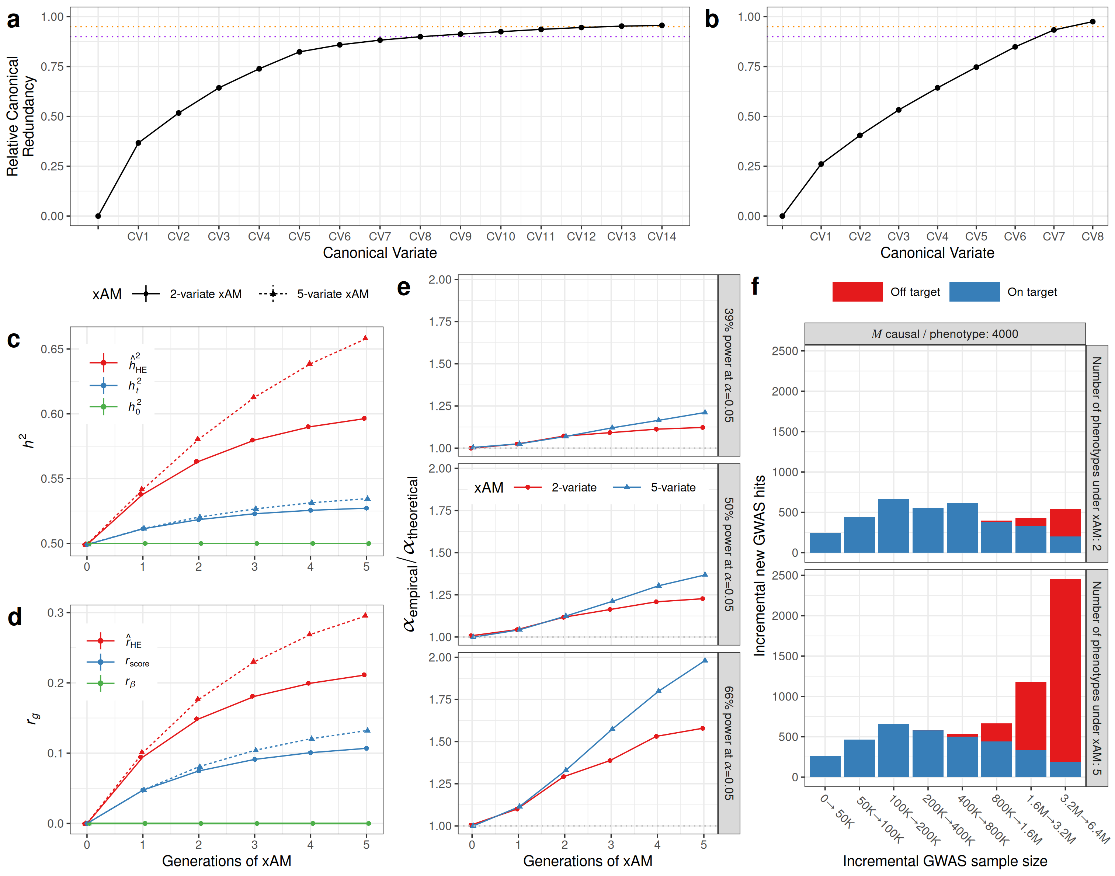

Figure 1. (a) Dimensionality of cross-mate correlations across 34 UK Biobank phenotypes. Scree plot illustrating the sex-averaged canonical redundancy for each canonical vector relative to the total variance accounted for by all vectors. Eight (resp. fourteen) dimensions were required to explain 90% (resp. 95%) of shared variance across mates (purple [resp. orange] dotted lines). (b) Dimensionality of cross-mate correlations across 11 Taiwan NHIRD phenotypes. Seven (resp. eight) dimensions were required to explain 90% (resp. 95%) of shared variance across mates (purple [resp. orange] dotted lines). (c) True and estimated heritability over 0 to 5 generations of bivariate versus 5-variate xAM for simulated phenotypes with a true panmictic heritability ($h_{0}^{2}$) of 0.5, zero pleiotropy, and exchangeable cross-mate correlations of 0.2. As has been previously demonstrated, bivariate xAM increases the true generation-t heritability ($h_{t}^{2}$), which is in turn overestimated by linear mixed model-based method-of-moments estimators such as Haseman-Elston and LD-score regression (${\hat{h}}_{HE}^{2}$). However, relative to bivariate xAM, 5-variate xAM has a modestly larger effect on $h_{t}^{2}$ but a substantially larger effect on ${\hat{h}}_{HE}^{2}$. (d) In the same simulation context, bivariate xAM increases the true correlation between polygenic scores ($r_{score}$) and induces further upward bias in the corresponding method-of-moment estimate (${\hat{r}}_{HE}$), even when the true correlation between genetic effects ($r_{β}$) is zero. As with heritability, 5-variate xAM has a modestly stronger effect on $r_{score}$, the correlation between additive genetic factors, and induces substantially more severe upward bias in ${\hat{r}}_{HE}$. (e) Ratio of empirical to expected type-I error rates for GWAS test statistics at Bonferroni significance across 0 to 5 generations of bivariate versus 5-variate xAM for simulated phenotypes. Panels correspond to the ratio of sample size to the number of causal variants-per-trait, with power increasing from top to bottom. (f) Expected number of new on-target and off-target genome-wide significant associations per sample size increment after five generations of xAM. We consider a GWAS of a single trait under xAM with one or four other phenotypes, each with 4,000 distinct causal variants. Each phenotype has a heritability of 0.5 and cross-mate cross-trait correlations are all set to 0.2. “On (resp. off) target” hits refer to genome-wide significant associations at causal variants for the focal (resp. any of the other) traits. Each bar reflects the additional expected associations for specific increments to the GWAS sample size.
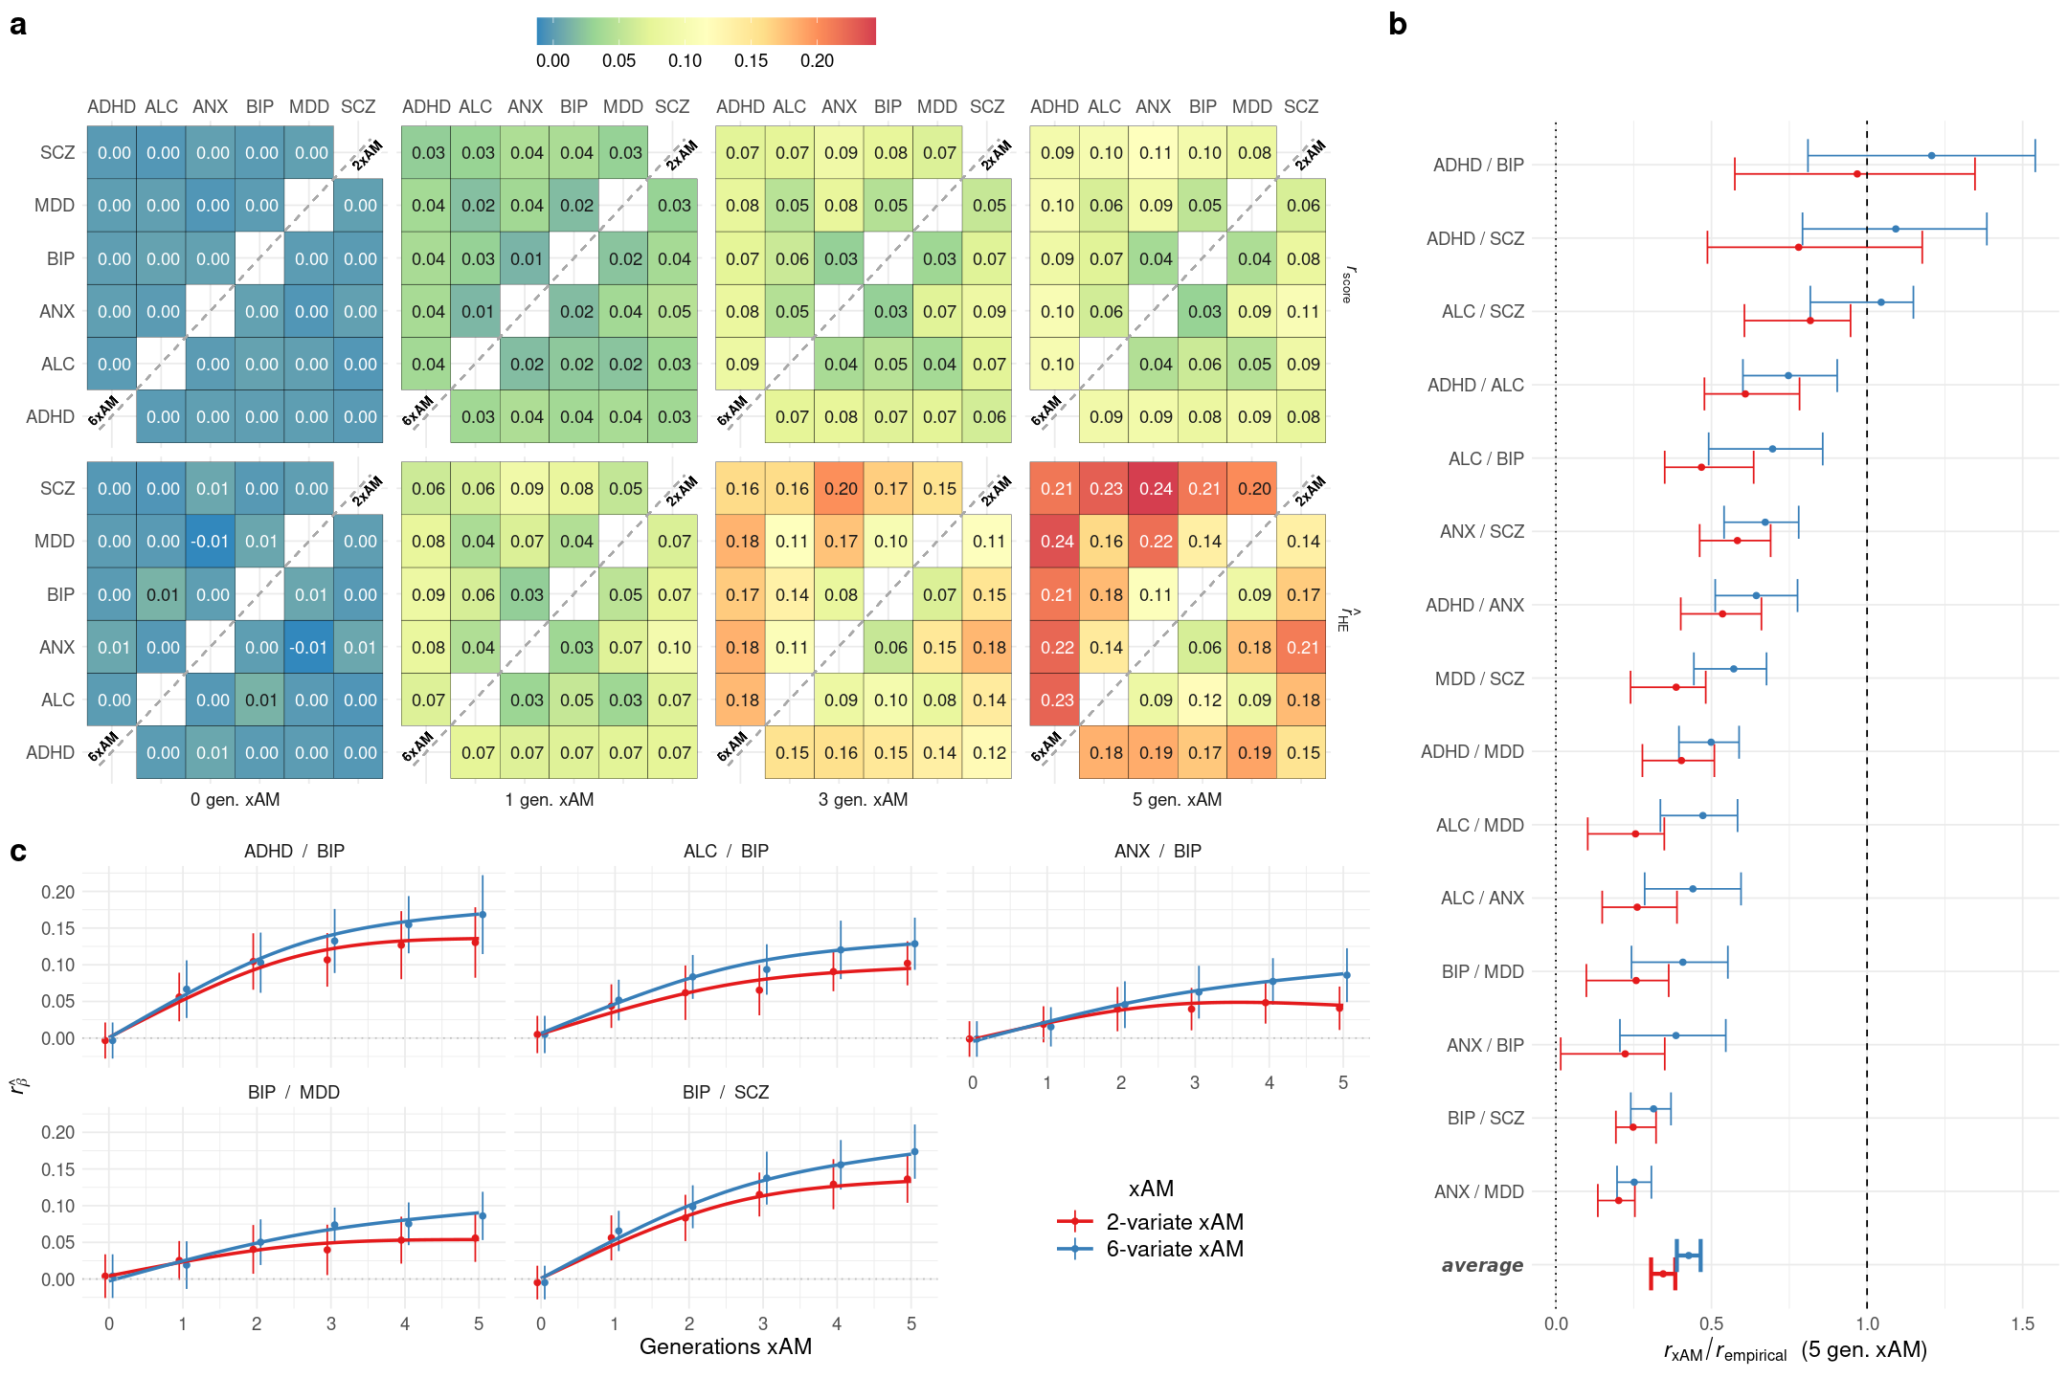

Figure 2. (a) True polygenic score correlations ($r_{score}$; top row) and method-of-moments genetic correlation estimates (${\hat{r}}_{HE}$; bottom row) and among six psychiatric disorders after 0 – 5 generations of simulated xAM congruent with empirical spousal correlations. Superdiagonal elements reflect bivariate assortative mating (i.e. each cell corresponds to an independent set of simulations of xAM across the two referenced traits and no others) whereas subdiagonal elements reflect empirical 6-variate xAM (i.e. simulations of xAM across all six traits simultaneously). (b) Ratio of predicted genetic correlation under bivariate versus 6-variate xAM without pleiotropy ($r_{xAM}$) to empirical LD-score regression genetic correlation estimates among psychiatric disorders ($r_{empirical}$); values close to one reflect empirical estimates consistent with xAM alone, i.e. in the absence of pleiotropy. (c) Expected change in disorder prevalence under bivariate and 6-variate xAM. ADHD=attention-deficit hyperactivity disorder, ALC=alcohol use disorder, ANX=anxiety disorders, BIP=bipolar disorders, MDD=major depressive disorder, SCZ=schizophrenia.

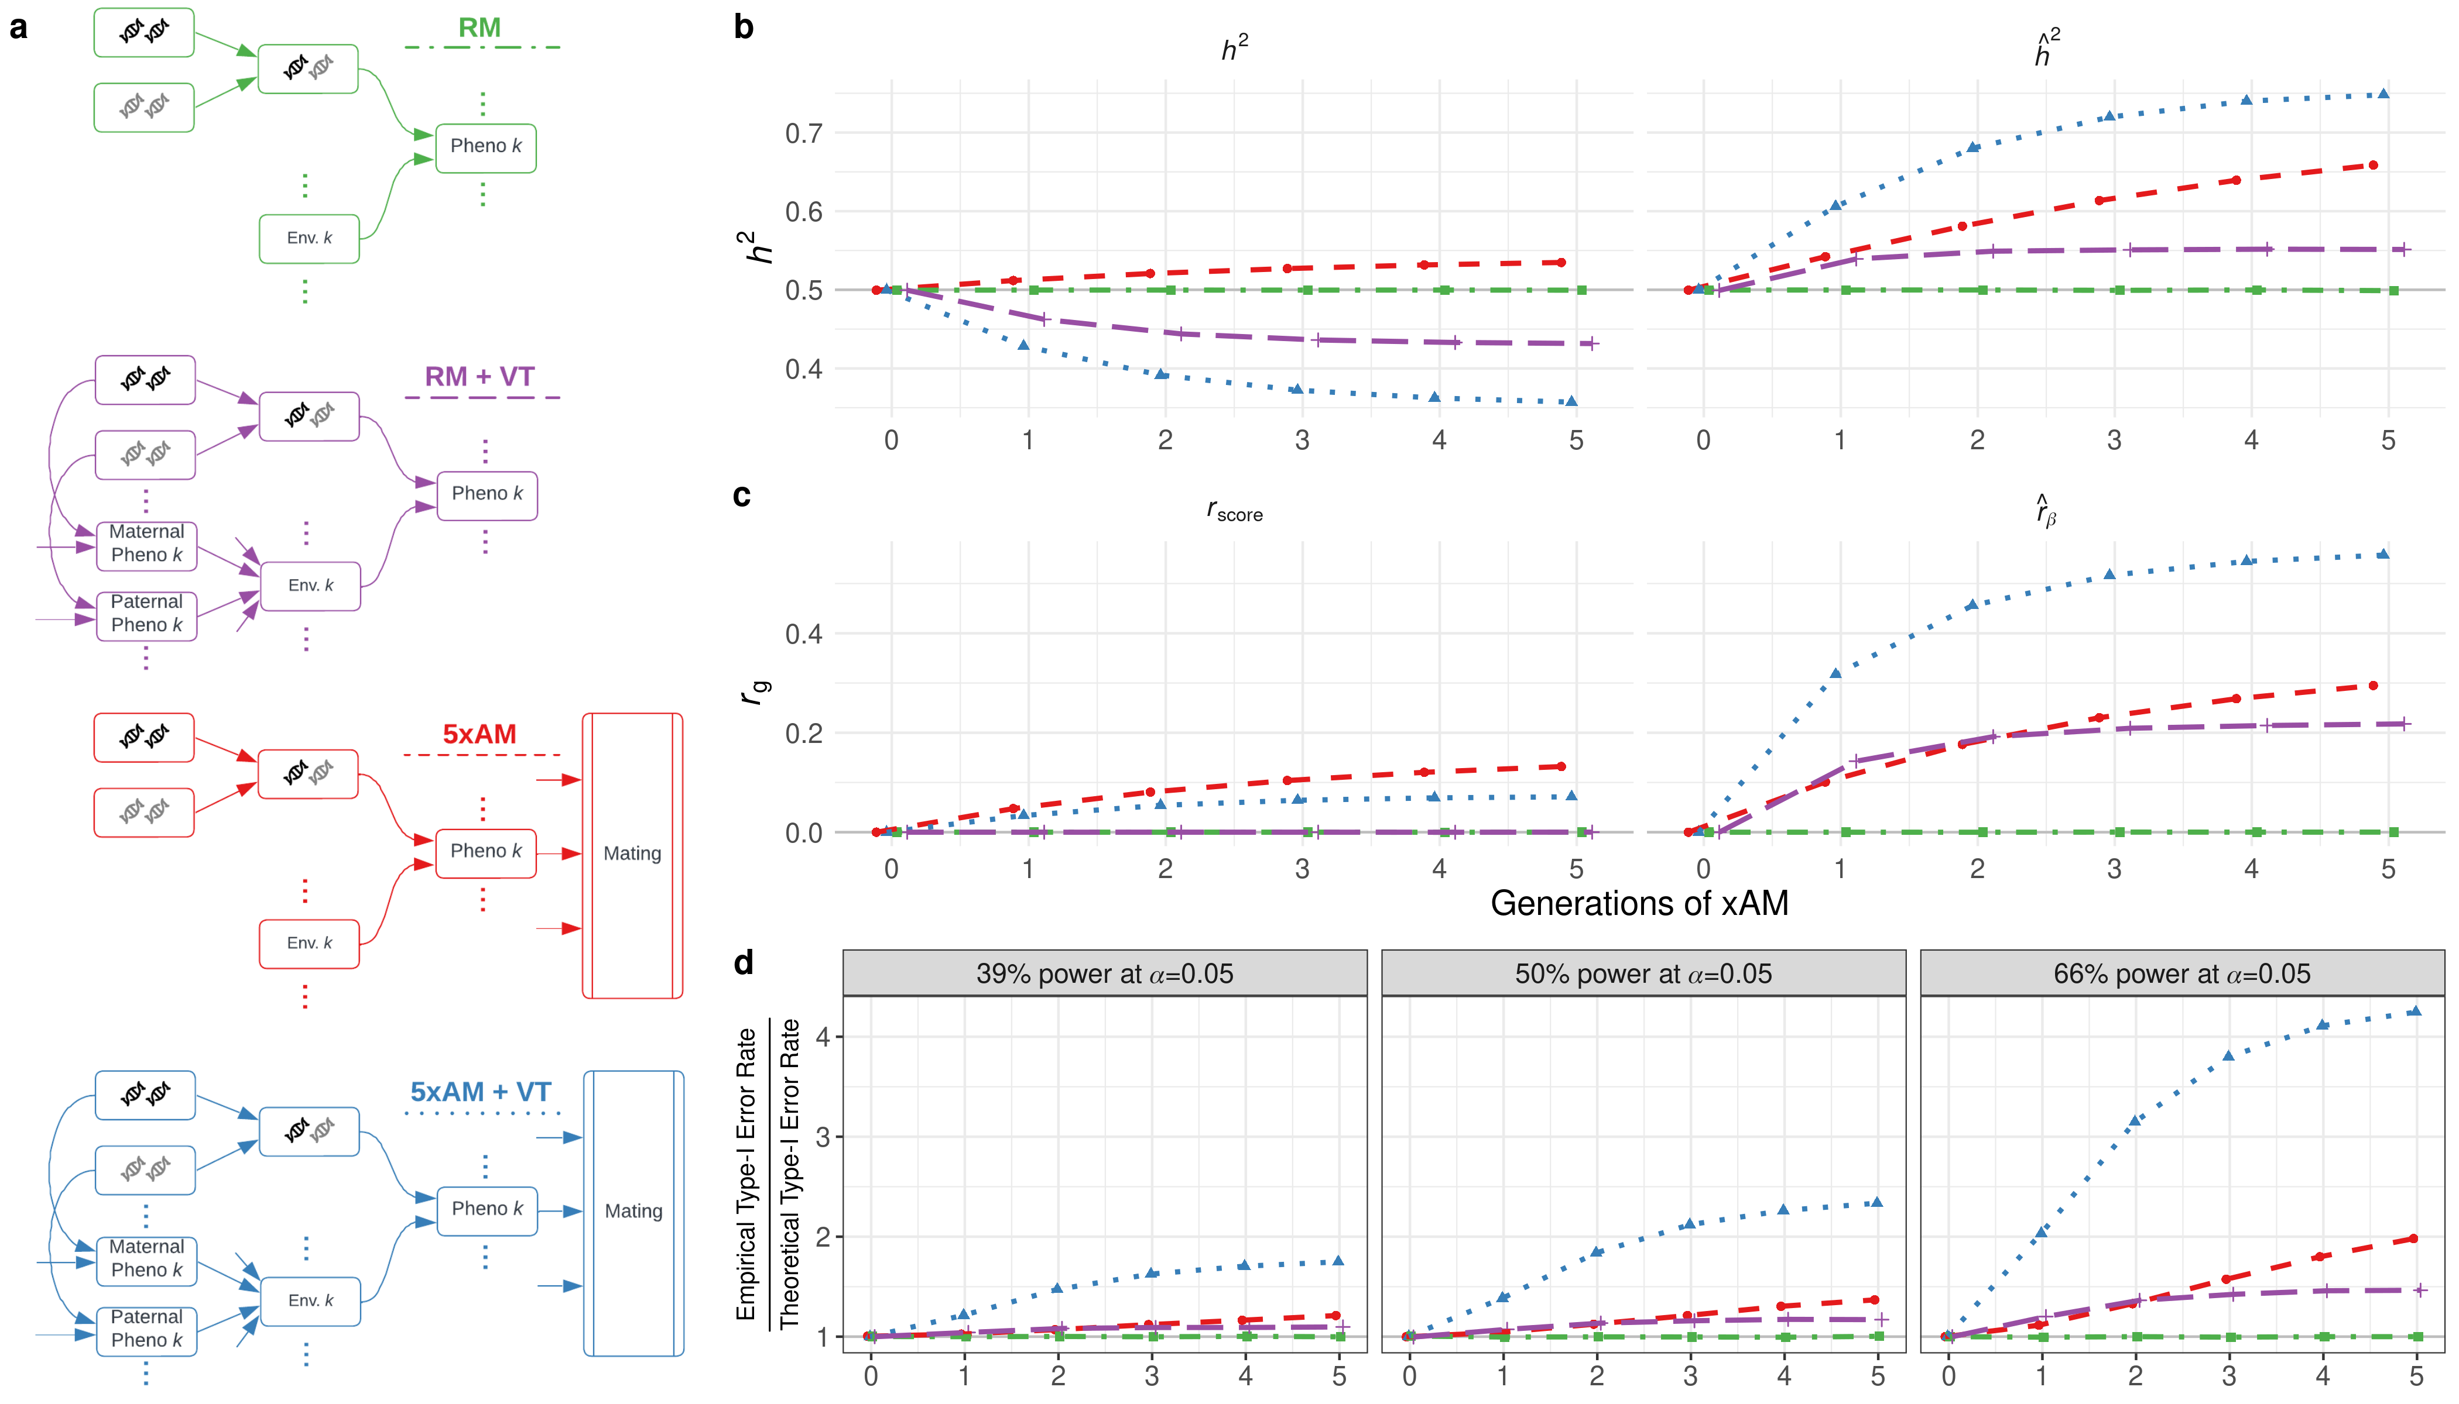
Figure 3. (a) Generative models for five phenotypes with orthogonal genetic effects. Phenotypes are subject to random versus 5-variate cross-trait assortative mating (RM versus 5xAM) and/or vertical transmission of environment from parent to offspring (VT). When present, VT accounts for 5% of the total phenotypic variance at generation zero (b) True ($h^{2}$) and estimated (${\hat{h}}^{2}$) heritabilites over successive generations across generative models. (c) True polygenic score correlation ($r_{score}$) and estimated effect correlation (${\hat{r}}_{HE}$) over successive generations across generative models. In all cases, the true effect correlation is exactly zero. (d) Relative inflation of empirical to nominal type-I error rates at nominal significance for GWAS with varying power (modulated here by the ratio of sample size to causal variants [n/m]). Note: The color of points in panels (b)-(d) correspond to those of the schematics in panel (a).

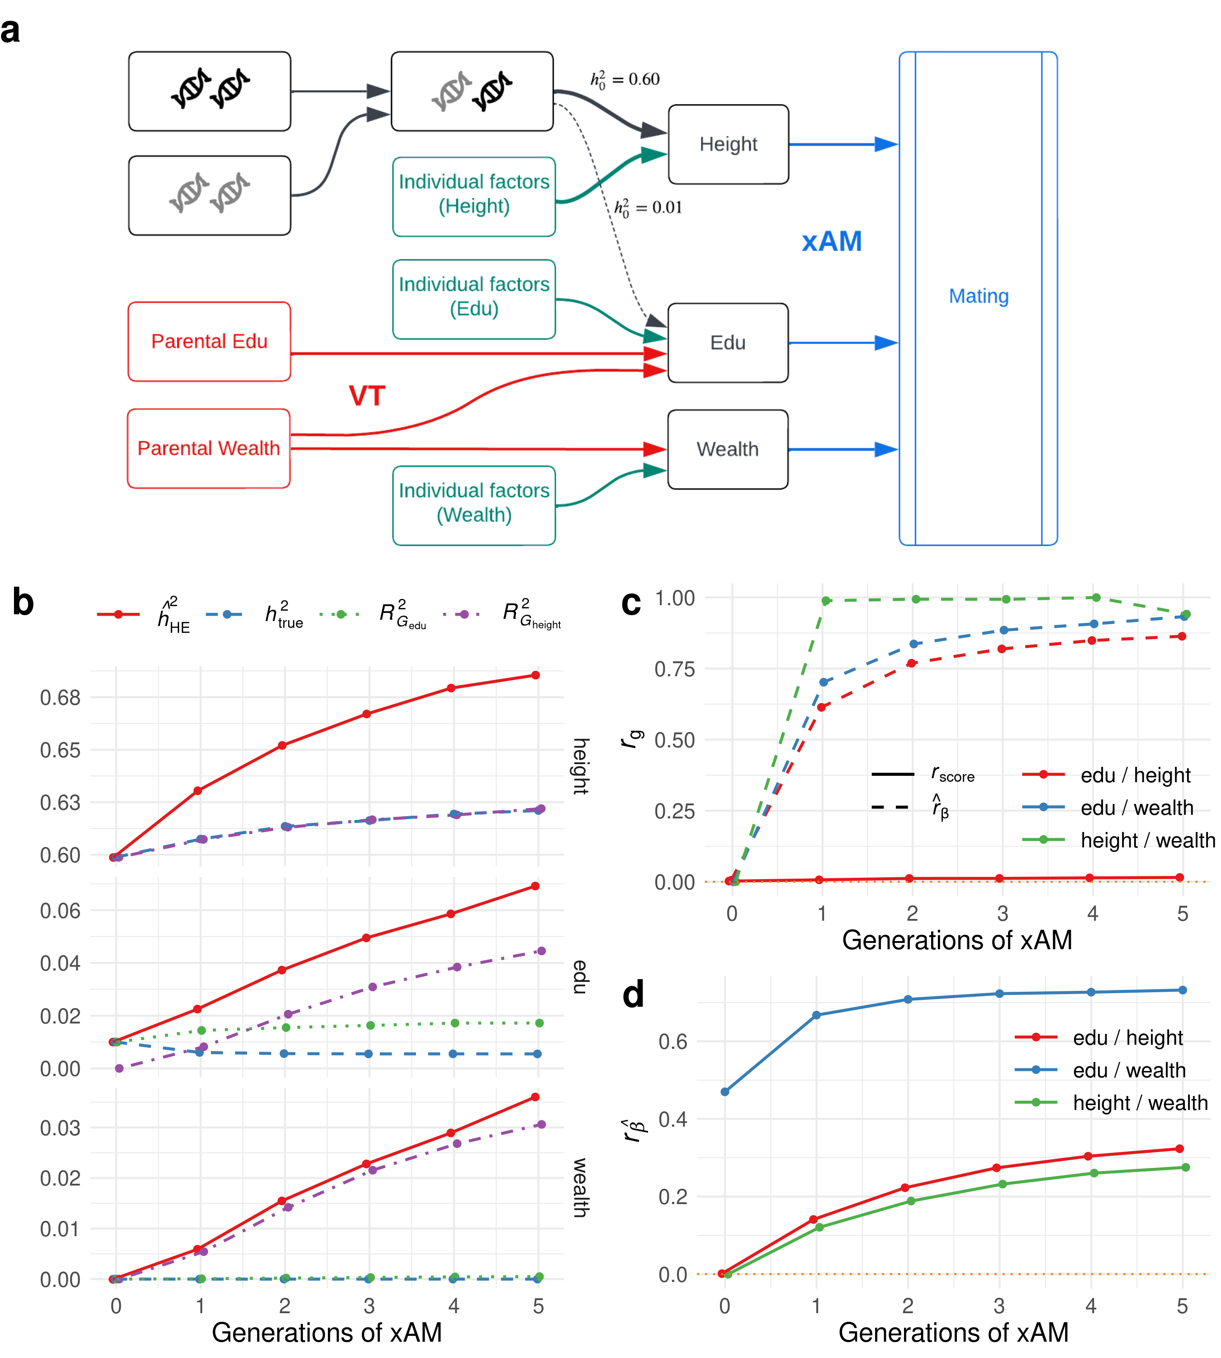

Figure 4. (a) Simplistic model of the joint architecture of wealth, education years (edu), and height. Height interacts with other phenotypes exclusively through cross-trait assortment (xAM), edu is trivially heritable ($h_{0}^{2}$=0.01) but affected by parental education and wealth, and wealth has no genetic component but is transmitted from parents to offspring. (b) Estimated and narrow-sense heritability across successive generations of xAM, along with variance explained ($R^{2}$) by true polygenic indices (PGI). (c) True PGI correlation and estimated genetic correlation across successive generations of xAM. Note that the true effect correlation between education and wealth in this case is identically one as wealth has no independent influences. (d) Correlation among GWAS effect estimates between height, edu, and wealth.

Supplementary Figures
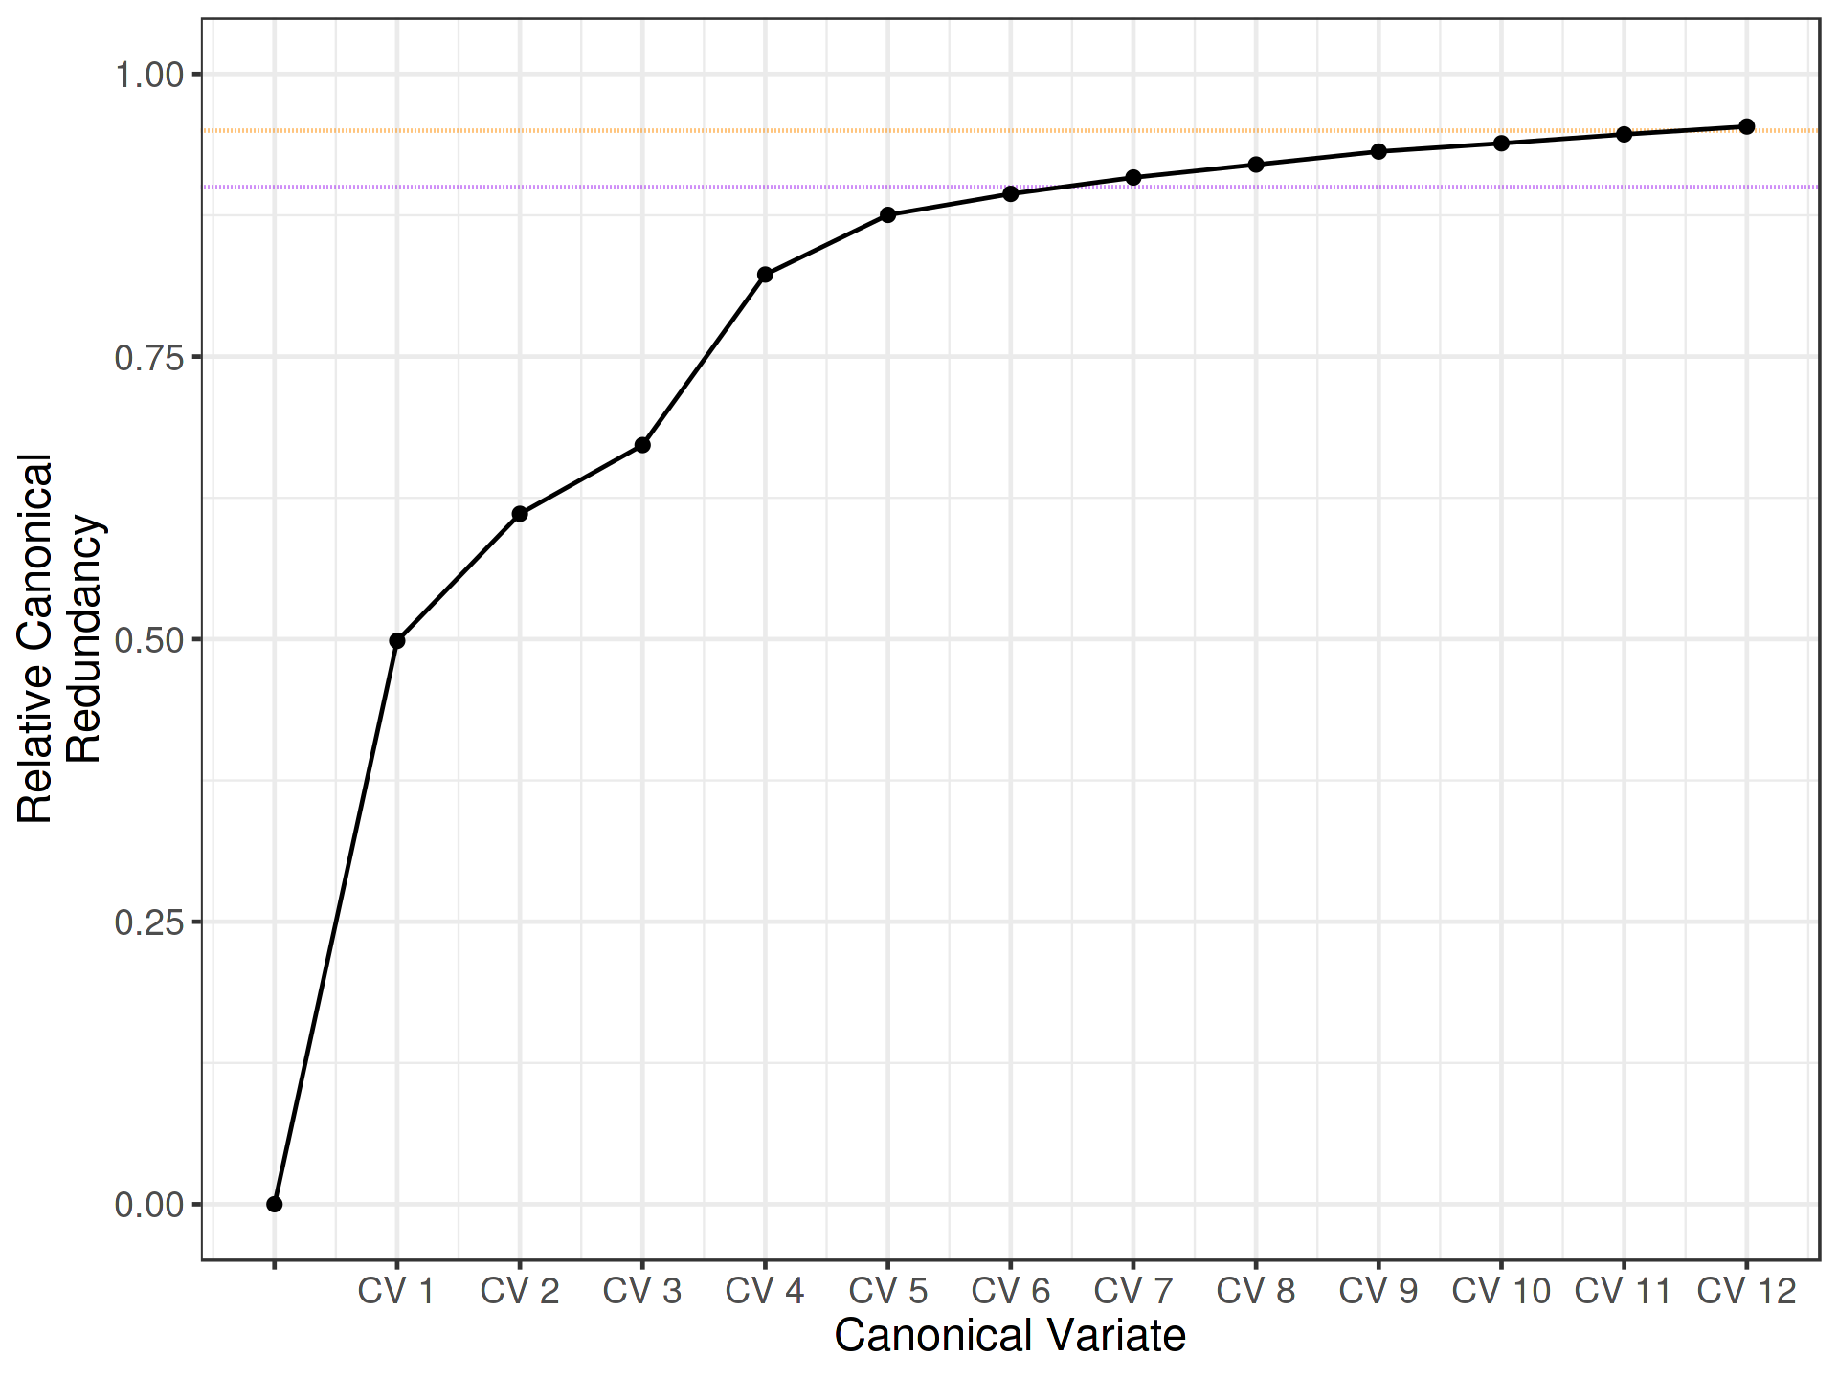

Figure S1. Cross-mate CCA scree plot based on multiply imputed data using predictive mean matching multiple imputation by chained equations. Vertical axis reflects sex-averaged cumulative relative canonical redundancy. Twelve linearly independent canonical variates are required to account for 95% of the variance explicable in one mate's phenotype by linear combinations of their partner's phenotypes. Values reflect median redundancies across 5 × 5 imputed datasets.

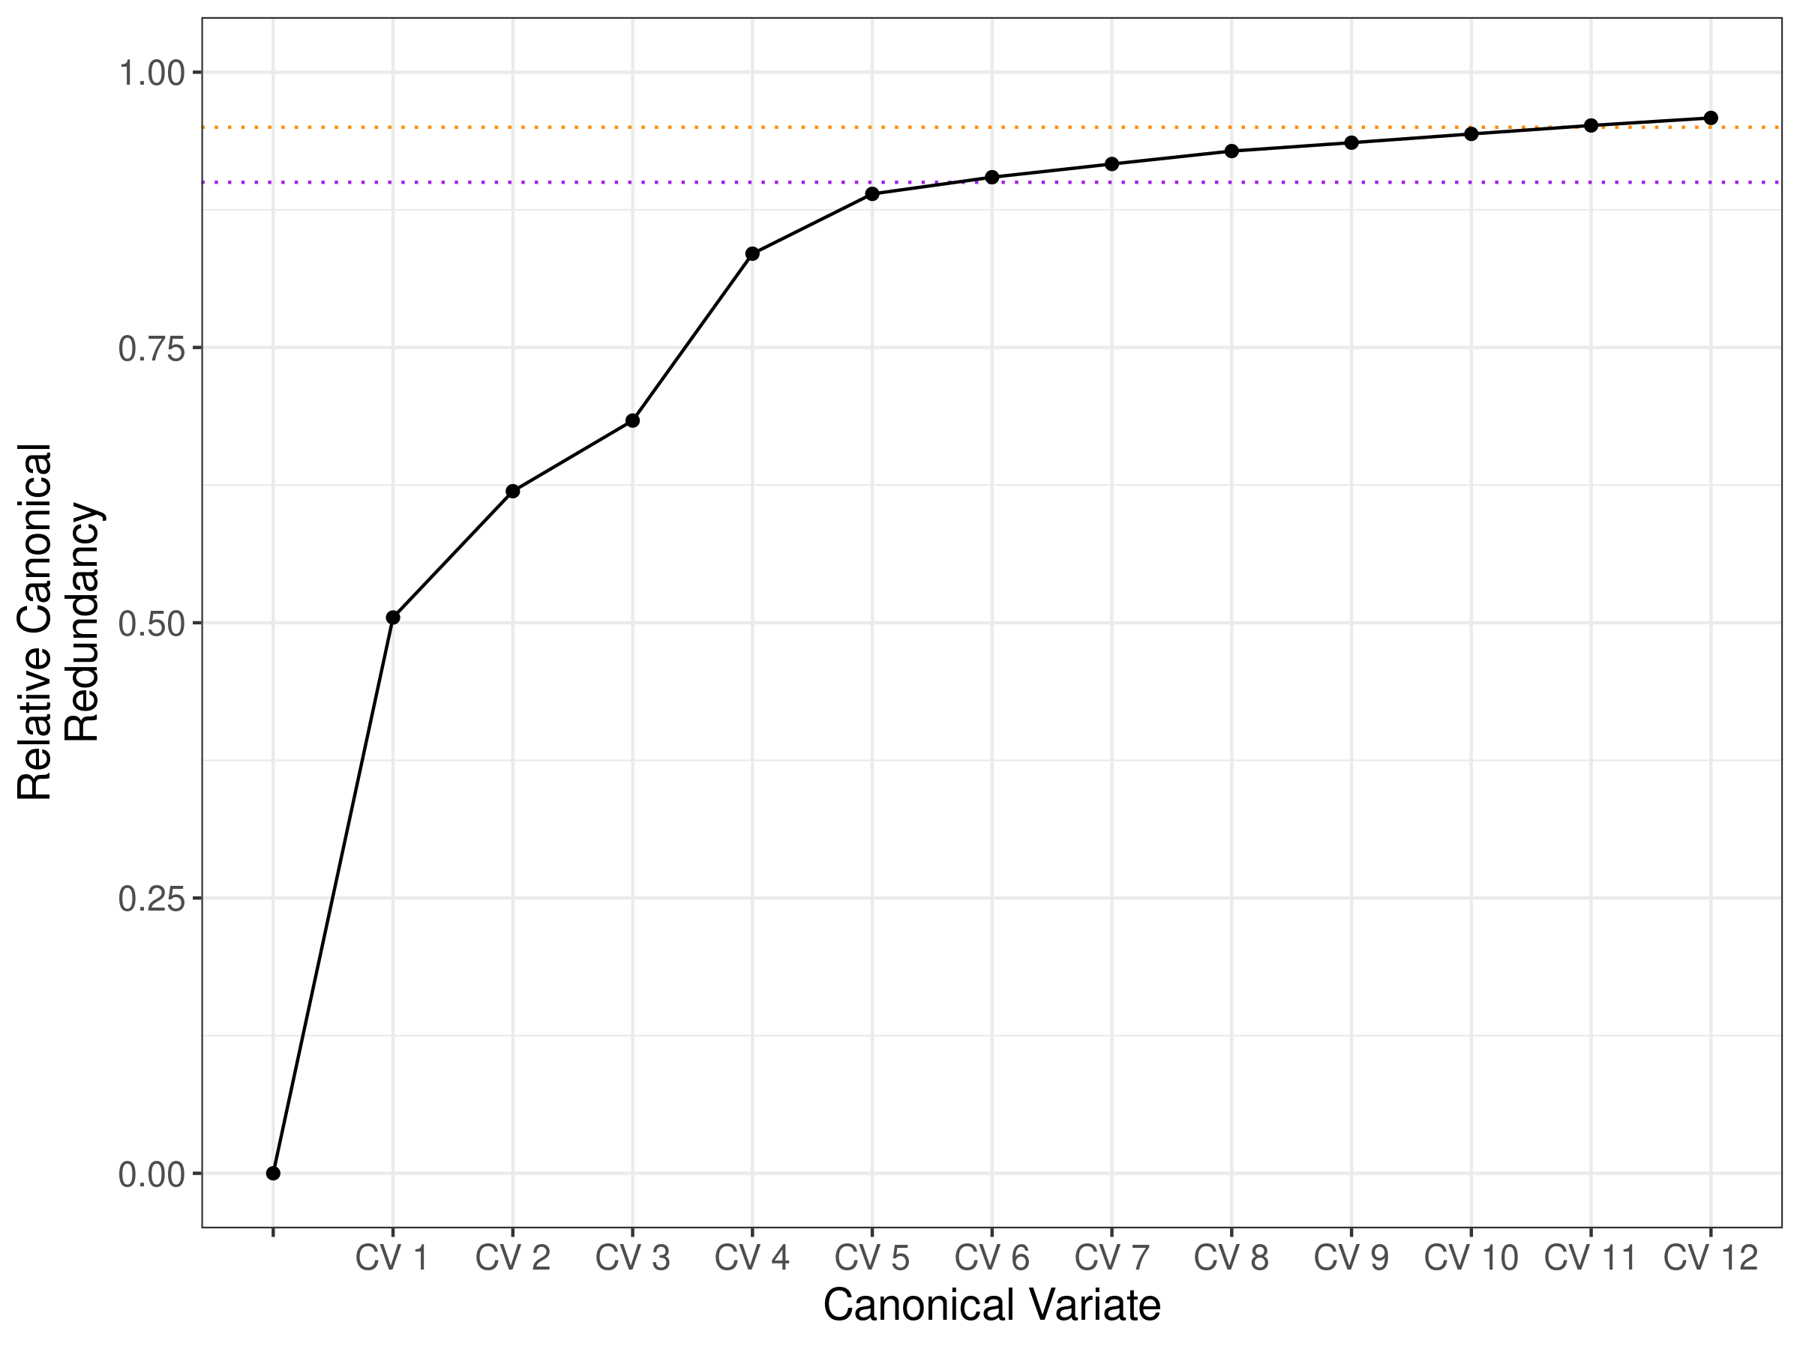

Figure S2. Cross-mate CCA scree plot based on alternative multiple imputation scheme. Vertical axis reflects sex-averaged cumulative relative canonical redundancy. Again, twelve linearly independent canonical variates are required to account for 95% of the variance explicable in one mate's phenotype by linear combinations of their partner's phenotypes. Here, missing values were imputed separately in males in females across five multiple imputations with chained equations using Random Forests predictions. Values reflect median redundancies across 5 × 5 imputed datasets.

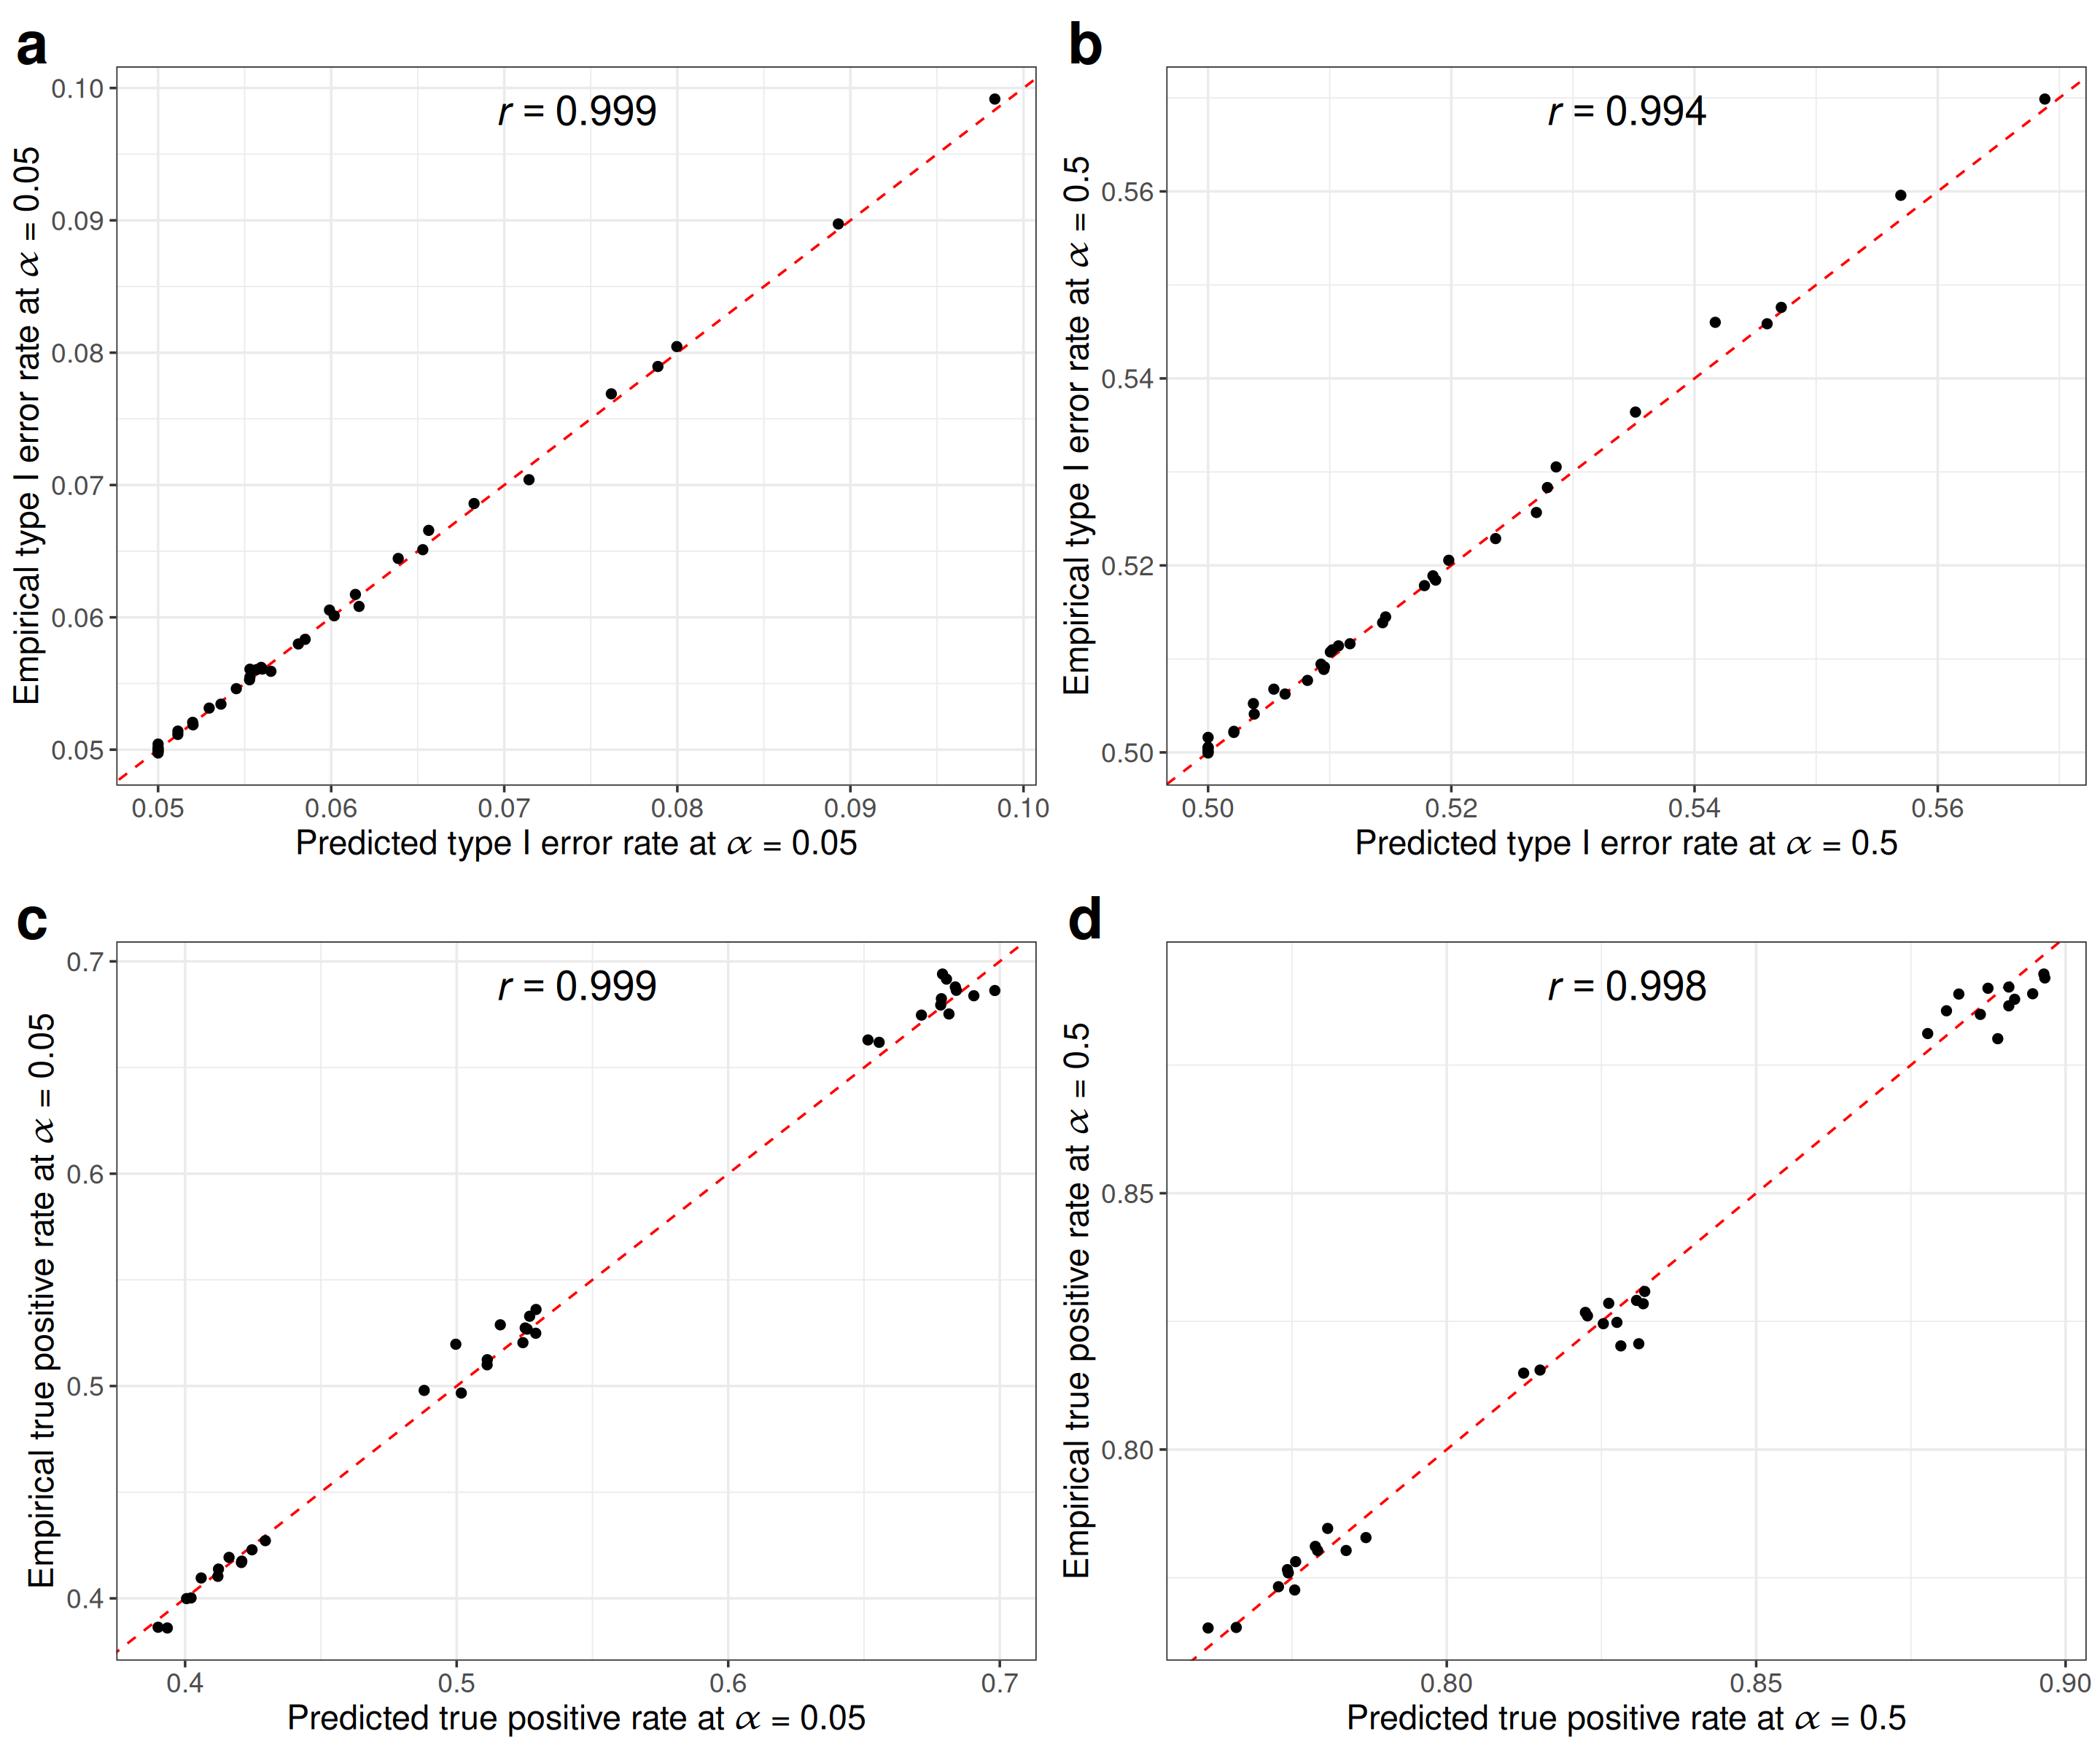

Figure S3. Theoretical predictions versus observed type-I error rates at off-target loci (top row) and power at on-target loci (bottom row) for α=0.05 (left column) and α=0.5 (right column) validate mathematical derivations with high accuracy (all Pearson correlations > 0.99) for all simulations presented in Figure 1e. “On target” hits refer to genome-wide significant associations at causal variants for the focal GWAS trait. “Off target” hits refer to genome-wide significant associations at causal variants for the any of the other traits, and hence reflect false positives.

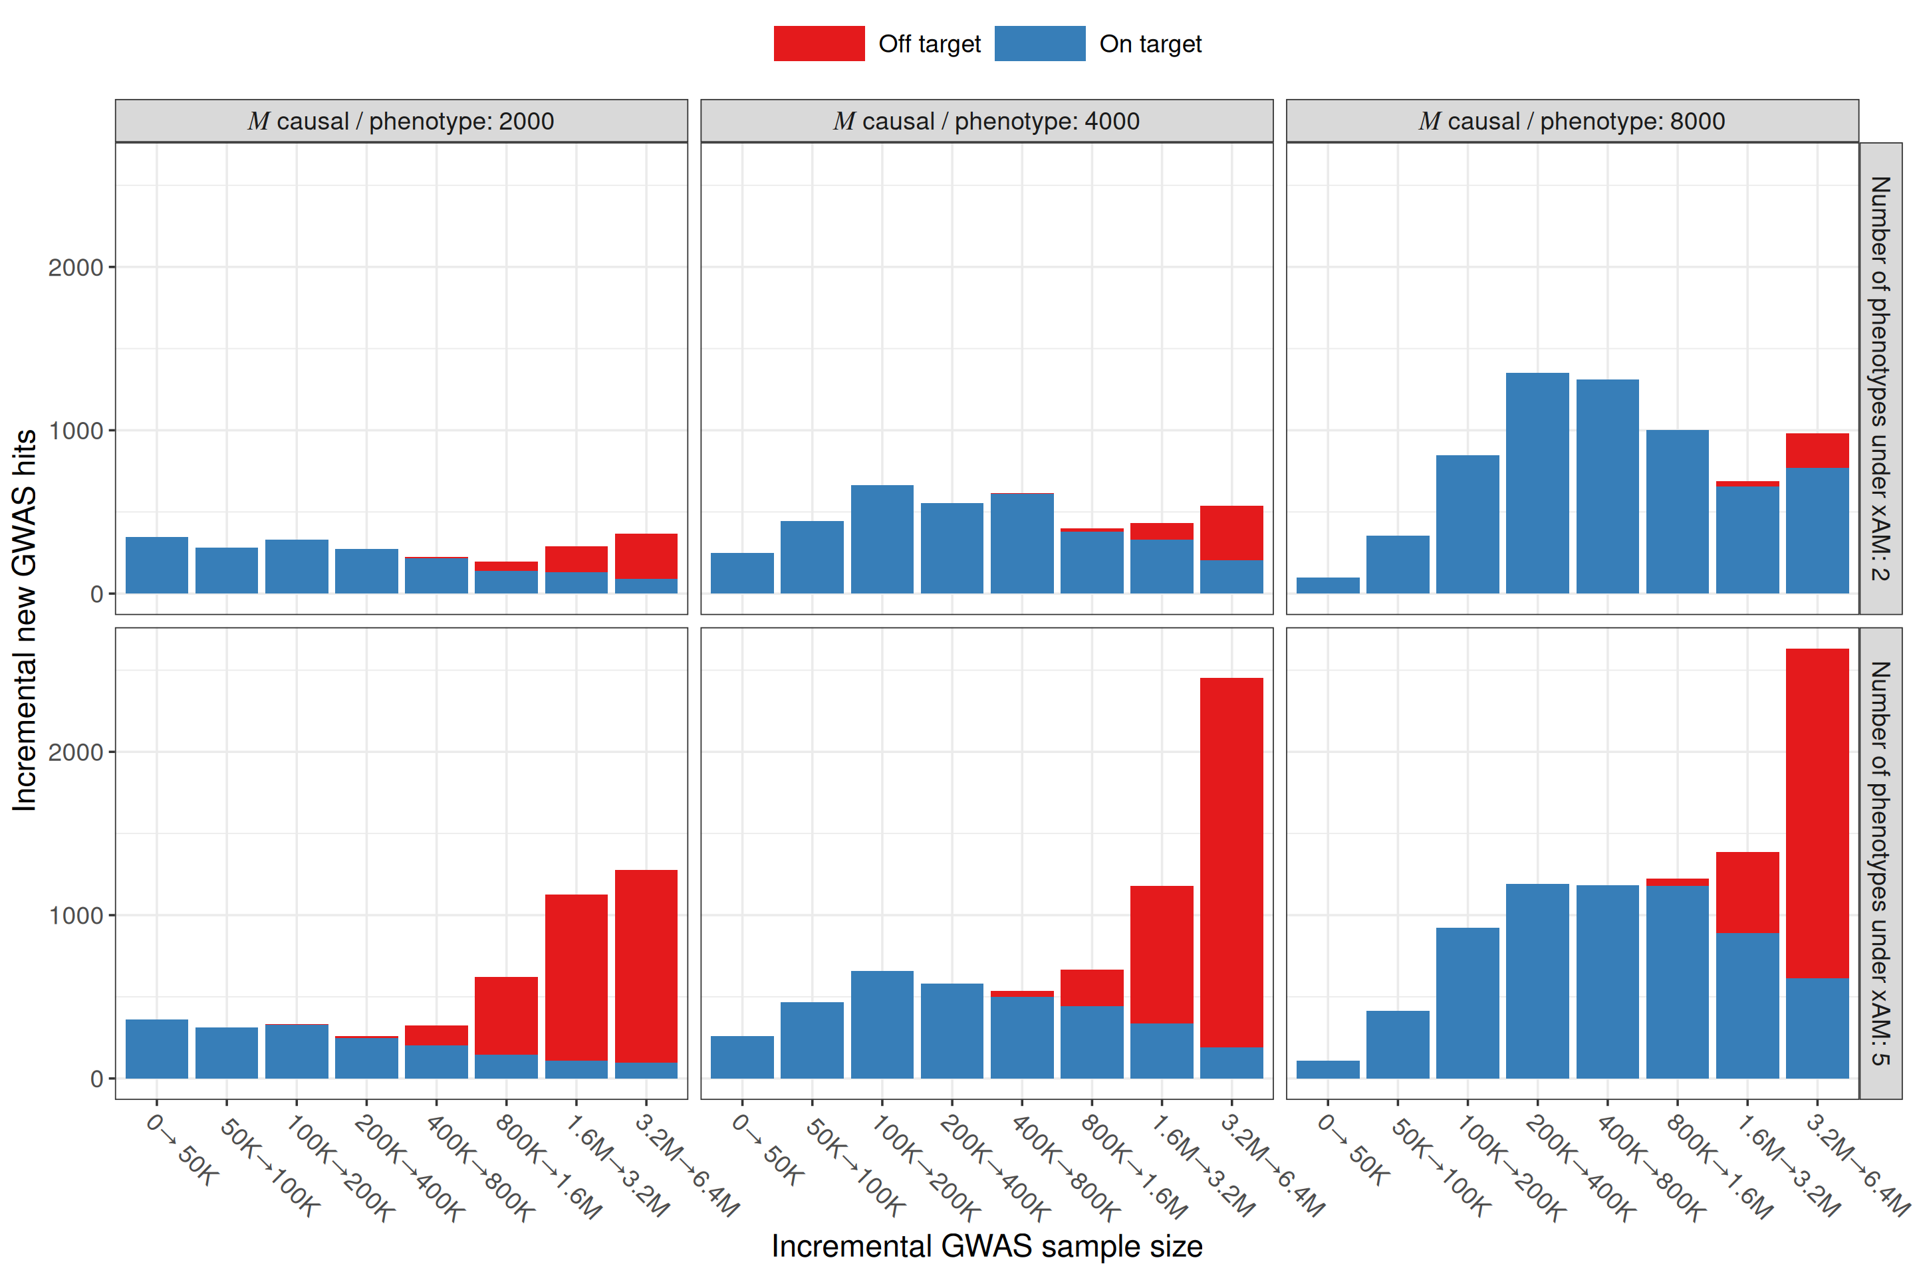

Figure S4. Incremental increases in the expected number of on-target versus off-target associations as a function of sample size increments after five generations of bivariate or 5-variate xAM. Here, we examine a GWAS of a single trait under xAM with one (top row) or four (bottom row) other phenotypes, each with M=2,000, 4,000, or 8,000 distinct causal variants each (vertical panels). Each phenotype has a heritability of 0.5 and cross-mate cross-trait correlations are all set to 0.2. “On target” hits refer to genome-wide significant associations at causal variants for the focal GWAS trait. “Off target” hits refer to genome-wide significant associations at causal variants for the any of the other traits, and hence reflect false positives. Each bar reflects the additional (i.e., not cumulative) expected associations for specific increments to the GWAS sample size.

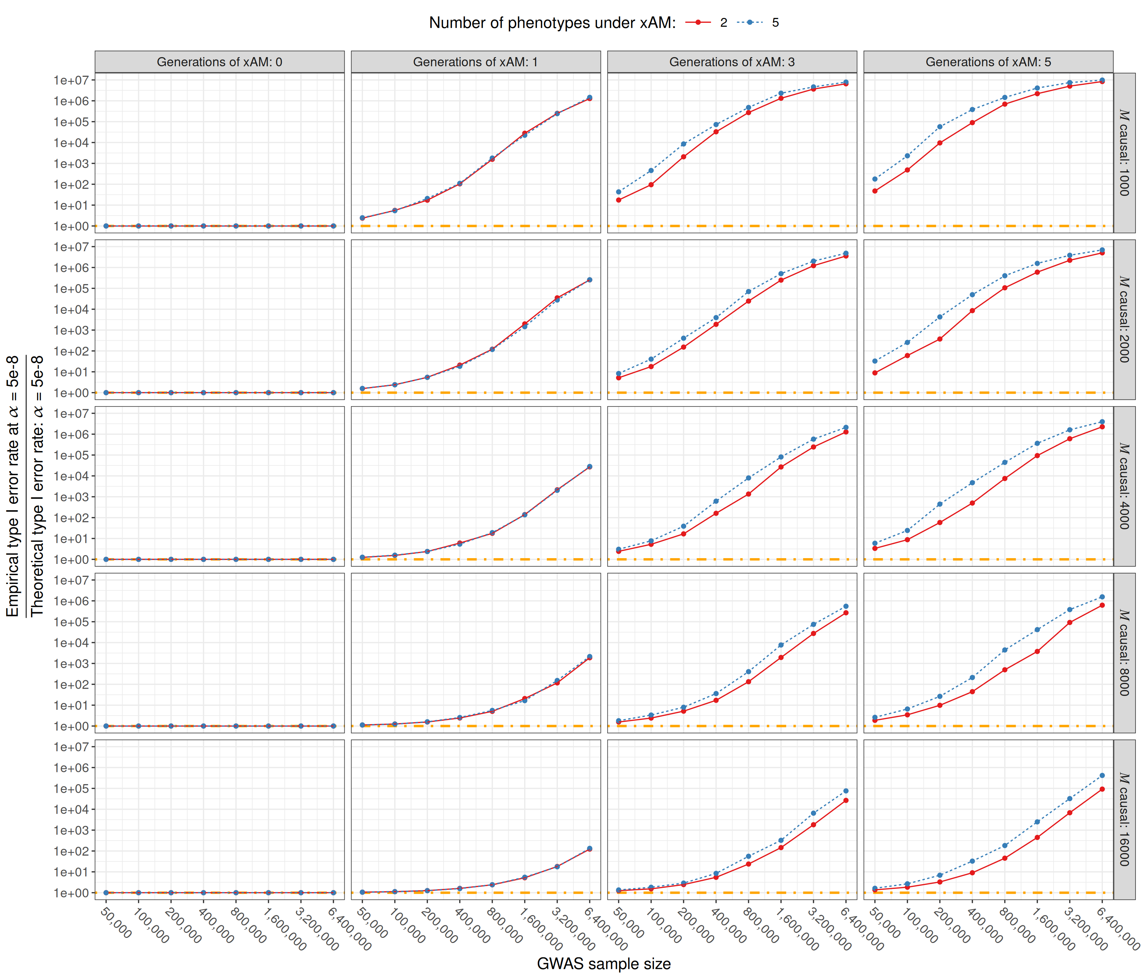

Figure S5. Inflation of type I error rates as a function of sample size driven by off-target associations under multivariate xAM. Here, we examine a GWAS of a single trait under xAM with one or four other phenotypes (colors / linetype), for varying numbers of distinct causal variants each (rows). Each phenotype has a heritability of 0.5 and cross-mate cross-trait correlations are all set to 0.2. “Off target” hits refer to genome-wide significant associations at causal variants for the any of the other traits, and hence reflect false positives.

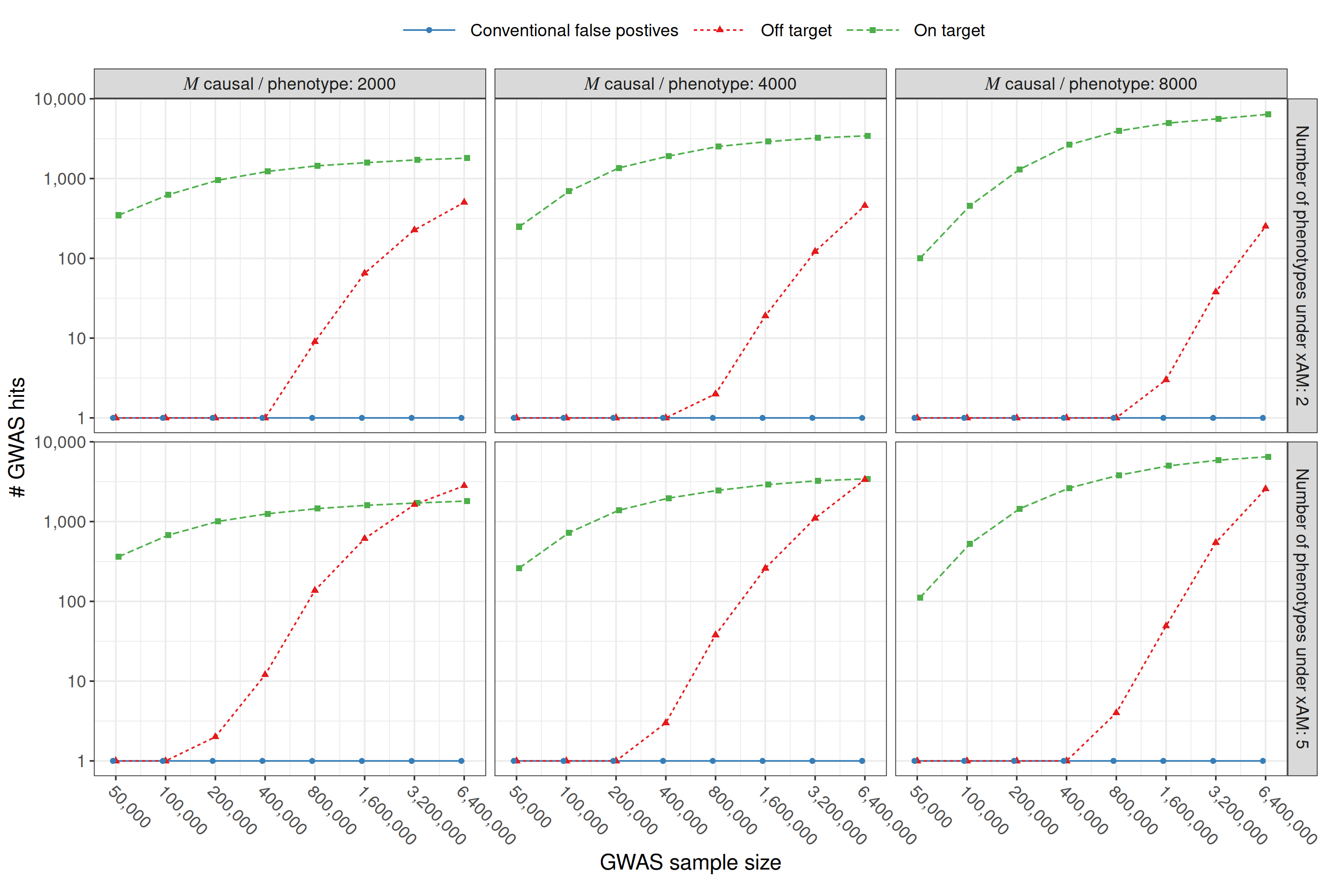

Figure S6. Expected number of on-target versus off-target associations as a function of GWAS sample size after five generations of bivariate or 5-variate xAM. Here, we examine a GWAS of a single trait under xAM with one (top row) or four (bottom row) other phenotypes, each with M=2000, 4000, or 8000 distinct causal variants each (vertical panels). Each phenotype has a heritability of 0.5 and cross-mate cross-trait correlations are all set to 0.2. “On target” hits refer to genome-wide significant associations at causal variants for the focal GWAS trait. “Off target” hits refer to genome-wide significant associations at causal variants for the any of the other traits, and hence reflect false positives.

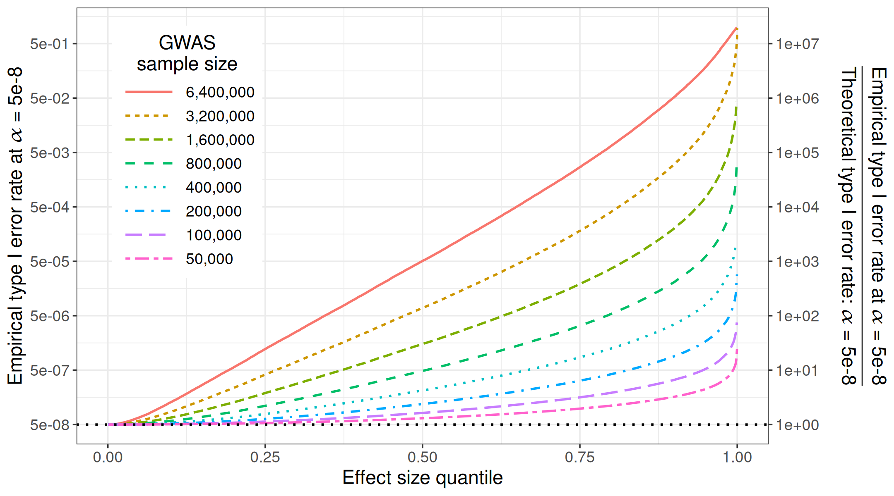

Figure S7. Expected false positive rate at a given off-target locus effect as a function of its magnitude (horizontal axis) and of sample size (color and line type). Each phenotype has a heritability of 0.5 with Gaussian standardized effects across 4000 distinct loci, and cross-mate cross-trait correlations are all set to 0.2. The right end of the axis reflects probability of detecting a genome-wide significant association with causal variant with the largest effect on a secondary trait under xAM with the focal GWAS trait. In a discovery sample of 6.4M individuals, the empirical type I error rate at the median effect size off-target causal variant will be 1,000 times greater than expected; at the largest effect size off-target loci this factor increases above 10,000,000.

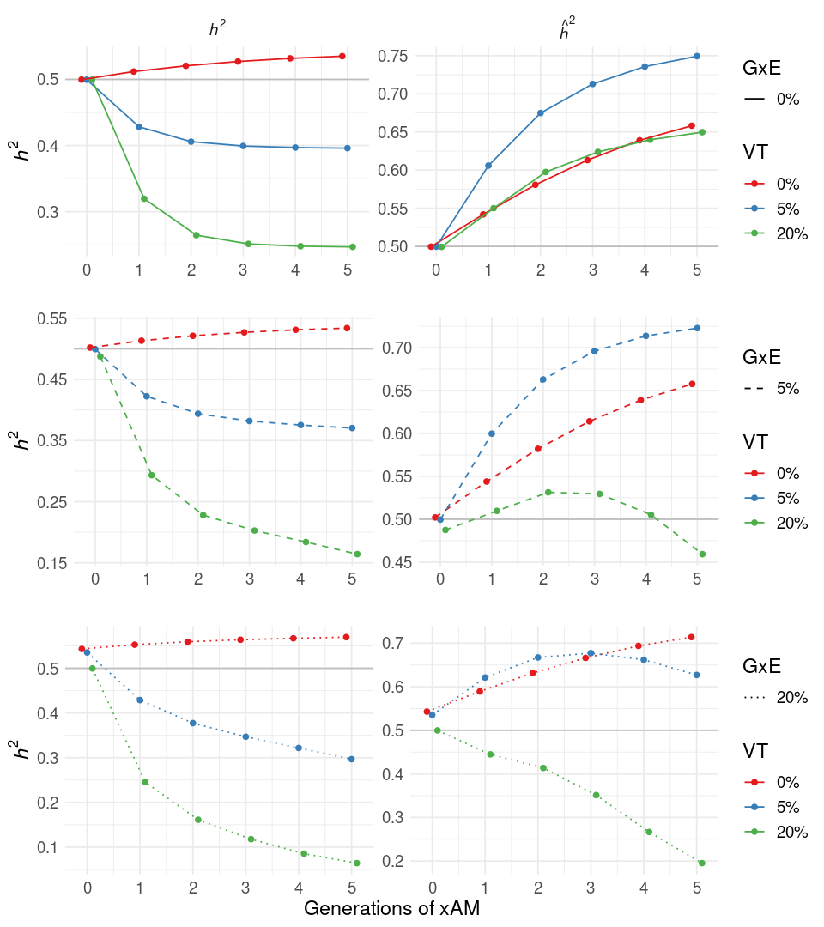
Figure S8. True and estimated heritability across successive generations of 5-variate xAM averaged over five phenotypes with orthogonal genetic effects. Architectures include gene-environment interactions (G×E; varying across rows), vertical transmission of environment from parent to offspring (VT), or both, in addition to cross-trait assortative mating (xAM). When present, G×E and VT account for 5% or 20% of the total phenotypic variance at generation zero.

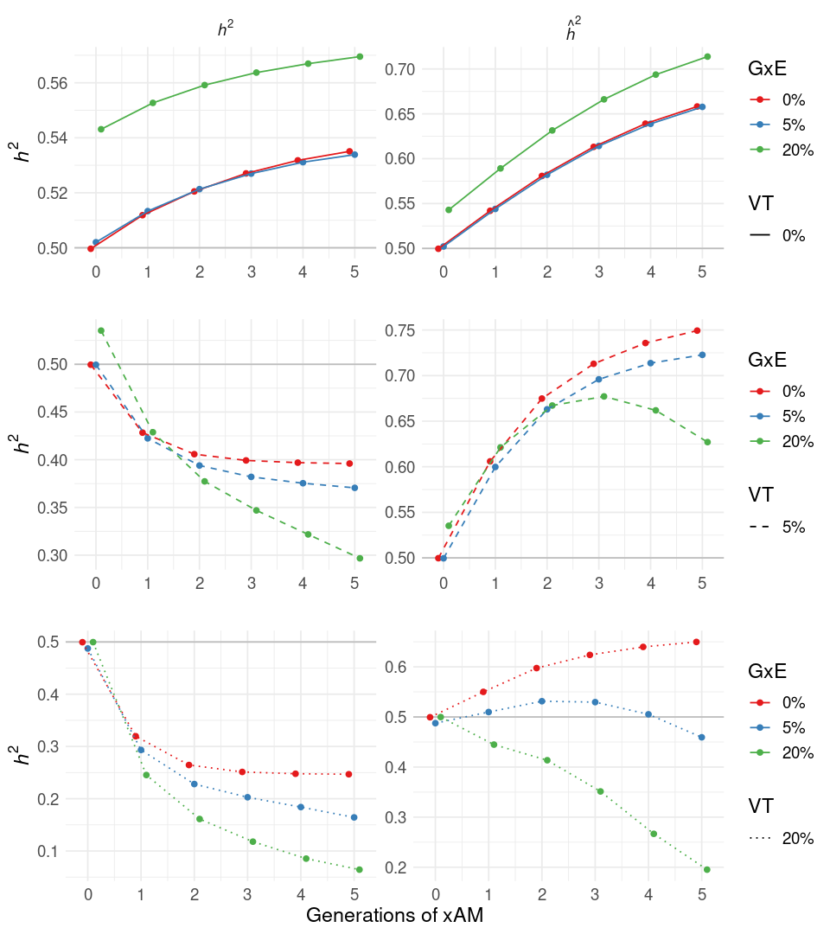

Figure S9. Alternative presentation of true and estimated heritability across successive generations of 5-variate xAM averaged over five phenotypes with orthogonal genetic effects. Architectures include gene-environment interactions (G×E), vertical transmission of environment from parent to offspring (VT; varying across rows), or both, in addition to cross-trait assortative mating (xAM). When present, G×E and VT account for 5% or 20% of the total phenotypic variance at generation zero.

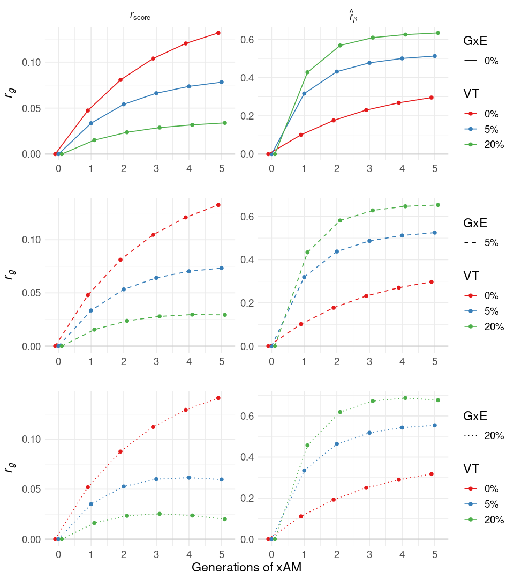

Figure S10. Alternative presentation of true polygenic score correlation and estimated effect correlation across successive generations of 5-variate xAM averaged over five phenotypes with orthogonal genetic effects. Architectures include gene-environment interactions (G×E), vertical transmission of environment from parent to offspring (VT; varying across rows), or both, in addition to cross-trait assortative mating (xAM). When present, G×E and VT account for 5% or 20% of the total phenotypic variance at generation zero.
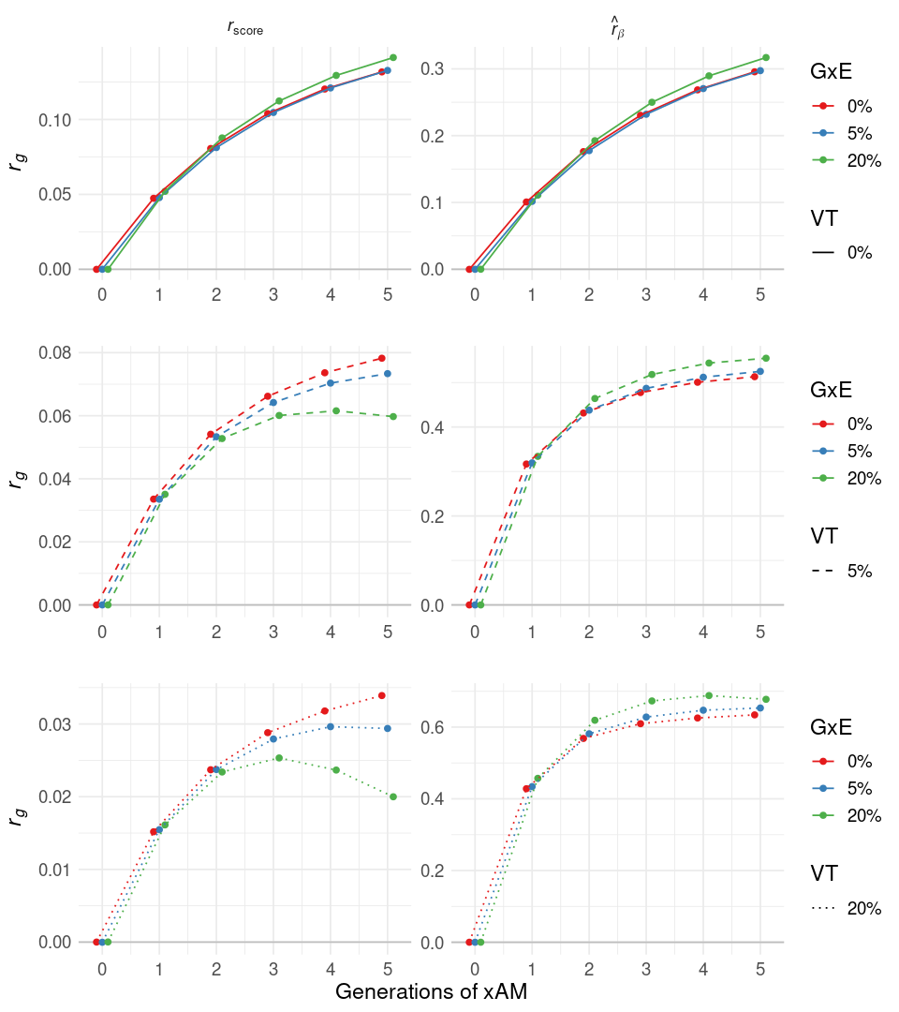

Figure S11. True polygenic index correlation and estimated effect correlation across successive generations of 5-variate xAM averaged over five phenotypes with orthogonal genetic effects. Architectures include gene-environment interactions (G×E), vertical transmission of environment from parent to offspring (VT; varying across rows), or both, in addition to cross-trait assortative mating (xAM). When present, G×E and VT account for 5% or 20% of the total phenotypic variance at generation zero.

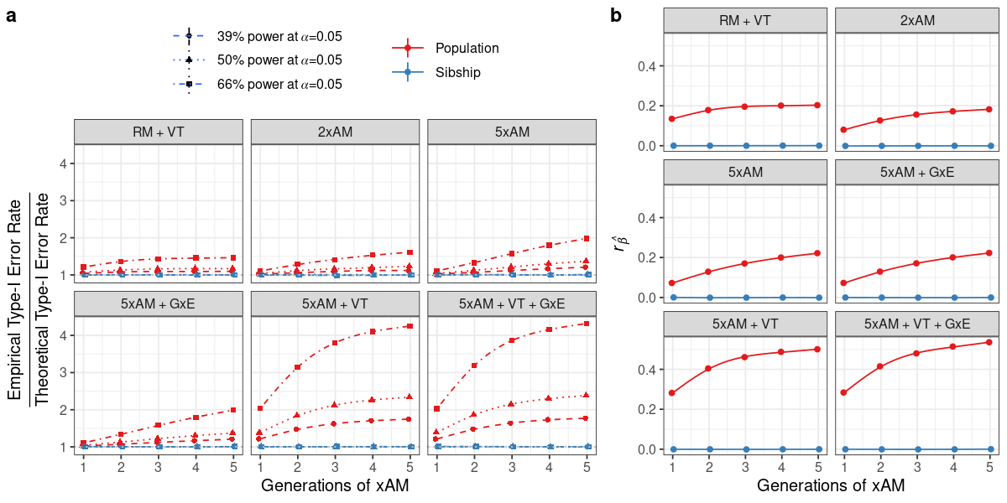
Figure S12. Population versus within-sibship GWAS. (a) Relative inflation of empirical to nominal type-I error rates at nominal significance for population-based and within-sibship GWAS with varying power (modulated here by the ratio of sample size to causal variants n/m) across successive generations. Simulations reflect random versus assortative mating (RM versus xAM) with or without gene-environment interactions (G×E) and/or vertical transmission (VT), all in the absence of pleiotropy. When present, G×E and VT account for 5% of the total phenotypic variance at generation zero. (b) Cross-phenotype correlations between population-based versus within sibship GWAS slope estimates over successive generations across simulation conditions.

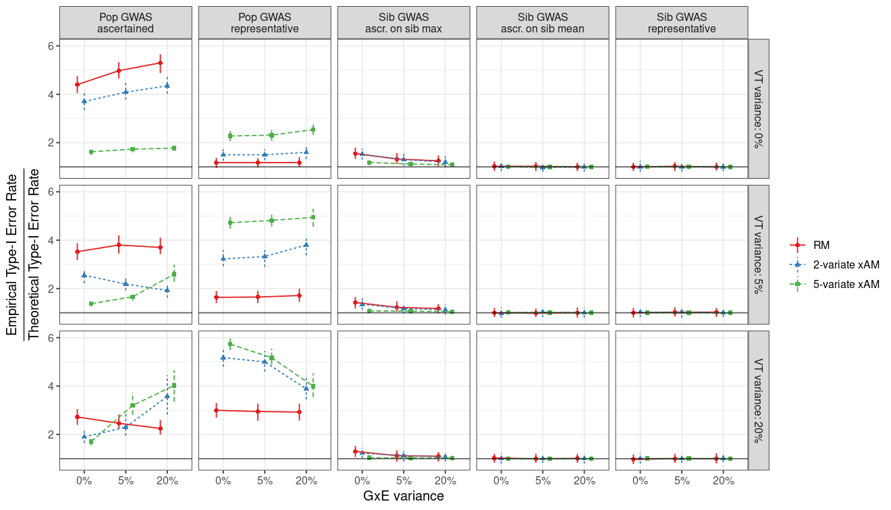

Figure S13. Relative inflation of empirical to nominal type-I error rates at nominal significance for within-sibship and population-based GWAS in representative samples versus ascertained samples where higher values are preferentially included. Simulations reflect varying mating regimes (random [RM] versus 2- and 5-variate cross-trait assortative mating [xAM] with exchangeable cross-mate cross-trait correlations of 0.2) across architectures with or without gene-environment interactions (G×E) and/or vertical transmission (VT), all in the absence of pleiotropy. When present, G×E and VT account for 5% or 20% of the total phenotypic variance at generation zero. In the case representative sampling, the within-sibship design mitigates the false positive rate inflation seen in population-based GWAS. Ascertainment is with respect to the sum of the 2 or 5 phenotypes (observations below the median value are discarded). Whereas ascertaining on sibling mean (i.e., the cross-sibling mean of these values) maintains this pattern, ascertaining on sibling maxima induces inflation and the extent of this inflation varies as a complex function of mating regime and the strength of G×E and VT effects.

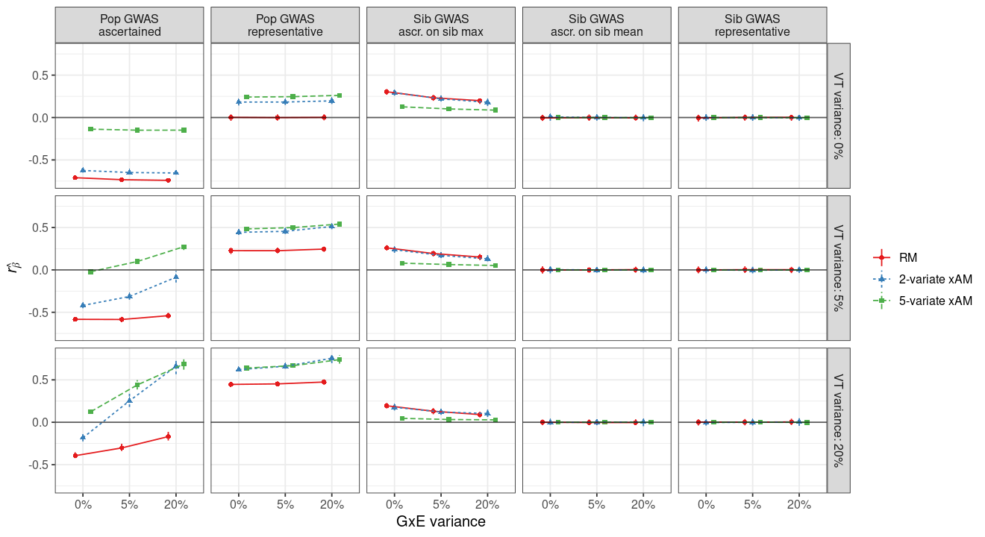

Figure S14. Correlation between within-sibship and population GWAS slope estimates in representative samples versus ascertained samples where higher values are preferentially included. Simulations reflect varying mating regimes (random [RM] versus 2- and 5-variate cross-trait assortative mating [xAM] with exchangeable cross-mate cross-trait correlations of 0.2) across architectures with or without gene-environment interactions (G×E) and/or vertical transmission (VT), all in the absence of pleiotropy (i.e., the true correlation slope correlation is zero). When present, G×E and VT account for 5% or 20% of the total phenotypic variance at generation zero. In the case of representative sampling, the within-sibship design mitigates the bias observed in population-based GWAS. Ascertainment is with respect to the sum of the 2 or 5 phenotypes (observations below the median value are discarded). Whereas ascertaining on sibling mean (i.e., the cross-sibling mean of these values) maintains this pattern, ascertaining on sibling maxima induces inflation and the extent of this inflation varies as a complex function of mating regime and the strength of G×E and VT effects.

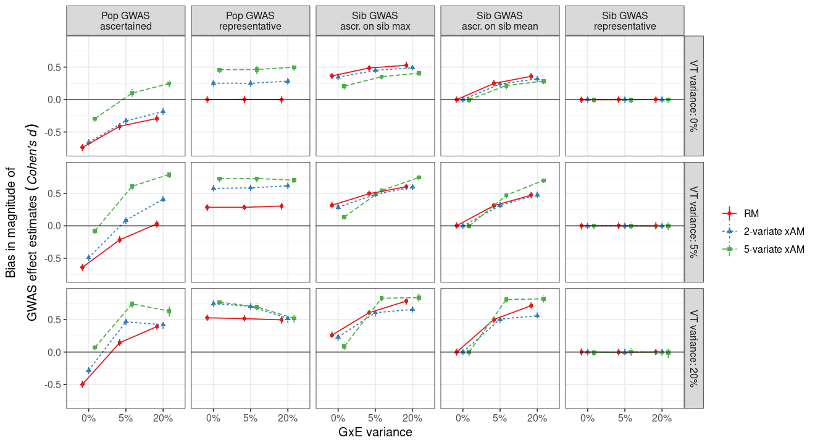

Figure S15. Bias in magnitude of estimated GWAS slopes for within-sibship and population-based GWAS in representative samples versus ascertained samples where higher values are preferentially included (observations below the median value are discarded). Bias is quantified using Cohen’s d. Simulations reflect varying mating regimes (random [RM] versus 2- and 5-variate cross-trait assortative mating [xAM] with exchangeable cross-mate cross-trait correlations of 0.2) across architectures with or without gene-environment interactions (G×E) and/or vertical transmission (VT), all in the absence of pleiotropy. When present, G×E and VT account for 5% or 20% of the total phenotypic variance at generation zero. In contrast to false positive rate inflation (Figure S13) and effect estimate correlations (Figure S14), both mean- and max-based ascertainment can induce artifacts in within-sibship GWAS.

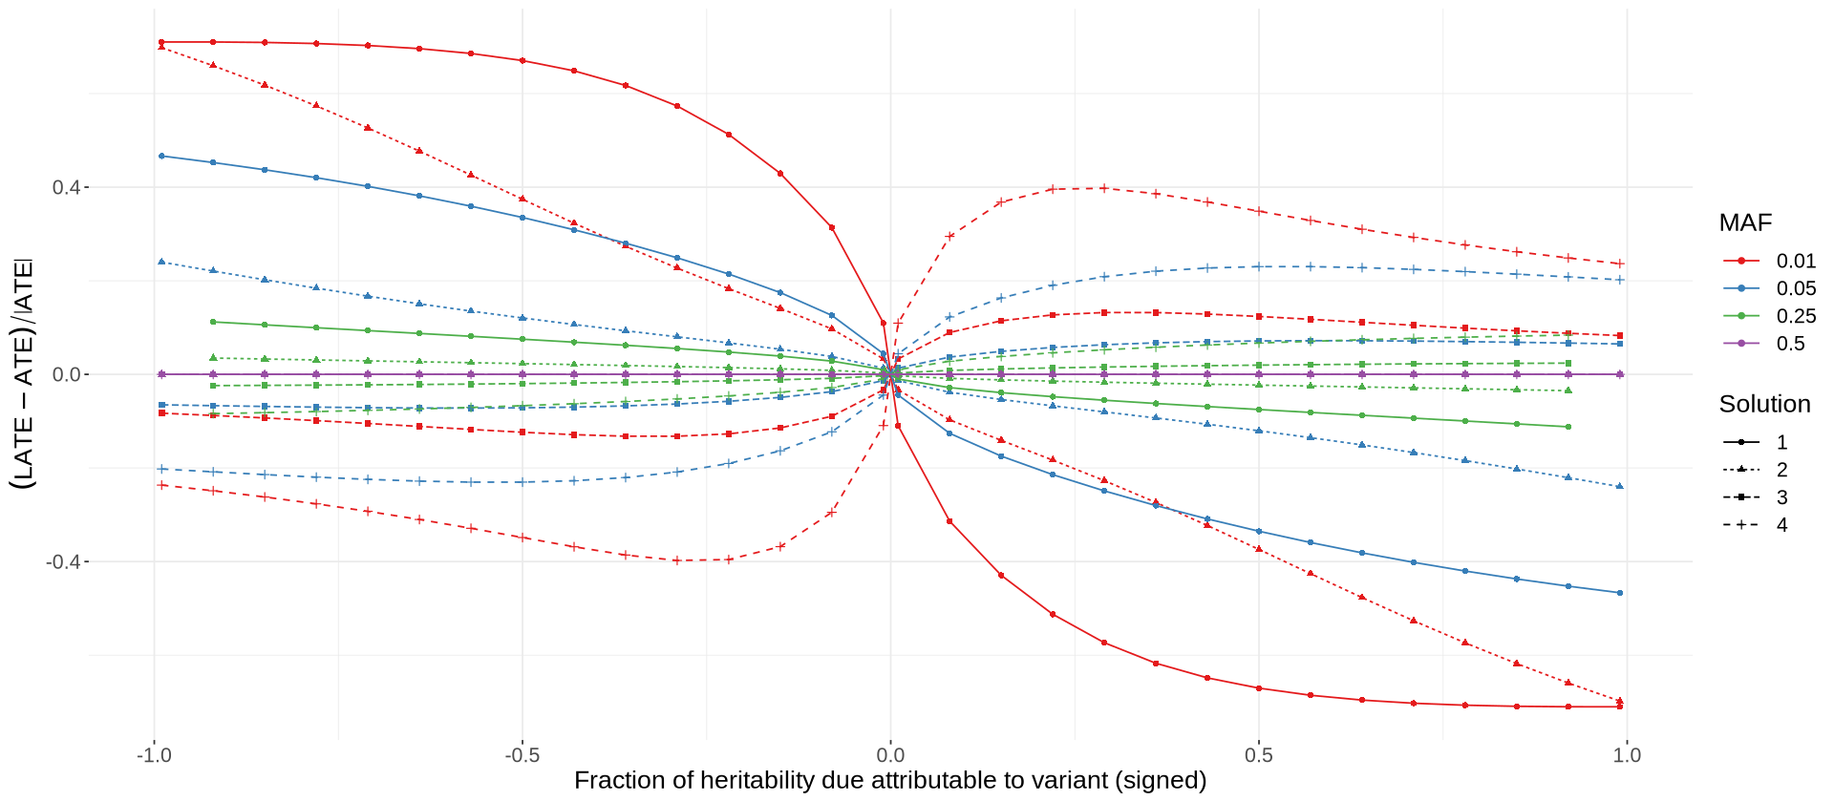

Figure S16. Relative difference between the local average treatment effect (LATE) for children of heterozygous parents and average treatment effect (ATE) of a single variant as a function of the fraction of heritability it accounts for, signed according to effect direction, for varying minor allele frequencies (MAF). Whereas the ATE reflects the average causal effect in the entire population, the LATE reflects that among individuals with one or more heterozygous parents at a given locus. Sibling-difference GWAS estimates the LATE as doubly-homozygous parents produce offspring with identical genotypes at the corresponding locus. In all cases, the total additive genetic, random noise, vertical transmission, and G×E variance components are respectively fixed to 0.5, 0.3, 0.1, and 0.1. For each MAF-effect combination, variance components alone do not uniquely determine a linear vertical transmission + G×E generative model, and instead correspond to four possible parametrizations, counting multiplicities. Points reflect numeric solutions obtained using a computer algebra system; missing values are an artifact of numerical instabilities at particular combinations of parameters.

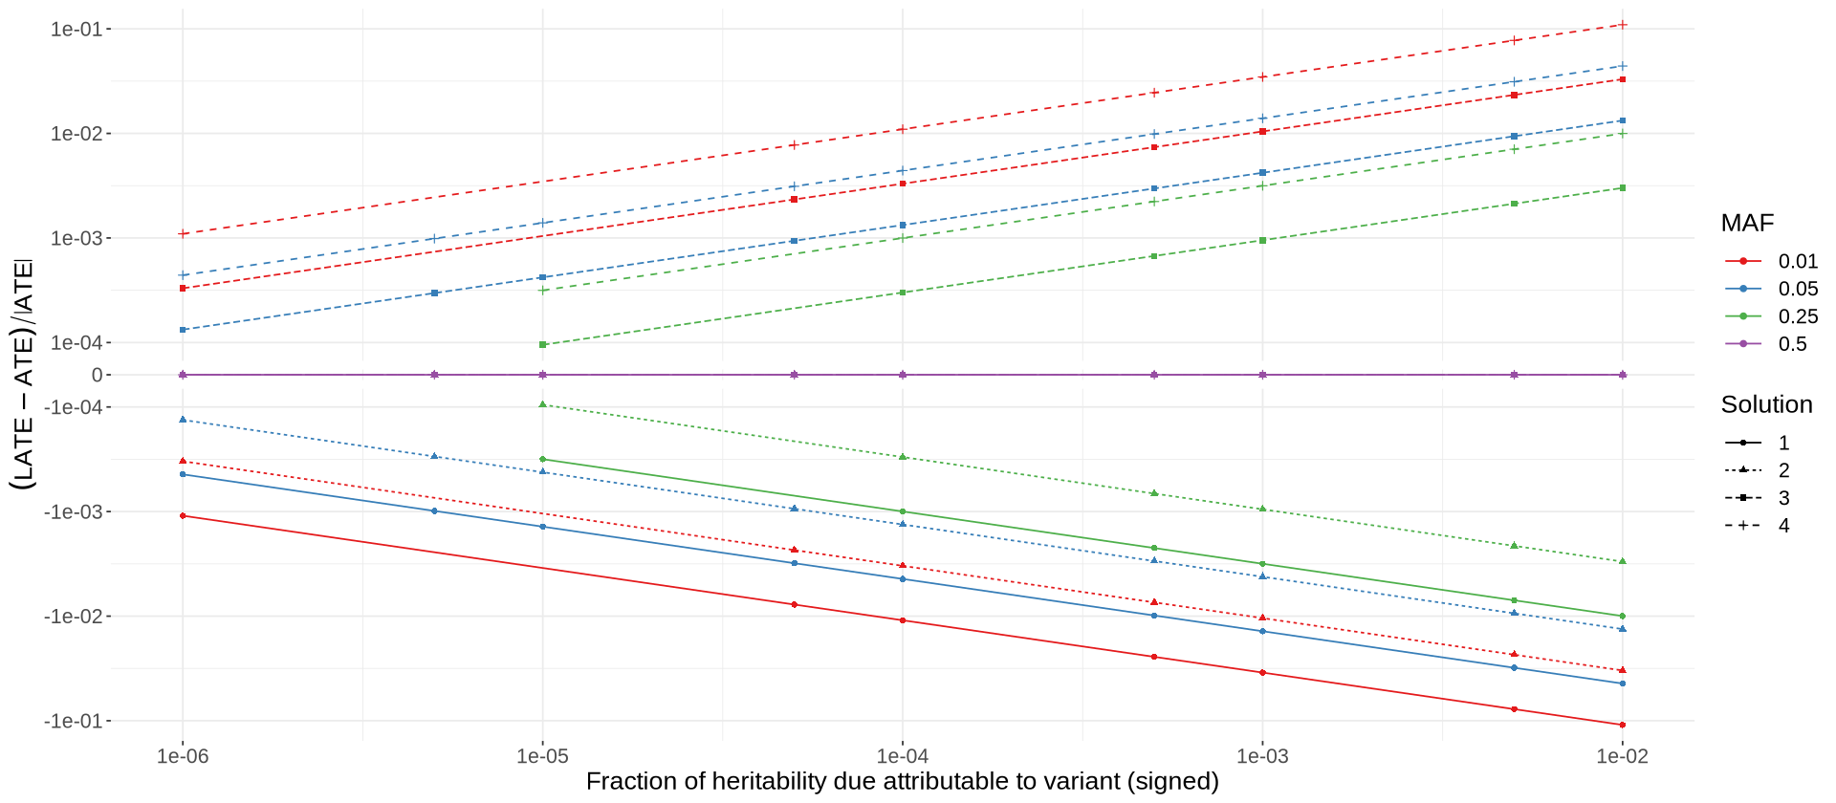

Figure S17. Relative difference between the local average treatment effect (LATE) for children of heterozygous parents and average treatment effect (ATE) of a single variant as a function of the fraction of heritability it accounts for, signed according to effect direction, for varying minor allele frequencies (MAF), on a pseudo-log₁₀ scale. Whereas the ATE reflects the average causal effect in the entire population, the LATE reflect that among individuals with one or more heterozygous parents at a given locus. Sibling-difference GWAS estimates the LATE as doubly-homozygous parents produce offspring with identical genotypes at the corresponding locus. In all cases, the total additive genetic, random noise, vertical transmission, and G×E variance components are respectively fixed to 0.5, 0.3, 0.1, and 0.1. For each MAF-effect combination, variance components alone do not uniquely determine a linear vertical transmission + G×E generative model, and instead correspond to four possible parametrizations, counting multiplicities. Points reflect numeric solutions obtained using a computer algebra system; missing values are an artifact of numerical instabilities at particular combinations of parameters.
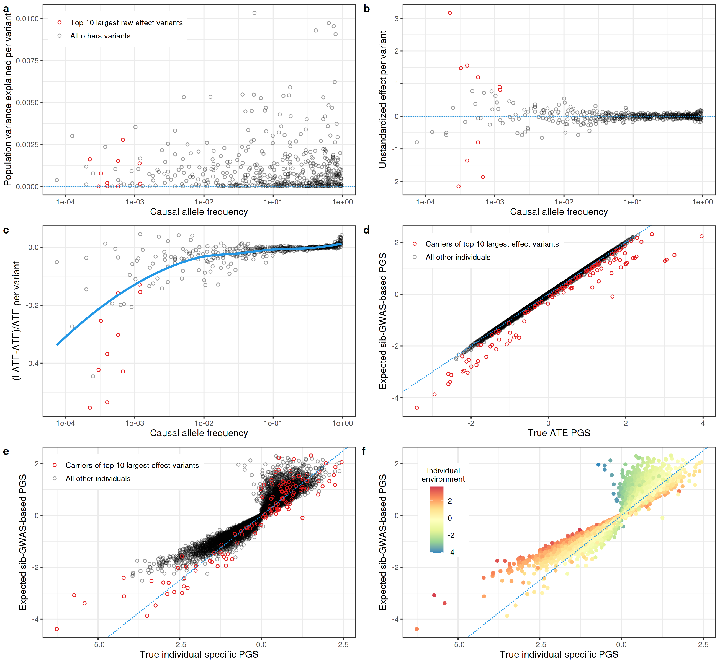

Figure S18. Vertical transmission and G×E induced bias of sibling-difference GWAS-derived PGI for carriers of large-effect variants when rare variants tend to have deleterious effects (see Online Methods for details of generative model). Despite (a) explaining little phenotypic variance in the population, (b) the top ten largest unstandardized effect variants (c) have substantially different sibling-GWAS estimated effects (the local average treatment effect [LATE] for individuals with one or more heterozygous parents) versus average treatment effects (ATE) in the population. As a result, (d) sibling-difference GWAS derived PGI for carriers of these rare large-effect variants yield substantially different values from PGI constructed using true ATE values. However, neither ATE- or LATE-based PGI fully characterize individual genetic liability in the presence of G×E (i.e., within individual-specific environmental contexts). Though not specific to family-based GWAS methods and (e) separate from the phenomenon inducing discrepancies among LATE- versus ATE- based PGI for carriers of large effect variants, (f) all additive PGI to account for individual environmental context and yield compromised estimates for individuals at environmental extremes.

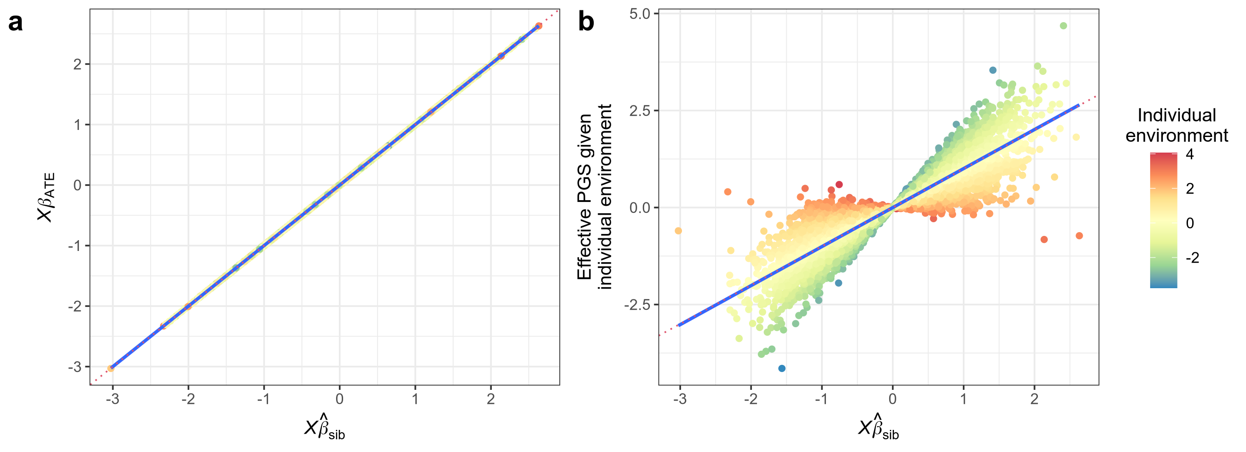

Figure S19. Individuals’ true average treatment effect (ATE) PGI (${Xβ}_{ATE}≔E[Xβ|E=\overline{E}]$), which averages across environments, versus true individual-specific PGI (i.e., in the context of individual-specific environments), as a function of sibling-difference GWAS derived PGI, in the presence of G×E. In all cases, the total additive genetic, random noise, and G×E variance components are respectively fixed to 0.5, 0.4, and 0.1 (See Online Methods for generative model). In this setting (which notably lacks variants of large effect), despite the fact that individual effect estimates differ from true ATEs (Supplemental Figures S16-S17), these differences average out across the genome and (a) sibling-difference GWAS based PGI provide unbiased estimates of individuals’ ATE-based PGI. (b) On the other hand, unbiased ATE-based PGI will still yield misleading predictions under G×E for individuals in extreme environments (here colored in terms of standard deviations from the population mean). This phenomenon is not unique to sibling-difference GWAS and will affect all polygenic predictors that do not account for individual environment.

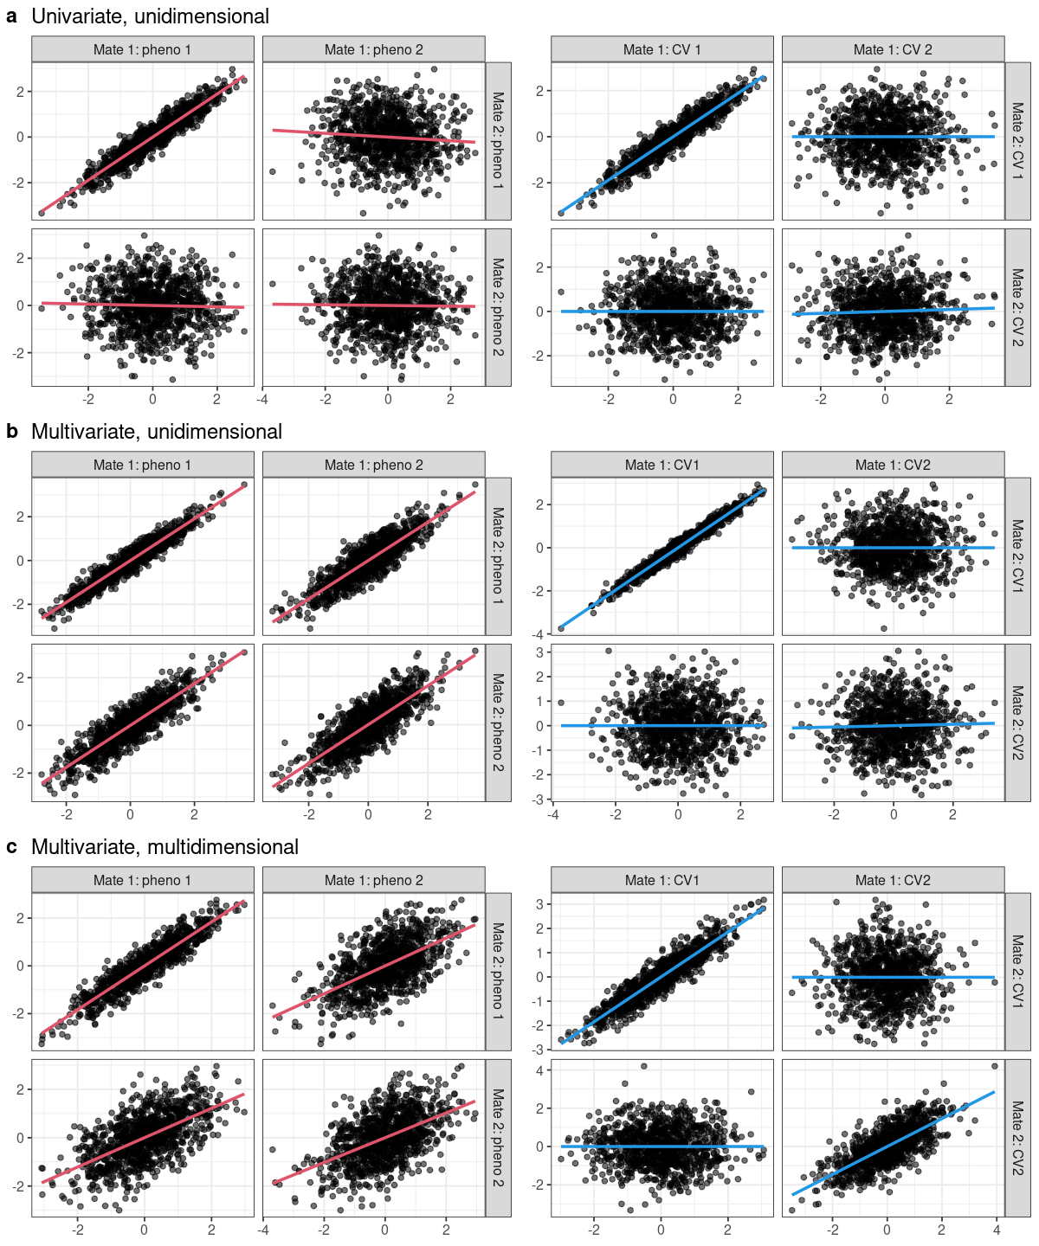

Figure S20. Multivariate versus multidimensional linear mating regimes. Each pane features cross-mate pair plots synthetic phenotypes (left) and corresponding canonical variates (CVs, right) with ordinary least squares best fit lines. (a) A univariate, unidimensional mating regime: mates are similar only on phenotype 1, and the first CV captures this covariance. (b) A multivariate, unidimensional mating regime: though mates are similar with respect to multiple phenotypes, this similarity is captured by a single CV. (b) A multivariate, multidimensional mating regime: mates are similar with respect to multiple phenotypes and multiple CVs are required to account for their similarity.

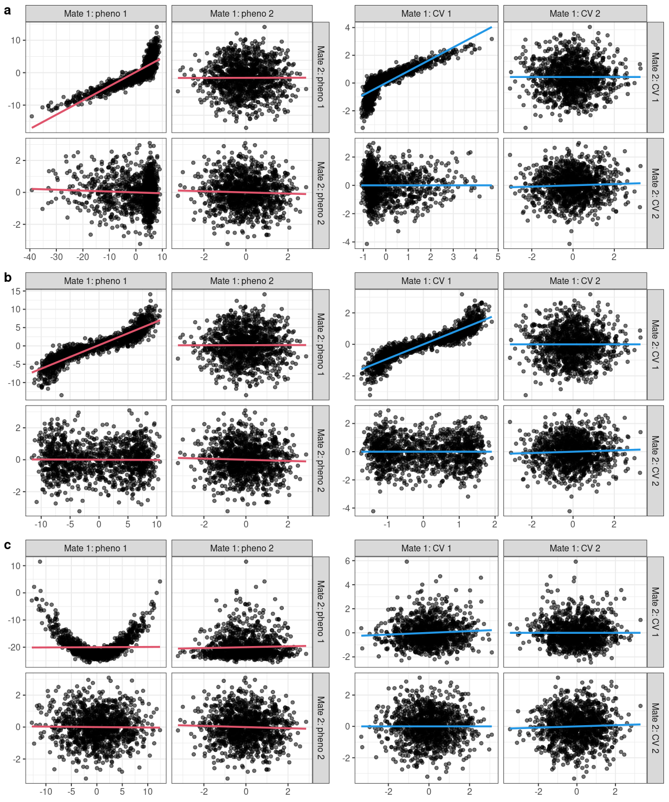
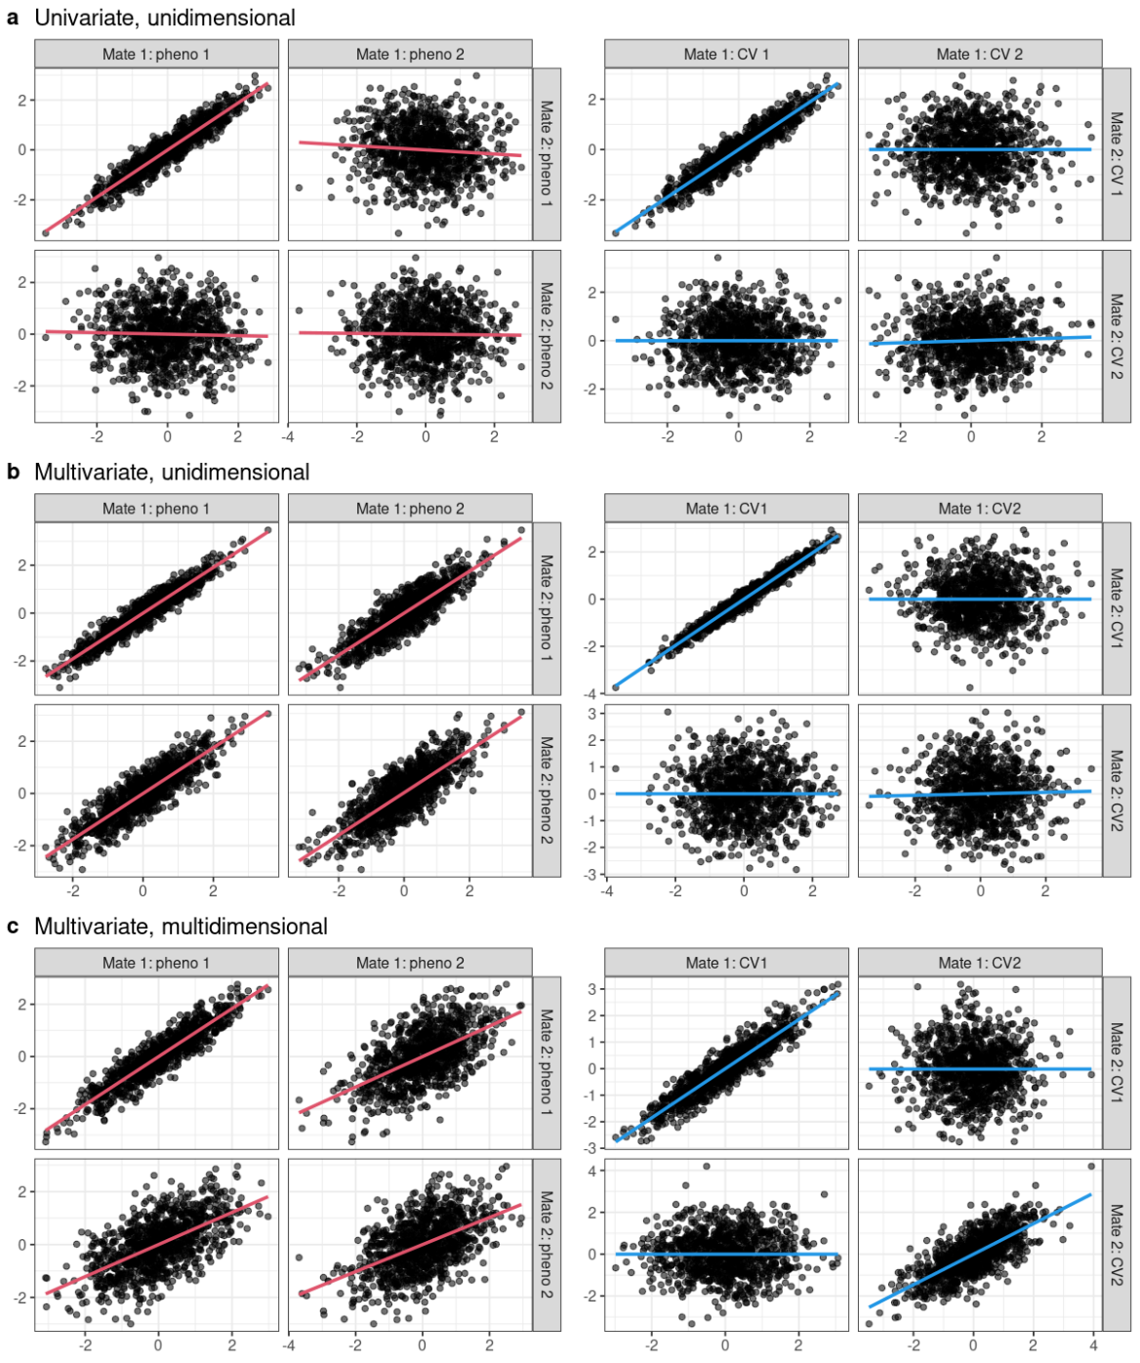
Figure S21. Canonical correlation analysis of univariate nonlinear mating regimes. Each pane features cross-mate pair plots synthetic phenotypes (left) and corresponding canonical variates (CVs, right) with ordinary least squares best fit lines. One mate’s phenotype is a (a) piece-wise linear, (b) inverse tangent, or (c) quadratic transformation of the other’s. These simple transformations fail to increase the apparent dimensionality: the monotonic transformations (a/b) are largely captured by a single CV and the non-monotonic transformation is not captured at all.

Figure S22. Genetic correlation estimates under unidimensional xAM with fixed latent correlation. Estimated genetic correlations across generations under constant-entry xAM models with approximately equal latent correlations (~0.5) distributed across varying numbers of traits: 2 traits at r=0.25 (2xAM.25; latent r = 0.50), 3 traits at r=0.167 (3xAM.167; latent r = 0.50), 4 traits at r=0.125 (4xAM.125; latent r = 0.50), and 5 traits at r=0.1 (5xAM.1; latent r = 0.50). All scenarios are unidimensional, with cross-mate similarity arising from sorting on a single standardized trait sum. At generation 5, genetic correlation estimates were 0.27, 0.19, 0.15, and 0.12, respectively. Interestingly, even with fixed latent correlation, the ratio of the genetic correlation estimate to the per-trait cross-mate correlation increases as assortment is distributed across more traits. Error bars represent standard deviations across simulation replicates. All simulations assume panmictic heritability of 0.5, orthogonal genetic effects (zero pleiotropy), and no vertical transmission.

Figure S21. Genetic correlation estimates under xAM with cross-mate correlations of 0.1 versus 0.2. Estimated genetic correlations across generations under 5-trait constant-entry xAM with pairwise cross-mate correlations of 0.1 (latent r = 0.5) or 0.2 (latent r = 1.0), with and without vertical transmission (VT) accounting for 5% of phenotypic variance. Under xAM alone, halving pairwise correlations approximately halves bias at generation 5 (rg = 0.12 at r=0.1 versus rg = 0.30 at r=0.2). However, with VT, even r=0.1 produces substantial bias: genetic correlation estimates reach 0.37 when the true value is zero, compared to 0.56 at r=0.2. These results demonstrate that (1) our core findings are not artifacts of the boundary case at r=0.2, and (2) vertical transmission amplifies xAM-induced biases across a range of cross-mate correlation strengths. Error bars represent standard deviations across simulation replicates. All simulations assume panmictic heritability of 0.5 and orthogonal genetic effects (zero pleiotropy).

Figure S21. Sensitivity of genetic correlation estimates to within-person noise correlations. Estimated genetic correlations across generations under 5-trait xAM (r=0.1) with and without vertical transmission (VT, 5%), comparing uncorrelated noise at generation 0 (CN = 0) to within-person noise correlations of 0.1 (CN = 0.1) and 0.2 (CN = 0.2). Under xAM alone, correlated noise substantially attenuates bias: at generation 5, estimates decrease from 0.12 (CN = 0) to 0.08 (CN = 0.1; 33% reduction) and 0.06 (CN = 0.2; 54% reduction). However, under xAM combined with VT, correlated noise has more limited effects: estimates decrease from 0.37 (CN = 0) to 0.34 (CN = 0.1; 7% reduction) and 0.32 (CN = 0.2; 12% reduction). The bias remains substantial under the more realistic xAM + VT scenario, with genetic correlation estimates of 0.32 when the true value is zero. This differential effect likely reflects the distinct bias mechanisms: under xAM alone, correlated noise dilutes the phenotypic signal for mate selection; under xAM + VT, bias additionally arises from confounding between genetic and environmental transmission pathways. Error bars represent standard deviations across simulation replicates.

Supplementary Tables

Table S1. Phenotype definitions. Across all phenotypes examined, we relied on a number of procedures to account for repeated measurements and/or missing data in the UK Biobank. We denote UK Biobank fields using the f.<field>.<instance>.<index> identifiers provided with the data. For example, f.709.0.0 through f.709.3.0 indicates each of the four possible times participants were asked about household size. Depending on the field, we either used the earliest available measurement, which we denote f.<field>.E.<index>, or the average measurements, which we denote f.<field>.A.<index>. We omit the index number when only one item is available, as is the case for many of the phenotypes, and use an asterisk when responses are array-valued.

Table S2. Cross-mate canonical correlation analysis results. Rows correspond to canonical variates. Columns include sex-specific canonical variate adequacies, canonical redundancies, and phenotype loadings (i.e., structural correlations).

Table S3. Cross-mate correlation estimates for UK Biobank phenotypes. For each trait pair, we provide sex-specific within individual and cross-mate Pearson and Spearman correlation estimates and corresponding standard errors.

Table S4. Cross-mate correlation estimates for Taiwan NHIRD phenotypes. For each trait pair, we provide sex-specific within individual and cross-mate Pearson correlation estimates and corresponding standard errors.

Scenario | Generation | $$h^{2}$$ | $${\hat{h}}^{2}$$ | $${\hat{h}}^{2}-h^{2}$$ | $$r_{score}$$ | $${\hat{r}}_{β}$$ | $${\hat{r}}_{β}-r_{score}$$
RM | 0 | 0.500 | 0.500 | 0.000 | 0.000 | 0.000 | 0.000
 | 5 | 0.500 | 0.500 | 0.000 | 0.000 | 0.000 | -0.001
RM + VT (5%) | 0 | 0.500 | 0.500 | 0.000 | 0.000 | 0.000 | 0.000
 | 5 | 0.442 | 0.552 | 0.110 | 0.000 | 0.199 | 0.199
2xAM | 0 | 0.499 | 0.499 | 0.000 | 0.000 | 0.000 | 0.000
 | 5 | 0.527 | 0.597 | 0.069 | 0.107 | 0.212 | 0.105
5xAM | 0 | 0.500 | 0.500 | 0.000 | 0.000 | 0.000 | 0.000
 | 5 | 0.535 | 0.658 | 0.124 | 0.132 | 0.296 | 0.164
5xAM + G×E (5%) | 0 | 0.502 | 0.502 | 0.000 | 0.000 | 0.000 | 0.000
 | 5 | 0.534 | 0.658 | 0.124 | 0.133 | 0.297 | 0.165
5xAM + G×E (20%) | 0 | 0.543 | 0.543 | 0.000 | 0.000 | 0.000 | 0.000
 | 5 | 0.570 | 0.714 | 0.145 | 0.141 | 0.317 | 0.175
5xAM + VT (5%) | 0 | 0.500 | 0.500 | 0.000 | 0.000 | 0.000 | 0.000
 | 5 | 0.396 | 0.749 | 0.353 | 0.078 | 0.513 | 0.435
5xAM + VT (5%) + G×E (5%) | 0 | 0.499 | 0.500 | 0.000 | 0.000 | 0.000 | 0.000
 | 5 | 0.371 | 0.723 | 0.352 | 0.073 | 0.525 | 0.452
5xAM + VT (5%) + G×E (20%) | 0 | 0.535 | 0.535 | 0.000 | 0.000 | 0.000 | 0.000
 | 5 | 0.297 | 0.627 | 0.330 | 0.060 | 0.555 | 0.495
5xAM + VT (20%) | 0 | 0.500 | 0.499 | 0.000 | 0.000 | 0.000 | 0.000
 | 5 | 0.247 | 0.650 | 0.403 | 0.034 | 0.634 | 0.600
5xAM + VT (20%) + G×E (5%) | 0 | 0.488 | 0.488 | 0.000 | 0.000 | 0.000 | 0.000
 | 5 | 0.164 | 0.459 | 0.295 | 0.029 | 0.653 | 0.624
5xAM + VT (20%) + G×E (20%) | 0 | 0.500 | 0.500 | 0.000 | 0.000 | 0.000 | 0.000
 | 5 | 0.064 | 0.195 | 0.130 | 0.020 | 0.677 | 0.658

Table S5. Median true and estimated variance components before and after five generations under random mating (RM), bivariate cross-trait assortative mating (2xAM), or 5-variate xAM (5xAM), with or without multivariate vertical transmission (VT) and/or gene-environment interactions (G×E) accounting for 5% or 20% percent of phenotypic variation at generation zero. When present, xAM is such that the cross-mate cross-correlations are 0.20 across all phenotype pairs. All phenotypes have additive genetic heritabilities of 0.50 at generation zero and orthogonal genetic effects.
 | Simulation | $$K$$ | $$r$$ | $$σ_{g}^{2}$$ | $$σ_{ε}^{2}$$ | $$θ$$ | $$ϕ$$
 |  | num. traits | x-mate corr. | additive var. | noise var. | VT var. | G×E var.
 | 2xAM* | 2 | 0.2 | 50% | 50% | 0% | 0%
 | 5xAM*† | 5 | 0.2 | 50% | 50% | 0% | 0%
 | RM† | 5 | 0.0 | 50% | 45% | 5% | 0%
 | RM + VT† | 5 | 0.0 | 50% | 45% | 5% | 0%
 | 5xAM + VT†⁑ | 5 | 0.2 | 50% | 45% | 5% | 0%
 | 5xAM + G×E†‡⁑ | 5 | 0.2 | 50% | 45% | 0% | 5%
 | 5xAM + VT + G×E†‡ | 5 | 0.2 | 50% | 40% | 5% | 5%
 | 5xAM + VT (20%)⁑ | 5 | 0.2 | 50% | 30% | 20% | 0%
 | 5xAM + G×E (20%)⁑ | 5 | 0.2 | 50% | 30% | 0% | 20%
 | 5xAM + VT (5%) + G×E (20%)⁑ | 5 | 0.2 | 50% | 25% | 5% | 20%
 | 5xAM + VT (20%) + G×E (5%)⁑ | 5 | 0.2 | 50% | 25% | 20% | 5%
 | 5xAM + VT (20%) + G×E (20%)⁑ | 5 | 0.2 | 50% | 10% | 20% | 20%

Table S6. Phenotype-agnostic simulation model parameters. “2xAM”=bivariate cross-trait assortative mating, “5xAM”=5-variate cross-trait assortative mating, “RM”=random mating, “VT”=vertical transmission, “G×E”=gene-environment interaction, “num.”=number, “x-mate corr.”=cross-mate correlation, “var.”=variance. *See Figures 1c – 1e. †See Figure 3. ⁑See Supplemental Figures S8-S10. ‡See Supplemental Figures S12-S15.

