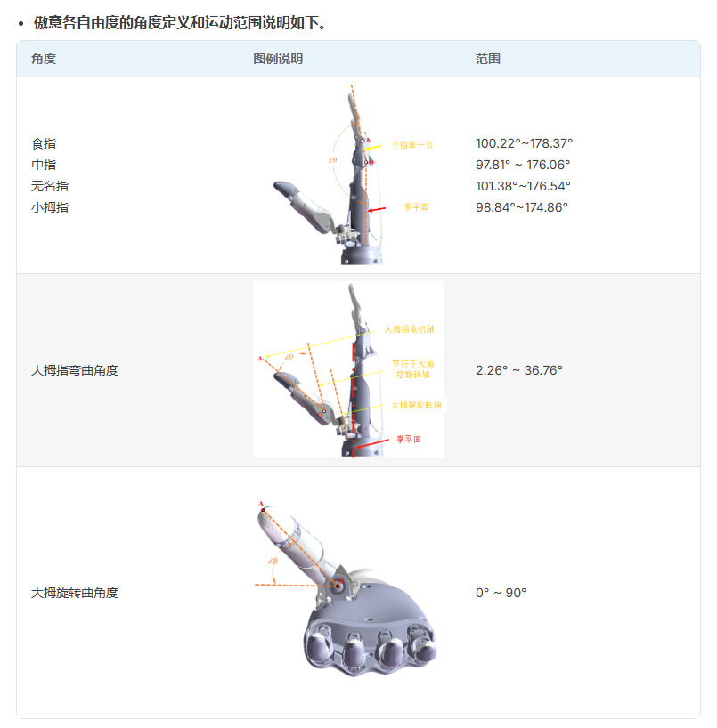

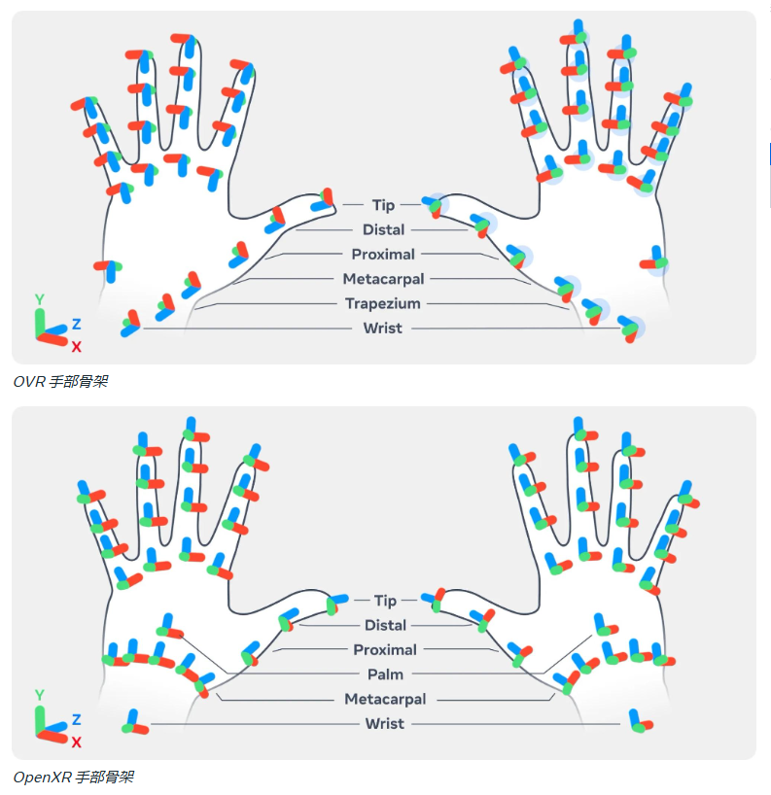

采用OpenXR手部骨架是新的，OVR是旧的。

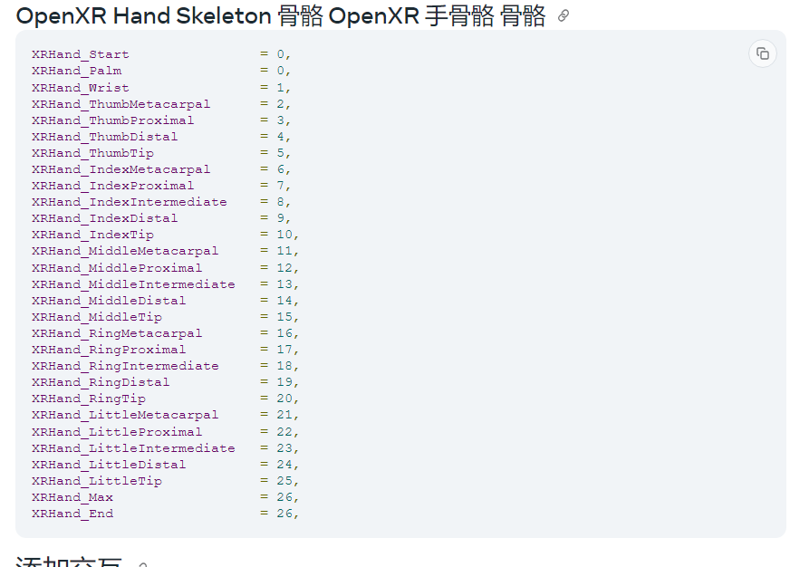

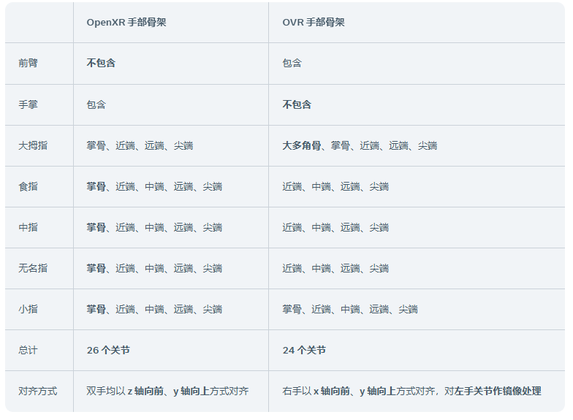

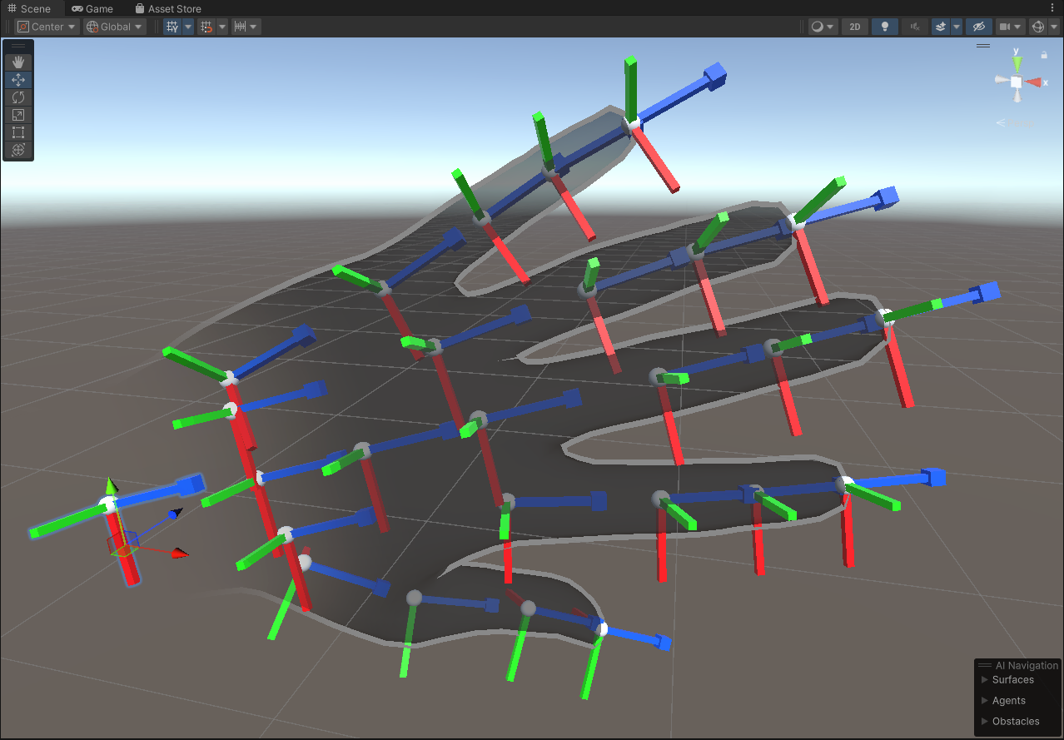

真正提取出的[84,7]矩阵手腕和手掌坐标系方向定义

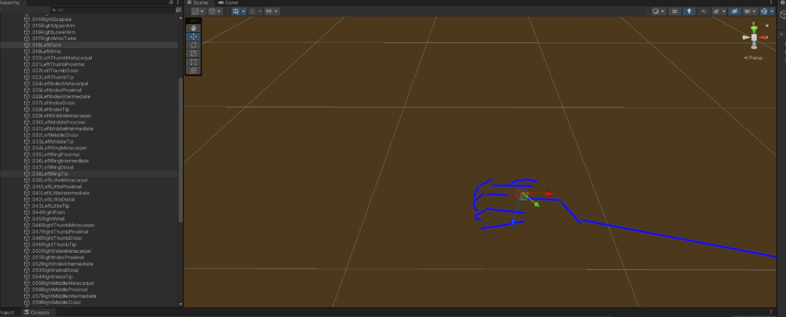

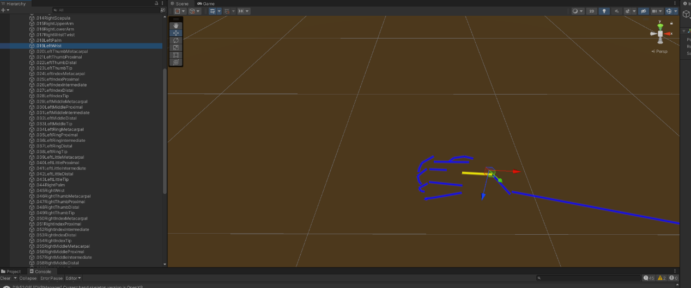

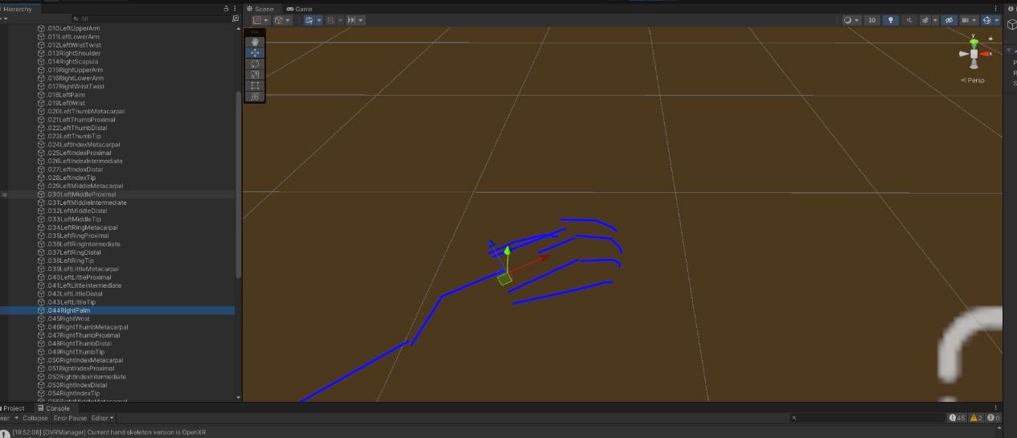

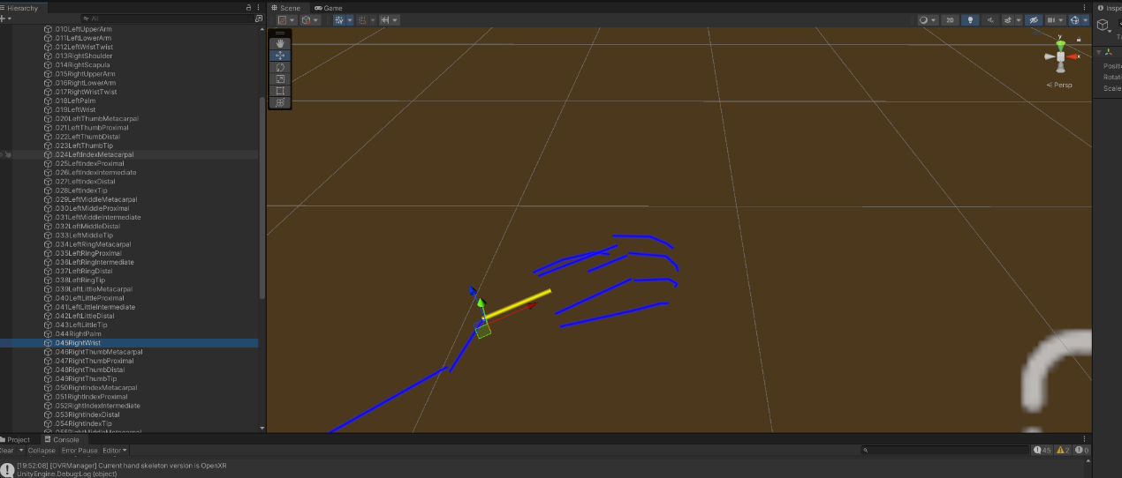

MANO模型关键点定义

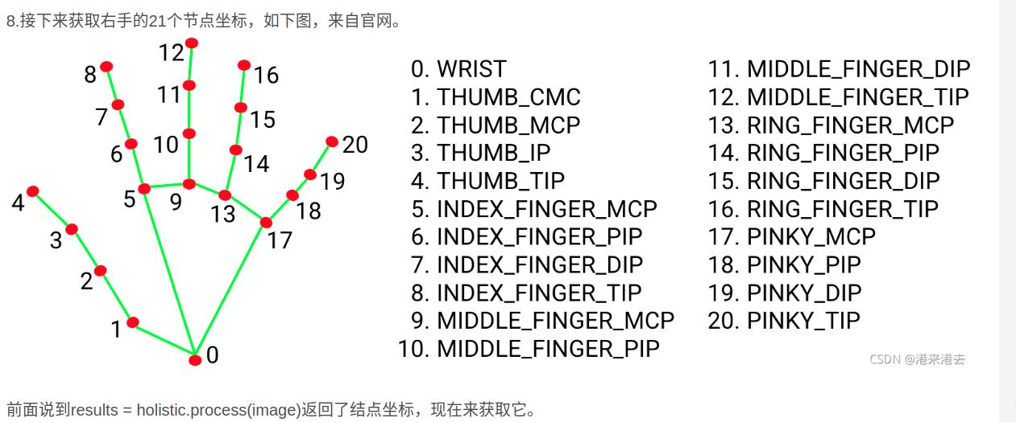

导出的Body关节定义，用从0(root)到83。左手为18-43，右手为44-69

public enum *BodyJointId*

{

    Invalid = -1,

    [InspectorName("Body Start")]

    Body_Start = 0,

    [InspectorName("Root")]

    Body_Root = 0,

    [InspectorName("Hips")]

    Body_Hips = 1,

    [InspectorName("Spine Lower")]

    Body_SpineLower = 2,

    [InspectorName("Spine Middle")]

    Body_SpineMiddle = 3,

    [InspectorName("Spine Upper")]

    Body_SpineUpper = 4,

    [InspectorName("Chest")]

    Body_Chest = 5,

    [InspectorName("Neck")]

    Body_Neck = 6,

    [InspectorName("Head")]

    Body_Head = 7,

    [InspectorName("Left Arm/Left Shoulder")]

    Body_LeftShoulder = 8,

    [InspectorName("Left Arm/Left Scapula")]

    Body_LeftScapula = 9,

    [InspectorName("Left Arm/Left Arm Upper")]

    Body_LeftArmUpper = 10,

    [InspectorName("Left Arm/Left Arm Lower")]

    Body_LeftArmLower = 11,

    [InspectorName("Left Arm/Left Hand Wrist Twist")]

    Body_LeftHandWristTwist = 12,

    [InspectorName("Right Arm/Right Shoulder")]

    Body_RightShoulder = 13,

    [InspectorName("Right Arm/Right Scapula")]

    Body_RightScapula = 14,

    [InspectorName("Right Arm/Right Arm Upper")]

    Body_RightArmUpper = 15,

    [InspectorName("Right Arm/Right Arm Lower")]

    Body_RightArmLower = 16,

    [InspectorName("Right Arm/Right Hand Wrist Twist")]

    Body_RightHandWristTwist = 17,

    [InspectorName("Left Hand/Left Hand Palm")]

    Body_LeftHandPalm = 18,0

    [InspectorName("Left Hand/Left Hand Wrist")]

    Body_LeftHandWrist = 19,1

    [InspectorName("Left Hand/Left Hand Thumb Metacarpal")]

    Body_LeftHandThumbMetacarpal = 20,2

    [InspectorName("Left Hand/Left Hand Thumb Proximal")]

    Body_LeftHandThumbProximal = 21,3

    [InspectorName("Left Hand/Left Hand Thumb Distal")]

    Body_LeftHandThumbDistal = 22,4

    [InspectorName("Left Hand/Left Hand Thumb Tip")]

    Body_LeftHandThumbTip = 23,5

    [InspectorName("Left Hand/Left Hand Index Metacarpal")]

    Body_LeftHandIndexMetacarpal = 24,6

    [InspectorName("Left Hand/Left Hand Index Proximal")]

    Body_LeftHandIndexProximal = 25,7

    [InspectorName("Left Hand/Left Hand Index Intermediate")]

    Body_LeftHandIndexIntermediate = 26,8

    [InspectorName("Left Hand/Left Hand Index Distal")]

    Body_LeftHandIndexDistal = 27,9

    [InspectorName("Left Hand/Left Hand Index Tip")]

    Body_LeftHandIndexTip = 28,10

    [InspectorName("Left Hand/Left Hand Middle Metacarpal")]

    Body_LeftHandMiddleMetacarpal = 29,11

    [InspectorName("Left Hand/Left Hand Middle Proximal")]

    Body_LeftHandMiddleProximal = 30,12

    [InspectorName("Left Hand/Left Hand Middle Intermediate")]

    Body_LeftHandMiddleIntermediate = 31,13

    [InspectorName("Left Hand/Left Hand Middle Distal")]

    Body_LeftHandMiddleDistal = 32,14

    [InspectorName("Left Hand/Left Hand Middle Tip")]

    Body_LeftHandMiddleTip = 33,15

    [InspectorName("Left Hand/Left Hand Ring Metacarpal")]

    Body_LeftHandRingMetacarpal = 34,16

    [InspectorName("Left Hand/Left Hand Ring Proximal")]

    Body_LeftHandRingProximal = 35,17

    [InspectorName("Left Hand/Left Hand Ring Intermediate")]

    Body_LeftHandRingIntermediate = 36,18

    [InspectorName("Left Hand/Left Hand Ring Distal")]

    Body_LeftHandRingDistal = 37,19

    [InspectorName("Left Hand/Left Hand Ring Tip")]

    Body_LeftHandRingTip = 38,20

    [InspectorName("Left Hand/Left Hand Little Metacarpal")]

    Body_LeftHandLittleMetacarpal = 39,21

    [InspectorName("Left Hand/Left Hand Little Proximal")]

    Body_LeftHandLittleProximal = 40,22

    [InspectorName("Left Hand/Left Hand Little Intermediate")]

    Body_LeftHandLittleIntermediate = 41,23

    [InspectorName("Left Hand/Left Hand Little Distal")]

    Body_LeftHandLittleDistal = 42,24

    [InspectorName("Left Hand/Left Hand Little Tip")]

    Body_LeftHandLittleTip = 43,25

    [InspectorName("Right Hand/Right Hand Palm")]

    Body_RightHandPalm = 44,0

    [InspectorName("Right Hand/Right Hand Wrist")]

    Body_RightHandWrist = 45,1

    [InspectorName("Right Hand/Right Hand Thumb Metacarpal")]

    Body_RightHandThumbMetacarpal = 46,2

    [InspectorName("Right Hand/Right Hand Thumb Proximal")]

    Body_RightHandThumbProximal = 47,3

    [InspectorName("Right Hand/Right Hand Thumb Distal")]

    Body_RightHandThumbDistal = 48,4

    [InspectorName("Right Hand/Right Hand Thumb Tip")]

    Body_RightHandThumbTip = 49,5

    [InspectorName("Right Hand/Right Hand Index Metacarpal")]

    Body_RightHandIndexMetacarpal = 50,6

    [InspectorName("Right Hand/Right Hand Index Proximal")]

    Body_RightHandIndexProximal = 51,7

    [InspectorName("Right Hand/Right Hand Index Intermediate")]

    Body_RightHandIndexIntermediate = 52,8

    [InspectorName("Right Hand/Right Hand Index Distal")]

    Body_RightHandIndexDistal = 53,9

    [InspectorName("Right Hand/Right Hand Index Tip")]

    Body_RightHandIndexTip = 54,10

    [InspectorName("Right Hand/Right Hand Middle Metacarpal")]

    Body_RightHandMiddleMetacarpal = 55,11

    [InspectorName("Right Hand/Right Hand Middle Proximal")]

    Body_RightHandMiddleProximal = 56,12

    [InspectorName("Right Hand/Right Hand Middle Intermediate")]

    Body_RightHandMiddleIntermediate = 57,13

    [InspectorName("Right Hand/Right Hand Middle Distal")]

    Body_RightHandMiddleDistal = 58,14

    [InspectorName("Right Hand/Right Hand Middle Tip")]

    Body_RightHandMiddleTip = 59,15

    [InspectorName("Right Hand/Right Hand Ring Metacarpal")]

    Body_RightHandRingMetacarpal = 60,16

    [InspectorName("Right Hand/Right Hand Ring Proximal")]

    Body_RightHandRingProximal = 61,17

    [InspectorName("Right Hand/Right Hand Ring Intermediate")]

    Body_RightHandRingIntermediate = 62,18

    [InspectorName("Right Hand/Right Hand Ring Distal")]

    Body_RightHandRingDistal = 63,19

    [InspectorName("Right Hand/Right Hand Ring Tip")]

    Body_RightHandRingTip = 64,20

    [InspectorName("Right Hand/Right Hand Little Metacarpal")]

    Body_RightHandLittleMetacarpal = 65,21

    [InspectorName("Right Hand/Right Hand Little Proximal")]

    Body_RightHandLittleProximal = 66,22

    [InspectorName("Right Hand/Right Hand Little Intermediate")]

    Body_RightHandLittleIntermediate = 67,23

    [InspectorName("Right Hand/Right Hand Little Distal")]

    Body_RightHandLittleDistal = 68,24

    [InspectorName("Right Hand/Right Hand Little Tip")]

    Body_RightHandLittleTip = 69,25

    [InspectorName("Left Leg/Left Leg Upper")]

    Body_LeftLegUpper = 70,

    [InspectorName("Left Leg/Left Leg Lower")]

    Body_LeftLegLower = 71,

    [InspectorName("Left Foot/Left Foot Ankle Twist")]

    Body_LeftFootAnkleTwist = 72,

    [InspectorName("Left Foot/Left Foot Ankle")]

    Body_LeftFootAnkle = 73,

    [InspectorName("Left Foot/Left Foot Subtalar")]

    Body_LeftFootSubtalar = 74,

    [InspectorName("Left Foot/Left Foot Transverse")]

    Body_LeftFootTransverse = 75,

    [InspectorName("Left Foot/Left Foot Ball")]

    Body_LeftFootBall = 76,

    [InspectorName("Right Leg/Right Leg Upper")]

    Body_RightLegUpper = 77,

    [InspectorName("Right Leg/Right Leg Lower")]

    Body_RightLegLower = 78,

    [InspectorName("Right Foot/Right Foot Ankle Twist")]

    Body_RightFootAnkleTwist = 79,

    [InspectorName("Right Foot/Right Foot Ankle")]

    Body_RightFootAnkle = 80,

    [InspectorName("Right Foot/Right Foot Subtalar")]

    Body_RightFootSubtalar = 81,

    [InspectorName("Right Foot/Right Foot Transverse")]

    Body_RightFootTransverse = 82,

    [InspectorName("Right Foot/Right Foot Ball")]

    Body_RightFootBall = 83,

    [InspectorName("Body End")]

    Body_End = 84

}

左SAPIEN 关节名: ['if_proximal_joint', 'mf_proximal_joint', 'rf_proximal_joint', 'lf_proximal_joint', 'th_root_joint', 'if_distal_joint', 'mf_distal_joint', 'rf_distal_joint', 'lf_distal_joint', 'th_proximal_joint', 'th_distal_joint']

左重定向关节名: ['if_proximal_joint', 'if_distal_joint', 'lf_proximal_joint', 'lf_distal_joint', 'mf_proximal_joint', 'mf_distal_joint', 'rf_proximal_joint', 'rf_distal_joint', 'th_root_joint', 'th_proximal_joint', 'th_distal_joint']

【0，4，6，2，8，9】

