1. INTRODUCTION

1.1Problem statement

In present, all work is done manually by hand in bulk of files which is hard to operate and to

maintain records of student. It is very slow and consuming much effort and time. Activities

like update also consume much time.when a new student arrives enrolling the details of him

will be difficult in files manually.It is not technically feasible also.

1.2 Scope of the project

- This serve to increase the problem facing enrollment that provides more easy way in enrolling.

- The information here can be viewed in just a second without worrying that a single file is lost.

- This will lessen the effort of faculty staff in storing files of students every now and then.

Feasibility study of the project

- It is economically feasible ,it will only require a single operator to operate the system ,who is responsible to enter the data into data base via an interface provided into him.

- It is technically feasible, since the whole system is designed into the latest technologies like ASP.net ,MS access.

- It is behavioral feasible as system provides a attractive user interface to the operator/end user, so he feel easy to work on it.

2. REQUIREMENT ANALYSIS

2.1 Software requirements

The software components used in our project are as under:

- Net Beans IDE 8.0

- MS access 2007

- JDK 7 or 8 is required

2.2System requirements

- Windows Platform (windows 7) .

- 1GB RAM.

- At least 5 GB HDD space FREE.

- Processor speed 1.7 Ghz or higher

3.SYSTEM ARCHITECTURE

The system is divided into two modules

3.1 Input Module

Storing the student information into Data base

Input
Interface

Input

Data
Base

New Registration

Java Application

3.2 Output Module

Finding the student information from the data base

Input/output
interface

Input

Data
Base

Java application

User information

4.DESIGN

4.1 DataBase Design

Table used

Table Name : Enrollment
(this table is used to store the details about the students)

Attribute | Type | Comment
StudentID | Varchar2 | ID of the student
StudentName | Varchar2 | Name of the student
Address | Varchar2 | Address of the Student
Department | Number | Department of the Student
SubjectID | Number | ID of the Student
SubjectName | Varchar2 | Name of the Subject
Marks | Number | Marks of the Student

4.2 System Design

This Design includes two types of diagrams.

4.2.1 ER Diagram

SNAME
SUBNAME
ADDRESS
STID
DEPT
SUBID
ENROLLMENT
STUDENT
SUBJECT

4.2.2 Class Diagram

System details

Create ()
Read ()
Update ()
Delete ()

Subject

Subject Id
Subject Name
Dept

Enrollment

Student Id
Subject Id
Marks

Student

Student Id
Student Name
Address

5.CODING

Enrollment form
It contains the information about the Student and the Subject information such as
Student details
- Student ID
- Student Name
- Address

Subject details
- Subject ID
- Subject Name
- Department
- Marks
package javaapplication5;

import java.sql.Connection;
import java.sql.DriverManager;
import java.sql.ResultSet;
import java.sql.Statement;
import javax.swing.JOptionPane;

/**
*
* @author user
*/
class NewJFrame extends javax.swing.JFrame {

Connection con;
Statement st;
ResultSet rs;
/**
* Creates new form NewJFrame
*/
public NewJFrame() {
initComponents();
}

/**
* This method is called from within the constructor to initialize the form.
* WARNING: Do NOT modify this code. The content of this method is always
* regenerated by the Form Editor.
*/
@SuppressWarnings("unchecked")
// <editor-fold defaultstate="collapsed" desc="Generated Code">
private void initComponents() {

jLabel1 = new javax.swing.JLabel();
jLabel2 = new javax.swing.JLabel();
jLabel3 = new javax.swing.JLabel();
jLabel4 = new javax.swing.JLabel();
jLabel5 = new javax.swing.JLabel();
jLabel6 = new javax.swing.JLabel();
jLabel7 = new javax.swing.JLabel();
jTextField1 = new javax.swing.JTextField();
jTextField2 = new javax.swing.JTextField();
jTextField3 = new javax.swing.JTextField();
jTextField4 = new javax.swing.JTextField();
jTextField5 = new javax.swing.JTextField();
jTextField6 = new javax.swing.JTextField();
jButton1 = new javax.swing.JButton();
jLabel8 = new javax.swing.JLabel();
jTextField7 = new javax.swing.JTextField();

setDefaultCloseOperation(javax.swing.WindowConstants.EXIT_ON_CLOSE);

jLabel1.setFont(new java.awt.Font("Tempus Sans ITC", 1, 36)); // NOI18N
jLabel1.setText("Student Enrollment System");

jLabel2.setFont(new java.awt.Font("Tempus Sans ITC", 0, 14)); // NOI18N
jLabel2.setText("Student ID");

jLabel3.setFont(new java.awt.Font("Tempus Sans ITC", 0, 14)); // NOI18N
jLabel3.setText("Student Name");

jLabel4.setFont(new java.awt.Font("Tempus Sans ITC", 0, 14)); // NOI18N
jLabel4.setText("Address");

jLabel5.setFont(new java.awt.Font("Tempus Sans ITC", 0, 14)); // NOI18N
jLabel5.setText("Department");

jLabel6.setFont(new java.awt.Font("Tempus Sans ITC", 0, 14)); // NOI18N
jLabel6.setText("Subject ID");

jLabel7.setFont(new java.awt.Font("Tempus Sans ITC", 0, 14)); // NOI18N
jLabel7.setText("Subject Name");

jTextField2.addActionListener(new java.awt.event.ActionListener() {
public void actionPerformed(java.awt.event.ActionEvent evt) {
jTextField2ActionPerformed(evt);
}
});

jTextField3.addActionListener(new java.awt.event.ActionListener() {
public void actionPerformed(java.awt.event.ActionEvent evt) {
jTextField3ActionPerformed(evt);
}
});

jTextField4.addActionListener(new java.awt.event.ActionListener() {
public void actionPerformed(java.awt.event.ActionEvent evt) {
jTextField4ActionPerformed(evt);
}
});

jTextField6.addActionListener(new java.awt.event.ActionListener() {
public void actionPerformed(java.awt.event.ActionEvent evt) {
jTextField6ActionPerformed(evt);
}
});

jButton1.setText("SUBMIT");
jButton1.addActionListener(new java.awt.event.ActionListener() {
public void actionPerformed(java.awt.event.ActionEvent evt) {
jButton1ActionPerformed(evt);
}
});

jLabel8.setFont(new java.awt.Font("Tempus Sans ITC", 0, 14)); // NOI18N
jLabel8.setText("Marks");

javax.swing.GroupLayout layout = new javax.swing.GroupLayout(getContentPane());
getContentPane().setLayout(layout);
layout.setHorizontalGroup(
layout.createParallelGroup(javax.swing.GroupLayout.Alignment.LEADING)
.addGroup(layout.createSequentialGroup()
.addGroup(layout.createParallelGroup(javax.swing.GroupLayout.Alignment.LEADING)
.addGroup(layout.createSequentialGroup()
.addGap(89, 89, 89)
.addComponent(jLabel1, javax.swing.GroupLayout.PREFERRED_SIZE, 529, javax.swing.GroupLayout.PREFERRED_SIZE))
.addGroup(layout.createSequentialGroup()
.addGap(51, 51, 51)
.addGroup(layout.createParallelGroup(javax.swing.GroupLayout.Alignment.LEADING)
.addComponent(jLabel2, javax.swing.GroupLayout.PREFERRED_SIZE, 127, javax.swing.GroupLayout.PREFERRED_SIZE)
.addComponent(jLabel3, javax.swing.GroupLayout.PREFERRED_SIZE, 106, javax.swing.GroupLayout.PREFERRED_SIZE)
.addComponent(jLabel4, javax.swing.GroupLayout.PREFERRED_SIZE, 75, javax.swing.GroupLayout.PREFERRED_SIZE)
.addGroup(layout.createParallelGroup(javax.swing.GroupLayout.Alignment.TRAILING, false)
.addComponent(jLabel5, javax.swing.GroupLayout.Alignment.LEADING, javax.swing.GroupLayout.DEFAULT_SIZE, javax.swing.GroupLayout.DEFAULT_SIZE, Short.MAX_VALUE)
.addComponent(jLabel6, javax.swing.GroupLayout.Alignment.LEADING, javax.swing.GroupLayout.DEFAULT_SIZE, javax.swing.GroupLayout.DEFAULT_SIZE, Short.MAX_VALUE)
.addComponent(jLabel7, javax.swing.GroupLayout.Alignment.LEADING, javax.swing.GroupLayout.DEFAULT_SIZE, 89, Short.MAX_VALUE))
.addComponent(jLabel8, javax.swing.GroupLayout.PREFERRED_SIZE, 170, javax.swing.GroupLayout.PREFERRED_SIZE))
.addGap(189, 189, 189)
.addGroup(layout.createParallelGroup(javax.swing.GroupLayout.Alignment.LEADING, false)
.addComponent(jTextField1)
.addComponent(jTextField2)
.addComponent(jTextField3)
.addComponent(jTextField4)
.addComponent(jTextField5)
.addComponent(jTextField6)
.addComponent(jTextField7, javax.swing.GroupLayout.PREFERRED_SIZE, 165, javax.swing.GroupLayout.PREFERRED_SIZE)))
.addGroup(layout.createSequentialGroup()
.addGap(247, 247, 247)
.addComponent(jButton1, javax.swing.GroupLayout.PREFERRED_SIZE, 146, javax.swing.GroupLayout.PREFERRED_SIZE)))
.addContainerGap(69, Short.MAX_VALUE))
);
layout.setVerticalGroup(
layout.createParallelGroup(javax.swing.GroupLayout.Alignment.LEADING)
.addGroup(layout.createSequentialGroup()
.addContainerGap()
.addComponent(jLabel1, javax.swing.GroupLayout.PREFERRED_SIZE, 66, javax.swing.GroupLayout.PREFERRED_SIZE)
.addGap(51, 51, 51)
.addGroup(layout.createParallelGroup(javax.swing.GroupLayout.Alignment.BASELINE)
.addComponent(jLabel2)
.addComponent(jTextField1, javax.swing.GroupLayout.PREFERRED_SIZE, javax.swing.GroupLayout.DEFAULT_SIZE, javax.swing.GroupLayout.PREFERRED_SIZE))
.addGap(18, 18, 18)
.addGroup(layout.createParallelGroup(javax.swing.GroupLayout.Alignment.BASELINE)
.addComponent(jLabel3, javax.swing.GroupLayout.PREFERRED_SIZE, 22, javax.swing.GroupLayout.PREFERRED_SIZE)
.addComponent(jTextField2, javax.swing.GroupLayout.PREFERRED_SIZE, javax.swing.GroupLayout.DEFAULT_SIZE, javax.swing.GroupLayout.PREFERRED_SIZE))
.addPreferredGap(javax.swing.LayoutStyle.ComponentPlacement.UNRELATED)
.addGroup(layout.createParallelGroup(javax.swing.GroupLayout.Alignment.BASELINE)
.addComponent(jLabel4, javax.swing.GroupLayout.PREFERRED_SIZE, 23, javax.swing.GroupLayout.PREFERRED_SIZE)
.addComponent(jTextField3, javax.swing.GroupLayout.PREFERRED_SIZE, javax.swing.GroupLayout.DEFAULT_SIZE, javax.swing.GroupLayout.PREFERRED_SIZE))
.addGap(18, 18, 18)
.addGroup(layout.createParallelGroup(javax.swing.GroupLayout.Alignment.BASELINE)
.addComponent(jLabel5)
.addComponent(jTextField4, javax.swing.GroupLayout.PREFERRED_SIZE, javax.swing.GroupLayout.DEFAULT_SIZE, javax.swing.GroupLayout.PREFERRED_SIZE))
.addGap(18, 18, 18)
.addGroup(layout.createParallelGroup(javax.swing.GroupLayout.Alignment.BASELINE)
.addComponent(jLabel6, javax.swing.GroupLayout.PREFERRED_SIZE, 21, javax.swing.GroupLayout.PREFERRED_SIZE)
.addComponent(jTextField5, javax.swing.GroupLayout.PREFERRED_SIZE, javax.swing.GroupLayout.DEFAULT_SIZE, javax.swing.GroupLayout.PREFERRED_SIZE))
.addGap(18, 18, 18)
.addGroup(layout.createParallelGroup(javax.swing.GroupLayout.Alignment.BASELINE)
.addComponent(jLabel7, javax.swing.GroupLayout.PREFERRED_SIZE, 26, javax.swing.GroupLayout.PREFERRED_SIZE)
.addComponent(jTextField6, javax.swing.GroupLayout.PREFERRED_SIZE, javax.swing.GroupLayout.DEFAULT_SIZE, javax.swing.GroupLayout.PREFERRED_SIZE))
.addGap(18, 18, 18)
.addGroup(layout.createParallelGroup(javax.swing.GroupLayout.Alignment.BASELINE)
.addComponent(jTextField7, javax.swing.GroupLayout.PREFERRED_SIZE, javax.swing.GroupLayout.DEFAULT_SIZE, javax.swing.GroupLayout.PREFERRED_SIZE)
.addComponent(jLabel8, javax.swing.GroupLayout.PREFERRED_SIZE, 23, javax.swing.GroupLayout.PREFERRED_SIZE))
.addPreferredGap(javax.swing.LayoutStyle.ComponentPlacement.RELATED, 47, Short.MAX_VALUE)
.addComponent(jButton1, javax.swing.GroupLayout.PREFERRED_SIZE, 40, javax.swing.GroupLayout.PREFERRED_SIZE)
.addGap(35, 35, 35))
);

pack();
}// </editor-fold>

private void jButton1ActionPerformed(java.awt.event.ActionEvent evt) {
// TODO add your handling code here:

String sd1=jTextField1.getText();
String sd2=jTextField2.getText();
String sd3=jTextField3.getText();
String sd4=jTextField4.getText();
String sd5=jTextField5.getText();
String sd6=jTextField6.getText();
String sd7=jTextField7.getText();
try
{
String driver="sun.jdbc.odbc.JdbcOdbcDriver";
Class.forName(driver);
String Source="jdbc:odbc:niharika";

con=DriverManager.getConnection(Source);

st=con.createStatement(rs.TYPE_SCROLL_INSENSITIVE,rs.CONCUR_UPDATABLE);
String sql="select * from enroll1";
rs=st.executeQuery(sql);
rs.moveToInsertRow();

rs.updateString("Address", sd3);
rs.updateString("StudentName", sd2);
rs.updateString("StudentID", sd1);
rs.updateString("Department", sd4);
rs.updateString("SubjectID", sd5);
rs.updateString("Subjectname", sd6);
rs.updateString("Marks", sd7);
JOptionPane.showMessageDialog(null, "uploaded");
//new gui3();
rs.insertRow();

//String sql="insert into enroll values('"+sd1+"','"+sd2+"','"+sd3+"')";

//String sql1="select * from enroll1";
//String sql3="select * from enroll3";
st.executeUpdate(sql);
JOptionPane.showMessageDialog(null, "uploaded");
jTextField1.setText("");
}
catch(Exception e){}

// TODO add your handling code here:

}

private void jTextField2ActionPerformed(java.awt.event.ActionEvent evt) {
// TODO add your handling code here:
}

private void jTextField3ActionPerformed(java.awt.event.ActionEvent evt) {
// TODO add your handling code here:
}

private void jTextField4ActionPerformed(java.awt.event.ActionEvent evt) {
// TODO add your handling code here:
}

private void jTextField6ActionPerformed(java.awt.event.ActionEvent evt) {
// TODO add your handling code here:
}

/**
* @param args the command line arguments
*/
public static void main(String args[]) {
/* Set the Nimbus look and feel */
//<editor-fold defaultstate="collapsed" desc=" Look and feel setting code (optional) ">
/* If Nimbus (introduced in Java SE 6) is not available, stay with the default look and feel.
* For details see http://download.oracle.com/javase/tutorial/uiswing/lookandfeel/plaf.html
*/
try {
for (javax.swing.UIManager.LookAndFeelInfo info : javax.swing.UIManager.getInstalledLookAndFeels()) {
if ("Nimbus".equals(info.getName())) {
javax.swing.UIManager.setLookAndFeel(info.getClassName());
break;
}
}
} catch (ClassNotFoundException ex) {
java.util.logging.Logger.getLogger(NewJFrame.class.getName()).log(java.util.logging.Level.SEVERE, null, ex);
} catch (InstantiationException ex) {
java.util.logging.Logger.getLogger(NewJFrame.class.getName()).log(java.util.logging.Level.SEVERE, null, ex);
} catch (IllegalAccessException ex) {
java.util.logging.Logger.getLogger(NewJFrame.class.getName()).log(java.util.logging.Level.SEVERE, null, ex);
} catch (javax.swing.UnsupportedLookAndFeelException ex) {
java.util.logging.Logger.getLogger(NewJFrame.class.getName()).log(java.util.logging.Level.SEVERE, null, ex);
}
//</editor-fold>

/* Create and display the form */
java.awt.EventQueue.invokeLater(new Runnable() {
public void run() {
new NewJFrame().setVisible(true);
}
});
}

// Variables declaration - do not modify
private javax.swing.JButton jButton1;
private javax.swing.JLabel jLabel1;
private javax.swing.JLabel jLabel2;
private javax.swing.JLabel jLabel3;
private javax.swing.JLabel jLabel4;
private javax.swing.JLabel jLabel5;
private javax.swing.JLabel jLabel6;
private javax.swing.JLabel jLabel7;
private javax.swing.JLabel jLabel8;
private javax.swing.JTextField jTextField1;
private javax.swing.JTextField jTextField2;
private javax.swing.JTextField jTextField3;
private javax.swing.JTextField jTextField4;
private javax.swing.JTextField jTextField5;
private javax.swing.JTextField jTextField6;
private javax.swing.JTextField jTextField7;
// End of variables declaration
}
5.2Enrollment Form
It generates a report about the student and subject information.

5.3Data Base Creation

ENROLLMENT TABLE
CREATE TABLE STUDENT(
STUDENT ID VARCHAR2(15) PRIMARY KEY,
STUDENTNAME VARCHAR2(20),
ADDRESS VARCHAR2(20),
SUBJECTID VARCHAR2(12),
SUBJECTNAME VARCHAR2(20),
DEPARTMENT VARCHAR2(5),
MARKS NUMBER(3)
);

6.SCREENSHOTS

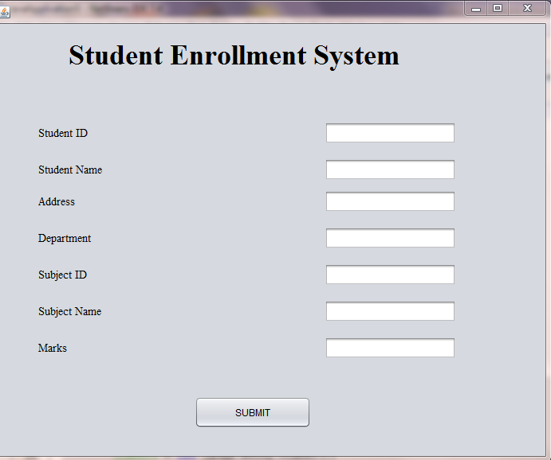

Fig 6.1 enrollment form

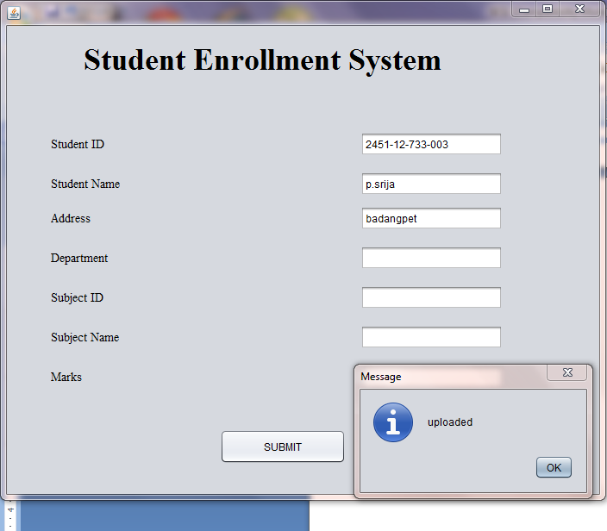

Fig 6.2 inserting student details

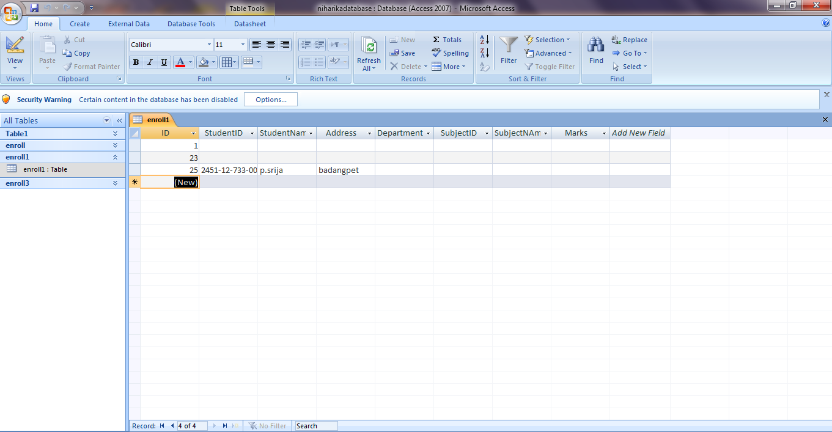

Fig 6.3 information of student stored in database
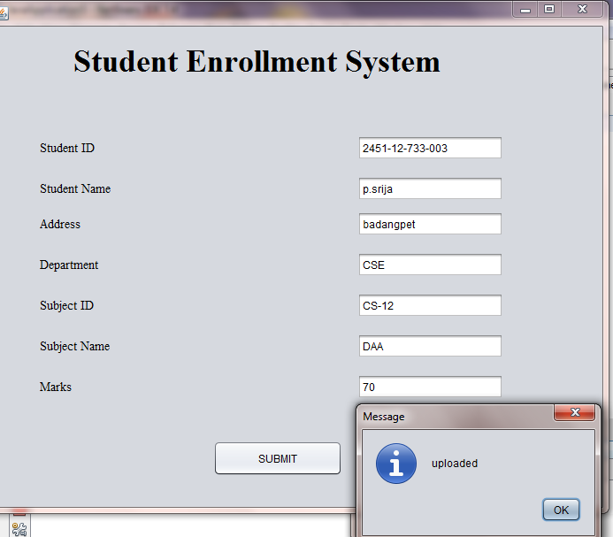

Fig 6.4 inserting subject details
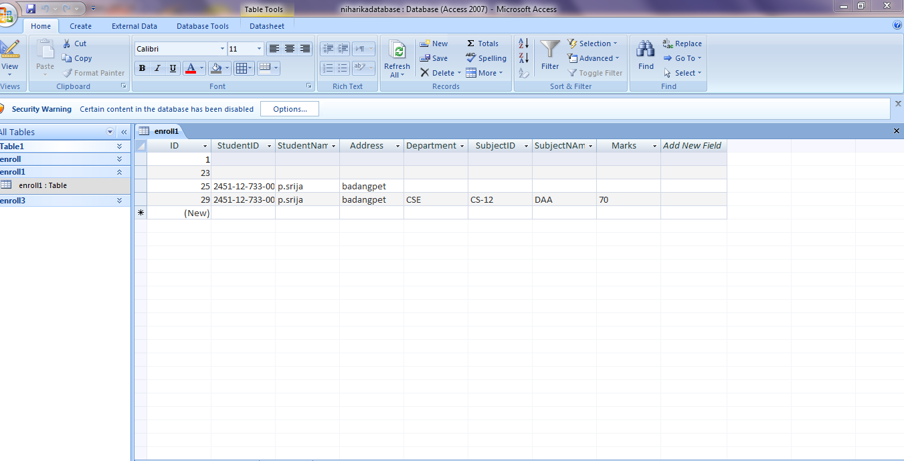

Fig 6.5 information of student is enrolled
7.CONCLUSION AND FUTUREWORK

A computerized enrollment system has been developed and the system was tested with sample data.

The system results in regular timely preparations of required outputs. In comparison with manual system the benefits under a computer system are considerable in the saving of man power working hours and Effort.

Provision for addition, updation and deletion of customers is there in the system .It is observed that proper filing system has been adopted for future reference. The entire project runs on windows environments.

The system can be used to make better management described at appropriate time. The user gets amount and timely information system.

The system may be further updated or modified at will owing to its simple structure. We can further add a transaction entity which will look after the payments made by the customer towards their policy. Depending on future requirements more changes can be made owing to the organization’s need.

References:
1.Nilesh shah “Database System using Oracle”,PHI,2007.
2.Rick F Van der Lans,”Introduction to SQL”,Fourth Edition,pearson Education,2007.
3.Herbert Schildt,The Complete Reference Java,7th Edition,Tata McGraw Hill,2005

