Crane Daily Inspection Checklist


CRANE: ___________________________________ DATE: ____________________

INSPECTOR: _____________________________________________

Check the box next to each item after it has passed inspection. Note any deficiencies or other observations that could pose a risk of injury or property damage.

NOTE: This checklist is for non-construction activities in general industry workplaces.

Item or Function Inspected Deficiencies/Notes

All exposed moving parts are guarded.

Mechanisms for lifting, swinging, and lowering the load or boom are free of defects that could result in unsafe operation.

Components are free of defects that could result in

unsafe operation:
Wire rope, including standing ropes
Sheaves
Drums
Rigging
Hardware and attachments
Wire rope is adequately lubricated.

All crane components are properly lubricated.

Hooks are free of deformities and cracks.

Hooks with cracks, excessive throat openings of 15 percent, or hook twists of 10 degrees or more have been removed from service.

Swivels rotate freely.

Boom and jib are straight.

Boom and jib are free of cracks, bends, and deformation of the welds.

Attachments connected to the chords and lacing are free of corrosion.
Chords and lacings are straight and free of kinks,

defects, and dents, and the paint is free of cracks or
flaking.
Tires are free of cuts, tears, and breaks, and are properly inflated.
No hydraulic fluid or air leaks.

Containers/reservoirs are filled to proper levels:

Fuel
Lubricating oil
Coolant
Hydraulic oil
Fire extinguisher is in place and fully charged.


Turntable connections are free of weld cracks and loose or missing bolts.

Outrigger beams and cylinders are free of distortion.

Outrigger welds are not cracked.

Outrigger beams and cylinders extend and retract

smoothly; hold the load.
Floats are in good condition and securely attached.

All brakes and clutches are tested, adjusted, and operate properly.

Boom hoist lockout and other operator aids, such as anti-two-block devices (ATB) and load moment indicators (LMI), are operating properly and calibrated.

While the engine was running, all gauges and warning lights gave proper readings and all controls functioned properly.
Cab windows are free of broken or cracked glass.

Crane Daily Inspection Checklist (cont’d)

Operating Mechanisms

Check the box next to each item after all of the operating mechanisms have been checked to ensure they are fully functional.
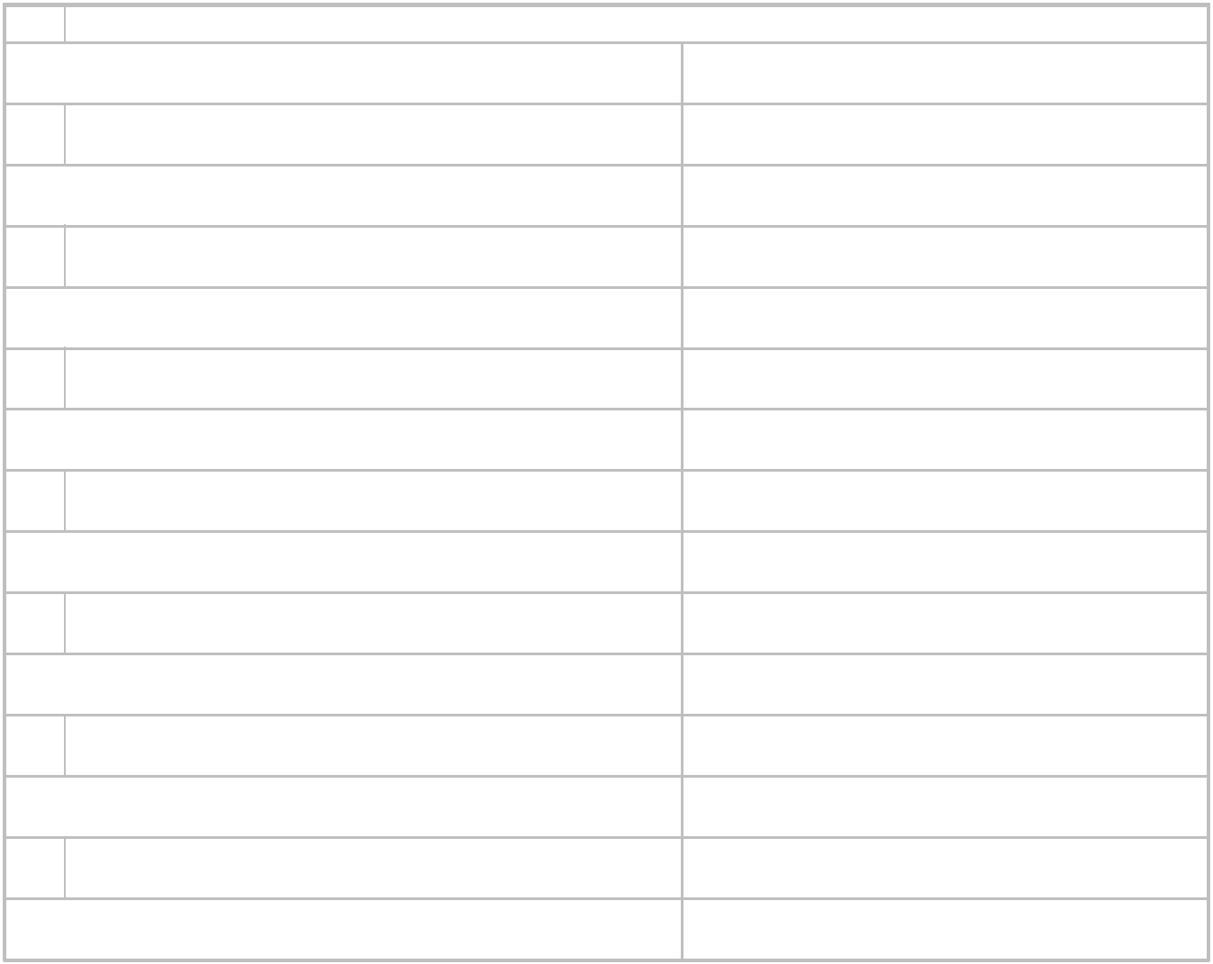

Sheaves
Drums

Brakes
Locking mechanisms

Hooks
Boom

Jib
Hook rollers

Brackets
Outrigger components

Limit switches Safety devices

Hydraulic cylinders Instruments

Lights

Item Deficiencies/Notes

