BLR
Audit

Checklists

Date: ______________________________

Work Area: _________________________

Inspected By: _______________________

Flammable Liquids Checklist

Flammable Liquids [29 CFR 1910.106]

 TANK STORAGE:
29 CFR 1910.106

❏ Are tanks for storing flammable liquids built of
steel or other approved material? [(b)(1)(i)]

❏ Are tanks located above ground or inside buildings made of noncombustible materials? [(b)(1)(i)(b)]

❏ Is the distance between any two flammable liquid storage tanks at least 3 feet? [(b)(2)(ii)(a)]

❏ Are underground storage tanks properly installed? [(b)(3)]

❏ Are all tanks installed on firm foundations? [(b)(5)(i)]

❏ Are all new tanks properly strength tested before being put into service? [(b)(7)(i)]

❏ Are all piping systems containing flammable liquids suitable for expected working pressures and structural stresses? [(c)(1)(i)]

❏ Are aboveground tanks properly vented? [(b)(2)(iv)]

❏ Are these tanks equipped with emergency relief venting devices to relieve excessive pressure caused by fire exposure? [(b)(2)(v)]

❏ Is vent piping constructed in accordance with the regulations? [(b)(2)(vi)]

❏ Is the drainage and diking system surrounding a storage tank (or tanks) properly constructed to prevent accidental discharge of liquid from endangering adjoining property or reaching waterways? [(b)(2)(vii)]

❏ Is the diked area kept free of any loose combustible material or empty or full barrels? [(b)(2)(vii)(c)(6)]

❏ Are openings for gaging provided with a vaportight cap or cover? [(b)(2)(viii)(d)]

10007700

 CONTAINER AND PORTABLE TANK STORAGE: 29 CFR 1910.106

❏ Do you use only approved containers and portable tanks for storage or transport of flammable liquids? [(d)(2)(i)]

❏ Are these portable tanks equipped with the specified emergency venting devices installed in the top? [(d)(2)(ii)]

❏ Is the size of containers in accordance with Table H-12 of the regulations? [(d)(2)(iii)]

❏ Are fire-resistant storage cabinets used to store small quantities of flammable liquids (no more than 60 gallons of Category 1, 2, or 3 liquids and no more than 120 gallons of Category 4 flammable liquids)? [(d)(3)(i)

and (ii)]

Continued ☞

☞ Continued

❏ Are inside storage rooms containing flammable

liquids provided with adequate ventilation? [(d)(4)(iv)]

❏ Is there one aisle at least three feet wide in each inside storage room? [(d)(4)(v)]

❏ Do you make sure that containers over 30 gallons are not stacked on top of one another? [(d)(4)(v)]

❏ Is dispensing done by approved pump or self-closing faucet only? [(d)(4)(v)]

❏ Is storage of flammable liquids in office areas prohibited, except for small amounts required for maintenance and operation of the building and equipment? [(d)(5)(iii)]

❏ Are office storage areas in cabinets away from areas of the building used by the public or in rooms not having a door that opens into a part of the building used by the public? [(d)(5)(iii)]

❏ Are leaking containers removed to a storage room or taken to a safe location outside the building and the contents transferred to an undamaged container? [(d)(5)(iv)(e)]

❏ Do flammable liquid warehouses or storage buildings comply with the regulations? [(d)(5)(vi)]

❏ Are suitable fire control devices available at all locations where these materials are stored? [(d)(7)]

❏ Are smoking and open flames prohibited in all flammable liquid storage areas? [(d)(7)(iii)]

❏ When Category 1 or 2 flammable liquids or Category 3 flammable liquids with a flashpoint below 100˚F are being handled by employees, are they always kept in covered, approved containers when not actually in use? [(e)(2)(iv)(a)]

❏ If not in a closed container, are means provided to dispose safely of leakage or spills? [(e)(2)(iv)(b)]

❏ When flammable liquids are drawn from or transferred into containers or portable tanks within a building, is this done only through a closed piping system, from safety cans, by means of a device drawing through the top, or from a container by gravity through an approved self-closing valve? [(e)(2)(iv)(d)]

❏ Are the regulations observed in unit physical operations where flammable liquids are mixed, evaporated, filtered, etc.? [(e)(3)(i)]

❏ Is there adequate fire extinguishing equipment available in areas where these liquids are being used? [(e)(5)]

OUTSIDE STORAGE:
29 CFR 1910.106

❏ Does storage of these liquids outside buildings comply with the regulations? [(d)(6)]

❏ Are outside storage areas graded to divert spills away from buildings or surrounded by a curb at least 6 inches high that complies with the regulations? [(d)(6)(iii)]

❏ Are outside storage areas secure and protected against trespassers? [(d)(6)(iv)]

FIRE CONTROL:
29 CFR 1910.106

❏ Are adequate measures taken to prevent the ignition of flammable vapors? [(e)(6)]

❏ Is electrical equipment properly installed in areas where flammable vapors may exist? [(e)(7)]

❏ Are good housekeeping practices followed in all areas where flammable materials are used or stored? [(e)(9)]

Continued ☞

10007700

☞

Continued

HAZARD COMMUNICATION

STANDARD:
29 CFR 1910.1200

❏ Do you provide employees who handle flammable liquids with effective information and training on these hazardous materials at the time of initial assignment and whenever a new chemical hazard is introduced into the work area? [(h)(1)]

❏ Are employees informed of any operations in their work area where these liquids are present? [(h)(2)(ii)]

❏ Do they have access to your written Hazard Communication program, including required SDSs? [(h)(2)(iii)]
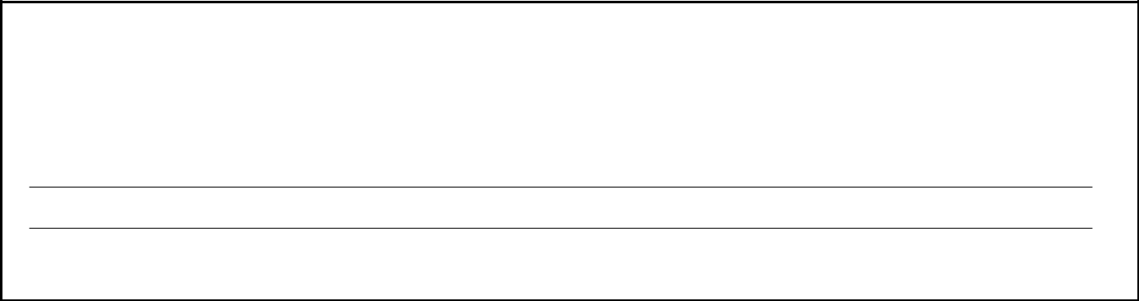

Corrective Action Completed (date): ______________________________________

Supervisor: __________________________________________________________

Routed to: ____________________________________________________________

10007700

