Substance: |  |  |  |  |  |  |  |  | Assessment #:
Supplier: |  |  |  |  |  |  |  |  | Emergency #:
No. Employees Involved: |  |  |  |  |  |  |  |  | CAS #

How is it Used?
HAZARDS (delete/ add as appropriate)
Corrosive | Highly Toxic |  | Toxic |  |  | Harmful |  |  | Flammable | Explosive |  | Harmful to the Environment |  |  | Other
 | 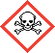 |  |  |  |  | 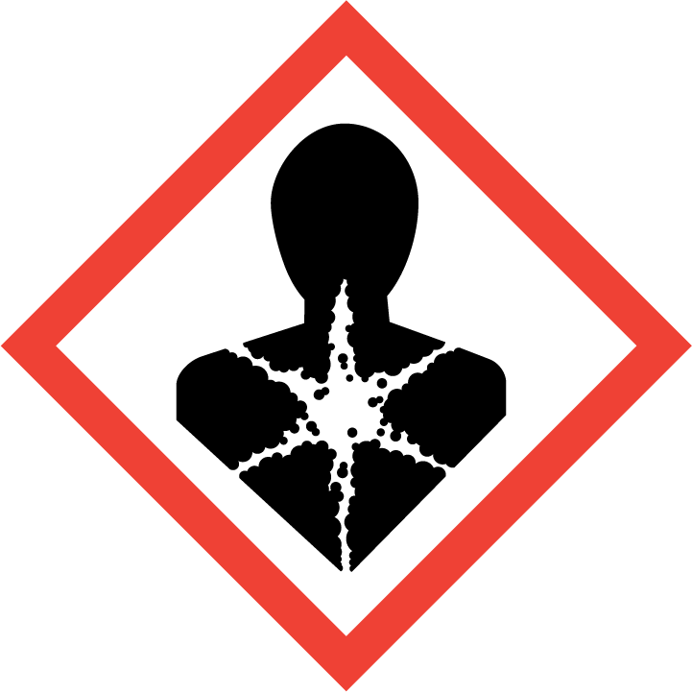 |  |  | 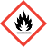 |  |  | 
HAZARD TYPE (delete/ add as appropriate)
Gas | Vapour |  | Mist |  |  | Fume |  |  | Dust | Liquid |  | Solid |  |  | Other
Description: |  |  |  |  | Yes/ No |  | Notes (incl. Relevant Exposure Standards, Safety and Risk Phrases)
Hazardous by inhalation?
Hazardous by ingestion?
Hazardous by absorption?
Irritant to the eyes?
Irritant to the skin?
Harmful to the environment?
Observations on task and possible exposures (incl. Storage, Movement, Handling, Use, etc.): |  |  |  |  |  |  |  |  | Existing Controls (incl. Enclosures, Ventilation, SWI’s etc.):
Hazard Assessment (attach additional information as an appendix): |  |  |  |  |  |  |  |  |  |  |  |  | N/A | YES |  | NO
- Is manufacturers Safety Data Sheet (MSDS) available?
- Has the ‘lowest hazard’ substance suitable for the task been selected?
- Has specific training required for handling this substance been provided?
- Is exposure monitoring required?
- Are additional control measures required?
- Are control measures routinely maintained, examined and tested?
- Is health surveillance necessary?
- Are Emergency Response Plans (first aid, fire, spill etc.) available and up to date?
- Is appropriate storage and dispensing requirements for the substance provided?
- Must an Authorised Waste Disposal Contractor dispose of the substance?
- Are all necessary permitting requirements understood and in place?
Require Personal Protective Equipment (state type and standard).
Respirator |  |  |  |  |  |  |  | Dust Mask
Safety Goggles |  |  |  |  |  |  |  | Face Shield
Gloves |  |  |  |  |  |  |  | Protective clothing

First Aid Measures
Inhalation
Skin Contact
Eye Contact
Ingestion
Workplace Exposure Limits (WEL)
Long term exposure limit (8hr TWA) |  | Short term exposure limit (15 mins)
Accidental release control measures
Disposal arrangements
Fire Fighting Measures
Any further information:

Assessor
Name (print) |  | Signature
Date |  | SDS Review Date

