 |  |  |  | DYNAMIC RISK ASSESSMENT
Select the appropriate risk assessment from the following and tick the box or boxes applicable.
Annexe A |  |  |  |  |  |  | Annexe B |  |  |  |  |  |  |  |  | Annexe C
The name(s) of the person(s) who is carrying out this assessment and will comply with the CONTROL MEASURES AT ANNEXES A, B & C Print Name(s) ……………………………
………….……………………………………………………………………………………………...
Tick the box to identify the groups of persons who could be affected by this work
Our  Personnel |  |  | Other Contractors |  |  |  |  |  |  | Clients Personnel |  |  |  |  |  |  | General Public
Is the work likely to involve any of the following equipment, operations or conditions? If it does ring the appropriate risk High(H) Medium(M) or Low(L) (refer to the inside cover of the pad) in the boxes below before control measures are taken and implement the precautions at Annexes A,B & C.
A1 | VEHICLE MOVEMENT |  |  |  |  | H - M - L |  | A 17 |  |  | NOISE |  |  |  |  |  |  |  | H - M - L
A2 | ASBESTOS |  |  |  |  | H - M - L |  | A 18 |  |  | VIBRATION |  |  |  |  |  |  |  | H - M - L
A3 | LONE WORKING |  |  |  |  | H - M - L
A4 | MANUAL HANDLING |  |  |  |  | H - M - L |  | B1 |  |  | HOT WORK |  |  |  |  |  |  |  | H - M - L
A5 | HAND TOOLS |  |  |  |  | H - M - L |  | B2 |  |  | ABRASIVE WHEELS |  |  |  |  |  |  |  | H - M - L
A6 | COSHH |  |  |  |  | H - M - L |  | B3 |  |  | PLUMBING |  |  |  |  |  |  |  | H - M - L
A7 | WORKING AT HEIGHT |  |  |  |  | H - M - L |  | B4 |  |  | PLANT & EQUIPMENT |  |  |  |  |  |  |  | H - M - L
A8 | OPEN FLOORS |  |  |  |  | H - M - L |  | B5 |  |  | SCAFFOLDING |  |  |  |  |  |  |  | H - M - L
A9 | FRAGILE ROOFS |  |  |  |  | H - M - L |  | B6 |  |  | MOBILE ELEVATED WORK PLATFORMS |  |  |  |  |  |  |  | H - M - L
A10 | LADDERS/STEPS |  |  |  |  | H - M - L |  | B7 |  |  | DUCTWORK |  |  |  |  |  |  |  | H - M - L
A11 | SERVICES |  |  |  |  | H - M - L
A12 | RESTRICTED SPACE |  |  |  |  | H - M - L |  | C1 |  |  | ELECTRICAL CONNECTIONS |  |  |  |  |  |  |  | H - M - L
A13 | CONFINED SPACES |  |  |  |  | H - M - L |  | C2 |  |  | PORTABLE ELECTRICAL EQUIPMENT |  |  |  |  |  |  |  | H - M - L
A14 | TASK/EMERGENCY LIGHTING |  |  |  |  | H - M - L
A15 | SITE ACCESS/EGRESS |  |  |  |  | H - M - L
A 16 | SLIPS TRIPS FALLS |  |  |  |  | H - M - L
Complete the appropriate section of management forms to be used
Permit to Work  No ____________________  Type __________________ |  |  |  |  |  |  | Client’s Permit to Work  No ____________________  Type __________________ |  |  |  |  |  |  | Method Statement  No ____________________  Type __________________
ADDITIONAL HAZARDS ……………………………………………………………………………
………………………………………………………………………………………………………… ………………………………………………………………………………………………………… …………………………………………………………………………………………………………
ADDITIONAL PRECAUTIONS ……………………………………………………………………
………………………………………………………………………………………………………… ………………………………………………………………………………………………………… ………………………………………………………………………………………………………… …………………………………………………………………………………………………………
RESIDUAL RISK
NEGLIGIBLE |  |  |  |  |  | ACCEPTABLE |  |  |  |  |  |  | NOT ACCEPTABLE

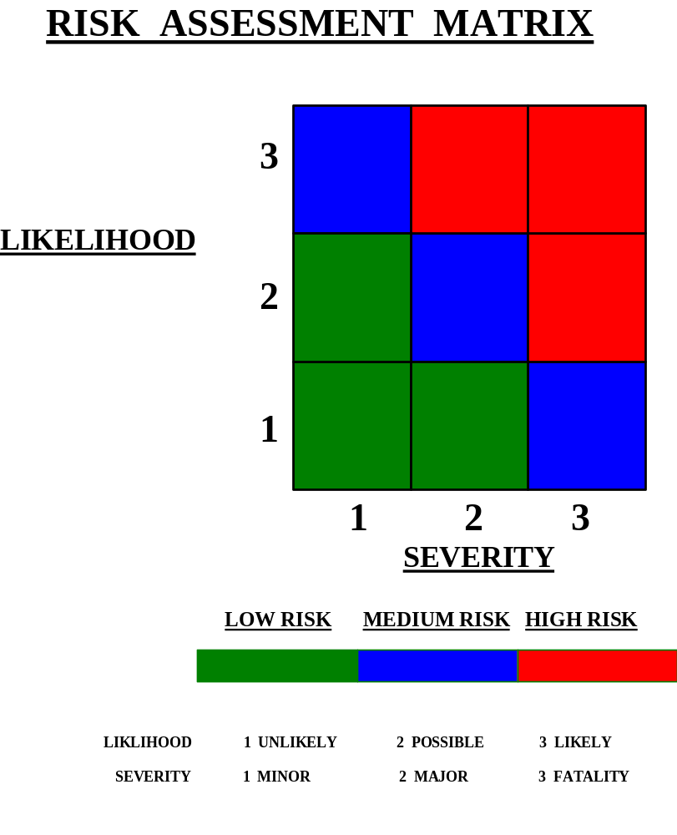

ANNEXE A

DYNAMIC RISK ASSESSMENT GENERAL PROCEDURES
ENSURE THE FOLLOWING CONTROL MEASURES ARE IMPLEMENTED FOR THE BOXES YOU HAVE TICKED
 | HAZARD | CONTROL MEASURES
A1 | ROADS & VEHICLES  Vehicle impact | Use cones, barriers, signs and traffic signals to protect the work area. Wear high visibility clothing.
A2 | ASBESTOS  Asbestos related diseases | Is there an asbestos register, ASK.  Do not attempt to work on any material suspected of containing asbestos. Stop work immediately. Report to your supervisor. Report to the Health and Safety Dept.
A3 | LONE WORKING  Violence  Isolation in emergency  Work at height  Electrical work  Near or over water. | Where work involves work at height, electricity or near water, lone working is to be avoided. Lone worker alarm or other form of communication e.g. mobile phone to be issued in case of emergency. Whereabouts of lone worker to be known at all times. Lone workers to be conversant with emergency procedures for sites they visit. Medically fit with no adverse medical condition.
A4 | MANUAL HANDLING  Back injuries  Strains  Lacerations | Use mechanical lifting aids if available and trained in their use. Check the load-weight, size, sharp or hot. Check the environment-lighting, weather, ground conditions. Check the individual-medical conditions, training, capabilities. Check PPE does not hinder movement.
A5 | USE OF HAND TOOLS  Lacerations  Eye injuries | Maintain hand tools in good condition. Check: chisels for mushroom heads, handles for deterioration and exposed tangs. Eye protection to be worn where required.
A6 | COSHH  Contact with or inhalation of certain substances may cause health problems to the exposed person. | Check labels and containers - refer to safety data sheets. Check COSHH Assessment. If there is no assessment, contact the Health and Safety Department. Ensure all personnel involved in the work are aware of the substances being used and the necessary precautions, e.g. PPE.
A7 | WORK AT HEIGHTS  Falls of persons  Falls of materials | Area to be cordoned off and warning signs posted. Safe access and egress required. Good housekeeping essential. Edge protection if working within 2m of roof edges. Correct selection of working at height equipment essential. Ladders & steps should be a last resort.
A8 | OPEN FLOORS  Falls of persons  Falls of materials | Erect barriers around open floors above and below.  Post warning signs. Use of fans, chutes for lowering debris. Do not leave the open area open when not in use - close and secure.
A 9 | FRAGILE ROOFS  Fall of persons  Access | Consider Mobile Elevated Work Platform. Isolate work area below by barriers. Suitable access and egress required. Fence off fragile areas, e.g. roof lights.
A10 | LADDERS AND STEPS  Fall of persons  Fall of materials  Ladders slipping | Use industrial grade ladders. Check ladder condition. Ladder angle of 4:1. Tied, footed or held to prevent slipping. Keep top step or hoop on steps at waist height or above. Keep feet within the uprights. Keep one hand on the ladder at all times. Do not overreach.
A11 | RESTRICTED SPACE  Blocked access and egress. Head injuries. | Ensure both access and egress are clear.  Keep both storage and use of tools and materials to a minimum. Wear bump caps.
A12 | CONFINED SPACE  Asphixiation  Explosion | Confined Space Trained.  Rescue Plan in place.  Rescue equipment available.  Implement Permit to Work.
A13 | TASK/EMERGENCY LIGHTING | Adequate amount of task lighting to be made available.  Adequate emergency lighting to be supplied by Principle Contractor
A14 | SITE ACCESS/EGRESS | Ensure Principle Contractor is advised of your arrival. Site induction to be obtained.
A15 | SLIPS TRIPS FALLS | Work area to be kept free from debris / equipment at all times.
A 16 | NOISE | Noise assessments to be carried in high noise areas. Applicable signage to be displayed in all hearing protection zones. Hearing protection to be worn.
A 17 | VIBRATION | Anti Vibration Tools to be used. Exposure limits to be adhered too. All equipment to be labelled with trigger times. All tools to be inspected and serviced.

ANNEXE B

GENERIC RISK ASSESSMENT MECHANICAL PROCEDURES
ENSURE THE FOLLOWING CONTROL MEASURES ARE IMPLEMENTED FOR THE BOXES YOU HAVE TICKED
 | HAZARD | CONTROL MEASURES
B1 | HOT WORK  Fire | Implement Permit to Work
B2 | ABRASIVE CUTTING AND GRINDING  Entanglement. Fire.  Lacerations. Contact.  Eye injuries. Dust.  Noise. | Trained personnel only. Fire extinguisher to be available. Check condition of machine and wheel. Ensure the guard is in position.  PPE: suitable eye protection BS166, hearing protection, dust mask, head and foot protection to be worn.
B3 | PLUMBING  Fire. Burns.  Hazardous substances  Eye injuries | See Hot Work B1. See COSHH A7. Fire extinguisher to be available. Check ventilation. PPE: eye protection, dust mask.
B4 | PLANT & EQUIPMENT  Injury caused by defective plant or equipment. Plant or equipment used by untrained personnel | Only trained personnel to use any plant or equipment. All plant and equipment to be used to the manufacturer’s instructions. Correct and suitable plant to be used. Daily maintenance checks to be carried out as per the user handbook. Replace defective plant or equipment.
B5 | SCAFFOLDING  Fall of persons  Fall of materials  Collapse of structure  Collapse of scaffold | See Working at Heights A8, Plant & Equipment B5. 600mm Platform working width. Mobile Towers: Safe, free standing height 3:1 (external) 3.5:1 (internal). No climbing the outside. Consider use of harness over 4m. Harness trained. PASMA trained to erect Mobile Towers.
B6 | MOBILE ELEVATED WORK PLATFORMS  Fall of persons  Fall of materials  Unintentional lowering  Overhead powerlines  Overturning of platform  Platform being struck | See Plant and equipment B5. See Work at Heights A8. Firm and level operating area. Stabilisers in position before raising. Lower platforms when not in use. Check for overhead obstructions. Check underground services, e.g. drains, etc. Check for poor ground conditions. Harness trained. Trained to operate.
B7 | DUCTWORK  Manual Handling  Falls from height  Inhalation of hazardous substances  Eye injuries. | See Manual Handling A5, COSHH A7, Asbestos A3. Suitable and adequate access and egress required. Erect barriers and warning notices. Wear Eye protection.

ANNEXE C

GENERIC RISK ASSESSMENT ELECTRICAL PROCEDURES
ENSURE THE FOLLOWING CONTROL MEASURES ARE IMPLEMENTED FOR THE BOXES YOU HAVE TICKED
 | HAZARD | CONTROL MEASURES
C 1 | CABLES & CONNECTIONS  Electrocution.  Fire. Overheating.  Poor condition of cables and connections. | Check condition of cables and connections.  Never exceed the current rating for cables.  Never use an extension lead to feed a 110v transformer. Always use an RCD when a 240 v supply is required.
C 2 | PORTABLE ELECTRICAL EQUIPMENT  Electrocution  Fire | Use only the correct tools for the work. Visual inspection for defects. Equipment must be PAT tested and in date.  110v only on construction sites. Ensure that all indicators are functioning. Check leads and cables for tripping hazards. Check that there is a minimum of brush arcing on rotating equipment.

