MANAGEMENT OF CHANGE PROCEDURE

PURPOSE

This standard establishes the minimum required procedures necessary to provide for the safety of personnel and facilities due to changes or modifications. This standard is designed to provide review of changes to equipment or operating procedures which are not replacement in kind prior to implementation. The process is to review any potential impact, caused by change, to the overall operation. In addition, these procedures require that process safety information be updated.

SCOPE

This standard applies to changes (except for replacement in kind) to process equipment, technology, procedures, or chemicals for any temporary or permanent modifications that impact the original design, safety or control system. A temporary change is defined as a modification with a duration of less than six months. This includes piping, valves, equipment and components, instrumentation and controls, metallurgy changes, procedures and processing chemicals. Assistance in determining what constitutes an in kind change is available from the local Facilities/Production Engineer.

DEFINITIONS

FCR - Facility Change Request Form (See Exhibit 4 for an example form) used to implement the management of change system.

FCR Coordinator - Person charged to track FCR's for an assigned area.

Operations - Facilities or groups such as plants, production, drilling or building services/maintenance.

GENERAL

Replacement in kind is generally construed to mean:

- Replacement of equipment with equipment having the same technical specifications.

- Operating procedures that are in agreement with approved operating practices.

- Adjusting operational set points for non-safety controllers or valves, such as dump valves, as long as the new set point is within the normal range specified for that controller.

- Minor changes in chemicals such as emulsion breakers or inhibitors

- Routine testing of safety devices and alarms. The Defeated Safety Device Log shall be utilized to manage this procedure.

The following changes are not considered to be "in kind" changes:

- Valves - if style, material, pressure rating, size, packing, seals or Pressure Safety Valve (PSV) settings change.

- Piping and flanges - if size, schedule, material, flange rating, facing or gasket type changes.

- Pumps and Compressors - if material (including internals), flange size, rating, capacity, head or type of seals change.

- Drivers - if Horsepower (Hp) rating, motor electrical rating classification or lubrication systems change.

- Vessels/tanks - if nozzles, service or configuration, Maximum Allowable Working Pressure (MAWP) or relief capacity are changed or welding on shell, heads or walls.

- Instrumentation - if changing device range, multiplier, or resetting critical alarm set points.

- Chemicals - if composition, function or reaction is changed.

- Operational Procedures - if procedural changes, operational software, computer or Programmable Logic Controller (PLC) control scheme, resetting control parameters outside of normal high or low limits or bypass of safety devices for equipment in service.

- Maintenance - if conducting in-service welding, hot tap, stopple work or changes to standard welding procedures.

PROCEDURES

Any employee must notify his or her immediate supervisor of any contemplated change to process equipment, technology, procedures, or chemicals for any temporary or permanent modifications that impact the original design, safety or control system.

The supervisor must review the proposed change in relation to the definition of "replacement in kind" as found in the standard as well as the examples of changes not considered "replacement in kind".

All facilities require application of the Management of Change process as outlined. If an FCR Form is used the procedure should follow the Procedures for Completing the FCR Form below. The supervisor or appropriate engineer will determine which sections of the form apply to the change requested. Where an FCR Form is not used it is important that the procedure include consideration of the key elements of a change as outlined on the sample Facility Change Request Form shown in Exhibit 4. Such key elements as Hazard Review, Operating/Maintenance Procedures, Training, Documentation updates and Pre-Startup Training and Inspection are critical considerations in any facility change. A record of all changes completed without the use of an FCR Form must be kept on file.

In emergency situations, changes may be implemented with verbal approval of line supervisor who is a direct report to a Manager. The change, however, must be reviewed by appropriate personnel, using the Management of Change Standard at the earliest practical opportunity. An change which requires in-service welding or hot tapping can not be approved verbally and requires a FCR Form.

PROCEDURES FOR COMPLETING THE FCR FORM

The initiator with a need to implement change shall provide as much information as possible. The justification for the change should be adequately explained. A sketch should be attached if necessary to help explain the scope of work required, apply to the change requested and sign the form for approval to proceed with review. The form shall be given to the area FCR coordinator who will file a copy of the form. FCR's must be approved before any work begins. . If the change is temporary, a notation to that effect must be made in the description section of the FCR Form

A detailed job procedure shall be written, if required, identifying the steps necessary to implement the change. The procedure shall include all necessary safety precautions and other procedures necessary to manage the safety of the job.

The form and package shall be approved by the operations supervisor after other appropriate reviews (such as Engineering, Safety, Environmental) are completed. The level of approval shall reflect the magnitude, complexity, extent or potential permit impacts of the change.

A final copy of the completed FCR shall be sent to the FCR coordinator, including documentation updates, once the work is completed and all activities are initialed as complete by the responsible party.

Completed FCR packages shall be kept on file.

MANAGEMENT OF CHANGE

EXHIBIT 4: Facility Change Request (FCR)
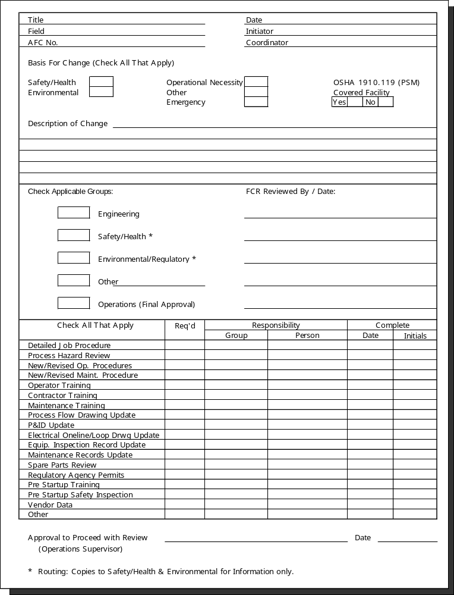

Forms can vary according to local needs.

