**Mobile Device Application Development**

**(140-440)**

**Home Work 1**

**Application: “Spell Your Name”**

**Mr.Borey Sok 5730211095**

**IT-3**

29/08/2016

1. **Descriptions**

User input their first name and last name then application will show each character in their name after is clicked.

Note: first name and last name only support a-z or A-Z. The other charactor will show “?” instead.

1. **Print Screen**

1

2

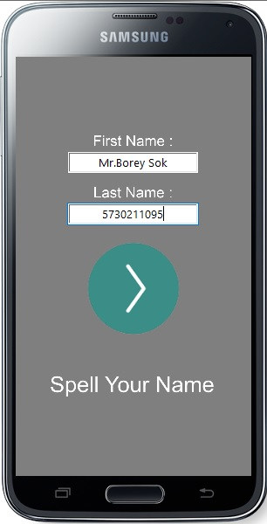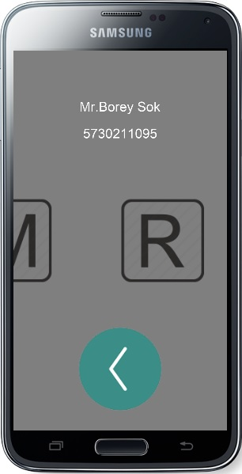

3

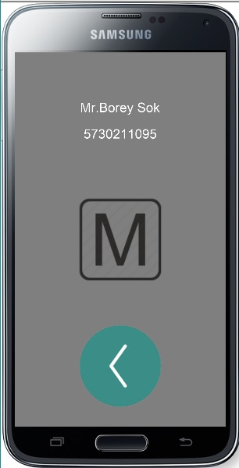

1. **Source Code**

local widget = require("widget")

local f_name, l_name, f_name_text, l_name_text, title

local cx, cy

local alphabetTimer

playing = false

len = 0

pos = 0

addAlphabet = {}

local function setAsDefault(event)

--remove object

pos = 0

for i=1 , #addAlphabet do

if(addAlphabet[i])then

addAlphabet[i]:removeSelf()

addAlphabet[i]=nil

end

end

--remove trigger

if(alphabetTimer)then

timer.cancel(alphabetTimer)

alphabetTimer = nil

end

--textfield defaul properties

transition.to(f_name, {time=700,x=cx})

transition.to(l_name, {time=700,x=cx})

--text defaul properties

transition.to(f_name_text, {time=500,y=cy-170})

transition.to(l_name_text, {time=500,y=cy-100})

transition.to(title, {time=700,x=cx})

f_name_text.text = "First Name :"

l_name_text.text = "Last Name :"

--button defaul position

transition.to(goButton, {time=500,y=cy+30})

goButton.rotation = 0

end

local function changeItemsProperties(event)

transition.to(goButton, {time=500,y=cy+4*cy/5})

goButton.rotation = 180

transition.to(f_name, {time=700,x=cx*3})

transition.to(l_name, {time=700,x=-cx*3})

transition.to(title, {time=700,x=cx*3})

transition.to(f_name_text, {time=500,y=f_name_text.y-30})

transition.to(l_name_text, {time=700,y=l_name_text.y-60})

f_name_text.text = f_name.text

l_name_text.text = l_name.text

end

local function showAlphabet(event)

if(playing) then

if(pos >= len) then

playing = false

setAsDefault()

else

transition.to(addAlphabet[pos+1], {time = 700, x = -cx*2})

pos = pos + 1

if(pos < len) then

transition.to(addAlphabet[pos+1], {time = 300, x = cx})

end

end

end

end

local function spellName(event)

--create alphabet object equeal to name length

addAlphabet = {}

name = string.lower(" "..f_name.text..l_name.text.." ")

len = string.len(name)

for i=1, len do

if(i==1 or i==len)then

table.insert(addAlphabet, display.newImage("img/start_end.png", cx*3,cy))

elseif (string.byte(name,i)<97 or 122<string.byte(name,i))then

table.insert(addAlphabet, display.newImage("img/alphabet/error.png", cx*3,cy))

else

table.insert(addAlphabet, display.newImage("img/alphabet/"..name:sub(i,i)..".png", cx*3,cy))

end

end

--show alphabet

addAlphabet[1].x = cx

alphabetTimer = timer.performWithDelay(500, showAlphabet, 0)

end

local function playButtonEventHandler(event)

if(event.phase == "ended") then

if(not playing) then

playing = true

changeItemsProperties()

spellName()

else

playing = false

setAsDefault()

end

end

end

display.setDefault("background", 0.5, 0.5, 0.5)

cx = display.contentCenterX

cy = display.contentCenterY

--first name

f_name_text = display.newText("First Name :",cx,cy-170,"Arial",20)

f_name = native.newTextField(cx,cy-140,180,30)

f_name.align = "center"

--last name

l_name_text = display.newText("Last Name :",cx,cy-100,"Arial",20)

l_name = native.newTextField(cx,cy-70,180,30)

l_name.align = "center"

--button

goButton = display.newImage("img/play.png",cx,cy+30)

goButton:addEventListener("touch",playButtonEventHandler)

--title

title = display.newText("Spell Your Name",cx,cy+2*cy/3,"Arial",30)