File permissions in Linux

Project description
The team of researchers at my company must adjust the access rights for specific files and folders within the projects folder. The current access rights do not align with the intended level of permissions. Reviewing and modifying these access rights will enhance the security of their system. To accomplish this, I carried out the following steps:

Check file and directory details

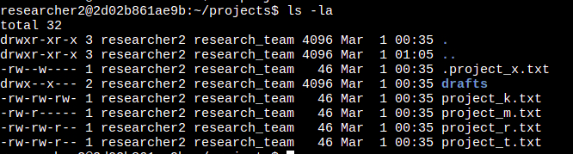
The initial line of the screenshot shows the command I typed, while the subsequent lines reveal the results. The script enumerates all items within the projects folder. I employed the ls command with the -la flag to generate a comprehensive list of the folder’s contents, including hidden files. The result of my command shows one folder called drafts, one concealed file labeled .project_x.txt, and five additional project files. The 10-character sequence in the first column signifies the access permissions assigned to each file or folder.

Describe the permissions string
The 10-character sequence can be broken down to identify who has access to the file and what specific rights they possess. The characters and their meanings are as follows:

• 1st character: This is either a "d" or a hyphen (-), denoting the file type. A "d" signifies a directory, while a hyphen (-) marks it as a standard file.

• 2nd-4th characters: These reflect the read (r), write (w), and execute (x) privileges for the owner. If a hyphen (-) appears in place of one of these, it means that particular privilege is denied to the owner.

• 5th-7th characters: These show the read (r), write (w), and execute (x) privileges for the group. A hyphen (-) in any position indicates that the corresponding privilege is not granted to the group.

• 8th-10th characters: These outline the read (r), write (w), and execute (x) privileges for others, meaning all users on the system outside the owner and group. A hyphen (-) in place of any of these letters signifies that the privilege is withheld from others.

Change file permissions
The company decided that users classified as "others" should not have the ability to modify any of their files. To align with this policy, I reviewed the file permissions I had previously retrieved. I identified that the write access for "others" needed to be revoked for the project_k.txt file.

The code below illustrates how I utilized Linux commands to achieve this:

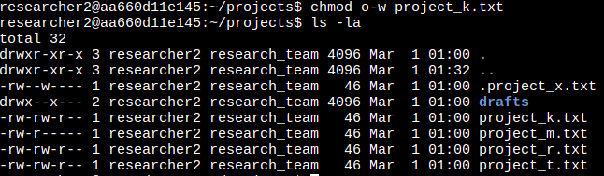
The top two lines of the screenshot show the commands I inputted, while the remaining lines present the output of the second command. The chmod command adjusts permissions for files and directories. Its first parameter defines which permissions to alter, and the second parameter names the target file or directory. In this case, I stripped the write permission for "others" from the project_k.txt file. Afterward, I ran ls -la to verify the changes I implemented.

Change file permissions on a hidden file

The research group at my company recently stored project_x.txt in an archive. They want to ensure no one can edit this project, though the owner and group should retain the ability to view it.

The code below shows how I applied Linux commands to modify the permissions:

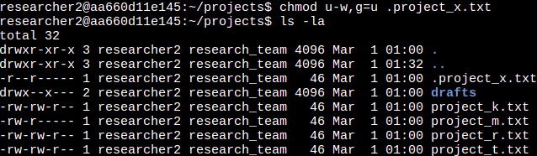

The top line of the screenshot capture the command typed. I recognize .project_x.txt as a hidden file due to its leading period (.). In this instance, I eliminated write access for both the owner and the group, while granting read access to the group. I revoked the owner’s write permission using u-w. Next, I removed the group’s write permission with g=u and ensured the group could only read like user.

Change directory permissions
My company has decided that only the researcher2 user should have access to the drafts directory and its contents, meaning no one else should have execute permissions.

The code below illustrates how I utilized Linux commands to adjust the permissions:

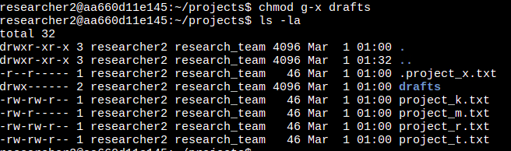

The initial two lines of the screenshot show the commands I inputted, while the subsequent lines present the output of the second command. I had earlier noted that the group possessed execute permissions, so I employed the chmod command to revoke them. Since the researcher2 user already had execute permissions, no additional changes were necessary for them.

Summary
I modified several permissions to align with the access levels my company desired for files and folders within the projects directory. My initial action was to run ls -la to examine the directory’s permissions, which guided my subsequent choices. Following that, I applied the chmod command repeatedly to adjust the permissions on various files and directories.

