Apply filters to SQL queries

Project description
My company is focused on enhancing the security of its infrastructure. My responsibility is to safeguard the system, examine any possible vulnerabilities, and apply necessary updates to staff computers. The steps below illustrate how I leveraged SQL with filtering techniques to address security-related activities.

Retrieve after hours failed login attempts
A possible security breach took place outside regular operating hours (post-18:00), and all unsuccessful login attempts during that time require scrutiny.

The code below shows how I designed a SQL query to isolate failed login attempts happening after normal business hours.
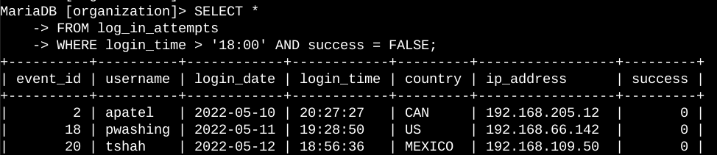

The initial section of the screenshot displays my query, while the subsequent section shows a segment of the results. This query narrows down to unsuccessful login attempts that took place after 18:00. I began by retrieving all records from the log_in_attempts table. Next, I applied a WHERE clause combined with an AND operator to refine the output, showing only login attempts that happened after 18:00 and did not succeed. The first criterion, login_time > '18:00', targets attempts after 18:00. The second criterion, success = FALSE, isolates the unsuccessful attempts.

Retrieve login attempts on specific dates
An unusual incident took place on May 9, 2022. All login actions from that date, as well as the previous day, require examination.

The code below illustrates how I constructed a SQL query to extract login attempts from particular dates.

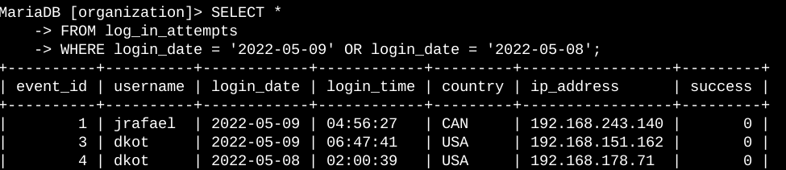

The upper section of the screenshot shows my query, while the lower section presents a segment of the results. This query retrieves all login attempts that took place on May 9, 2022, or May 8, 2022. I began by pulling all records from the log_in_attempts table. Next, I implemented a WHERE clause with an OR operator to narrow the output to login attempts occurring on either May 9, 2022, or May 8, 2022. The first condition, login_date = '2022-05-09', targets logins from May 9, 2022. The second condition, login_date = '2022-05-08', isolates logins from May 8, 2022.

Retrieve login attempts outside of Mexico
Upon reviewing the company’s login attempt records, I suspect a problem with logins originating from locations outside Mexico. These attempts warrant further investigation.
The code below shows how I built a SQL query to isolate login attempts that took place outside of Mexico.

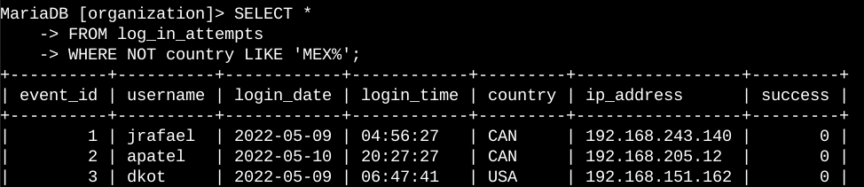

The top part of the screenshot shows my query, and the bottom part displays some of the results. This query pulls all login attempts from countries besides Mexico. I began by grabbing everything from the log_in_attempts table. Then, I added a WHERE clause with NOT to exclude Mexico. I used LIKE with the pattern MEX% to cover both "MEX" and "MEXICO" in the data. The % symbol in LIKE stands for any extra characters that might follow.

Retrieve employees in Marketing
My team needs to upgrade computers for specific Marketing department staff. To do this, I need to find out which employee machines require updates.

The code below shows how I made a SQL query to pick out employee machines from Marketing staff in the East building.

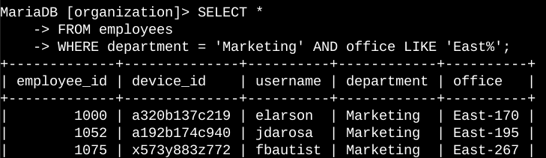

The top of the screenshot shows my query, and the bottom has some of the results. This query lists all Marketing department employees in the East building. I started by pulling everything from the employees table. Then, I used a WHERE clause with AND to narrow it down to Marketing staff in the East building. I used LIKE with East% to catch all East building offices, since the office column includes specific office numbers after "East." The first part, department = 'Marketing', picks out Marketing employees. The second part, office LIKE 'East%', grabs those in the East building.

Retrieve employees in Finance or Sales
Computers for staff in the Finance and Sales departments need upgrades too. Because they require a unique security update, I need to identify employees just from these two areas.

The code below shows how I built a SQL query to select employee machines from those in the Finance or Sales departments.

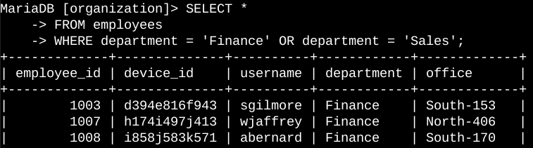

The top of the screenshot shows my query, and the bottom displays some results. This query lists all employees from the Finance and Sales departments. I began by grabbing everything from the employees table. Then, I used a WHERE clause with OR to pick out employees from either Finance or Sales. I chose OR instead of AND to include everyone from both departments. The first part, department = 'Finance', selects Finance staff. The second part, department = 'Sales', picks Sales staff.

Retrieve all employees not in IT
My team has one final security update for employees outside the Information Technology department. To apply it, I need to first identify these employees.

The code below shows how I built a SQL query to select employee machines for those not in the Information Technology department.

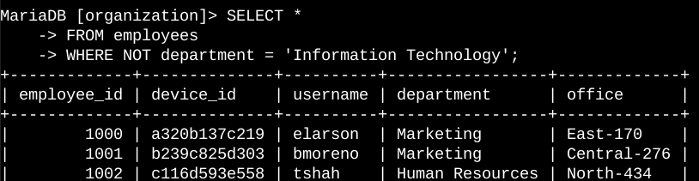

The top of the screenshot shows my query, and the bottom has some of the results. This query lists all employees who aren’t in the Information Technology department. I began by pulling everything from the employees table. Then, I added a WHERE clause with NOT to exclude those in that department.

Summary
I used SQL filters to pull targeted details about login attempts and employee computers. I worked with two tables: log_in_attempts and employees. I applied AND, OR, and NOT operators to get the exact data for each job. I also used LIKE with the % wildcard to match patterns.

