CPS 485 Projects

Enigma Machine

Parts of an Enigma Machine

* Keyboard
* Lamp Board
* Rotors
* Plugboard

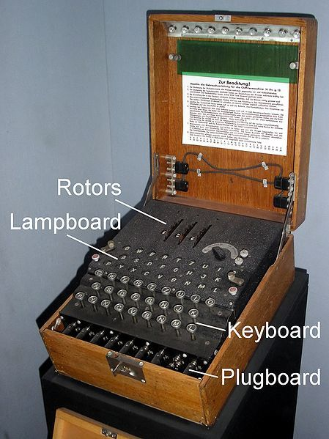

**Plugboard**

The plugboard the following settings A/L - P/R - T/D - B/W - K/F - O/Y. Essentially the idea of the plugboard allows for certain letters to swap creating another level of scrambling. The idea is that one wire can connect to two different letter slots and if one letter is pressed then the other letter it is connected to will be displayed. For example, if the letters “A” and “X” were connected on the plugboard then if the letter “A” was pressed then the letter “X” will be displayed. If “X” was pressed then the letter “A” will be displayed.

**Rotors**

The Enigma Machine comes with usually 3 rotors that each have a different encoding scheme (sometimes they had more than 3 rotors). Each of the rotors can be taken out and placed in a different slot in order to change up the scheme even more allowing for more variation. After each rotor is placed in there are letters on display for the rotors to help with specific number of turns each rotor needs to move each day in order to keep all the messages encoded. When a letter is pressed the rotors will rotate a certain number of times in order to change the letter that was typed into a different letter.

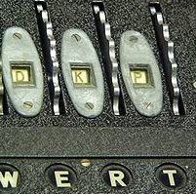

**Lamp Board**

The lamp board is just an extra set of letters on the machine that helps you determine what the output is after the message is encoded. So, if the letter “A” was pressed then a different letter on the lamp board would light up such as the letter “X” and we would know that “X” is the letter “A”.