Enigma G (Abwehr):

Enigma Model G31. Developed in 1931. Successor to the Zahlwerk Enigma (model A28). Sometimes used by German secret service.

Irregular stepping mechanism, has a crank which can be wound back and forth. Sometimes referred to as the 11-15 -17 machine referring to the number of notches on each rotor. Rotors are unique, smaller than all other machine rotors, cannot be interchanged with other rotors.

Three different versions of the Abwehr enigma.

Standard version CH.15a- examples of this are the G-312 & the G-260

Printer Socket version CH.15b- examples of this machine are G-111

Plug Board version CH.15c- No known surviving examples of this machine, contained a plug-board but it was different from the one used by the German army.

About 200 machines were ever built.

German Secret Service bought “blanks” unwired wheels to keep the wiring secret. Different branches of the secret service used differently wired rotors. Over the course of WWII the wiring of the secret service wheels changed several times.

Default Wiring to the Engima G. Identical to the Enigma D in terms of wiring but has a different amount of notches.

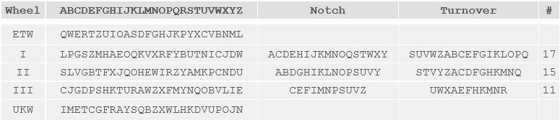

Wiring for the G31 Serial G-312(rewired Reflector(UKW)):

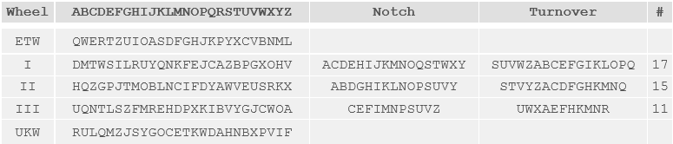

Wiring for the G31 Serial G-260(found in Argentina):

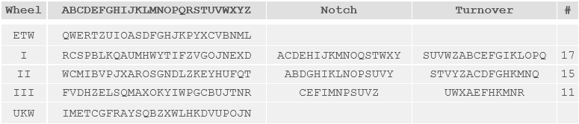

Wiring for G31 serial G-111:

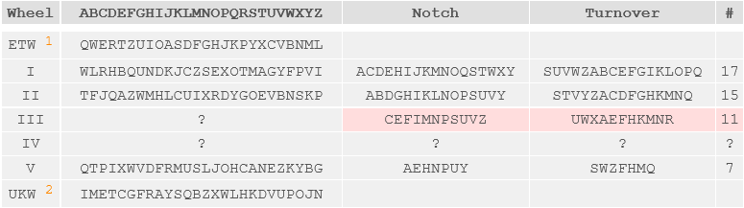

in the first batch of G machines ever created, in the first 24, most likely used by Hungarian intelligence/army. Only 3 rotor slots but rotors that were found with the machine were numbered I, II, & V. Rotors I & II are wired identically to the other machines.

Different features of note for the Engima G:

Model A28(predecessor):

Drastically increased notches on rotors. They also differ based on rotors as we can see in the table; 17,15,11.

Reflector can be placed in any initial position and be moved during enciphering.

Each cipher rotor has 52 teeth on the right side. The left side has the same spacing but some teeth are missing. A pair of teeth on the left hand side provides the same function as a “gap” on a regular enigma rotor, these gaps/pairs of teeth are what move subsequent wheels forward. These pairs of teeth allow for the mechanism to be turned forwards and backwards with a crank. This was used to correct mistakes or be used for the cryptographic key.

Model G31:

Mainly the same as the A28. Used smaller wheels, arranged in a zig-zag pattern to accommodate spring loaded contacts and oval shaped contact pads. It is assumed that the machine was intended for commercial use initially because the reflector wiring and the rotor wirings are identical to the wirings of the enigma D. Important to remember the secret service unwired wheels to configure them in secret.

Additional photos of the machine and rotors:

