Johnson & Johnson

STOCKTAKE

SYSTEM SPECIFICATION

Ver 1.00

Prepared by:

Meenakshi Ananthraman

1. FREEZE SYSTEM QUANTITY
Freeze quantity i.e. a snap shot of the inventory is copied to a the stocktake table
Eg: Table bax_jj_stock can be with the following fields
(Location ,
sku ,
JNJ Lot which is lottable01,
ccid, ****
system_qty,
Packsize, which is the packkey from the sku table
No of cartons,
count_qty,
addate,
editdate,
addwho,
editwho,
Remarks)

**** Is the count book printed based on the aisle and column. For JNJ no segregation is required based on the level
Eg: Location 2921C4
The id would be 29ODD since ‘21’ the column is odd and accordingly all the odd columns in aisle 29 will be under this count book.

The above table is just. Could be designed as needed by the programmer.

2.GENERATION OF AUDITOR’s REPORT
To print the inventory report exactly in the same format as the count book with system quantity instead of the physical quantity. Remarks column is not required. This report has to be printed count book wise.

3. COUNT BOOK PRINTING
Screen to print the count book

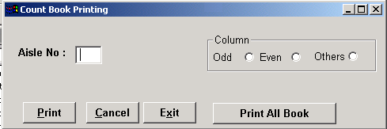

The others will include the HOLD location

- COUNT SHEET:
The format of the count book to be as follows.


PLEASE IGNORE THE DATA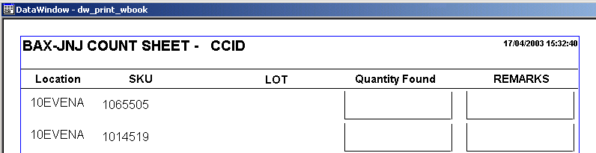

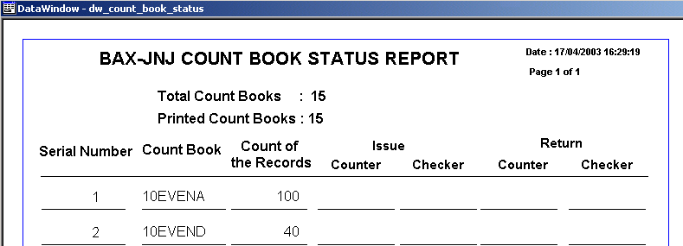5. COUNT BOOK STATUS
After printing the count sheets, the Count Supervisor requires to print the count book status report to have a check on the number of count books we have and records that each count book has and if all of them have been printed.

Please ignore the data
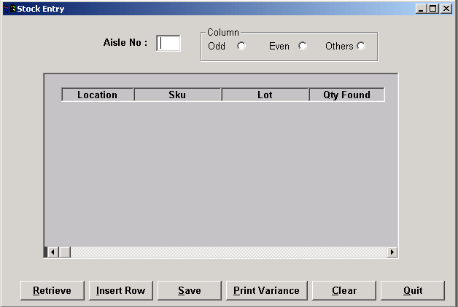6. PHYSICAL ENTRY SCREEN

JNJ receives and ships by packsize. Each carton is packed as per the packsize specified for the particular sku. User will key in the no of cartons in the found. When saved the system should save both the values i.e. the no of cartons and the actual qty.
E.g.: Sku A has a packsize of 5 and the no of cartons found is 6 then the qtyfound should be calculated as 5 * 7 and saved as 35 PCs.

7. PRINT VARIANCE REPORT
After data entry is done for each count book we need to print the variance. Even if there is no variance
The report need to be printed with “ NO VARIANCE” stamped under the details. Format of the variance report.
