Block reason;
1. Reserve for Pilot build;
2. Reserve for Special Order;
3. Requested by buyer/engineer
4. Incoming problem [damaged, wet, shortshipped]
5. Others
From: Jimmy Tan Getubig [mailto:jimmy.tan@dbschenker.com]
Sent: Wednesday, September 19, 2012 11:06 AM
To: 'Harrison Lui'
Cc: 'Eric Tok'; 'mei-lai.chong@dbchenker.com'; 'Kuik Ser Huat'; 'Iriawan Irwan'; 'Eddie Khoo Kwang Wei'; 'Jhun Deo'
Subject: RE: Rainbow hub revision

Hi Harrison,

Please raise an ASR for this request.

Regards,

Jimmy Tan
IT Solutions Department, Singapore
Schenker Singapore (Pte) Ltd
17 Changi South Street 2, S'pore (486129)
DID +65 65491347
Mobile +65 8468 0174
Email: jimmy.tan@dbschenker.com
Global Website: www.dbschenker.com

From: Harrison Lui [mailto:harrison.lui@dbschenker.com]
Sent: Tuesday, September 18, 2012 6:29 PM
To: jimmy.tan@dbschenker.com
Cc: 'Eric Tok'; 'mei-lai.chong@dbchenker.com'; 'Kuik Ser Huat'; 'Iriawan Irwan'
Subject: RE: Rainbow hub revision

Hi Jimmy

Right now, there is no inventory hold in Amtek hub.

Could you add in the inventory hold as we want to block part by buyer as requested (same like HP rainbow hub).

Appreciate for your assistance (pls view attached example copies) .

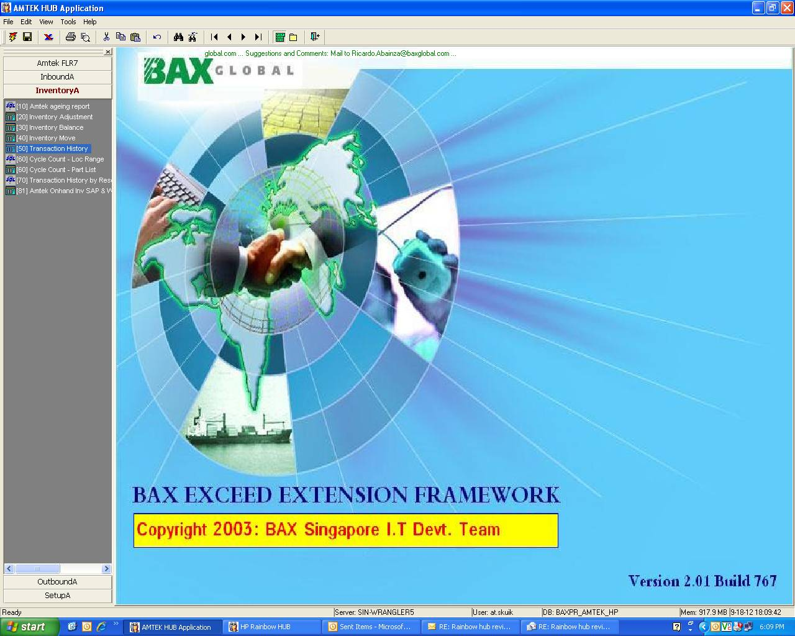

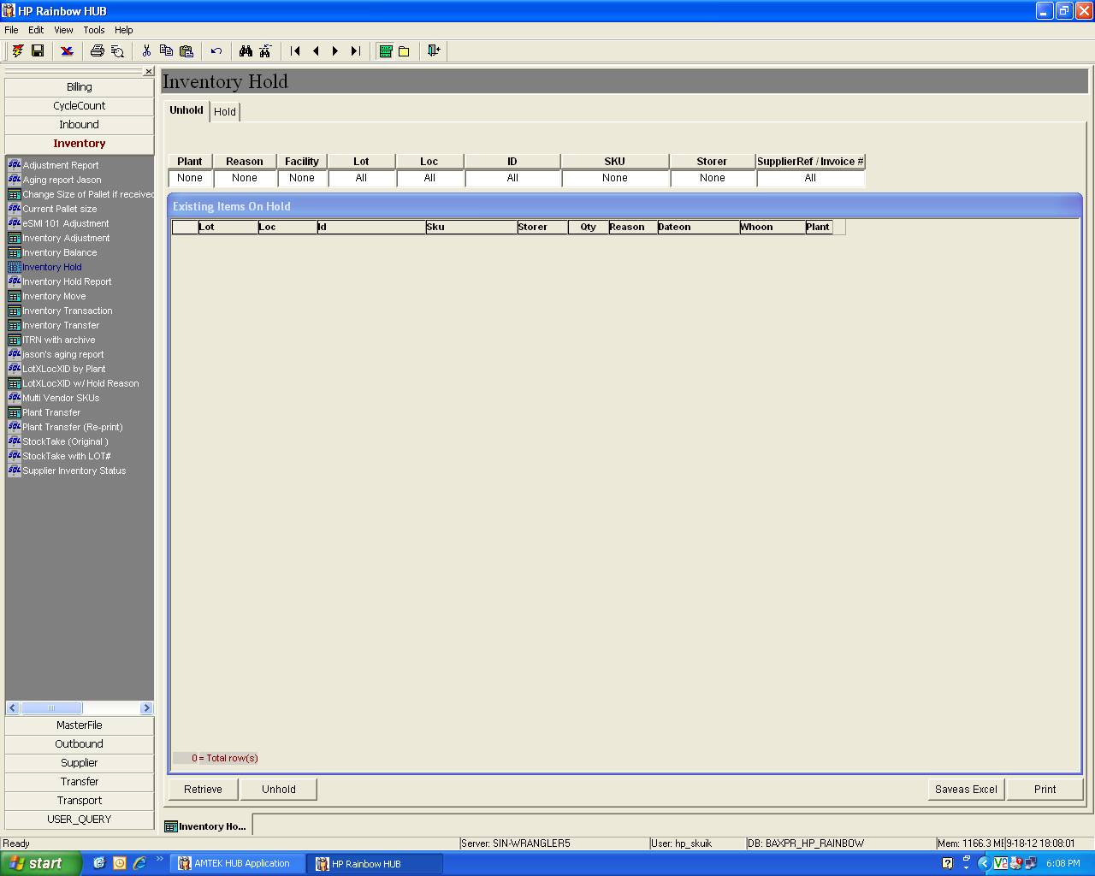

Rgds,
Harrison Lui
Schenker Singapore (Pte) Ltd
452 Alexandra Road
Hewlett Packard Building
Singapore 119961

