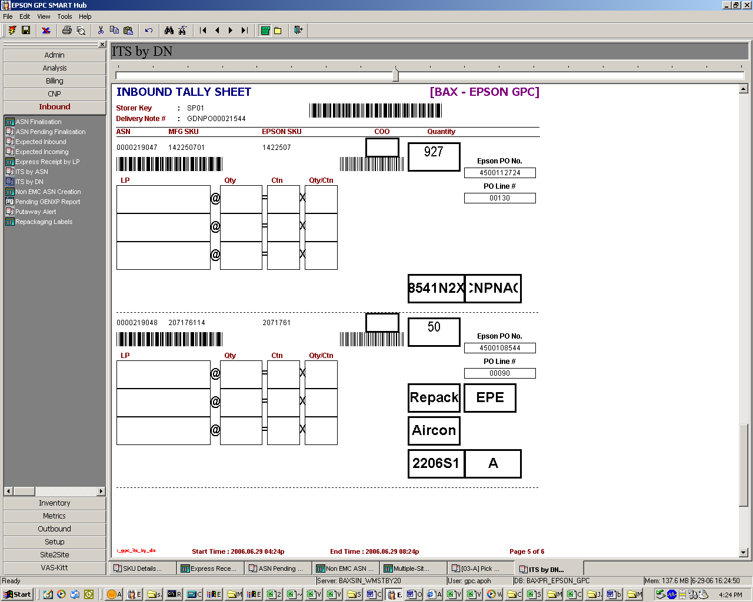
1)Reflect Kitting if it’s the one of the 4 part under kitting
kitting
2)Reflect the location for the newest LP either in CNP or SLC2

1)adding of Kitting Field for these 4 part, F004010, F071000,F102000, F038020(kitting parent parts)

2)for the location shown below each ASN, as i know, show only the location IN SLC2 only even if the part's newest LP is in CNP, i wish the the field show its location for its newest LP irregardless of CNP or SLC2

