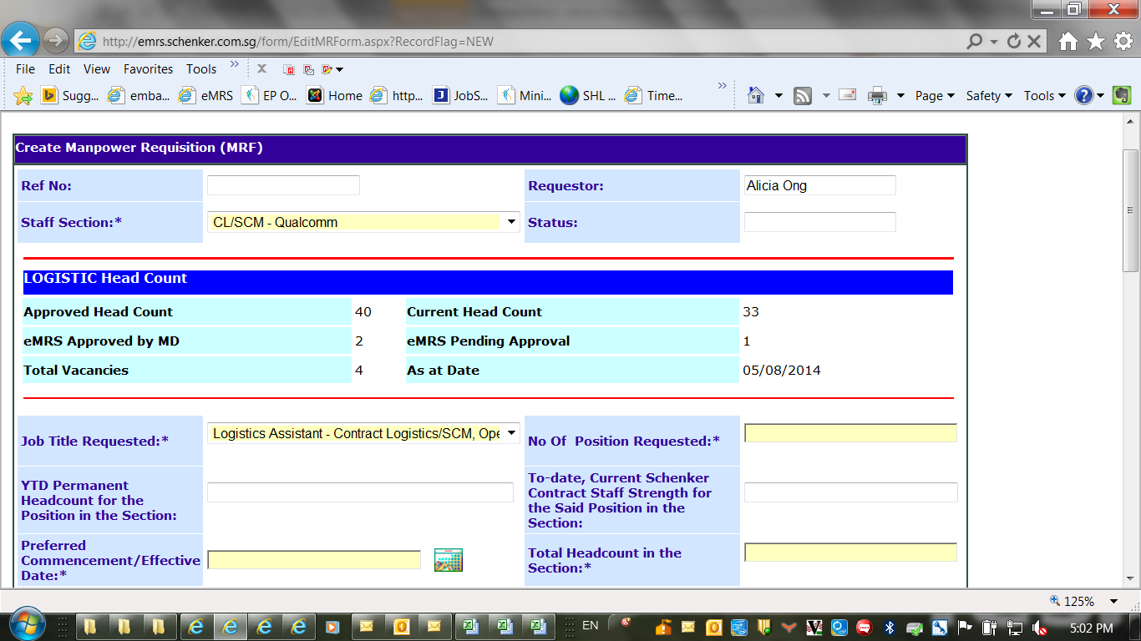

We will need to change the eMRS Approved by MD and eMRS Pending Approval to the following:

eMRS Approved by MD – Change to **No. of Positions approved by MD**

eMRS Pending Approval – Change to **No. of Positions Pending Approval**