Improvement - eMRS

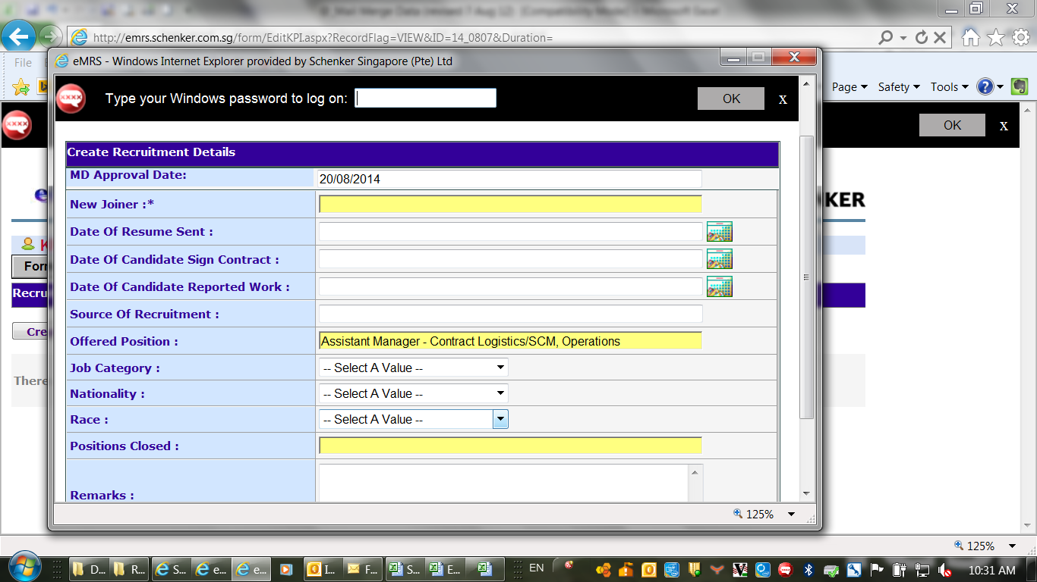

Fields to add into the KPI entry tab:

1. Cost of recruitment fee (mandatory) after source of recruitment into the print-screen tab below
2. Source of recruitment please help to add in the following sentence in red:

Source of Recruitment:

(pls indicate the name of agencies/name of referral)