Bright Sparks Enhancements:

1. To include month and year (separate column) in Financial Tracking report (work track)

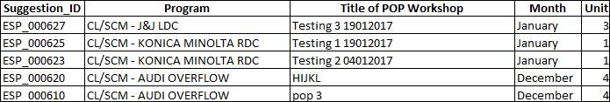

1. To include month and year (one column) in submission score report (Survey score)

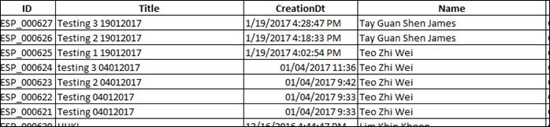

1. Include remarks for each scoring in excel report

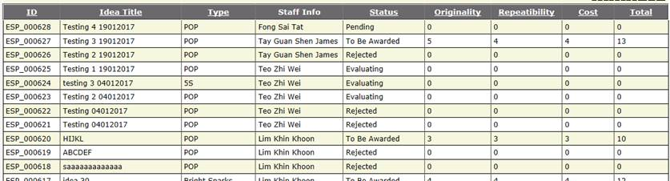

1. To do mass edit and update in admin page (Under Masters, Programs)
2. To be able to click project ID link and show projects on both accepted and rejected list
3. Accepted projects

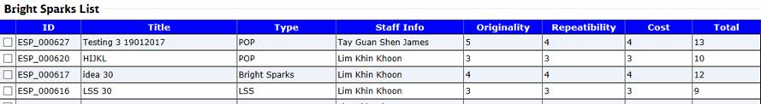

1. Rejected projects

