1. The structure of the program

All the code of this project is under the src folder.

Makefile the makefile of the project

TokenRing.h the header file which include the data structure we use

The payload data structure was defined in this file, which is show below

typedef nx_struct data{

nx_uint16_t opcode;

nx_uint16_t length;

}data_t;

TokenRingAppC.nc the token ring network project configuration

TokenRingC.nc the module of the token ring network

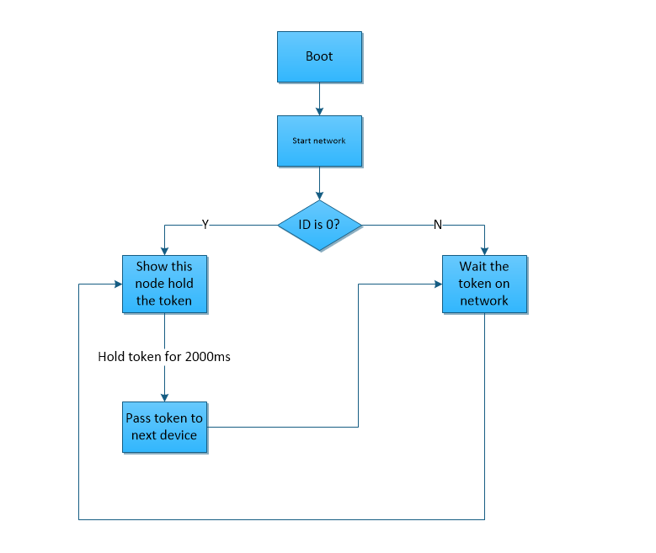

The first stage is the system booting up. In this stage, the led will be initialized (Led 0 On, Led 1 Off, Led 2 Off), and the network will be start.

The second stage depends on the ID of the node device.

If the ID of node is 0, then we will consider this node hold the token, and the node will show it hold the token that light on the Led 1. A 2000ms timer will be set. The token will be pass to next node whose ID is (CURRENT ID+ 1) % NUM OF NODE IN THE NETWORK when the timer fired. Also the Led 1 will be light off after the token passed to next device.

If the ID of node is not 0, then the node will wait for the network until it receive the token. It will show it hold the token like above.

1. How to compile the code

cd TokenPass/src

make genomote install.ID master

(the ID we choose 0 to 2 because we hard code the quantity of node in the network to 3)

make genomote install.0 master for first node

make genomote install.1 master for second node

make genomote install.2 master for third node

1. How to run the code and show the token ring network

First, run the node 2 and node 3

Second run the node 0.

Then we will see the token passed on the token ring network