**Why is income per person so much higher in Belgium than in India**?

Marianne Dewilde, Eric Wang, and Romelu Lukaku

(BSc Business Economics)

Introduction to de Macroeconomics

Professor Luc Hens

25 March 2020

**Why is income per person so much higher in Belgium than in India**?

This document is an example of the formatting for your student papers in Introduction to Macroeconomics or Statistics I for Business and Economics. The formatting is known as *APA Style* (7th edition) (APA stands for American Psychological Association. *APA Style* is the most common style for scientific papers in the social sciences. Use this document as a template. Download the .doc file, duplicate and rename it, open it in your word processor (LibreOffice Writer, Pages, or Microsoft Word) and type over the existing text.

Note that the title repeats at the beginning of the main text on p. 2. The page number is in the header, right-aligned. If you use the .doc version of this document as your template, the page numbers appear automatically.

**Some of the formatting and style rules**

In English (and Dutch) always write your first (given) name first and your surname (family name) last, as on the title page if this document. The only exception is in an alphabetical list such as the list of references at the end of this document. In that case, the family name is followed by a comma and the first name (or in the references: the initial of the first name).

Write complete sentences (a complete sentence has minimally a subject and a verb). Use paragraphs to group related ideas. A paragraph is longer than one sentence. Don’t leave a blank line between paragraphs. APA Style recommends using first person (I or we) when appropriate: We computed the average growth rate as follows (…).

In *APA Style* always double-space and indent each paragraph by ½ inch (1.3 cm). Use the tab (–>|) to indent. Never underline, also titles or headers. Italicize words in a foreign language (in Latin all other things equal is *ceteris paribus*), and (in the list of references) the titles of books and journals. For a short paper (like the papers for Introduction to Macroeconomics or Statistics I) you don’t have to use headers and subheaders. Use one font and font size throughout (Times New Roman 12 pt). In figures annotations of axes, legends etc. should be in a *sans serif* font such as Arial of Calibri.

If you use a mathematical formula or an equation, always introduce it by a short declarative sentence. For the formula or an equation, indent by ½ duim (1.3 cm) using the tab key. Here is an example. Gross domestic product (*Y*) measured as expenditures is:

*Y* = *C* + *I* + *G* + *NX*

Only indent the sentence following the formula if you start a new paragraph.

Tables and figures are always numbered, even if there is only one table (table 1) or figure (figure 1). Every table of figure jas a short descriptive title (see table 1). Keep a table on a single page. If a table is longer than one page, continue the table on the next page (*Table 1 (continued)*) and repeat the headers of the columns. In table headers or axes labels in a figure, report units of measurement (dollar, billion dollars, kg). If you include a table or figure in a paper, always refer to it and discuss it. Group tables and figures at the end, after the list of references. In tables omit the gridlines between rows, as illustrated in table 1. The next sentence illustrates who to refer to a table or figure. Real income per person in Belgium increased to 33,800 dollar in 2000, from about 7,500 in 1950 (in prices of the year 2000) (figure 1). Round numbers to the number of decimals that is relevant for your reader, as in the previous sentence. Report the units of measurement (percent per annum, dollar, …): between 1960 and 2000 GDP per capita in Belgium increased by 2.8 percent per year; in 2000 physical capital per worker in Belgium was 157,700 dollar (prices of 2000, adjusted for international differences in purchasing power). Pay attention to the correct formatting of numbers: in English, commas are used to separate thousands (7,350 dollar is seven thousand five hundred and fifty dollars) and a point to separate decimals (the rate of growth was 2.8 percent per year). In Dutch or French it is the other way around.

If you have to hand in a paper copy, staple pages at the top left; no paperclips (they tend to fall off), no binding, no plastic covers, no fancy cover pages.

**Document your sources**

*APA Style* uses the author-date system to document your sources. Cite a source in-text by reporting the last name(s) of the author(s) and the year of publication: Mankiw & Taylor (2020) explain how the aggregate production function is used to distinguish the potential sources of growth; or at the end of a sentence: the aggregate production function is used to distinguish the potential sources of growth (Mankiw & Taylor, 2020). The reader can then look up the bibliographical details (title, publisher, title of scholarly journal) of the cited source in the list of references. The author can be an institutional author. That is often the case for sources of statistical data: World Bank (2009) contains comparative data of indicators of economic development across countries. Also report internet sources (Weil, 2009) using the author-date system De auteur van een geciteerd werk kan ook een institutionele auteur zijn.

The list of references starts on a new page following the main text,. The header (**Reference**) is in bold and centered. Every source in the list is left-aligned for the first line and indented by ½ inch (1.3 cm) for the next lines. That is called a “hanging indent.” Only list sources you refer to in the text, and make sure that every source you cite is in the list of references. Order the sources in the list of reference alphabetically by family name of the first author.

If you need more information about APA Style or example documents, consult the web site [apastyle.apa.org](http://apastyle.apa.org). Bullock, Brody en Weinberg (2014, pp. 158-191) is a useful guide, too. I posted the excerpt on Canvas.

**References**

Bullock, R., Brody, M., and Weinberg, F. (2014). *The Little Seagull Handbook* (2nd edition). W.W. Norton & Company.

Mankiw, N. G., & Taylor, M.P. (2020). *Economics* (5de edition). Cengage Learning.

Weil, D. (2010). Companion Website for Economic Growth: Data Plotter. http://wps.aw.com/aw_weil_econgrowth_2/

World Bank. (2009). *World Development Report 2010: Development and Climate Change.* World Bank. http://www.wdronline.worldbank.org/

**Figure 1**

*Real Income Per Person in Belgium, 1950-2005 (in US dollars, prices of 2005)* 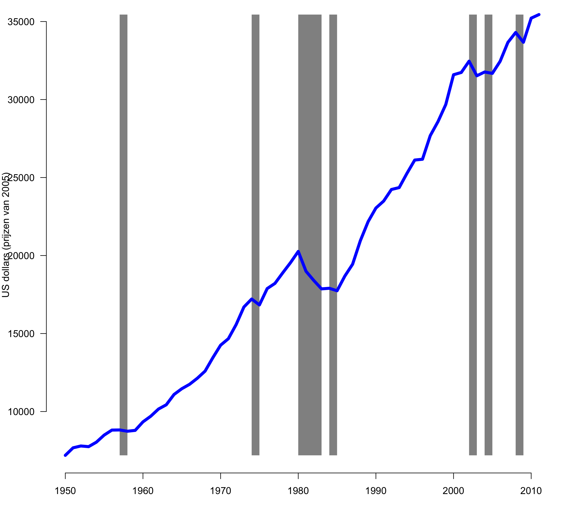

*Note.* The grey bars indicate recessions. The data are variable rgdpch from Heston, A., Summers, R., & Aten, B. (2009). *Penn World Table Version 6.3.* Center for International Comparisons of Production, Income and Prices at the University of Pennsylvania. http://pwt.econ.upenn.edu/php_site/pwt_index.php.

**Table 1**

*Openness in Some European Countries, 2007 (Exports Plus Imports, Expressed as a Percentage of Gross Domestic Product)*

|  |  |
| --- | --- |
| Belgium | 174 |
| Denmark | 104 |
| Germany | 86 |
| Spain | 59 |
| France | 55 |

*Note*. Data are variable openc from Heston, A., Summers, R., & Aten, B. (2009). *Penn World Table Version 6.3.* Center for International Comparisons of Production, Income and Prices at the University of Pennsylvania. http://pwt.econ.upenn.edu/php_site/pwt_index.php.