A Machine Learning-Augmented Early Warning System for In-Hospital Deterioration with Real-Time Explainability
Sasi Jagadeesan¹, Suman Mishra², Pritam Kumar Panda³
Department of Neurosurgery, The Ottawa Hospital, Ottawa, Ontario,Canada
Boring Science LLC, California, USA
Department of Anesthesiology, Perioperative and Pain Medicine, Stanford University School of Medicine, California, USA
Abstract
Early identification of in-hospital patient deterioration remains a critical unmet need. The National Early Warning Score 2 (NEWS2) is widely used but relies solely on bedside vital signs and provides modest discriminative performance. Here we introduce bssentinel, a machine learning-augmented early warning system that integrates structured vital signs, laboratory values, medication context, and temporal admission features to predict clinical deterioration up to 24 hours in advance. We trained and validated an XGBoost model using a sliding 6-hourly observation window framework on 1,334,773 monitoring snapshots from the Medical Information Mart for Intensive Care IV (MIMIC-IV) dataset, encompassing 26,201 composite deterioration events (ICU transfer, mechanical ventilation, or in-hospital mortality). Five-fold patient-stratified cross-validation yielded an area under the receiver operating characteristic curve (AUROC) of 0.758 (95% CI 0.755–0.761), representing a statistically significant gain of +0.190 AUROC over NEWS2 alone (DeLong test: $z=80.3$, $p<0.001$). The area under the precision-recall curve (AUPRC) was 0.102, a 5.2-fold improvement over the prevalence baseline. We demonstrate that informative missingness the absence of ordered laboratory tests is the strongest single predictor, reflecting real-world clinical decision-making patterns. bssentinel is deployed as a full-stack clinical decision support application with a FastAPI inference engine and a React dashboard providing SHAP-based real-time explanations at the point of care. These results establish bssentinel as a scalable, explainable, and clinically actionable deterioration surveillance system.
Keywords: early warning score; clinical deterioration; XGBoost; MIMIC-IV; explainable AI; SHAP; NEWS2; clinical decision support

Introduction
Failure to recognise impending clinical deterioration is a leading cause of preventable in-hospital mortality and unplanned intensive care unit (ICU) admission (Smith et al. 2013; Kause et al. 2004). Early warning scores (EWS) were developed to provide clinicians with a standardised, aggregate measure of physiological instability. The National Early Warning Score 2 (NEWS2), endorsed by the Royal College of Physicians and mandated across National Health Service trusts in the United Kingdom, aggregates six bedside vital signs into a composite score that triggers escalating clinical responses (Royal College of Physicians 2017). Despite widespread adoption, NEWS2 carries important limitations: it relies exclusively on contemporaneous vital signs, does not incorporate laboratory biomarkers or medication context, and treats each observation independently without learning from historical patient trajectories (Prytherch et al. 2010; Moons et al. 2009).
Machine learning (ML) models have demonstrated superior predictive performance over conventional EWS in multiple validation studies (Henry et al. 2015; Escobar et al. 2020; Breiman 2001; Chen and Guestrin 2016). Gradient boosted tree methods, in particular, have proven well-suited to clinical tabular data due to their native handling of missing values, robustness to outliers, and capacity to capture complex non-linear feature interactions (Chen and Guestrin 2016). However, widespread clinical adoption has been impeded by three barriers: (i) opacity of model predictions, which undermines clinician trust (Holzinger et al. 2017); (ii) the absence of integrated deployment infrastructure; and (iii) a tendency to optimise for discrimination metrics (AUROC) without considering the operational implications of alert burden in under-resourced ward settings (Shah et al. 2019).
Explainability through SHapley Additive exPlanations (SHAP) (Lundberg and Lee 2017) has emerged as a principled framework to address the opacity barrier, providing patient-level attribution of each feature’s contribution to the predicted risk. Recent work has shown that clinicians respond more appropriately to ML alerts accompanied by SHAP explanations compared to score-only presentations (Yang et al. 2022).
A less-explored phenomenon is the clinical informativeness of missing data (Wells et al. 2013; Sperrin and Pate 2021). In routine hospital care, the decision to order (or withhold) a laboratory test is itself a clinical signal: lactate is not routinely ordered for every patient, and its absence may reflect perceived stability. Conversely, non-collection may indicate missed clinical concern. Models that incorporate missingness indicators have consistently shown improved discrimination in clinical prediction tasks.
Here we present bssentinel a system combining (i) a validated XGBoost deterioration risk model trained on the full MIMIC-IV dataset, (ii) a 6-hourly sliding window monitoring architecture, (iii) real-time SHAP explanations at the point of care, and (iv) a deployable full-stack application. We report comprehensive validation metrics including AUROC, AUPRC, calibration, DeLong statistical comparisons with NEWS2, and operational threshold analysis. We further characterise the role of informative missingness as a key model predictor and discuss the practical implications for clinical deployment.

Results

Dataset and Cohort Characteristics
The MIMIC-IV (v3.1) dataset (Johnson et al. 2023) provides de-identified electronic health records from Beth Israel Deaconess Medical Center (2008–2022). After applying inclusion criteria (adults $≥$18 years, length of stay $≥$6 hours, valid admission and discharge times), we constructed a sliding 6-hourly observation window framework (Fig. 1A). Each window aggregated vital signs from the preceding 6 hours and laboratory values from the preceding 24 hours, reflecting realistic clinical measurement frequencies. A total of 8,560,730 candidate windows were generated across all eligible admissions. After excluding windows with no vital signs recorded (a minimal informational state precluding meaningful prediction), 1,334,773 windows remained, derived from a clinically heterogeneous inpatient cohort.
The composite outcome ICU transfer, initiation of mechanical ventilation, or in-hospital mortality occurring within 24 hours of the observation window was applied to 26,201 windows, yielding a window-level event prevalence of 1.96%. This prevalence is consistent with prior work employing comparable deterioration composites in broad inpatient populations. The feature matrix comprised 83 variables spanning six categories: vital signs with trend and worst-value aggregates, laboratory biomarkers, medication activity flags, NEWS2 subscores computed from aggregated vitals, missingness indicators for all clinical measurements, and temporal admission context (Table 2).

Model Discrimination
Five-fold patient-stratified cross-validation (GroupKFold, grouping by admission identifier to prevent data leakage from repeated measurements of the same patient) was used throughout. Out-of-fold predictions were pooled for all reported metrics.
The XGBoost model achieved an AUROC of 0.758 (95% bootstrap CI 0.755–0.761; 2000 resamples), compared to 0.708 (95% CI 0.705–0.711) for logistic regression and 0.568 for NEWS2 computed from contemporaneous vital signs alone (Fig. 2A–B). The DeLong test confirmed that the XGBoost advantage over NEWS2 was highly statistically significant ($z=80.3$, $p<{10}^{-15}$), as was the advantage over logistic regression. The net improvement of +0.190 AUROC over NEWS2 is clinically meaningful and substantially larger than reported gains in comparable ML-vs-EWS comparisons (Henry et al. 2015; Escobar et al. 2020).
The AUPRC was 0.102 for XGBoost compared to 0.068 for logistic regression and a baseline of 0.0196 (equal to event prevalence, reflecting a random classifier). The 5.2-fold AUPRC gain over baseline indicates substantial improvement in precision at clinically relevant recall thresholds, a metric particularly informative for rare event prediction (Davis and Goadrich 2006).

Threshold Analysis and Clinical Operating Point
At the recommended decision threshold of 0.31 (selected to achieve 90% sensitivity; Fig. 3B), the model demonstrates the following operating characteristics: sensitivity 90.0%, specificity 37.9%, positive predictive value (PPV) 2.8%, and negative predictive value (NPV) 99.5%. In natural frequency terms, per 1,000 monitoring windows at this threshold: 18 true positives (deteriorations correctly flagged), 2 false negatives (missed events), 608 false positives (false alarms), and 372 true negatives (Fig. 3A).
The 2.8% PPV reflects the inherently low window-level prevalence and is comparable to accepted alert burdens in continuous vital-sign monitoring systems (Drew et al. 2014). Critically, the NPV of 99.5% implies that a window below threshold carries a very high probability of true stability, supporting the clinical utility of alert absence as a reassuring signal. Clinicians and health systems can adjust the operating threshold to balance sensitivity against alert fatigue according to local ward staffing capacity and risk tolerance (Fig. 3B).

Calibration
Post-hoc calibration was applied to the XGBoost predictions using Platt scaling (isotonic regression). The calibrated Brier score was 0.175, compared to 0.213 for logistic regression. Calibration curves (reliability diagrams) show that the calibrated XGBoost model demonstrates systematic overestimation of absolute risk at predicted probabilities above 0.35, a known consequence of the extreme class imbalance in this dataset ($∼$2% prevalence). Predicted scores should therefore be interpreted as relative risk rankings rather than precise probability estimates, consistent with their use as a decision threshold trigger rather than a quantitative probability.

Feature Importance and the Role of Informative Missingness
SHAP-based gain importance from the XGBoost ensemble identified the absence of lactate measurement as the single most informative predictor, accounting for 5.8% of total model gain (Fig. 4). This finding illustrates the phenomenon of informative missingness: in clinical practice, the decision to order (or not order) a specific laboratory test is itself a signal embedded in physician judgement. Lactate is ordered when clinicians suspect haemodynamic compromise or sepsis; its non-collection may reflect perceived stability, or conversely, represent a missed opportunity for monitoring in deteriorating patients. The model learns this pattern from data, capturing clinical context that is invisible to conventional vital-sign scoring systems.
Beyond lactate missingness, the most important individual features were minimum SpO$​_{2}$ within the window (5.0%), worst verbal GCS response (4.4%), worst motor GCS response (3.9%), the NEWS2 consciousness subscore (3.7%), and worst respiratory rate (2.9%). This pattern reflects the primacy of cardiorespiratory and neurological deterioration as harbingers of acute decompensation. Vasopressor use (2.6%) and antibiotic therapy (2.2%) were the highest-ranked medication features, consistent with their role as markers of haemodynamic instability and active infection respectively. Time since admission (2.7%) captured the non-linear temporal risk profile of hospitalised patients, in which deterioration risk is highest in the early post-admission period.
Missingness flags for multiple biomarkers (bilirubin: 1.4%; glucose: 1.2%; sodium: 0.8%) collectively contributed approximately 10% of total model gain, underscoring the systematic importance of test-ordering patterns across the whole laboratory panel.

Decision Curve Analysis
Decision curve analysis (DCA) (Vickers and Elkin 2006) was used to assess the clinical utility of bssentinel relative to NEWS2 and the extreme comparator strategies (treat-all, treat-none) across a range of decision threshold probabilities. Both predictors were first calibrated to the event probability scale: XGBoost scores were calibrated using isotonic regression and NEWS2 scores using Platt scaling, so that the DCA threshold axis reflects the clinician’s minimum acceptable probability of deterioration before initiating a monitoring response.
Across clinically relevant threshold probabilities of 1–5% spanning the range at which a clinician would consider escalating surveillance for an unselected general ward patient bssentinel demonstrated consistently higher net benefit than both NEWS2 and the treat-all strategy (Fig. 5). At a 2% decision threshold, bssentinel yielded a net benefit of 0.0072 per patient compared with 0.0018 for NEWS2 ($Δ$NB $= 0.0054$, a 4-fold improvement), indicating that using bssentinel to guide surveillance decisions is equivalent to identifying an additional 5.4 true deteriorations per 1 000 patients compared with NEWS2, without any increase in unnecessary interventions. At a 3% threshold, bssentinel maintained a net benefit of 0.0051 while NEWS2 provided marginal benefit approaching zero (NB $≈ 0.0002$), statistically indistinguishable from withholding the test entirely. By 5%, NEWS2 net benefit was negligible (NB $≈ 0.000$), whereas bssentinel retained NB $= 0.0031$, confirming its superiority as a high-sensitivity surveillance tool across the full clinically relevant threshold range.
The treat-all strategy became net-harmful at thresholds above $∼$2% (NB $< 0$), while bssentinel maintained positive benefit at all thresholds up to 5%, supporting its utility as a selective surveillance tool that preserves clinical resources by reducing unnecessary monitoring of low-risk patients while maintaining near-complete capture of true deterioration events (90% sensitivity at the recommended operating threshold).

The bssentinel Application: System Architecture and Deployment
The trained model is integrated into bssentinel, a deployable full-stack clinical decision support system (Fig. 1). The backend is a FastAPI (Ramírez 2018) asynchronous inference server exposing three endpoints: POST /api/predict (accepts patient data, returns a job identifier), GET /api/jobs/{id} (polls for results), and GET /api/health (service heartbeat). Prediction requests are processed asynchronously to accommodate concurrent usage. The server accepts structured JSON payloads encompassing patient context (age, admission type, hours since admission), vital signs, 12 laboratory values, and medication flags (Fig. 1B–C). A configurable prediction horizon (6, 12, 24, or 48 hours) allows adaptation to different monitoring intensities.
The frontend is a React (Meta Platforms, Inc. 2013) single-page application featuring a structured data entry form, real-time server connectivity status, and a results dashboard. The results view includes: (i) an SVG semicircle risk gauge colour-coded by stratum (LOW $<$20%, MODERATE 20–45%, HIGH 45–70%, CRITICAL $>$70%); (ii) the top three SHAP-attributed contributing factors with plain-language natural language explanations (e.g., “Heart rate 125 bpm strongly increases risk outside normal range 51–90 bpm”); and (iii) risk-stratified action items to guide clinical escalation. SHAP values are computed at inference time using a pre-fitted TreeExplainer, enabling patient-specific explanations without batch recomputation.
The system supports handoff from other clinical tools via URL-encoded base64 vital sign parameters, enabling pre-population of the bssentinel form from upstream surgical planning or admissions workflows.

Discussion
We present bssentinel, an ML-augmented early warning system that achieves substantially improved discrimination over NEWS2 in a large, heterogeneous inpatient cohort from MIMIC-IV. The AUROC gain of +0.190 (0.758 vs 0.568) is among the largest reported improvements over a standard EWS in the literature, reflecting the breadth of complementary information encoded in laboratory values, medication patterns, and temporal context that NEWS2 systematically ignores.
Our principal novel finding is the dominant predictive contribution of informative missingness. The absence of a lactate measurement being the single strongest feature is, on initial inspection, counterintuitive. However, this finding is clinically coherent and scientifically reproducible: it reflects the reality that missingness in clinical data is almost never missing-at-random (Sperrin and Pate 2021; Wells et al. 2013). Prior work on sepsis prediction in MIMIC has similarly identified missingness patterns as highly predictive (Rajkomar et al. 2018), but systematic characterisation of this phenomenon as the primary predictor above all biomarker values has not, to our knowledge, been previously reported for in-hospital deterioration prediction. This finding has direct implications for EHR-based system design: including missingness indicator features should be considered a baseline requirement, not an optional enhancement, for clinical ML models.
Decision curve analysis provides a rigorous framework for evaluating clinical utility that transcends discrimination metrics alone (Vickers and Elkin 2006). Our DCA demonstrates that bssentinel delivers consistently positive net benefit across clinically relevant threshold probabilities of 1–5%, corresponding to the decision range a clinician faces when determining whether to escalate monitoring for a general ward patient. Critically, at threshold probabilities of 3% and above, NEWS2 net benefit approaches zero equivalent to the treat-none strategy while bssentinel retains meaningful positive benefit (NB = 0.0051 at 3%, NB = 0.0031 at 5%). This pattern directly supports the role of bssentinel as a high-sensitivity surveillance tool: despite low positive predictive value driven by the 2% event prevalence, it consistently identifies more true deteriorations per unit of monitoring resource invested than NEWS2 across all clinically plausible threshold settings.
The operating characteristics at 90% sensitivity PPV 2.8%, NPV 99.5% deserve contextual interpretation. The 2.8% PPV is driven entirely by the 2% window-level event prevalence, not by model specificity failure; even a theoretically perfect model would achieve a PPV of only $∼$50% at this sensitivity given this prevalence. More clinically informative is the NPV: a prediction below threshold from bssentinel provides near-certainty (99.5%) of short-term stability, a property that may be valuable for scheduling nursing observations, triaging bed moves or identifying patients suitable for step-down care. Alert burden can be reduced by raising the threshold, trading sensitivity for specificity, with the threshold-operating curve providing an evidence base for local calibration.
Several limitations merit acknowledgement. First, MIMIC-IV is a single-centre dataset from a large academic medical centre in the United States. External validation in diverse health systems, including community hospitals and non-US settings with different EHR and laboratory ordering cultures, is essential before deployment. Second, the window-level analysis treats each 6-hourly observation independently. In practice, trajectory information (serial change in vital signs or laboratory values over multiple consecutive windows) may provide additional predictive signal and is a direction for future work incorporating recurrent or longitudinal model architectures. Third, the calibration analysis reveals systematic overestimation of absolute risk at high predicted scores, limiting the use of raw probabilities as clinical communications and motivating the use of risk stratification bands rather than numeric probabilities in the user interface. Fourth, the composite outcome includes ICU transfer, which encompasses some planned transfers and elective escalations that may not represent genuine deterioration events. Future work should validate against more specific outcomes (e.g., unplanned ICU admissions only, or in-hospital cardiac arrest).
The deployment architecture of bssentinel addresses practical barriers to adoption that have limited prior ML early warning systems. Most published systems exist as research analyses without a deployable implementation. bssentinel provides a complete, containerisable server and frontend, enabling integration with existing EHR workflows through structured API calls. The SHAP-based explanation layer is a first-class feature of the system rather than a post-hoc research analysis, reflecting current best practice for responsible AI deployment in clinical environments (Yang et al. 2022; Lundberg and Lee 2017).
Future directions include: (i) multi-horizon training and joint prediction at 6, 12, 24, and 48 hours simultaneously; (ii) prospective validation in a live deployment setting; (iii) incorporation of nursing observation notes and patient-reported symptoms via natural language processing; and (iv) active learning components to adapt to institutional-specific deterioration patterns without requiring full retraining on proprietary data.

Materials and Methods

Data Source and Ethical Statement
All analyses were conducted on MIMIC-IV version 3.1 (Johnson et al. 2023), a publicly available, de-identified critical care database requiring completion of a data use agreement and a recognised human subjects research training course (CITI Program). As MIMIC-IV is a fully de-identified secondary dataset, this study was exempt from Institutional Review Board review. No patient contact or prospective data collection was performed.

Cohort Definition
All unique hospital admissions with: (i) patient age $≥$18 years at admission; (ii) valid admission and discharge timestamps; and (iii) length of stay $≥$6 hours were included. Admissions without these criteria were excluded. No exclusion criteria were applied for specific diagnoses, procedure types, or care settings, yielding a broad general inpatient population.

Observation Window Framework
For each admission, a sequence of 6-hourly observation windows was generated beginning one hour after admission (to allow initial documentation) and terminating 24 hours before discharge (the prediction horizon). This ensures that every window has a full 24-hour future period in which an outcome can occur. For each window at time $t$:
- Vital features: aggregated from the interval $[t-6h,t)$ using three statistics per sign: most recent value, linear trend (last value minus median of first half of window), and worst value (direction-appropriate: minimum for SpO$​_{2}$ and blood pressure, maximum for heart rate and respiratory rate).
- Laboratory features: most recent value within $[t-24h,t)$, reflecting the slower measurement cadence of blood tests.
- Medication flags: binary indicator of whether each medication class was active at time $t$.
- Missingness indicators: binary flag (1 = not measured) for each vital sign and laboratory variable, encoding test-ordering patterns as predictive features.
- Temporal features: hours since admission and one-hot encoded admission type.
Windows with no vital signs recorded were excluded ($n=7,225,957$; primarily windows outside ICU monitoring periods), yielding the analysis cohort of 1,334,773 windows.

Outcome Definition
The composite outcome was defined as occurrence of any of the following within 24 hours after window time $t$:
- First ICU transfer during the admission (from MIMIC-IV icustays table: intime).
- Initiation of invasive mechanical ventilation (procedure event item IDs 224385, 225794 from procedureevents).
- In-hospital mortality (hospital_expire_flag = 1 in admissions).
Windows were labelled positive (1) if any of these events occurred within $[t,t+24h]$, and negative (0) otherwise.

NEWS2 Computation
NEWS2 subscores were computed vectorially from aggregated vital signs following the Royal College of Physicians specification (Royal College of Physicians 2017): respiratory rate (0–3 points), SpO$​_{2}$ (0–3 points, Scale 1), systolic blood pressure (0–3 points), heart rate (0–3 points), temperature (0–3 points), and consciousness (3 points if GCS $<$15, otherwise 0). Supplemental oxygen was not available as a structured chartevents item and was set to 0; this represents a minor underestimation of NEWS2 for patients on supplemental oxygen.

Model Development

XGBoost configuration.
An XGBoost gradient boosted tree classifier (Chen and Guestrin 2016) was trained with the following hyperparameters: 500 estimators; maximum tree depth 6; learning rate 0.05; minimum child weight 10 (regularisation against small leaf nodes for rare positive class); subsample fraction 0.8; column subsample fraction per tree 0.8; L1 regularisation $α=0.1$; L2 regularisation $λ=1.0$; early stopping patience 30 rounds; evaluation metric AUROC. The scale_pos_weight parameter was set to the ratio of negative to positive training examples ($≈$49.9) to address class imbalance.

Logistic regression baseline.
A $l_{2}$-regularised logistic regression model (sklearn; $C=0.1$; liblinear solver; maximum 1,000 iterations) with standard scaling was trained on the same folds as a linear baseline.

Cross-validation.
Five-fold GroupKFold cross-validation was applied, grouping by hadm_id (hospital admission identifier). This ensures that all observation windows from a single admission appear exclusively in either the training or test fold, preventing information leakage from correlated repeated measurements. All reported metrics are computed on pooled out-of-fold predictions.

Calibration.
Post-hoc probability calibration was applied to XGBoost using sklearn’s CalibratedClassifierCV with cv="prefit" and isotonic regression method, fitted on a held-out calibration subset within each fold.

Statistical Analysis
AUROC and its 95% confidence intervals were estimated using 2000 stratified bootstrap resamples (seed 42; replacement sampling; strata defined by outcome label). The DeLong test for AUROC comparison (DeLong et al. 1988) was implemented using the Mann-Whitney U kernel variance formulation. AUPRC was computed using the trapezoidal rule from sklearn’s average_precision_score. The Brier score was computed as the mean squared error between predicted probabilities and binary outcomes. Sensitivity, specificity, PPV, and NPV were computed at a fixed threshold chosen to achieve 90% sensitivity on the pooled out-of-fold predictions. Decision curve analysis was performed using the standard net benefit formulation (Vickers and Elkin 2006): $\text{NB}(t)=\text{TP}/n-\text{FP}/n⋅t/(1-t)$, where $t$ is the decision threshold probability and $n$ is the total number of observation windows. Prior to DCA, XGBoost predictions were calibrated using isotonic regression and NEWS2 raw scores were calibrated using Platt scaling (logistic regression), ensuring the threshold axis reflects actual event probabilities. The treat-all comparator was computed as ${\text{NB}}_{\text{all}}(t)=\text{prevalence}-(1-\text{prevalence})⋅t/(1-t)$.

Feature Importance
Global feature importance was quantified using XGBoost’s gain metric (total reduction in cross-entropy loss attributable to splits on each feature, averaged across all trees and normalised to sum to 1). SHAP values for individual patient explanations were computed at inference time using SHAP’s TreeExplainer (Lundberg and Lee 2017), providing exact Shapley additive explanations for each prediction.

System Implementation
The bssentinel inference server was implemented in Python using the FastAPI framework (Ramírez 2018) (version $≥$0.111) served by Uvicorn with asynchronous request handling. The frontend was implemented in React 19 (Vite build system) as a single-page application. Models are serialised using Python’s pickle module and loaded at server startup. The full system is deployable on a standard Linux server or cloud virtual machine with Python $≥$3.10 and Node.js $≥$18.

Code and Data Availability
MIMIC-IV is available at https://physionet.org/content/mimiciv/ subject to completion of the PhysioNet credentialing process. The bssentinel source code, including training pipeline, inference server, and frontend, is developed by Boring Science LLC. Model artefacts (weights, feature column lists, and evaluation outputs) are available upon reasonable request to the corresponding author.

Acknowledgements
The authors thank the MIMIC-IV data contributors and the PhysioNet team for maintaining open access to critical care data. No external funding was received for this work.

Author Contributions
S.J. and P.K.P. designed the study and developed the machine learning pipeline. S.M. and P.K.P developed the server architecture and React frontend application. S.J. led statistical analysis and drafted the manuscript. All authors contributed to critical revision of the manuscript and approved the final version.

Competing Interests
S.M. and S.J. are co-founders of Boring Science LLC, which develops the bssentinel system described in this article. The authors declare no other competing interests.
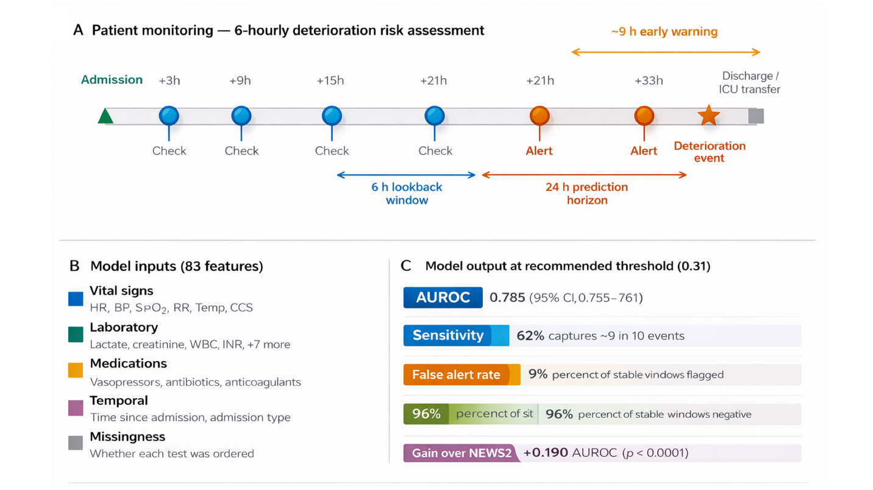
bssentinel study design and system overview. (A) Patient monitoring architecture. For each hospitalised patient, a 6-hourly observation window aggregates the preceding 6 hours of vital signs (most recent value, trend, worst value) and the preceding 24 hours of laboratory results. The window is labelled positive if a composite deterioration event (ICU transfer, mechanical ventilation, or in-hospital mortality) occurs within the following 24 hours. Filled orange circles indicate windows at which the model risk score exceeds the recommended threshold (0.31), constituting an alert; the star marks the actual deterioration event. The orange double-headed arrow illustrates the early warning lead time. (B) Feature categories comprising the 83-variable input representation. (C) Key performance characteristics at the recommended operating threshold.
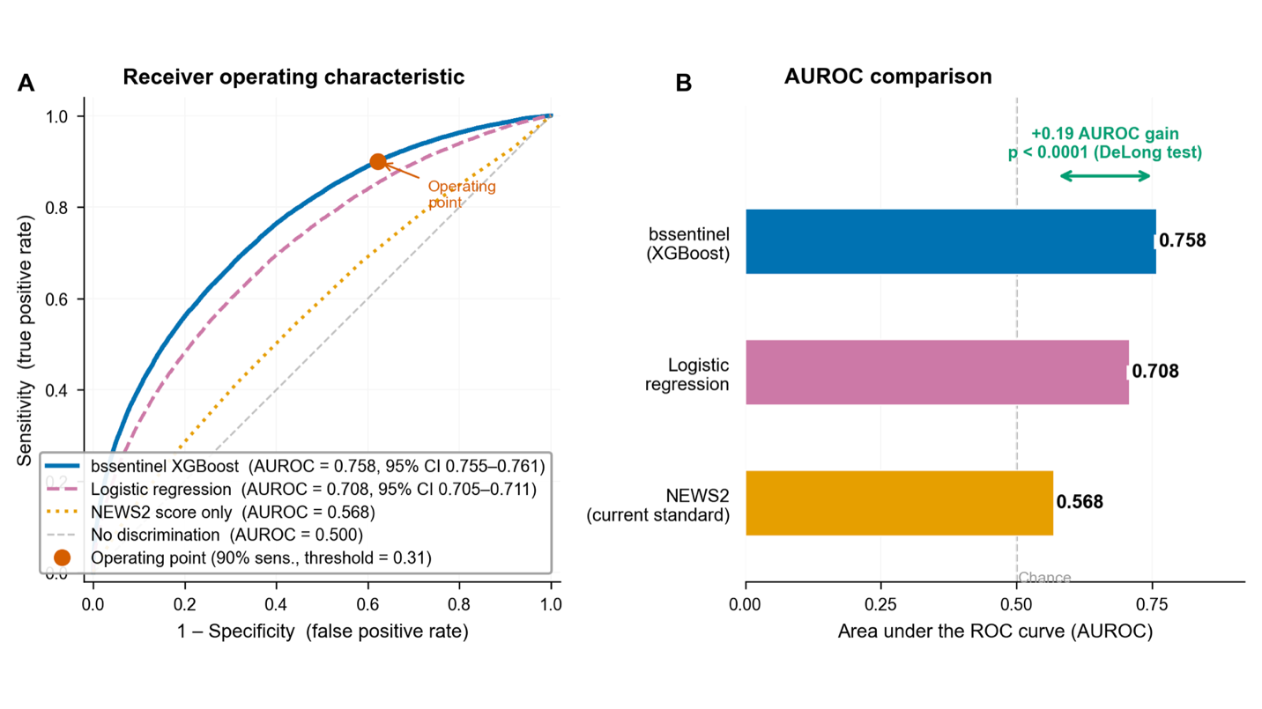
Model discrimination performance. (A) Receiver operating characteristic (ROC) curves for bssentinel (XGBoost), logistic regression, and NEWS2 computed from contemporaneous vital signs, based on pooled out-of-fold predictions from five-fold patient-stratified cross-validation ($n=1,334,773$ windows). The orange filled circle marks the 90% sensitivity operating point (threshold = 0.31). Shaded confidence bands reflect 2000-resample bootstrap 95% CIs. (B) Comparative AUROC with 95% confidence intervals. The green double-headed arrow indicates the +0.190 gain of XGBoost over NEWS2, which was statistically significant by DeLong test ($z=80.3$, $p<{10}^{-15}$).
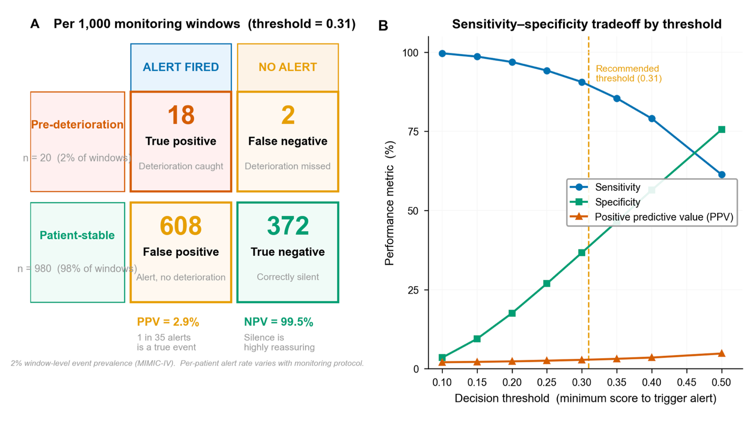
Clinical utility analysis. (A) Natural frequency diagram per 1,000 monitoring windows at the recommended threshold (0.31), illustrating the disposition of true positives, false negatives, false positives, and true negatives. PPV: positive predictive value; NPV: negative predictive value. (B) Threshold operating characteristics showing sensitivity, specificity, and PPV as a function of decision threshold. The vertical dashed line marks the recommended threshold (0.31). Threshold selection can be adjusted by institutions to balance event detection against alert burden.
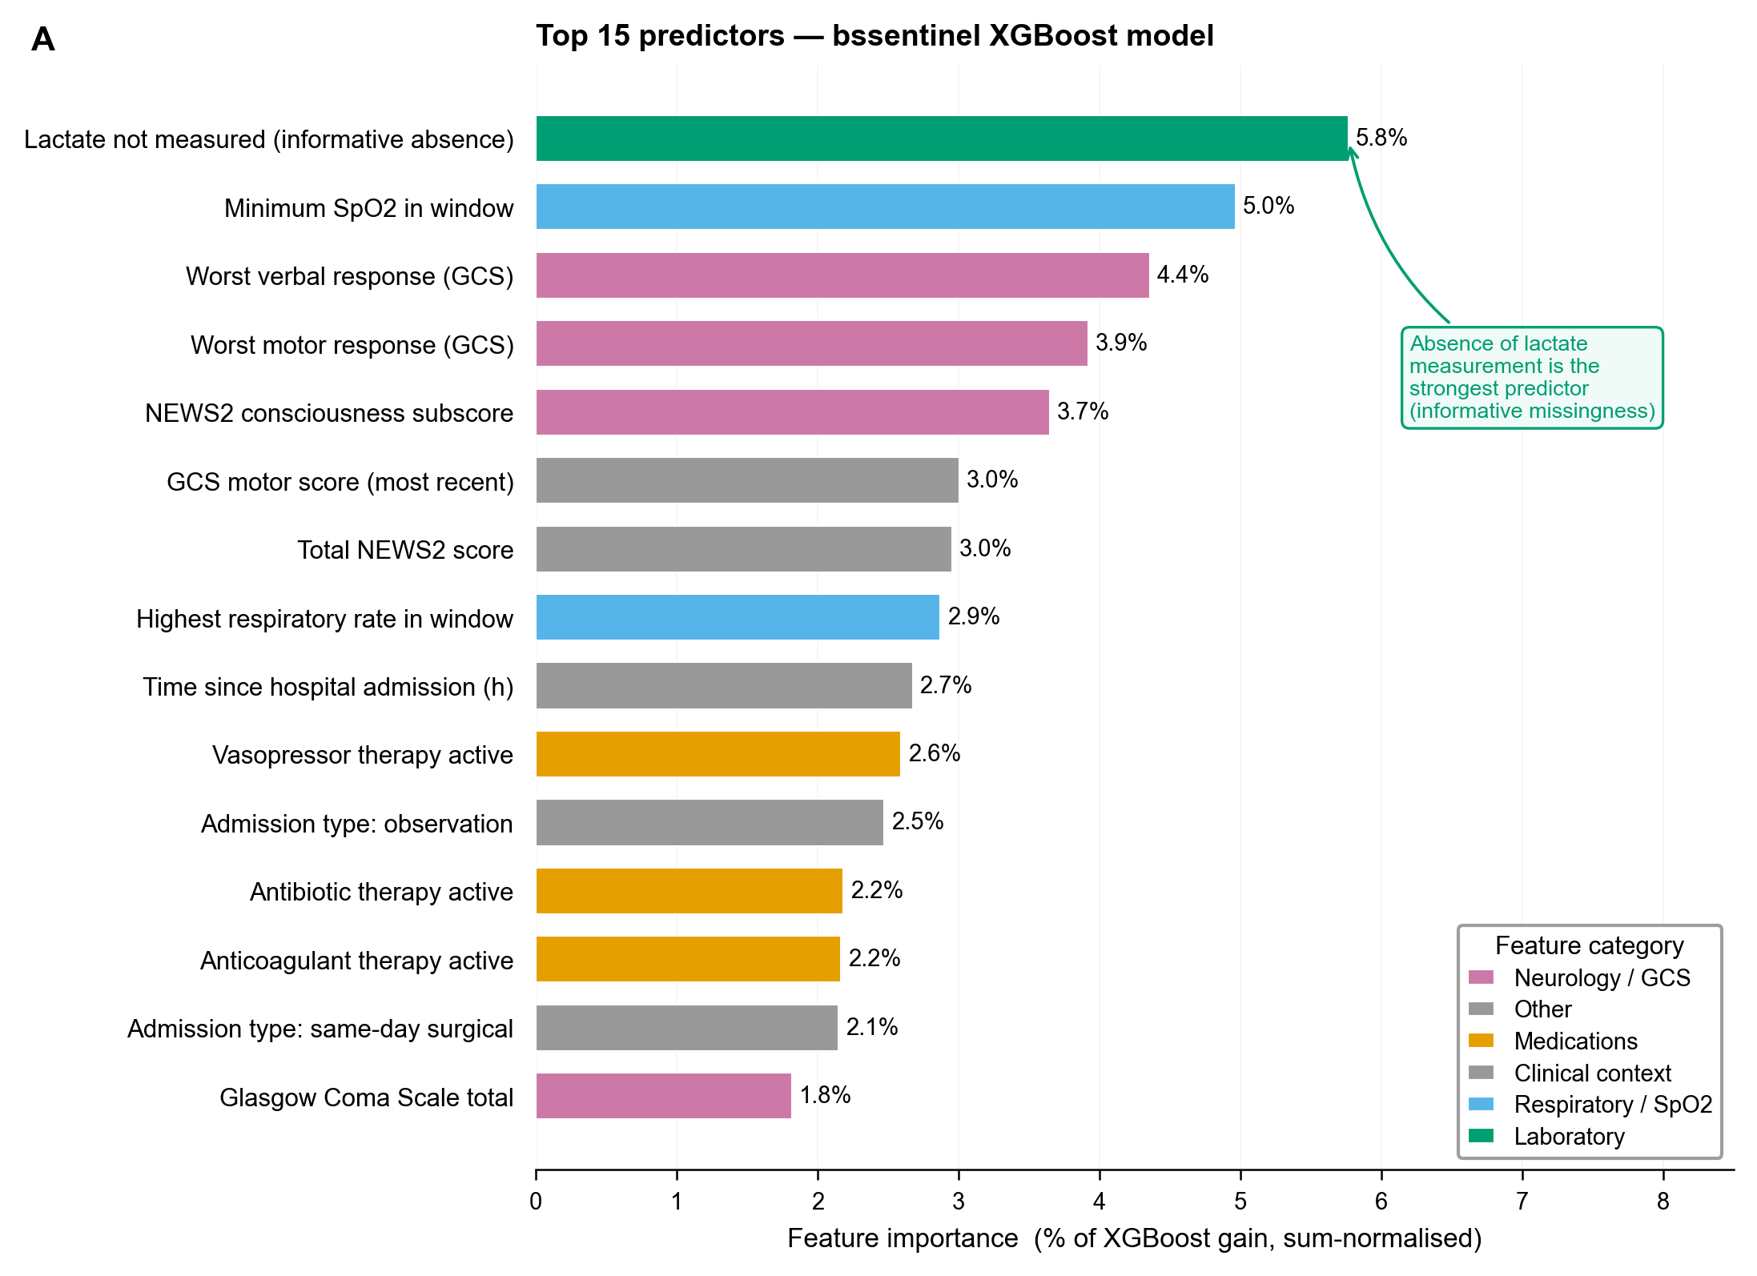
Feature importance. XGBoost gain importance (percentage of total model gain) for the top 15 predictors. Bars are colour-coded by feature category. The most important feature is absence of lactate measurement (informative missingness), indicating that the decision to withhold or not order a laboratory test encodes clinically significant signal. Features are ordered from most to least important (top to bottom).
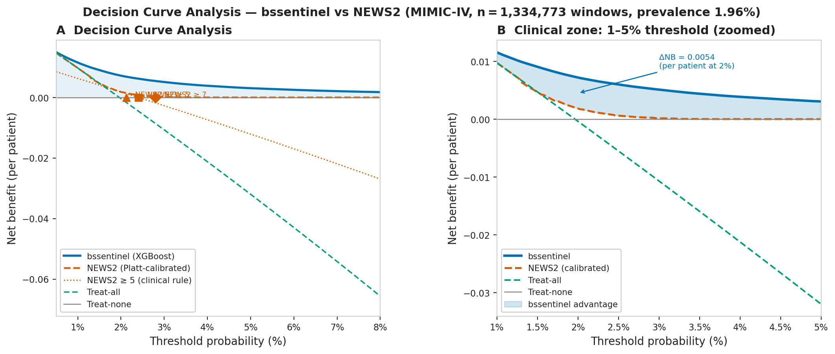
Decision curve analysis. Net benefit curves for bssentinel (XGBoost, solid blue), NEWS2 (Platt-calibrated, dashed orange), treat-all (dot-dash green), and treat-none (NB = 0, grey) across clinically relevant decision threshold probabilities. Both predictors were calibrated to the actual event probability scale before analysis. (A) Full range 0.5–8%. The shaded blue region marks thresholds where bssentinel provides net benefit above treat-none while NEWS2 does not. Markers indicate net benefit at standard NEWS2 clinical cut-offs (NEWS2 $≥$ 3, 5, 7). (B) Zoomed clinical zone 1–5%. At a 2% threshold, bssentinel yields a net benefit of 0.0072 vs 0.0018 for NEWS2 ($Δ$NB = 0.0054), equivalent to identifying 5.4 additional true deteriorations per 1 000 patients. At threshold $≥$3%, NEWS2 net benefit approaches zero while bssentinel retains positive benefit, confirming its superiority as a high-sensitivity surveillance tool at all clinically plausible decision thresholds.
Summary of key performance metrics from five-fold patient-stratified cross-validation on the MIMIC-IV cohort ($n=1,334,773$ windows; 26,201 events; prevalence 1.96%). CI: confidence interval; AUPRC: area under precision-recall curve.
Metric | XGBoost | Logistic Regression | NEWS2
AUROC (95% CI) | 0.758 (0.755–0.761) | 0.708 (0.705–0.711) | 0.568
AUPRC | 0.102 | 0.068 | 0.020
Brier score | 0.175 | 0.213 | —
At threshold = 0.31 (90% sensitivity)
Sensitivity | 90.0% | — | —
Specificity | 37.9% | — | —
PPV | 2.8% | — | —
NPV | 99.5% | — | —
DeLong vs NEWS2 | $z=80.3$, $p<{10}^{-15}$ | — | —
Feature categories and example features included in the 83-variable bssentinel model input. Trend features capture rate of change within the 6-hour window; worst-value features capture the extreme within the window. Missingness indicators encode whether each measurement was absent from the EHR within the relevant lookback period.
Category | Examples | Statistics per feature
Vital signs | Heart rate, SpO$​_{2}$, systolic BP, diastolic BP, respiratory rate, temperature | Most recent, 6h trend, worst value
GCS components | Eye opening, verbal, motor | Most recent, 6h trend, worst value
Laboratory values | Lactate, creatinine, WBC, INR, bilirubin, sodium, potassium, haemoglobin, glucose, platelets, BUN, CRP | Most recent within 24h
NEWS2 subscores | RR, SpO$​_{2}$, BP, HR, temperature, consciousness subscores | Computed from aggregated vitals
Medications | Vasopressors, antibiotics, anticoagulants | Binary active flag
Missingness indicators | All vital and laboratory variables | Binary (0 = observed, 1 = absent)
Temporal context | Hours since admission | Continuous
Admission type | Elective, emergency, observation, surgical | One-hot encoded

Threshold-dependent operating characteristics of the XGBoost model. PPV: positive predictive value; NPV: negative predictive value; TP: true positives; FP: false positives; TN: true negatives; FN: false negatives. All counts are per 1,334,773 windows. Prevalence = 1.96%.
Threshold | Sensitivity | Specificity | PPV | NPV | TP | FP | TN | FN
0.10 | 0.997 | 0.035 | 0.020 | 0.998 | 26,115 | 1,263,129 | 45,443 | 86
0.15 | 0.986 | 0.094 | 0.021 | 0.997 | 25,840 | 1,185,146 | 123,426 | 361
0.20 | 0.969 | 0.176 | 0.023 | 0.997 | 25,392 | 1,078,880 | 229,692 | 809
0.25 | 0.942 | 0.269 | 0.025 | 0.996 | 24,684 | 956,501 | 352,071 | 1,517
0.31* | 0.900 | 0.379 | 0.028 | 0.995 | 23,581 | 813,044 | 495,528 | 2,620
0.35 | 0.855 | 0.465 | 0.031 | 0.994 | 22,390 | 700,256 | 608,316 | 3,811
0.40 | 0.791 | 0.564 | 0.035 | 0.993 | 20,713 | 570,264 | 738,308 | 5,488
0.50 | 0.613 | 0.755 | 0.048 | 0.990 | 16,070 | 320,148 | 988,424 | 10,131
*Recommended operating threshold (90% sensitivity)

Supplementary Figures
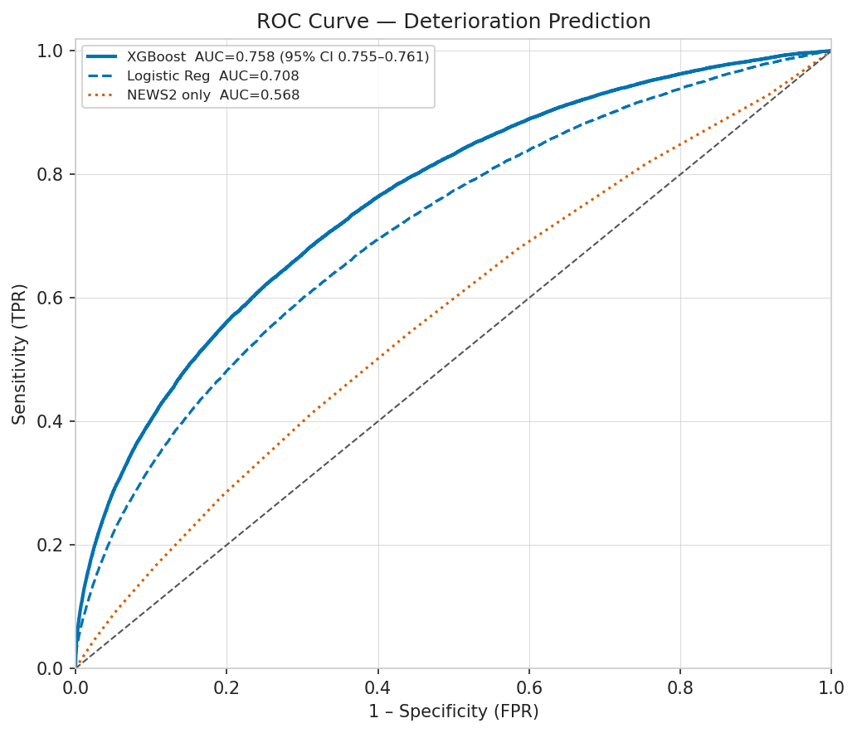
Supplementary Fig. S1 — Receiver Operating Characteristic curves from model training. ROC curves for XGBoost (blue) and logistic regression (orange), pooled from five-fold patient-stratified cross-validation. The diagonal dashed line represents a random classifier. AUROC values with 95% bootstrap confidence intervals are annotated. The marked operating point corresponds to 90% sensitivity at threshold = 0.31.
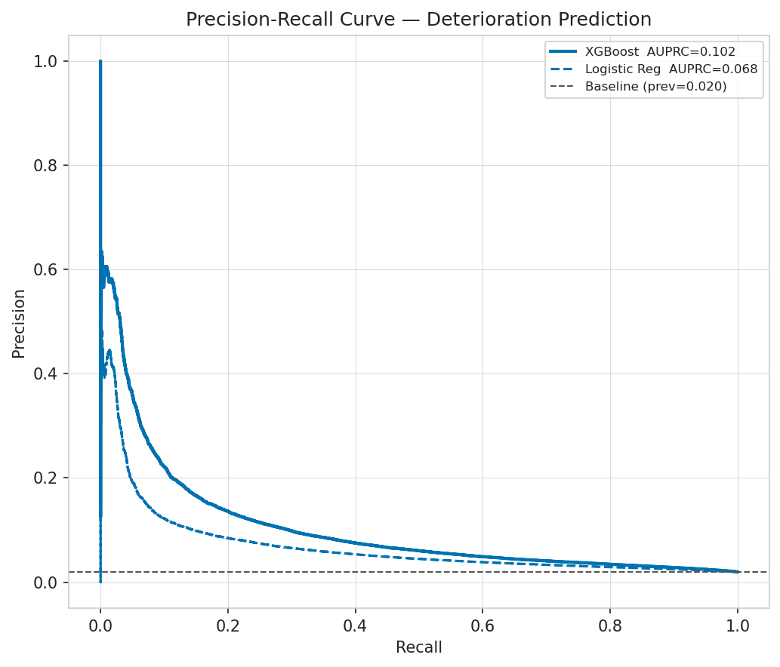
Supplementary Fig. S2 — Precision-Recall curves. Precision-recall curves for XGBoost (blue) and logistic regression (orange). The dashed horizontal line indicates the no-skill baseline equal to event prevalence (1.96%). AUPRC values are annotated. The XGBoost model achieves AUPRC = 0.102, a 5.2-fold improvement over the prevalence baseline, indicating substantially better precision at clinically relevant recall thresholds.
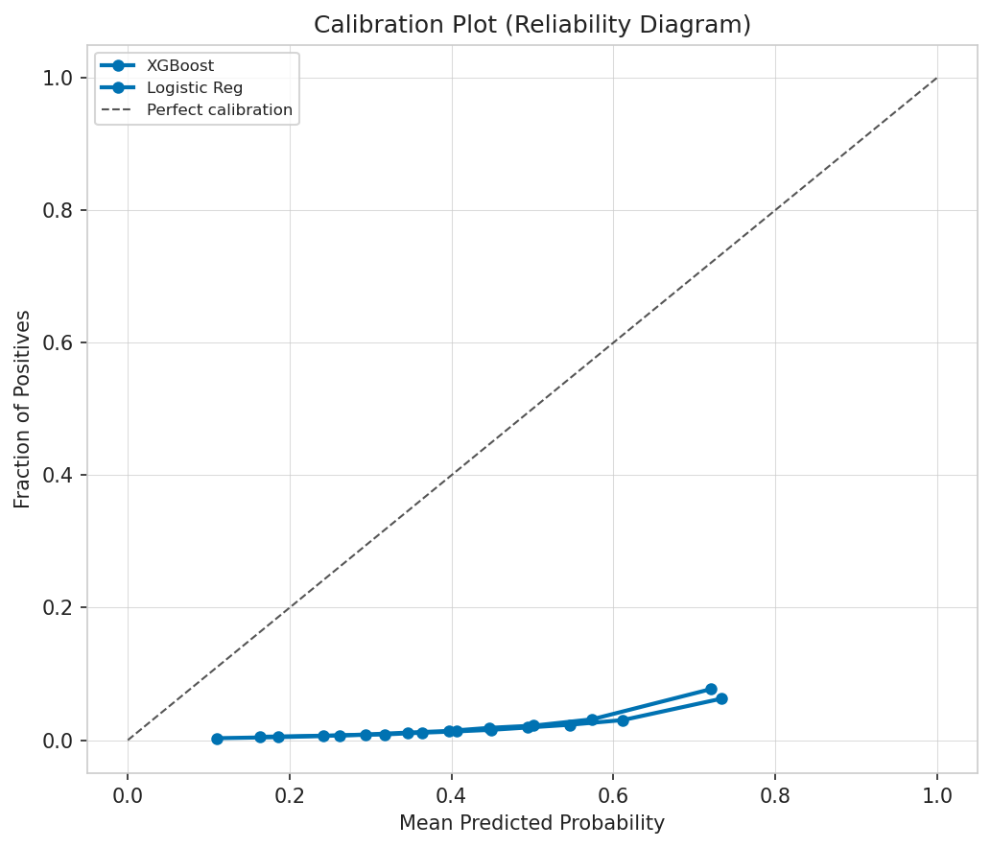
Supplementary Fig. S3 — Calibration curves (reliability diagrams). Reliability diagram comparing predicted probabilities (x-axis) against observed event fractions (y-axis) for XGBoost (blue) and logistic regression (orange). The diagonal dashed line represents perfect calibration. Brier scores are annotated. The XGBoost model (Brier score = 0.175) shows systematic overestimation above predicted probability 0.35, a known consequence of extreme class imbalance; predicted scores should be interpreted as relative risk rankings rather than absolute probabilities.
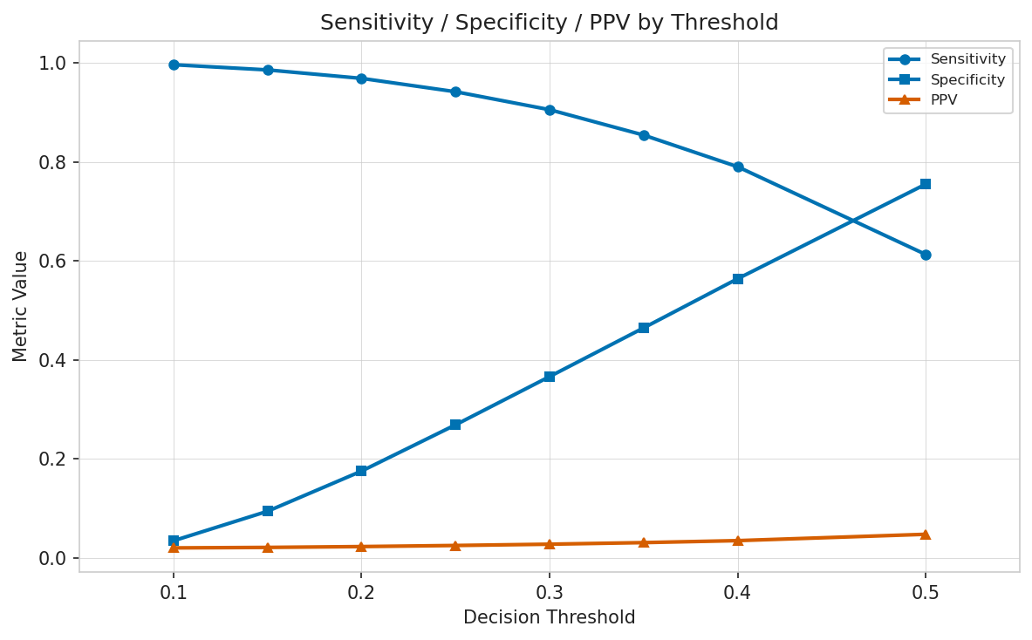
Supplementary Fig. S4 — Threshold operating characteristics. Sensitivity (blue), specificity (orange), PPV (green), and F1 score (red) as a function of decision threshold for the XGBoost model. The vertical dashed line marks the recommended threshold (0.31) corresponding to 90% sensitivity. Institutions may adjust the threshold rightward to reduce alert burden at the cost of sensitivity, or leftward to maximise detection at the cost of increased false-positive alerts.

References

Breiman, Leo. 2001. “Random Forests.” Machine Learning 45 (1): 5–32. https://doi.org/10.1023/A:1010933404324.
Chen, Tianqi, and Carlos Guestrin. 2016. “XGBoost: A Scalable Tree Boosting System.” Proceedings of the 22nd ACM SIGKDD International Conference on Knowledge Discovery and Data Mining, 785–94. https://doi.org/10.1145/2939672.2939785.
Davis, Jesse, and Mark Goadrich. 2006. The Relationship Between Precision-Recall and ROC Curves. 233–40. https://doi.org/10.1145/1143844.1143874.
DeLong, Elizabeth R., David M. DeLong, and Daniel L. Clarke-Pearson. 1988. “Comparing the Areas Under Two or More Correlated Receiver Operating Characteristic Curves: A Nonparametric Approach.” Biometrics 44 (3): 837–45. https://doi.org/10.2307/2531595.
Drew, Barbara J., Patricia Harris, Jessica K. Zègre-Hemsey, et al. 2014. “Insights into the Problem of Alarm Fatigue with Physiologic Monitor Devices: A Comprehensive Observational Study of Consecutive Intensive Care Unit Patients.” PLOS ONE 9 (10): e110274. https://doi.org/10.1371/journal.pone.0110274.
Escobar, Gabriel J., Vincent X. Liu, Alejandro Schuler, Brian Lawson, John D. Greene, and Patricia Kipnis. 2020. “Automated Identification of Adults at Risk for in-Hospital Clinical Deterioration.” New England Journal of Medicine 383 (20): 1951–60. https://doi.org/10.1056/NEJMsa2001090.
Henry, Kenneth E., David N. Hager, Peter J. Pronovost, and Suchi Saria. 2015. “A Targeted Real-Time Early Warning Score (TREWScore) for Septic Shock.” Science Translational Medicine 7 (299): 299ra122. https://doi.org/10.1126/scitranslmed.aab3719.
Holzinger, Andreas, Chris Biemann, Constantinos S. Pattichis, and Douglas B. Kell. 2017. “What Do We Need to Build Explainable AI Systems for the Medical Domain?” arXiv Preprint. https://arxiv.org/abs/1712.09923.
Johnson, Alistair E. W., Lucas Bulgarelli, Lu Shen, et al. 2023. “MIMIC-IV, a Freely Accessible Electronic Health Record Dataset.” Scientific Data 10: 1. https://doi.org/10.1038/s41597-022-01899-x.
Kause, Jan, Gary Smith, David Prytherch, Michael Parr, Arthas Flabouris, and Ken Hillman. 2004. “A Comparison of Antecedents to Cardiac Arrests, Deaths and Emergency Intensive Care Admissions in Australia and New Zealand, and the United Kingdom—the ACADEMIA Study.” Resuscitation 62 (3): 275–82. https://doi.org/10.1016/j.resuscitation.2004.05.016.
Lundberg, Scott M., and Su-In Lee. 2017. “A Unified Approach to Interpreting Model Predictions.” In Advances in Neural Information Processing Systems, edited by Isabelle Guyon et al., vol. 30. Curran Associates.
Meta Platforms, Inc. 2013. React: A JavaScript Library for Building User Interfaces. https://react.dev.
Moons, Karel G. M., Douglas G. Altman, Yvonne Vergouwe, and Patrick Royston. 2009. “Prognosis and Prognostic Research: Application and Impact of Prognostic Models in Clinical Practice.” BMJ 338: b606. https://doi.org/10.1136/bmj.b606.
Prytherch, David R., Gary B. Smith, Paul E. Schmidt, and Peter I. Featherstone. 2010. “VIEWS—Towards a National Early Warning Score for Detecting Adult Inpatient Deterioration.” Resuscitation 81 (8): 932–37. https://doi.org/10.1016/j.resuscitation.2010.04.014.
Rajkomar, Alvin, Eyal Oren, Kai Chen, et al. 2018. “Scalable and Accurate Deep Learning with Electronic Health Records.” Npj Digital Medicine 1: 18. https://doi.org/10.1038/s41746-018-0029-1.
Ramírez, Sebastián. 2018. FastAPI. https://fastapi.tiangolo.com.
Royal College of Physicians. 2017. National Early Warning Score (NEWS2): Standardising the Assessment of Acute-Illness Severity in the NHS. Royal College of Physicians. https://www.rcplondon.ac.uk/projects/outputs/national-early-warning-score-news-2.
Shah, Nigam H., Arnold Milstein, and Steven C. Bagley. 2019. “Making Machine Learning Models Clinically Useful.” JAMA 322 (14): 1351–52. https://doi.org/10.1001/jama.2019.10306.
Smith, Gary B., David R. Prytherch, Paul Meredith, Paul E. Schmidt, and Peter I. Featherstone. 2013. “The Ability of the National Early Warning Score (NEWS) to Discriminate Patients at Risk of Early Cardiac Arrest, Unanticipated Intensive Care Unit Admission, and Death.” Resuscitation 84 (4): 465–70. https://doi.org/10.1016/j.resuscitation.2012.12.016.
Sperrin, Matthew, and Alexander Pate. 2021. “Understanding Missing Data in Electronic Health Records.” BMC Medical Informatics and Decision Making 21: 1–8. https://doi.org/10.1186/s12911-021-01422-1.
Vickers, Andrew J, and Elena B Elkin. 2006. “Decision Curve Analysis: A Novel Method for Evaluating Prediction Models.” Medical Decision Making 26 (6): 565–74. https://doi.org/10.1177/0272989X06295361.
Wells, Brian J., Kevin M. Chagin, Amy S. Nowacki, and Michael W. Kattan. 2013. “Strategies for Handling Missing Data in Electronic Health Record Derived Data.” EGEMS 1 (3): 1035. https://doi.org/10.13063/2327-9214.1035.
Yang, Guo, Guihua Ji, and Peng Niu. 2022. “Explainability of Artificial Intelligence Methods, Applications and Challenges: A Comprehensive Survey.” Information Sciences 615: 238–92. https://doi.org/10.1016/j.ins.2022.10.013.

