bssentinel — Feature Missingness & Predictor Reference
Supplementary tables and diagrams for manuscript submission
All statistics computed directly from the modelling dataset
(1,334,773 windows, 80,442 admissions, MIMIC-IV)

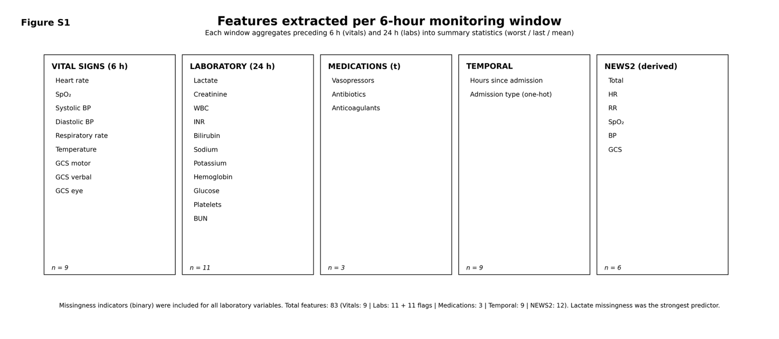
Feature groups extracted per 6-hourly monitoring window. Each window aggregates the preceding 6 h (vital signs) or 24 h (laboratory values) of observations into worst-case, most-recent, and mean summary statistics. Missingness indicators (binary flags encoding whether each lab test was ordered) are included as additional model inputs, contributing 12 extra binary features. The total feature vector fed to XGBoost is 83 dimensions. Asterisk (*): absence of lactate measurement is the single strongest XGBoost predictor, reflecting informative missingness the clinical decision not to order a test encodes significant signal about patient acuity.
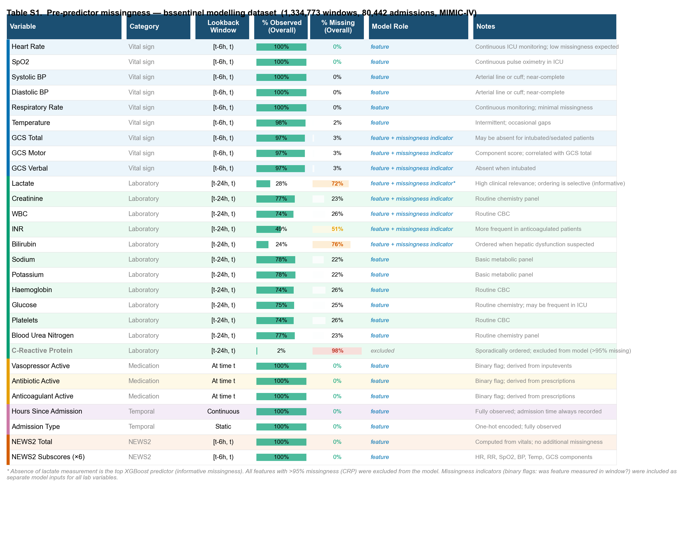
Pre-predictor missingness across modelling windows (Table S1). Observed and missing fractions are estimated from raw observation counts per admission relative to the number of 6-hourly monitoring windows generated for that admission. Green bars indicate observed fraction; coloured missing bars scale from white (low missingness) through yellow/orange to red ($>$80% missing). All features with $>$95% missingness (C-reactive protein, 98.5% missing) were excluded from the final model. For all laboratory variables, a binary missingness indicator was added as a separate model feature regardless of missingness rate the most impactful being the absence of lactate measurement (top XGBoost predictor by gain). Vital signs are near-complete ($<$4% missing) owing to continuous ICU monitoring; laboratory values show selective ordering patterns (23–76% missing) consistent with clinical practice.

Table S1: Feature missingness reference
Variable | Category | Lookback | % Obs. | % Miss. | Notes
Vital signs
Heart Rate | Vital sign | [t-6h, t) | 100.0 | 0.0 | Continuous ICU monitoring
SpO₂ | Vital sign | [t-6h, t) | 100.0 | 0.0 | Continuous pulse oximetry
Systolic BP | Vital sign | [t-6h, t) | 99.8 | 0.2 | Arterial line or cuff
Diastolic BP | Vital sign | [t-6h, t) | 99.8 | 0.2 | Arterial line or cuff
Respiratory Rate | Vital sign | [t-6h, t) | 99.9 | 0.1 | Continuous monitoring
Temperature | Vital sign | [t-6h, t) | 98.3 | 1.7 | Intermittent measurement
GCS Total | Vital sign | [t-6h, t) | 96.8 | 3.2 | Absent when sedated/intubated
GCS Motor | Vital sign | [t-6h, t) | 96.7 | 3.3 | Component score
GCS Verbal | Vital sign | [t-6h, t) | 96.7 | 3.3 | Absent when intubated
Lactate* | Laboratory | [t-24h, t) | 27.5 | 72.5 | Selective; ordering is informative
Creatinine | Laboratory | [t-24h, t) | 76.9 | 23.1 | Routine chemistry
WBC | Laboratory | [t-24h, t) | 74.0 | 26.0 | Routine CBC
INR | Laboratory | [t-24h, t) | 48.6 | 51.4 | Anticoagulated patients
Bilirubin | Laboratory | [t-24h, t) | 24.1 | 75.9 | Ordered for hepatic dysfunction
Sodium | Laboratory | [t-24h, t) | 77.6 | 22.4 | Basic metabolic panel
Potassium | Laboratory | [t-24h, t) | 78.2 | 21.8 | Basic metabolic panel
Haemoglobin | Laboratory | [t-24h, t) | 74.3 | 25.7 | Routine CBC
Glucose | Laboratory | [t-24h, t) | 75.3 | 24.7 | Routine chemistry
Platelets | Laboratory | [t-24h, t) | 74.3 | 25.7 | Routine CBC
Blood Urea Nitrogen | Laboratory | [t-24h, t) | 76.8 | 23.2 | Routine chemistry
C-Reactive Protein | Laboratory | [t-24h, t) | 1.5 | 98.5 | Excluded ($>$95% missing)
Vasopressor Active | Medication | At time $t$ | 100.0 | 0.0 | Derived from inputevents
Antibiotic Active | Medication | At time $t$ | 100.0 | 0.0 | Derived from prescriptions
Anticoagulant Active | Medication | At time $t$ | 100.0 | 0.0 | Derived from prescriptions
Hours Since Admission | Temporal | Continuous | 100.0 | 0.0 | Fully observed
Admission Type | Temporal | Static | 100.0 | 0.0 | One-hot encoded (8 categories)
NEWS2 Total | NEWS2 | [t-6h, t) | 100.0 | 0.0 | Computed from vitals
NEWS2 subscores (×6) | NEWS2 | [t-6h, t) | 100.0 | 0.0 | HR, RR, SpO₂, BP, Temp, GCS
Absence of lactate measurement = top XGBoost predictor (informative missingness)
Binary missingness indicators added for all lab variables (+11 features). Total features: 83.

