**Abstract**

Monitoring blood pressure (BP) and peripheral capillary oxygen saturation (SpO2) plays a crucial role in healthcare management for patients with chronic problems especially hypertension and other cardiovascular diseases. However, BP measuring devices such as cuff-based BP measurement can make the patients uncomfortable inflation and deflation process. As photoplethysmogram (PPG) signals are collected via non-invasive devices, it has aroused researchers＇interest to integrate the function of estimating BP with deep learning on PPG signals. In addition, high correlation between PPG signals and blood pressure SpO₂ indicates the possibility of simultaneous estimation of SBP, DBP, and SpO₂ using PPG signals. In this paper, we propose a Transformer-based deep learning architecture that utilizes PPG signals as input to conduct personalized estimation of blood oxygen (SpO₂), systolic blood pressure (SBP) and diastolic blood pressure (DBP). The proposed method was evaluated with a subset of 1,732 subjects from the publicly available dataset MIMIC III. The mean absolute error is 3.62 ± 5.48 mmHg for SBP, 1.96 ± 3.11 for DBP, and 0.62 ± 1.43 for SpO₂, which satisfy the requirements of the Association of Advancement of Medical Instrumentation (AAMI) standard and achieve grade A for the British Hypertension Society (BHS) standard. The results indicate that our model meets clinical standards and could potentially boost the accuracy of BP and SpO₂ measurement to deliver high quality healthcare.

*Keywords*: blood pressure estimation; photoplethysmogram; deep learning; Transformer

1. **Introduction**

Chronic heart diseases are considered to be one of the most prevalent causes of death nowadays [[1]](https://paperpile.com/c/j086y4/mRpS), and high blood pressure (BP) is one of the main issues to be blamed for [[2]](https://paperpile.com/c/j086y4/psDt). Hypertension, defined as systolic blood pressure (SBP) higher than 140 mmHG or diastolic blood pressure (DBP) higher than 90 mmHG [[3]](https://paperpile.com/c/j086y4/60ri). According to the World Heart Federation (WHF), approximately 50 percent of ischemic strokes are caused by hypertension [[4]](https://paperpile.com/c/j086y4/1rkZ). In addition, with the Covid-19 pandemic ravaging the world, a recent study shows almost 75% of patients who have died due to Covid-19 in Italy had a history of hypertension, which indicates a high correlation between hypertension and Covid-19 mortality [[5]](https://paperpile.com/c/j086y4/3CQh). For patients who are suffering from heart diseases, BP monitoring and management in the normal range is crucial.

Techniques like cuff-based BP measurement devices have been widely used for continuously monitoring BP. However, such measurement always brings discomfort to patients during the inflation and deflation of the cuff, which may affect patients' blood pressure and introduce higher levels of uncertainty [[6,7]](https://paperpile.com/c/j086y4/qVXQ+Eoxw). Thus, cuffless-based measurement has aroused researchers' and clinicians' interests for non-invasive purposes [[8,9]](https://paperpile.com/c/j086y4/S2JB+otuD). Photoplethysmography (PPG) and electrocardiogram (ECG) signals are collected by harmless measurement devices (i.e., Fibre optic sensor [[10]](https://paperpile.com/c/j086y4/Uz1O), force sensitive electromechanical film (EMFi) sensor [[11]](https://paperpile.com/c/j086y4/euPS)), which have shown close correlation when estimating blood pressure. BP is a quasi-periodic signal in sync with the patient’s heartbeats. The peak in each period is defined as systolic blood pressure (SBP), and lower bound refers to diastolic blood pressure (DBP), and high correlation between SBP, DBP, and PPG signals is shown in figure 1.

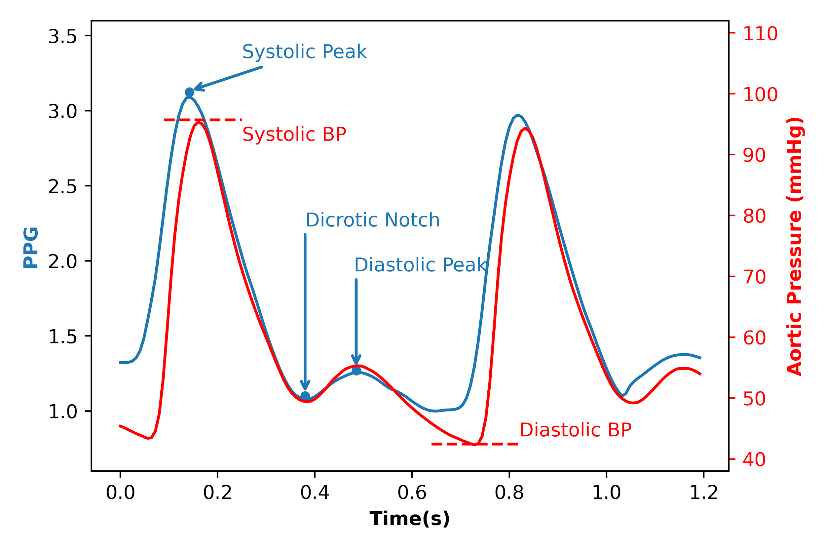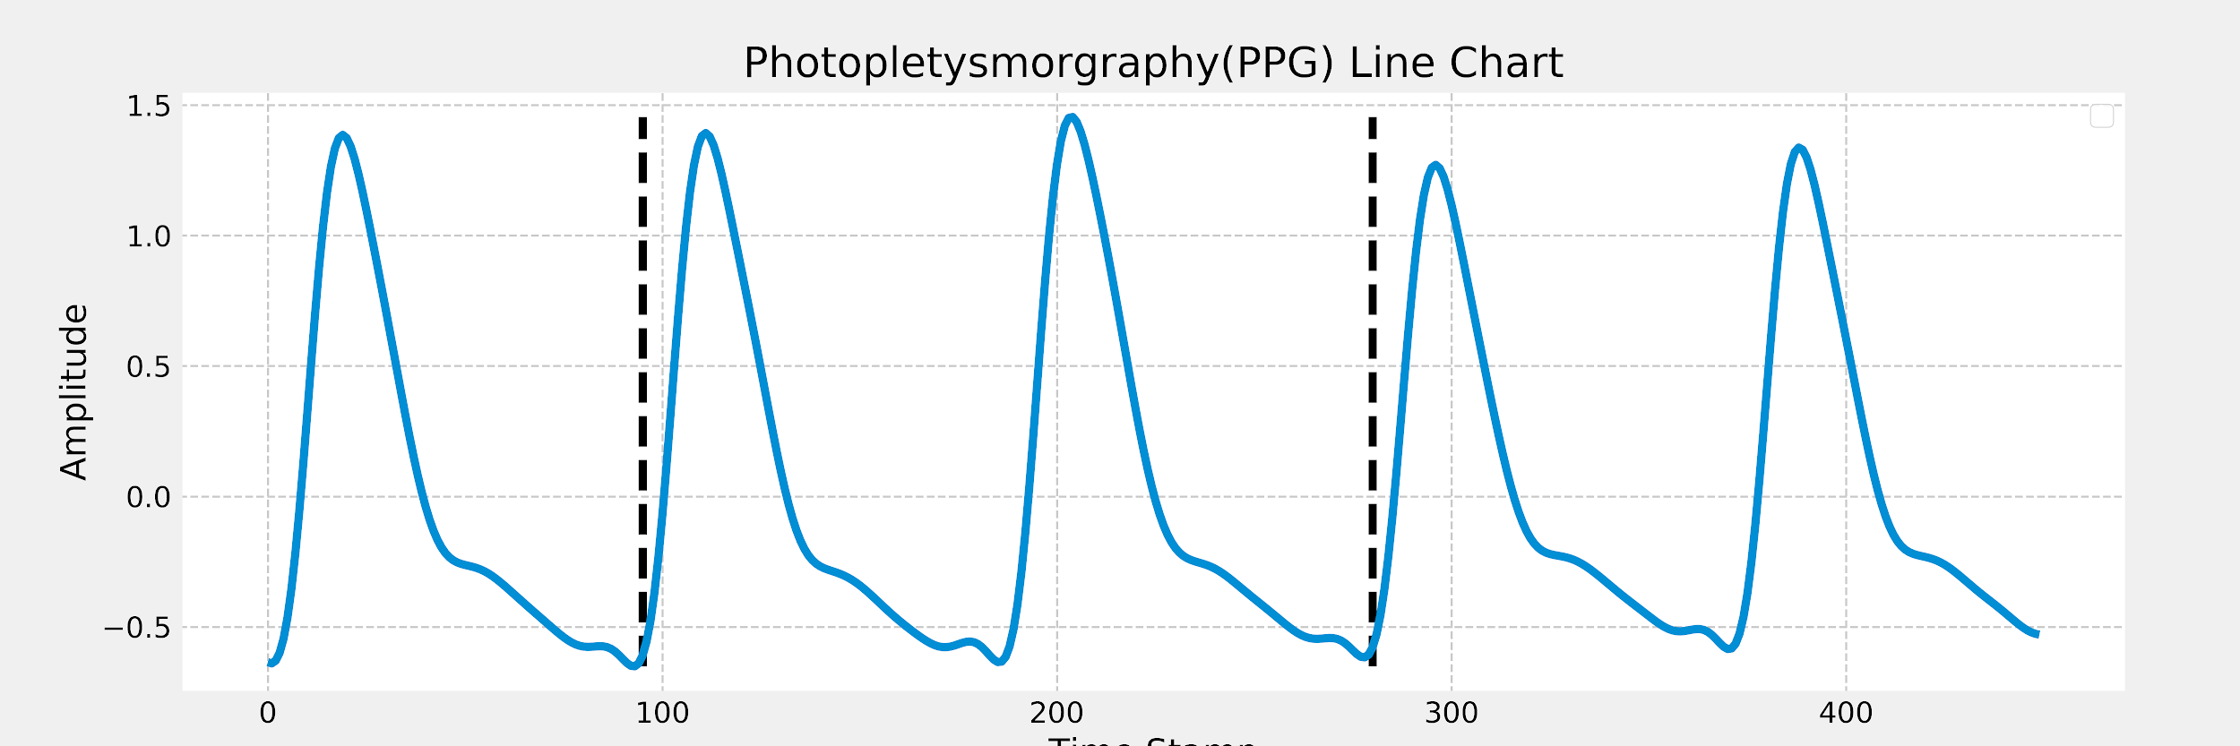

**Figure 1**. Aortic Pressure and PPG signals

Besides potential in the estimation of BP, PPG signals serve as a promising input in estimation of SpO₂ with appropriate modelling [[12]](https://paperpile.com/c/j086y4/VWcv). Oxygen saturation is an indicator of the percentage of hemoglobin saturated with oxygen at the time of the measurement, often documented as SpO₂ [[12,13]](https://paperpile.com/c/j086y4/VWcv+jATX). Normal SpO2 ranges in 95 to 100 percent, while below 90 percent is considered as abnormal and called hypoxemia, which may cause other complications, such as nausea [[14]](https://paperpile.com/c/j086y4/gCCo), fatigue [[15]](https://paperpile.com/c/j086y4/94ys), organ damage and failure [[16]](https://paperpile.com/c/j086y4/8QHS). Several works have demonstrated how mechanisms of PPG signaling could be used to measure the level of SpO₂ [[12,17]](https://paperpile.com/c/j086y4/E03B+VWcv). However, up to date we haven’t found works that utilize deep learning (DL) models on PPG signals acquired from medical devices to estimate SpO₂ level and blood pressure simultaneously.

Hence, in this paper, we propose a method to estimate BP and SpO₂ simultaneously using Transformer based deep learning architecture and multitask learning. Our model only needs the raw PPG signal to estimate SBP, DBP, and SpO₂. To the best of our knowledge, this is the first work in estimation of SBP, DBP, and SpO₂ simultaneously. In addition, this is the first work employing Transformer based algorithms in estimation of BP and SpO₂ using PPG signals. This approach maintains many advantages including:

1. Utilizing multitask learning to estimating SBP, DBP, and SpO₂ from raw PPG signals simultaneously could boost the overall performance due to high correlation among these tasks.
2. This method does not require beat-segmentation of PPG signals and is suitable for a diverse time range of PPG signals to deliver accurate BP and SpO₂ estimation.
3. Pre-training and fine-tuning models are naturally appropriate for personalized model training, which improve the accuracy.
4. The model satisfies the requirements of Association of Advancement of Medical Instrumentation (AAMI) standard and achieves grade A for the British Hypertension Society (BHS) standard with significantly low mean absolute error (MAE) on a large testing set.

This paper is organized in the following manner. Section 2 focuses on related work and motivation of this study. Section 3 illustrates the data collection and pre-processing of raw data. Section 4 introduces the Transformer-based personalized BP and SpO₂ estimation pipeline. Section 5 discusses the experiment results and shows a comparison with the AAMI and BHS standard. Section 6 concludes the advantages and limitations of this work.

1. **Related Works and Motivation**

The objective of this paper is to estimate SBP, DBP, and SpO₂ using a PPG signal. Prior works proposed several methods for estimation of SBP and DBP by using the PPG signal, which could be categorized into feature-extraction approaches and deep learning-based approaches.

In recent years, many studies have been conducted to estimate BP using PPG signals. [[18]](https://paperpile.com/c/j086y4/uRi1) adopted the spectro-temporal neural network consisting of convolutional neural networks (CNN) and gated recurrent units (GRU) to predict blood pressure level based on PPG signals and its first and second derivative. [[19]](https://paperpile.com/c/j086y4/G6we) employed a U-net based deep learning architecture to estimate arterial BP (ABP) waveform using PPG signal only, and estimation of related BP is achieved by using the peak detection algorithm on MIMIC dataset. [[19,20]](https://paperpile.com/c/j086y4/G6we+ZymD) introduced a GRU-based deep learning approach with time domain-based features to estimate BP using raw PPG signals. However, these methods failed to estimate BP and SpO₂ simultaneously, whose high correlation contributes to more robust and accurate estimation. In addition, relatively small sample size may introduce higher uncertainty in the deep learning model training process and undermine generalizability.

In [[21–23]](https://paperpile.com/c/j086y4/SA8E+WR1u+hg87), the methods based on Pulse Transit Time (PTT) were proposed. PTT refers to the time used for blood pressure waves transiting to the wrist, where the PPG signal is recorded. Moreover, [[24–26]](https://paperpile.com/c/j086y4/gTVn+yma6+MA6V) introduced additional features based on the second derivative of PPG signal and demographic features to boost accuracy of estimating BP. All feature extraction-based methods start with extracting features from the PPG signal with a pre-defined feature extraction pipeline, which may fail to capture all information inherited in the signals and lead to deteriorated generalizability. In addition, none of feature extraction-based methods exploit temporal information by considering PPG signals as time series data, which undermines the estimation performance.

With the development of deep learning, many studies implemented deep learning-based methods in estimation of BP using PPG signals [[18–20,27]](https://paperpile.com/c/j086y4/G6we+uRi1+F91L+ZymD). Introduction of convolutional neural network and recurrent neural network tremendously improved estimation accuracy due to its remarkable local and temporal information extraction by complicated non-linear model architecture. Although extraordinary performance is achieved by deep learning-based methods, its requirement for input format may burden its deployment since heterogeneity in clinical settings may require BP estimation given PPG signals with varying sequence lengths. Furthermore, the number of objects in previous studies is limited, and robustness is not fully discussed.

We noticed that SpO₂ maintains high correlation with PPG signals, and we believe multi-task estimation of SBP, DBP, and SpO₂ could be mutually beneficial since additional information is introduced in representation learning procedures. Hence, we introduced Transformer encoder-based pipeline to simultaneously estimate SBP, DBP, and SpO₂, which overcome the shortcoming of deep learning-based methods by introducing masking mechanism, while achieving impressive estimation performance satisfying AAMI and BHS standards.

1. **Materials and Methods**

Our work utilizes the MIMIC III database, available at [[28]](https://paperpile.com/c/j086y4/8tb1). This database contains a mixture of different types of digital data (typically contains ECG, ABP, respiration, PPG and others) with over 60,000 records from more than 30,000 ICU patients. Each patient has at least one record, which ranges from seconds (usually anomalies) to hundreds of hours. Following methods described in [[18]](https://paperpile.com/c/j086y4/uRi1), we extracted ABP and PPG signals from bedside waveform records,

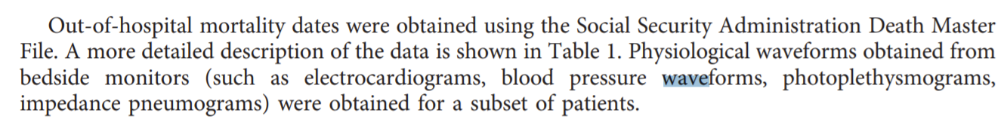

cleaned and pre-processed the data to rule out the anomalies. After that, we did empirical mode decomposition on PPG 20-second slices and divided the results onto 4 channels and fed them into a Transformer encoder-based model, and finally the embedding of each record are fed as input into a feed-forward network for regression on the corresponding SpO₂, SBP and DBP values.

The preprocessing and cleaning steps of the dataset are illustrated in Figure 1. The entire waveform dataset was downloaded into a dedicated server and transformed to the proper MATLAB format by the wfdb2mat function in the WFDB software package. In addition, using waveform type information from the header files, we excluded those records not containing ABP or PPG (specified as ABP and PLETH in header files), and removed the files smaller than 17 kilobytes.

Afterwards, we took more detailed cleaning procedures to enhance waveform quality. Initially, we set the time length threshold of records to be 10 minutes while records shorter than that were deleted. Then we checked the morphology of waveform signals and found that a large proportion of signals contain abnormalities, which can be divided into two major categories: flat lines and flat peaks. We applied a cycle peak-valley detection algorithm proposed by [[18,29]](https://paperpile.com/c/j086y4/uRi1+Lq8o) on both ABP and PPG signals, and signals were further cut into slices which contain separate cycles. Using locations of peaks and valleys, we defined “flat” as 3 or more consecutive equal values, hence the proportion of flat parts in the whole record of both ABP and PPG signals was calculated. If the proportion was beyond 5%, we simply discarded the whole record. For those records containing flat parts less than 5%, we discarded the flat part and sutured the remaining part.

After initial preprocessing, we then filtered the PPG data with a 4th order Butterworth band-pass filter with a range of frequencies in 0.5 to 8 Hz to filter out baseline wandering under 0.5 Hz and high-frequency noise above 8 Hz. ABP data was filtered with a Hampel filter with a sliding window of 100 values. The median of each window was computed. Outliers were replaced with the median if it differed 3 sigma below or above from the median. It’s important to note that since our data came from different sources, we didn’t apply any global or local normalization to the records.

Finally, we made slices based on the preprocessed data. For PPG signals, from the onset time point of the beat cycle, we checked the following 20-second slices and located all cycles within the range and evaluated them. If no more than 3 cycles were determined to be abnormal, we then checked the corresponding ABP signals in the same procedure, and then calculated the related average SBP and DBP values. If more than 3 cycles in ABP or PPG signals appeared to be abnormal, we discarded this slice.

After preprocessing and cleaning of the dataset, we have in total 804,676 slices with related SBP and DBP values, belonging to 2,641 records of 1,732 patients. The distribution of SBP, DBP, and SpO₂ values are shown in Figure 2.

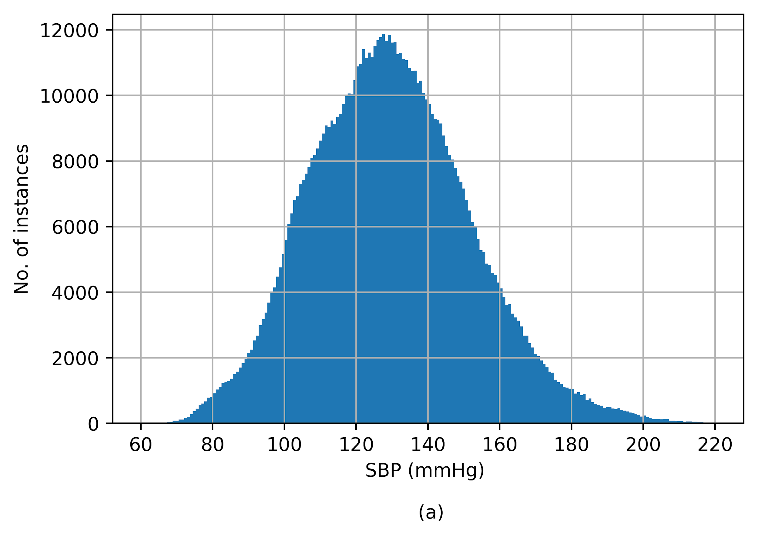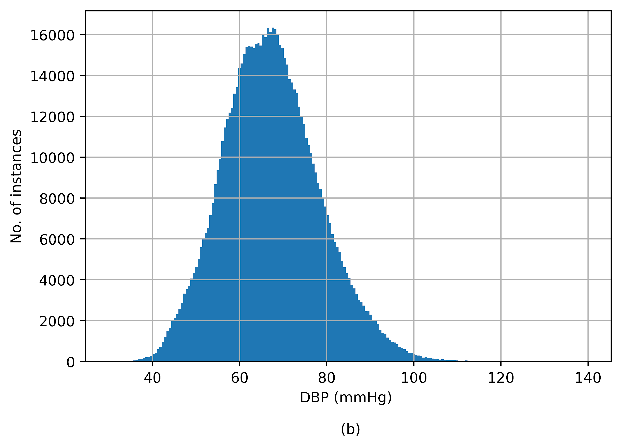

**Figure 2**. Distribution of (**a**) systolic BP (SBP), (**b**) diastolic BP (DBP), and (**c**) SpO₂

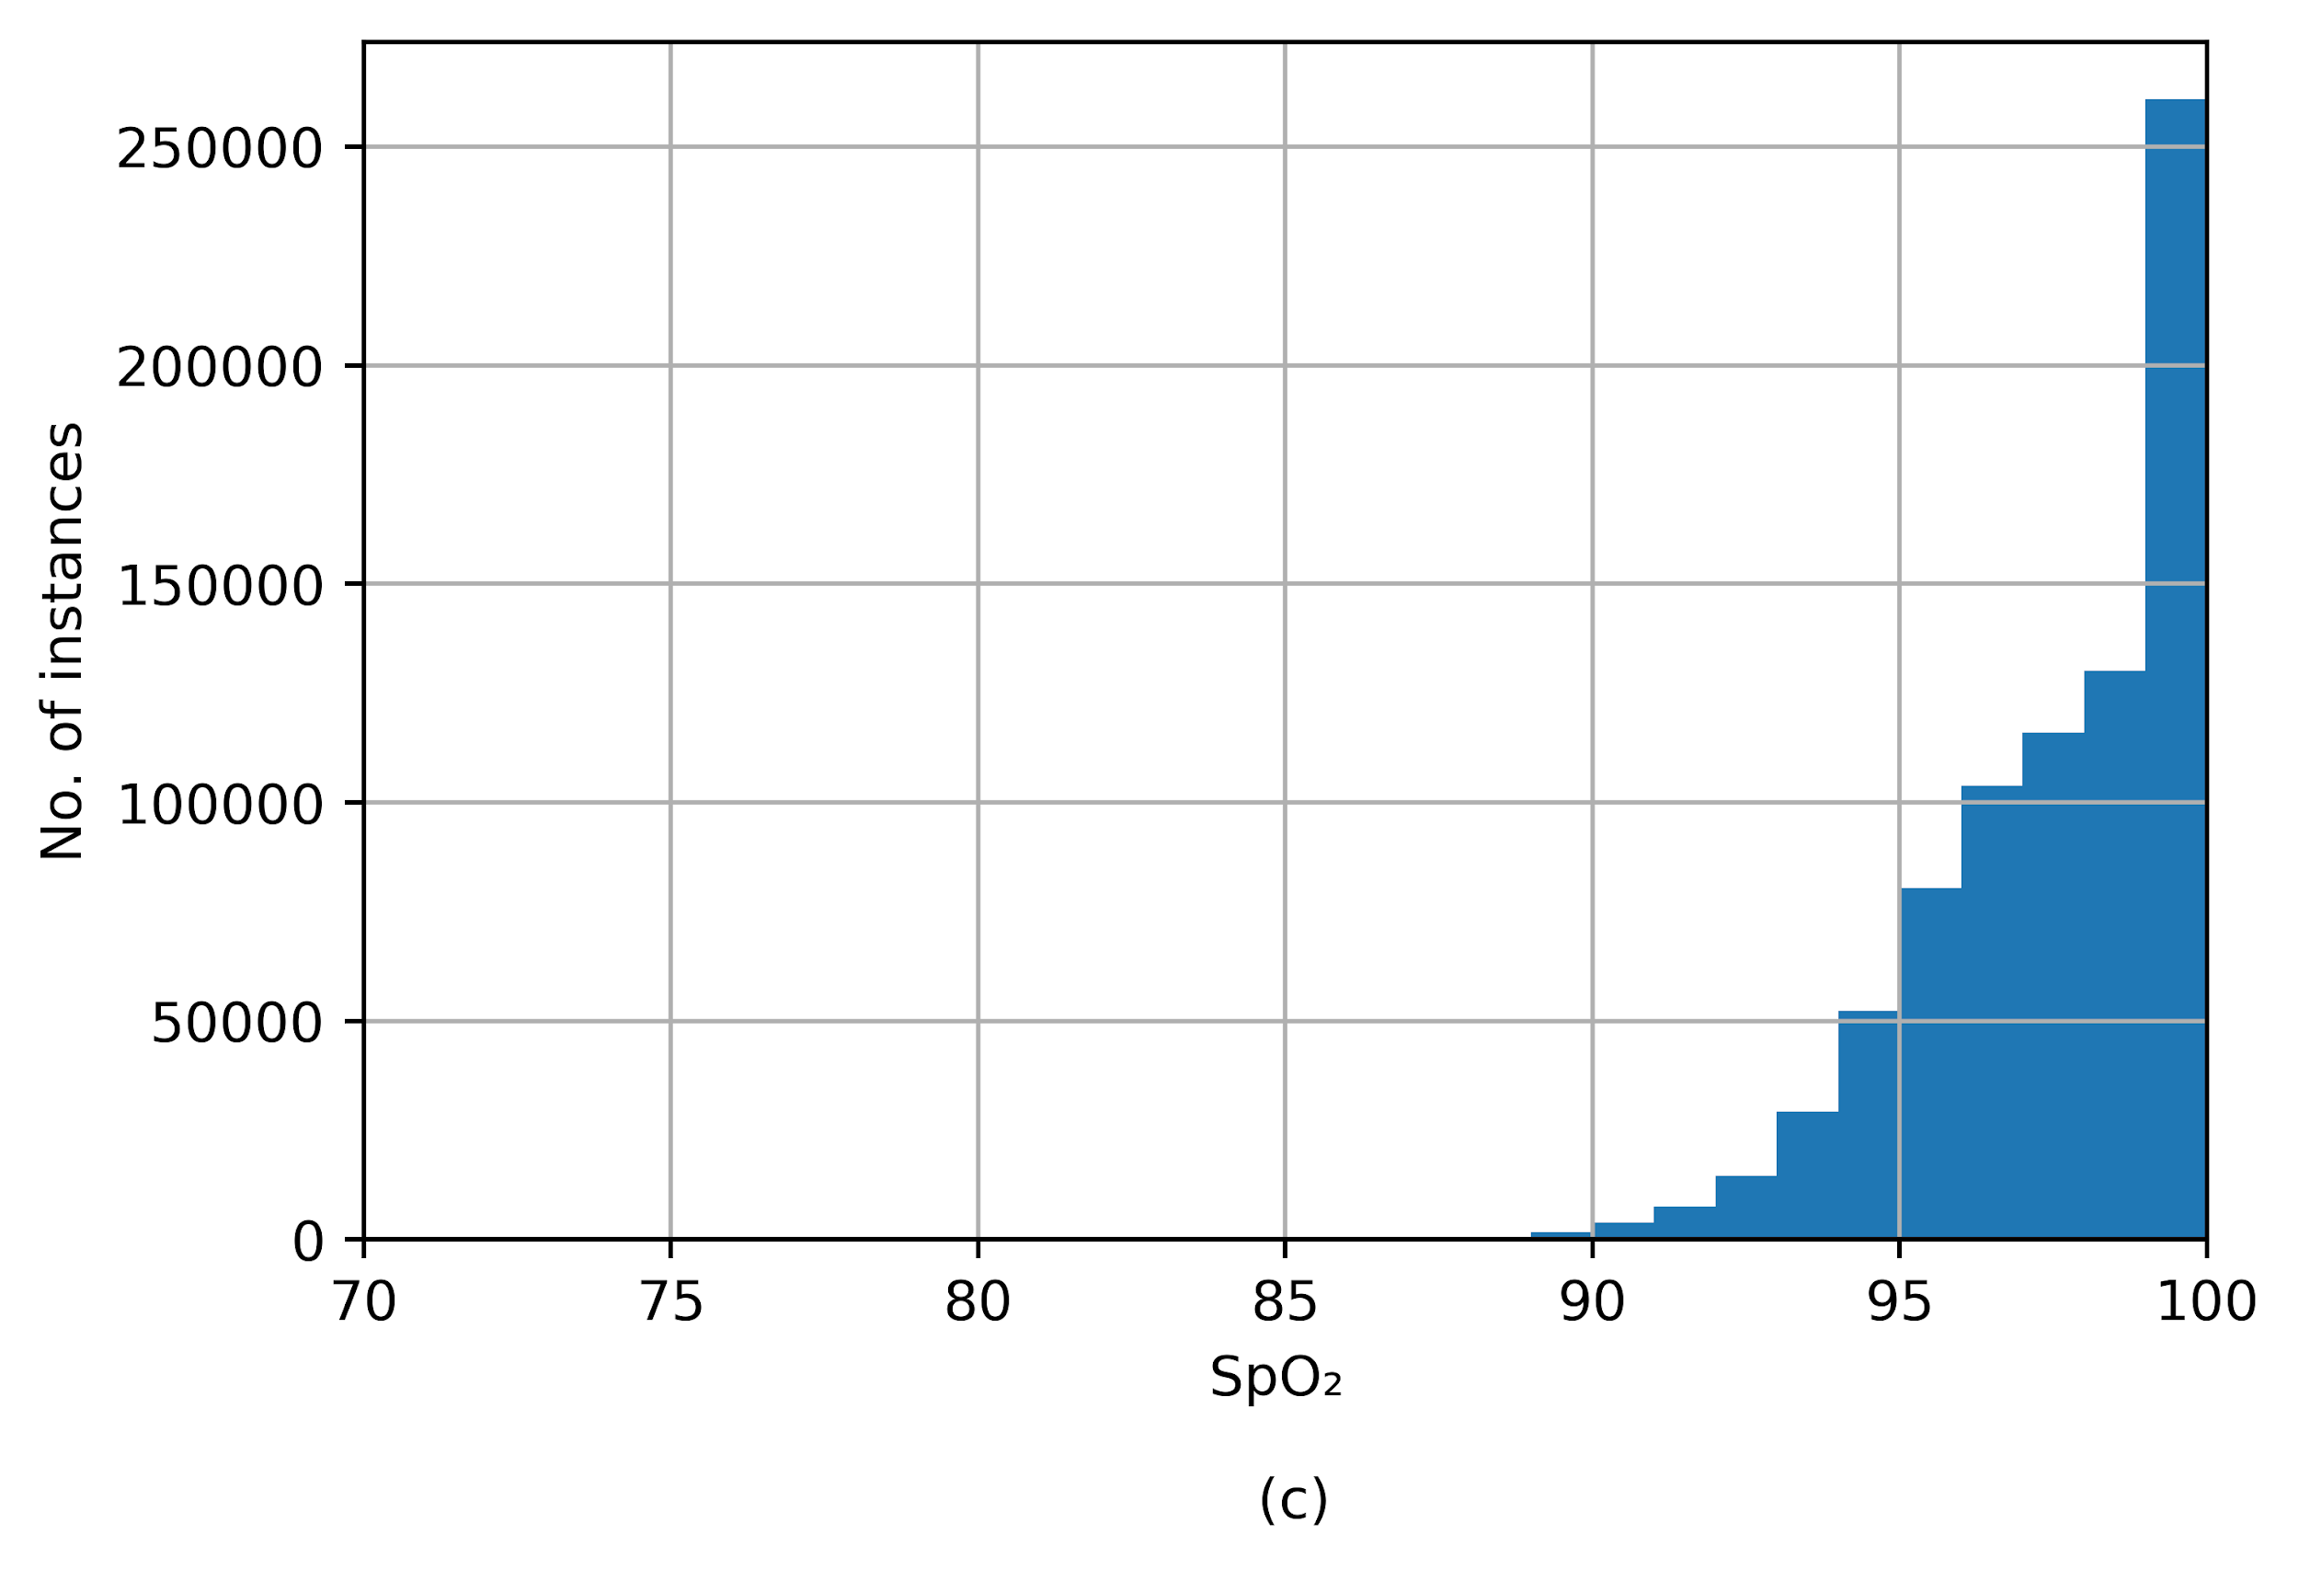

To denoise the PPG signals, we employed empirical mode decomposition (EMD) to process the PPG signals. Since EMD holds a mild assumption on time-series data and is not based on simple sine and cosine waves, it can be used for denoising and feature extraction with original dimensions inherited from raw signals. Hence, a 4-channel time-series data with dimension 2,500 (20 seconds) serves as our input for model training.

1. **Proposed Model**

Recently, Transformer-based models achieved superior performance in NLP and Computer Vision (CV) tasks due to their extraordinary ability of temporal feature extraction and representation. In addition, many previous works applied Transformer to time series forecasting, which showed its potential in time-series regressions [[30,31]](https://paperpile.com/c/j086y4/ooAc+kQoQ). Our deep learning architecture utilizes the Transformer encoder, introduced in the original Transformer work by [[32]](https://paperpile.com/c/j086y4/lr8F). The reason we did not adopt the full Transformer architecture with encoders and decoders is that estimation of BP and SpO₂ concentrates on feature extraction from input data instead of downstream generative tasks. To be specific, the Transformer encoder maintains scalability in feature extraction from time-series inputs and is more suitable for our tasks. We refer the readers to the original paper of Transformer for details in Transformer encoder architecture [[32]](https://paperpile.com/c/j086y4/lr8F) for further clarification.

**4.1 Transformer Encoder Model**

For each training sample , where *w* refers to the number of channels generated by EMD, and *l* refers to length of channel. Standardization for each channel is conducted by subtracting its mean and divide by the standard deviation and then a linear projection onto *D*-dimensional representation space is used, where *D* refers to input dimension of the transformer model:

where are learnerable linear projection parameters. The output serves as the input for the transformer encoder model, which could be used as queries, keys, and values in self-attention layers.

Since the attention mechanism could not naturally capture ordering information, a positional encoder is required to inform the model of the ordering of input signals. So we added positional encodings to the input vector :

We noticed that in the original transformer encoder, the deterministic sinusoidal positional encoder achieved extraordinary performance in many NLP tasks, however, PPG signals maintain periodic patterns and a learnable positional encoding could extract such pattern more effectively.

Although input dimension and length of PPG signals in our dataset remains fixed, we may encounter considerable variance in signal length when deploying in real life. This issue is effectively solved with our Transformer-based approach: after setting a maximum signal length , samples with shorter input length are padded, and a padding mask, which introduces extremely large negative values to the attention scores for the padded positions, is utilized to force the model to overlook padded positions. By doing so, our model could potentially handle any PPG signal shorter than our maximum length.

Finally, a layer normalization is conducted after computing self-attention scores and the feed-forward of each encoder block, leading to a robust output. Instead of batch normalization, the layer normalization could achieve better estimation performance since our input signals maintain periodic patterns.

To deliver regression on SBP, DBP, and SpO₂, we adopt fully connected layers to project embedding vectors learned by transformer encoder blocks onto a scalar for each task:

where and are learnable parameters in fully connected layers. The loss function is squared error and is the ground truth values.

**4.2 Pre-trained and Fine-tuning for Personalization Regression**

To further investigate the proposed model in personalized BP and SpO₂ prediction, we introduced unsupervised learning-based pre-training and fine-tuning techniques to conduct personalized prediction. The unsupervised pre-training part aims at learning latent patterns inherited in PPG data from training samples from diverse patients, while the fine-tuning part conducts personalized BP and SpO₂ prediction using individual training samples and model parameters initialized by the pre-training part.

In the unsupervised pre-training part, an autoregressive task is utilized. Basically, for each PPG sequence, a random set of records is masked, and the model is asked to predict masked parts. With pre-trained transformer encoders, we further fine-tune the personalized model for each patient. To avoid the data leakage issue, we split the training and validation set chronologically.

The overall architecture of our Transformer-based model on estimation of BP and SpO₂ using PPG data is shown using a flowchart in Figure 3.

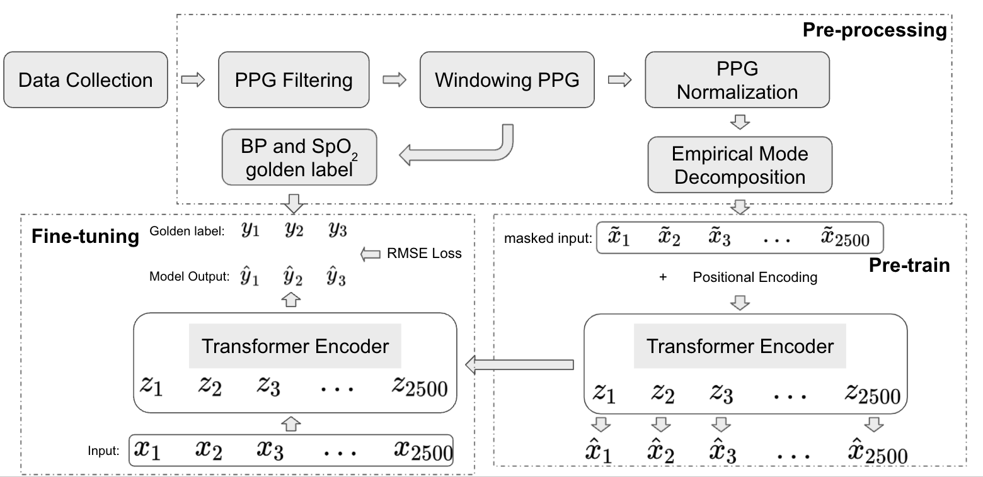

**Figure 3**. BP and SpO₂ Estimation using Photopletysmorgraphy (PPG) by Transformer-based Time Series Model

1. **Experiments**

**5.1 Evaluation Metrics and Experimental Setup**

In this section, the BP and SpO₂ prediction are compared with other models by the mean absolute error (MAE), which is defined as

and the root mean square error (RMSE), which is defined as

The dataset is splitted into training, validation, and testing sets with 70%, 10%, and 20%, respectively.

**5.2 Estimation of BP and SpO₂**

To compare the performance of the proposed approach, several baselines are adopted for prediction of BP and SpO₂, which is shown in Table 1.

|  |  |  |  |
| --- | --- | --- | --- |
| Methods | SpO₂ | SBP | DBP |
| Transformer | 1.65 | 6.7 | 3.5 |
| U-Net with second derivative | 1.02 | 5.03 | 2.98 |
| Transformer with fine-tuning | 0.75 | 4.86 | 2.81 |
| Transformer with personalization (visits with more than 1 record) | **0.62** | **3.62** | **2.16** |

**Table 1**. Performance of the proposed Transformer Model on test dataset for SBP, DBP, and SpO₂ in comparison with traditional Transformer and U-Net.

The Bland-Altman plots for the personalized Transformer model are shown in Figure 4. The x-axes refer to pressure from 60 to 220 mmHg for SBP and 30 to 140 mmHg for DBP, while the y-axes stand for error ranging from -30 to 30 mmHg for our estimation. The dashed horizontal lines refer to error at -15 to 15 mmHg with 5 mmHg as intervals step size. As the Figure 4 shows, most of the SBP and DBP errors lie in [-5, 5].

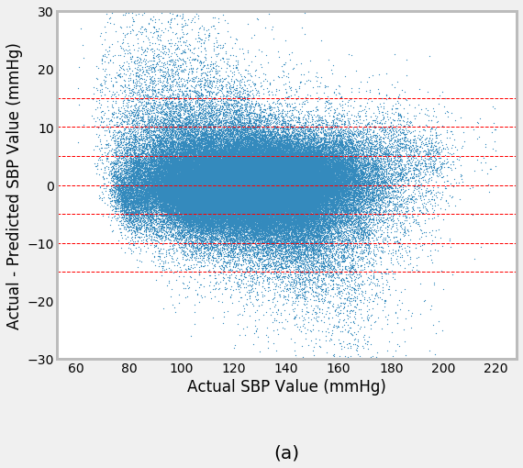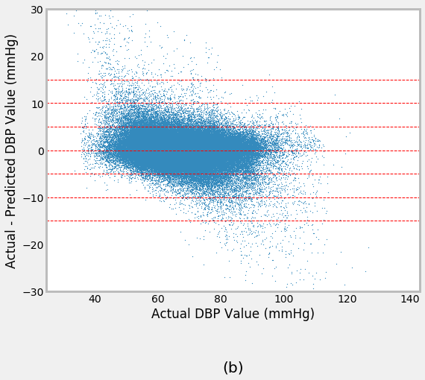

**Figure 4**. Bland-Altman scatterplot for (**a**) SBP and (**b**) DBP values

**5.3 Compliance with Standards**

The estimation on test dataset is compared with the AAMI error standard for estimation of BP [[33]](https://paperpile.com/c/j086y4/S3uM). Note that the Association for the Advancement of Medical Instrumentation (AAMI) standard requires the MAE less than 5 in prediction of BP with more than 85 subjects. Comparison between the AAMI standard and our proposed model is in Table 2.

|  |  |  |  |  |
| --- | --- | --- | --- | --- |
|  |  | No. of Subjects | MAE (mmHg) | STD (mmHg) |
| AAMI Standard [[33]](https://paperpile.com/c/j086y4/S3uM) |  | >85 | <5 | <8 |
| our model (general) | SBP | 1,732 | 4.86 | 7.21 |
| DBP | 1,732 | 2.81 | 4.17 |
| our model (personalized) | SBP | 1,732 | **3.62** | **5.48** |
| DBP | 1,732 | **2.16** | **3.47** |

**Table 2.** Comparison of our result with Association for the Advancement of Medical Instrumentation (AAMI) standard

In addition, the performance of our model is also evaluated by the British Hypertension Society (BHS) grading standard [[34]](https://paperpile.com/c/j086y4/QUaL), which is shown in Table 3. The BHS grading standard measures the cumulative percentage of a pre-defined error range. According to the evaluation, our results achieved “Grade A”.

|  |  |  |  |  |
| --- | --- | --- | --- | --- |
|  |  | Cumulative Error (%) | | |
|  |  | ≤ 5 mmHg | ≤ 10 mmHg | ≤ 15 mmHg |
| BHS grading standard [[34]](https://paperpile.com/c/j086y4/QUaL) | Grade A | 60% | 85% | 95% |
| Grade B | 50% | 75% | 90% |
| Grade C | 40% | 65% | 85% |
| Proposed model | SBP | 88.56% | 96.81% | 98.76% |
| DBP | 96.28% | 99.31% | 99.74% |

**Table 3**. Comparison of our result with British Hypertension Society (BHS) grading standard

1. **Discussion**

In this study, a transformer-based pre-training deep learning model for prediction of BP and SpO₂ simultaneously was proposed using PPG data as the input. Due to the large data dimension and heterogeneity among patients, especially ICU patients, feature extraction based methods are impractical and hard to implement in real life [[35]](https://paperpile.com/c/j086y4/8wnO). Hence, we rely on deep learning models to deliver end-to-end BP and SpO₂ prediction.

Different from LSTM and other recurrent neural networks, transformer based models do not require complicated gates and cell designs to process sequential information, instead attention mechanism is utilized to automatically recognize significant patterns from raw data, which not only boost model’s ability in latent pattern recognition, but also save the computational resources. In addition, since the transformer model was proposed naturally to process unstructured text data, it could tolerate different lengths of input by introducing masks to pad the input. Moreover, pre-training and fine-tuning enable us to train personalized models using not only individual data, but all training samples to deliver robust and reliable results. The experiments showed that personalized models boosted MAE of SBP, DBP and SpO₂ by 1.02, 0.65, and 0.13, respectively.

In our experiment, we collected over 3,000 subjects, which is much higher compared with previous works. Although we achieved similar performance with other works [[19]](https://paperpile.com/c/j086y4/G6we), we are the first one to deliver BP and SpO₂ prediction simultaneously with pre-trained and fine-turned models, which serves as a satisfactory personalization model for not only ICU patients, but also general usage.

In future studies, combination of additional information, e.g. demographic and clinical information, and deep learning model may improve the model performance, which is not fully discovered in this paper. Moreover, in real-world implementation, proper data collection techniques may be required since deep learning models rely on high quality data, which is easily affected in clinical settings. Hence, improper PPG signals are supposed to be abandoned.

**Reference**

[1] [R. Lozano, M. Naghavi, K. Foreman, S. Lim, K. Shibuya, V. Aboyans, J. Abraham, T. Adair, R. Aggarwal, S.Y. Ahn, M. Alvarado, H.R. Anderson, L.M. Anderson, K.G. Andrews, C. Atkinson, L.M. Baddour, S. Barker-Collo, D.H. Bartels, M.L. Bell, E.J. Benjamin, D. Bennett, K. Bhalla, B. Bikbov, A. Bin Abdulhak, G. Birbeck, F. Blyth, I. Bolliger, S. Boufous, C. Bucello, M. Burch, P. Burney, J. Carapetis, H. Chen, D. Chou, S.S. Chugh, L.E. Coffeng, S.D. Colan, S. Colquhoun, K.E. Colson, J. Condon, M.D. Connor, L.T. Cooper, M. Corriere, M. Cortinovis, K.C. de Vaccaro, W. Couser, B.C. Cowie, M.H. Criqui, M. Cross, K.C. Dabhadkar, N. Dahodwala, D. De Leo, L. Degenhardt, A. Delossantos, J. Denenberg, D.C. Des Jarlais, S.D. Dharmaratne, E.R. Dorsey, T. Driscoll, H. Duber, B. Ebel, P.J. Erwin, P. Espindola, M. Ezzati, V. Feigin, A.D. Flaxman, M.H. Forouzanfar, F.G.R. Fowkes, R. Franklin, M. Fransen, M.K. Freeman, S.E. Gabriel, E. Gakidou, F. Gaspari, R.F. Gillum, D. Gonzalez-Medina, Y.A. Halasa, D. Haring, J.E. Harrison, R. Havmoeller, R.J. Hay, B. Hoen, P.J. Hotez, D. Hoy, K.H. Jacobsen, S.L. James, R. Jasrasaria, S. Jayaraman, N. Johns, G. Karthikeyan, N. Kassebaum, A. Keren, J.-P. Khoo, L.M. Knowlton, O. Kobusingye, A. Koranteng, R. Krishnamurthi, M. Lipnick, S.E. Lipshultz, S.L. Ohno, J. Mabweijano, M.F. MacIntyre, L. Mallinger, L. March, G.B. Marks, R. Marks, A. Matsumori, R. Matzopoulos, B.M. Mayosi, J.H. McAnulty, M.M. McDermott, J. McGrath, G.A. Mensah, T.R. Merriman, C. Michaud, M. Miller, T.R. Miller, C. Mock, A.O. Mocumbi, A.A. Mokdad, A. Moran, K. Mulholland, M.N. Nair, L. Naldi, K.M.V. Narayan, K. Nasseri, P. Norman, M. O’Donnell, S.B. Omer, K. Ortblad, R. Osborne, D. Ozgediz, B. Pahari, J.D. Pandian, A.P. Rivero, R.P. Padilla, F. Perez-Ruiz, N. Perico, D. Phillips, K. Pierce, C.A. Pope 3rd, E. Porrini, F. Pourmalek, M. Raju, D. Ranganathan, J.T. Rehm, D.B. Rein, G. Remuzzi, F.P. Rivara, T. Roberts, F.R. De León, L.C. Rosenfeld, L. Rushton, R.L. Sacco, J.A. Salomon, U. Sampson, E. Sanman, D.C. Schwebel, M. Segui-Gomez, D.S. Shepard, D. Singh, J. Singleton, K. Sliwa, E. Smith, A. Steer, J.A. Taylor, B. Thomas, I.M. Tleyjeh, J.A. Towbin, T. Truelsen, E.A. Undurraga, N. Venketasubramanian, L. Vijayakumar, T. Vos, G.R. Wagner, M. Wang, W. Wang, K. Watt, M.A. Weinstock, R. Weintraub, J.D. Wilkinson, A.D. Woolf, S. Wulf, P.-H. Yeh, P. Yip, A. Zabetian, Z.-J. Zheng, A.D. Lopez, C.J.L. Murray, M.A. AlMazroa, Z.A. Memish, Global and regional mortality from 235 causes of death for 20 age groups in 1990 and 2010: a systematic analysis for the Global Burden of Disease Study 2010, Lancet. 380 (2012) 2095–2128.](http://paperpile.com/b/j086y4/mRpS)

[2] [H.-C. Kung, J. Xiu, Hypertension-related Mortality in the United States, 2000-2013, 2015.](http://paperpile.com/b/j086y4/psDt)

[3] [S.S. Virani, A. Alonso, H.J. Aparicio, E.J. Benjamin, M.S. Bittencourt, C.W. Callaway, A.P. Carson, A.M. Chamberlain, S. Cheng, F.N. Delling, M.S.V. Elkind, K.R. Evenson, J.F. Ferguson, D.K. Gupta, S.S. Khan, B.M. Kissela, K.L. Knutson, C.D. Lee, T.T. Lewis, J. Liu, M.S. Loop, P.L. Lutsey, J. Ma, J. Mackey, S.S. Martin, D.B. Matchar, M.E. Mussolino, S.D. Navaneethan, A.M. Perak, G.A. Roth, Z. Samad, G.M. Satou, E.B. Schroeder, S.H. Shah, C.M. Shay, A. Stokes, L.B. VanWagner, N.-Y. Wang, C.W. Tsao, American Heart Association Council on Epidemiology and Prevention Statistics Committee and Stroke Statistics Subcommittee, Heart Disease and Stroke Statistics-2021 Update: A Report From the American Heart Association, Circulation. 143 (2021) e254–e743.](http://paperpile.com/b/j086y4/60ri)

[4] [P. Jeemon, T. Séverin, C. Amodeo, D. Balabanova, N.R.C. Campbell, D. Gaita, K. Kario, T. Khan, R. Melifonwu, A. Moran, E. Ogola, P. Ordunez, P. Perel, D. Piñeiro, F.J. Pinto, A.E. Schutte, F.S. Wyss, L.L. Yan, N.R. Poulter, D. Prabhakaran, World Heart Federation Roadmap for Hypertension - A 2021 Update, Glob. Heart. 16 (2021) 63.](http://paperpile.com/b/j086y4/1rkZ)

[5] [R. Kreutz, E.A.E.-H. Algharably, M. Azizi, P. Dobrowolski, T. Guzik, A. Januszewicz, A. Persu, A. Prejbisz, T.G. Riemer, J.-G. Wang, M. Burnier, Hypertension, the renin–angiotensin system, and the risk of lower respiratory tract infections and lung injury: implications for COVID-19, Cardiovascular Research. 116 (2020) 1688–1699. https://doi.org/](http://paperpile.com/b/j086y4/3CQh)[10.1093/cvr/cvaa097.](http://dx.doi.org/10.1093/cvr/cvaa097.)

[6] [M.J. Zawadzki, A.K. Small, W. Gerin, Ambulatory blood pressure variability: a conceptual review, Blood Press. Monit. 22 (2017) 53–58.](http://paperpile.com/b/j086y4/qVXQ)

[7] [A.J. Viera, L. Tuttle, J. Zeng, Dollars and Discomfort: What Will People Be Willing to Give for Better Blood Pressure Assessment?, J. Clin. Hypertens. . 18 (2016) 422–423.](http://paperpile.com/b/j086y4/Eoxw)

[8] [R. Shriram, A. Wakankar, N. Daimiwal, D. Ramdasi, Continuous cuffless blood pressure monitoring based on PTT, 2010 International Conference on Bioinformatics and Biomedical Technology. (2010). https://doi.org/](http://paperpile.com/b/j086y4/S2JB)[10.1109/icbbt.2010.5479013.](http://dx.doi.org/10.1109/icbbt.2010.5479013.)

[9] [N. Luo, W. Dai, C. Li, Z. Zhou, L. Lu, C.C.Y. Poon, S.-C. Chen, Y. Zhang, N. Zhao, Flexible Piezoresistive Sensor Patch Enabling Ultralow Power Cuffless Blood Pressure Measurement, Advanced Functional Materials. 26 (2016) 1178–1187. https://doi.org/](http://paperpile.com/b/j086y4/otuD)[10.1002/adfm.201504560.](http://dx.doi.org/10.1002/adfm.201504560.)

[10] [T.S. Myllylä, A.A. Elseoud, H.S.S. Sorvoja, R.A. Myllylä, J.M. Harja, J. Nikkinen, O. Tervonen, V. Kiviniemi, Fibre optic sensor for non-invasive monitoring of blood pressure during MRI scanning, J. Biophotonics. 4 (2011) 98–107.](http://paperpile.com/b/j086y4/Uz1O)

[11] [H. Sorvoja, Noninvasive Blood Pressure Pulse Detection and Blood Pressure Determination, 2006.](http://paperpile.com/b/j086y4/euPS)

[12] [T. Tamura, Current progress of photoplethysmography and SPO for health monitoring, Biomed Eng Lett. 9 (2019) 21–36.](http://paperpile.com/b/j086y4/VWcv)

[13] [K.K. Tremper, Pulse Oximetry, Chest. 95 (1989) 713–715. https://doi.org/](http://paperpile.com/b/j086y4/jATX)[10.1378/chest.95.4.713.](http://dx.doi.org/10.1378/chest.95.4.713.)

[14] [O. Akça, D.I. Sessler, Supplemental oxygen reduces the incidence of postoperative nausea and vomiting, Minerva Anestesiol. 68 (2002) 166–170.](http://paperpile.com/b/j086y4/gCCo)

[15] [A. Lewko, P.L. Bidgood, R. Garrod, Evaluation of psychological and physiological predictors of fatigue in patients with COPD, BMC Pulm. Med. 9 (2009) 47.](http://paperpile.com/b/j086y4/94ys)

[16] [P.P. Pandharipande, A.K. Shintani, H.E. Hagerman, P.J. St Jacques, T.W. Rice, N.W. Sanders, L.B. Ware, G.R. Bernard, E.W. Ely, Derivation and validation of Spo2/Fio2 ratio to impute for Pao2/Fio2 ratio in the respiratory component of the Sequential Organ Failure Assessment score, Crit. Care Med. 37 (2009) 1317–1321.](http://paperpile.com/b/j086y4/8QHS)

[17] [M. Shafique, P.A. Kyriacou, S.K. Pal, Investigation of photoplethysmographic signals and blood oxygen saturation values on healthy volunteers during cuff-induced hypoperfusion using a multimode PPG/SpO2 sensor, Medical & Biological Engineering & Computing. 50 (2012) 575–583. https://doi.org/](http://paperpile.com/b/j086y4/E03B)[10.1007/s11517-012-0910-z.](http://dx.doi.org/10.1007/s11517-012-0910-z.)

[18] [G. Slapničar, N. Mlakar, M. Luštrek, Blood Pressure Estimation from Photoplethysmogram Using a Spectro-Temporal Deep Neural Network, Sensors . 19 (2019). https://doi.org/](http://paperpile.com/b/j086y4/uRi1)[10.3390/s19153420.](http://dx.doi.org/10.3390/s19153420.)

[19] [T. Athaya, S. Choi, An Estimation Method of Continuous Non-Invasive Arterial Blood Pressure Waveform Using Photoplethysmography: A U-Net Architecture-Based Approach, Sensors . 21 (2021). https://doi.org/](http://paperpile.com/b/j086y4/G6we)[10.3390/s21051867.](http://dx.doi.org/10.3390/s21051867.)

[20] [C. El Hajj, P.A. Kyriacou, Cuffless and Continuous Blood Pressure Estimation From PPG Signals Using Recurrent Neural Networks, Conf. Proc. IEEE Eng. Med. Biol. Soc. 2020 (2020) 4269–4272.](http://paperpile.com/b/j086y4/ZymD)

[21] [M. Kachuee, M.M. Kiani, H. Mohammadzade, M. Shabany, Cuff-less high-accuracy calibration-free blood pressure estimation using pulse transit time, in: 2015 IEEE International Symposium on Circuits and Systems (ISCAS), 2015: pp. 1006–1009.](http://paperpile.com/b/j086y4/SA8E)

[22] [J. Lass, K. Meigas, D. Karai, R. Kattai, J. Kaik, M. Rossmann, Continuous blood pressure monitoring during exercise using pulse wave transit time measurement, Conf. Proc. IEEE Eng. Med. Biol. Soc. 2004 (2004) 2239–2242.](http://paperpile.com/b/j086y4/WR1u)

[23] [F. Miao, N. Fu, Y.-T. Zhang, X.-R. Ding, X. Hong, Q. He, Y. Li, A Novel Continuous Blood Pressure Estimation Approach Based on Data Mining Techniques, IEEE J Biomed Health Inform. 21 (2017) 1730–1740.](http://paperpile.com/b/j086y4/hg87)

[24] [M. Liu, City University of Hong Kong, Hong Kong SAR, China. He is now with the Department of Computer Science, Chu Hai College of Higher Education, Hong Kong SAR, China, L.-M. Po, H. Fu, Cuffless blood pressure estimation based on photoplethysmography signal and its second derivative, Int. J. Comput. Theory Eng. 9 (2017) 202–206.](http://paperpile.com/b/j086y4/gTVn)

[25] [M. Elgendi, Y. Liang, R. Ward, Toward Generating More Diagnostic Features from Photoplethysmogram Waveforms, Diseases. 6 (2018). https://doi.org/](http://paperpile.com/b/j086y4/yma6)[10.3390/diseases6010020.](http://dx.doi.org/10.3390/diseases6010020.)

[26] [M.H. Chowdhury, M.N.I. Shuzan, M.E.H. Chowdhury, Z.B. Mahbub, M. Monir Uddin, A. Khandakar, M.B.I. Reaz, Estimating Blood Pressure from the Photoplethysmogram Signal and Demographic Features Using Machine Learning Techniques, Sensors. 20 (2020) 3127. https://doi.org/](http://paperpile.com/b/j086y4/MA6V)[10.3390/s20113127.](http://dx.doi.org/10.3390/s20113127.)

[27] [K. Qin, W. Huang, T. Zhang, Deep generative model with domain adversarial training for predicting arterial blood pressure waveform from photoplethysmogram signal, Biomed. Signal Process. Control. 70 (2021) 102972.](http://paperpile.com/b/j086y4/F91L)

[28] [B. Moody, G. Moody, M. Villarroel, G. Clifford, I. Silva, MIMIC-III Waveform Database, (2020). https://doi.org/](http://paperpile.com/b/j086y4/8tb1)[10.13026/c2607m.](http://dx.doi.org/10.13026/c2607m.)

[29] [M. Elgendi, I. Norton, M. Brearley, D. Abbott, D. Schuurmans, Systolic peak detection in acceleration photoplethysmograms measured from emergency responders in tropical conditions, PLoS One. 8 (2013) e76585.](http://paperpile.com/b/j086y4/Lq8o)

[30] [G. Zerveas, S. Jayaraman, D. Patel, A. Bhamidipaty, C. Eickhoff, A Transformer-based Framework for Multivariate Time Series Representation Learning, arXiv [cs.LG]. (2020).](http://paperpile.com/b/j086y4/ooAc) <http://arxiv.org/abs/2010.02803>[.](http://paperpile.com/b/j086y4/ooAc)

[31] [L. Cai, K. Janowicz, G. Mai, B. Yan, R. Zhu, Traffic transformer: Capturing the continuity and periodicity of time series for traffic forecasting, Transactions in GIS. 24 (2020) 736–755. https://doi.org/](http://paperpile.com/b/j086y4/kQoQ)[10.1111/tgis.12644.](http://dx.doi.org/10.1111/tgis.12644.)

[32] [A. Vaswani, N. Shazeer, N. Parmar, J. Uszkoreit, L. Jones, A.N. Gomez, L. Kaiser, I. Polosukhin, Attention Is All You Need, arXiv [cs.CL]. (2017).](http://paperpile.com/b/j086y4/lr8F) <http://arxiv.org/abs/1706.03762>[.](http://paperpile.com/b/j086y4/lr8F)

[33] [G.S. Stergiou, B. Alpert, S. Mieke, R. Asmar, N. Atkins, S. Eckert, G. Frick, B. Friedman, T. Graßl, T. Ichikawa, J.P. Ioannidis, P. Lacy, R. McManus, A. Murray, M. Myers, P. Palatini, G. Parati, D. Quinn, J. Sarkis, A. Shennan, T. Usuda, J. Wang, C.O. Wu, E. O’Brien, A Universal Standard for the Validation of Blood Pressure Measuring Devices: Association for the Advancement of Medical Instrumentation/European Society of Hypertension/International Organization for Standardization (AAMI/ESH/ISO) Collaboration Statement, Hypertension. 71 (2018) 368–374.](http://paperpile.com/b/j086y4/S3uM)

[34] [E. O’Brien, J. Petrie, W. Littler, M. de Swiet, P.L. Padfield, K. O’Malley, M. Jamieson, D. Altman, M. Bland, N. Atkins, The British Hypertension Society protocol for the evaluation of automated and semi-automated blood pressure measuring devices with special reference to ambulatory systems, J. Hypertens. 8 (1990) 607–619.](http://paperpile.com/b/j086y4/QUaL)

[35] [W.-H. Lin, X. Li, Y. Li, G. Li, F. Chen, Investigating the physiological mechanisms of the photoplethysmogram features for blood pressure estimation, Physiol. Meas. 41 (2020) 044003.](http://paperpile.com/b/j086y4/8wnO)