Preventing Denial of Service Attacks (DoS)in Linux servers using syn_handler
Sathya Prakash.K (B.E ) Varun.V.(B.E)
Sathyaprakash222@gmail.com varum89.malar@gmail.com
Panimalar engg college, Chennai , tamilnadu ,India

Abstract:

Today the most common threats faced by the IT Security industry comes from
the Denial of Service attacks(DoS),Its a serious threat to the legitimate use of the
Internet.There are many ways to carry out such attacks,but our scope lies in the SYN
FLOODING attack,since it is on the rise.The existing system for the pevention of SYN
FLOODING in some linux server distributions like RED HAT uses SYN COOKIES,SYN
COOKIES provide a good protection mechanism against SYN FLOODING,but the
cryptological functions make it hefty and sloggy on low bandwith servers and consumes a
lot of CPU cycles(resources).In this paper we propose a algorithm to replace the heavy
encryption system with some logical function modules ,as those encryption functions make
SYN COOKIES Bulky and the network sloggy. Our algorithm (SYN_HANDLER) is aimed
at providing a good prevention mechanism for low bandwith and economic class servers
without altering the quality of the service.

2.Introduction: DoS
As the name implies DoS is a Denial of Service to a victim trying to access a resource.In many cases it can be safely said that the attack requires a protocol flaw as well as some kind of network amplification for the attack to be effective. Denial of Service is also an attack on a computer system or network that causes a loss of service to users,typically the loss of network connectivity and service through the consumption of bandwidth of the victim network,or by overloading the computational resources of the victim.The motivation of DoS is not to
break the system,it is to deny the legitimate use of the system or network to others who need its services. One can say that this will typically happen through one of thefollowing means:
1. Crashing the system.

2. Deny communication between systems.
3. Bring the network or the system down or have it operate at a reduced speed which affects productivity.
4. Hang the system, which is more dangerous than crashing since there is no automatic reboot. Productivity can be disrupted indefinitely.
DoS attacks can also be major components of other type of attacks.

3.DoS:
3.1 Types of attacks:
There are many kinds of attack methods in case of DoS ,some of the popular ones are
1. Distributed DoS
2. Bandwidth exhaustion attacks
3. Network connectivity attacks
1.DDoS:
A Distributed DoS (DDoS) is the combined effort of several machines to bring down victim. In many cases there is a master machine that launches the attack to zombie machines that are part of a bot network, as shown below in Figure 1. Some bot networks contain many thousands of machines used to launch an attack
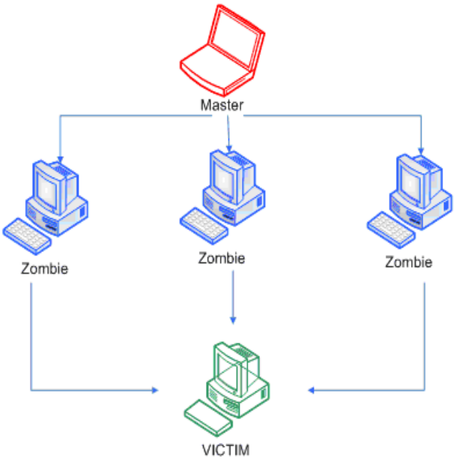
With DoS and DDos defined, we'll now take a look at attacks that affect the consumption of resources, such as Smurf attacks, and then address attacks like SYN Flood that affect network connectivity.
2. Bandwidth exhaustion attacks
A bandwidth exhaustion attack is where an attacker tries to consume the available bandwidth of a network by sending a flood of packets. This is most often accomplished with the help of several other machines.There is soon a flood of malicious nonsense packets on the network in large quantity, whereby the chances of survival of any good, legitimate packets becomes remote. Eventually the network becomes choked with these packets, and the network is effectively cutoff from the Internet and services are denied. An ideal example of a bandwidth
exhaustion attack would be Smurf attacks. Consider a scenario with an ISP and three clients, as shown below in Figure 2. In this scenario, the ISP receives extensive traffic for client 2 on its backbone. Since the connection to client 2 is of limited capacity and smaller than the ISP's backbone, it can't push all the data received for client 2
through the link to client 2. Therefore it will start to drop packets, and the TCP connections will lead to retransmissions of the lost/dropped packets. There will be a time when a legitimate host wants to connect to Client 2's network, but this will timeout and hence a DoS will occur.
Figure 2.
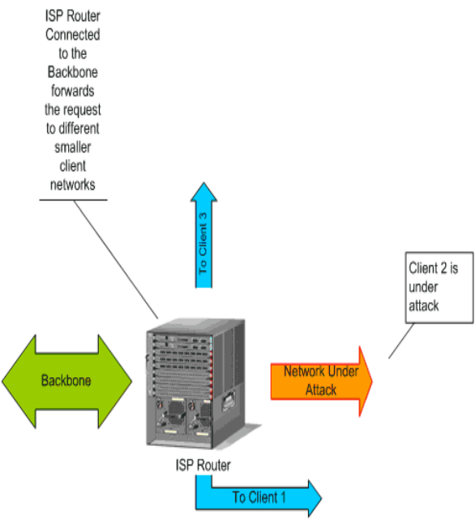
Figure 2. Scenario for
a bandwith exhaustion attack.

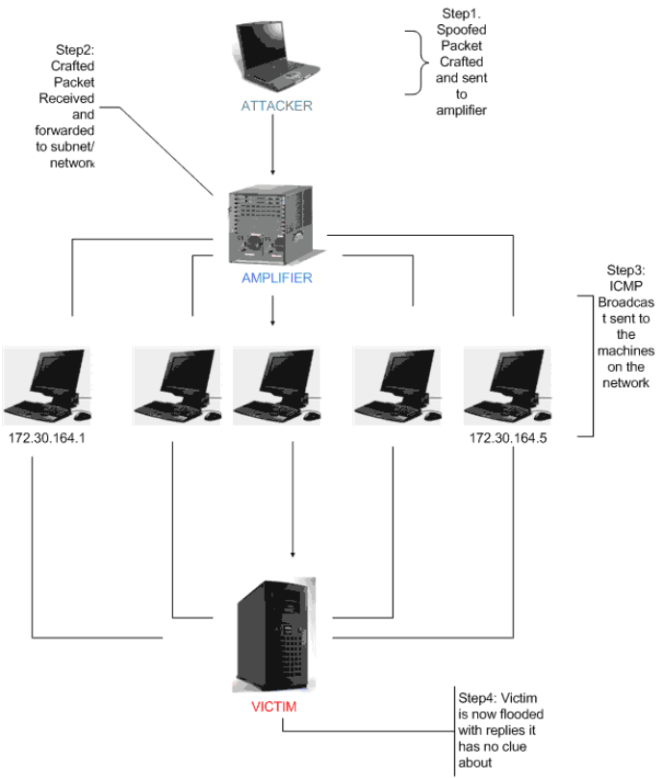
Figure 3. Typical directed broadcast Smurf
attack.
3. Network connectivity
Attacks:
These attacks overload the victim so that its TCP/IP stack is not able tohandle any further conections, and processing queues are completely full with nonsense malicious packets. As a consequence of this attack, legitimate connections are denied. One classic example of a network connectivity attack is a SYN Flood. We will see SYN Flood attacks in more detail.
3.2 SYN Flooding:
To get a clear idea on SYN Flood attacks we have to get into networking a little bit.
3.2.1 Three Way Handshake mechanism:
Whenever a client tries to connect to a server the following takes palce
1.The client sends a Data packet with SYN Flag set,to the server
2.The server after receiving it sends an acknowledgement packet to the client.
3.The client again transmits a re-acknowledgement packet to the server
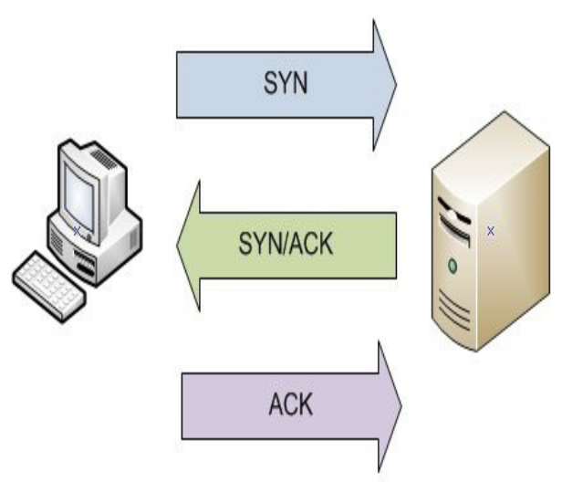
In these steps the type of connection the port to be connected etc are exchanged between the client and
the server.

3.2.2 Spoofed SYN Flooding:
A SYN Flood is where an attacker sends packets with a spoofed source IP Address and a TCP SYN Flag set
to the server (victim). Let's first assume that the attacker knows which ports are open on the server. Since the source IP is spoofed, the response sent to the SYN packet by the server will never receive a reply back. The server will keep waiting until it times out. If this happens for a very large number of connections the result will be a DoS, since the server won't be available for any legitimate connections and its resources will be choked.
As will be shown, this attack exploits a vulnerability of the TCP protocol, by the way in which the TCP threeway connection is established.
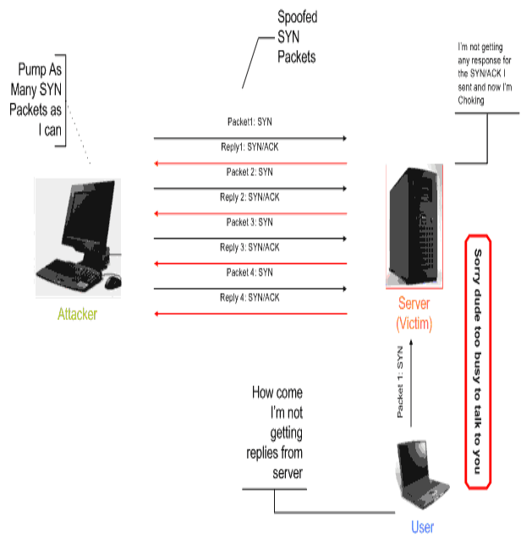
3.2.3.Flaws in TCP/IP:
3.2.3.1Retransmission of packets:
The main flaw present in TCP/IP architecture is the retransmission of SYN/ACK packets when they are not acknowledged by the client,This leads to a large number of SYN/ACK packets travelling away from the server which considerably decreases the Backlog queue size and hence a legitimate client could not establish a connection to the server.
3.2.3.2 Back Log Queue:
There is a queue in which the clients whose SYN packets received by the server are maintained.This queue is typically of fixed size.In case of a SYN FLOODING attack, The queue will be as shown below.
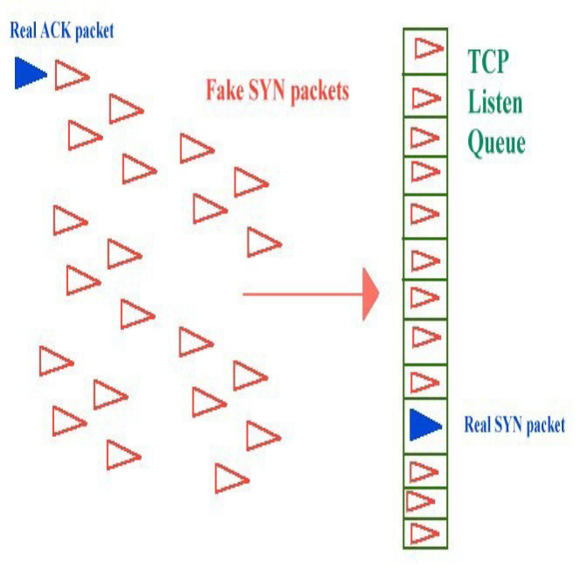
Thus during such a SYN FLOODING attack the TCP Listen Queue is flooded with fake SYN Packets making the Host unavailavlable for legtitmate client and also consumes.
4.Protection against DoS:
4.1 Windows
4.1.1.Built-in protection mechanisms(SYN ATTACK PROTECT). The most important parameter in Windows 2000 and also in Windows Server 2003 is SynAttackProtect. Enabling this parameter allows the operating system to handle incoming connections more efficiently. The protection can be set by adding a SynAttackProtect DWORD value to the following registry key: HKLM\SYSTEM\CurrentControlSet \Services\Tcpip\Parameters The operating system enables protection against SYN attacks automatically when it detects that values of the following three parameters are exceeded. These parameters are TcpMaxHalfOpen,
TcpMaxHalfOpenRetried and TcpMaxPortsExhausted. To change the values of these parameters, first we have to add them to the same registry key as we made for SynAttackProtect. The TcpMaxHalfOpen registry entry defines the maximum number of SYN RECEIVED states which can be handled concurrently before SYN
protection starts working. The recommended value of this parameter is 100 for Windows 2000 Server and 500 for Windows 2000 Advanced Server. TcpMaxHalfOpenRetried defines the maximum number of halfopen
connections, for which the operating system has performed at least one retransmission, before SYN protection begins to operate. The recommended value is 80 for Windows 2000 Server, and 400 for Advanced Server.
The TcpMaxPortsExhausted registry entry defines the number of dropped SYN requests, after which the
protection against SYN attacks starts to operate. Recommended value is 5 Depending on the value set to the
SynAttackProtect registry it decreases the number of retransmission of SYN/ACK packets. In both Windows and Linux. Increasing the backlog queue can significantly reduce the impact caused by DoS
4.1.2.Increasing the
backlog queue
Under a SYN attack, we can modify the backlog queue to support more connections in the halfopen
State without denying access to legitimate clients. In some operating systems, the value of the backlog queue is
very low and vendors often recommend increasing the SYN queue when a system is under attack. Increasing the backlog queue size requires that a system reserve additional memory resources for incoming requests. If a system has not enough memory for this operation, it will have an impact on system performance. We should also make sure that network applications like Apache or IIS can accept more connections.
Windows:
HKLM\System\CurrentControlSet\S
ervices\AFD\Parameters
Linux:
#sysctlwnet.ipv4.tcp_max_syn_backlog="2048"

4.2 Linux
4.2.1 SYN COOKIES
Operating system: Linux RedHat
RedHat, like other Linux operating systems, has implemented a SYN cookies mechanism which can be enabled in the following way:
# echo 1 >
/proc/sys/net/ipv4/tcp_syncookies
Note that to make this change permanent we need to create a startup file that sets this variable. We must do the same operation for other UNIX variables described in this paper because the values for these variables will return to default upon system reboot. SYN cookies protection is especially useful when the system is under a
SYN flood attack and source IP addresses of SYN packets are also forged (a SYN spoofing attack). This mechanism allows construction of a packet with the SYN and ACK flags set and which has a specially crafted
initial sequence number (ISN), called a cookie. The value of the cookie is not a pseudorandom number generated by the system but instead is the result of a hash function. This hash result is generated from information like: source IP, source port, destination IP, destination port plus some secret values. During a SYN attack the system generates a response by sending back a packet with a cookie, instead of rejecting the connection when the SYN queue is full. When a server receives a packet with the ACK flag set (the last stage of the threeway handshake process) then it verifies the cookie. When its value is correct, it creates the connection,
even though there is no corresponding entry in the SYN queue. Then we know that it is a legitimate connection and that the source IP address was not spoofed. It is important to note that the SYN cookie mechanism works by not using the backlog queue at all, so we don't need to change the backlog queue size. The working procedure of
syncookies is shown below pictorically.

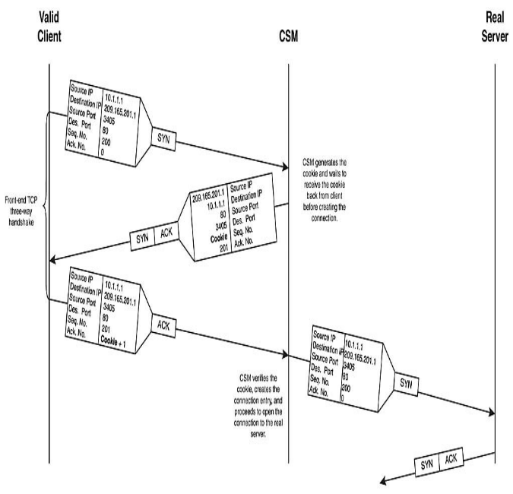

The entire process of SYN COOKIES is little bit complicated in case of huge traffic,hence we will be looking at this new algorithm.

4.2.2 SYN_HANDLER: (our algorithm for embedded operating systems)
Since embedded systems are also vulnerable to DoS attacks. We developed a new algorithm named as SYN HANDLER.In this algorithm we are not going to consume any resources of the server by using cryptographic functions but by using some simple logic.we have implemented a firewall like structure which could be turned on and off depending on the Backlogqueue. 1.When client tries to establish a connection to the server the SYN packet sent by the client passes through firewall (firewall is off) and reaches the server,and as normal the server sends an SYN/ACK packet 2.In case of a DoS attack the Backlog Queue is flooded by SYN packets,when the number of packet reaches 75% of the max backlog queue size,The firewall turns on. 3.Now any more incoming SYN requests have to pass through the firewall(Both Legitimate and Attackers) The firewall acts in a Transparent manner,it just gathers the source IP ,Time. It then sends an ICMP Echo for that address practically in case of SYN FLOODING the chosen IP to spoof is nonexistent and hence it doesn’t receives any reply from the client
therefore that IP and TIME(T1) is logged in ICMP LOG,in case of a legitimate client it receives a reply.This is the first trap we set for the attacker. 4.Once the server finds that ICMP LOG is not empty,it monitors for the packet with the IP corresponding to that in the ICMP LOG, once it found it,it logs its time again to the ICMP LOG file with the time(T2) 5.Now the final step is guessable,if T2>T1 the firewall requests the server to reset all the connections in the Backlogqueue corresponding to that IP address and further it is added to the block list to prevent further attacks from it.
This algorithm can be implemented in any embedded operating systems that uses TCP/IP for networking
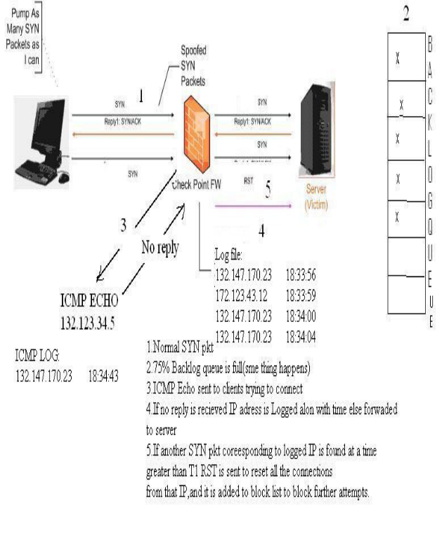
6.Conclusion:
The previous algorithm developed for windows and linux have some flaws in it as we saw earlier in this paper, SYN HANDLER developed by us will be a better subustitute for these programs(platform independent),which uses TCP/IP for networking.We conclude by saying that whatever the algorithm we prepare, it could be broken some day.so the best way to protect servers from DoS Attack is to educate users about it.
References:
Computer Networks By Andrew.S.TanenBaum
PacketStrorm [http://www.packetstorm.com]
SecurityFocus[http://www.securityfocus.com]
Hacking Exposed 5 By StuartMcClure
Bugtraq mailing list.

