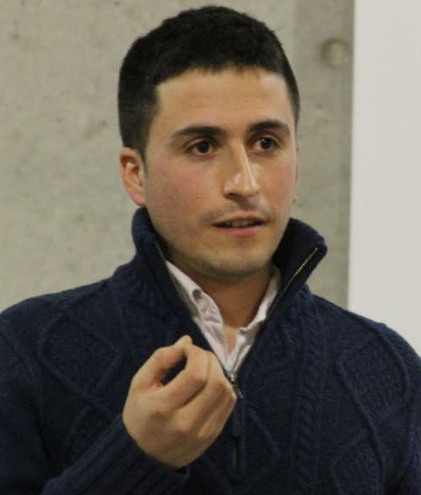
BORIS BOLLIET

PhD student at Université Grenoble Alpes
Fulbright Visiting Student Researcher at Lousiana State University (August – December 2016)

École Normale Supérieure de Lyon (ENS Lyon)
Laboratoire de Physique Subatomique et de Cosmologie de Grenoble (LPSC)
Université Grenoble Alpes (UGA)

Contact: boris.bolliet@ens-lyon.fr, Tel: (+33)781267783
Website: www.borisbolliet.com

Research Interests

- Theories of modified gravity and phenomenology of dark energy
- Loop quantum gravity and phenomenology of loop quantum cosmology
- Large scale structure formation

Education

2014 - 2017 PhD studies at LPSC Grenoble, supervised by Pr. Aurélien Barrau.

2014 MSc. Physique Subatomique et Astroparticules (Grenoble University), Highest Honors.
MSc. Open Course Programme at ENS Lyon.

2010 BSc. at ENS Lyon and Lycée Louis-Le-Grand (Paris).

Languages: French (native), English (fluent), Spanish (advanced), learning Romanian and Hindi.

Grants and Awards

2016 Fulbright Grant (6k$), for a 4 months research residency at Louisiana State Univ.
Selected Young Scientist at the 66th Lindau Nobel Laureate Meeting.
EOLE Grant (500€) to fund research for two weeks at Radboud University (NL).

2015 CPTGA Grant (500€) for attending the 14th Marcel Grossmann Meeting.

2014 PhD Grant from ENS Lyon (18k€/year over three years).
Diplôme de l'ENS Lyon (Honorary degree).

2009 ENS Lyon Studentship Grant (16k€/year over four years).

2007 Supporting grant from Association Promotion des Talents (8k€/year over two years).

Research Experience and Placements

2016 University of Manchester , Dark Energy with Pr. Richard Battye (1 week).
Radboud University in Nijmegen (NL), Loop Quantum Cosmology (1 week).

2015 Centre de Physique Théorique in Marseille with Pr. Carlo Rovelli (1 week).
Jagiellonian University in Kraków (PL), Loop Quantum Cosmology (1 week).

2014 University of Manchester on Dark Energy with Pr. Richard Battye (6 months).

2013 LPSC Grenoble on Loop Quantum Cosmology (6 months).

2012 French Embassy in India on Foreign Science Policy (6 months).
Utrecht University on Quark Gluon Plasma (2 months).

2010 Brookhaven National Laboratory on Quark Gluon Plasma (3 months).

Computing and Editing: HTML, LaTeX, GitHub, Mathematica, Python, C/C++, ROOT, CLASS.

Scientific Talks, Posters and Seminars

2016 60th Birthday of Carlo Rovelli, Marseille. Poster.
Theoretical Cosmology in the Era of Large Surveys, Firenze. Talk.
Astrophysics Seminar, Radboud University, Nijmegen. Talk.

2015 Relativity Seminar, CPT, Marseille. Talk.
Theory Seminar, Jagiellonian University, Poland. Talk.
Marcel Grossmann 14, Roma, Italia. Talk.
LOOPS 15, FAU, Erlangen, Germany. Talk.
Cosmology Seminar, IAS Paris. Talk.
Quantum Gravity in Kraków n°4, Poland. Talk.

2013 LOOPS 13, Perimeter Institute, Canada. Poster.

Teaching Experience

2016 Nuclear Physics, Bachelor level (15 hours).
Supervisor of a master student's internship (3 months).

2015 Numerical Computing, Bachelor level (40 hours).
Nuclear Physics, Master level, Experimental (40 hours).
Data analysis, Master level (20 hours).
Supervisor of a bachelor student's internship (3 months).

2014 Teaching preparatory classes for Concours Général de Physique.

In 2014 I created weekly Student Seminars, which I continue to organize at LPSC Grenoble. I am also an elected representative for the PhD students on the University Board.

Workshops and Summer Schools Attended

2016 Focus Week on Dark Energy and Modified Gravity. GGI, Firenze.

2015 Introduction to Mathematical General Relativity, Institut Henri Poincaré, Paris.

2014 CLASS Code Workshop, Barcelona, Spain.
SIGRAV School: Gravity and the Quantum, Como, Italia.

Public Outreach

2015 Public Lecture at Annemasse City Hall (France) on Cosmology.
Presentations in high schools during the French National Science Week.

2014 Volunteered at the charity Coups de Pouce Étudiants Grenoble (helping students).

Other Interests and Achievements

Neurosciences, Indian classical music (playing Tablas since 2012), History, Literature.

2009 Authored a video report about post-1990 Central Asia Centrale (Kazakhstan, Kirghizstan, Tadjikistan, Uzbekistan), a two months project funded by local institutions (3k€).

2008 Authored a photo report about the rural world in the Middle East (Turkey, Syria, Jordan, Israël, Palestine), a two months project funded by local institutions (3k€).

List of Publications

To access my publications online, please visit my Inspire profile page or follow the arXiv links bellow.

In preparation:

- Probing the acceleration of the universe with the thermal Sunyaev-Zel'dovich power spectrum – B. Bolliet, B. Commis, J.-M. Perez, E. Komatsu.

- A unified framework for studing dark sector theories: the equation of state approach and its numerical implementation – B. Battye, B. Bolliet, F. Pace.

Published:

- Quantum-gravity phenomenology with primordial black holes – A. Barrau, B. Bolliet, M. Shutten, F. Vidotto, C. Weimer, arXiv:1609.02159, Proceedings of the 2015 Karl Schwarzschild Meeting on Gravitational Physics (2016).

- Conceptual issues in loop quantum cosmology – A. Barrau and B. Bolliet, Int.J.Mod.Phys. D25 (2016) no.08, 1642008, arXiv:1602.04452 (2016).

- The Equation of State Approach to Cosmological Perturbations in f(R) Gravity - B. Bolliet, R.A. Battye, J.A. Pearson, arXiv:1601.07585, Proceedings of the XIV Marcel Grossmann Meeting, World Scientific (2016).

- Observational exclusion of a consistent quantum cosmology scenario -
B. Bolliet, A. Barrau, J. Grain, S. Schander, Phys.Rev. D93 124011, arXiv:1510.08766 (2016).

- Primordial scalar power spectrum from the Euclidean big bounce - S. Schander, A. Barrau, B. Bolliet, L. Linsefors, J. Mielczarek, J. Grain, Phys.Rev. D93 2, 023531, arXiv:1508.06786 (2016).

- f(R) as a dark energy fluid - R.A. Battye, B. Bolliet, J.A. Pearson, Phys.Rev. D93 4, 044026, arXiv:1508.04569 (2016).

- Phenomenology of bouncing black holes in quantum gravity: a closer look - A. Barrau, B. Bolliet, F. Vidotto, C. Weimer, JCAP 1602, 02 022 arXiv:1507.05424 (2016).

- Comparison of primordial tensor power spectra from the deformed algebra and dressed metric approaches in loop quantum cosmology - B. Bolliet, C. Stahl, J. Grain, L. Linsefors, A. Barrau, Phys.Rev. D91 8, 084035, arXiv:1502.02431 (2015).

- The Rise and Fall of the Ridge in Heavy Ion Collisions - P. Sorensen, B. Bolliet, Á. Mócsy, Y. Pandit, N. Pruthi, Phys.Lett. B705 71-75, arXiv:1102.1403 (2011).

Publications in French

- Un corrigé du concours général de physique 2009 : L'art et les sciences physiques - B. Bolliet, H. Lauret, BUP 918 (2009).

- La science en Inde - Paysage national de la recherche, l'innovation et l'enseignement supérieur – B. Bolliet, E. Layan, V. Briquet-Laugier. Disponible sur www.frenchscienceindia.org (2014).

