Humanitarian Architecture and User Experience: A Transitional Housing Prototype for Migrant Integration in Chile
Abstract
The migratory phenomenon in Chile has undergone a structural transformation by the year 2024, characterized by a staggering increase in the housing deficit and the emergence of informal settlements that challenge the National Migration and Foreigners Policy (PNME) 2024-2025. This article reports on the design and validation of the “Casa de paso” (Halfway House) prototype, a transitional housing solution based on User Experience (UX) methodology and universal design principles for vulnerable populations in irregular situations. Through exploratory qualitative research involving 44 migrants and 90 architecture students, a five-stage UX path (Empathize, Research, Design, Prototype, and Test) was applied to capture user voices and translate them into technical housing requirements. Findings revealed three critical categories for dignified habitability: the notion of temporary home as a space for emotional connection, the efficiency of geodesic modular housing, and the integration of civic life through common spaces that foster social fabric. Results demonstrate that humanitarian architecture, when articulated with a person-centered approach, not only satisfies the basic need for shelter but also acts as a tool for dignification and resistance against systematic exclusion. The study concludes that it is imperative to align these architectural innovations with public urban integration policies to transition from emergency response toward sustainable and inclusive settlement models in the Latin American context.

Introduction
The staggering increase in the number of forcibly displaced persons has reconfigured global socio-demographic dynamics, reaching a historical high of 108.4 million external displacements by the year 2022 (ACNUR, 2022). Following this trend, Latin America and the Caribbean have recorded a 52% increase in human mobility, positioning Chile as one of the primary regional receptors due to its relative economic stability and quality of life (United Nations, 2017). By 2020, the Chilean territory hosted 1.645,015 immigrants, representing 8.45% of the total population, with a predominance of Venezuelan, Peruvian, and Haitian communities that have integrated diversely into the social fabric (Departamento de Extranjería y Migraciones, 2021). However, this massive exodus, exacerbated by irregular entries and structural vulnerability factors, poses critical challenges for national public policies, which must guarantee the human rights of the migrant population while fostering effective integration into the host society (Barahona Urbina et al., 2022).
Sánchez-Montijano (2022) and Galán Crespo (2023) argue that integration into the host country emerges as a multidimensional process that transcends mere administrative regularization, involving linguistic barriers, socio-cultural stigmatization, and, fundamentally, access to basic services such as health, education, and housing. The latest National Camp Registry (2022-2023) evidence a sustained growth of informal settlements, where 34.74% of resident families are migrants, many of them in irregular situations (TECHO-Chile & CES, 2023). This phenomenon is closely linked to the worsening of post-pandemic economic conditions and precarious employment, factors that push migrants toward informal housing solutions due to legal barriers to accessing the formal rental market (Ávila Martínez, 2022; Tapia et al., 2020). The lack of a coherent housing response from the State has exacerbated the vulnerability of these groups, who are often excluded from fundamental guarantees of security and dignified habitability.
Faced with this problematic, this article explores housing expectations and the functional characteristics that a transitional housing solution should possess for the migrant population in irregular situations. The central objective is the design of the “Casa de paso” prototype, conceived as a humanitarian architecture response for emergency or social risk environments. To achieve this purpose, the results of applying qualitative tools designed from a User Experience (UX) perspective are reported, which valued direct user information to understand their behaviors and needs (Aguirre et al., 2021; Aguirre-Villalobos et al., 2023). The methodology employed not only seeks architectural functionality but also integrates sustainability principles, using recyclable materials and easy assembly techniques that minimally impact the natural environment (Espinosa & Villagómez, 2021; Ferrer-Mavárez et al., 2023). Through this person-centered approach, the study proposes a model of dignified living that dialogues with the recent National Migration and Foreigners Policy (PNME) 2024-2025, seeking to bridge the gap between housing emergency and effective social integration.

Methodology
The development of the transitional housing proposal was based on exploratory research with a descriptive design, articulated through interdisciplinary collaboration between a Chilean public university with technological specialization and technical advice from a public research university in the United States. The study sample consisted of forty-four migrants in irregular situations, corresponding to eight families residing in the Santiago and Tarapacá regions, along with ninety architecture students organized into twenty-two work teams. The recruitment process was facilitated by the Jesuit Migrant and Refugee Service, ensuring a bond of trust with the participating communities. The main methodological strategy focused on User Experience (UX) methodology, supported by the Design Thinking approach to prioritize accessibility, usability, and final user satisfaction in the architectural design (Aguirre et al., 2021; Martínez Padua et al., 2022). This conceptual framework allowed for the integration of the migrant population’s voice in each phase of the project, ensuring that the final prototype responded to the socio-cultural and housing realities detected in the field.
The implementation of the UX path was structured sequentially through five critical stages that allowed for transitioning from abstract understanding of needs to empirical validation of the architectural product. In this sense, the initial phase of Empathize (UX Empathy) focused on deep exploration of the integration and exclusion realities experienced by immigrants in Chile through semi-structured interviews. Following this progression, the Research stage (UX Research) analyzed the collected qualitative data to define housing expectations and the geographical adaptability of the prototype, using tools such as user journey mapping and comparative benchmarking. Subsequently, in the Design phase (UX Design), visual inspiration canvases or moodboards were generated, connecting the age and cultural characteristics of the participants with specific chromatic and formal proposals. Finally, the Prototyping (UX Prototyping) and Testing (UX Testing) stages allowed for the materialization of models in various fidelity levels (low, medium, and high) to evaluate their functionality and sustainability alongside relevant actors, adjusting the final design based on direct feedback from the migrant community.
Furthermore, the design process was managed under a collaborative and self-organized work model, employing development cycles known as sprints to ensure agility and continuous value delivery. During these defined time periods, focus groups and expert reviews were conducted to evaluate task quality and optimize workflow from the user experience (Schwaber & Sutherland, 2020). The integration of the migrant population in these phases was crucial to eliminate “waste” in the design and ensure that habitability criteria were consistent with their life stories and migratory trajectories (Orozco et al., 2023).
Qualitative data processing was performed using Reflexive Thematic Analysis (Braun & Clarke, 2006), structured in six phases that allowed for transitioning from initial semantic coding to the identification of latent themes. For the management and systematization of verbatim excerpts derived from interviews and focus groups, Atlas.ti (v.23) qualitative analysis software was used, facilitating the organization of emerging categories (temporary home, modular housing, and civic life). Methodological rigor was guaranteed through a researcher triangulation process, where themes were collectively refined by the academic team and architecture students to ensure intersubjective validity of the findings. This approach not only captured users’ functional needs but also revealed the emotional and symbolic dimensions that configure migrant living in contexts of transience.
The use of sustainable materials and rapid assembly techniques was transversal to the entire methodology, seeking not only a functional solution but a model that minimized environmental impact and maximized the dignity of transient residents in contexts of extreme vulnerability.

Results
Results derived from interviews in the initial empathy stage revealed that migrant family nuclei are mostly composed of young adults, accompanied by children, adolescents, and, to a lesser extent, elderly persons, who perceive their pets as integral members of the household. These participants expressed a significant willingness to integrate into Chilean society, highlighting their interest in assimilating local customs, although they face communication barriers due to local slang and phonetics. Narratives emphasized the persistence of cultural traditions, such as Christian religiosity and the valuation of the kitchen as a central space for neighborhood and family gatherings, where memories of their countries of origin are preserved. In this context, the need for dignified housing emerges as an absolute priority for the reconstruction of the social fabric, a desire frequently hindered by prolonged and uncertain administrative regularization processes in Chile.
We want to take root in this place. To see our family grow and not forget who we are, to preserve our traditions, what we are, like this—united, joyful, and driven [sic] mmm… well, we know the little kids [children] will soon speak like Chileans. Well, maybe… (Male immigrant, between 40-50 years old).
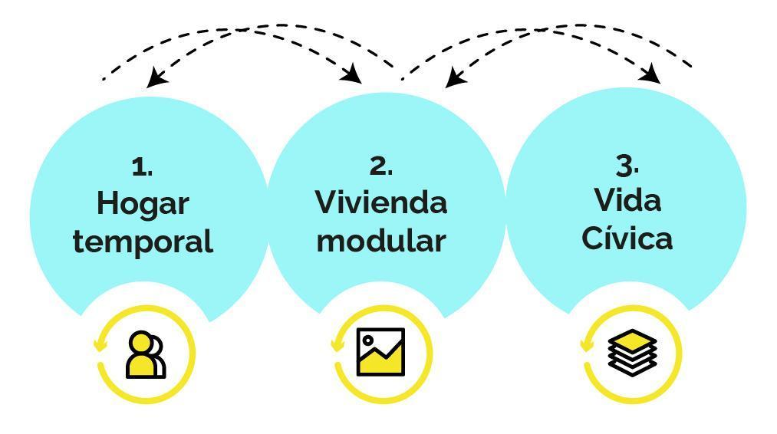
Categorical analysis derived from qualitative research.
Kharbouch (2019) notes that the notion of temporary home is defined as a space loaded with identity, experiences, and hopes, where daily domestic practices allow for a significant emotional connection with the architectural environment. On the other hand, modular housing was conceived as a construction system based on noble materials and easy assembly, where the use of warm and vibrant colors acts as a psychological catalyst to reminisce about their Caribbean and solar origin environments. Finally, Barria Oyarzo (2020) links civic life with economic and social participation in the local community, where the appropriation of spaces such as itinerant markets and public squares contributes to mitigating the hostility of host territories.
Home is more than the house; of course, it’s important to have a place to live, but the home is filled by what is lived, the memories, the day-to-day, so many emotions when the family arrives or we gather at home. It doesn’t matter if the place is tiny, at Christmas we all fit, the neighbors also come, and we have a good time (Female immigrant, between 29-31 years old).
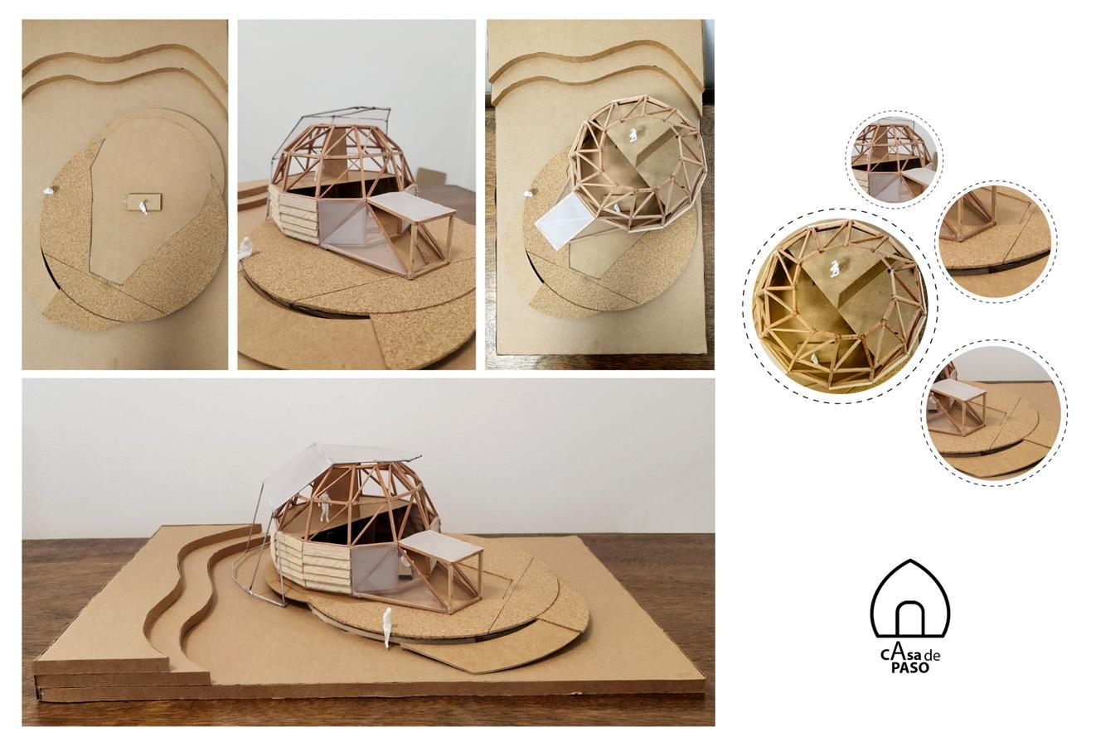
Inspiration canvas (Moodboard) with a Caribbean cultural focus.
The final prototype of the “Casa de paso” materialized as a high-fidelity system integrating seven critical universal design criteria: equitable use, flexibility, simple and intuitive use, perceptible information, tolerance for error, low physical effort, and size and space for approach and use. These guidelines allowed for the development of an architectural model that guarantees accessibility for users with diverse physical abilities, incorporating non-slip ramps, safe surfaces, and adequate lighting to minimize accidental risks. During the testing stage, participants positively valued the inclusion of large windows to maximize natural light entry and the creation of a centralized common space that fosters family coexistence. The selection of geodesic forms and contrasting colors, inspired by the collectively validated moodboard, reinforced the sense of belonging and emotional well-being, demonstrating that humanitarian architecture can be efficient and, at the same time, aesthetically coherent with the cultural identity of its occupants.
When I see that canvas, I saw us. It feels like the Caribbean; it gives me emotion to see it, there is a lot of light, a lot of color, I see big windows. You can tell that a lot of light will come through those windows… in the morning, in the afternoon. And at night, let the light keep coming in because for us it is valuable that what is outside, like nature, is also felt inside the house (Male immigrant, between 39 and 42 years old).
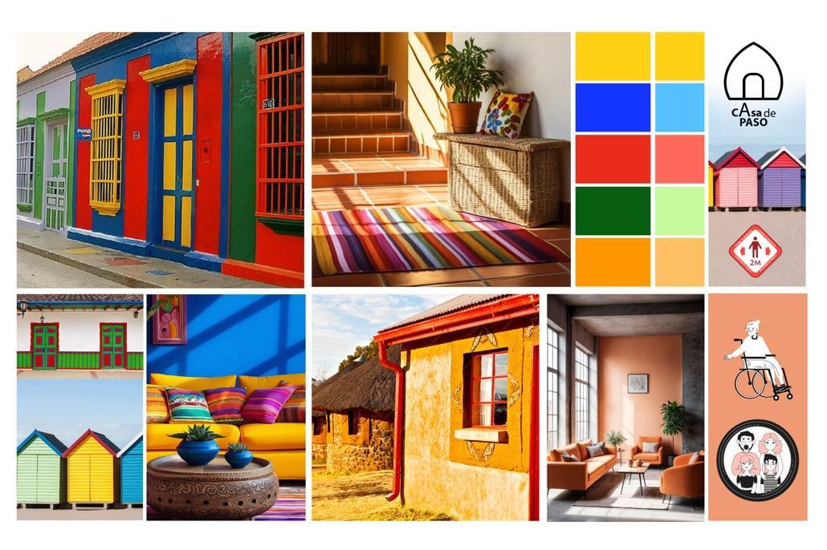
High-fidelity prototype: Physical model of the modular system.

Discussion
The discussion of findings reveals that the design of the “Casa de paso” transitional housing prototype transcends a mere technical response to the housing emergency, situating itself at a critical intersection between humanitarian architecture and public policies for migrant integration in Chile. In this regard, the National Migration and Foreigners Policy (PNME) 2024-2025, formalized through Decree 181 (Gobierno de Chile, 2024), prioritizes security and control measures, such as biometric registration for persons who entered through unauthorized crossings. While these actions seek identification and management of administrative backlogs, the manuscript reveals an operational void in the “Housing and Habitability” axis: current policy lacks technical guidelines for creating transitional reception infrastructures, delegating habitability responsibility to structurally overwhelmed municipalities and civil society organizations (serviciomigraciones.cl, 2024).
The results of this study suggest that User Experience (UX) methodology offers an effective operational framework to bridge the gap between migratory control and the realities lived by the population in irregular situations. This strategic alignment allows the “Casa de paso” prototype to be interpreted not as a marginal intervention, but as a technical infrastructure capable of operationalizing the humanitarian regularization mentioned in Decree 181. Ávila Martínez (2022) highlights that access to shelter is directly linked to the reconstruction of dignity and autonomy for displaced persons, facilitating the transition toward resilient urban integration. However, the persistence of biometric registration as a control measure may act as a psychological barrier to full appropriation of these spaces, unless architecture is designed, as in this case, under principles of trust and emotional connection.
Furthermore, the research underscores the importance of considering architecture not only as a physical object but as a communication and emotional resilience device. The persistence of cultural elements—such as the use of warm colors and centralized coexistence spaces—acts as a tool of resistance against the hostility of host territories and socio-cultural stigmatization. However, the effectiveness of these prototypes is limited by the existing disconnection between academic innovations and Chilean State housing policies, which, as Tapia et al. (2020) warn, tend to prioritize market solutions that often perpetuate socio-spatial segregation. The integration of universal design and sustainability principles in the “Casa de paso” demonstrates that it is feasible to develop high technical quality infrastructures that are, at the same time, inclusive and sensitive to the human context. Therefore, it is imperative that current regulatory frameworks transcend the emergency phase and foster the creation of comprehensive reception environments that value cultural diversity as an asset for sustainable urban development.
In conclusion, the prototype designed through the UX path is positioned as a coherent response to the migrant housing crisis, based on the notion of home as the axis of transitional habitability. The research demonstrated that active user participation in design allows for the development of solutions that not only satisfy functional requirements but also strengthen the emotional connection and sense of belonging of vulnerable communities. The replicability of this model in other global migratory crisis contexts represents an opportunity to transform emergency architecture into an engine for social integration and human dignity. It is recommended that future Chilean public housing policies incorporate user-centered design methodologies to ensure that transitional housing solutions cease to be spaces of exclusion and become true catalysts for inclusion and well-being for all persons inhabiting the national territory, regardless of their administrative status.

Conclusion
The research and design of the “Casa de paso” transitional housing prototype demonstrate conclusively that humanitarian architecture, when grounded in direct user experience, possesses transformative potential for the social integration of migrant communities in Chile. Through the systematic application of User Experience (UX) methodology, the study successfully transitioned from identifying habitability barriers to validating a housing product that not only meets functional technical requirements but also serves as a support for emotional connection and human dignity. Results underscore that the notion of home, articulated through chromatic warmth, spatial flexibility, and the integration of civic life, is a determining factor for the success of temporary housing solutions in contexts of extreme vulnerability. In this sense, the geodesic prototype not only offers physical shelter but symbolizes a commitment to radical inclusion that challenges the logic of segregation and precariousness prevailing in the informal housing market.
Finally, the study highlights the imperative need to align these architectural innovations with more ambitious and human mobility-sensitive public policy frameworks. The emerging guidelines of the National Migration and Foreigners Policy (PNME) 2024-2025 represent a significant advance but need to be complemented by housing strategies that value cultural diversity and universal design as pillars of social cohesion. The replicability of the UX methodology and the “Casa de paso” prototype in other latitudes suggests a horizon of hope for the management of global migratory crises, where architecture ceases to be a reactive response to become an engine for human development and urban justice. It is fundamental, therefore, that academic and state agendas converge in creating reception infrastructures that recognize migrants as subjects of rights, capable of contributing to and redefining destination territories through their dignified and participatory living.

References
ACNUR. (2022). Agencia de la ONU para los refugiados | ACNUR. https://www.acnur.org/
Aguirre, E., Ferrer, M., & Rojas, C. (2021). La esquematización como estrategia de comunicación visual para una grata experiencia de usuario: Un análisis de las aplicaciones educativas virtuales. Kepes, 18(23), 219–242. https://doi.org/10.17151/kepes.2021.18.23.8
Aguirre-Villalobos, E. R., Guzmán, G., & Lorena, G. (2023). Metodología design thinking en la enseñanza universitaria para el desarrollo y logros de aprendizaje en arquitectura. Revista de Ciencias Sociales. https://doi.org/10.31876/rcs.v29i2.39992
Ávila Martínez, J. M. (2022). El mercado de vivienda informal en arriendo para la población venezolana asentada en bogotá. Revista de Geografía Norte Grande, 82, 71–87. https://doi.org/10.4067/S0718-34022022000200071
Barahona Urbina, P., González Quezada, J. P., & Veres Ferrer, E. (2022). Inmigración internacional en chile: El caso de venezuela. Rumbos TS, 17(27), 129–148. https://doi.org/10.51188/rrts.num27.626
Braun, V., & Clarke, V. (2006). Using thematic analysis in psychology. Qualitative Research in Psychology, 3(2), 77–101. https://doi.org/10.1191/1478088706qp063oa
Departamento de Extranjería y Migraciones. (2021). Biblioteca de datos y estadísticas de migración en chile. https://www.infomigra.org/
Espinosa, J., & Villagómez, M. (2021). Arquitectura y sostenibilidad: Parámetros de desarrollo arquitectónico.
Ferrer-Mavárez, M., Aguirre-Villalobos, E. R., & Valecillos-Pereira, J. B. (2023). Applicability of the user experience methodology: Communication and employment web portal for older adults. Media and Communication, 11(3), 63–76. https://doi.org/10.17645/mac.v11i3.6775
Gobierno de Chile. (2024). Política nacional de migración y extranjería (PNME) 2024-2025. https://www.serviciomigraciones.cl/
Martínez Padua, J. V., Quitian Monroy, J. S., & Castiblanco Jiménez, I. A. (2022). Caracterización y comparación de metodologías ágiles y tradicionales de desarrollo de producto. Ciencia e Ingeniería Neogranadina, 32(2), 9–26. https://doi.org/10.18359/rcin.5168
Orozco, H., Godoy, D., Lopera, C. P., & Aguirre-Villalobos, E. R. (2023). Oportunidades y nuevos retos de la digitalización de la participación ciudadana en proyectos urbanos, en chile y colombia. Revista de Urbanismo, 48, 41–61. https://doi.org/10.5354/0717-5051.2023.66962
Schwaber, K., & Sutherland, J. (2020). La guía de scrum, la guía definitiva de scrum: Las reglas del juego. https://scrumguides.org/docs/scrumguide/v2020/2020-Scrum-Guide-Spanish-European.pdf
Tapia, R. D., Rodríguez, R. R., & Rojas, D. Q. (2020). “Ordenar la casa”: Securitización y producción de irregularidad en el norte de chile. Sociologías, 22, 172–196. https://doi.org/10.1590/15174522-105689
TECHO-Chile, & CES. (2023). Catastro nacional de campamentos 2022-2023. https://cl.techo.org/wp-content/uploads/sites/9/2023/03/CNC22-23.pdf
United Nations. (2017). International migration report 2017.

