רשת APN – IGD05 ו-IG05 (01, ינואר 2006)

ערכים בדאטום ישראל גיאודטי – IGD05:

ALON 31 42 28.56962 34 36 23.92196 55.666
AREL 32 06 08.50235 35 12 33.38800 706.258
BSHM 32 46 44.34467 35 01 22.74078 225.044
CSAR 32 29 17.71470 34 53 24.66784 36.586
DRAG 31 35 35.52169 35 23 31.45294 31.803
DSEA 31 02 12.89041 35 22 07.76365 -360.806
ELAT 29 30 33.40483 34 55 14.15975 29.544
ELRO 33 10 55.22902 35 46 14.33669 1083.172
GILB 32 28 45.61374 35 24 59.31950 506.803
JSLM 31 46 16.15199 35 12 08.82778 790.340
KABR 33 01 22.13656 35 08 42.20966 103.393
KATZ 32 59 42.88567 35 41 17.82172 347.029
LHAV 31 22 40.15902 34 51 58.71247 488.934
NRIF 30 02 18.30519 35 02 09.74793 457.515
RAMO 30 35 51.37919 34 45 47.30162 886.830
SLOM 31 13 41.45540 34 17 01.75503 112.721
TELA 32 04 04.78448 34 46 51.22945 58.335
YRCM 30 59 29.64830 34 55 41.76498 516.050

ערכים ברשת ישראל 2005 – IG05:

ALON 162789.567 624088.359
AREL 219912.868 667669.519
BSHM 202456.453 742718.779
CSAR 189919.648 710505.891
DRAG 237264.418 611226.192
DSEA 235150.075 549543.569
ELAT 191935.979 380214.284
ELRO 272262.631 787544.532
GILB 239387.954 709493.352
JSLM 219268.266 630942.784
KABR 213908.447 769747.629
KATZ 264676.455 766792.416
LHAV 187291.194 587379.305
NRIF 203214.589 438847.720
RAMO 177133.917 500909.745
SLOM 131740.781 571103.738
TELA 179463.565 663937.126
YRCM 193078.342 544537.213

פרמטרי התמרה מ- IGD05 ל- IG05:

הזזה: | 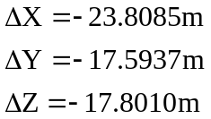
קנה מידה: | 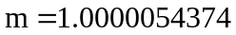
סיבוב: | 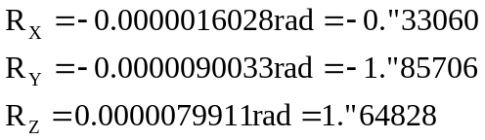

משוואות ההיטל

ITM Israeli Transverse Mercator Grid (New Grid)
-----------------------------------------------
1. Refference ellipsoid GRS80
a(m): 6378137.000000000000000
1/f: 298.257222000000000
2. Main datum point values
Lat of origin (D-M-S): 31 44 3.816999999992845
Lon of origin (D-M-S): 35 12 16.260999999993260
3. Main point grid values
False Easting (m): 219529.584000000000000
False Northing(m): 626907.389999999900000
4. Grid scale factor
1.000006700000000
5. Projection
Transverse Mercator

