TECHNICAL DOCUMENTATION

Project name/ID | Weather Application
Version | V1.0
Type | Public
Author | Boris Mihajlovski

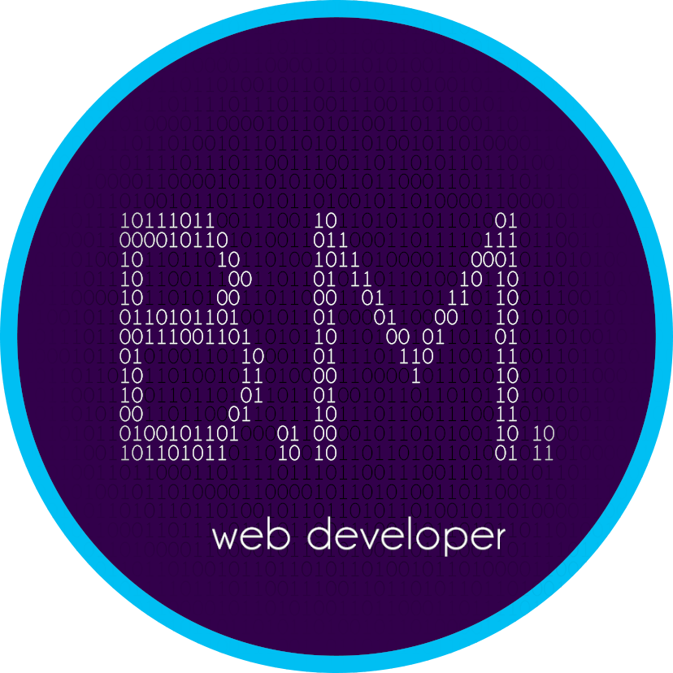

Overview

This application was made in a docker environment, using React library. The application was rewritten from a tutorial for demonstrative and educational purposes.

Intro

The application consists of a single view which has single input, which receives a location. This location is then used to retrieve data.

View
The view has a width standard for mobile phones. It has one input, where a user inserts a location. This location is then sent to the WeatherAPI. After a response is received, the data is displayed on the view. It displays the location, the current temperature and other info. Depending on the temperature, the background can be warm or cold.

