Near-field Measurements using Low Cost Equipment
for RF Device Characterization
Radoslav B. Borisov, Kaloyan I. Zlatkov, Plamen I. Dankov

Near-field electromagnetic scanners are widely used for microwave, antenna and electromagnetic compatibility measurements. The scanner determines the spatial distribution of an electrical quantity provided by a single or multiple field probes in the near-field region of a device under test (DUT). Depending on a signal receiver detecting the probe signal, voltage as a function of time or frequency is a typical measured quantity. It should be underlined that as the DUT may be considered any object radiating or storing electromagnetic field energy intentionally or unintentionally, e.g. the antenna radiation excited beyond its resonance frequency. The voltage pattern is usually mapped on planar, cylindrical or spherical geometrical surfaces as a collection of a finite number of spatial samples. Different numerical post-processing methods enable the conversion of the measured quantity into electromagnetic field. This publication describes the process of building low cost near-field electromagnetic scanner using standard microwave equipment and 3D printer. The critical parts in the design are described in details and two samples were measured using the build near-field scanner. Using the system one passive antenna working in L band and one balanced amplifier working in UHF range were measured. Additional post-processing is done over the measured data using open source software for visualization and further processing – ParaView [1]. Some of the advantages of near-field measurements include high accuracy, high throughput (high data rate) and complete characterization of device’s performance.
Ниско бюджетен скенер работещ в близката област за радиочестотни измервания (Радослав Борисов, Калоян Златков, Пламен Данков). Скенерите за измерване на електромагнитно поле работещи в близката зона се използват за микровълнови и антенни измервания, както и за измервания свързани с електромагнитната съвместимост (ЕМС). Скенера измерва пространственото разпределение на електрическия заряд, който се детектира чрез една или няколко електромагнитни сонди, поставени в близката област на тестваното устройство. Тази публикация има за цел да опише процеса на изграждане на ниско бюджетен електромагнитен скенер работещ в близката област, използвайки стандартно оборудване за микровълнови измервания и 3D принтер. Критичните компоненти в дизайна са описани подробно и две устройства са измерени, използвайки така направения скенер. Използвайки системата една пасивна антена работеща в L обхвата и един балансен усилвател бяха измерени. Допълнителната обработка на измерените данни се извършва с помощта на софтуер с отворен код за визуализация и допълнителна обработка - Paraview[1]. Някои от предимствата на измерванията със скенер работещи в близката област включват високата точност, високата производителност (голямо количество данни) и възможността за пълното характеризиране на измерваното устройство.

Introduction
The developments of modern technologies have increased a systems complexity and new problems like signal integrity and coupling between the system components have appeared. One of the methods for characterization of the device performance is near-field scanning technique. Electromagnetic (EM) near-field scanner determines the spatial distribution of electrical quantity acquired in a near field region of the device using single or multiple probes. Using numerical post-processing techniques it is possible to convert measured quantity into electromagnetic field.
Typically near-field scanners are used for antenna measurements [2] or electromagnetic interference measurements [3]. The advantages of near-field measurements include high accuracy, high throughput (or data rate), a complete characterization of device under test (DUT), ability to control different environment effects, minimal requirements and compatibility with special project requirements.
In RF system designs the most common technique for characterization of the electromagnetic field is using simulators. Complex designs are divided into sub areas and simulated individually, because of computation power and time required for solving the problem increases with the size of structure area. Basically the simulators solve Maxwell’s equations using different approaches like MoM, FEM, FDTD etc. The structure is described using text files or it is constructed using graphical interface of the software in 2.5D or 3D. The definition of the ports shows where the electromagnetic energy enters the structure and how it exits. The scattering matrix shows the energy scattered from the structure at the port’s plane. Increasing the ports number adds to the simulation time drastically. Simulated parts of the complex problem could be combined using S-parameters into more complex model of the device or the system. This technique is widely used, but it still doesn’t give the full picture, due to the fact, that there is coupling between the individually simulated parts, that we don’t take into account. Usually simulated results are in good agreement with the measurements. The so explained process takes a lot of steps and good understanding of the problem is needed. Good knowledge about the technologies used in the production of the structure and experience with the simulator is desirable. The simulation technique solves coupling problems in pre and post production phase and determines optimal size or shape of the structures. Large simulations are usually undesirable and the time needed for solving the equations and visualization of the EM field could take days, even on servers with 8-cores and 32 GB RAM.
Near-field scanning technique could be used for rapid measurement of the EM field, verification of prototypes, layout optimization and finding coupling problems between different modules. Direct measurements give relative information about the distribution of the field. Additional computation is needed to get absolute results for the distribution of the field in the far-field region. The scanner could maximize designer’s productivity and is focused on solving instead of finding EMC problems, which leads to reduced number of board spins. Measured data is stored and could be used for comparison between board iterations. It is possible to get immediate feedback for the effectiveness of the corrective measures. Using the near-field scanner the designer’s productivity could be optimized, design and compliance cost could be reduced and of course the time to market is reduced significantly.
The main purpose of this article is to describe the process of building small low cost near-filed scanner using standard equipment and 3D printer.
This paper describes a methodology for the creation of a small near-field EM scanner using standard RF measurement equipment and 3D printer [4]. Verification of the build system is done using two devices – one passive and one active device that work in different sub bands of the RF spectrum. Small L-band left-hand circular polarized patch antenna is measured using the scanner with two types of RF probes for verification. Using the scanner we were able to generate animation of the currents distribution on the patch surface for set of frequencies. The measurements show that the phase rotates as the wave propagates through space in left direction, just as the theory predicts. Balanced amplifier has been measured using the same technique and the electric and magnetic fields distributions are shown on graphics.
Near-field scanner
A near-field scanner consists of a pulsed network analyzer (PNA) connected to an RF probe carried by a low cost 3D printer. The block diagram of the near-field measurement system is shown on Fig.1. The network analyzer is used to generate and measure the response of the DUT. PC software controls the movement of the RF probe mounted to the 3D printer and synchronizes measured data with the movement.
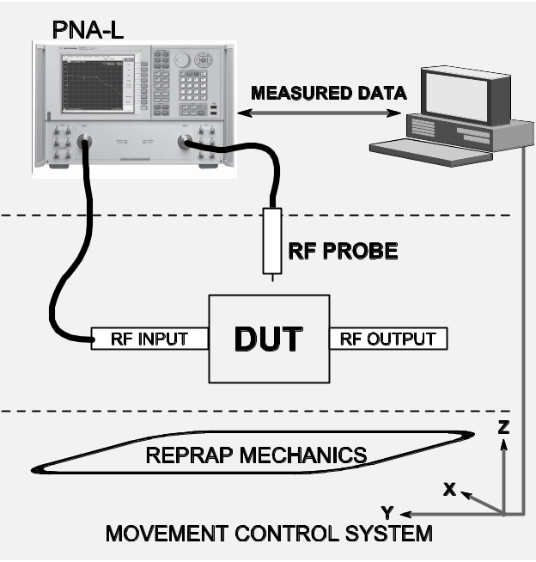
Fig.1. Simplified block diagram of near-field scanner.
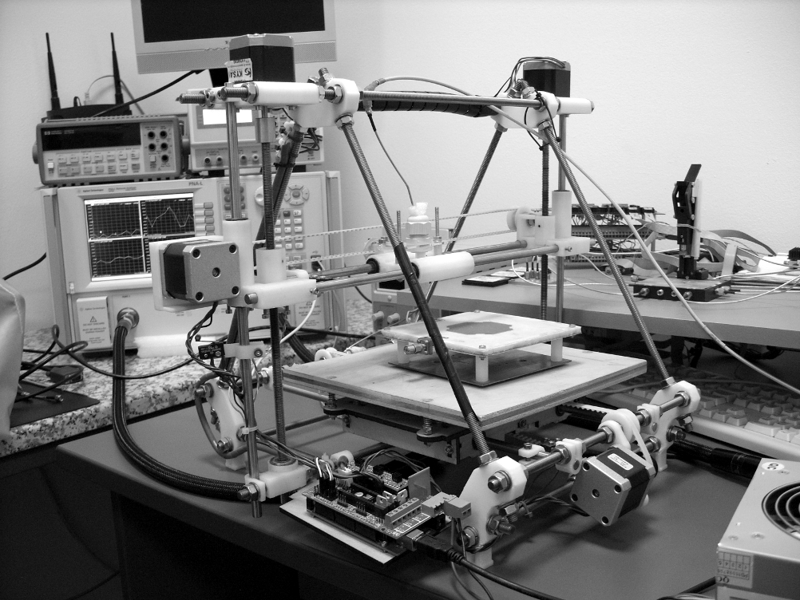
Fig.2.Photo of near-field measurement system.
Photo of the assembled system is shown on Fig.2 in laboratory. Different approach is described at the end of this article, where a low cost portable transceiver with receive signal strength indicator (RSSI) is used to measure the input level taken from the RF probes.
Pulsed Vector Network Analyzers (PVNAs) are typically used to evaluate the performance of microwave components / devices under non-continuous operation. These measurements are essential when dealing with pulsed-RF applications like radar or burst-mode transmitters, or in semiconductor device characterization when dissipation problems need to be avoided. Photo of PNA-L N5230C is shown on Fig.3. Network analyzer is expensive equipment even for RF laboratories, but the functionality needed for the experiments is irreplaceable. They provide good dynamic range and precise frequency generation in wide bandwidth. Sweep option provides ability the DUT to be tested with different input powers, while the response is measured. This is convenient for the initial tunings of the system, where the optimal input power should be considered for the field measurements, so that we could provide the best dynamic range of the system. The PNA could be programmed using the standard GPIB interface or using telnet over Ethernet. The control software uses telnet for communication with the PNA and defines frequency range for the measurement, the number of measurement frequencies and receives the S-parameters data.
Different types of probes are used to measure the electromagnetic field. Open ended RF probes (Fig.3a and Fig.3b) are used to measure electrical component (E-field) of the field, while the magnetic component (H-field) is measured using a closed loop RF probe like the one shown on Fig.3c.
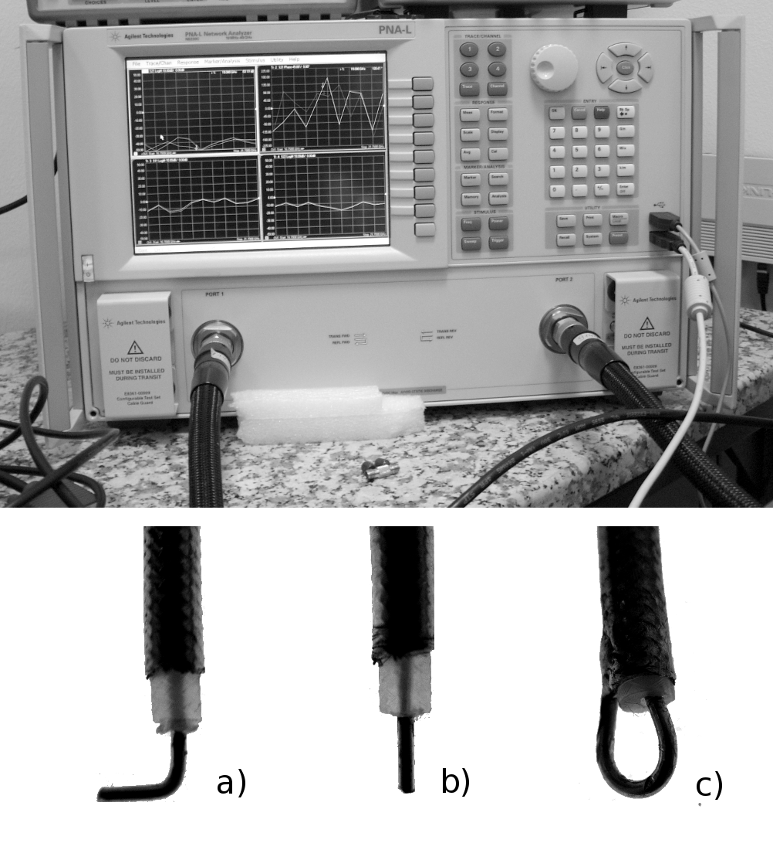
Fig.3.PNA-L N5230C.
The scanner system could be divided in 3 parts from engineering point of view – mechanical, electrical and software parts. Mechanical part consists of all mechanical parts like Arduino PCB, RF probes, bearings, motors, belts, pulleys, cables, measurement equipment and more. The limitations in the mechanical parts define the resolution of the near-field scanner. RepRap has typical resolution of 0.1 mm on all axes, which defines the scanner resolution.
Electrical part consists of Arduino Mega board with RAMPS 1.4 shield [5] used to control the 3D printer’s movement. Stepper drivers control the movement of the RF probe precisely. Typically rf boards have traces and gaps in orders of 0.15 to 0.2 mm. More precise mechanics is needed for on wafer or rf chip measurements.
Software part could be divided into firmware and pc software. The firmware used in the near-field scanner is open source and is called Sprinter [6]. It is configured to work with RAMPS hardware and represents a G-code interpreter [7]. Standard G-code commands are used to define the coordinate system (relative / absolute), axis, movement step and movement speed. Arduino is using USB to serial converter for the connection to PC and the software. From PC software the RepRap is seen as standard COM port working on 115200 baud rate.
Additional software written in python controls the rf probe’s movement and to collects measured data from the PNA synchronously. Before each measurement a number of parameters are defined: set of frequencies, measurement points in X, Y and Z directions and step size (measurement resolution). The PNA measures the amplitude response and phase for each point and for all set of frequencies. Using only this option one scan collects information about the electromagnetic field distribution for the given set of frequencies as amplitude and phase. Measured data is saved as standard Excel file for post-processing later on. Additional open source software called Paraview [8] is used for 3D visualization and post-processing of the collected data. The collected data could be compared with previous results from measurements and analyzed.
The following two examples show the briefly explained procedure and some of the results collected using the near-field scanner.
L-band antenna
The scanner is used to measure the performance of L-band patch antenna with left handed circular polarization shown on Fig.4. The patch was scanned using H-field probe in range 2.0 – 2.4 GHz with 10 MHz step. Fig.5 shows graphically the results from collected data. Amplitude distribution of the surface currents is shown on Fig.5a and Fig.5b for two frequencies – 2.15 and 2.3 GHz. Dynamic ranges of the measurements is around 45 dB and we could conclude that measured field is stronger for 2.3 GHz, which means that working at this frequency the efficiency of the antenna will be higher. The phase distribution is shown on Fig.5c and Fig.5d.
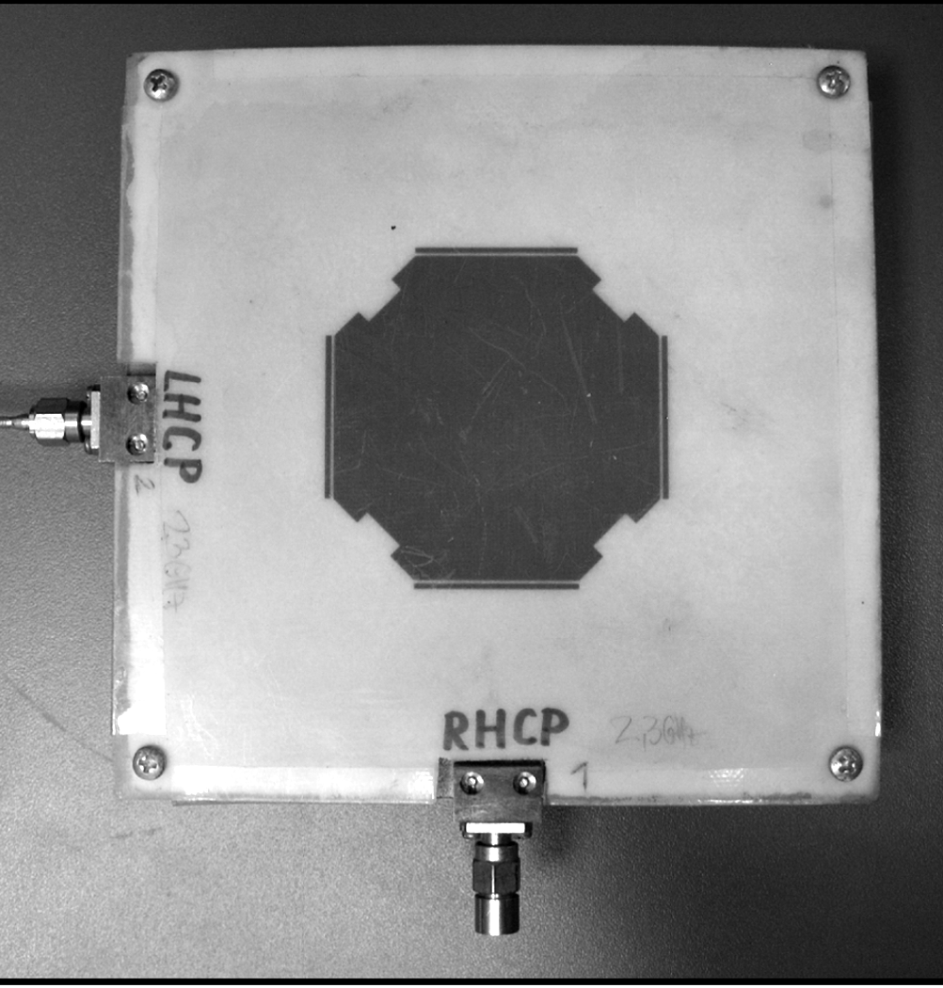
Fig.4.Photo of near-field measurement system.
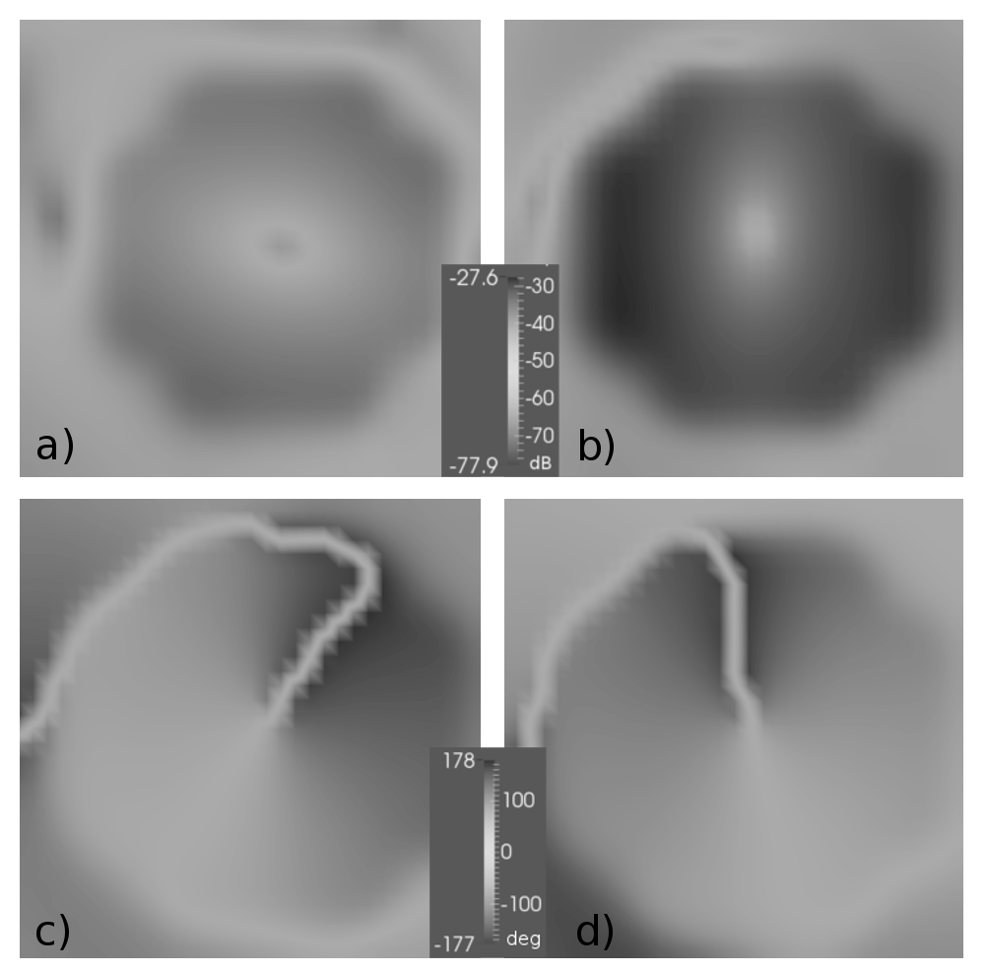
Fig.5.Photo of near-field measurement system.
The phase distributions of the field for single frequency 2.3 GHz are measured on two different distances from the patch’s surface – 1 mm and 3 mm. From the phase distribution we can see that the relative phase has changed in left direction from Fig.5c to Fig.5d. This shows that we are working with left hand circular polarized antenna.
The overall scanned frequencies are 40 for 2.0 – 2.4 GHz band and the dynamic range of the measurements is around 50 dB using the PNA. The size of the patch antenna is 59 x 59 mm and the scanned area is 75 x 75 x 62.5 mm. Simple calculations show that single scan with 1 mm resolution will give 75 x 75 = 5625 measurement points just for one plane. If we set the measurement to 40 frequency points we get 5625 x 40 = 225000 values just for the amplitude on one plane. From this simple example it is obvious that the main problem is the handling of such big data structures effectively.
Using Paraview software it is possible to be handled and visualized big data structures even on laptops and standard computers. Different filters and cuts could be applied to the data for processing. It is possible collected data to be exported in video format as animation. This gives unique opportunities for visualization of DUT‘s resonant effects.
Balanced amplifier
Using the same technique another device was scanned. The balanced amplifier shown on Fig.6. works in the frequency range 700 – 900 MHz. The input of the amplifier is connected to the first port of
the PNA, while the output is terminated with 50 Ω load. The second PNA’s port is connected to the H-type RF probe and S21 parameter is measured. Measured data is shown on Fig.7a and Fig.7b. The orientation of the RF probe defines detectable currents on the surface of the PCB. Shown data is for such orientation of the probe, that it could detect only RF currents flowing along the horizontal traces between the RF input and the RF output. The vertical currents tend to be blurry and unclear on the visualization graphics. Even with single H probe we could easy distinguish, where the amplifying elements are.
The balanced amplifier consists of two hybrid couplers one at the input and one at the output. The input hybrid divides the input power and split the signal in 90 deg. phase, so that the active components in the circuit have less coupling and better isolation between each other. The output hybrid coupler combines the amplified signal at the output in phase. Using this technique the output power increases with ~3 dB compared to the amplification from single amplifier device.
Scanned area of the balanced amplifier is 45 x 90 x 3 mm with 1 mm resolution. On Fig.7a and Fig.7b are shown amplitudes distribution of the field for two frequencies respectively 760 MHz and 860 MHz. Visual analysis of the data shows that the field around the RF input is stronger at 760 MHz, which simply means that we don’t have very good matching for these frequency, while for 860 MHz less energy is lost in the matching. Another interesting observation is that we have stronger field around the coil elements at the output of the active devices and this field is stronger for the second frequency.
Fig.8 shows the relative phase distribution for the same frequencies fig.8a/8b respectively 760 MHz and 860 MHz. Visually we could see from collected data that the phase distribution is somehow blurry for the lower frequency, while for 860 MHz the phase difference is more distinguishable. Upper part of the circuit has relative phase 90 degrees with respect to the bottom part defined by the 90-deg hybrid couplers. The phases near the input and output are influenced by the cables and the connectors to the PCB. There the phases are mixed with the different reflections from the design of the board and the connectors. The amplifier has ~20 dB gain in the working bandwidth and this defines the relatively low input power that we provide to the input in order to get around 0 dB at the output. After the amplification stage the phases are much more defined, because the signal is stronger and the voltage generated by the probe is higher. This explains the better phase distribution at the output.
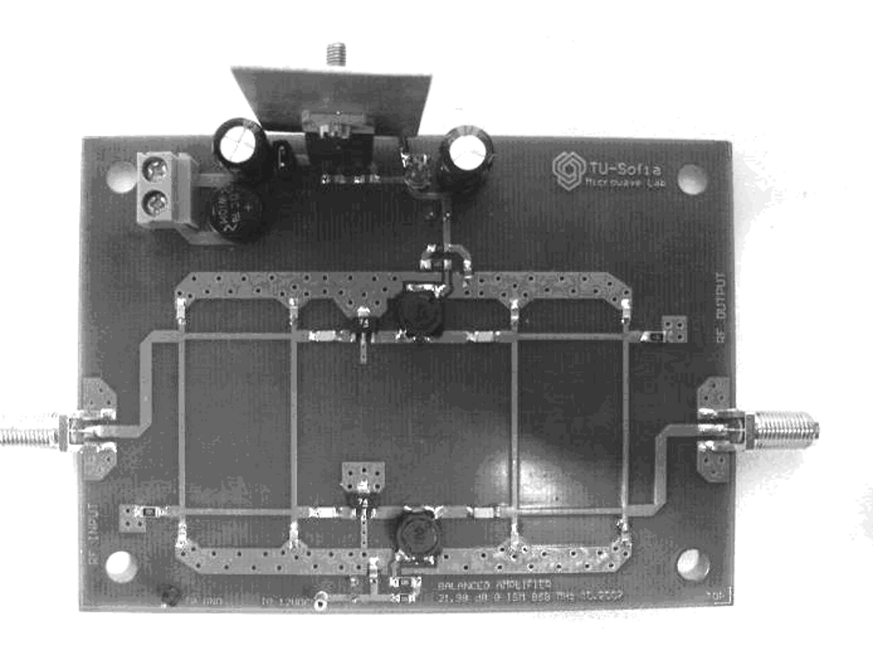
Fig.6.Balanced amplifier measured with the scanner..
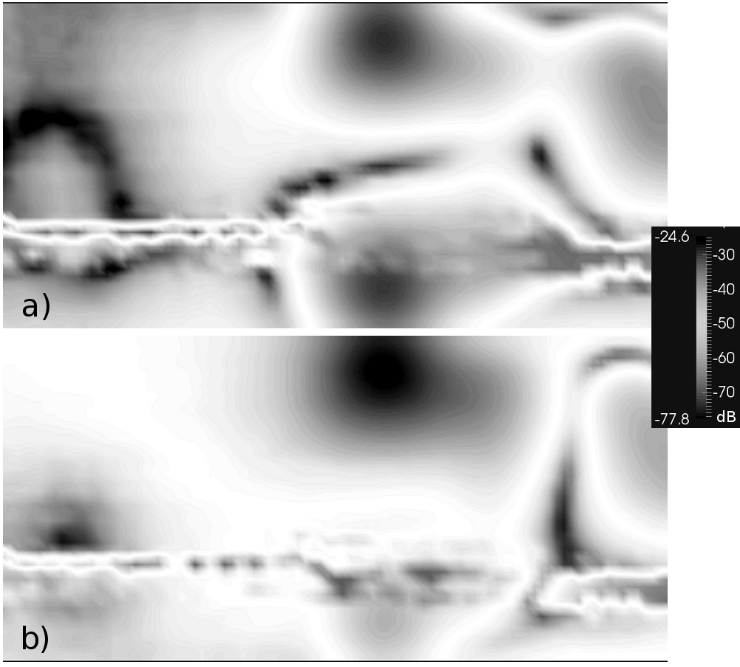
Fig.7.Surface currents amplitude for a) 760 b) 860 MHz .
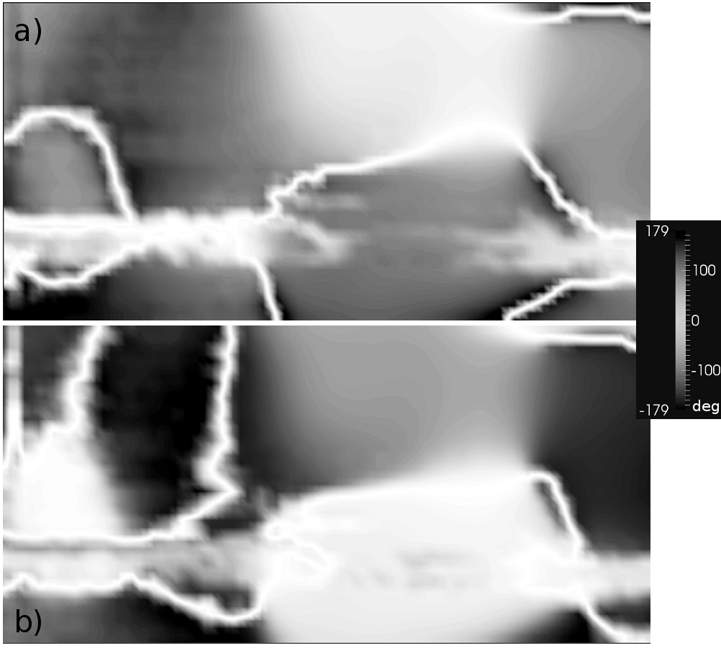
Fig.8.Surface currents relative phases for
a) 760 b) 860 MHz.
Software
Different types of software skills are needed for the design of a near-field scanner system. Most of the software used for these measurements is open source.
There are many different approaches to combine the available software with measurement device to get even lower cost near-field scanner. One such example is the usage of microprocessor with RF front. Using Arduino board combined with appropriate transmitter and receiver working in the RF band of interest it is possible to get dynamic range better than 30 dB for amplitude measurements. Most important part of the project is the selection of device that could generate CW signal for the desired band.
Example of such approach is the usage of low cost transceiver from ATMEL with integrated RF front end like ATMEGA128RFA1. Using the RSSI (received signal strength indicator) as an absolute measuring device we were able to measure the amplitude field distribution for single frequency with dynamic range up to 30 dB. Using the same processor the EM field of the patch antenna could be measured within the range 2.4 to 2.485 MHz in 5 MHz steps. In order this to be accomplished successfully additional step should be considered for synchronization between the transmitter’s and receiver’s frequency.
Most difficult part of the software is the synchronization between the measured data and control software that generates the movement of the 3D printer and respectively moves the RF probe. The software should be able to process and collect the data from the PNA and move the RF probe fast enough and with the desired accuracy. All python software is published in repository [9].
Conclusion
This article tries to present a work done for solving a complex problem like near-field scanning technique using existing equipment and tries to describe the process of building low cost near-field measurement system. A basic setup for RF measurements of electromagnetic field has been set and two radio frequency devices were measured. Measured data was presented visually and analyzed.
The potential of the approach is not limited to EM measurements only and could be applied to temperature measurements also.
Finer near-field scanners [10] need better mechanical structure and finer stepper control for IC measurements. Software part is applicable to all single probe scanners.
Acknowledgements
The authors thank to all the persons involved in the open source software movement and RepRap project. Without their hard work and skillful designed software this project would be much harder to for us and we appreciate their devotion.
The authors thank to Scientific Research Found of Sofia University St. Kliment Ohridski for the support.
REFERENCES
- http://www.paraview.org
- http://www.nearfield.com/products/NearFieldSystems.aspx
- IEC/TS 61967-3 ed1.0 Integrated circuits - Measurement of electromagnetic emissions, 150 KHz to 1 GHz - Part 3: Measurement of radiated emissions - Surface scan method.
- http://www.reprap.org
- http://reprap.org/wiki/RAMPS_1.4
- http://reprap.org/wiki/Sprinter
- http://en.wikipedia.org/wiki/G-code
- http://www.paraview.org
- https://github.com/borisov-r/EM3Dscanner
- Adam Tankielun, Uwe Keller, Etienne Sicard, Peter Kralicek, Bertrand Vrignon. Electromagnetic Near-Field Scanning for Microelectronic Test Chip Investigation, IEEE EMC Society Newsletter, Collection IEEE EMC, Octobre 2006

Radoslav B. Borisov is MMIC Designer at “RaySat BG” and currently is making his Ph.D. in the field of Microeletronics at Microelectronics Department of Technical University of Sofia.
е-mail: radoslav.borisov@gmail.com
PhD Student Kaloyan Ivanov Zlatkov is currently a PhD Student in Sofia University “St. Kliment Ohridski” Bulgaria, where he completed his Bachelor degree in Physics in 2008 and his Master degree in Microwave Networks and Devices in 2010. He works from 2008 in RaySat Bulgaria and currently takes the position of Head of Antenna-Test Department. His interests are in the microwave antenna measurements, EMC and especially Near-field test setups.
е-mail: kaloyan_zlatkov@abv.bg
Dr. Plamen I. Dankov is Assoc. Prof. in Faculty of Physics, Sofia University "St. Kliment Ohridski". He is specialist in the microwave and wireless technique, microwave measurements, material characterization, antennas, electromagnetic simulators.
е-mail: dankov@phys.uni-sofia.bg

