Instructions for paper styles
and rules for publication in the journal “Е+Е”
Ivan P. Georgiev, Asen H. Dimitrov, Elena G. Todorova

This model contains information about the formation of the full text of papers offered for publication in the journal “E+E”. This paragraph contains an abstract of the text of the paper. The abstract should have at least 10 and not more than 15 lines. It must contain the most important information from the paper. Please use a plain text, avoiding citations and symbols. Set used Times New Roman 11pt Italic. Paragraph formatting: First line 0,8 cm, Line Spacing Single, Indentation Left 1cm, Right 1cm; Alignment Justified. The journal “E+E” accepts for publication material from all areas of electrical engineering, electronics, computers, telecommunications and their applications. The aim of this paper is to inform the prospective authors about the requirements for the design of papers, which are to be published in the journal. The full length of the paper must not exceed 8 pages size A4. The authors need to pay a fixed fee of 100 BGN (50 EUR) per paper for peer review and publication of the paper. The fee shall be paid by bank transfer to the bank account of the Union of Electronics, Electrical and Telecommunications (CEEC). If the paper is not accepted for publication, the fee will not be returned. The authors must leave e-mail and a phone number, where they can be contacted. For more information, please e-mail epluse@mail.bg.
Заглавие на статията на български език (Иван Георгиев, Асен Димитров, Елена Тодорова). Този параграф съдържа резюме на статията на български език в обем минимум 10 реда и максимум 15 реда. Представя се най-важната информация за работата – необходимост, основни постижения и изводи. Използван шрифт Times New Roman 11pt Italic. Paragraph formatting: First line 0,8cm, Line Spacing Single, Indentation Left 1cm, Right 1cm; Alignment Justified. Списание “Електротехника и електроника” приема за публикуване материали от всички области на електротехниката, електрониката компютърната техника, телекомуникациите и техните приложения. Целта на този документ е да запознае авторите с изискванията за оформянето на статиите, които ще бъдат публикувани в списание “Е+Е”. Ръкописът трябва ясно и стегнато да описва състоянието на проблема, начините на изследването, резултатите от работата на авторите, тяхната важност и с какво те се различават от предишните работи на същите и други автори. Пълният текст на статията да не надхвърля 8 страници формат A4. Авторите трябва да оставят e-mail и телефон, на който могат да бъдат потърсени. За повече информация пишете на е-mail epluse@mail.bg.

Journal “Electrotechnica and Electronica” accepts for publication materials from the areas of electrical engineering, electronics, computers, telecommunications and their applications. The language of the papers should be English.
The aim of this paper is to introduce authors to the requirements for the design of papers to be published in the journal “E + E”.
For more information please e-mail epluse@mail.bg.
Text Design
It is recommended that the paper follows the following sequence: Introduction (state the art of the problem), Used data, Method, Algorithm, (Program) Implementation, Results, Literature, Aknowledge-ments to contributors who are not authors of the manuscript. If the work is performed under a contract, it is recommended to indicate its number, or specify sponsors.
The manuscript should clearly and concisely describe the state of the problem, the ways of the research, results of the authors’ work, their importance and how they differ from their or other author’s previous work. It is required to pay particular attention to the formulation and application of scientific claims of the authors.
References should be presented in brackets in the order of citations in the text [1] [2] [3].
The text should be prepared with Microsoft Word 2002 (Office XP) or 2003. These instructions are written in Microsoft Word 2003.
We recommend using this document as a model for shaping the text of your paper. You can write directly on the sections of this file, or insert text from another file (Edit | Paste Special | Unformatted Text), using the present formatting. The full length of the paper must not be over 8 pages (including figures, tables and graphs) of size A4.
Page format
The page size must be А4. The text should be enclosed in a box of dimensions: 24cm height and 18cm width (offset boundaries (margins): top 2,8 cm, bottom - 2,9 cm, left and right - 1,5 cm); Footer 1,9 cm, Different odd and even.
Formatting text sections
Different sections of the text must be formatted as described below.
Used font
The font should be Times New Roman 11pt. In all sections please use use single line spacing.
Title font is Times New Roman 18pt, Bold, the paragraph must centered, before 28pt, after 18pt.
Author names must be centered with font Times New Roman 14pt, Bold, 12pt after the paragraph.
The paragraph with the line after the authors is formatted in the following way: font Times New Roman 11pt; Indentation Left 3,5cm, Right 3,5cm; Alignment Justified. The line is before the paragraph and must be 1pt wide.
The requirements for the summaries in Bulgarian and English are pointed in themselves – look above.
The paragraph with the line after the summaries is formatted the following way: font Times New Roman 11pt; Line Spacing Single, Indentation Left 3,5cm, Right 3,5cm; Alignment Justified, Spacing After 24pt. The line is after the paragraph and must be 1pt wide.
Paper text
The text of the paper must be divided into two columns, formatted in the following way: Width 8,5cm, Spacing 1cm where the box Equal column width is checked.
Section headings must use font Times New Roman 11pt Bold; Line Spacing Single, Alignment Justified, Spacing Before 12pt, After 3pt.
Additional Headings must be formatted the following way: Times New Roman 11pt Bold Italic; Line Spacing Single, Alignment Left, Spacing Before 12pt, After 3pt.
The text must be divided into paragraphs designed in the following way: font Times New Roman 11pt; First line 0,5cm, Line Spacing Single, Alignment Justified. There mustn’t be any additional spaces before and after the paragraphs.
If in the text there are listings it is recommended that they are formatted the following way:
- using Bulleting (menu Format | Bullets and numbering);
- Bullet position, Indent at 0,5cm;
- Text position, Tab space after 0,8cm, Indent at 0,8cm.
ATTENTION! How to format the text?
If you’re only just beginning, write directly over the current file or insert text from another file (Edit | Paste Special | Unformatted Text), while using the already made design.
If you already have a designed file, the easies way to re-design is using styles. Used styles for formatting the parts of the paper are described in Table 1.
Table 1
Used styles in the document (10pts)
Title | EE title
Authors | EE authors
Line before the summary | EE line before the summary
Bulgarian summary | EE summary BG
English summary | EE summary EN
Line after the summary | EE line after the summary
Heading | EE Heading
Under heading | EE Under heading
Paragraph text | EE paragraph
Listings (bulleted) | EE bullet
Figure caption | EE figure caption
Table | EE table
Table caption | EE table caption
Literature | EE Literature
References | EE references
Line before the authors | EE line before the authors
Information about the authors | EE authors info

In order to use styles you must copy them to your own file. Here are the instructions how to do it. Select Tools => Templates and Add-Ins => Organizer => You see the menu shown in Fig.1.
On the first side is your file and on the other you choose “Close file” and then “Open file” and open the file with the instructions – “E+E_Instructions.doc”.
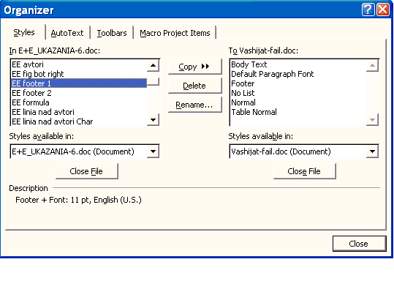
Fig.1. Menu Organizer of Templates and Add-Ins.
Don’t forget to click “All files” in “Files of type”, because by default you will only see files with the “.dot” extension. After that choose all styles from the files with the instructions and copy them to your file with the button “Copy”. If there is duplication click “Yes”. Now you have all the needed styles and your document is ready to be used.
Using styles happens the following way. First click Format | Styles and Formatting or click the styles button and the list appears on the right side of the text. In order to format a current paragraph with a current style you must click with the mouse somewhere in the paragraph and click on the name of desired style on the right. If you format text in a way different from the existing styles, then a new style is automatically created. For example there is a style Style EE paragraf + Bold for the bold text in the paragraph. This is not a problem.
Formulas and equations
All formulas must be created using the in-built Word Equation editor, and not with MathType. Settings for the size of the (menu Size | Define) are as follows: Full 11pt, Subscript/Superscript 7pt, Sub-Subscript/Superscript 5pt, Symbol 16pt, Sub-Symbol 11pt.
So styles from the menu Style | Define are defined the way, shown in Fig.2. Exponential functions are written using “exp”.
The equations must be numbered on the left, the way shown in equation (1). They can also be part of a sentence where colons are only written in front of formulas when they are being listed.
All symbols, used in the formulas and equations must be defined before or right after the formula or equation.
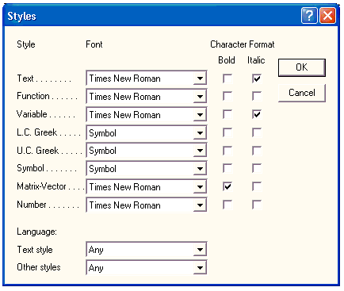
Fig.2. Defining styles in Equation Editor.
Here is an example of the formula for electromagnetic torque of a hybrid step motor.
(1) 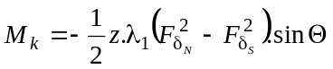,
where z – number of rotor teeth, 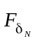и 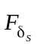- magnetic voltage drops in the air gap under the north and south pole of the magnet.
If the formula cannot fit in one line its size must be decreased using Format | Object | Size | Scale, but not more than 70% of the original size – look at equation (2). If that is still not enough then the formula is transferred in an appropriate way on the next line.
(2) 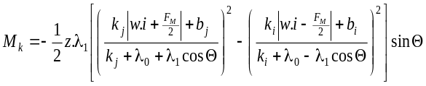.
Paragraphs with the formulas must be formatted the following way: Times New Roman 11pt; Line Spacing Single, Alignment Left, Spacing Before 7pt, After 6pt. The tabulator after the number of the formula is a standard one with 1,27cm spacing.
Figures
Figures must be centered and captions must be put below them, as shown in Fig.1. They must be put inside the text as close as possible to the place where they were first mentioned. The size of the figures must have under 8,5cm or 18cm width size and under 22cm height size.
Captions under the figure must be formatted the following way: Times New Roman 10pt Italic; Line Spacing Single, Alignment Center, Spacing Before 3pt, After 12pt.
If the figures are too large, they can occupy both columns. In this case a Text box (or Frame) is used, and the figure and the caption are positioned inside. Do not insert additional sections or format text as single-columned! There is an example shown with Fig. 3. When it occupies both columns, the figure is positioned in the upper or lower end of the page in order not to divide the text. The position of the Text box is defined the following way: choose Format text box | Layout | Advanced. In Advanced layout menu in Picture position make the current settings: Horizontal alignment – Center – Relative to margin, Vertical alignment – Top (or Bottom) Relative to margin, from Options uncheck the box Move with text. In the Text Wrapping menu choose Top and Bottom, Distance from text remains 0cm.
When inserting the figures in one column they must be positioned “In line with text” using Format Object | Layout | In line with text.
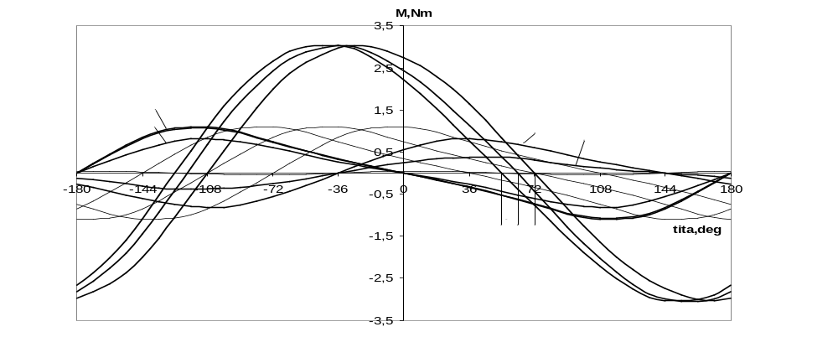
Fig.3. Example of a figure occupying both columns.
Each figure must be one object, which can be manipulated as a whole. Don’t put additional text and don’t draw in the text over already inserted figures, because later they rearrange themselves when the text is further processed.
In order to have high quality of the printed paper, we recommend you follow the following rules for inserting figures. When inserting vector graphics use Edit | Paste Special | Picture, so that way all of them will be in able to be edited with Microsoft Word Picture Editor. An .EPS extension can be used.
Scanned graphics and drawings must be black and white or grayscale. Resolution must be from 300 to 600 dpi. Use file extensions .bmp, .tiff, .gif. Do not use .jpg!
Photos must have a resolution of 300÷600 dpi. Here we recommend using .jpg.
For screenshots we recommend using .bmp, .tiff, .gif or .png with a max of 16 bit colour. Do not use .jpg!
It is not recommended to expand raster figures as this worsens their quality.
Tables
Tables can be created using the command Table | Insert table. The font in the tables must be Times New Roman 11pt. or smaller. It is not recommended that you divide tables into two pages. Table captions must be above the tables. After the tables an empty paragraph is left.
It is not recommended that tables contain formulas or figures. If the tables are larger they can occupy both columns following the rules about figures mentioned above.
References
All references should be numbered in square brackets both in the list and in the text, when citing them [1], [2]. The list of the references should be in order of their citation in the text. It is recommended that their number does not exceed 10, but is also not less than 5.
The font of the list of references is Times New Roman 10pt.
Paper submission
The papers must be submitted by e-mail to epluse@mail.bg.
Authors pay a fixed fee of 100BGN (50EUR) per paper for review and publication of their paper. In case the paper is not published then the fee is not returned. The fee should be transferred by bank transfer to the following bank account:
UniCredit Bulbank AD, 7 Sveta Nedelya Sq.
IBAN: BG75 UNCR 9660 1018 8624 01
BIC: UNCRBGSF
Account holder: CEEC
Please indicate: Е+Е, article's author

When submitting the paper, attach also a scanned copy of the bank transfer document.
Conclusion
There should be a corresponding author (with e-mail and telephone number), to whom all correspondence connected with the paper will be directed.
Acknowledgements
Aknowledgements are expressed only to contributors who are not authors of the manuscript. If work is performed under the contract, it is desirable to indicate its number, or to mention the sponsors.
REFERENCES
- Antonov, S., M. Petkov, L. Stefanov. Title of the paper with only first letter capitalized. Journal or conference papers, Volume 1, 1999, pages 196-203.
- Kokornaczyk, E., M. Stiebler. A Method for Experimentally Optimized Ministepping of Permanent Magnet and Variable Reluctance Motors. Int. Conf. PEMC'94, Warsaw, Poland, Vol.1, 1994, pp.343-347.
- Young, M. The Technical Writer's Handbook. Mill Valley. CA, University Science, 1989.

Prof. Dr. Ivan P. Georgiev - author information, containing data on present employment, where and when has he completed his education, his scientific interests. Used font Times New Roman 10pt Italic. Paragraph formatting: First line 0,5cm, Line Spacing Single, Alignment Justified.
tel.:............ е-mail: .........................
Assoc. Prof. Dr. Asen Dimitrov and information about him. Paragraph formatting: First line 0,5cm, Line Spacing Single, Alignment Justified, Before paragraph 6pt .
tel.:............ е-mail: .........................
Eng. Elena G. Todorova and information about her. Paragraph formatting: First line 0,5cm, Line Spacing Single, Alignment Justified, Before paragraph 6pt.
tel.:............ е-mail: .........................

