Low COST NEAR-FIELD SCANNER FOR
RF mEASUREMENTS
Radoslav BORISOV*
* RaySat BG Ltd., MMIC Department, 1700 Sofia, Bulgaria, 2A Mogilata St.,
E-mail: radoslav.borisov@gmail.com
Резюме. Електромагнитните скенери работещи в близката зона се използват за микровълнови и антенни измервания. Скенера измерва пространственото разпределение на електрически заряд посредством една или няколко електромагнитни сонди. Полето се измерва в близката зона на измерваното устройство, като допълнителна математическа обработка на данните позволява преобразуването на измерените стойности в електромагнитно поле. Статията представя методология за създаването на електромагнитен скенер, работещ в близката област използващ налични инструменти за измерване и 3Д принтер. Представени са резултати от измервания използвайки ЕМ скенер.
Ключови думи: електромагнитен скенер, измерване, 3Д принтер, антена, микровълнов усилвател.
INTRODUCTION
The developments of modern technologies have increased systems complexity and new problems like signal integrity and coupling aroused. One of the methods for characterization of the device performance is near-field scanning technique. Electromagnetic near-field scanner determines the spatial distribution of electrical quantity acquired in a near field region of the device using single or multiple probes. Using numerical post-processing techniques it is possible to convert measured quantity into electromagnetic field. Typically near-field scanners are used for antenna measurements [1] or electromagnetic interference measurements [2].
In RF system designs the most common technique for characterization of the electromagnetic field is using EM simulators. Usually the problem is divided into sub areas and simulated individually, because for bigger problems the computation power and time needed for solving the problem increases with size area. 2.5D and 3D simulators solve the scattering matrix for defined ports in the simulation and can be used later on for the creation of more complex models of the system. The simulation technique is solves coupling problems in pre and post production phase and determines optimal size or shape of the structures. Usually the results are in good agreement with the measurements. Unfortunately this technique involves a lot of experience with the simulator and good knowledge about the technologies used in the production. Bigger simulations are usually undesirable and the time needed for solving the equations and visualization of the EM field could take days even on servers with 8-cores and 32 GB RAM.
Near-field scanning technique could be used for rapid measurement of the EM field, verification of prototypes, layout optimization and finding coupling problems between different modules. Direct measurements give relative information about the distribution of the field. Additional computation is needed to get absolute results for the distribution of the field in the far-field region. The scanner could maximize designer’s productivity and is focused on solving instead of finding EMC problems, which leads to reduced number of board spins. Measured data is stored and could be used for comparison between board iterations. It is possible to get immediate feedback for the effectiveness of the corrective measures.
This paper describes a methodology for the creation of a small near-field EM scanner using standard rf measurement equipment and 3D printer [3]. Small L-band left-hand circular polarized antenna is measured using the scanner with two types of rf probes for verification. Using the scanner we were able to generate animation of the currents distribution on the patch surface for set of frequencies. The measurements show that the phase rotates as the wave propagates through space in left direction. Balanced amplifier has been measured using the same technique and the EM field distribution results are shown.
NEAR-FIELD SCANNER
System description
Basic setup of the system is given in Fig.1. Network analyzer is used to generate and measure the response of the DUT. PC software controls the movement of the RF probe and synchronizes measured data with the movement.

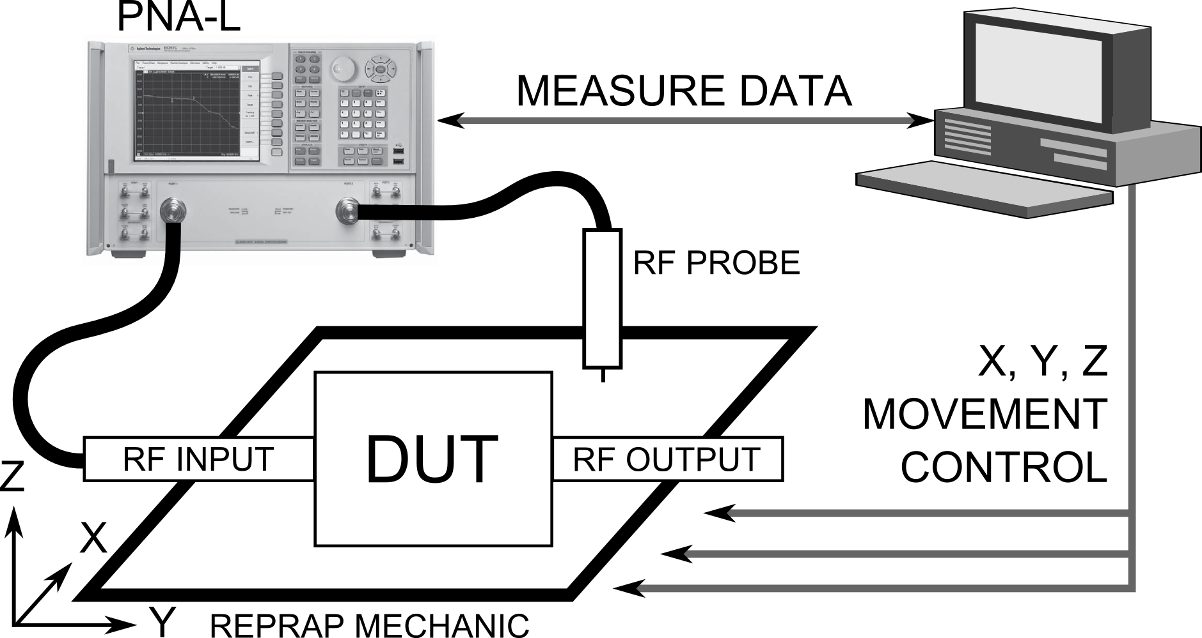
Figure 1. Simplified block diagram of near-field scanner.

The scanner setup consists of RepRap 3D printer, network analyzer, rf probes, measurement and visualization software. The main photo in the left on Fig.2 shows the setup of the near-field scanner and the main building blocks. PNA-L N5230C (Fig.2a) is used to generate the rf signal and measure DUT’s response. Different types of probes are used to measure EM field. Open ended rf probes are used to measure electrical component (E-field) of the EM field, while magnetic component (H-field) is measured using closed loop rf probe (Fig.2b). Patch antenna scanned using the system is shown on Fig.2c.

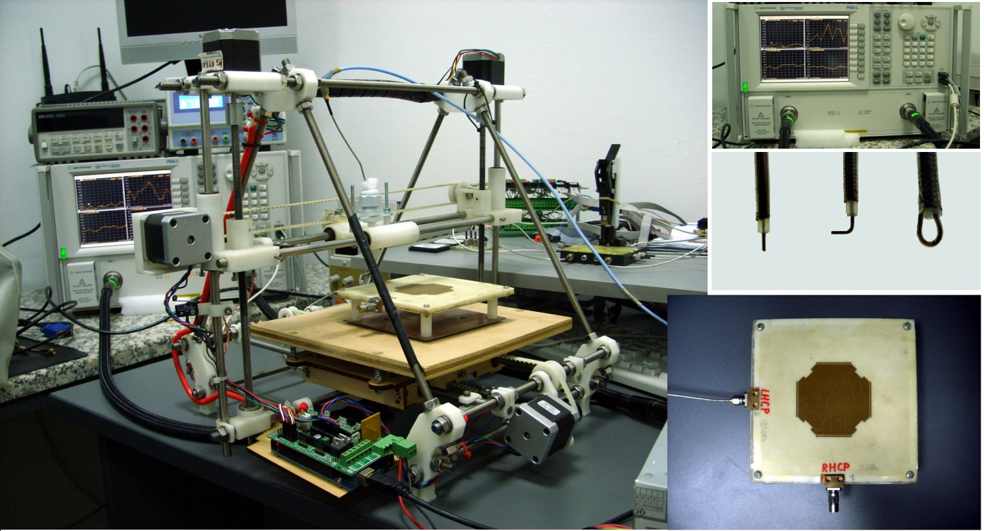
a)
b)
c)
Figure 2. Near-field scanner with PNA (a), probes (b) and DUT - patch antenna (c).
The system could be divided in 3 parts from engineering point of view – mechanical, electrical and software parts. Mechanical part consists of all mechanical parts like arduino pcb, rf probes, bearings, motors, belts, pulleys, cables, measurement equipment and more. The limitations in the mechanical parts define the resolution of the near-field scanner. RepRap has typical resolution of 0.1 mm on all axes, which defines the scanner resolution.
Electrical part consists of Arduino Mega board with RAMPS 1.4 shield [4] used to control the 3D printer’s movement. Stepper drivers control the movement of the RF probe precisely. Typically rf boards have traces and gaps in orders of 0.15 to 0.2 mm. More precise mechanics is needed for on wafer or rf chip measurements.
Software part could be divided into firmware and pc software. The firmware used in the near-field scanner is open source and is called Sprinter [5]. It is configured to work with RAMPS hardware and represents a G-code interpreter [6]. Standard G-code commands are used to define the coordinate system (relative / absolute), axis, movement step and movement speed. Arduino is using usb to serial converter for the connection with the PC software. On PC side the connection is initiated using standard serial COM port with 115200 baud rate.
Additional software was written in python to control the rf probe’s movement and to collect measured data from the PNA synchronously. Before each measurement a number of parameters are defined: set of frequencies, measurement points in X, Y and Z directions and step size (measurement resolution). The PNA measures the amplitude response and phase for each point and for all set of frequencies. Using only this option one scan collects information about the electromagnetic field distribution for the given set of frequencies as amplitude and phase. Measured data is saved as standard Excel file for post-processing later on. Additional open source software called Paraview [7] is used for 3D visualization and post-processing of the collected data. The data could be compared with previous results and analyzed.
The following two examples show the briefly explained procedure and some of the results collected using the near-field scanner.
L-band antenna
The scanner is used to measure the performance of L-band patch antenna with left handed circular polarization shown on Fig.3a. The patch was scanned using H-field probe in range 2.0 – 2.4 GHz with 10 MHz step. On Fig.3b and 3c are shown the results for amplitude and phase distribution of the surface high frequency currents for two frequencies - 2.15 and 2.3 GHz. After comparison and visualization we can conclude that the H-field for 2.3 GHz has higher density compared to the field at 2.15 GHz, which means that the efficiency of the antenna will be higher at 2.3 GHz.

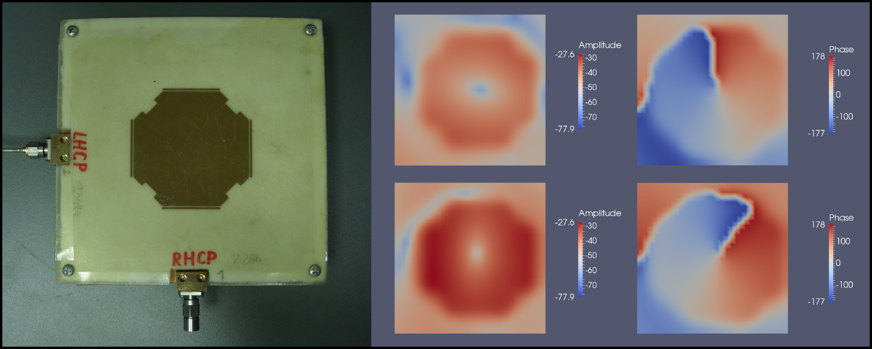
a)
b)
c)
Figure 3. L-band circular polarized antenna a) and measurements for 2.1 GHz b) and 2.2 GHz c).
The overall scanned frequencies are 40 for 2.0 – 2.4 GHz band and the dynamic range of the measurements is 50 dB using the PNA. The size of the patch antenna is 59 x 59 mm and the scanned area is 75 x 75 x 62.5 mm. Simple calculations show that single scan with 1 mm resolution will give 75 x 75 = 5625 measurement points just for one plane. If we set the measurement to 40 frequency points we get 5625 x 40 = 225000 values just for the amplitude on one plane. From this simple example it is obvious that the main problem is the handling of such big data structures effectively.
Using Paraview software it is possible to be handled and visualized big data structures even on laptops and standard computers. Different filters and cuts could be applied to the data for processing. It is possible collected data to be exported in video format as animation. This gives unique opportunity for visualization of resonant effects of the DUT ‘s electromagnetic field.
Balanced amplifier
Using the same technique another device was scanned. The balanced amplifier shown on Fig.4 works in the frequency range 700 – 900 MHz. The input of the amplifier is connected to the first port of the PNA, while the output is terminated with 50 ohms load. The second PNA’s port is connected to the H-type rf probe and S21 parameter is measured. Measured data is shown on Fig.4.
The balanced amplifier consists of two hybrid couplers one at the input and one at the output. The input hybrid divides the input power and split the signal in 90⁰ deg. phase, so that the active components in the circuit have less coupling and better isolation between each other. The output hybrid coupler combines amplified signal from the active components in phase. Using this technique the output power is increased with 3 dB.
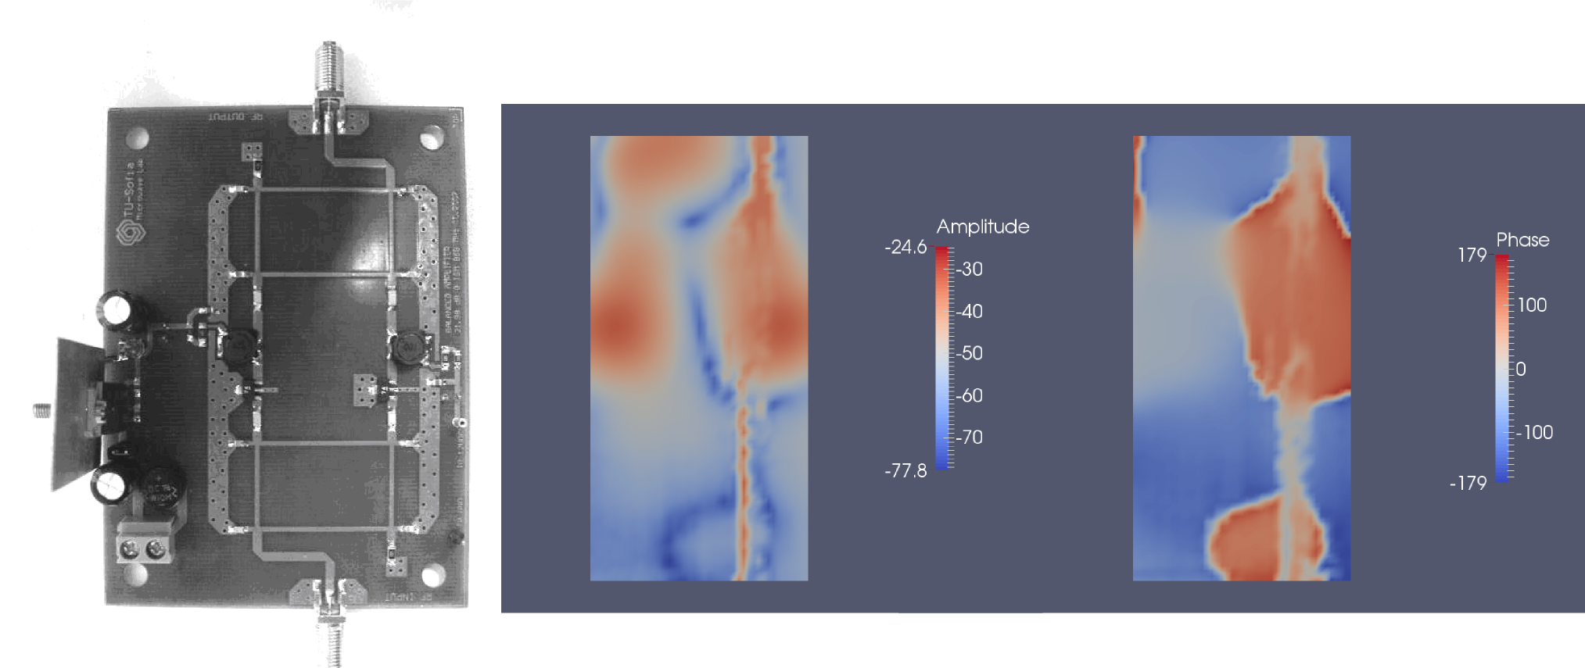
Figure 4. Balanced amplifier, amplitude and phase measurements.
Scanned area of the balanced amplifier is 45 x 90 x 3 mm with 1 mm resolution. Visual analysis of Fig.4 shows that the output of the amplifier is on top side of the image, because of the increased field density in this area. Output resonant coils of at the amplifiers are well outlined. From the amplitude distribution we could see that there is coupling between the termination resistor of the output hybrid coupler and the SMA connector at the output of the circuit. The phase distribution shows that there are around 90⁰ difference between left and right side of the amplifier as we expected from the hybrid couplers.
Software
Different types of software skills are needed to make near-field scanner. Most of the software used for these measurements is open source. There are many different approaches to combine the available software with measurement device and get even lower cost near-field scanner. One such example is using microprocessor with rf front end like ATMEGA128RFA1 and use RSSI (received signal strength indicator) as absolute measuring device. Using the same processor EM field of the patch antenna could be measured within the range 2.4 to 2.485 MHz in 5 MHz steps.
The most difficult part of the software is to synchronize the probe’s movement and collected data to work accurate and fast. My approaches to the problem are published online on my github repository [8].
CONCLUSIONS
In this paper a simple approach to complex problem as near-field scanning technique is proposed. Basic setup has been set and electromagnetic field of two devices was measured and visualized. The potential of the approach is not limited to EM measurements only and could be applied to temperature measurements also.
Finer near-field scanners [9] need better mechanical structure and finer stepper control for IC measurements. Software part is applicable to all single probe scanners.
The author thanks to Scientific Research Found of Sofia University St. Kliment Ohridski for the support.
REFERENCES
- http://www.nearfield.com/products/NearFieldSystems.aspx.
- IEC/TS 61967-3 ed1.0 Integrated circuits - Measurement of electromagnetic emissions, 150 KHz to 1 GHz - Part 3: Measurement of radiated emissions - Surface scan method.
- http://www.reprap.org
- http://reprap.org/wiki/RAMPS_1.4
- http://reprap.org/wiki/Sprinter
- http://en.wikipedia.org/wiki/G-code
- http://www.paraview.org/
- https://github.com/borisov-r/EM3Dscanner
- Adam Tankielun, Uwe Keller, Etienne Sicard, Peter Kralicek, Bertrand Vrignon. Electromagnetic Near-Field Scanning for Microelectronic Test Chip Investigation, IEEE EMC Society Newsletter, Collection IEEE EMC, Octobre 2006

