Balanced Amplifier Using Reduced Size Hybrids
Marin V. Nedelchev, Ilia G.Iliev

Abstract: This paper presents a general theory and measurement of a balanced amplifier using reduced size hybrid couplers. Close form synthesis formulas are derived for the reduced size hybrid coupler. The balanced amplifier topology is applicable for the lower GHz band and integration in MMIC. Simulated and measurement results are presented. A good match between the theory and the measurement is observed.
Keywords: reduced size hybrid, balanced amplifier
I. Introduction
The single amplifier meets the specification for noise figure and gain but fails to meet the return loss specification due to the large mismatches on the inputs and outputs.
To overcome this problem one solution is to use balanced amplifier topology.
With a traditional transistor amplifier, a fairly flat gain response can be obtained if the amplifier is designed for less than maximum gain, but the input and output matching will be poor. The balanced amplifier circuit solves this problem by using two 90 deg couplers to cancel input and output reflections caused by two identical amplifiers. The basic circuit of a balanced amplifier using reduced size hybrids is shown on Fig.1. The first hybrid coupler divides the input signal into two equal-amplitude components with 90 deg phase difference, which drive the two amplifiers. The second coupler recombines the amplifier outputs. Because of the phasing properties of the hybrid coupler, any reflections of an incident signal on the input due to the poor match of the amplifiers will be channelled back through the input hybrid to the 50 Ohm load where they will be absorbed, and similarly on the output. Therefore if we look into the amplifier we will effectively ‘see’ the 50 Ohm loads and will therefore present a good input and output match.
In addition this configuration will give us an extra 3 dB’s of output power and also the 1 dB compression point will be approximately 3 dB’s higher. That means that the circuit will be able to handle double the power without distortion. The main drawback of the design is the power required for two amplifiers instead of one. The balanced amplifier employs two quadrature hybrids in this case two reduced size hybrids (although branchline couplers can be used).
The gain bandwifth is not improved over that of the single amplifier sections.
Marin Nedelchev – Assist. Prof., PhD in Dept. of Radiocommunication and Videotechnologies in Faculty of Telecommunications in TU –Sofia E-mail mnedelchev@tu-sofia.bg
Ilia G. Iliev – Assoc. Prof., PhD in Dept. of Radiocommunication and Videotechnologies in Faculty of Telecommunications in TU –Sofia E-mail igiliev@tu-sofia.bg
Radoslav Borisov – student in Faculty of Communications and Communication Technologies in TU –Sofia

This type of circuit is more complex than a single-stage amplifier since it requires two hybrids and two separate amplifier sections, but it has a many interesting advantages:
- the individual amplifier stages can be optimized for gain flatness or noise figure, without concern for input and output matching
- reflections are absorbed in the coupler terminations, improving input/output matching as well as the stability of the individual amplifiers
- the circuit provides a graceful degradation of a -6 dB loss in gain if a single amplifier section fails
- bandwidth can be an octave or more, primarily limited by the bandwidth of the coupler.
In practice balanced MMIC amplifiers often use Lange couplers, which are broadband and very compact, but quadrature hybrids and Wilkinson power dividers (with an extra 90 deg line on one arm) can also be used.

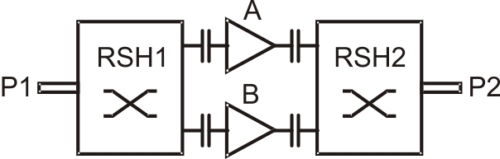

Fig.1 Balanced amplifier using reduced size hybrid
This paper presents a general theory and measurement of a balanced amplifier using reduced size hybrid couplers. Close form synthesis formulas are derived for the reduced size hybrid coupler. The balanced amplifier topology is applicable for the lower GHz band and integration in MMIC. Simulated and measurement results are presented. A good match between the theory and the measurement is observed.
II. Balanced Amplifier Design

The circuit of balanced amplifer is shown on Fig.2. Two amplifiers are connected between 3 dB reduced size hybrids. The scattering parameters for the circuit are given through S-parameters of each amplifier S(A1), S(A2) and hybrid’s power division coefficient - t. Parameter t defines the power ratio in both braches of the hybrids if unequal power split hybrid is used. For equal power split t=0.5 the following S-paramaters are valid
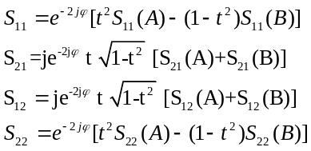
It is obvious that for an equal split power hybrids (t=0.5) and amplifiers with same S-parameters (S(A)= S(B))
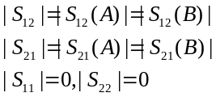
Design with different amplifiers (S(A)≠S(B)) and unequal power split hybrids is described through following S-parameters:
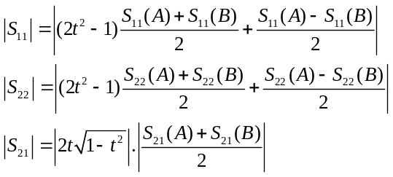
These equations give analytical description of the balanced amplifier, however they don’t give information about its physical size. The size of the amplifier in general depends on size of the hybrid, which size is function of λ. For lower frequencies (below 1 GHz) the size of hybrid gets bigger and it’s not convenient a conventional branch line hybrid to be used. In order to reduce the size of the amplifier, a special type of hybrid has been simulated.

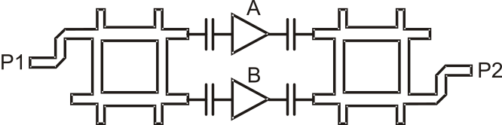

Fig.2 Balanced amplifier with reduced size hybrid

The next section describes how the size of the hybrid can be arbitrary selected in order to reduce the size of the balanced amplifier for lower frequencies.
III. Reduced Size hybrid
The main element in the conventional hybrid coupler is the quarter-wavelength transmission line. In order to obtain reduced-size coupler, shown on Fig.2, in [1,2] is proposed to use capacitive loaded transmission line instead of quarter-wavelength line. To assure equivalent electrical parameters, it is examined both circuits shown on Fig.3a and Fig.3b. The circuit on Fig.3b may be considered as a unit element of periodic slow wave structure [3].
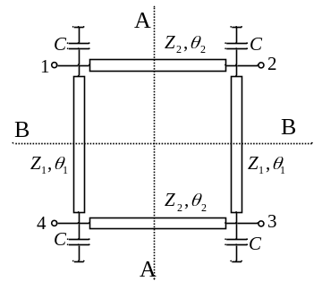
Fig.2 Reduced size branch-line coupler
The slow-wave line consists of a transmission line loaded on both sides by lumped capacitors . The main parameters of the transmission line are the characteristic impedance 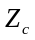, length of the line , and the propagation constant .
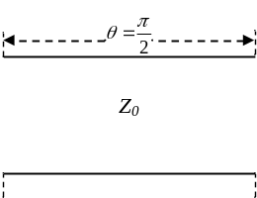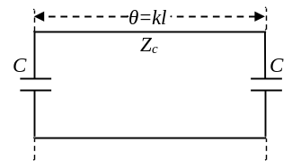
(a) (b)
Fig.3 (a) Quarter wavelength line, (b) capacitive loaded line
The electric length of the unloaded line is 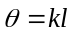. The electrical characteristics of the line are described by the ABCD matrix. The overall matrix of the resonator is a product of the three ABCD matrices – the lumped capacitors and the unloaded transmission line.
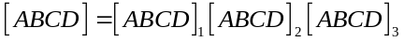 (1) ,
where
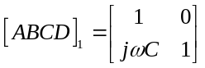, 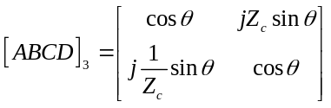, 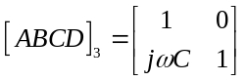.
After the multiplication, the elements of the ABCD matrix are derived as:
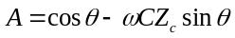 (2a)
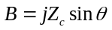 (2b)
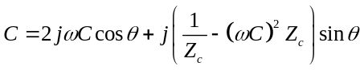 (2c)
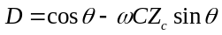 (2d)
It is easily checked out the main property of the ABCD matrix: .
The ABCD matrix of the quarter wavelength line is:
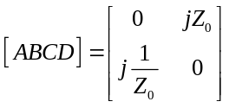 (3)
Comparing the ABCD matrices of both circuits (2) and (3) it is obtained the main design equations:
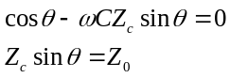 (4)
It is obvious from Eq.4 that the characteristic impedance of the slow-wave line is greater than the characteristic impedance 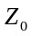 of the conventional hybrid coupler.
There are two main approaches to design a reduced-size branch-line coupler. The first approach starts with the choice of the characteristic impedances 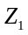 and 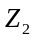 of the transmission lines (Fig.2) and calculation of their electrical lengths and 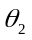. On the final stage the value of the lumped element capacitor is calculated. The design equations become:
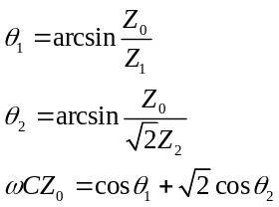 (5).
The second approach starts with the choice of the electrical lengths of the transmission lines , and calculation of the characteristic impedances and the value of the lumped capacitor. The design equations are as follows:
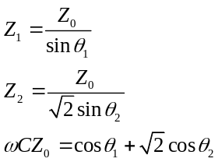 (6)
The analysis of the reduced size hybrid is carried out using the fourfold symmetry of the schematic shown on Fig.2. Using proper excitation of the structure both symmetry planes AA and BB can be either magnetic (open circuit) or electric walls (short circuit). The equivalent schematics for the four different excitations are shown on Fig.4.
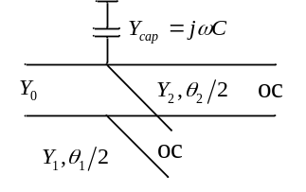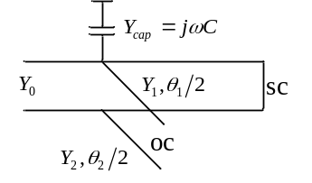
(a) (b)

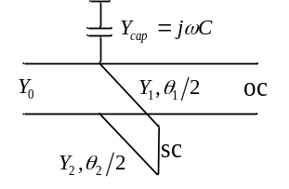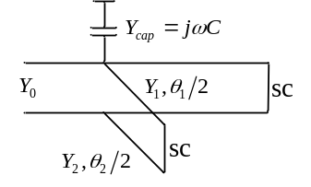
(c) (d)
Fig.4. Equivalent schematics for one quarter section when (a) AA and BB are magnetic walls, (b) AA is electric wall, BB is magnetic wall, (c) AA is magnetic wall, BB is electric wall, (d) AA and BB are electric walls.
The reflection coefficients of each equivalent schematic are obtained as follows:
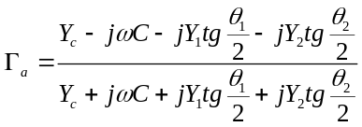 (7a)
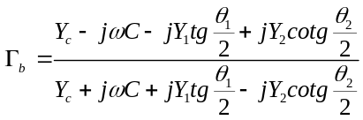 (7b)
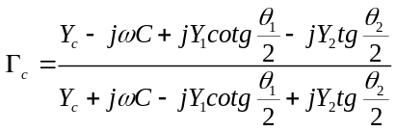 (7c)
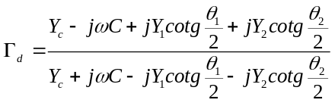 (7d).
The scattering matrix elements are derived as follows [4,5]:
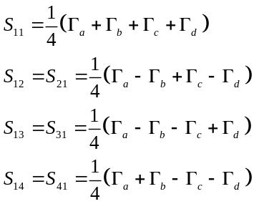 (9)
If the reduced size hybrid is designed according to Eq.5 or Eq.6, therefore the scattering matrix elements (Eq.9) will reduce to 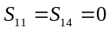, 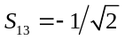, 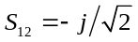.
III. Theoretical and Experimental Results
To verify the proposed method, a balanced amplifier using reduced size hybrids has been designed and fabricated. In this case the operating frequency of the amplifier is 800 MHz. The thickness and dielectric constant of the FR4 substrate is 0.8 mm and 4.1 respectively. Thus the line width of traditional branch line coupler is 1.6 mm and of the hybrid is 59.2 x 59.2 mm. If the size of the branch λ/4 is reduced to 16.3 mm and 5.6 pF shunt capacitors are added then the size of the whole branch-line coupler is reduced to 18.7 x 36,8 x mm. The expected miniaturization ratio is 3.3 in area. The related parameters according to different lengths, capacitive load and miniaturization ratio are listed in Table 1.
Table 1 Reduced size branch-line coupler
 | Traditional Hybrid | Reduced size hybrid | Miniaturization ratio
λ/4 , mm | 59.2 | 16.3 | 3.63
C, pF | - | 5.6 | -
Θ, deg | 90 | 27.18 | 3.31
The photo of the manufactured amplifier is shown on Fig.5.
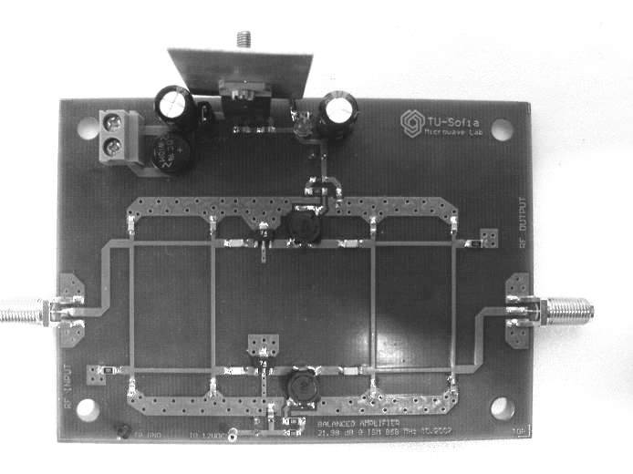
Fig.5 Photo of the realized amplifier
A wideband amplifier with high dynamic range GALI74+ has been used as a key element of the balanced amplifier. It uses transient protected Darlington configuration transistors and is fabricated using InGaP HBT technology in SOT-89 package.
We used Ansoft Designer to obtain the simulated results. The S-parameters of GALI74+ are given on Fig. 6.

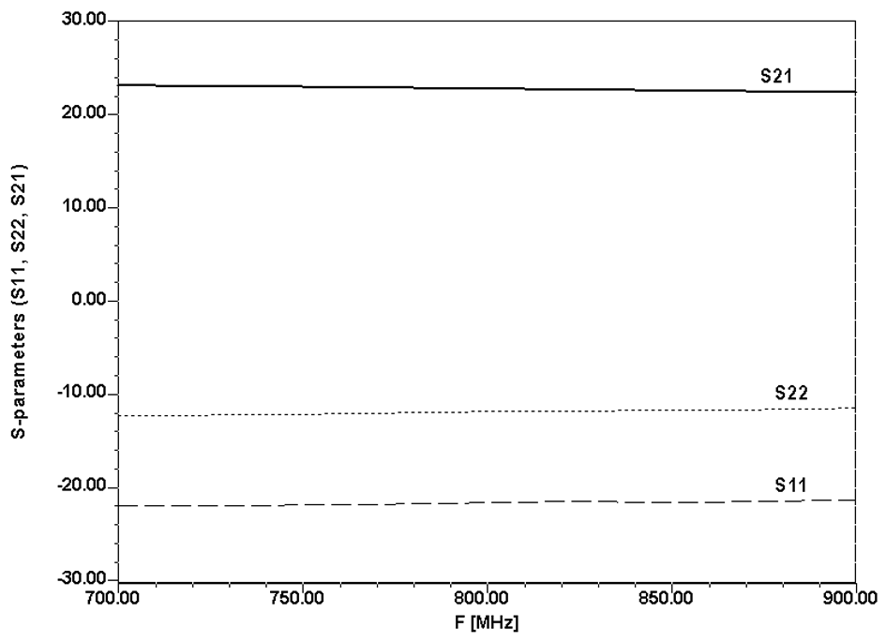
Fig. 6 S-parameters of GALI74+
The figure shows that the amplifier has more than 20 dB gain and input match –20 dB. This means that there is no need of addition matching network if we use the amplifier for the given range.

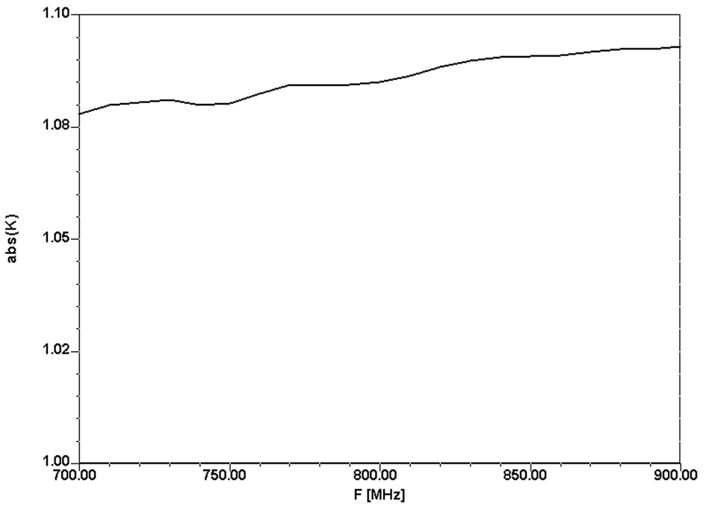
Fig. 7 Stability factor K of GALI74+
Fig.7 shows that the transistor is unconditionally stable in the whole frequency range.
Simulated balanced amplifier has 21 dB gain and –21 dB return loss for 800 MHz. The frequency band is 130 MHz.
A good agreement between numerical and experiment results is shown on Fig. 8 and Fig. 9, except for the gain which is sensitive to line lengths and widths of the reduced size hybrid.
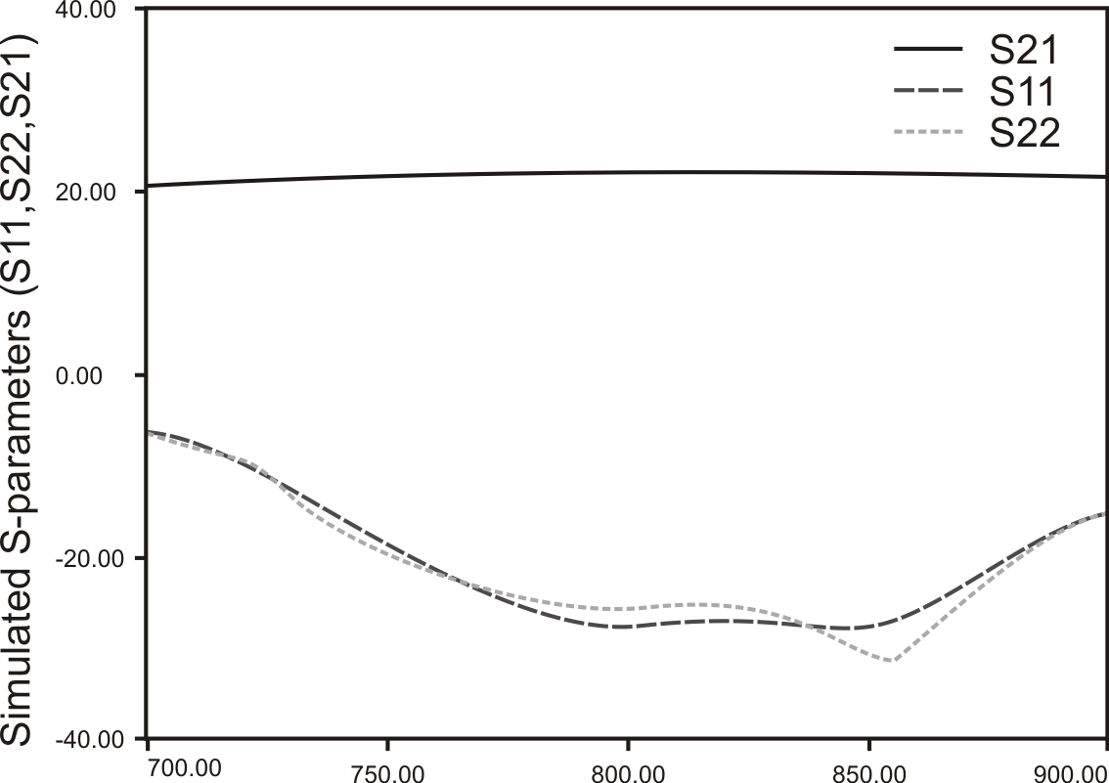

Fig. 8 Simulated results using Ansoft Designer
The fabricated balanced amplifier had been measured using HP 8510 vector network analyser and the following results were obtained.
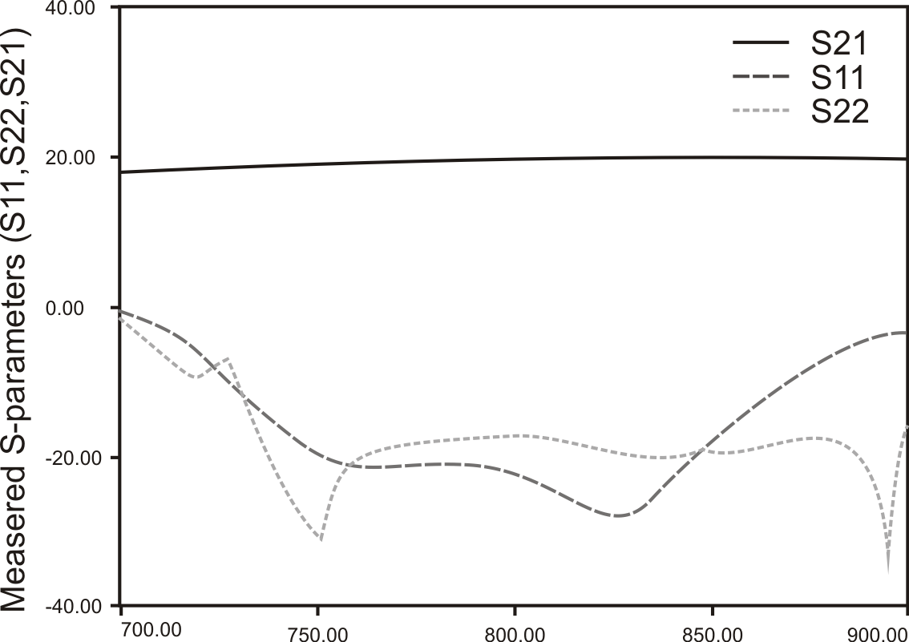

Fig. 9 Measured results using Ansoft Designer
V. Conclusion
This paper presents a general theory and measurement of a balanced amplifier using reduced size hybrid couplers. Close form synthesis formulas are derived for the reduced size hybrid coupler. The balanced amplifier topology is applicable for the lower GHz band and integration in MMIC. Simulated and measurement results are presented. A good match between the theory and the measurement is observed.
References
[1] Hirota, Minakawa, Muraguchi, Reduced-Size Branch-Line and Rat-Race Hybrids for Uniplanar MMIC’s, IEEE Trans on MTT March, 1990, pp.270-275
[2] Mongia, Bahl, Bhartia, RF and Microwave Coupled-Line Circuits, Artech House, 1999
[3] Nedelchev, Iliev, Resonance and Dispersion Characteristics of Microstrip Slow-Wave Open-Loop Resonator, ICEST 2007, Bitola Macedonia
[4] Collin, Foundation for Microwave Engineering, McGraw-Hill, 1999
[5] Pozar, Microwave Engineering, JohnWiley&Sons, 1998

