____________________________________

**Software Requirements**

**Speciﬁcation**

for

**PokemonTool**

**July 26, 2015**

**Team Members:**

Myron Kolodiy, Boris Valerstein

**Professor:**

Dr. Adrian Barb

Penn State University

Table of Contents

1 Introduction 3

1.1 Abstract 3

1.2 Purpose 3

1.3 Scope 3

1.4 Overview 4

2 Functional Requirements 5

2.1 User Interface 5

2.2 Status 6

2.2.1 Confusion 6

2.2.2 Burn 6

2.2.3 Poison 6

2.2.4 Sleep 6

2.2.5 Paralysis 6

2.3 Health Indicator 7

2.3.1 Minus Sign 7

2.3.2 Plus Sign 7

2.4 Refresh 7

2.5 Bench 7

2.5.1 Pokeball 8

2.5.1 Minus Sign 8

2.5.2 Plus Sign 8

2.5.3 Middle Button 8

2.6 Coin Flip 9

2.7 Menu 9

2.7.1 Settings 9

2.8 Database 9

3 Non-Functional Requirements 10

3.1 Application Hardware 10

3.2 Emulation 10

3.3 Response Times 10

# 1 Introduction

## 1.1 Abstract

Pokemon Trading Card Game is one of the largest trading cards games in the world, played by millions of players worldwide. One of the principal issues with the game is the requirement of memorization or using devices such as dice to keep track of the status of the game. Our goal is to eliminate this need by creating a simple to use Android application that can be installed on a player’s phone. This would remedy the need to carry dice, coins, and other helpful accessories to play the game.

## 1.2 Purpose

This document details all of the software requirements for the PokemonTool application. These requirements directly relate to the functionalities, performances, attributes, and interfaces of the system.

PokemonTool provides players with an interface to track the health and status of their Pokemon during a Pokemon Trading Card Game match. In a Pokemon game, the Pokemon is a monster that is summoned to the field of play to combat an enemy Pokemon. During each fight, the Pokemon can acquire certain conditions: burn, sleep, confusion, poison, and paralysis. In addition, the Pokemon will lose and gain health points during the fight. The Pokemon can also be withdrawn to the bench in order for another Pokemon to be summoned in its place.

The primary goal of PokemonTool is to provide a means of recording the status of the players’ Pokemon during the Pokemon match. This includes health, condition status, and bench. In addition, the application has an integrated ability to coin flip, which is another requirement to play the game. In essence, PokemonTool makes Pokemon Trading Card Game playable without dice, coins, or other accessories.

## 1.3 Scope

This document describes the software requirements and all associated functionalities for the initial release of PokemonTool, version 1.0. The intended audience of this document exclusively includes the developers, testers, and end-users of the system.

## 1.4 Overview

The rest of the document contains information regarding the functional and non-functional requirements of running PokemonTool. This includes what the user sees on the screen, how to operate the application, and what hardware is required for PokemonTool to operate.

# 2 Functional Requirements

## 2.1 User Interface

The User Interface is split in half, where each half is identical in functionality. The bottom half faces the bottom of the phone and the top half faces the top of the phone.

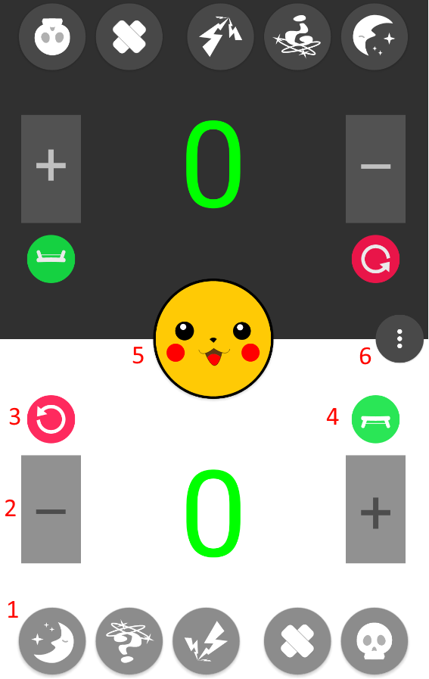

Figure 2.1: 1 – status, 2 – health indicator, 3 – refresh, 4 – bench, 5 – coin flip, 6 – menu.

## 2.2 Status

There are five indicators: confusion, burn, poison, sleep, and paralysis. Each indicator is displayed as a circle with the respective icon inside of it. Touching the indicator will toggle it on or off. When the status indicator is on, it is lit up. When the status indicator is off, it is not lit up.

### 2.2.1 Confusion

Each time this indicator is turned on, the confusion counter data is recorded in the application which is sent to the database.

### 2.2.2 Burn

Each time this indicator is turned on, the burn counter data is recorded in the application which is sent to the database.

### 2.2.3 Poison

Each time this indicator is turned on, the poison counter data is recorded in the application which is sent to the database.

### 2.2.4 Sleep

Each time this indicator is turned on, the sleep counter data is recorded in the application which is sent to the database.

### 2.2.5 Paralysis

Each time this indicator is turned on, the paralysis counter data is recorded in the application which is sent to the database.

## 2.3 Health Indicator

The health point tracker keeps track of the current health points of the currently played Pokemon. The current health point value is displayed as a large numerical value, printed in the center of the screen. The default health point value is 30.

### 2.3.1 Minus Sign

Next to the health point value is a large minus sign. Touching the minus sign decreases the health point value by 10. The minimum value is 0. When the value becomes 0, the value is displayed in green color font. Touching the minus sign further has no function.

### 2.3.2 Plus Sign

Next to the health point value is a large plus sign. Touching the plus sign increases the health point value by 10. The maximum value is 990. When the value becomes 990, the value is displayed in red color font. Touching the plus sign further has no function.

## 2.4 Refresh

When the refresh button is touched, the current health point value in the Health Indicator is set to 0 and is displayed in green color font.

## 2.5 Bench

When the bench button is touched, the bench window opens up from the bottom of the screen. The bench shows 5 Pokeballs with numerical values to indicate their health points, defaulted at 0.

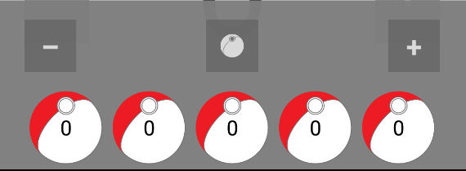

Figure 2.5.1: The bench window.

### 2.5.1 Pokeball

Each Pokeball is selectable by touching it. Multiple Pokeballs can be selected at the same time.

### 2.5.2 Minus Sign

On the top left is a large minus sign. Touching the minus sign decreases the health point value of all currently selected Pokeballs by 10. The minimum value is 0. When the value becomes 0, touching the minus sign further has no function.

### 2.5.3 Plus Sign

On the top right is a large plus sign. Touching the plus sign increases the health point value of all currently selected Pokeballs by 10. The minimum value is 990. When the value becomes 990, touching the plus sign further has no function.

### 2.5.4 Middle Button

In the middle on the top of the bench is a middle button. The button starts out as the Pokeball button. When any Pokeball is selected the middle button turns into the swap button.

#### 2.5.4.1 Pokeball Button

When the Pokeball button is touched, all of the Pokeballs in the bench become selected.

#### 2.5.4.2 Swap Button

When the Swap button is pressed, the current value of the health indicator and the current value of the currently selected Pokeball are swapped, effectively moving the Pokemon from play to the bench and summoning the benched Pokemon to the field.

## 2.6 Coin Flip

The coin flipper simulates flipping a coin. The coin is the Pokemon coin, with the Pikachu Pokemon symbolizing “heads” and the Pokemon logo symbolizing “tails.” The coin is displayed on the screen, the most recent result side up. The coin defaults to being heads up. Touching the coin initiates a coin flip. During the coin flip, the coin will appear to spin. After 1000 milliseconds, the coin will stop on either “heads” or “tails.”

## 2.7 Menu

This is the default Android menu button. Usually, this button is on the top of the screen. In order to accommodate the layout of PokemonTool, the menu button is in the middle of the screen, still easily accessible. The settings menu is currently implemented.

### 2.7.1 Settings

The settings allows for the changing of PokemonTool settings. Currently only screen rotation is implemented.

#### 2.7.1.1 Screen Rotation

The screen rotation setting is a toggle of on or off. When set to off, the application will always be in vertical layout. When set to on, the application will adapt and change to the current rotation of the device, using Android’s built in technology.



Figure 2.7.1.1: Screen rotation toggle.

## 2.8 Database

The external database records data for collection and analytical use. In order to avoid performance issues, the database is updated every 5 minutes with the confusion, burn, poison, sleep, and paralysis counters.

# 3 Non-Functional Requirements

## 3.1 Application Hardware

PokemonTool has only been tested on a Samsung Galaxy Note 4.

## 3.2 Emulation

PokemonTool has been built and tested on emulated hardware of a Google Nexus 5.

## 3.3 Response Times

All response times for the PokemonTool interface are to be within 100 milliseconds.