## Modeling of Wave parameters and Storm Surge in Climada (by GMT-TNC)

# Introduction

This document describes the main formulas and equations used within CLIMADA and developed by the GMT-TNC to define the Storm Surge (SS) and wave parameters (Hs, Tp) in the Gulf of Mexico, although the approach is extensible to other hurricane prone areas.

Validation is also provided for three specific storms: Katrina (2005), Wilma (2005) and Ike (2008). More results on the validation will shortly be available as well, although they are not covered in this document. More results on this regard can also be found in a previous work on which this approach is based:

*CEPAL 2012, Documento 1. Dinámicas, tendencias y variabilidad climática CEPAL-ONU. “Regional study on the effects of Climate Change in the coast of Latin America and the Caribbean”*

In the following, the different parametrical models used for the Pressure, Wind, Wave parameters and Storm Surge fields are briefly explained.

# Data

The hurricane parameters are taken from CLIMADA as done for other variables within the package. However, due the nature of the SS and wave parameters, bathymetry is required for the computation. The *General Bathymetric Chart of the Oceans* (GEBCO) (<http://www.gebco.net/>) has been used for such regard.

Besides, validation data is also require to contrast the output values. The buoys used for the validation in the Caribbean are shown in Figure 1 and their characteristics explained in Table 1.

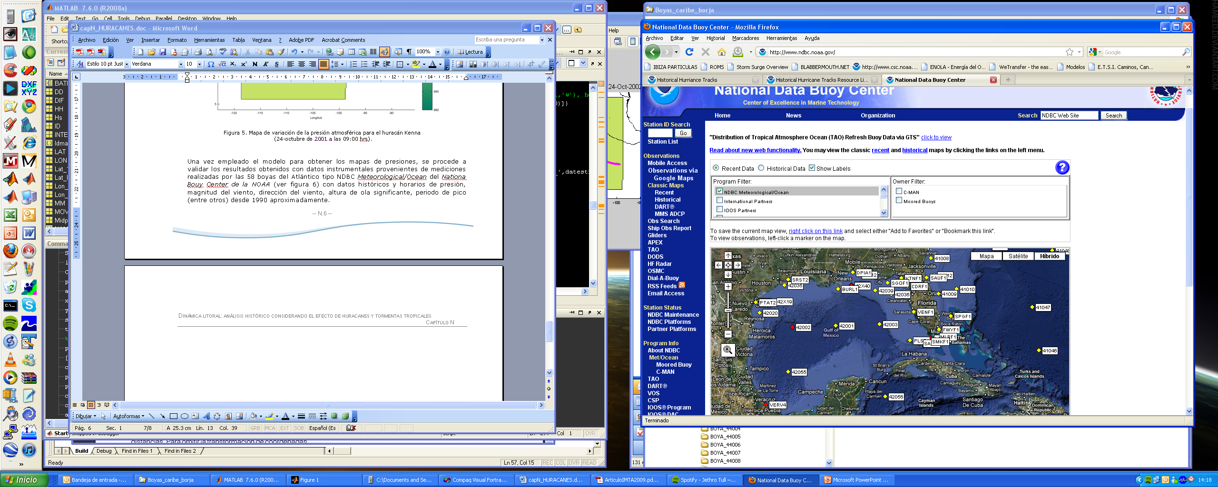

1. Buoys for validation – NOAA (picture taken from: <http://www.ndbc.noaa.gov/>).

|  |  |  |  |  |  |  |  |
| --- | --- | --- | --- | --- | --- | --- | --- |
| **Wind & Waves** | | **NAME** | **LON** | **LAT** | **DEPTH** | **START YEAR** | **END YEAR** |
|  | 1 | **42056** | 19.802 | -84.857 | 4684 | 2005 | 2012 |
|  | 2 | **42057** | 17.002 | -81.501 | 293 | 2005 | 2012 |
|  | 3 | **42055** | 22.203 | -94 | 3566 | 2005 | 2012 |
|  | 4 | **42039** | 28.784 | -96.006 | 274.3 | 1995 | 2012 |
|  | 5 | **42012** | 30.065 | -87.555 | 27.7 | 1983 | 2012 |
|  | 6 | **42035** | 29.232 | -94.413 | 13.7 | 1993 | 2012 |
|  | 7 | **42002** | 25.79 | -93.666 | 3566 | 1973 | 2012 |
|  | 8 | **42001** | 25.88 | -89.658 | 3365 | 1975 | 2012 |
|  | 9 | **42019** | 27.913 | -95.353 | 78.9 | 1990 | 2012 |
|  | 10 | **42020** | 29.968 | -96.694 | 79.9 | 1990 | 2012 |
|  | 11 | **42040** | 29.212 | -88.207 | 164.6 | 1995 | 2012 |
|  | 12 | **42036** | 28.5 | -84.517 | 50.6 | 1994 | 2012 |
|  | 13 | **42003** | 26.044 | -85.612 | 3282.7 | 1976 | 2012 |

Table 1. Coordinates of the buoys used to validate the wave results

For validation of the Storm Surge values, the GESLA dataset (Menendez and Woodworth, 2010) has been used (Figure 2), although the tidal gauges in the Gulf of Mexico are very scarce and they only cover two instances of the three storms considered.

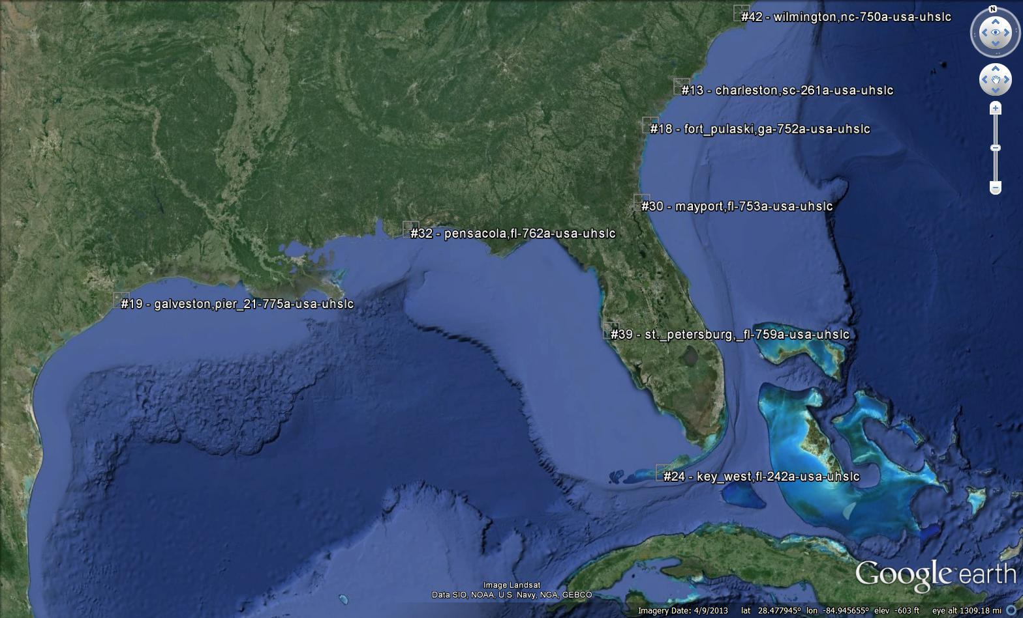

1. Tidal gauges of the GESLA dataset in the area of study.

# Pressure model:

The model used (Figure 3) for deriving the pressure fields is the Hydromet-Rankin Vortex (1980):

 (1.1)

Where

P0 is the pressure at the center of the hurricane (mb)

Pr is the pressure at a distance r from the center (km)

PN is the pressure outside the hurricane (usually1013 mb).

R is the radius of the maximum ciclostrofic winds (km).

La figura 1.208 muestra la geometría de un mapa de presiones cualquiera, para los parámetros de para un dominio de.

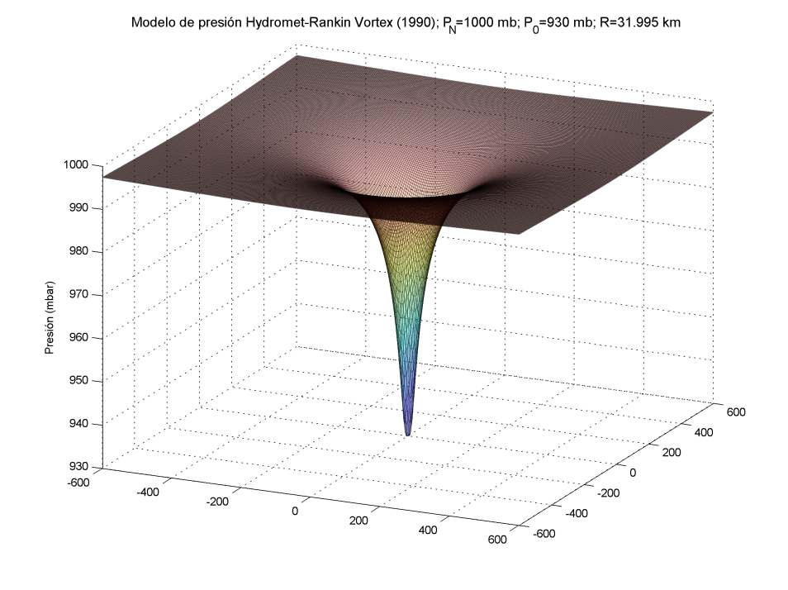

1. Radius of Hurricane (radio ciclostrófico) taken from the formulation derived with measurements in Silva et al. (2002). R=31.95 km, P0=930 mb, region 1200 km x 1200 km

With

 (1.2)

Pressure fields are defined on a 20x20 degrees grid. Winds and other parameters will be derived on the same computational grid. Figure 4 shows some comparison for the Katrina for several locations in the Gulf of Mexico.

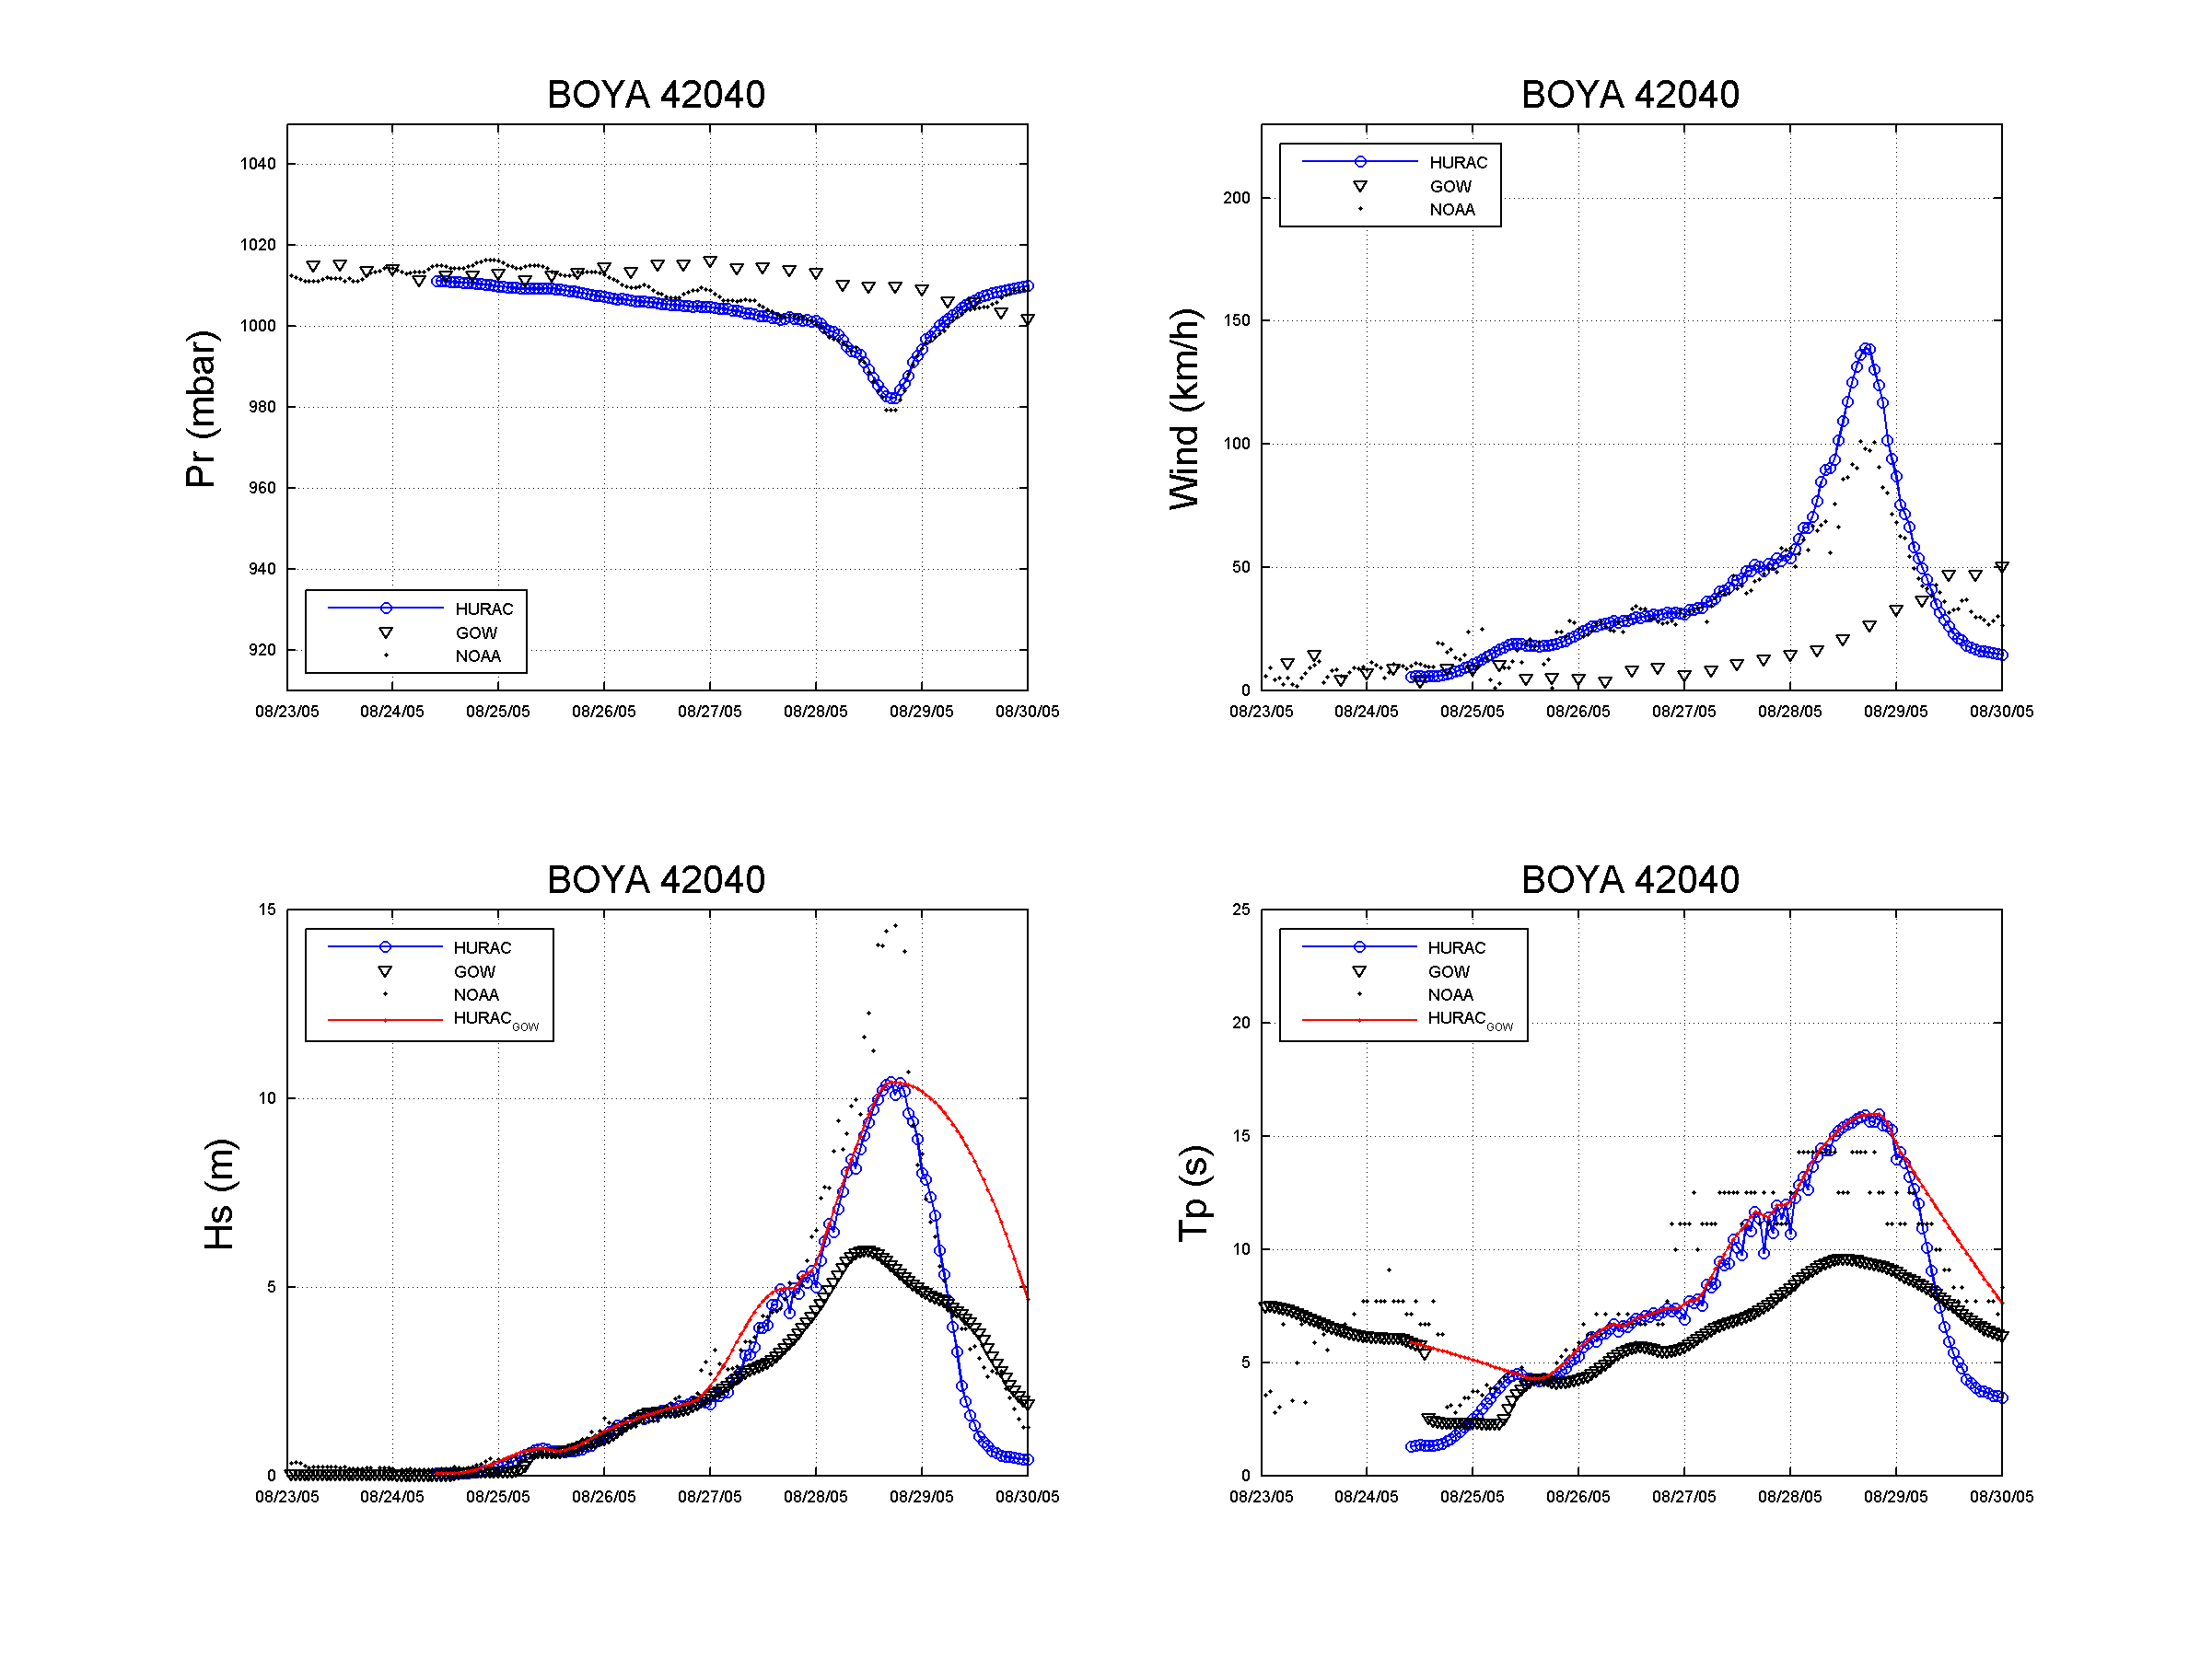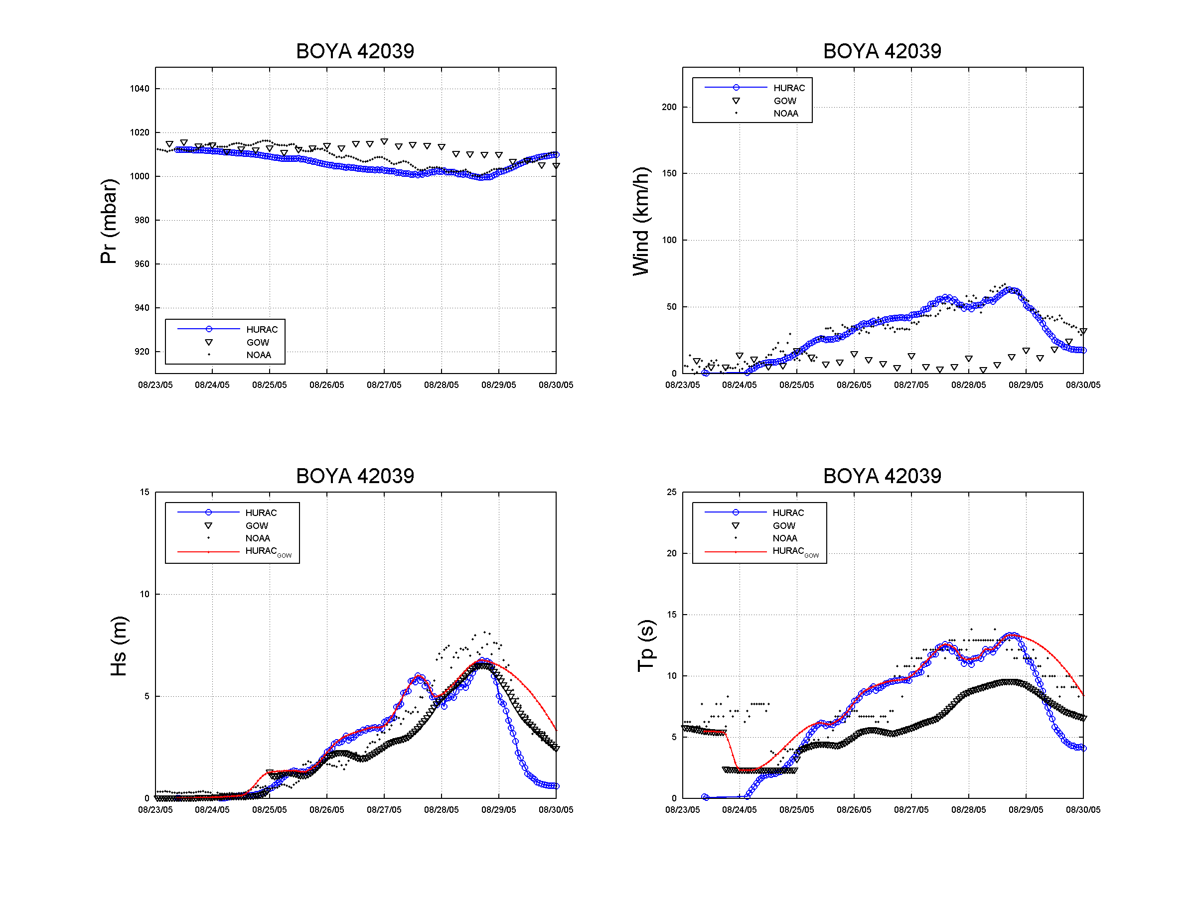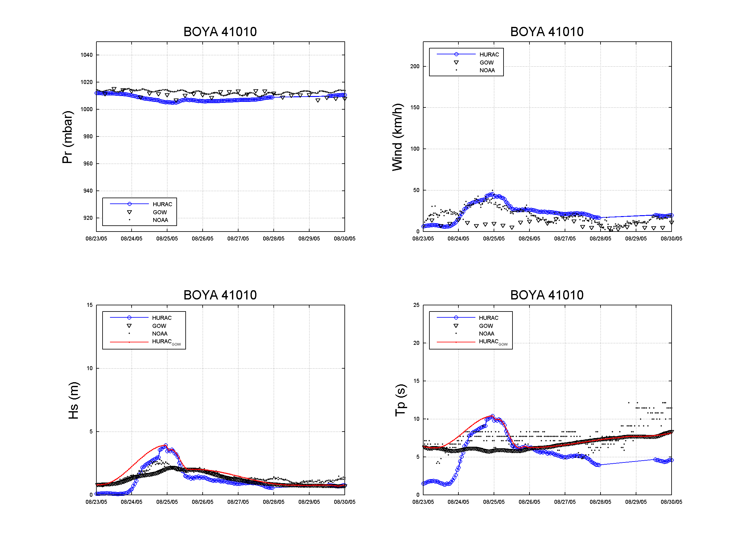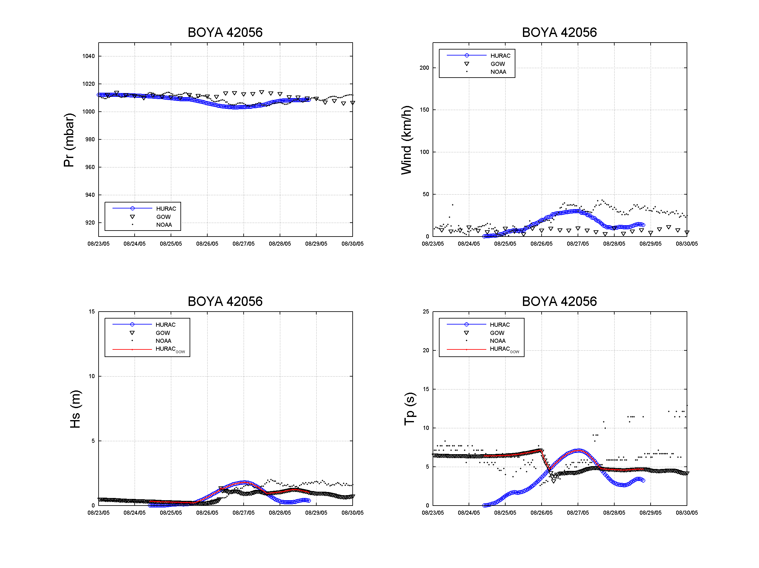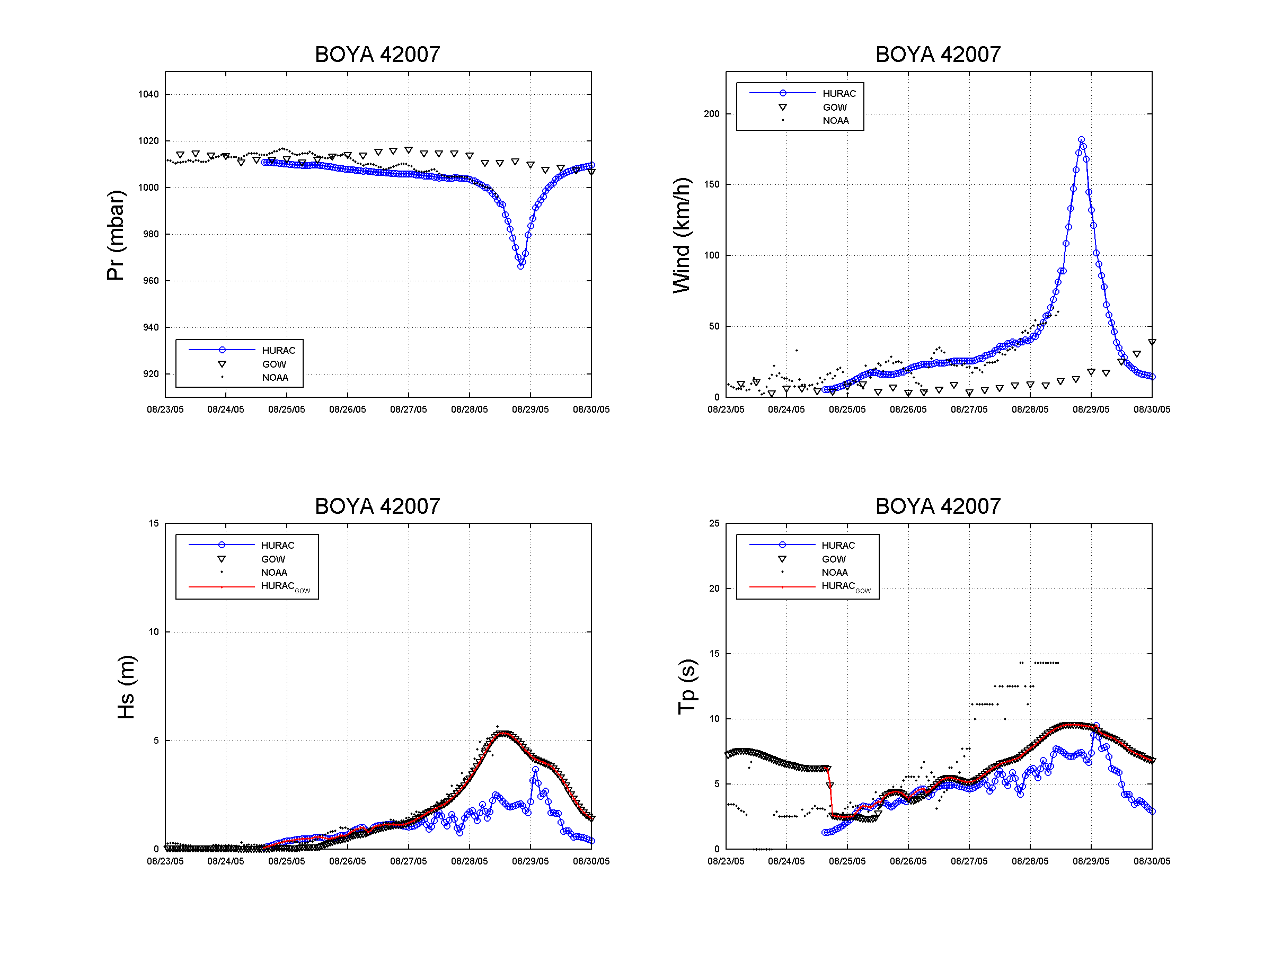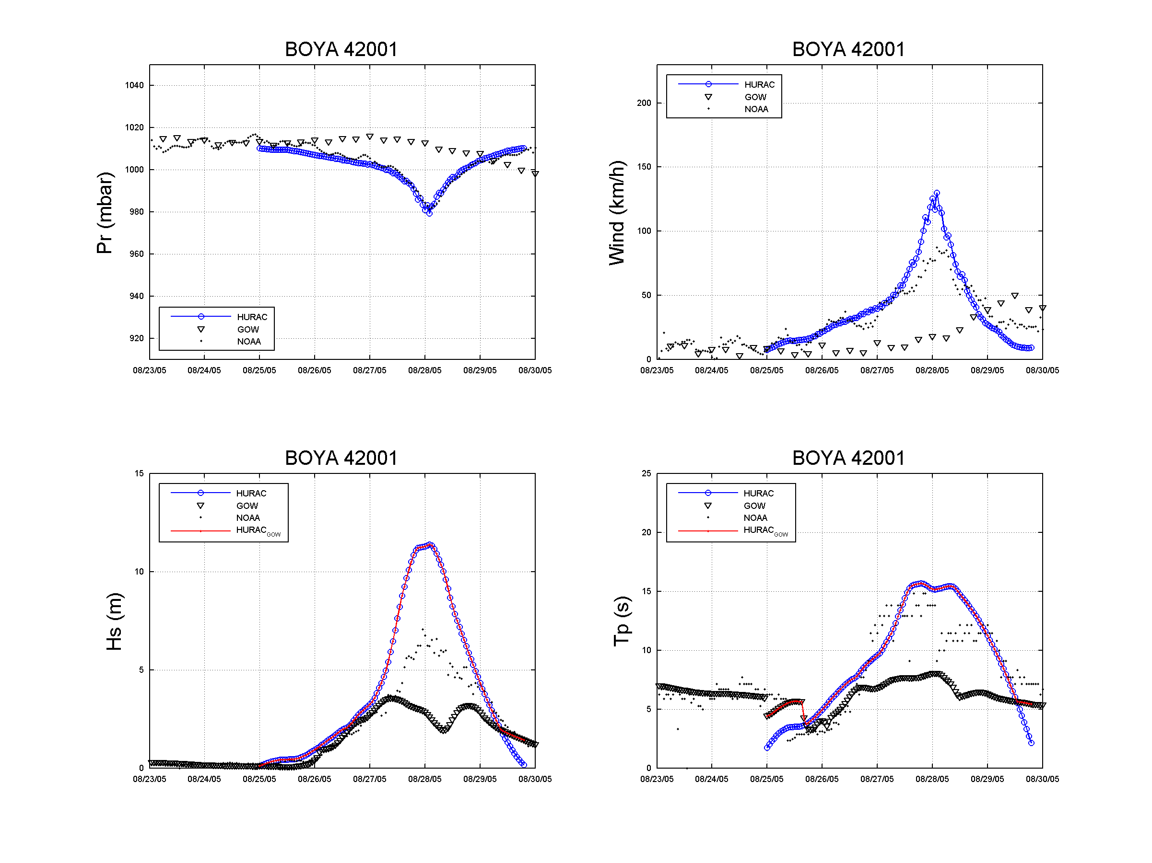

1. Time series of pressure for model HURAC-Hydromet-Rankin Vortex (1980) (blue dots), buoy measurementes (black dots) and NCEP/NCAR reanalysis (black triangles). Storm: Katrina (2005).

# Wind field:

The model used for the wind field is the Hydromet-Rankin Vortex, Bretscneider (1990). The maximum gradient of winds *UR* (km/h) can be obtained from:

 (1.3)

Where *f* is the Coriolis parameter and y  is the latitude in degrees

The wind velocity (10 m; km/h) at a distance r from the center of the storm is:

 (1.4)

Where  represents the angle between the hurricane moving speed  (velocidad del movimiento del huracán, km/h) and the wind speed at a certain distance from its center, *UR* (km/h).  is a damping factor, taken from:

 para  (hacia el centro del huracán) (1.5)

 para  (hacia el exterior del huracán)

With





Figure 5 shows an example of this model. Figure 6, 7 and 8 provide a validation for Katrina (2005), Wilma (2005) and Ike (2008), respectively.

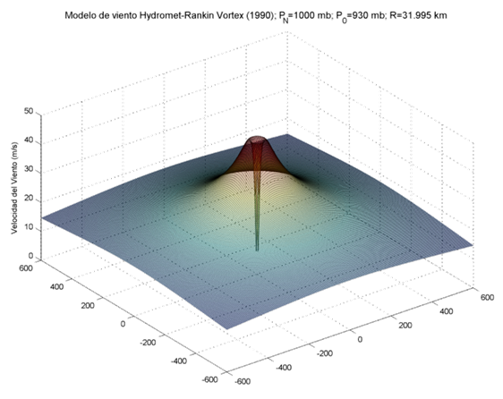  
Example of the Bretscneider (1990) wind-model for R=31.95 km and P0=930 mb in a domain of 1200 km x 1200 km.

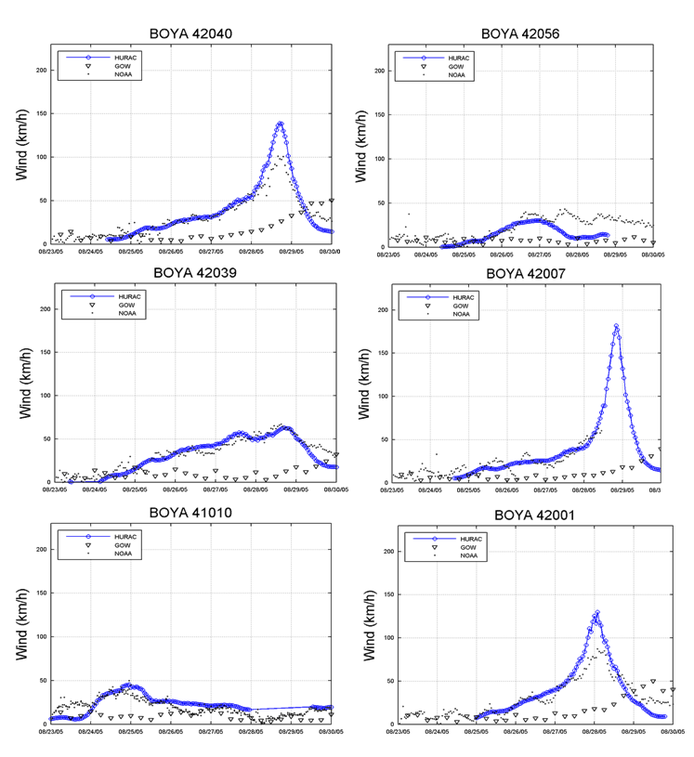

1. Comparison of the wind model (Bretschneider, 1990) (blue dots) with buoys (black dots) and the NCEP/NCAR reanalysis (black triangles) for Katrina (2005).

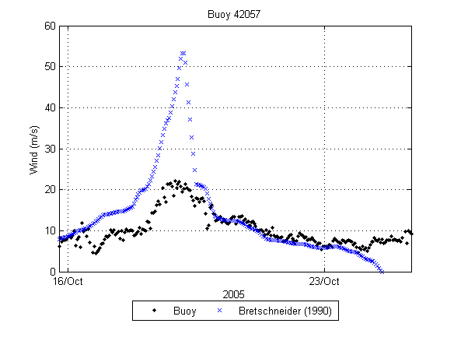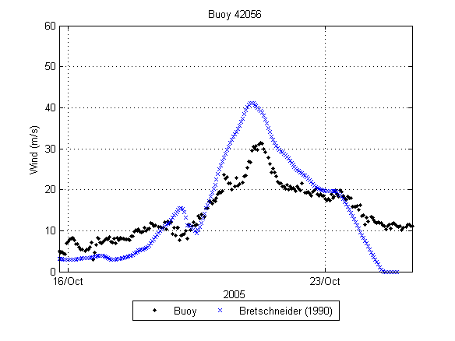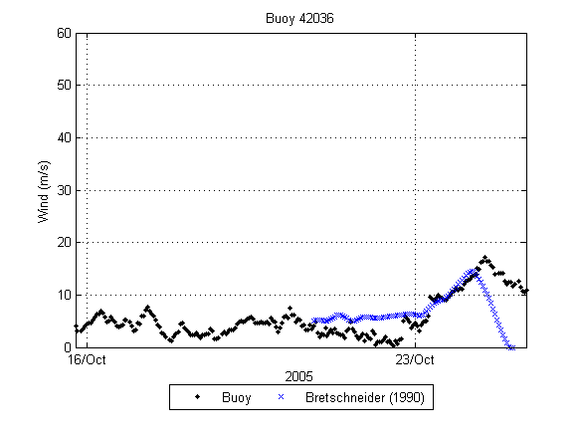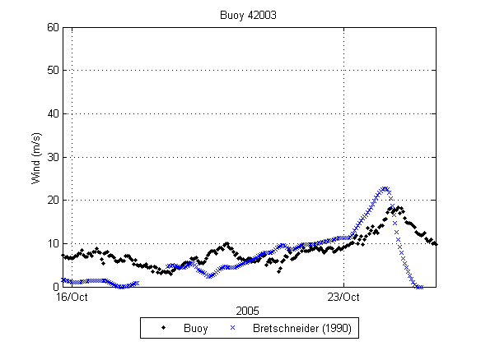

1. Wind speed at different buoys for Storm: Wilma, 2005

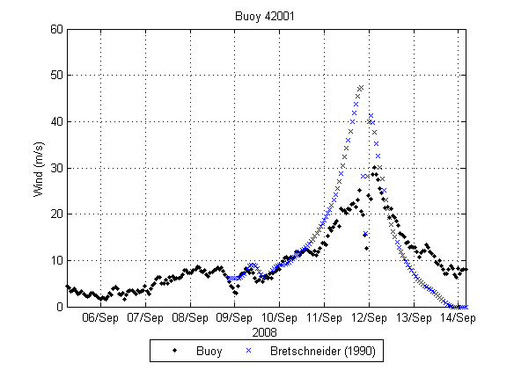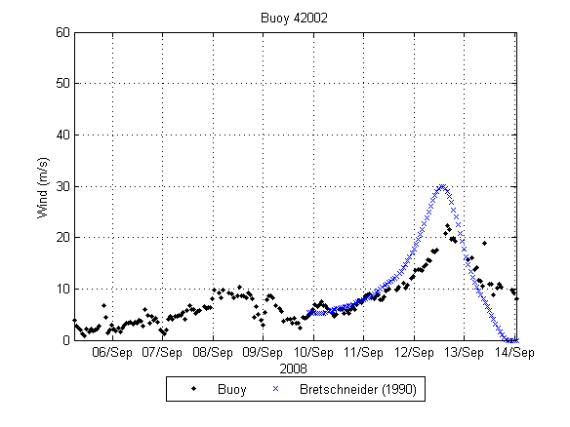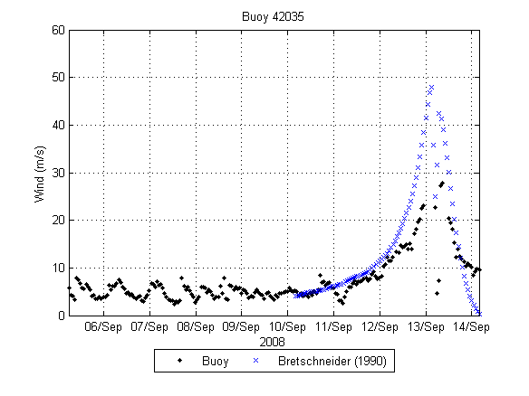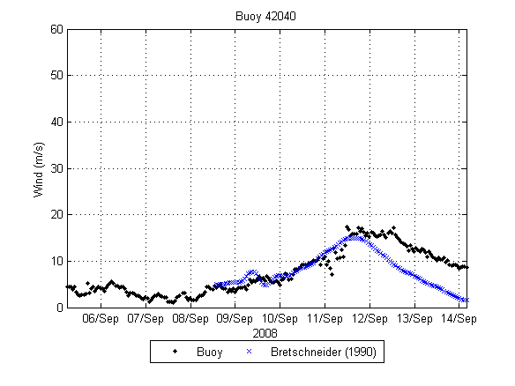

1. Wind speed at different buoys for Storm: Ike, 2008

Figure 8 shows the scatter plots for the peak wind speed for each location compared for the three storms of reference.

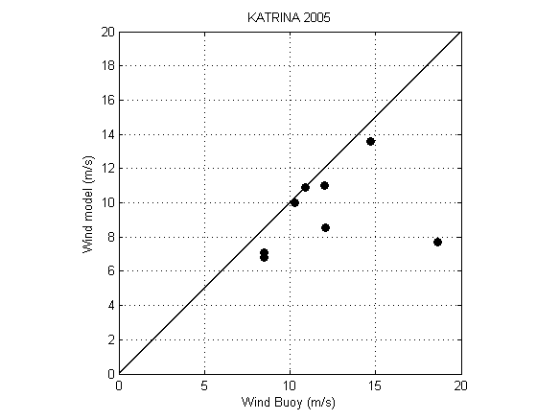 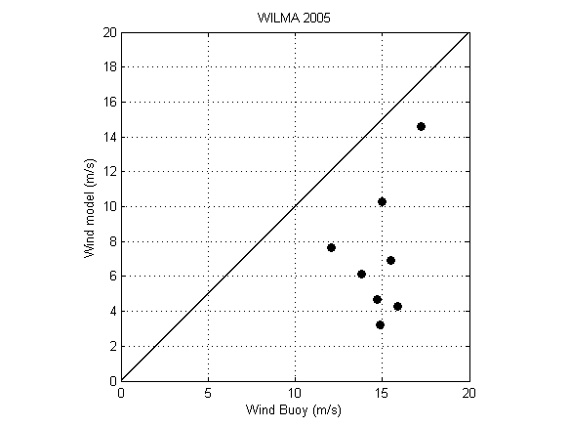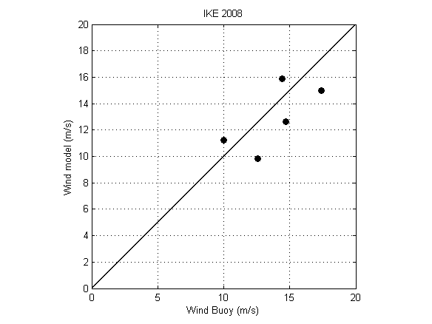

1. Scatter plots of peak wind speed for the three storms (Katrina, 2005; Wilma, 2005; and Ike, 2008)..

# Wave models:

Three models were tested in the work to define wave parameters from the wind fields. Each of them is explained below. The referenced bibliography can be consulted for the parameters in the formulae.

1. **Bretschneider (1990),** for Hs from a non-stationary cyclone at offshore depths

 (1.6)



1. **Young (1988)**, adjusting and calibrating the Hs max with numerical modeling at offshore depts.

 (1.7)



1. **Shore Protection Manual (SPM 1984)**, modified to include some of the near-shore depth induced effects on the waves (Hs and Tp)

 (1.8)



The three models have been implemented in the software and their results contrasted with the buoys for different storms. Overall, the SPM-mod model show the best performance.

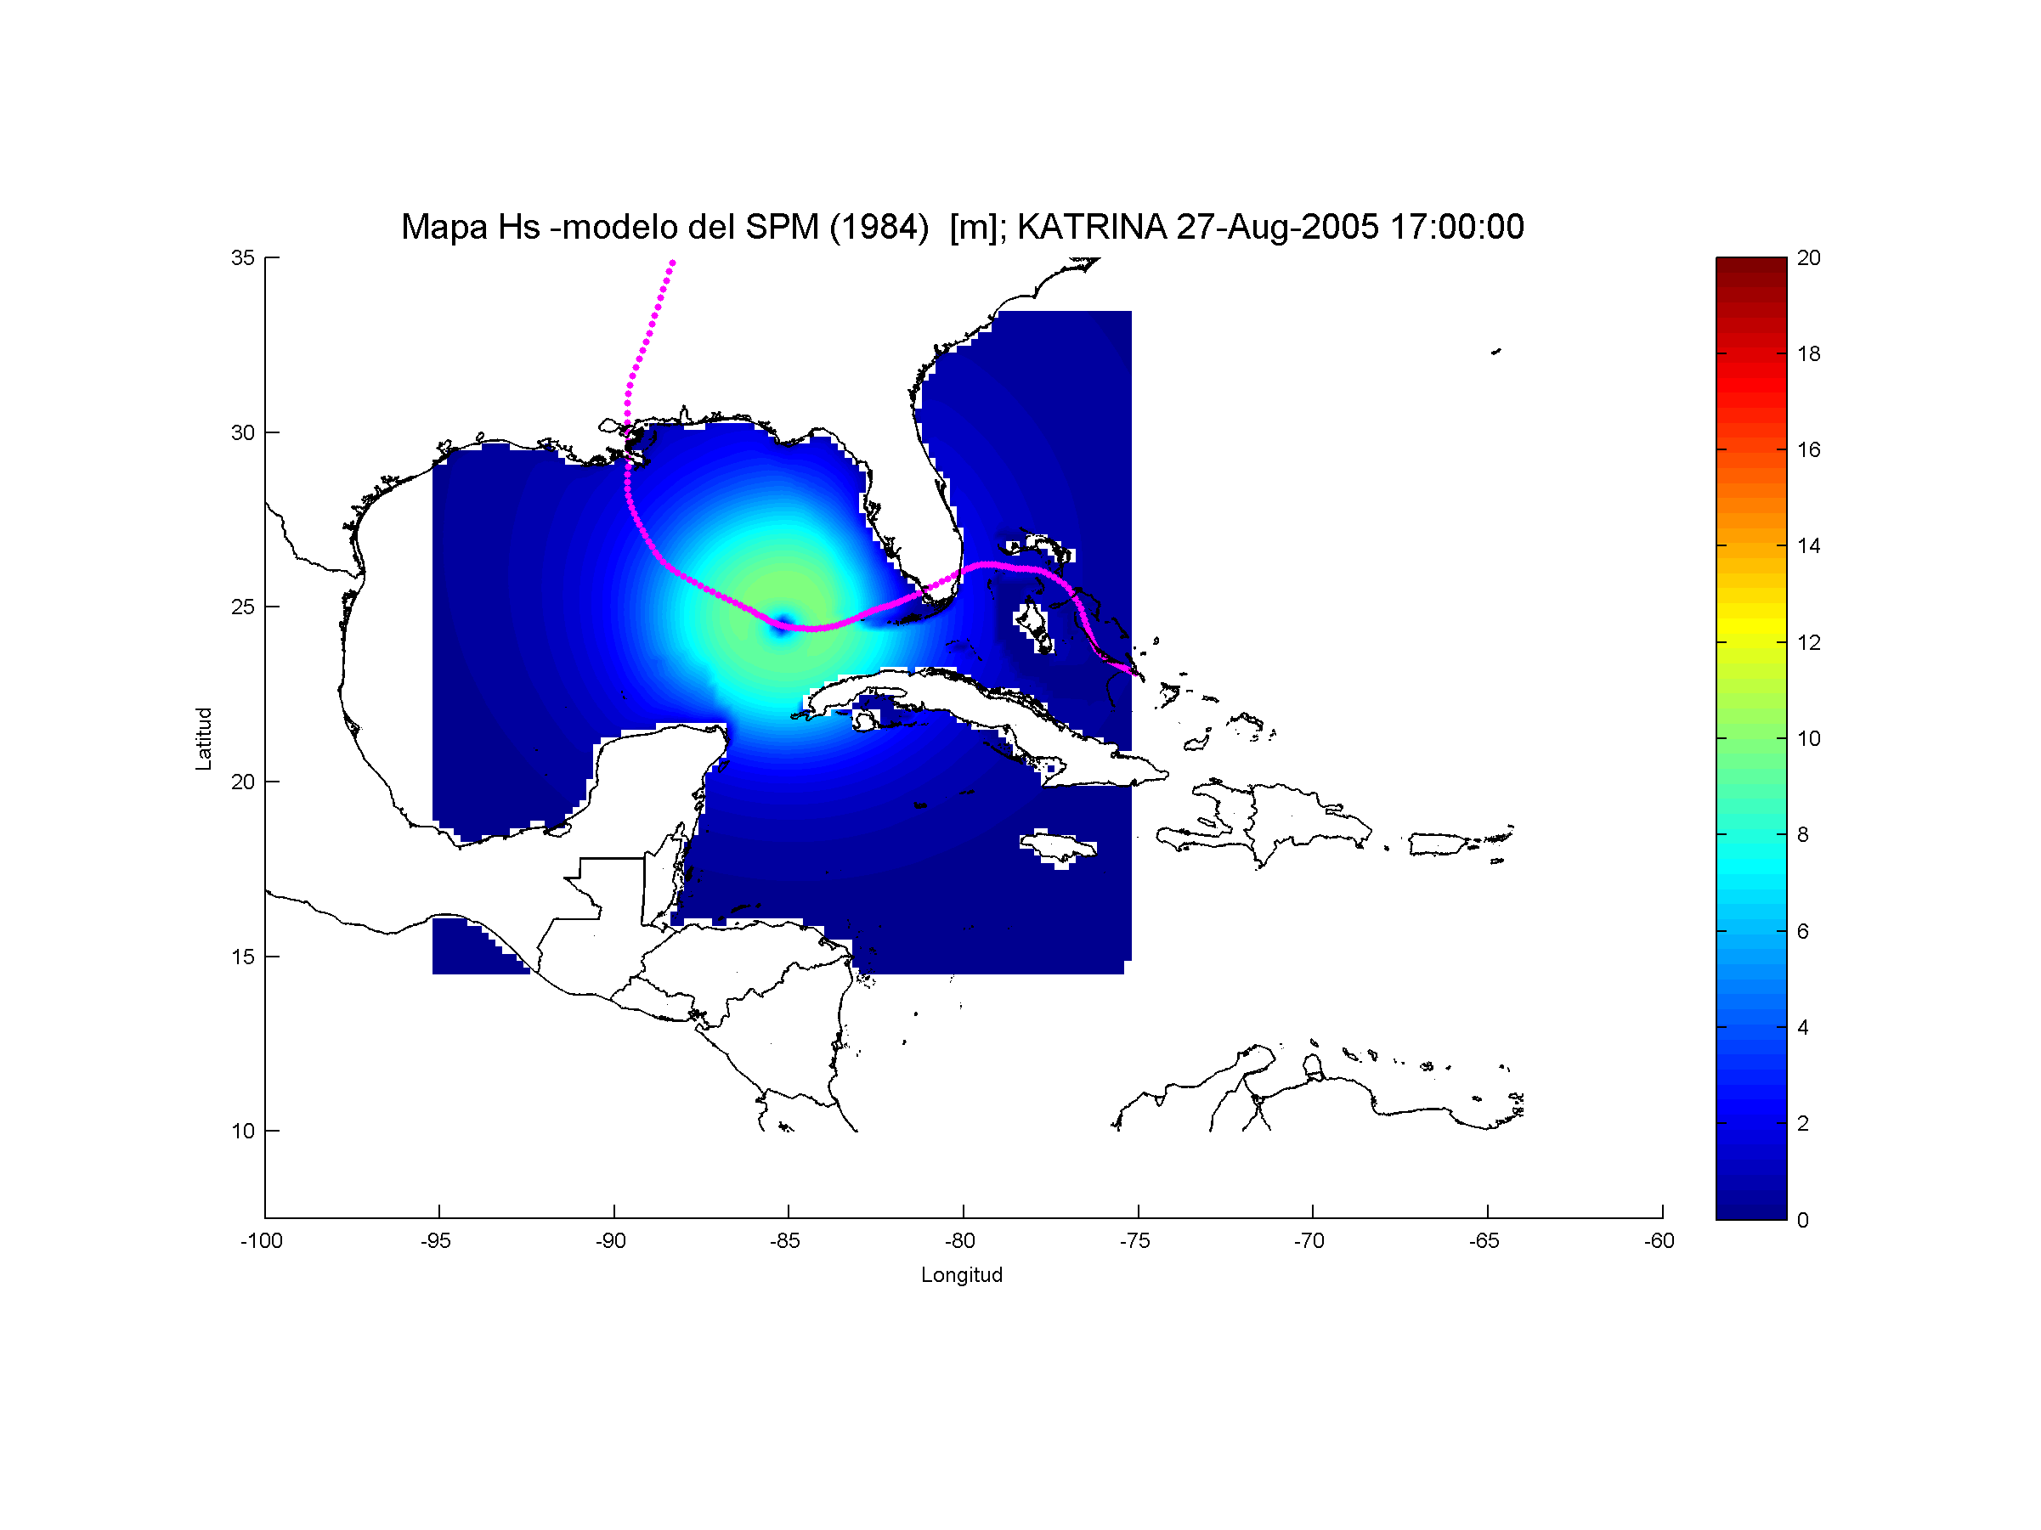 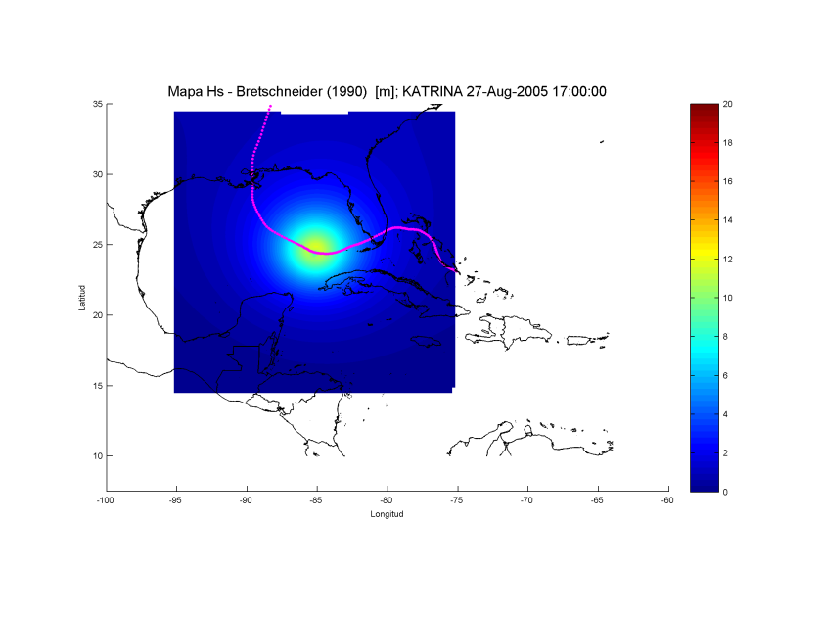

1. Hs patterns for Hurricane Katrina at 27-Aug- 2005 at 17:00 hrs: (left) SPM-mod(1990); (right) Bretscneider (1990)

Note that none of the models include transformation or dissipation processes like shoaling, refraction or diffraction that affect waves near shores. Consequently, results should be considered representative only of the open and exposed areas.

Figures 10, 11 and 12 show some comparisons at buoys in the Gulf of Mexico for the three storms taken as reference.

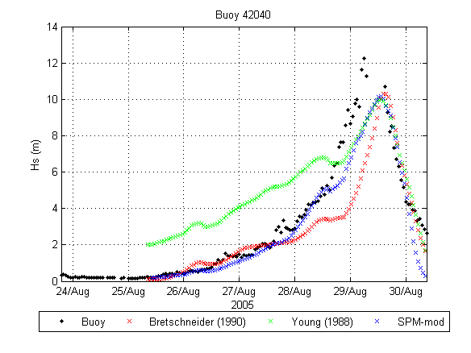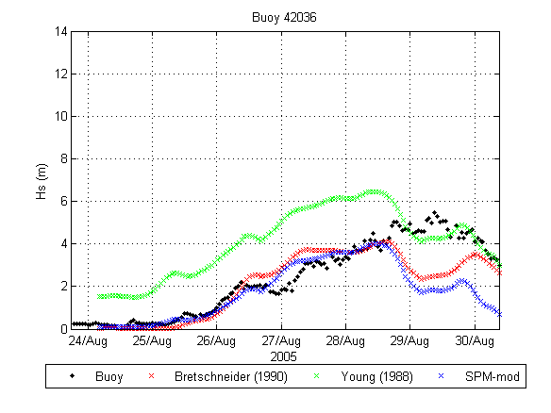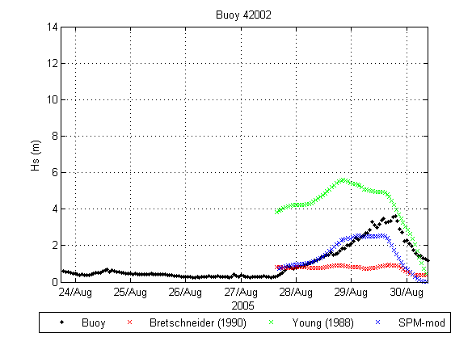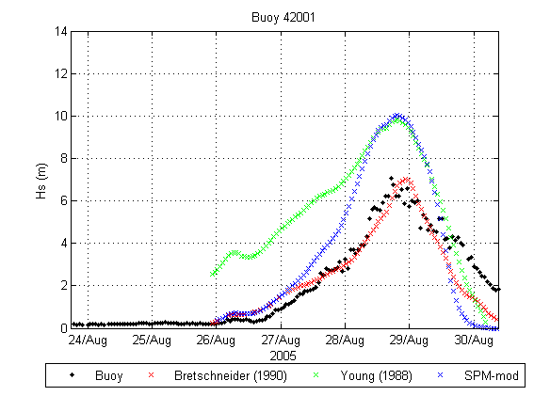

1. Significant wave height at several buoys for Storm: Katrina, 2005.

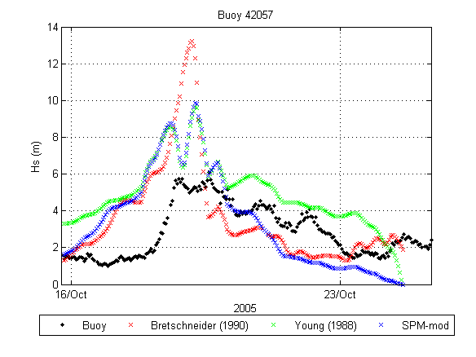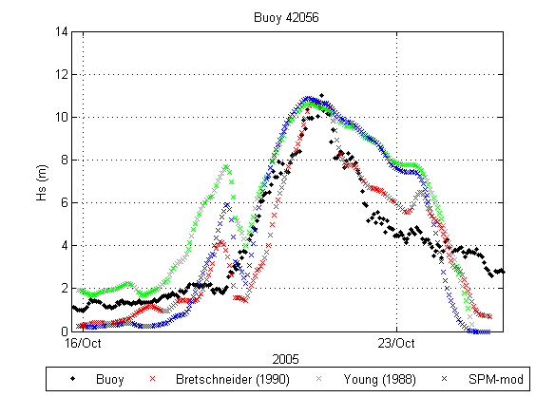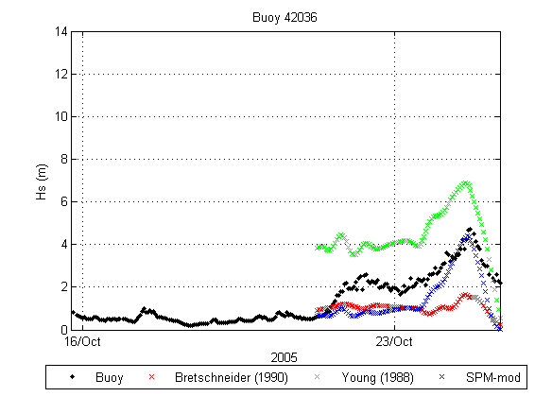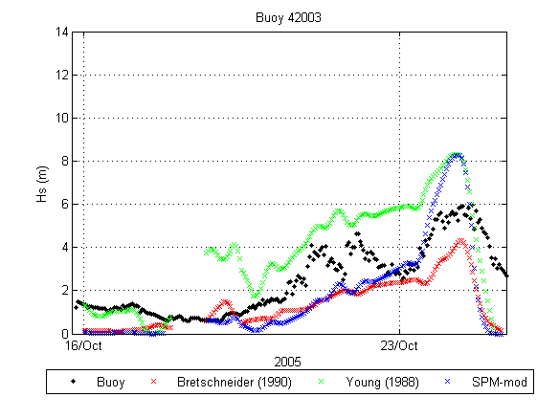

1. Significant wave height at several buoys for Storm: Wilma, 2005.

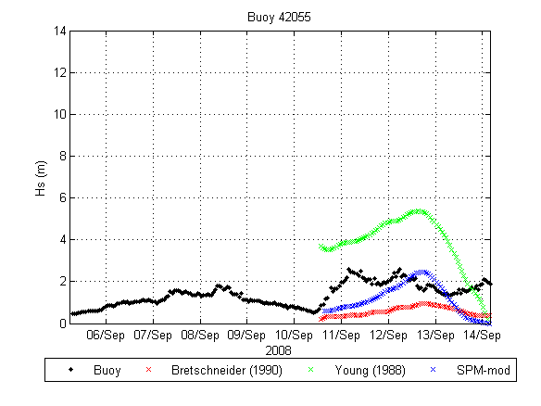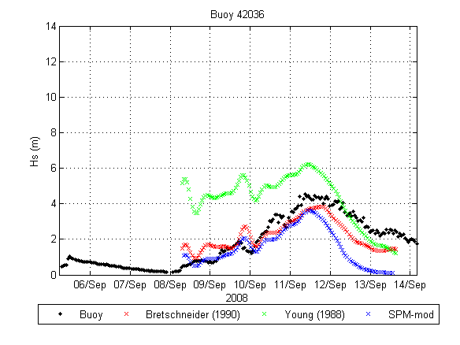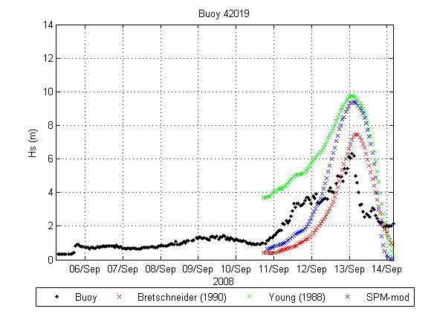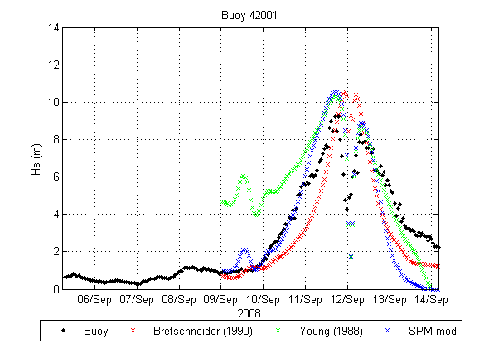

1. Significant wave height at several buoys for Storm: Ike, 2008

Figure 13 shows the results for the peak value of each storm at all the buoys considered.

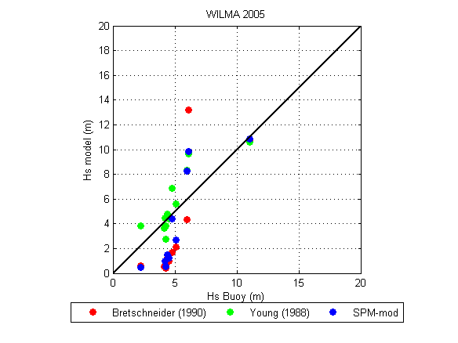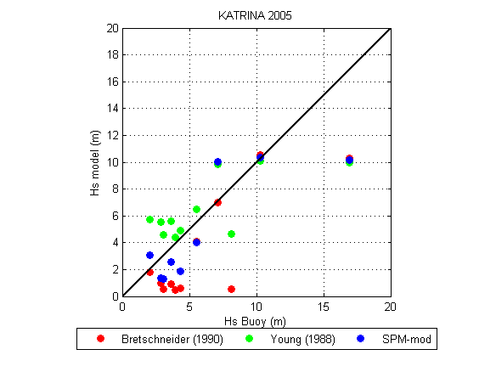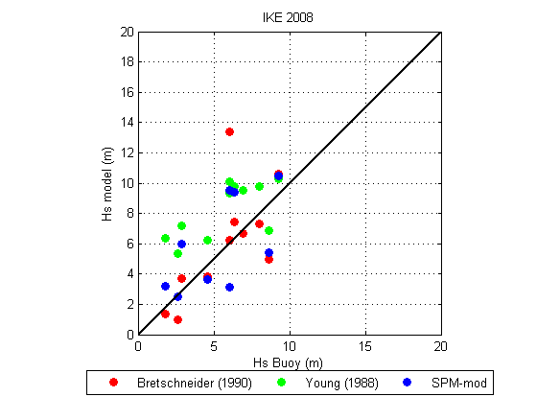

1. Scatter plots of peak values of significant wave height for the three storms.

# Storm Surge model:

The storm surge is supposed to be the linear sum of two effects: (1) elevation due to the atmospheric pressure and (2) the wind shear stress over the sea surface.

1. **Sea level pressure effect**

SS spatial variation is supposed stationary and symmetric, only depending on the pressure gradient. The model used is Dean and Dalrymple (1984):



Where

 sea level elevation

Pn pressure outside the storm (mbar)

P0 central pressure (mbar)

 water density (1025 kg/m³).

R hurricane radious (km)

1. **Wind** [**thrust**](http://www.linguee.es/ingles-espanol/traduccion/thrust.html) **(explain in page 157, Dean and Dalrymple, 1984)**

The shear stress produced by the wind on the sea surface generates a elevation of the water level at the coastline known as Storm Surge. Although its modeling is complex (e.g., Jacobsen, 2013), the long wave equations can be used to described it on the continental shelf (Freeman et al., 1957) or a lagoon. Although the wind shear stress is usually very small, when its effect is integrated over a large body of water, like the Gulf of Mexico, it results in water levels in excess of 6 m.

The approach assumes an orthogonal transect to the bathymetry (Figure 14). It responds to an approximation of the long-wave shoaling on the continental shelf (see sketch in Figure below). See references for further detail.

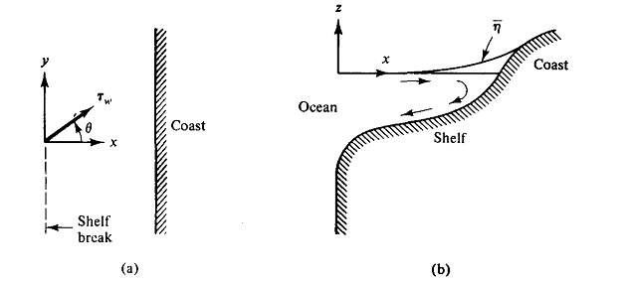

1. Sketch of the plan (a) and cross-sectional view of the coast for using the simplified approach. Figure from Dean & Dalrymple (1984).

Conditions are also supposed stationary for each storm position and the maximum wind speed acting on the coastal transect. The relative angle between the maximum wind speed and the bathymetric transect is considered to define the tangential stress and is taken at the beginning of the continental shelf (i.e. where shoaling starts having an effect), assumed in 200 m deep. Bottom friction and 2DH effects are not considered.

The model used is comprehensively explained in Dean & Darlymple (1984). The wind stress over the water surface is (SPM, 1984):

 (1.9)

where,

 is the water density in kg/m³.

 is the maximum wind speed (10 m over sea level), m/s.

 is a friction factor, O(106) , taken from Van Dorn (1953):

 

 

The wind stress acting on the transect is . The sea level surface induced by the wind stress (; SS) can be obtained from the following equation:



h: depth

n: factor taken from SPM (1977), between 1.15 and 1.30 (n=1-Sb/Ssx)

Figure 15 shows the transects used for the validation points (wave buoys and tidal gauges) as passed to the climada codes. A similar approach is applied to obtain results along the coastline.

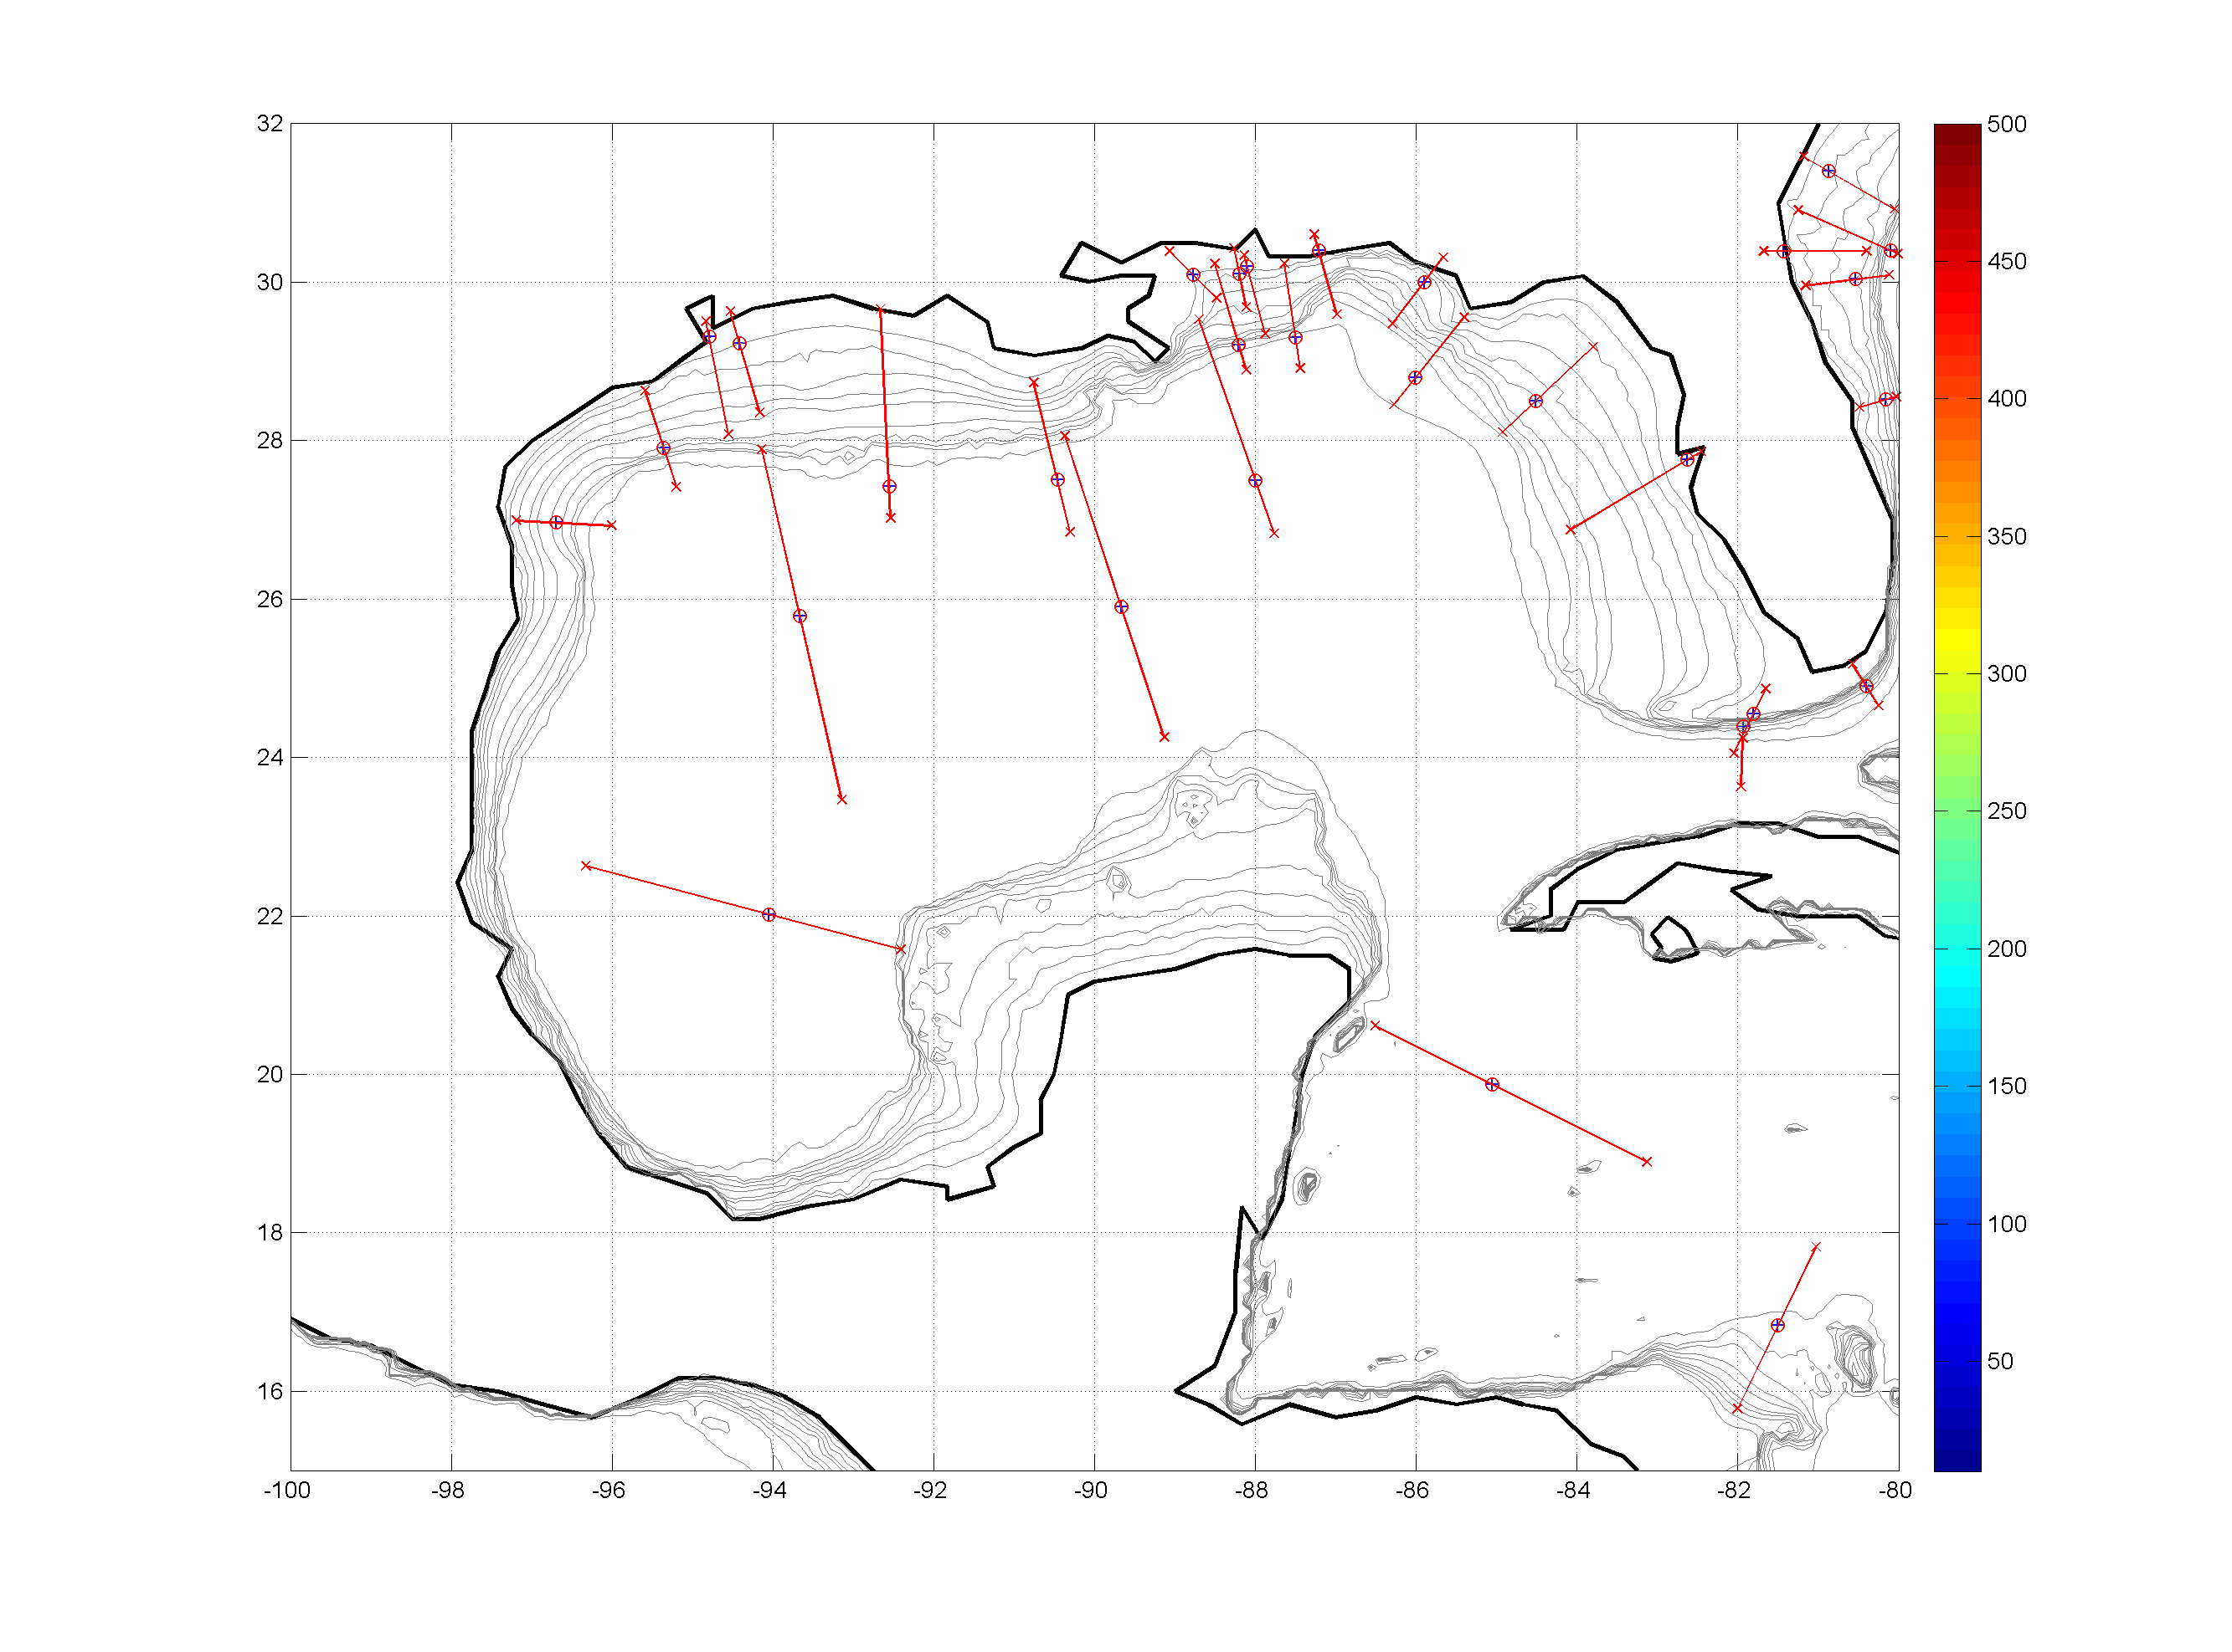

1. Bathymetric transects and main alignments considered for the Storm Surge approximation at the Validation points (Wave Buoys and Tidal Gauges locations). Isobaths are shown in grey.

Figure 16 and 17 shows the wind contour maps and the shear stress along the transect (left panels) and the bathymetry, wind and Storm Surge profiles over each transect for two locations affected under Katrina and Wilma (2005).

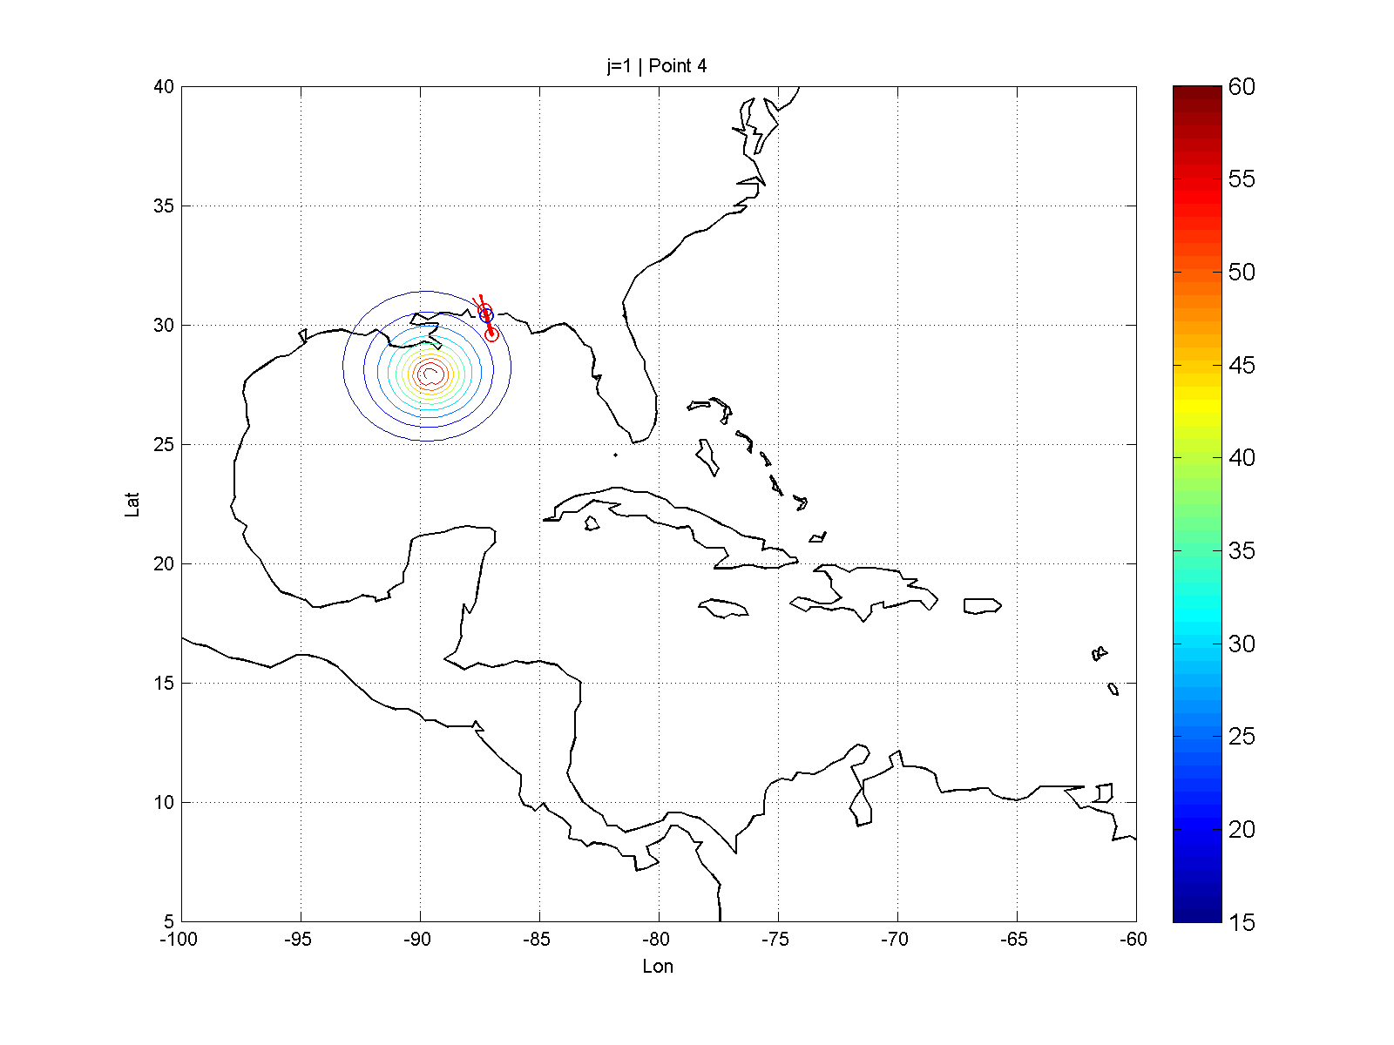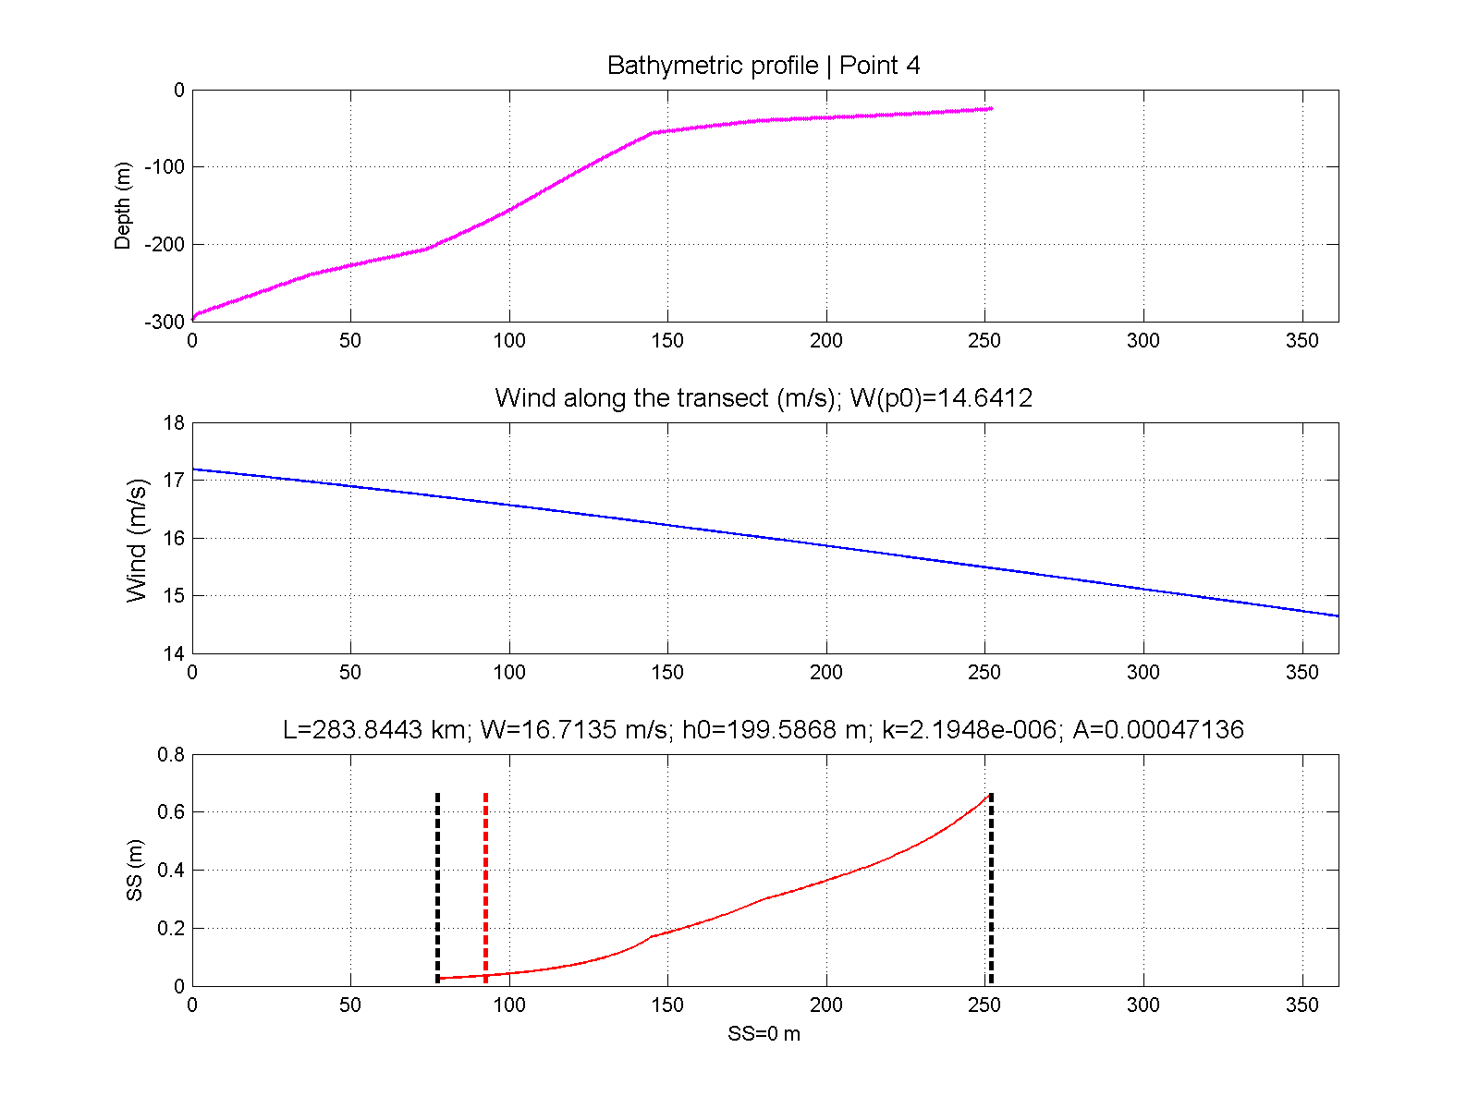

1. Figure X. Wind map (left), indicating the wind vector and the coastal transect where the Storm Surge is calculated. Profiles (right) for the corresponding transect of bathymetry, wind speed and Storm Surge shoaling. The discontinuous red line indicates the position of the output location. Storm: Katrina, 2005

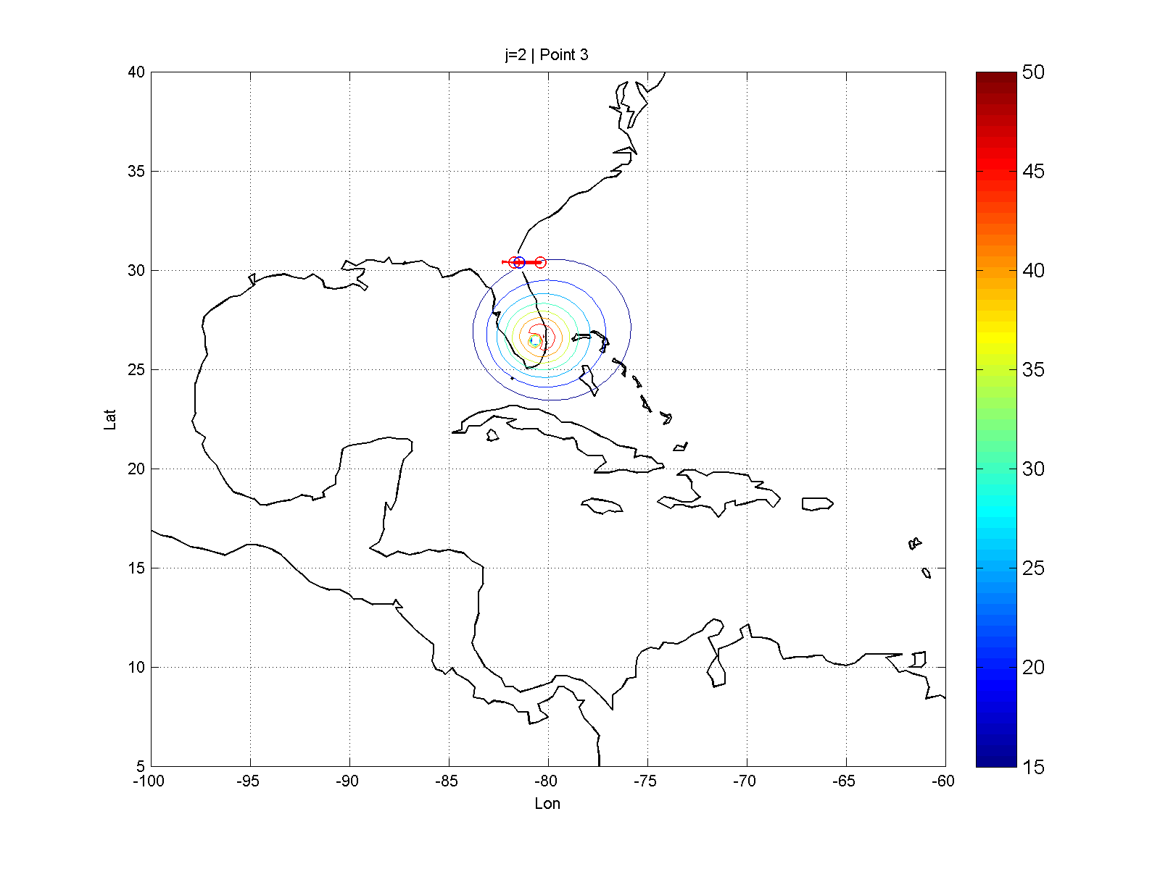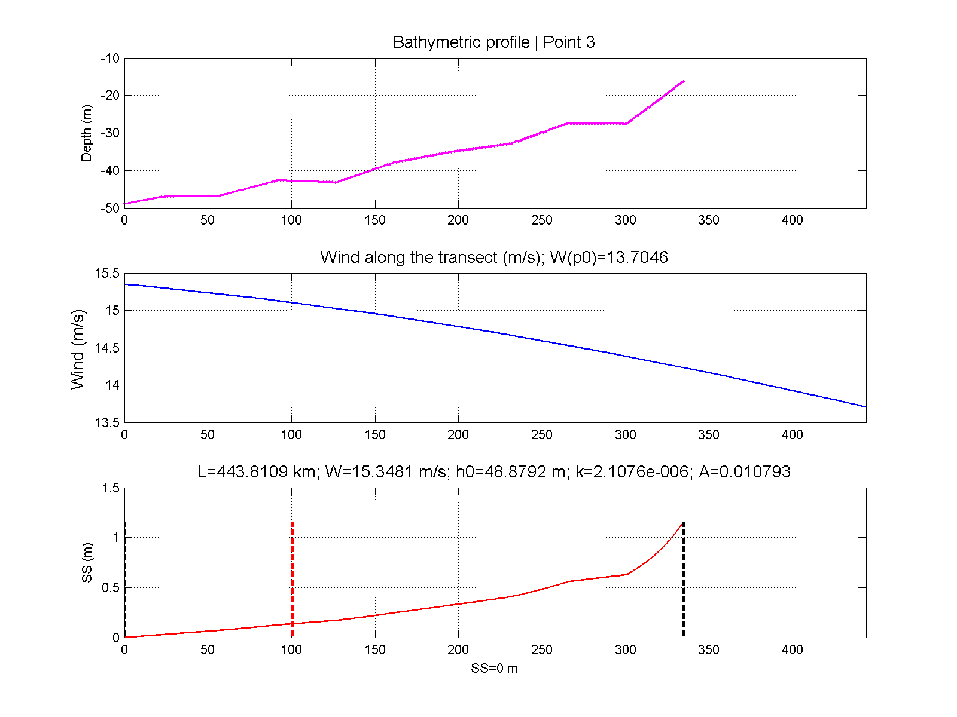

1. Figure X. Wind map (left), indicating the wind vector and the coastal transect where the Storm Surge is calculated. Profiles (right) for the corresponding transect of bathymetry, wind speed and Storm Surge shoaling. The discontinuous red line indicates the position of the output location. Storm: Wilma, 2005

Despide the lack of data in the Gulf Coast and the fact that the available tidal gauge records do not cover the recent years when the three reference storms occurred, the validation for Storm Surge has only been available at two sites. Also, spetial caution should be noticed to the tracks and influence area of each storm, since the aprroach is very sensitive to each transect and area of influence of the storm. The information provided on Google-Earth may help to provide a more comprehensive understanding of these matters.

Tidal Gauge #24 is representative for Wilma (2005) because it followed a track through Florida, as can be seen in the Google-Earth auxiliary animations or in Figure 18. Figure 19 provides the time series comparison with the adopted approach.

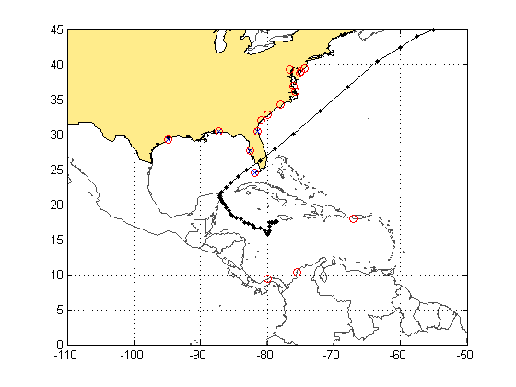

1. Figure X. Wilma (2005) track. Red dots indicate the GESLA tidal gauges available. Blue crosses highlight the tidal gauges in the area for the three storms here analyzed.

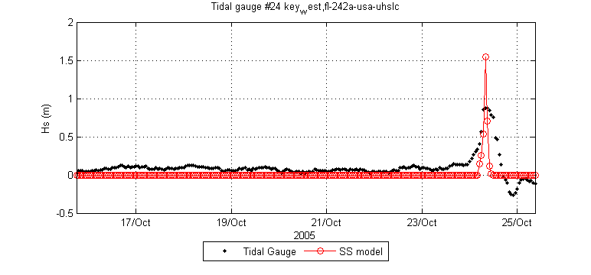

1. Comparison of time series at tidal gauge GESLA no. 24, for Wilma, 2005.

# REFERENCES

DEAN, R., DALRYMPLE, R. 1984, Water Wave Mechanics for Engineers and Scientists, Prentice-Hall Inc., Englewood Cliffs, New Jersey.

BRETSCHNEIDER, C.L. 1990 Tropical cyclones. Handbook of Coastal and Ocean Engineering. Vol. 1. Houston: Gulf Publising Co., pp. 249-370.

FREEMAN, J. C., L. BAER, and G. H. JUNG, 1957 “The Bathystrophic Storm Tide,” J. Mar. Res., Vol. 16, No. 1,1957

Jacobsen, B. 2013 Hurricane Surge Hazard Analysis: The State of the Practice and Recent Applications for Southeast Louisiana. Report prepared for the Southeast Louisiana Flood Protection Authority. Task order 02-03-006

Menéndez, M., and Woodworth , P.L. 2010, Changes in extreme high water levels based on a quasi-global tide-gauge data set, J. Geophys. Res., 115, C10011, Doi:10.1029/2009JC005997

Ruiz, G.R., Silva, R. Perez, D.M., Posada, G., Gustavo, E. 2009 Modelo hibrido para la caracterizacion del oleaje. Ingenieria hidraulica en Mexico, vol XXIV, 3, pp 5-22

SHORE PROTECTION MANUAL, 1984. Us Corps of Engineers. Coastal Engineering Research Center (U.S.). Department of Defense, Department of the Army, Coastal Engineering Research Center, 1984.

SILVA, R., GOVAERE, G., SALLES, P., BAUTISTA, G. and DÍAZ, G. 2002 Oceanographic vulnerability to hurricanes on the Mexican coast. Proc. 28th International Conference on Coastal Engineering. World Scientific. Singapure,.

YOUNG, I.R., 1988. A parametric hurricane wave prediction model. J. Waterway Port Coast. Ocean Eng. 114 (5), 639–652.

# Google- Earth Auxiliary files

Some graphics and animations are provided on the Google-Earth platform to help understanding and analyzing the results obtained by the approaches here explained. The data provided can be obtained from:

* NDBC MeteorologicalOcean

<https://dl.dropboxusercontent.com/u/19533302/CLIMADA_GulfMex/NDBC%20MeteorologicalOcean.kmz>

* TidalGauges_GESLA_2010

<https://dl.dropboxusercontent.com/u/19533302/CLIMADA_GulfMex/TidalGauges_GESLA_2010.kml>

* KATRINA_WindField_timeline

<https://dl.dropboxusercontent.com/u/19533302/CLIMADA_GulfMex/KATRINA_WindField_timeline.kml>

* WILMA_WindField_timeline

<https://dl.dropboxusercontent.com/u/19533302/CLIMADA_GulfMex/WILMA_WindField_timeline.kml>

* IKE_WindField_timeline

<https://dl.dropboxusercontent.com/u/19533302/CLIMADA_GulfMex/IKE_WindField_timeline.kml>