Manual. Coastal Hazard module for climada suite

Contenido

1. Introduction 1

2. Methodology for Probabilistic damage model 1

3. Hazard Models 4

1. Pressure field 5

2. Wind field 5

3. Tropical cyclone wind waves 6

4. Tropical cyclone surges 7

5. Astronomical tides 9

6. Sea Level Rise 9

6.1. Historical sea level rise 9

6.2. Projections of sea level rise 9

6.3. Land subsidence 9

4. Coastal flood and expected damages calculation 10

5. Other auxiliary functions 10

6. Example of use 10

7. References 10

# Introduction

*'Climada'* stands for 'climate adaptation' and is a probabilistic natural catastrophe damage model. Information on the core package can be found at <https://github.com/davidnbresch/climada/wiki>. This module add specific features for coastal zones.

This module adds specific functions to the climada suite that are particularly interesting for coastal areas and coastal risks. The functions and tools in this module work with the climada main core functions and applications (i.e. you need to have climada installed). Some functions have been modified from core climada original functions and adapted to more user specific needs and further customization.

This document provides a more theoretical background than the brief “README” guide that can be found in the github repository. It first describes the basis of probabilistic cat modeling and provides further insight in the equations and tools of the ‘*coastal hazards module’*. A final section describes some examples that can be found in the ‘code’ folder of the module and further functionalities.

# Methodology for Probabilistic damage model

**Risk** is generally defined as a possible danger; which size can be expressed as loss potential multiplied by the occurrence frequency. An **event loss** or damage is the sum of all individual losses resulting from a single occurrence. In risk assessments, the risk depends on three basic sets of data, which configure different sections of the damage model:

* **Hazard** (or peril): Where, how often and with what intensity do events occur?
* **Damage function** (also called vulnerability or vulnerability curve): the extent of damage at a given event intensity
* **Assets** (also referred to as value distribution or portfolio of exposed assets): location and value of the various types of buildings and/or people

These three building blocks are quantified separately and are then combined to estimate the damaged generated by an event (Figure 1). This approach may generally be applied to all forms of natural hazard, whether storm, flood or any other type of peril.

Under this framework, adaptation takes play when we modify either the hazard, the damage functions or the assets, through actions that reduce each driver of risk ECA . Coastal adaptation measures can include structural and non-structural interventions to attenuate or mitigate the hazard, for example, levees, flood walls or wetland restoration; but can also involve updated building codes, which would modify the original damage curves; or coastal management practices that influence the distribution of assets (e.g. coastal setbacks or other coastal development regulations).

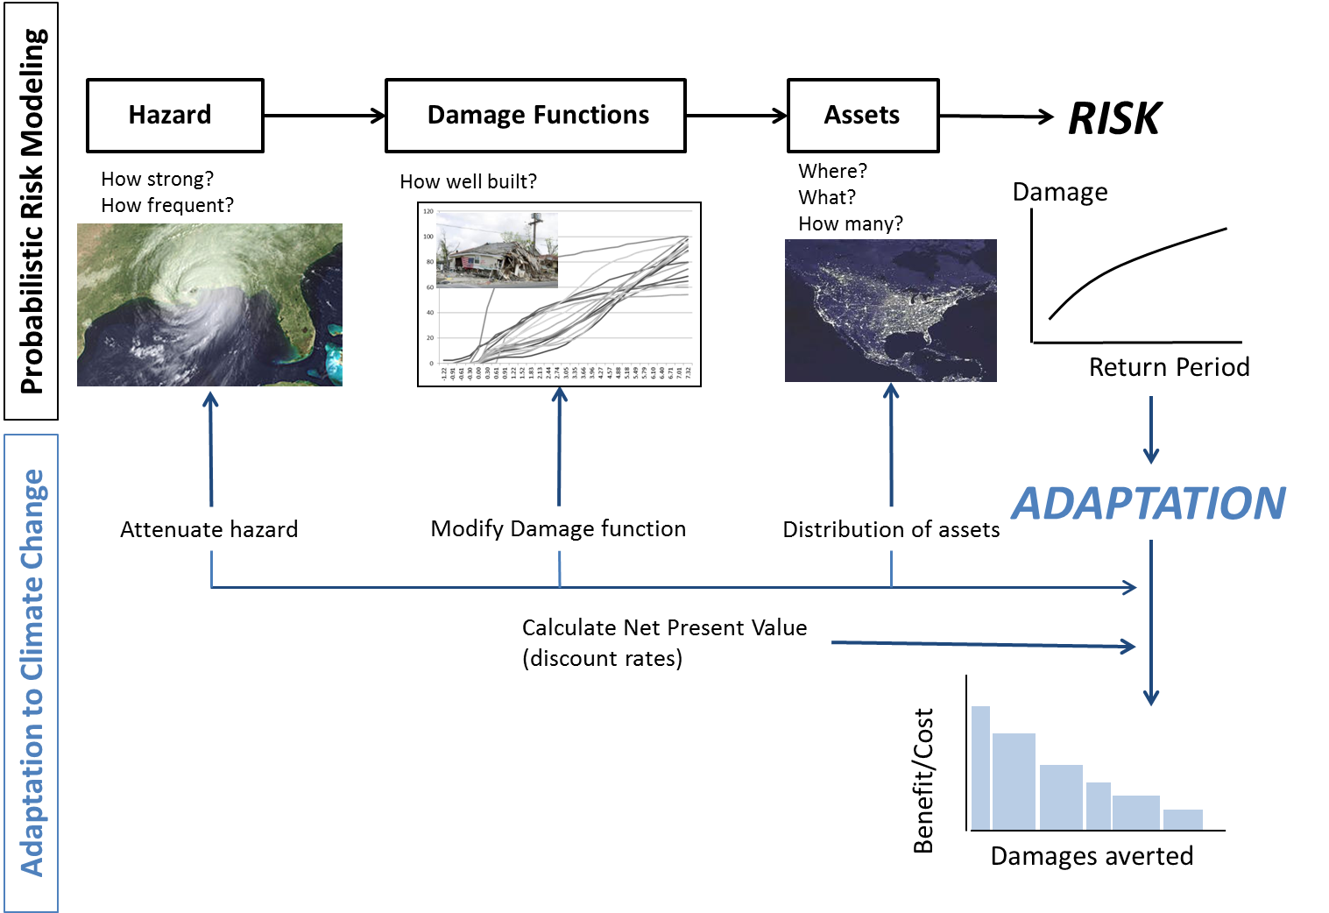

Figure 1. Sketch for quantitative risk assessment and assessing the economic benefit of adaptation

The simplest way to assess the damage is to simulate an individual natural catastrophe scenario. This is known as “deterministic” or “scenario-based” modeling. Such models often refer back to major historical damage events, applying these to the assets that exist now (“as-if analysis”). The disadvantage of this method is that, whilst it allows a single, extreme, individual event damage to be assessed, it fails to take account of all the other events that might occur. Therefore, it is not possible to calculate an expected annual damage for a portfolio of assets from a single event damage, and predictions of the occurrence frequency will remain uncertain.

However, a “probabilistic” or “stochastic” approach simulates a set of possible events that could unfold during a period of time (thousands of events), informed by the historical distribution of storms, rather than simply analyzing one individual event. This approach produces a “representative” list of event damages (i.e. that accurately reflects the risk). From this set of events, it is possible to understand the relationship between damage potential and frequency of occurrence, and hence the cost of average and extreme damage burdens.

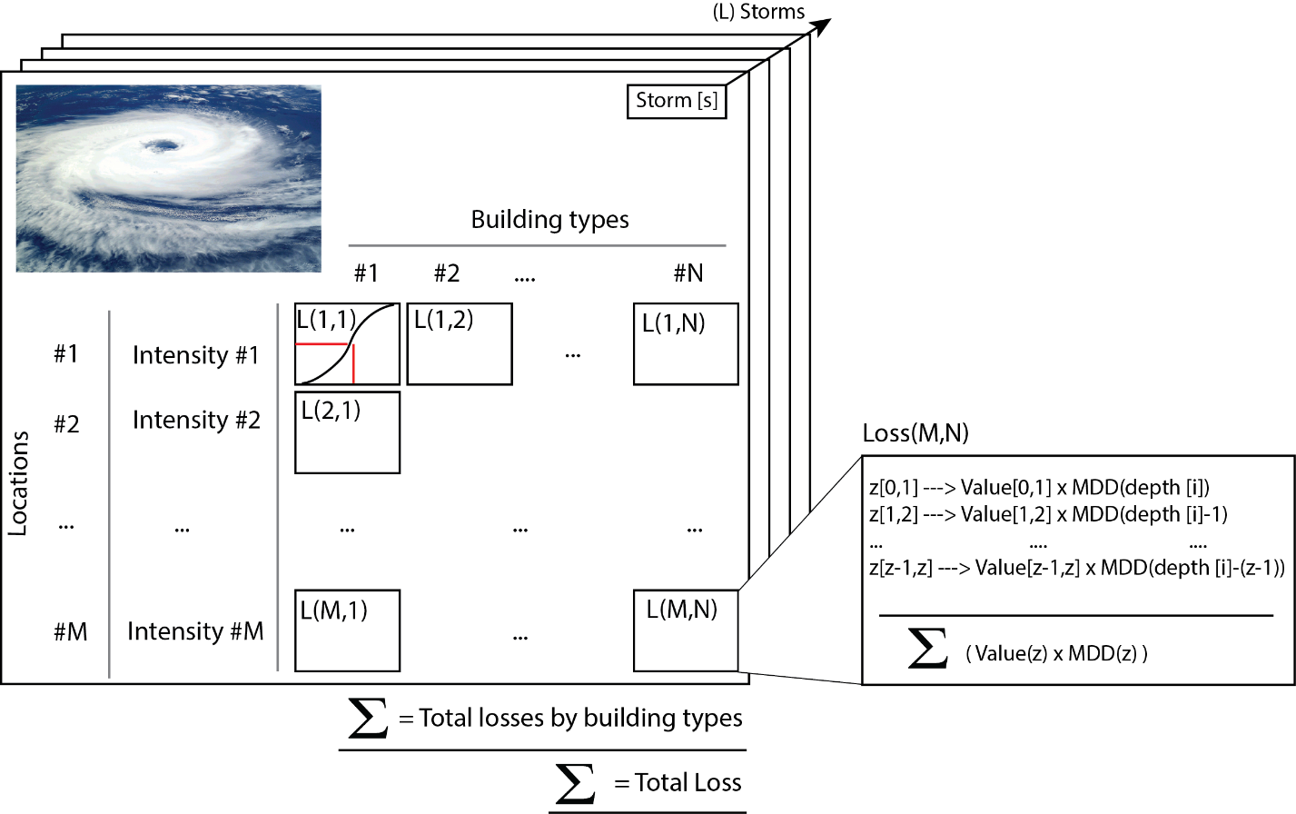

Figure 2. Methodological concept for probabilistic risk assessment.

Therefore, the **quantitative probabilistic risk assessment** is the statistical description of losses across events and scenarios. Losses from each individual storm are calculate across locations and types of assets as follow (Figure 2):

1. The hazard module generates L storms, based on the historical distribution of storms, from 1851 onwards from <http://weather.unisys.com/hurricane>. We use random walks with random origin and track pathway (Figure 3). More details can be found in the module dedicated to tropical cyclones in *climada* (Bresch and Mueller, 2014).
2. For each storm or event (st), the expected intensity is calculated at each location (or centroid). For flooding, the intensity corresponds to the **total water level**, which is the combination of mean sea level, tides, surges and wave run up (Losada et al., 2013), while for wind is the wind gust. A specific section on hazard modules follows describing the models used to simulate each hazard component.
3. For each asset type, there is a **damage function** (also called vulnerability curve) that is specific to the asset type (e.g. type of building) and relates the intensity of the hazard (e.g. local water depth) with the damage degree (i.e. mean damage degree, MDD), which represents the damage inflicted by that intensity to the total value of the asset. The damage or loss is calculated by multiplying the MDD (e.g. 40%) and the value of the asset (e.g. 1,000,000), resulting in a (ground up) damage of 40,000.
4. In the case of flooding, the water depth at each asset location depends on the elevation. The model factors in this effect for each study unit or centroid, where the asset value at each elevation has been previously precomputed (e.g. value between elevation 0 and 1 meters, 1 and 2, etc.). The coastal exposure (i.e. value of assets for different ground elevations, i.e. *value(z)*) is then associated with the MDD for each specific relative depth (1, 2, …. meters) as indicated in Figure 2: loss at elevation z = [value(z) x MDD (z)]. Finally, the total loss at the location is the sum of relative losses of buildings across elevations (see description for loss at location m and asset n in the Figure).
5. This process runs for all the asset types and all locations, throughout storms. The result is a distribution of losses that can be aggregated and analyzed statistically. The sum of all damages produces the total damage from one event is the event damage. For example, in the figure, losses are aggregated by building types and the total loss associated from the storm is calculated.

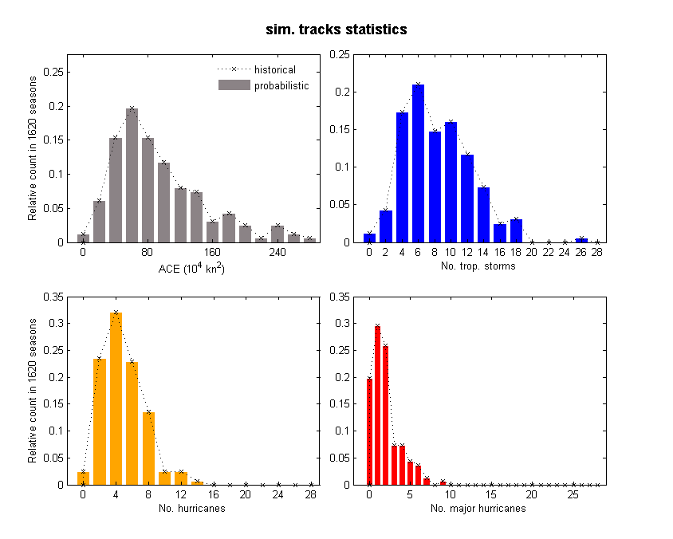

Figure 3. Statistics of simulated storms based on historical tracks. The simulation reproduces the statistical distribution of Accumulated Cyclone Energy (upper left panel), the number of tropical storms (upper right), total number of hurricanes (lower left) and major hurricanes, i.e. category of 3 or above (lower right).

The set of losses is then analyzed statistically, e.g. (Olsen et al., 2015), to define (1) expected annual damage, as the total sum of each event damage multiplied by the probability of each storm; and (2) extreme event loss, which corresponds to a certain return period. **Return period** describes the average time within which the magnitude of an event is reached or exceeded. The return period is inversely proportional to the occurrence frequency, i.e. a return period of 100 year corresponds to an occurrence frequency of 1 in 1,000 years, i.e. 0.01 per year.

# Hazard Models

There is a family of functions implemented in this module that can help to assess different coastal hazards:

* 1. **Storm simulation**: simulate storm wind and pressure field, to compute surge and wave fields
  2. **Sea Level Rise**: calculates (i) historical sea level rise and subsidence, as in Losada et al (2013), as well as (ii) end of the century projections using AR5 outputs (see documentation)
  3. **Tides**: calculates astronomical tide for any location in the globe (based on TPXO database).
  4. **Surges**: simulates storm surge at coastal points. This module includes four different methods: two published relationships between surges and wind speeds; and one approximation of the shoaling of long waves for uniform and not uniform slopes (one assumes constant coastal shelf slope, another one uses a coastal transect with irregular bathymetry).
  5. **Hurricane wind-waves**: generates wave fields (wave height and periods) for hurricanes using three different methods.
  6. **Global Waves** –extratropical- (requires installing ‘wave climate module’ and additional data): calculates main statistics of global wave climate based on Reguero et al (2012) and (2015); and includes useful functions to analyze wave climate.

## Pressure field

To define the pressure field of each tropical storm, we use the Hydromet-Rankin Vortex model (Holland, 1980):

 (1.1)

where P0 is the pressure at the center of the hurricane (mb), Pr is the pressure at a distance r from the center (km), PN is the pressure outside the hurricane (usually1013 mb), and R is the radius of the maximum ciclostrofic winds (km), with . These parameters can be obtained from the historical storms records.

## Wind field

For the wind field, we use a non-symmetric fields model (Bretschneider, 1990), where the maximum gradient of winds *UR* (km/h) can be obtained from:

 (1.3)

Where *f* is the Coriolis parameter and y  is the latitude in degrees

The wind velocity (10 m; km/h) at a distance r from the center of the storm is:  (1.4)

With  being the angle between the hurricane moving speed  and the wind speed at distance R from its center, *UR*.  is a damping factor that depends on the relative location to the storm:

 for  (inside the eye of the storm) (1.5)

 para  (outside the eye)

With A and B being:





## Tropical cyclone wind waves

We then calculate wind waves generated by the wind field using three different models, for comparison purposes (Bretschneider, 1990; USACE, 1984; Young, 1988):

Bretschneider (1990) (Bretschneider, 1990), for Hs from a non-stationary cyclone at offshore depths

 (1.6)



Young (1988) (Young, 1988), adjusting and calibrating the Hs max with numerical modeling at offshore depths.

 (1.7)



Shore Protection Manual (USACE, 1984), modified to include some of the near-shore depth induced effects on the waves (Hs and Tp)

 (1.8)



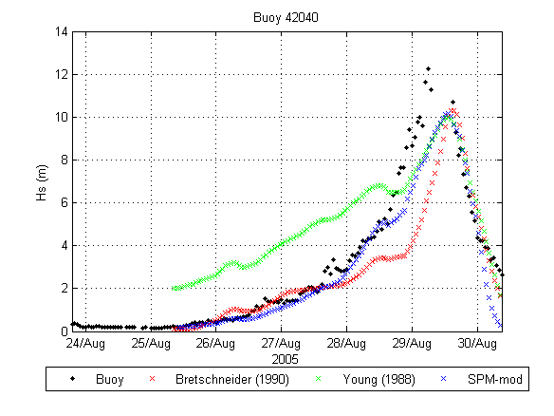

Figure 4. Significant wave height at NOAA buoy 42040 (29.212 North, 88.207 West, 164.6 m deep)

## Tropical cyclone surges

Storm Surge is supposed to be the linear sum of two effects: (1) elevation due to the atmospheric pressure and (2) the wind shear stress over the sea surface. The storm surge sea level pressure effect spatial variation is supposed stationary and symmetric, only depending on the pressure gradient, and is calculated as(Dean and Dalrymple, 1991)**:**



Where  sea level elevation; Pn pressure outside the storm (mbar); P0 central pressure (mbar);  water density (1025 kg/m³) and R is the hurricane radius (km)

The shear stress produced by the wind on the sea surface generates an elevation of the water level at the coastline, known as Storm Surge. Although its modeling is complex (Jacobsen, 2013; Resio and Westerink, 2008), the long wave equations can be used to described it on the continental shelf or a lagoon (Dean and Dalrymple, 1991)**:**

The sea level surface induced by the wind stress (; SS) can be obtained from the following equation:



Where h is the depth, n is a factor taken that varies between 1.15 and 1.30, and is the wind shear stress in the cross shore direction.

The wind stress over the water surface is (USACE, 1984):

 (1.9)

where  is the water density in kg/m³;  is the maximum wind speed (10 m over sea level), m/s;  is a friction factor, O(106) , taken from (Van Dorn, 1953):

 for  and  for 

The wind stress acting on the transect is . Although the wind shear stress is usually very small, when its effect is integrated over a large body of water, like the coastal shelf, it results in significant water levels onshore.

The approach assumes an orthogonal transect to the bathymetry and responds to an approximation of the long-wave shoaling on the continental shelf. Conditions are also supposed stationary for each storm position and the maximum wind speed acting on the coastal transect. The relative angle between the maximum wind speed and the bathymetric transect is considered to define the tangential stress and is taken at the beginning of the continental shelf (i.e. where shoaling starts having an effect), here assumed at 200 m deep. Bottom friction and 2D effects are neglected in this approach.

## Astronomical tides

## Sea-Level Rise

To calculate sea level rise, the module includes (1) historical mean sea level data, (2) IPCC projections for the end of the century, and (3) land subsidence to account for the relavtive movement between the land and the sea, i.e. relative sea level rise.

## Historical sea-level rise

From LOSADA ET AL 2013

## Dynamic Projections of sea-level rise

From IPCC CHURCH

## Land subsidence

From

# Coastal flood and expected damages calculation

# Other auxiliary functions

# Example of use

# References