climada module **country risk**  24 Dec 2015

<https://github.com/davidnbresch/climada_module_country_risk>

[david.bresch@gmail.com](mailto:david.bresch@gmail.com)

melanie.bieli@bluewin.ch

This module runs all (available) perils for one country or for a list of countries. First, it allows generating the country assets (10 or 1 km resolution, based on night light intensity[1]), second to generate the hazard event sets and second to run all damage calculations.

Currently implemented is the automatic generation of earthquake (EQ), tropical cyclone (TC), torrential rain (TR), storm surge (TS) and European winter storm (WS) hazard event sets. The core function is country_risk_calc, which does it all in one go[2]. Instead of whole countries, one can also analyze single states/provinces, see country_admin1_risk_calc. The module does contain a series of support functions to calibrate country results – they are named cr_*, while the top-level functions of this module are named country_* or country_risk_*, see function reference below. The batch code selected_countries_all_in_one does provide the reference xample about how to use all these functions.

Further, the module calculates the economic loss (i.e. the full range of economic costs in the wake of a natural disaster) associated with the hazard event sets[3].

Content

Table of Contents

Country risk module – basics 2

country_risk_calc 2

country_risk_report 5

country_admin1_risk_calc 6

climada_nightlight_entity 6

cr_economic_loss_calc 7

Country and peril calibration 7

country_risk_calibrate 7

cr_country_hazard_test 8

Function reference 10

Top level functions 10

Plotting functions 11

Support-level functions 11

Also useful 11

Appendix 12

A. Calculation of economic damage in cr_economic_loss_calc 12

# Country risk module – basics

The whole module introduces the structure country_risk, the core output of country_risk_calc and country_admin1_risk_calc which contains country results in a standardized way and is therefore input to a series of functions of this module. country_risk(i).res.hazard(j) contains the EDS for country i and hazard j (country_risk(i).res.hazard(j).EDS), the name of the peril in country_risk(i).res.hazard(j).peril_ID, the name of the entity in country_risk(i).res.hazard(j).entity_file and the name of the hazard event set in country_risk(i).res.hazard(j).hazard_set_file.

## country_risk_calc

Basic procedure implemented in country_risk_calc is as follows:

1) generate centroids for the country (uses climada_create_GDP_entity[4] or climada_nightlight_entity)

2) figure which hazards affect the country

3) create the hazard event sets, using

- climada_tc_hazard_set (tropical cyclone wind[5])

- climada_tr_hazard_set (tropical cyclone rain[6])

- climada_ts_hazard_set (tropical cyclone surge[7])

- eq_global_hazard_set (earthquake[8])

- European winter storm (hazard not generated, just assigned[9])

4) run the risk calculation for all hazards

Next steps are country_risk_report, country_risk_EDS_combine and country_risk_EDS2YDS plus cr_plot_DFC or cr_plot_DFC_aggregate to plot the resulting country damage frequency curves.

In essence, you define the country and the code runs the generation of centroids, default assets (from nightlight intensity, see climada module GDP_entity) and the EQ, TC, TR and TS hazard event sets plus checks for WS Europe exposure. It even figures whether the country is exposed to more than one ocean basin and in such a case generates a suite of TC/TS/TR hazard event sets for each ocean basin. The code is ready for upgrade with additional hazards (usually a new hazard is a new climada module). That’s why the code notifies the user if the specific hazard module is missing (even indicates the github location where to get it from).

Simply call e.g.country_risk_calc(‘El Salvador’)

If called without any argument, a list dialog to select the country pops up. See code header for details, i.e. help country_risk_calc

Behind the scenes, the code centroids_generate_hazard_sets does the heavy lifting, i.e. steps 2) and 3) from above. This way one can generate all relevant hazard sets with one call to centroids_generate_hazard_sets for any set of centroids (e.g. only a part of a country, a region, a city…[10]):

centroids_hazard_info=...

centroids_generate_hazard_sets(centroids,force_recalc,check_plots)

The resulting structure centroids_hazard_info contains the names of the generated hazard sets (or the ones generated earlier if just called to check for step 2) in centroids_hazard_info.res.hazard(i).hazard_set_file (the somewhat complicated nested structure is due to the flexibility required by country_risk_calc).

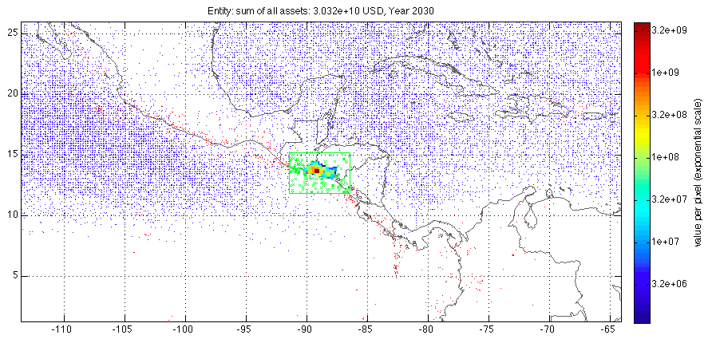

Figure: Step 1 (generate centroids, assets distribution, color scale indicates value per centroid) and step 2 (hazard selection). The green box shows the selection area around the country, the blue dots are all the TC track nodes (historic) and the red dots the epicenters (historic). This figure is generated if check_plot=1 in the call, e.g. country_risk_calc(‘El Salvador’,0,0,1).

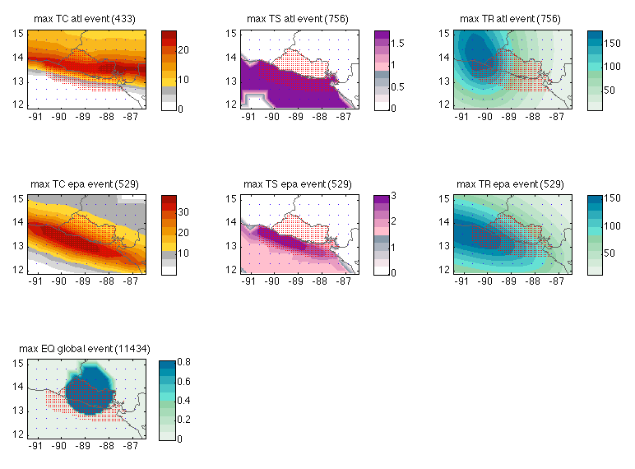

Figure: The most intense single event for all hazard generated for El Salvador (Step 3). Note that El Salvador is both exposed to tropical cyclones from the East and West, that’s why there are two hazard events sets for TC/TS/TR, one for the Atlantic side (atl for Atlantic), one for the Pacific side (epa for East Pacific Ocean). The earthquake model is global. Note further the nice feature of hazard (or peril) – dependent color scales; and the coarser resolution of centroids (blue) around the country (with red dots at high-density centroids) to support plotting hazard intensities around the country, too. This figure is generated if check_plot=1 in the call, e.g. country_risk_calc(‘El Salvador’,0,0,1)

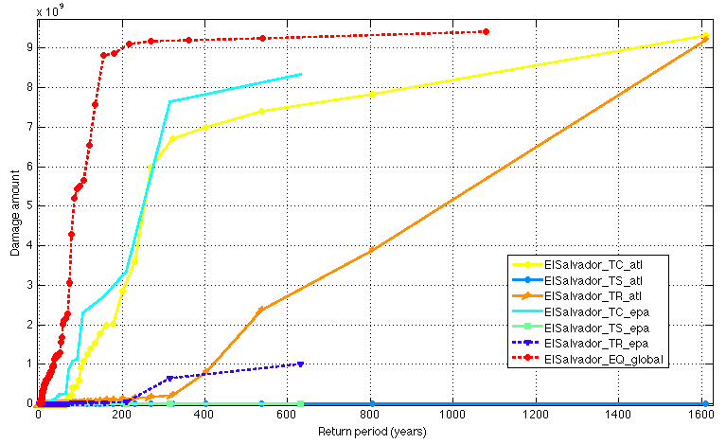

Figure: The resulting damage frequency curves (DFC) for all seven (!) hazards affecting El Salvador (values just for illustration, based on dummy damage functions). This figure is generated with check_plot=1 in the call, e.g. country_risk_report(country_risk_calc(‘El Salvador’,1,1),0,1)

## country_risk_report

Comes in handy if one runs some select countries, e.g:

country_risk=country_risk_calc(‘Barbados’)

country_risk(2)=country_risk_calc(‘El Salvador’)

country_risk(3)=country_risk_calc(‘Costa Rica’)

And then country_risk_report(country_risk,0) results in the following output (to stdout, also an Excel or .csv file is written[11]):

Barbados (1)

TR EL=36572051.496470 (8.481508%o) Barbados_TR_atl

TC EL=23083330.494007 (5.353308%o) Barbados_TC_atl

TS EL=7531.966739 (0.001747%o) Barbados_TS_atl

EQ EL=0.000000 (0.000000%o) Barbados_EQ_global

ElSalvador (2)

EQ EL=415631535.361110 (17.943889%o) ElSalvador_EQ_global

TR EL=141613002.072040 (6.113800%o) ElSalvador_TR_epa

TC EL=59386249.565168 (2.563858%o) ElSalvador_TC_atl

TC EL=16152772.894979 (0.697357%o) ElSalvador_TC_epa

TR EL=621784.438763 (0.026844%o) ElSalvador_TR_atl

TS EL=0.000000 (0.000000%o) ElSalvador_TS_epa

TS EL=0.000000 (0.000000%o) ElSalvador_TS_atl

Costa Rica (3)

EQ EL=523833928.441207 (12.396559%o) Costa Rica_EQ_global

TR EL=1530537.767294 (0.036220%o) Costa Rica_TR_epa

TC EL=73978.520263 (0.001751%o) Costa Rica_TC_epa

TR EL=5765.009179 (0.000136%o) Costa Rica_TR_atl

TS EL=1689.347413 (0.000040%o) Costa Rica_TS_atl

TC EL=60.830655 (0.000001%o) Costa Rica_TC_atl

TS EL=0.000000 (0.000000%o) Costa Rica_TS_epa

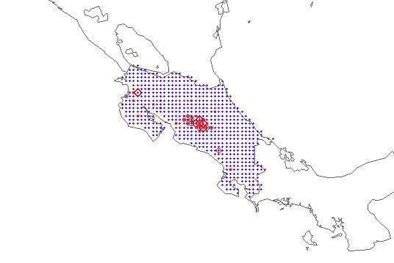

Figure: The local damage for a given peril (here EQ) for one country (here Costa Rica) in spatial resolution (e.g. at each centroid). Produced by the call (following from above resulting structure country_risk):

country_i=3; hazard_i=7[12];

climada_circle_plot(...

country_risk(country_i).res.hazard(hazard_i).EDS.ED_at_centroid,...

country_risk(country_i).res.hazard(hazard_i).EDS.assets.Longitude,...

country_risk(country_i).res.hazard(hazard_i).EDS.assets.Latitude)

## country_admin1_risk_calc

Same as country_risk_calc, but for a state or province (admin1 level) of any given country. Run the all (available) perils for one country's admin1 level. Obtains the admin1 boundaries (from [www.naturalearthdata.com](http://www.naturalearthdata.com), shape files already part of the data that comes with the country risk module) and carve out the respective centroids (set Value at all others to zero). Runs the risk calculation for each admin1 for all hazards. In case one would like to skip hazards, just (temporarily) remove the respective {country_IOS3}_{country_name}_*.mat hazard event sets or see parameter peril_ID in the call to country_admin1_risk_calc. ONLY makes sense if country_risk_calc has been run for the respective country (we keep it like this, as automatic mode might trigger lots of un-wanted calculations). If not, the code terminates with the respective messages (no entity found, no hazard set(s) found...). But one can run country_admin1_risk_calc for more than one country, if the respective countries have been run as country_risk_calc. NOTE: Before using this code, make yourself familiar with country_risk_calc and country_risk_report (same format as country_risk_calc).

## climada_nightlight_entity

Construct an entity file based on high-res (1km!) night light data[13]. Reads an image file with nightlight density[14] and matches it to the local geography. Prompts for country (admin0) and state/province (admin1), constrains the active centroids (with values>0) to the selected country or admin1 and saves the entity. Since we're dealing with admin1, no automatic scaling or allocation of GDP to centroids is performed (for this, see climada_create_GDP_entity[15]).

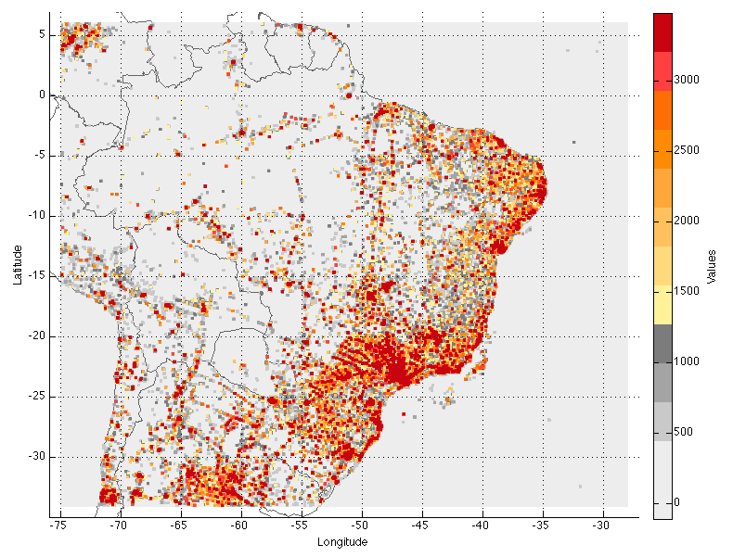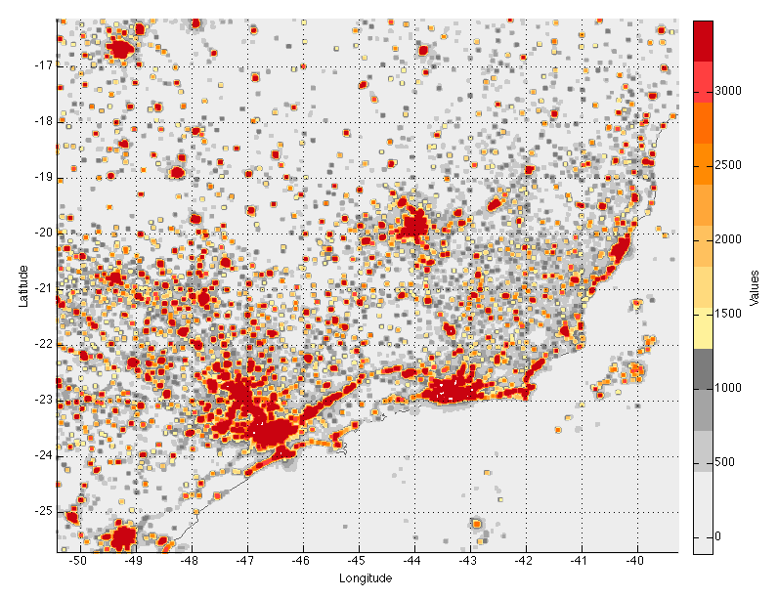

Figure: Brazil value distribution on 1km (!) resolution (left, zoomed in right) as generated by climada_nightlight_entity(‘Brazil’,’’,2).

## cr_economic_loss_calc

Major natural disasters can and do have severe negative short-run economic impacts, the severity of which depends on the affected country's resilience, or ability to recover. cr_economic_loss_calc calculates the economic damages resulting from the simple property damages in the hazard event set, taking into account socio-economic data on the country's financial strength, supply chain risk profile, resilience and preparedness for natural disasters (see appendix for details).

# Country and peril calibration

## country_risk_calibrate

Calibrate a given country (or a list of countries). Make sure you called country_risk_calc before (not necessarily in the same session, but the country entities need to exist – at least the ones for present ({ISO}_{CountryName}_entity.mat).

The most common use therefore looks like (as an example, generate the asset distributions for listed countries and all the probabilistic hazard sets for all perils that affect any of these countries):

country_list={'Colombia','Costa Rica','Dominican Republic','United States'};  
country_risk=country_risk_calc(country_list,-3);

country_risk_calibrate(country_list); % **calibrate** all countries

Standard procedure is that the switch statement in the function country_risk_calibrate has entries for countries (and lists of countries) and hence performs the specific adjustments, primarily to the damage function(s).

In case you consider editing this function, be careful to check for repetitious application. The code sets the field entity.calibrated=1 the first time a country is treated, but since one might need to re-calibrate, one should rather assign absolute values to e.g. entity.damagefunctions.MDD, since a mere multiplication of existing values might lead to troubles on subsequent calls. Luckily, country_risk_calibrate calls climada_damagefunctions_replace, which does indeed not replace on repetitious calls if the result would be exactly the same.

See also cr_country_hazard_test in order to *test* country calibration.

## cr_country_hazard_test

Given a country_risk results structure (see above, generated by country_risk_calc), experiment with one country and hazard to test different damage function settings etc.

This code is MOST LIKELY to be edited by the user, i.e. to set damagefunction parameters etc. It provides merely a TESTBED for efficient calibration of country results.

Process:

* Run country_risk_calc for either one or a set of countries. A set makes particularly sense for e.g. a peril region, such as TC atl, in order to ensure (neighboring) countries in that region have similar damagefunction settings. Hence you might e.g. run  
    
  country_list={'Colombia','Costa Rica','Dominican Republic','United States'};  
  peril_ID=['atl_TC';'atl_TS']; % TC and TS in Atlantic region  
  country_risk=country_risk_calc(country_list,-7,0,0,peril_ID);
* call cr_DFC_plot to get a first overview by country, e.g.  
    
  cr_DFC_plot(country_risk)
* call cr_DFC_plot_aggregate to get a first overview or the combined results of all countries, e.g. (note that the code does combine sub-peril EDSs himself)  
    
  cr_DFC_plot_aggregate(country_risk)
* Note that especially the comparison with EM-DAT makes only sense for either larger countries or a group of smaller ones - otherwise it might be too much due to chance whether a country got hit in the past years or not.
* Now, call cr_country_hazard_test to test different damagefunction settings (or modifications) for one country and peril, e.g. (for above country_list and perils, 2 points to Costa Rica[16], and 1 is the first peril in this country, i.e. TC[17] Atlantic):  
    
  country_risk=cr_country_hazard_test(country_risk,2,1)  
    
  Within cr_country_hazard_test, the damagefunction for TC is modified see section indicated with *** edit the damage function below *** in the code, e.g.  
    
  % ****** edit the damage function below *******************  
    
  [damagefunctions,dmf_info_str]=climada_damagefunction_generate(0:5:120,20,3,0.5,'exp','TC',0);  
  fprintf('%s TC atl: %s\n',country_name_char,dmf_info_str);  
  entity=climada_damagefunctions_replace(entity,damagefunctions);  
    
  % ****** end edit the damage function ********************
* Within cr_country_hazard_test the modified damagefunction is written temporarily to entity.damagefunctions[18] and the specific event damage set (EDS) is re-calculated[19]. You now repeat the process (edit damage function parameters, call cr_country_hazard_test) until you’re happy with the result.
* In case there is a sub-peril (in the present case TS[20]), you might want to repeat the process for the sub-peril (**2** for TS), i.e.   
    
  country_risk=cr_country_hazard_test(country_risk,2,**2**)  
    
  And repeat this call after each edit of the TS damagefunction again in the *** edit the damage function below *** section in cr_country_hazard_test.
* Note that cr_country_hazard_test shows the single-(sub-)peril results (e.g. for TC *or* TS). Therefore, in order to finally compare the combined result (TS *and* TS) with the combined EM-DAT (and, if present comparison model), call[21]  
    
  cr_DFC_plot(country_risk_EDS_combine(country_risk),2,**1**)
* You might also occasionally use this call while you experiment with e.g. the TC settings to check the combined result. Note that you can also provide damagefunction modifications for both TC and TS in cr_country_hazard_test, e.g.

% ****** edit the damage function below *******************  
  
[damagefunctions,dmf_info_str]=climada_damagefunction_generate(0:5:120,20,3,0.5,'exp','TC',0);  
fprintf('%s TC atl: %s\n',country_name_char,dmf_info_str);  
entity=climada_damagefunctions_replace(entity,damagefunctions);  
  
[damagefunctions,dmf_info_str]=climada_damagefunction_generate(0:16,0.5,2,0.3,'s-shape','TS',0);  
fprintf('%s TS atl: %s\n',country_name_char,dmf_info_str);  
entity=climada_damagefunctions_replace(entity,damagefunctions);  
  
% ****** end edit the damage function ********************

* And then call it twice[22] (to re-calculate the TC and TS EDSs) and then check the aggregate result with cr_DFC_plot(country_risk_EDS_combine(country_risk),2,1).
* And in case you’d like to see the full basin-wide aggregated result, call  
    
  cr_DFC_plot_aggregate(country_risk)
* This is NOT the same as cr_DFC_plot(country_risk_EDS_combine(country_risk),2,1), as above call aggregates over all countries, while cr_DFC_plot(…,2,1) only shows the results for country 2 (here Costa Rica).
* Finally, once you’re happy with the combined result, consider adding (or updating) the particular section in country_risk_calibrate, e.g. for the above example, this could be[23]:  
  …  
  switch country_name_char  
   case 'Costa Rica'  
   [damagefunctions,dmf_info_str]=climada_damagefunction_generate(0:5:120,20,3,0.5,'exp','TC',0);  
   fprintf('%s TC atl: %s\n',country_name_char,dmf_info_str);  
   entity=climada_damagefunctions_replace(entity,damagefunctions);  
   if ~isempty(entity_future)  
   entity_future=climada_damagefunctions_replace(entity_future,damagefunctions);end

[damagefunctions,dmf_info_str]=climada_damagefunction_generate(0:16,0.5,2,0.3,'s-shape','TS',0);  
 fprintf('%s TS atl: %s\n',country_name_char,dmf_info_str);  
 entity=climada_damagefunctions_replace(entity,damagefunctions);

if ~isempty(entity_future)  
 entity_future=climada_damagefunctions_replace(entity_future,damagefunctions);end  
…

* Note that one can really copy-paste the specific code segment (here highlighted in green) from cr_country_hazard_test and only needs to add the future entity treatment (here in blue).

In order to avoid troubles with GitHub, please make your copy of the function cr_country_hazard_test, name it e.g. cr_country_hazard_mytest, and experiment with different damage function settings for a given country and region (group of countries). In special cases, you might also consider adjusting hazard event sets.

Next step: put your final adjustments in country_risk_calibrate (and if you’re really of the opinion they are an improvement of climada, please check these changes in).

# Function reference

Use help {function name} to get a detailed description and input/output specification

## Top level functions

country_risk_calc: generate assets and hazard sets for a given country (i.e. admin0, or a list of countries). This function provides a convenient way to get started for any given country.

country_admin1_risk_calc: Once country_risk_calc has been run for a country (or a series of), calculate the admin1 (state/province) level results.

country_risk_EDS_combine: combine sub-peril EDSs in country_risk structure, such as TC and TS – helpful to reduce the complexity of results.

country_risk_EDS2YDS: convert event event damage sets to year damage sets

country_risk_report: produce a report given output from country_risk_calc, country_admin1_risk_calc or cr_economic_loss_calc (see also cr_loss_multiplier_plot).

country_risk_calibrate: for many countries, climada has been calibrated (to some extent) and this code does modify the damagefunctions of a given country accordingly. Just call this code with the full list of countries you’ve processed once with country_risk_calc – and climada does automatically apply all calibrations to all countries (and all hazards). This overwrites damagefunctions in the respective entities (entity.damagefunctions…), but keeps track of changes (and does not re-apply on subsequent calls, hence one can call country_risk_calibrate repeatedly).

climada_nightlight_entity: Generate the (high-resolution) asset distribution for any country (admin0) and any state/province (admin1) within.

## Plotting functions

cr_DFC_plot: plot damage frequency curves (DFC) for all countries and perils in country_risk

cr_DFC_plot_aggregate: plot combined peril damage frequency curves (DFC) for all countries and also plot the peril region aggregate as well as the global aggregate DFC.

## Support-level functions

cr_economic_loss_calc: given (property damage) output from country_risk_calc, calculate total economic loss

cr_EDS_emdat_adjust: given an event damage set, adjust such that it matches best the EM-DAT damage history of a given country and hazard (see also emdat_read)

emdat_read: read the EM-DAT global damage database ([www.emdat.be](http://www.emdat.be), by country and peril)

cr_country_hazard_test: given a country_risk results structure, experiment with one country and hazard to test different damage function settings etc. Make your own copy before using this code, as you will need to edit it.

## Also useful

climada_entity_value_GDP_adjust: given an entity with assets for a country, adjust total asset value to represent country assets (a simple formula based on GDP and country development index).

climada_damagefunctions_plot: plot damage functions

climada_create_GDP_entity: create an entity (asset distribution) based on night light intensity (climada module GDP_entity).

## Useful data sources

Here, we list a couple data sources useful for purposes as provided by this module.

* [*http://web.ornl.gov/sci/landscan/*](http://web.ornl.gov/sci/landscan/)*: global population distribution, 1 km resolution (30" x 30")[24].*
* <http://due.esrin.esa.int/page_globcover.php>: Global Land Cover Map, 300 m resolution, 2009.

# Appendix

## A. Calculation of economic damage in cr_economic_loss_calc

Starting point for the economic loss calculation is damage(event_i), i.e. the property damage calculated by climada_EDS_calc. The economic loss then also includes secondary losses to an economy including e.g. lost ouput, retail sales, wages, costs to business form rerouting goods and services around the affected area, reduced taxable receipts, etc.

The underlying rationale of the calculation is that a property damage resulting from a natural disaster does not have a major impact on a country's economy as long as the damage is small compared to the country's GDP, and as long as adequate financing and national resources exist. However, if a damage is big, it will be exacerbated depending on how well a country is "in shape" to deal with major shocks.

cr_economic_loss_calc intends to estimate the economic damage as it manifests itself about 3-6 months after a disaster occurred. This first-round effect of natural disasters is usually that income and output (GDP) fall. What happens in the next round then depends on the way the country or region responds to the crisis. For example, Japan is a strong economy and has the resources to start rebuilding quickly, while smaller and badly managed countries such as Haiti can suffer severe long-term effects. It should be noted that cr_economic_loss_calc only calculates the temporary dip following the first months after a disaster (see Figure).

After that initial dip, different scenarios can lead to no, positive or negative follow-on effects over the long run. In particular, a natural disaster can even positively affect total factor productivity, e.g. when it leads to the replacement of damaged, outdated production facilities and physical infrastructure with state-of-the-art facilities and infrastructure. However, as noted above, cr_economic_loss_calc only deals with the calculation of the initial impact, not with the long-term scenarios.

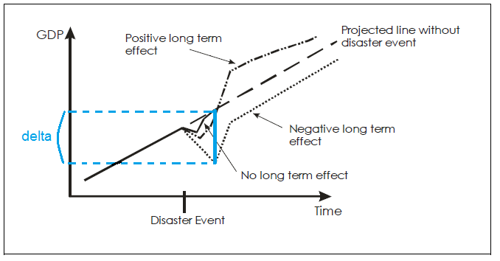

Figure: Possible trajectories of GDP after a disaster[25]. The delta is the initial temporary dip cr_economic_loss_calc provides an estimate for.

In cr_economic_loss_calc, the economic loss caused by the natural disaster is calculated according to:

**economic_loss(event_i) = damage(event_i) * loss_multiplier**

where loss_multiplier is defined by:

**loss_multiplier =**   
**1 + cr_get_damage_weight(damage(event_i)/GDP) * country_damage_factor**

with:

cr_get_damage_weight: function that determines how much weight a damage should be given based on its ratio to GDP

country_damage_factor = 1/financial_strength ...  
 + BI_and_supply_chain_risk ...

+ natural_hazard_economic_exposure ...

– disaster_resilience

Hence, country_damage_factor consists of four terms:

* financial_strength measures a country's economic health and ability to finance the recovery.

financial_strength = total_reserves/GDP ...

+ insurance_penetration ...

+ income_group ...

- central_government_debt

* BI_and_supply_chain_risk measures a country's risk of disaster-related business and supply chain interruption

BI_and_supply_chain_risk = GDP_industry ...

+ FM_resilience_index_supply_chain/100

* natural_hazard_economic_exposure assesses which countries have a concentration of their total economic output exposed to natural hazards

natural_hazard_economic_exposure = ...

1 - Natural_Hazards_Economic_Exposure/10

* disaster_resilience measures the quality of a country's natural hazard risk management, i.e., the country's "preparedness" to deal with the consequences of a disaster

disaster_resilience = FM_resilience_index_risk_quality/100 ...

+ (global_competitiveness_index-1)/6

See economic_indicators_mastertable.xls (in the data folder of the country_risk module[26]) for more information on the four components of country_damage_factor (and their respective subcomponents).

1. I.e. the module allows the generate centroids and entities for each country on these (high) spatial resolution.
2. The routine climada_country_risk allows for processing a list or even all countries. As always, use e.g. help climada_country_risk to get a detailed description on the options.
3. See appendix for details on the calculation of economic loss based on the damages in the hazard event set.
4. See <https://github.com/davidnbresch/climada_module_GDP_entity> and further below for climada_nightlight_entity which allows to generate a high-resolution entity for any country and state/province.
5. Core climada contains the basic tropical cyclone hazard, but please add the module <https://github.com/davidnbresch/climada_module_tropical_cyclone> to generate useful probabilistic hazard event sets (see parameter probabilistic in country_risk_calc). Please consider to run climada_tc_get_unisys_databases (climada core) in order to download the latest tropical cyclone databases for all ocean basins (core climate comes with TC Atlantic to start with).
6. See climada module <https://github.com/davidnbresch/climada_module_tropical_cyclone>
7. See climada module <https://github.com/davidnbresch/climada_module_tropical_cyclone> which also requires the module <https://github.com/davidnbresch/climada_module_etopo>
8. See climada module [https://github.com/davidnbresch/climada_module_earthquake_volcano](https://github.com/davidnbresch/climada_module_eq_global)
9. See climada module for European winter storm, which contains the hazard sets <https://github.com/davidnbresch/climada_module_storm_europe>
10. See e.g. the code climada_cut_out_GDP_entity from <https://github.com/davidnbresch/climada_module_GDP_entity> and also country_admin1_risk_calc and climada_nightlight_entity further below (part of module country risk)
11. The report does contain the annual expected damage (ED) as well as defined return periods (such as 100 and 250 years). In case writing an Excel file fails, a .csv file is written.
12. Note that the number seven here corresponds to the 7th hazard analyzed (EQ). The report to stdout shows EQ as the first result, since country_risk_report sorts by descending damage, unless it is called with the second parameter (print_unsorted) set to 1.
13. One can also run it at moderate (10x10km) resolution, see parameter selections, i.e. type help climada_highres_entity
14. The climada module country_risk comes with the .mat file F182012.v4c_web.stable_lights.avg_vis.mat (24MB), since the .tif image is about 700MB. See <http://ngdc.noaa.gov/eog/dmsp/downloadV4composites.html#AVSLCFC3> to obtain the file <http://ngdc.noaa.gov/eog/data/web_data/v4composites/F182012.v4.tar> and unzip the file F182012.v4c_web.stable_lights.avg_vis.tif in there to the /data folder of country_risk module. As the .tif is so much larger, the climada module country_risk comes with the .mat file, but does not contain the original (.tif). Should the .mat file not exist, climada_nightlight_entity creates it on first call. Please note that the GDP_entity could also deal with such a high-res dataset (see respective documentation).
15. See footnote 8 above
16. country_list={'Colombia',**'Costa Rica'**,'Dominican Republic','United States'}
17. peril_ID=[**'atl_TC'**;'atl_TS'];
18. Note that the modified entity is NOT saved, as climada_damagefunctions_replace does only return the entity with damagefunction(s) replaced. Only once you are happy with the adjustment, the code country_risk_calibrate does store the modified damagefunction(s) back to the entity file.
19. In the specific case hence country_risk(2).res.hazard(1).EDS and the resulting DFC is plotted by cr_country_hazard_test calling itself cr_DFC_plot(country_risk,2,1).
20. i.e. peril_ID=['atl_TC';**'atl_TS'**]
21. Note that the last parameter ‚1’ now refers tot he combined EDS, since country_risk_EDS_combine did add the TS damage tot he TC damage, stored into the TC EDS.
22. i.e. country_risk=cr_country_hazard_test(country_risk,2,1); country_risk=cr_country_hazard_test(country_risk,2,2)
23. Standard procedure is that the switch statement below has entries for countries (and lists of countries) and hence performs the specific actions. Be careful to check for repetitious application. We set the field entity.calibrated=1 the first time it is treated here, but since one might need to re-calibrate, one should rather assign absolute values (e.g. damagefunctions.MDD=((1:length(damagefunctions.Intensity))^2)/...  
    (length(damagefunctions.Intensity)^2), and avoid statements such as damagefunctions.MDD=...  
    damagefunctions.MDD*2, since a mere multiplication of existing values might lead to troubles on subsequent calls. The code climada_damagefunctions_replace does indeed not replace on repetitious calls if the result would be exactly the same.
24. Only listed for reference, since not open-access. License fee for humanitarian organizations, educational research and commercial organizations determined on a case-by-case basis.
25. Source: Hochrainer, 2006

    https://openknowledge.worldbank.org/bitstream/handle/10986/4162/WPS4968.pdf?sequence=1
26. Download: <https://github.com/davidnbresch/climada_module_country_risk>