*climada* module landslides (part of flood)

<https://github.com/davidnbresch/climada_module_flood> 24 November 2015

Lea Mueller,[muellele@gmail.com](mailto:muellele@gmail.com)

# Purpose

This is an additional *climada* module to create a landslide hazard. The hazard is a *climada* hazard structure that defines the hazard intensities and frequencies at specific locations (hazard.intensity, hazard.frequencies, hazard.lon, hazard.lat).

The landslide hazard depends solely on the digital elevation data and can therefore be created for the entire globe. However if more data of landuse, vegetation, soil parameters are at hand, the module can be further develop to make use of this data.

# Example

We create a landslide hazard set for Las Cañas neighborhood [1]in the city San Salvador, Central America. The edge coordinates of Las Cañas neighborhood are [-89.145 -89.1 13.692 13.727].

Type **[hazard, centroids, fig] = climada_ls_hazard_set([-89.145 -89.1 13.692 13.727]);** into the command line to create the hazard set.

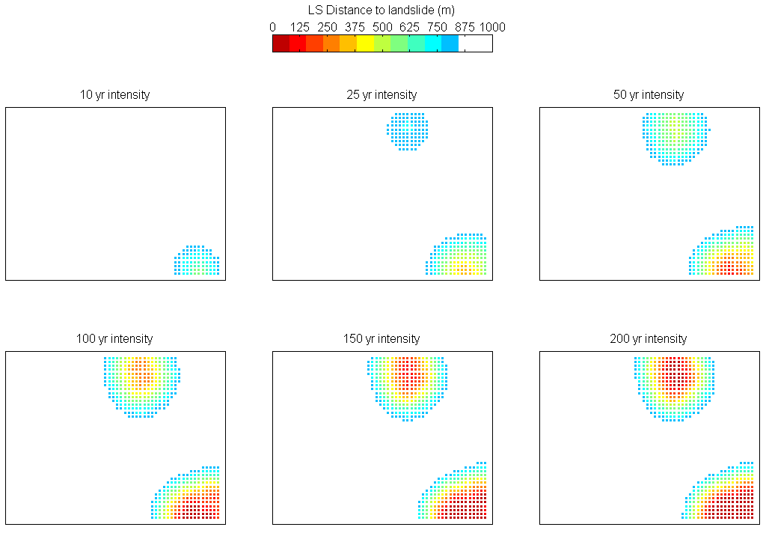

Figure 1: Landslide hazard as created with **[hazard, centroids, fig] = climada_ls_hazard_set([-89.145 -89.1 13.692 13.727])**. The hazard maps show which areas might be affected by landslides on average every 10 years, 25, 50, 100, 150 and 200 years respectively. Red points denote areas that are very close to a landslide (less than 100 m away), blue points denote areas that are more than 750 m away from a potential landslide.

|  |
| --- |
| Figure 2: Elevation from SRTM for the las canas neighborhood in San Salvador. |
| Figure 3: Slope in degree |
| *Figure 4: Topographical wetness index (TWI) is calculated using the elevation. TWI ranges from 2 to 12 and indicates the water accumulation potential at every location. The water flows from South to North.* |

Appendix

# Input data

We use publicly available digital elevation data (DEM) from SRTM[2]. Use your own DEM data, if you have a finer resolution.

1. Type **climada_srtm_get('El Salvador')** or any other country name into the command line.
2. The command line will tell you what tiles you need to download from <http://srtm.csi.cgiar.org/SELECTION/inputCoord.asp>
3. Move it to .../dem/data/
4. Unzip it (it might do so automatically, e.g. on a Mac)
5. Do not rename the file
6. Read the data using **SRTM =** **climada_srtm_get('El Salvador')** or any other country name

# Introduction

Existing models for landslides are based on historical event analysis, heuristical methods (using expert knowledge), statistical regression analysis or deterministic methods. We develop a new method based on probabilistic landslide events. The probabilistic landslide model is based on physical parameters and historical events and refined with expert knowledge.

The strength of the probabilistic landslide model is that we create a representative set of possible landslide events in terms of frequencies, locations and regional extent (see Figure 5).

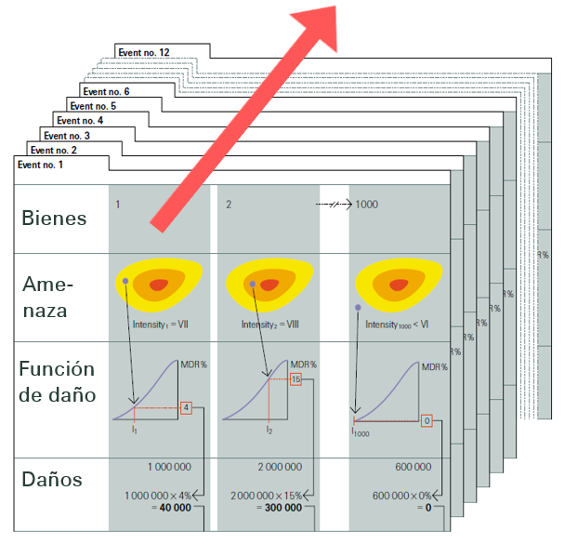

Figure 5: Probabilistic events are generated to create a set of possible events that characterize the landslide situation in San Salvador in terms of frequencies, location and regional extent. Source: Swiss Re, Natural catastrophes and reinsurance, http://media.swissre.com/documents/Nat_Cat_reins_en.pdf

Based on this set of possible events we can create landslide hazard maps for return periods between 5 and 50 years as presented in Figure 1. The probabilistic model enables us to change frequencies and severities of the events to represent climate change scenarios.

# Methodology

We generate landslides that are triggered by heavy rainfalls. Earthquakes are not included as triggering factors. The landslide model relies on the basic principle of slope stability. Landslides occur when the driving forces equal or exceed the resisting forces. This principle is reflected with the equation of the factor of safety of a slope, which is defined as the ratio of resisting forces to driving forces.

Angle of slope β

Driving force τ

Resisting force σ

Figure 6: The stability of a slope can be described based on the factor of safety, which is defined as the ratio of resisting forces to driving forces. Landslides occur when the driving forces equal or exceed the resisting forces.

If the factor of safety is less than or equal to 1 ( i.e., F ≤ 1), the slope fails because driving forces equal or exceed the resisting forces. If F is significantly greater than 1, the slope is quite stable. However if F is only slightly greater than 1, small disturbances may cause the slope to fail.

The most dominant factors that increase the driving force are:

* steeps slopes
* precipitation that adds weight to the slope, especially on the upper part
* water accumulation potential

While the definition of the factor of safety varies throughout the literature, we have chosen to follow a modification Carpentier et al.[3] 2012) to the theory set out by Casadei et al.[4] (2003), which takes into account the difference between saturated and moist soil. c' denotes the effective cohesion of the soil, γ_m,γ_s, and γ_w correspond to the specific weight of moist soil, saturated soil and water respectively, D is the soil depth, h_w is the water table height, ϕ' is the effective internal angle of friction, and β is the slope angle.

We use the topographical wetness index (TWI) to define the water accumulation potential at each grid cell (see Figure 4). According to Beven & Kirkby the TWI is defined as:

a is the drainage area above a certain location and β is the slope at a specific location. TWI is a purely topographic characteristic and does not vary over time. It is an efficient index to determine hydrological processes.

We use historical precipitation data and distribute the rainfall volume over the study region. This increases the soil water content of affected cells, increases driving forces for landslides and can therefore lead to landslides. Based on soil water content and slope, we calculate the factor of safety for every grid cell and compute a potential landslide cells. If a landslide cell is detected, the landslide can spread over the slope and lead to an entire landslide event. Based on different distribution of rainfall volume over the study region we generate a set of 1000 landslide events.

Simplifying assumptions:

* The basic component of the landslide model is the digital elevation model (DEM). The DEM used has a resolution of 90 m x 90 m.
* We calculate the distance between the assets and the occurring landslide to estimate the damage that a certain asset experiences. With this method we can achieve a decent spatial variation and define for every asset how close it is to a landslide of a certain return period.
* Most of the existing landslide damage estimation is based on debris flows where a damage can be defined based on the height of the debris flows. However we assume that landslides affect assets much more destructive than debris flows and therefore an asset is completely destroyed when it is located within the landslide area.
* In addition to the directly damaged assets, assets within a certain distance to the landslide are also affected- through destabilized soil, reconstruction work or prevention and safety measures.

Neither there are other landslide models available at this scale that we know of nor there is a good database of historical landslide including landslide size and damage for comparison. There are other landslide models which could be used for validation (A satellite-based global landslide model, A. Farahmand and A. AghaKouchak, University of California Irvine, Irvine, CA 92697, USA; Nat. Hazards Earth Syst. Sci., 13, 1259–1267, 2013), but they work either on a larger scale or on a much smaller one, where exact input data is needed. However applying such a model to the San Salvador study region would require significant time and budget resources.

# Limitations

The landslide model is based on a representative set of landslide events, however it does not replicate a specific historical landslide event. The model cannot be used to calculate where and when the next landslide can occur and it is therefore not applicable as an early warning tool. Because we create a set of representative landslide events, we are able to quantify damage for assets today and quantify damage for future scenarios based on economic development and climate change. It is not the focus to quantify exact damage for a single event and specific house. Small scale erosion is not captured. The landslide model depends strongly on the input data, namely the digital elevation model.

1. The name is derived from the river Rio Las Cañas and the neighborhood consist of the two municipalities [Soyapango and Ilopango](https://www.google.ch/maps/place/Ilopango,+El+Salvador).
2. The SRTM dataset consists of global digital elevation data on a 90 m resolution, it stands for Shuttle Radar Topographic Mission and is provided by NASA, see <http://srtm.csi.cgiar.org/Index.as>
3. Carpentier, Stefan, et al. "Geophysical imaging of shallow subsurface topography and its implication for shallow landslide susceptibility in the Urseren Valley, Switzerland." Journal of applied geophysics 83 (2012): 46-56.
4. Casadei, M., W. E. Dietrich, and N. L. Miller. "Testing a model for predicting the timing and location of shallow landslide initiation in soil‐mantled landscapes." *Earth Surface Processes and Landforms* 28.9 (2003): 925-950.