climada module **tc rain**  22 Dec 2014

<https://github.com/davidnbresch/climada_module_tc_rain>

[muellele@gmail.com](mailto:muellele@gmail.com), [david.bresch@gmail.com](mailto:david.bresch@gmail.com)

This climada module allows to generate the precipitation fields accompanying a tropical cyclone - the torrential rain (TR) hazard event set.

Simply read the header in **climada_tr_hazard_set**, all other code implements subroutines. Please consider the module tc_hazard_advanced[1], too.

A good demonstration of the application of both modules can be found in centroids_generate_hazard_sets of the module country risk[2].

Table of Contents

Theoretical Background 1

Generate the Rain Sum Footprint 3

Collect the Damages and Benefits of Measures of different hazards 7

## Theoretical Background

Main source: Tuleya et at., 2006: Evaluation of GFDL and Simple Statistical Model Rainfall Forecasts for U.S. Landfalling Tropical Storms.

The symmetric rainfall field can be computed after Tuleya et al., 2006 who developed a simple rainfall climatology and persistence model (R-CLIPER). Rainfall rates are calculated as a function of storm intensity and radius. The accumulated rainfall rate along the storm track can then be derived by integrating the rainfall rate along the storm track, give the intensity.

R-CLIPER:









Figure: R-CLIPER radial rainfall rates profiles based on the Saffir-Simpson Hurricane wind speeds. Rainfall rates increase linearly between r = 0 and r = rm, which is the maximum rainfall rate, and decay exponentially with r>rm.

More variables that influence the distribution and amount of precipitation:

* Forward Speed
* Curvature
* Vertical Wind Shear: Precipitation Pattern Asymmetries
* Topography: Orographic Enhancement on windward hillside
* Interaction with Frontal Boundaries/Upper Level Troughs

## Generate the Rain Sum Footprint

Generate rain sum field resulting from single track of tropical cyclone. The function computes rain rates for every hour and accumulates rain fall for every storm, based on R-CLIPER (symmetric rain field). Results saved in res.rainsum as total rain fall in mm per storm.

Equal time steps of one hour (interpolation of longitude, latitude, maximum sustained wind speed, minimum pressure).

[res,tc_track,centroids] = climada_tc_rainfield(tc_track,...  
centroids,equal_timestep,silent_mode,check_plot)

Analog to climada_tc_windfield, the rain field code makes use of climada_nonspheric_distance_m and climada_RCLIPER



Figure: Rainfall sum footprint.

Calculate Rain Rate for Each Node of Specific Tc Track Based on Symmetric Rain Field R-CLIPER

rainrate = climada_RCLIPER (fmaxwind_kn,inreach,Radius_km)

Given the windspeed (kn) at a specific node calculate the rain rate at all centroids according to RCLIPER (symmetric rainfield).



from: R-CLIPER (Tuleya et at., 2006: Evaluation of GFDL and Simple Statistical Model Rainfall Forecasts for U.S. Landfalling Tropical Storms).

climada_tc_rainrate_field_animation: Calculate the Rain Rate Fields for a Single Track and Display as Animation

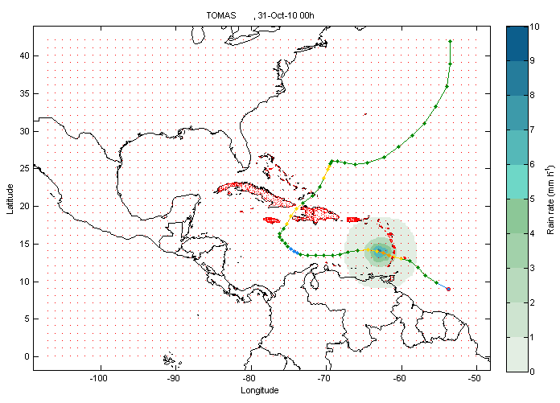Figure: Rain rate field for the highest probabilistic storm, see *climada_tc_rainrate_field_animation*

climada_tc_rainsum_field_animation: Calculate the rain sum fields for a single track and display as animation

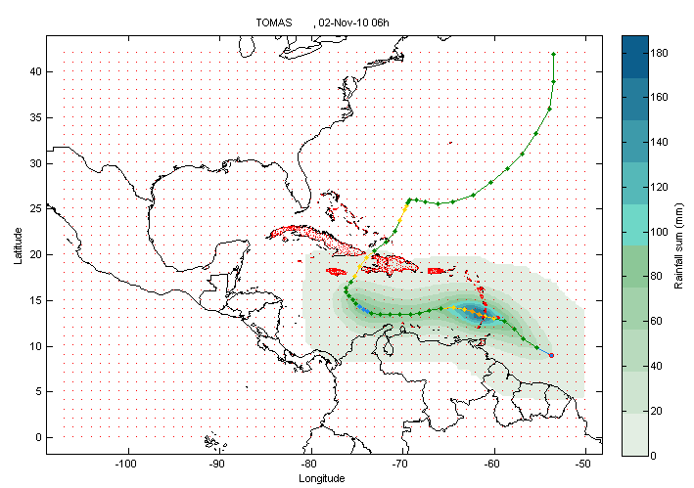

Figure: Rainfall sum field, see climada_tc_rainsum_field_animation

climada_tc_hazard_rain: Generate the Rain Hazard Set (i.e. All Rain Sum Footprints). It needs climada_tc_rainfield, climada_nonspheric_distance_m and climada_RCLIPER.

Analyze Statistics; Plot Rain Sum for Specific Return Periods at all Centroids for Historical Data Set, Probabilistic Data Set or Climate Change Scenario

climada_hazard_stats: Plot rain sum based historical, probabilistic or climate change data, for requested return periods at all centroids.

Figure: Rain sum maps for specific return periods, see climada_hazard_stats

Plot Waterfall Figure for Today’s Damage and Future’s Damage Including Economic Growth and Climate Change Separately for one or two hazards

climada_waterfall_graph_advanced: Include one or two hazard (3 EDS per hazards). The EDS files get sorted (according to hazard type and EDS size automatically)

|  |
| --- |
|  |

* 

Figure: waterfall plot for the hazard rain and wind. See climada_waterfall_graph_advanced-

## Collect the Damages and Benefits of Measures of different hazards

Impacts_collected=climada_collect_measures_impact(impact1,impact2)

This function sums up the benefits (damage averted) and costs[3] of shared measures (i.e. measures with the exact same name). WARNING: It is assumed that the two hazards are insured separately, therefore make sure to not use the same name for both hazards e.g. risk_transfer_rain and risk_transfer_wind. If one insurance covers both hazards sum up the losses of both hazards, apply the risk transfer and calculate the NPV of the benefits and the premium.

After collection of impacts, use climada_adaptation_cost_curve(impacts_collected) as usual to plot the adaptation cost curve.

|  |  |
| --- | --- |
|  |  |



Figure: Cost curve of collected impacts.

1. <https://github.com/davidnbresch/climada_module_tc_hazard_advanced>
2. <https://github.com/davidnbresch/climada_module_country_risk>
3. takes higher costs if costs not the same.