NAME: _____SOLUTIONS_______________

ECE 210
EXAM 2
Spring 2011

FOR GRADERS’ USE ONLY.
PROBLEM # | GRADE | POINTS
1 |  | 8
2 |  | 12
3 |  | 32
4 |  | 30
TOTAL |  | 82

1. (2 points each, 8 points total) Match the letter of the Configuration with the appropriate circuit diagram:
A) Inverting Configuration
B) True Differential Configuration
C) Non-inverting Configuration
D) Buffer Configuration

V_{in}
+
-
+
-
+
-
V_{out}
+
-
+
-
V_{in}
+
-
V_{out}

Configuration: __C_____ Configuration: __D_____

V₂
V₁
+
-
+
-
+
-
V_{out}
+
-
R_{f}
R_{f}
R_{i}
R_{i}
V_{in}
+
-
+
-
+
-
V_{out}

Configuration: __A______ Configuration: __B_____

2.) (12 points total)
Given this circuit containing an Ideal Op-Amp, capable of Rail-to-Rail operation (that is, the output is able to go all the way to the supply voltage):
1 kΩ
+
-
+
-
V_{in}
+
-
10 kΩ
V_{out}
+10V
-10V

A. (2 points) Is this: Non-Inverting, Inverting, Comparator, Differential, or Buffer Configuration (CIRCLE ONE.)

B. (6 points) Given part A, what is the output V_{out} in terms of the input V_{in}?

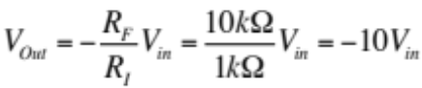

C. (2 points) If V_{in} is 0.3V, what will the output be?

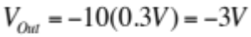

D. (2 points) If V_{in} is 2V, what will the output be?
 which is greater than V_{CC}=-10V, so V_{Out}=-10V.
3. (32 points total)

Given the circuit below, in which the switch has been open for a long time and closes at t=0, answer the following questions:
R_{S} = 20 Ω
+
-
12V
t=0
-
+
v
1 µF
R_{L} = 10 Ω

A. (4 points) If I asked you for the TOTAL response of anything in this circuit (current through or voltage across ANY passive element) and I called it Y(t), what general form would it take?

Y(t) = ___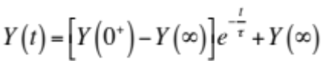______________________________________

B. (6 points) Which quantity, voltage across or current through which element in this circuit, MUST be continuous across the switch closing, and what is its initial value?

Voltage across the capacitor MUST be continuous. The circuit is source-free, so v(0⁻)=0.

NOW, I am going to ask you to find the voltage across the capacitor, v (t).

C. (2 points) What is the final value of v (i.e., v(∞))?
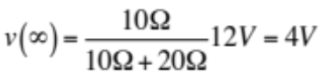

D. (4 points) What is v just after the switch closes (i.e., v(0⁺))?
Must be continuous, so v(0⁺)=0V

E. (2 points) What is the decay constant, τ? (NOTE: This is for time t≥0.)

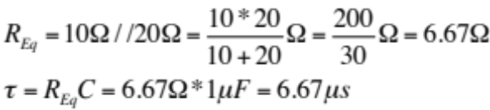

F. (8 points) Evaluate the constant(s) and give the formula for v(t) for t>0:
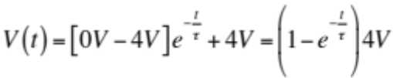

v(t) = ______________________________________________________________

G. (2 points) How long would I have to wait to make sure all transients from the switch have died away?
5 TIME CONSTANTS is 5(6.67µs)=33.35µs.

H. (4 points) Sketch v(t):
V
t

4. (30 points total)

Given the circuit below, in which the switch has been closed for a long time and opens at t=0, answer the following questions:

R_{S} = 5 Ω
+
-
10V
t=0
-
+
v_{L}
1 mH
R_{L} = 50 Ω

A. (6 points) Which quantity, voltage across or current through which element in this circuit, MUST be continuous across the switch opening, and what is its value?

Current through inductor must be continuous.
I_{L}(0⁻)=10V/5Ω=2A.

NOW, I am going to ask you to find the voltage across the inductor, v_{L}(t).

B. (2 points) What is the voltage across the inductor just before the switch opens, v_{L} at t=0⁻?
Inductor looks like short at t=0⁻, so v_{L}(0⁻)=0V.

C. (2 points) What is the final value of v_{L}, v_{L}(∞)?
L again looks like short ckt, so v_{L}(∞)=0V

D. (4 points) What is v_{L} just after the switch opens, v_{L}(0⁺)?

Voltage Division, V_{L}=(50/55)x10V=100/11V=9.09V
ADMISSION: In scrolling back and forth to typeset this, without a handwritten copy in front of me, I for some reason though it was for the switch Closing, not Opening. Here’s the correct version:
The switch opens, leaving the 2A of current to flow UP through the 50Ω resistor, so
v_{R}(0⁺)=v_{L}(0⁺)=-(50Ω)(2A)=-100V.

E. (2 points) What is the decay constant, τ? (NOTE: This is for time t≥0.)

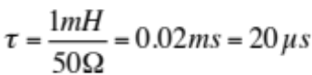

F. (8 points) Evaluate the constant(s) and give the formula for v_{L}(t) for t>0:
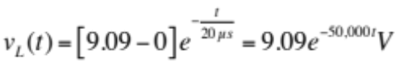 My Bad, use correct value of v(0⁺):
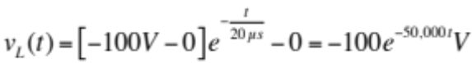

v_{L}(t) = ___________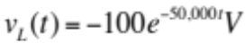_________________________________________

G. (2 points) How long would I have to wait to make sure all transients from the switch have died away?
5 time constants=100µs.

H. (4 points) Sketch v_{L}(t):
V_{L}
t

0V for t<0, exponential decay to zero from an initial value of -100V for t>0.

